Rajvaibhav Rahane

17u283 223045

SE-C Comp,Viit,Pune

**AIM:-**

Create employee bio-data using following classes

1. Personal record
2. Professional record
3. Academic record Assume appropriate data members and member function to accept required data & print bio-data. Create bio-data using multiple inheritance using C++.

**THEORY :-**

**Inheritance:-**

  Inheritance allows us to define a class in terms of another class, which makes it easier to create and maintain an application. This also provides anopportunity to reuse the code functionality and fast implementation time.

When creating a class, instead of writing completely new datamembers and member functions, the programmer can designate thatthe new class should inherit the members of an existing class. This existing class is called the baseclass, and the new class is referred to as the derived class.

The idea of inheritance implements the is a relationship.

***CODE:***

#include<iostream>

using namespace std;

class PersonalData {

protected:

string name,address,mobNo,bloodGroup,gender,dob;

int age;

void setPersonalData()

{

cout<<"___________________________________"<<endl;

cout<<"\tPersonal Data "<<endl;

cout<<"\tName: ";

cin>>name;

cout<<"\tMobile No : ";

cin>>mobNo;

cout<<"\tAge : ";

cin>>age;

cout<<"\tGender : ";

cin>>gender;

cout<<"\tDate of Birth : ";

cin>>dob;

cout<<"\tBlood Group : ";

cin>>bloodGroup;

}

void getPersonalData(){

cout<<"________________PERSONAL DATA___________________"<<endl;

cout<<"\tPersonal Data"<<endl;

cout<<"\tName: "<<name<<endl;

cout<<"\tMobile No : "<<mobNo<<endl;

cout<<"\tAge : "<<age<<endl;

cout<<"\tGender : "<<gender<<endl;

cout<<"\tDate of Birth : "<<dob<<endl;

cout<<"\tBlood Group : "<<bloodGroup<<endl;

}

};

class ProfessionalData {

int salary;

string name,empId,currComp,earlyExp,post;

protected:

void setProfessionalData(){

cout<<"______________________________________"<<endl;

cout<<"\tProfessional Data"<<endl;

cout<<"\tName: ";

cin>>name;

cout<<"\tEmployee ID : ";

cin>>empId;

cout<<"\tCurrent Company : ";

cin>>currComp;

cout<<"\tCurrent Post : ";

cin>>post;

cout<<"\tSalary : ";

cin>>salary;

cin.ignore();

cout<<"\tEarly Experience : ";

cin>>earlyExp;

}

void getProfessionalData(){

cout<<"_________________PROFESSIONAL DATA_________________________"<<endl;

cout<<"\tProfessional Data"<<endl;

cout<<"\tName: "<<name<<endl;

cout<<"\tEmployee ID : "<<empId<<endl;

cout<<"\tCurrent Company : "<<currComp<<endl;

cout<<"\tCurrent Post : "<<post<<endl;

cout<<"\tSalary : "<<salary<<endl;

cout<<"\tEarly Experience : "<<earlyExp<<endl;

}

};

class AcedemicData{

int hscMarks,sscMarks;

float finalCgpa;

string deg,name,yog;

protected:

void setAcedemicData(){

cout<<"_____________________________________"<<endl;

cout<<"\tAcedemic Data"<<endl;

cout<<"\tName: ";

cin>>name;

cout<<"\tDegree : ";

cin>>deg;

cout<<"\tHSC score : ";

cin>>hscMarks;

cout<<"\tSSC score :";

cin>>sscMarks;

cout<<"\tFinal CGPA : ";

cin>>finalCgpa;

cin.ignore();

cout<<"\tYear of Graduation: ";

cin>>yog;

}

void getAcedemicData(){

cout<<"______________________ACADEMIC DATA_________________________"<<endl;

cout<<"\tAcedemic Data"<<endl;

cout<<"\tName: "<<name<<endl;

cout<<"\tDegree : "<<deg<<endl;

cout<<"\tHSC score : "<<hscMarks<<endl;

cout<<"\tSSC score :"<<sscMarks<<endl;

cout<<"\tYear of Graduation : "<<yog<<endl;

}

};

class Employee : protected PersonalData,protected ProfessionalData,protected AcedemicData{

public:

void setBiodata(){

setPersonalData();

setProfessionalData();

setAcedemicData();

}

void showBiodata(){

getPersonalData();

getProfessionalData();

getAcedemicData();

}

};

int main(){

Employee e1;

e1.setBiodata();

e1.showBiodata();

return 0;

}

***Output:***

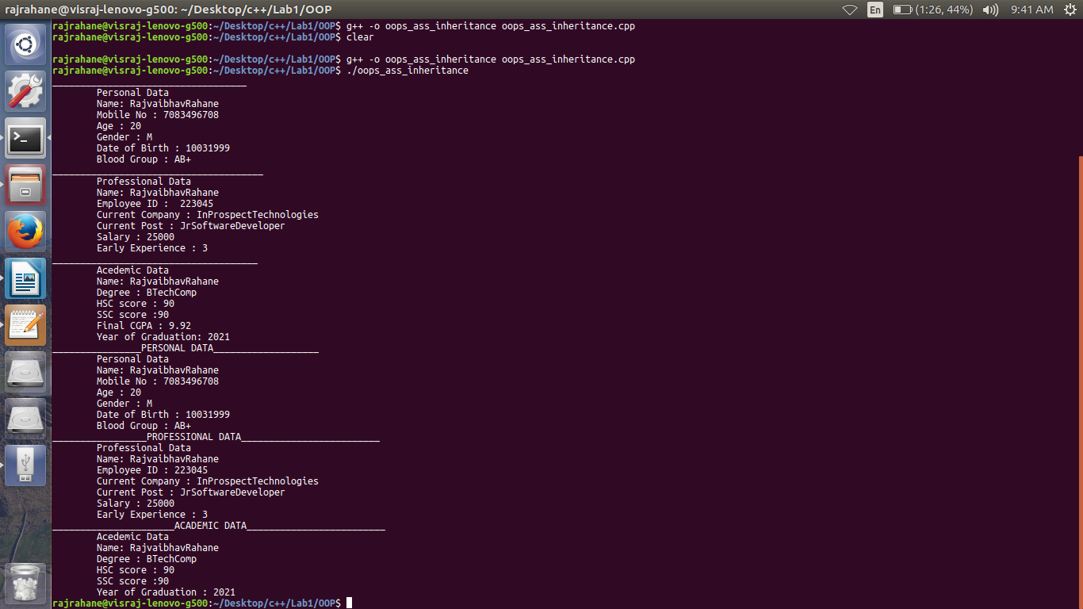

Conclusion-The Concept of Inheritance is studied.