Rajvaibhav Rahane

17u283 223045

SE-C Comp,Viit,Pune

**AIM :-**

Write a function template and class template selection Sort. Write a program that inputs, sorts and outputs an integer array and a float array.

**THEORY:-**

Template is simple and yet very powerful tool in C++. The simple idea is to pass data type as a parameter so that we don’t need to write same code for different data types. For example a software company may need sort() for different data types. Rather than writing and maintaining the multiple codes, we can write one sort() and pass data type as a parameter.

***CODE:***

#include<iostream>

using namespace std;

template<class T>

void printArray(T* arr,int size){

for(int i=0;i<size;i++){

cout<<arr[i]<<" ";

}cout<<endl;

}

template<class T>

void selectionSort(T*arr,int size,bool ascendingOrder){

T temp;

int i,j,maxElementIndex;

for(i=size-1;i>0;i--){

maxElementIndex=0;

for(j=1;j<=i;j++){

if(ascendingOrder){

if(arr[maxElementIndex]-arr[j]<0){

maxElementIndex=j;

}

}else{

if(arr[maxElementIndex]-arr[j]>0){

maxElementIndex=j;

}

}

}

temp=arr[maxElementIndex];

arr[maxElementIndex]=arr[i];

arr[i]=temp;

cout<<"Iteration"<<size-i<<" ";printArray(arr,size);

}

}

void printMenu(){

cout<<"1)Int Array\t";

cout<<"2)Float Array\t";

cout<<"3)Exit\tChoice : ";

}

int main(){

int choice,size,i;

cout<<"Selection Sort in Descending Order\n";

printMenu();

do{

cin>>choice;

switch(choice){

case 1:{

cout<<"Size : ";cin>>size;

int arr[size];

for(i=0;i<size;i++){

cin>>arr[i];

}

selectionSort(arr,size,false);

break;

}

case 2:{

cout<<"Size : ";cin>>size;

float arr[size];

for(i=0;i<size;i++){

cin>>arr[i];

}

selectionSort(arr,size,false);

break;

}

}

}while(choice!=3);

return 0;

}

***Output:***

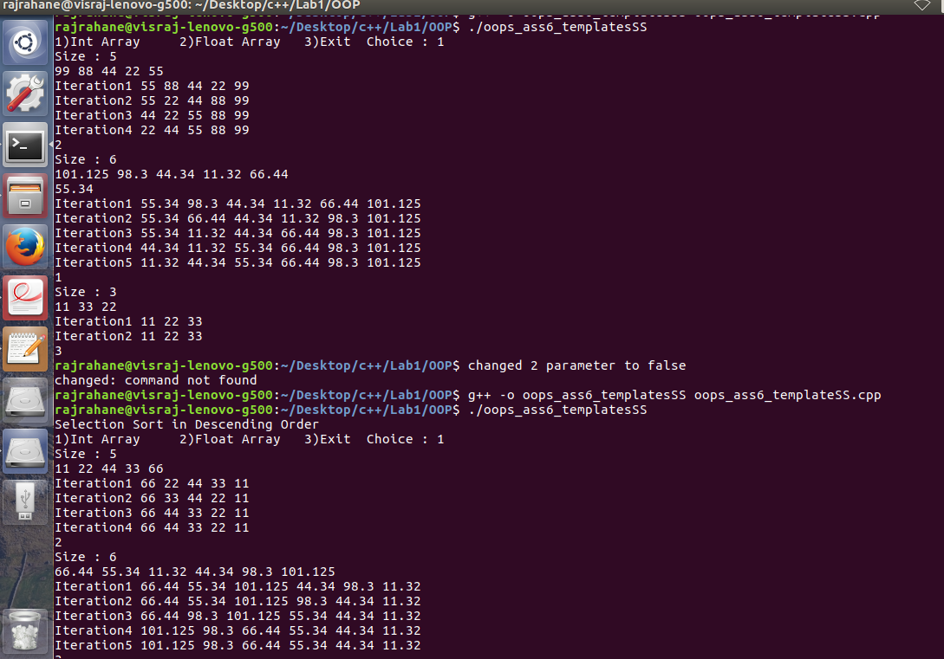

Conclusion-Function Templates and Selection Sorting Algorithm were studied.