Rajvaibhav Rahane

17u283 223045

SE-C Comp,Viit,Pune

**AIM:-Study C++ Exceptions**

Create User defined exception to check the following conditions and throw the exception if the criterion does not meet.

1. User has age between 18 and 55
2. User stays has income between Rs. 50,000 – Rs. 1,00,000 per month .

Accept age, Income, from the user and check for the conditions mentioned above. If any of the condition not met then throw the exception. If user does not enter proper input throw the exception.

**THEORY:-**

Exceptions provide a way to transfer control from one part of a program to another. C++ exception handling is built upon three keywords: try, catch,and throw.

1. **Throw** − A program throws an exception when a problem shows up. This is done using a throw keyword.
2. **Catch** − A program catches an exception with an exception handler at the place in a program where you want to handle the problem. The catch keyword indicates the catching of an exception.
3. **Try** − A try block identifies a block of code for which exceptions will be activated. It's followed by one or more catch blocks.

***CODE:***

/*

*

*@Rajvaibhav Rahane

*

*/

#include<iostream>

using namespace std;

int main(){

int age;float salary;

try{

cin>>age;

if(age<18||age>55)

throw age; //throws int type

cin>>salary;

if(salary<50000|| salary>100000)

throw salary; //throws float type

cout<<"all conditions met\n";

}catch(int e){

cout<<e<<" age condition not met\n";

}catch(float e){

cout<<e<<" salary condition not met\n";

}

return 0;

}

***AIM:***

***Output:***

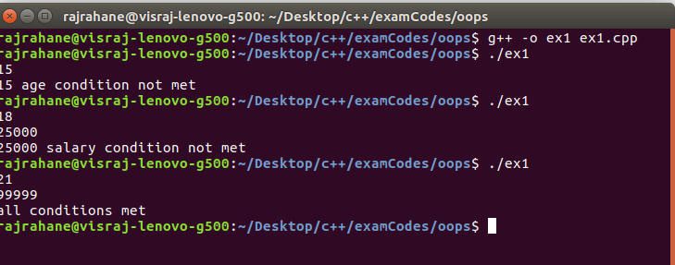

Conclusion- C++ Exception Handling was Studied