Rajvaibhav Rahane

17u283 223045

SE-C Comp,Viit,Pune

**AIM:-**

Create User defined exception to check the following conditions and throw the exception if the criterion does not meet.

1. User stays in Pune/ Mumbai/ Bangalore / Chennai
2. User has 4-wheeler

City, Vehicle from the user and check for the conditions mentioned above. If any of the condition not met then throw the exception. If user does not enter proper input throw the exception.

**THEORY:-**

Exceptions provide a way to transfer control from one part of a program to another. C++ exception handling is built upon three keywords: **try, catch,**and **throw**.

**1)Throw** − A program throws an exception when a problem shows up. This is done using a **throw** keyword.

**2)Catch** − A program catches an exception with an exception handler at the place in a program where you want to handle the problem. The **catch** keyword indicates the catching of an exception.

**3)Try** − A **try** block identifies a block of code for which particular exceptions will be activated. It's followed by one or more catch blocks.

***CODE:***

#include<iostream>

using namespace std;

int main(){

string cityName;char hasVehicle;bool vehicleCondition,cityNameCondition=vehicleCondition=true;

cout<<"Enter Your City Name\t";

try{

try{

cin>>cityName;

if(!(cityName=="Mumbai"||cityName=="Pune" || cityName=="Bangalore" || cityName=="Chennai"))

throw cityName;

cout<<"Your City is present in the list\n";

}catch(string cityName){

cout<<"City absent in City List\n";

cityNameCondition=false;

}

cout<<"Do you own a 4 Wheeler(y/n)\t";

try{

cin>>hasVehicle;

if(hasVehicle!='y')

throw hasVehicle;

cout<<"Congo!\n";

}catch(char hasVehicle){

cout<<"Its Okay\n";vehicleCondition=false;

}

if(!cityNameCondition)throw cityName;

if(!vehicleCondition)throw hasVehicle;

cout<<"You Drive In a Smart City\n";

}catch(...){

cout<<"You can't Drive In our City\n";

}

return 0;

}

***Output:***

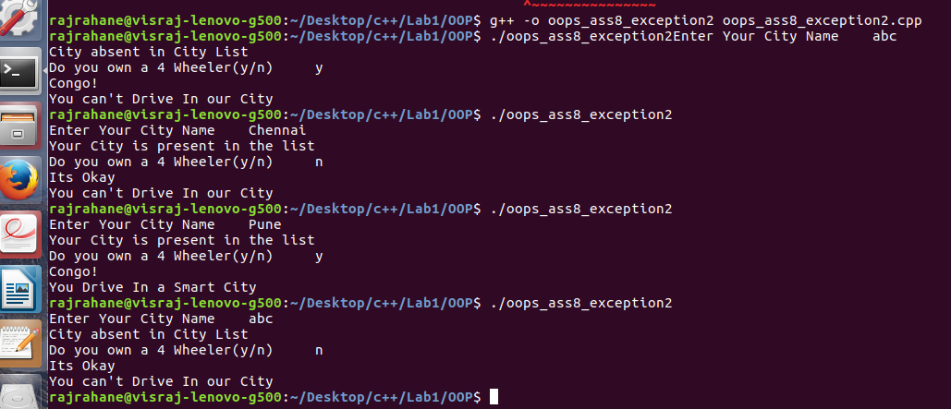

Conclusion-C++ Exception Handling was studied