**XML FILE GENERATOR**

**GROUP MEMEBERS :**

1. RAJVAIBHAV RAHANE.(17U283)
2. JUGAL PATIL (17U183)
3. SAKSHI KHODE (17U116)
4. SHRAVAN SHETTY(17U201)
5. SUMEDH KULKARNI(17U150)

**AIM :**

Student database of marks in spreadsheet.

**DATA STRUCTURES :**

1. List
2. Map

**PROGRAM :**

/*

*@Rajvaibhav Rahane

*/

#include<iostream>

#include<map>

#include<string.h>

#include<list>

#include<fstream>

using namespace std;

class Exam{

string name;

int totalMarks;

public:

Exam(){}

void setName(string name){

this->name=name;

}

string getName(){

return name;

}

void setTotalMarks(int totalMarks){

this->totalMarks=totalMarks;

}

int getTotalMarks(){

return totalMarks;

}

};

class ExamDetails{

private:

list<Exam> examList;

public:

void addExam();

list<Exam> getExamList();

int getExamListSize();

};

void ExamDetails::addExam(){

string examName;

int totalMarks;

cout<<"Enter Exam name : \t";

cin>>examName;

cout<<"Enter Total Marks : \t";

cin>>totalMarks;

Exam *exam=new Exam();

(*exam).setName(examName);

(*exam).setTotalMarks(totalMarks);

examList.push_back(*exam);

}

list<Exam> ExamDetails::getExamList(){

return examList;

}

int ExamDetails::getExamListSize(){

return examList.size();

}

class Student{

string name;

int prnNo;

map<Exam*,int> examMarksMap;

public:

void setPrnNo(int prnNo){

this->prnNo=prnNo;

}

void setName(string name){

this->name=name;

}

string getName(){

return name;

}

int getPrnNo(){

return prnNo;

}

map<Exam*,int> getExamMarksMap(){

return examMarksMap;

}

void setStudent(ExamDetails);

void printStudent();

};

void Student::setStudent(ExamDetails examDetails){

cout<<"Enter Name : ";cin>>name;

cout<<"Enter PRN No : ";cin>>prnNo;

list<Exam> examList=examDetails.getExamList();

cout<<"Enter Subject Marks\n";

int marks;

for(list<Exam>::iterator it=examList.begin();it!=examList.end();it++){

cout<<(*it).getName()<<" : ";cin>>marks;Exam exam;

std::pair<Exam*,int> examMarks=std::make_pair(&(*it),marks);

examMarksMap.insert(examMarks);

}

}

void Student::printStudent(){

cout<<name<<""<<prnNo<<endl;

for(map<Exam*,int>::iterator it=examMarksMap.begin();it!=examMarksMap.end();it++){

cout << it->first->getName() <<" =>"<< it->second << '\n';

}

}

void createFile(ExamDetails examDetails){

ofstream studentDB_oFile("examResults.xlsx");

studentDB_oFile<<"Roll No\t"<<"Name\t";

list<Exam> examList=examDetails.getExamList();

for(list<Exam>::iterator it=examList.begin();it!=examList.end();it++){

studentDB_oFile<<(*it).getName()<<"\t";

}

studentDB_oFile<<"Total\t"<<endl;

studentDB_oFile.close();

}

void addStudent(ExamDetails examDetails){

Student student;

student.setStudent(examDetails);

student.printStudent();

fstream studentDatabase_oFile("examResults.xlsx");

cout<<studentDatabase_oFile.is_open()<<endl;

if(!studentDatabase_oFile.is_open()){ //file does not exist

createFile(examDetails);

}else{ //file exists

studentDatabase_oFile.close();

}

studentDatabase_oFile.open("examResults.xlsx",ios::app);

if(studentDatabase_oFile.is_open()){

cout<<"open\n";

studentDatabase_oFile<<student.getPrnNo()<<"\t"<<student.getName()<<"\t";

map<Exam*,int> examMarksMap=student.getExamMarksMap();

int sum=0;

for(map<Exam*,int>::iterator it=examMarksMap.begin();it!=examMarksMap.end();it++){

sum+=it->second;

studentDatabase_oFile << it->second << '\t';

}

studentDatabase_oFile<<sum<<"\t"<<endl;

studentDatabase_oFile.close();

}

}

void printMenu(){

cout<<"\nMenu\n";

cout<<"\t1)Add Student\n";

cout<<"\t2)Exit\nChoice : ";

}

int main(){

ExamDetails examDetails;

/*fstream iFile("examDetails1.txt",ios::in);

if(iFile.is_open()){

iFile.close();

iFile.open("examDetails1.txt",ios::in);cout<<"File Opened\n";

while(!iFile.eof()){

iFile.read((char*)(&examDetails),sizeof(ExamDetails));

}

iFile.close();

}else{*/

int exams;

cout<<"Enter Number of Exams : ";

do{

cin>>exams;

if(exams<=0)

cout<<"Number of Exams should be greater than zero, Reenter : ";

}while(exams<=0);

while(exams--)

examDetails.addExam();

//ofstream oFile("examDetails1.txt",ios::out);

//list<Exam> examList=examDetails.getExamList();

//oFile.write((char*)(&examDetails),sizeof(ExamDetails));

/*for(list<Exam>::iterator it=examList.begin();it!=examList.end();it++){

}*/

//oFile.close();

//}

list<Exam> examList=examDetails.getExamList();

for(list<Exam>::iterator it=examList.begin();it!=examList.end();it++){

cout<<(*it).getName()<<""<<(*it).getTotalMarks()<<"\t";

}cout<<endl;

int choice,count;

do{

printMenu();cin>>choice;

switch(choice){

case 1:{

addStudent(examDetails);break;

}case 2:{

break;

}

}

}while(choice!=2);

return 0;

}

**OUTPUT :**

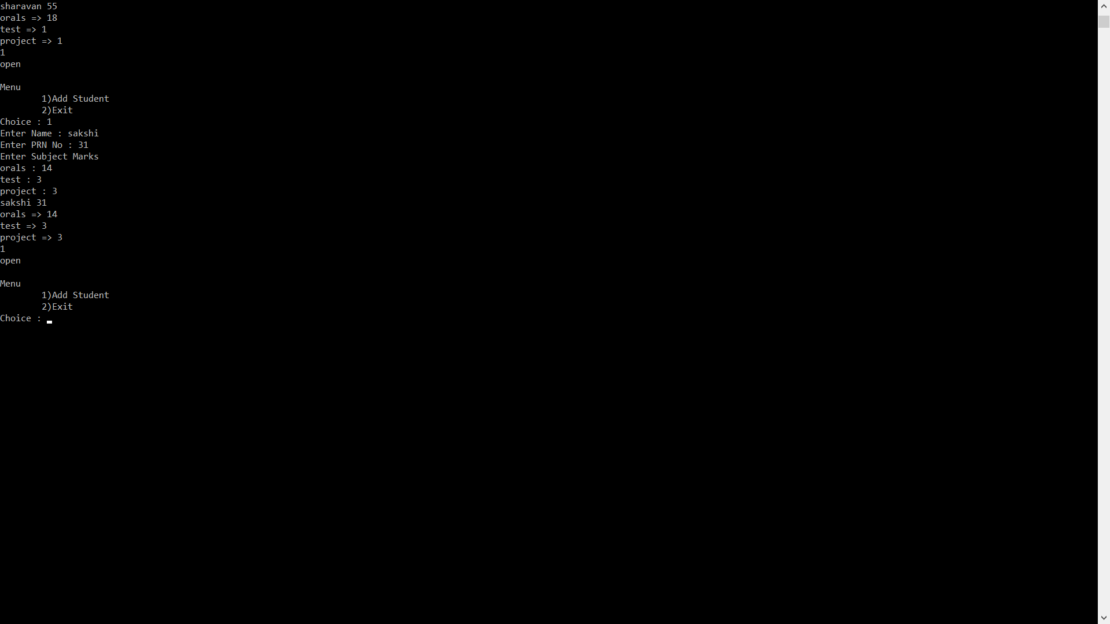



**SPREADSHEET :**

