Name: RAJSEKHAR PRADHA N

Branch: Electronics and Telecommuications , 1st year

Group: 11

College: VSSUT , Burla

Q.1: Write a C-program to enter two numbers and perform all arithmetic operations .

Ans:

code:

#include<stdio.h>

int main()

{

int a,b,c,d,e,f;

printf("Enter two number\n");

scanf("%d",&a);

scanf("%d",&b);

c=a+b;

d=a-b;

e=a\*b;

f=a/b;

printf("The addition is=%d\n",c);

printf("The substraction is=%d\n",d);

printf("The multiplication is=%d\n",e);

printf("The division is=%d",f);

return 0;

}

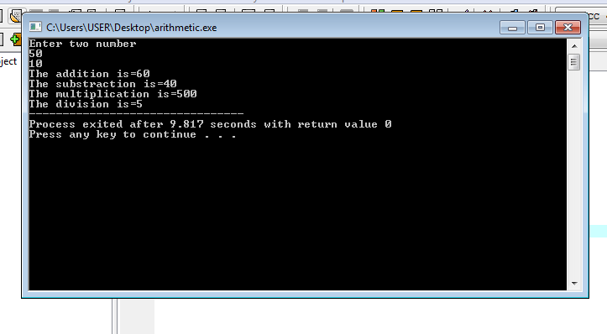

Q.2: Write a C-program to enter temperature in Celcius and convert it into Farenhit .

Ans:

code:

#include<stdio.h>

int main()

{

int t1,t2;

printf("Enter the temperature in Celcius:\n");

scanf("%d",&t1);

t2=(t1\*9/5)+32;

printf("The temperature in Farenhit is:%d\n",t2);

return 0;

}

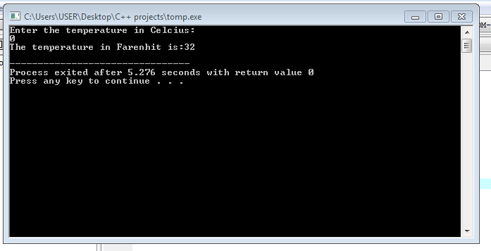

Q.3: Write a C-program to enter the radius of a circle and find its diameter, circumference and area.

Ans:

code:

#include<stdio.h>

int main()

{

int r,d,c,a;

printf("Enter the radius of circle:\n");

scanf("%d\n",&r);

d=2\*r;

c=3.14\*2\*r;

a=3.14\*r\*r;

printf("The Diameter of the circle is:%d\n",d);

printf("The Circumference of the circle is:%d\n",c);

printf("The Area of the circle is:%d\n",a);

return 0;

}

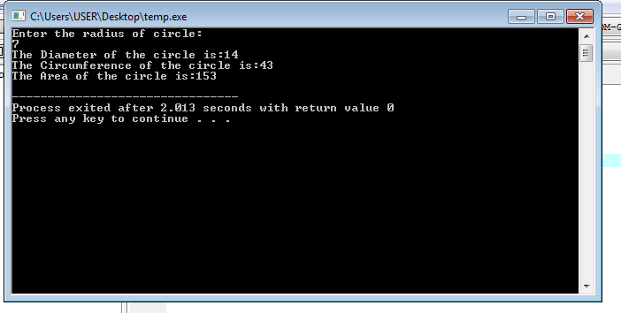

Q.4: Write a C-program to input marks of five subjects Physics , Chemistry , Biology , Mathematics and Computer . Calculate percentage and grade accordnig to following:

Percentage >=90% : Grade A

Percentage >=80% : Grade B

Percentage >=70% : Grade C

Percentage >=60% : Grade D

Percentage >=40% : Grade E

Percentage < 40% : Grade F

Ans:

code:

#include<stdio.h>

int main()

{

int p,c,b,m,x,tot,perc;

printf("Enter mark in Physics:\n");

printf("Enter mark in Chemistry:\n");

printf("Enter mark in Biology:\n");

printf("Enter mark in Mathematics:\n");

printf("Enter mark in Computer:\n");

scanf("%d",&p);

scanf("%d",&c);

scanf("%d",&b);

scanf("%d",&m);

scanf("%d",&x);

tot=p+c+b+m+x;

perc=tot\*100/500;

printf("Total mark:%d\n",tot);

printf("Percetage:%f\n",perc);

printf("Grade:");

if(perc>90){

printf("A\n");

}

else if(perc>=80){

printf("B\n");

}

else if(perc>=70){

printf("C\n");

}

else if(perc>=60){

printf("D\n");

}

else if(perc>=40){

printf("E\n");

}

else{

printf("F\n");

}

return 0;

}

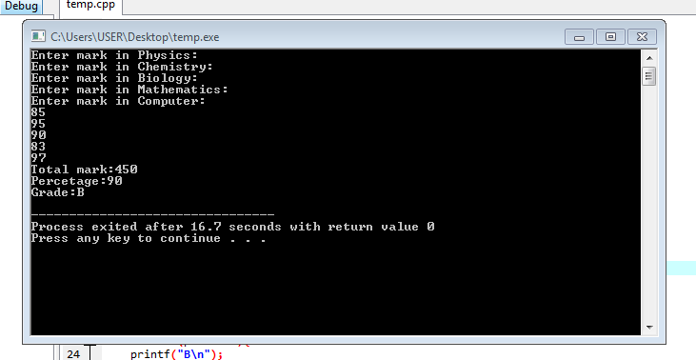

Q.5: Write a C-program to check wether an alphaet is vowel or consonantusing switch case .

Ans:

code:

#include<stdio.h>

int main()

{

char c;

printf("Enter a letter:");

scanf("%c",&c);

switch(c)

{

case 'a':

printf("Vowel");

break;

case 'e':

printf("Vowel");

break;

case 'i':

printf("Vowel");

break;

case 'o':

printf("Vowel");

break;

case 'u':

printf("Vowel");

break;

case 'A':

printf("Vowel");

break;

case 'E':

printf("Vowel");

break;

case 'I':

printf("Vowel");

break;

case 'O':

printf("Vowel");

break;

case 'U ':

printf("Vowel");

break;

default:

printf("Consonant");

}

return 0;

}

