Name: RAJSEKHAR PRADHA N

Branch: Electronics and Telecommuications , 1st year

Group: 11

College: VSSUT , Burla

**Q1. Write a C program to calculate sum of digits of a number.**

**Ans:**

**Code-**

#include<stdio.h>

int main()

{

int n,r,i,s=0;

printf("Enter a number: ");

scanf("%d",&n);

i=n;

while(i!=0)

{

r=i%10;

s=s+r;

i=i/10;

}

printf("The sum of all digits of the number is %d",s);

return 0;

}

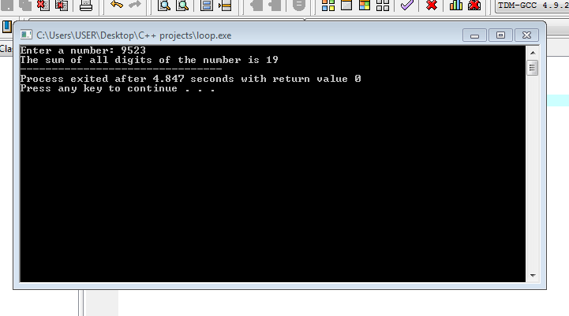

**Q2. Write a C program to print the sum of all the even elements and even position elements In an array.**

**Ans:**

**Code-**

#include<stdio.h>

int main()

{

int arr[6],i,s=0;

printf("Enter an array having 6 elements : \n");

for(i=0;i<6;i++)

{

scanf("%d",&arr[i]);

}

for(i=0;i<6;i++)

{

if(i%2!=0)

{

s=s+arr[i];

}

if(arr[i]%2==0)

{

s=s+arr[i];

}

}

printf("Sum of all the even elements and even position elements of the array is: %d",s);

return 0;

}

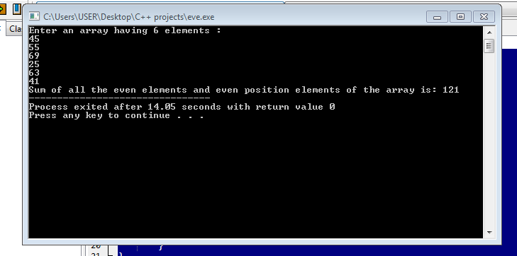

**Q3.Write a C program to count the total number of words In a string.**

**Ans:**

**Code-**

#include<stdio.h>

#include<string.h>

void main()

{

char c[100];

int r=0,i;

printf("Enter a string : \n");

sacnf ("%[^\n]c", c);

for(i=0; c[i]='\0'; i++)

{

if(c[i]==' ' && c[i+1] != ' ')

r++

}

printf("The number of words in the sentece is : ",r+1);

return 0;

}



**Q4.Write a C program to find largest and smallest element In an array.**

**Ans:**

**Code-**

#include<stdio.h>

int main()

{

int a[100],i,j,l,s;

printf("number of elements : ");

scanf("%d",&j);

printf("Enter the array : ");

for(i=0;i<=j-1;++i)

scanf("%d",&a[i]);

l=s=a[0];

for(i=1;i<=j-1;++i)

{

if(a[i]>l)

l=a[i];

if(a[i]<s)

s=a[i];

}

printf("The largest element is %d\n",l);

printf("The smallest element is %d",s);

return 0;

}

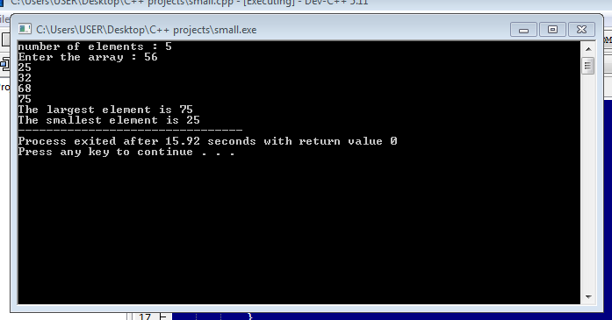

**Q5.Write a C program to print the given pattern using loops.**

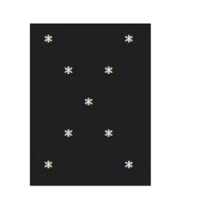

**Ans:**

**Code-**

#include<stdio.h>

int main()

{

int i,j;

for(i=1;i<=5;i++)

{

for(j=1;j<=5;j++)

{

if(j==i || (j==5 - i+1))

printf("*");

else

printf(" ");

}

printf("\n");

}

return 0;

}

