Using cordova in android studio

# 1)Creating a new cordova application –

1. Install the cordova module using the command line

***npm install -g cordova***

1. Using the cordava module in the CLI create a new cordova project- ***cordova create Helloworld***
2. Add the android platform using the command

***cordova platform add android***

1. Build the project using the command ***cordova build android***

**After this close the command prompt and open android studio**

1. Go to files>new>import project
2. Go to the location where you’ve created the cordova folder and select platforms>android
3. Upon selection click ok to build the gradle and cordova is synced with your android project.
4. Place the files you want to run in the assets/www folder or manually give the path where your file is located.
5. Copy the files located in \platforms\android\platform_www in your source file for it to run properly.

# 2)Integrating cordova in an existing application:

1. Follow steps 1-3 as mentioned above.
2. Open the existing android studio project, go to file>new>import module
3. Go to the cordova folder and select

platforms\android\CordovaLib

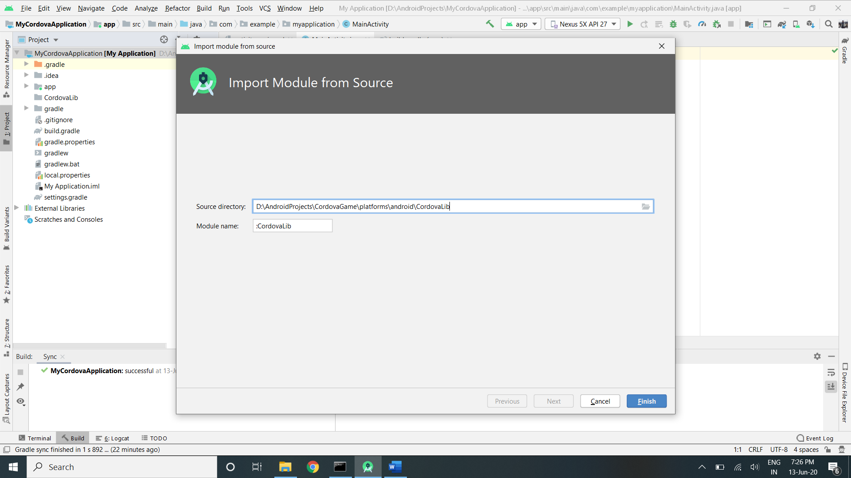

4)Keep your directory in project view, right click on your application and open module settings

5)Go to dependencies>add dependencies>module and add the cordova lib dependency

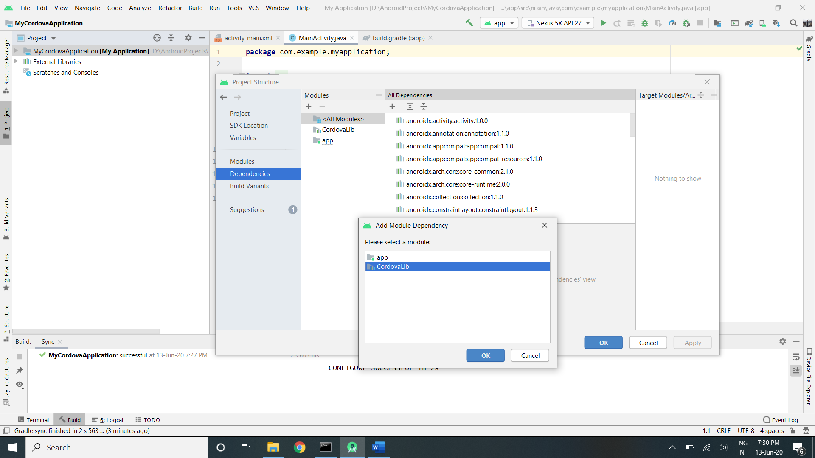

6)Apply the dependency and after gradle sync, cordova is successfully added to the project.

7)To use cordova, any activity needs to extend the CordovaActivity and call load files using loadUrl(“filepath”).

**Copy the files located in \platforms\android\platform_www in your source file before running the app.**