Rajashekar Mudigonda

A20556922

**CS 585 Spring 2024 Written Assignment #03**

Due: **Saturday, February 24, 2024 at 11:59 PM CST**

Points: **30**

**Objectives:**

1. (20 points) Demonstrate your understanding of the Naive Bayes classifier.
2. (10 points) Demonstrate your understanding of POS Tagging with Hidden Markov Model and Viterbi algorithm.

**Problem 1 [20 pts]**

Your task is to **manually** develop a Naive Bayes **SPAM** classifier / model. Training and test sets are provided below. Assume that no additional pre-processing is necessary:

|  |  |
| --- | --- |
| **Training set:** | |
| **Sample:** | **Label:** |
| get cheap pills online | SPAM |
| online pharmacy pills fast | SPAM |
| online pills fast shipment | SPAM |
| my pills prescription | HAM |
| shipment not fast | HAM |
| order pills online | SPAM |
| fast pills delivery | SPAM |
| this online pharmacy | HAM |
| take your pills | HAM |
| get your pills cheap | SPAM |
| my online order | HAM |

|  |  |
| --- | --- |
| **Test set:** | |
| **Sample:** | **Label:** |
| order pills fast | SPAM |
| no prescription online pharmacy | SPAM |
| this order was online | HAM |

1. **[3 pt]** Extract vocabulary from data (you can add / remove rows as necessary):

|  |  |  |  |
| --- | --- | --- | --- |
| **Vocabulary:** | | | |
| **Word** | **count** | **Word** | **count** |
| get | 2 | Not | 1 |
| cheap | 2 | delivery | 1 |
| pills | 8 | this | 1 |
| online | 6 | take | 1 |
| pharmacy | 2 | your | 2 |
| Fast | 4 | order | 2 |
| shipment | 2 |  |  |
| my | 2 |  |  |
| prescription | 1 |  |  |

Total unique words in vocabulary : 15

Total number of words = 37

Total words of the class SPAM = 22

Total words of the class HAM = 15

1. **[10 pt]** Construct the model(s) (**include add-1 smoothing**) / derive all parameters. Include all formulas and detailed derivation.

|  |
| --- |
| **Model / parameters:** |
| **Prior Probabilities**  P(y=SPAM) = 6/11  P(y=HAM) = 5/11  **Likelihood Probabilities of words for class SPAM:**  P(xi | class) = count(xi, SPAM)/ sum(Count(x,y=SPAM))  Using the above likelihood equation :  P(x=get|y=SPAM) =count(get, SPAM) = 2/22  P(x=cheap|y=SPAM) =count(get, SPAM) = 2/22  P(x=pills |y=SPAM) =count(get, SPAM) = 6/22  P(x=online|y=SPAM) =count(get, SPAM) = 4/22  P(x= pharmacy |y=SPAM) =count(get, SPAM) = 1/22  P(x= Fast |y=SPAM) =count(get, SPAM) = 3/22  P(x= shipment |y=SPAM) =count(get, SPAM) = 1/22  P(x= my |y=SPAM) =count(get, SPAM) = 0/22  P(x= prescription |y=SPAM) =count(get, SPAM) = 0/22  P(x= Not |y=SPAM) =count(get, SPAM) = 0/22  P(x= delivery |y=SPAM) =count(get, SPAM) = 1/22  P(x=this|y=SPAM) =count(get, SPAM) = 0/22  P(x=take|y=SPAM) =count(get, SPAM) = 0/22  P(x=your|y=SPAM) =count(get, SPAM) = 1/22  P(x=order|y=SPAM) =count(get, SPAM) = 1/22  Adding Laplace smoothing:  Count(w) + 1/22+15 = 1/37  P(x=get|y=SPAM) =count(get, SPAM) = 3/37  P(x=cheap|y=SPAM) =count(get, SPAM) = 3/37  P(x=pills |y=SPAM) =count(get, SPAM) = 7/37  P(x=online|y=SPAM) =count(get, SPAM) = 5/37  P(x= pharmacy |y=SPAM) =count(get, SPAM) = 2/37  P(x= Fast |y=SPAM) =count(get, SPAM) = 4/37  P(x= shipment |y=SPAM) =count(get, SPAM) = 2/37  P(x= my |y=SPAM) =count(get, SPAM) = 1/37  P(x= prescription |y=SPAM) =count(get, SPAM) = 1/37  P(x= Not |y=SPAM) =count(get, SPAM) = 1/37  P(x= delivery |y=SPAM) =count(get, SPAM) = 2/37  P(x=this|y=SPAM) =count(get, SPAM) = 1/37  P(x=take|y=SPAM) =count(get, SPAM) = 1/37  P(x=your|y=SPAM) =count(get, SPAM) = 2/37  P(x=order|y=SPAM) =count(get, SPAM) = 2/37  **Likelihood Probabilities of words for class HAM:**  P(x=get|y=HAM) =count(get, HAM) = 0/15  P(x=cheap|y=HAM) =count(get, HAM) = 0/15  P(x=pills |y= HAM) =count(get, HAM) = 2/15  P(x=online|y= HAM) =count(get, HAM) = 2/15  P(x= pharmacy |y= HAM) =count(get, HAM) = 1/15  P(x= Fast |y= HAM) =count(get, HAM) = 1/15  P(x= shipment |y= HAM) =count(get, HAM) = 1/15  P(x= my |y= HAM) =count(get, HAM) = 2/15  P(x= prescription |y= HAM) =count(get, SPAM) = 1/15  P(x= Not |y= HAM) =count(get, HAM) = 1/15  P(x= delivery |y= HAM) =count(get, SPAM) = 0/15  P(x=this|y= HAM) =count(get, SPAM) = 1/15  P(x=take|y= HAM) =count(get, SPAM) = 1/15  P(x=your|y= HAM) =count(get, SPAM) = 1/15  P(x=order|y= HAM) =count(get, SPAM) = 1/15  Adding Laplace smoothing: count(word)+1/15+15 = (c+1)/30  P(x=get|y=HAM) =count(get, HAM) = 1/30  P(x=cheap|y=HAM) =count(get, HAM) = 1/30  P(x=pills |y= HAM) =count(get, HAM) = 3/30  P(x=online|y= HAM) =count(get, HAM) = 3/30  P(x= pharmacy |y= HAM) =count(get, HAM) = 2/30  P(x= Fast |y= HAM) =count(get, HAM) = 2/30  P(x= shipment |y= HAM) =count(get, HAM) = 2/30  P(x= my |y= HAM) =count(get, HAM) = 3/30  P(x= prescription |y= HAM) =count(get, SPAM) = 2/30  P(x= Not |y= HAM) =count(get, HAM) = 2/30  P(x= delivery |y= HAM) =count(get, SPAM) = 1/30  P(x=this|y= HAM) =count(get, SPAM) = 2/30  P(x=take|y= HAM) =count(get, SPAM) = 2/30  P(x=your|y= HAM) =count(get, SPAM) = 2/30  P(x=order|y= HAM) =count(get, HAM) = 2/30 |

1. **[5 pt]** Test your model (**include all derivations | ignore “unknown” words if necessary**):

|  |
| --- |
| **Testing:** |
| **Test1(t1) : order pills fast**  P(y=SPAM) * P(x=order|SPAM) * P(pills | SPAM) * P(fast|SPAM)  =6/11 * 2/37 * 7/37 * 4/37 = 336/557183 = 0.00060303 = 6.0303E-4  P(y=HAM) * P(x=order|HAM) * P(pills | HAM) * P(fast|HAM)  = 5/11 * 2/30 * 3/30 * 2/30 = 60/297000 = 0.00020202 = 2.0202E-4  From above P(Y=SPAM| t1) > P(Y=HAM | t1).  So **true positive(TP)**  **Test2(t2) : no prescription online pharmacy**  P(y=SPAM) * P(no|SPAM) * P(prescription|SPAM) * P(online | SPAM) * p(pharmacy| SPAM)  = 6/11 * 1/37 * 5/37 * 2/37 * 3/30 =180/16715490 = 0.00001077  = 1.077E-5  P(y=HAM) * P(no|HAM) * P(prescription|HAM) * p(online | HAM) * p(pharmacy| HAM)  = 5/11 * 2/30 * 3/30 * 2/30  = 60/297000 = 0.00020202 = 2.0202E-4  P(y=HAM) > P(SPAM)  So **False Negative (FP)**  **Test3(t3): this order was online**  P(y=SPAM) * P(this|SPAM) * P(order|SPAM) * p(was | SPAM) * p(online| SPAM)  6/11 *1/37 * 2/37 * 5/37 = 60/557183= 0.00010768 =1.0768E-5  P(y=HAM) * P(this|HAM) * P(order|HAM) * p(was | HAM) * p(online| HAM)  = 5/11 * 2/30 * 2/30 * 3/30 = 60 / 297000 = 0.00020202 = 2.0202E-4  P(y=HAM) > P(y=SPAM)  **True Negative(TN)** |

1. **[2 pts]** Evaluate your model (**create confusion matrix, calculate accuracy, sensitivity (recall), precision, specificity, negative predictive value, accuracy and F-Score**):

|  |
| --- |
| evaluation: |
| |  |  |  |  | | --- | --- | --- | --- | |  | Positive  **SPAM** | Negative  **HAM** |  | | Positive: **SPAM** | TP = 1(t1) | FN = 1(t2) | **Sensitivity**  TP/TP+FN =1/2 = 0.5 | | Negative: **HAM** | 0 | TN = 1(t3) | **Specificity**  =TN/TN+FP  =1/1 + 0 = 1.0 | |  | **Precision**  TP /(TP + FP)  = 1/1+0 = 1.0 | **Negative Predictive**  = TN/TN+FN  = 1/1+1 = 0.5 | Accuracy:  1+1/1+1+1  =2/3 |   F-Score: 0.5 |

**Problem 2 [10 pts]**

Given the following Hidden Markov model (transition probabilities shown; emission probabilities to be determined by you using corpus C data) based on corpus C:

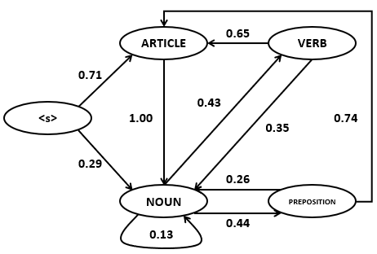

And the following table of selected word counts from some corpus C:

|  |  |  |  |  |  |
| --- | --- | --- | --- | --- | --- |
| **Word/Tag** | **N** | **V** | **ART** | **P** | **TOTAL** |
| *flies* | 21 | 23 | 0 | 0 | 44 |
| *fruit* | 49 | 5 | 1 | 0 | 55 |
| *like* | 10 | 30 | 0 | 21 | 61 |
| *a* | 1 | 0 | 201 | 0 | 202 |
| *the* | 1 | 0 | 300 | 2 | 303 |
| *flower* | 53 | 15 | 0 | 0 | 68 |
| *flowers* | 42 | 16 | 0 | 0 | 58 |
| *birds* | 64 | 1 | 0 | 0 | 65 |
| **others** | 592 | 210 | 56 | 284 | 1142 |
| **TOTAL** | 833 | 300 | 558 | 307 | 1998 |

Use Viterbi algorithm to tag (with Part of Speech tags) the following sentence:

*birds like the fruit*

Calculating Transition Probability Matrix:

|  |  |  |  |  |  |
| --- | --- | --- | --- | --- | --- |
|  | <s> | ARTICLE | NOUN | VERB | PREPOSITION |
| <s> | 0 | 0.71 | 0.29 | 0 | 0 |
| ARTICLE | 0 | 0 | 1.00 | 0 | 0 |
| NOUN | 0 | 0 | 0.13 | 0.43 | 0.44 |
| VERB | 0 | 0.65 | 0.35 | 0 | 0 |
| PREPOSITION | 0 | 0.74 | 0.26 | 0 | 0 |

Computing Observation Matrix:

|  |  |  |  |  |
| --- | --- | --- | --- | --- |
|  | birds | like | the | fruit |
| <s> | 0.000 | 0.000 | 0.000 | 0.000 |
| ARTICLE | 0.000 | 0.000 | 0.537 | 0.001 |
| NOUN | 0.076 | 0.012 | 0.001 | 0.058 |
| VERB | 0.003 | 0.100 | 0.000 | 0.016 |
| PREPOSITION | 0.000 | 0.068 | 0.006 | 0.000 |

**Computing the Viterbi values for First Column:**

V(1, ) = Viterbi[s, observation]:

V(1,1) = viterbi[ARTICLE, birds] =P(ARTICLE | <s>) * P(birds | Article) = 0.71 *0 = 0.000

V(1,2) = viterbi[NOUN, birds] =P(NOUN | <s>) * P(birds | NOUN) = 0.29 *0.076 = 0.0220

V(1,3) = viterbi[VERB, birds] =P(VERB | <s>) * P(birds | VERB) = 0.0 *0.003 = 0.000

V(1,4) = viterbi[Preposition, birds] =P(Preposition | <s>) * P(birds | Preposition) = 0 *0 = 0.000

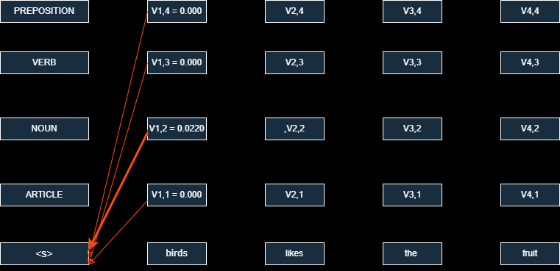

**Computing the states in the second column :**

V2 (1) = viterbi[ARTICLE, like] = maxs’(viterbi[state s’, like] * as’,1 * b1 (like)) = max(

V1 (1) * P(ARTICLE | ARTICLE) * P(like| ARTICLE) = 0.000 * 0.00 * 0.000 = 0.000

V1 (2) * P(ARTICLE | NOUN) * P(like| ARTICLE) = 0. 0220* 0.29 * 0.000 = 0.000

V1 (3) * P(ARTICLE | VERB) * P(like| ARTICLE) = 0.000 * 0.00 * 0.000 = 0.000

V1 (4) * P(ARTICLE | PREPOSITION) * P(like| ARTICLE) = 0.000 * 0.74 * 0.000= 0.000

= 0.000

V2 (2) = viterbi[NOUN, like] = maxs’(viterbi[state s’, like] * as’,2 * b2 (like)) = max(

V1 (1) * P(NOUN | ARTICLE) * P(like| NOUN) = 0.000 * 1.00 * 0.012 = 0.000

V1 (2) * P(NOUN | NOUN) * P(like| NOUN) = 0.0220 * 0.13 * 0.012 = 0.0001131

V1 (3) * P(NOUN | VERB) * P(like| NOUN) = 0.000 * 0.35 * 0.012 = 0.000

V1 (4) * P(NOUN | PREPOSITION) * P(like| NOUN) = 0.000 * 0.26 * 0.012 = 0.000)

**V2 (2) = 0.00003432.**

V2 (3) = viterbi[VERB, like] = maxs’(viterbi[state s’, like] * as’,3 * b3 (like)) = max(

V1 (1) * P(VERB | ARTICLE) * P(like| VERB) = 0.000 * 0.00 * 0.100 = 0.000

V1 (2) * P(VERB | NOUN) * P(like| VERB) = 0.02204 * 0.43 * 0.100 = 0.0094772

V1 (3) * P(VERB | VERB) * P(like| VERB) = 0.000 * 0.00 * 0.100 = 0.000

V1 (4) * P(VERB | PREPOSITION) * P(like| VERB) = 0.000 * 0.00 * 0.100 = 0.000)

**V2 (3) = 0.0094772**

**3rd column:**

V3 (1) = viterbi[ARTICLE, the] = maxs’(viterbi[state s’, the] * as’,1 * b1 (the)) = max(

V2 (1) * P(ARTICLE | ARTICLE) * P(the | ARTICLE) = 0.000 * 0.00 * 0.360 = 0.000

V2 (2) * P(ARTICLE | NOUN) * P(the | ARTICLE) = 0.0001131 * 0.00 * 0.360 = 0.000

V2 (3) * P(ARTICLE | VERB) * P(the | ARTICLE) = 0.0094772* 0.65 * 0.537 = 0.00330802

V2 (4) * P(ARTICLE | PREPOSITION) * P(the | ARTICLE) = 0.000 * 0.74 * 0.360 = 0.000

**V3 (1) = 0. 00330802**

V3 (2) = viterbi[NOUN, the] = maxs’(viterbi[state s’, the] * as’,2 * b2 (the)) = max(

V2 (1) * P(NOUN | ARTICLE) * P(a | NOUN) = 0.000 * 1.00 * 0.001 = 0.000

V2 (2) * P(NOUN | NOUN) * P(the | NOUN) = 0.00003432* 0.10 * 0.001 = 3.432E-9

V2 (3) * P(NOUN | VERB) * P(the | NOUN) = 0. 0094772* 0.35 * 0.001 = **3.32E-7**

V2 (4) * P(NOUN | PREPOSITION) * P(the | NOUN) = 0.000 * 0.26 * 0.001 = 0.000)

V3 (2) = **3.32E-7**

**4th column:**

V4 (1) = viterbi[ARTICLE, fruit] = maxs’(viterbi[state s’, fruit] * as’,1 * b1 (fruit)) = max(

V3 (1) * P(ARTICLE | ARTICLE) * P(fruit | ARTICLE) = 0. **00330802**\* 0.00 * 0.000= 0.000

V3 (2) * P(ARTICLE | NOUN) * P(fruit | ARTICLE) = 3.32E-7 * 0.00 * 0.000= 0.000

V3 (3) * P(ARTICLE | VERB) * P(fruit | ARTICLE) = 0.000 * 0.65 * 0.000 = 0.000

V3 (4) * P(ARTICLE | PREPOSITION) * P(fruit | ARTICLE) = 0.000 * 0.74 * 0.000= 0.000)

V4 (1)=0.000

V4 (2) = viterbi[NOUN, fruit] = maxs’(viterbi[state s’, fruit] * as’,2 * b2 (fruit)) = max(

V3 (1) * P(NOUN | ARTICLE) * P(fruit | NOUN) = 0.00330802* 1.00 * 0.058 = **1.91187E-5**

V3 (2) * P(NOUN | NOUN) * P(fruit | NOUN) = 3.32E-7 * 0.10 * 0.058 = 1.98256E-9

V3 (3) * P(NOUN | VERB) * P(fuit | NOUN) = 0.000 * 0.35 * 0.058 = 0.000

V3 (4) * P(NOUN | PREPOSITION) * P(fruit | NOUN) = 0.000 * 0.26 * 0.058= 0.000

V4 (2) = **1.91187E-5**

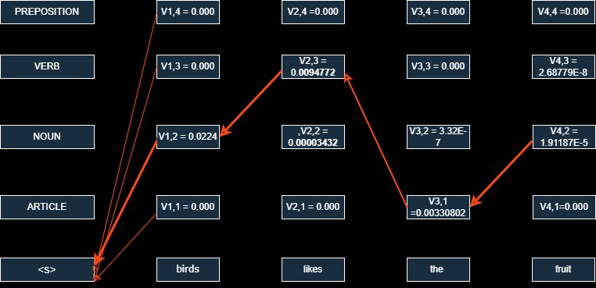

**The most probable tags are : Noun, VERB, ARTICLE, NOUN for the words in the sentence: birds, like, the, fruits**