

**Submission Report**

**On**

**AI in Construction and Manufacturing**

**Submitted by :-**

|  |  |  |
| --- | --- | --- |
| **Reg no.** | **Name** | **Roll no.** |
| 12110224 | Sahil Kumar | 08 |
| 12110770 | Nitesh Srivastava | 32 |
| 12113426 | Egala Abhishsek | 56 |

**Index**

## 1)Abstract

## 2)Introduction

## 3)History of Ai

## 4) Background of the study and Rationale

## 5) Literature review

## 6) Artificial intelligence (AI)

## How can we leverage AI in Construction?

## Emerging Trends of AI in Construction safety sensors

## How AI is changing construction?

## The rise of AI in Construction

## Structural analysis and design

## Smart building cities

## 7) ADVANTAGES AND DISADVANTAGES

## 8) CORROSION DETECTION TOOL

## 9) Conclusion:

## 10) References

**ACKNOWLEDGEMENT**

## I would like to express my sincere gratitude to the following individuals who have contributed to the successful completion of this project,mrs. Ankita Wadhawan mam my project supervisor, for providing me with valuable guidance and support throughout the project. Your insights and expertise were instrumental in shaping the direction of the project and ensuring its successful completion. my colleagues, for their collaboration, feedback, and support throughout the project. Your contributions were invaluable in enhancing the quality of the project and achieving its objectives.team member for providing me with access to the necessary resources, materials, and equipment required for the project. Your support was crucial in ensuring that the project was executed effectively and efficiently.My friends, for their unwavering support and encouragement throughout the project. Your love and encouragement were a constant source of motivation for me.I would also like to acknowledge the support and guidance provided by the institution and its staff, which has provided me with an environment conducive to learning and research.

## Thank you all for your contributions to the project

**Abstract**

The integration of Artificial Intelligence (AI) into the manufacturing and construction industries has the potential to revolutionize the way these sectors operate. The application of AI in manufacturing can enable automation of processes, predictive maintenance, and quality control, leading to increased efficiency and productivity. AI can also help in the

design and construction of buildings, by analyzing data from sensors and other sources to optimize building performance and energy efficiency.

In this project, we explore the use of AI in manufacturing and construction and propose a framework for implementing AI solutions in these sectors. We analyze the challenges and opportunities associated with integrating AI and machine learning techniques in these industries, including the availability and quality of data, privacy concerns, and the need for specialized expertise.

The proposed framework includes the identification of key performance indicators, selection of appropriate AI techniques, data collection and preprocessing, model development, and deployment of the AI system. We also discuss the importance of continuous monitoring and evaluation of the AI system to ensure that it performs optimally and remains up to date.

Through this project, we aim to provide a comprehensive understanding of the potential benefits of AI in manufacturing and construction and demonstrate how these technologies can be implemented in a responsible and effective manner. Ultimately, our goal is to improve the efficiency and sustainability of these industries and enhance the quality of life for those who rely on their products and services.

**Introduction**

I have chosen this topic to spotlight on one of the most technological trend these days

known as AI (Artificial Intelligent). Therefore; I will discuss some of the most important aspects

related to AI in which it will help in a better understanding of Artificial Intelligent and both its

advantages and disadvantages to be able to protect ourselves from the upcoming technological

trend. This paper will also discuss some of the algorithms used in AI systems

I have chosen this topic to spotlight on one of the most technological trend these days

known as AI (Artificial Intelligent). Therefore; I will discuss some of the most important aspects

related to AI in which it will help in a better understanding of Artificial Intelligent and both its

advantages and disadvantages to be able to protect ourselves from the upcoming technological

trend. This paper will also discuss some of the algorithms used in AI systems

Artificial Intelligence (AI) refers to the simulation of human intelligence in machines that are programmed to think and act like humans. This technology is used to develop intelligent machines that can perform tasks that typically require human intelligence, such as recognizing speech, understanding natural language, making decisions, and recognizing

patterns in large data sets.

AI has many applications in various industries, including healthcare, finance, manufacturing, and transportation. For example, AI-powered medical devices can help doctors diagnose diseases and plan treatments, while AI-powered financial analysis tools can assist investment

managers in making investment decisions.

There are several techniques used in Al, including machine learning, deep learning, natural language processing, and robotics. These techniques rely on large amounts of data and powerful computing systems to learn from patterns and improve their performance over time.

While AI has the potential to transform many aspects of our lives, it also raises ethical concerns around privacy, bias, and job displacement. As such, it is important to develop responsible AI systems that are transparent, fair, and accountable.

**History of AI**

Artificial Intelligence was first proposed by John McCarthy in I956 in his first academic conference on the subject. The idea of machines operating like human beings began to be the center of scientist's mind and whether if it is possible to make machines have the same ability to think and learn by itself was introduced by the mathematician Alan Turing. Alan Turing was able to put his hypotheses and questions into actions by testing whether "luau/tines can think"? After series of testing (later was called as Turing Test) it turns out that it is possible to enable machines to think and learn just like humans. Turing Test uses the pragmatic approach to be able to identify if machines can respond as humans.

**Background of the study and Rationale**

Construction is the large industry which is of strategic importance on the regional, national and global levels. It is also an industry which has been suffering from a number of problems for many decades, including low productivity, lowprofit margins, and waste and safety concerns. (Pistorius, 2017). Recent literature is gathered from the National and International reputed journals pertaining to Construction industry (CI), Construction project (CP), Construction Management (CM) and construction business. Secondary sources are books, reports, magazines, theses, conference papers, and book chapters. On referring to the literature in current decades led to the preparation of review paper, we have considered new emerging technology that is, Artificial Intelligence. Construction companies shift to digital stand to realize significant gains over the competition. Major areas impacted by digitalization include enterprise, knowledge, construction sites, project collaboration, and skilled labor networks. While studying digital transformation technology in concern to construction business, some questions arise in mind .These are: How AI is changing construction?, How can Architect adopt to AI in construction? How AI could link to Machine learning technique and Block chain? What are drawbacks and benefits of AI in construction? Innovative solutions in CI various tools, techniques and trends are being applied in construction business .This is the main theme of this article. Answers to these questions are presented considering as new age construction and architectural design in construction technology.

**Literature review**

Many references have been mentioned by various authors based on Construction Industry (CI), Construction Management (CM) and Construction Technology (CT) and CP regarding digital technologies viz: Big data, atomization, standardization, IoT, CC,AI and BIM,(Gerber & Kensek, 2009), Prefabrication & Disrupting along with applications and significance ,drawbacks and benefits.( Adwan & Soufi (2016) Benham (2017), Barbosa (2017), Brandt & Moyers (2013), Cearley (2017), Egbu (2004), Kapliński (2018), Buyer (2017) explained how Digitalization technology is useful in changing the CI. The construction business in India is growing at a fast pace and there's a major scope for improvement through adoption of rising new technologies like automation and artificial intelligence. The construction industry is that the second largest trade business in India followed by Agriculture sector. A lot of construction projects are incorporating systems of digital sensors, intelligent machines, mobile devices, and new software system application; progressively integrated with a central platform of BIM. Big data has the potential to produce solutions to construction problems and speedily rework each method of construction contracting.

Recent literature is gathered from the National and International reputed journals pertaining to CI, CP, CM and construction business. Secondary sources are books, reports, magazines, theses, conference papers, and book chapters. On referring to the literature in current decades led to the preparation of review paper on applications of Artificial Intelligence in construction industry.

We have collected relevant information from year 2000 onwards based on digital transformation in CI. Ilter & Dikbas (2018) reviewed applications of AI in construction dispute resolution. Steven (2017) stated various implications of AI in construction. Its rise in construction sector is precisely noted by Guinn (2017). Waldeck-Consulting (2017) linked AI in transforming the CI. Bhardwaj (2018) discussed many AI applications in construction–current use-cases.Further he also explained its applications in additive manufacturing (3D printing). Blanco et al.(2017) outlined AI is next frontier in construction business. Chaturvedi (2018) and Chengu (2018) explained immense and massive potential of AI in the construction management. Recently, Marvin (2018) described 10 steps to adopt AI in construction business. Wadlow (2018) quoted feature: “How AI supports the CI?” And conversely, Debney (2018) emphasized importance and supporting the CI with AI. Very recently, (Patil, 2018) reviewed in depth various “recent aspects on digitalization in construction industry/construction management”. She described various tools, techniques and technologies in the CM and construction business. This paper is the extension of previous data on digital technologies transformation implied in construction business. Out of all emerging technology hitting the market today, AI is a new technology that is on track to revolutionize the construction industry. One of the overall goals of Artificial Intelligence is to develop computer algorithms that can improve automatically through experience in construction. We can use these algorithms to improve processes in a much faster way than a human brain could ever imagine doing Autodesk’s product line on generative design opens a new world of design possibilities for Architects & Engineers.

**Artificial intelligence (AI)**

AI is a rapidly advancing technology made possible by internet that may soon have significant impacts on our daily lives, AI traditionally refer `to an artificial creation of human –like intelligence that can learn, reason, plan, perceive or process natural language. These traits allow AI to bring immense socioeconomic opportunities while also posing ethical and socioeconomic challenge. AI is beginning to make its way into construction. In the future of construction, AI will play a larger role in terms of improving productivity, quality, and safely on the jobsite (Clavero, 2018). AI captures large amounts patterns and trends. In essence, AI uses the power of machines to model natural intelligence of human. It uses the machine learning (ML) to store problems and execute tasks with greater speed & recovery. (Tan, 2016; Rajgopal, 2017). Hence, we can say AI in construction happening now. Some of the strategies on application of AI in CI are summarized here. These are:

* **How can we leverage AI in Construction?**

The adoption of Technology in the construction job-site is happening sure, it’s happening slowly. However the good news is that the adoption is casting on. Thanks to cloud-based applications and mobile devices the amount of data i.e. captured (Jobsite photos, material used, labor hours, equipment utilization etc) on a job-site has grown exponentially ever the past 10 years. The value of this information is to do deeper analysis, trending, and what-if scenarios to make projects and companies more profitable. Activities that hamper construction can now use AI to make improvements in productivity, safety, quality, and scheduling. (Goubau, 2018). The immense potential of AI in construction industry is well explained by Chaturvedi (2018) and he stated that the further digitalization and automation of the construction industry would involve synchronization of AI & BIM. A new ecosystem has to be developed which faster ingenuity and helps in increasing an arenas about the prospects of AI. It has the potential to be a decisive game-changer would be helpful in its evolution as mass adoption of it in construction becomes a reality. In the same year, Cheung has broadly explained the massive potential of AI in the C.I.

* **Emerging Trends of AI in Construction safety sensors**

The IoT has automated our home to be more energy efficient. Similarly, the IoT is automating our job-site to make them safer; we have able sensors such as spot identify the location of workers & provide any alerts if a worker slip or falls. Field reporting software allows foreman to enter job-site activity or alerts issues like keeping important project stake holders informed in real time even if they are not on job-site. Drones, Autonomous vehicles, and Robots are some emerging trends of AI (Clavero, 2018). Wu et al(2017), in their project on supply chain resilience assessment with structure dynamics consideration, analyzed AI in engineering risk analytics. Risk exit in every aspects of our lives, and can mean different things to different people.

* **How AI is changing construction?**

In year, 2010, Wang described importance of parallel control management for intelligent Transportation Systems, concept, Architectures and applications.

AI is changing the way the construction industry does business. After years of hype, the technology is finally here and can boost productivity, safety, and other critical aspects of business success.( Monroe,2017). Kranz makes the analogy that AI is the brain and IoT is the body, with IoT providing both input (Data) and output (action) for the smart computing and analytics function of a centralized AI system. For the construction industry, AI has come long in leaps and bounds, both a solid tooling option and a management support. (Debney, 2018). By using combination of Virtual Assistants (VA) and AI in place of manpower, the CI can save money and time.

* **The rise of AI in Construction**

Rajagopal (2017) exhaustively described various processes those are making changes across various areas, including risk management, Schedule management, Subcontractor management, Construction site environmental monitoring, and Safety. As part of the BIM 360 project IQ team at Autodesk, he had the privilege to participate in Autodesk’s foray in to ML for construction. Clavero (2018) mentioned AI utilizes computer processing to complete tasks that normally require human intelligence. However, it performs action with a greater level of accuracy & much quickly. Because of this capability, AI in CM is another tool in a contractor’s digital tool box.

* **Structural analysis and design**

AI algorithms can assist in structural analysis and design process once the construction material has been selected. Structural design is commonly carried out using analytical models created from fundamentals or simply through codes of practice or/and using computer simulations based on numerical simulations such as Finite Element Analysis (FEA). When it comes to AI algorithms, their blackbox nature is the main challenge to integrating in real-world structural engineering design. However, there are some ambiguous and unpredictable design challenges where designs are based on statistical analysis and probabilistic theories where the benefits of AI in resolving those uncertainties outweigh the disadvantage of blackbox nature. This section discusses the use of artificial intelligence (AI) to improve certain aspects of structural engineering. Seismological design, buckling and fatigue analysis, loading capacity prediction, and damage level prediction of existing structures for retrofitting are among the topics discussed. Finally, in comparison to traditional design approaches, how new features such as generative design can aid structural design by providing a greater number of design possibilities are discussed.

The complexity of seismic events makes it difficult to efficiently identify the earthquake response and extract indicative features from continuously detected seismic data, affecting the performance of traditional seismic load and response models for structures and impeding seismology growth in general. [AI techniques](https://www.sciencedirect.com/topics/engineering/artificial-intelligence-technique) can aid in this and can be used as effective statistical tools to address these difficulties, leveraging their advantages in data analysis. AI helps in finding unknown features by extracting useful sensing data from noisy data and revealing seismic occurrences that are below the detection level. Another significant aspect is the use of AI to assist in the architectural design process with the knowledge of seismology. The failure of the structural system which did not considered well in the architectural design phase leads to unexpected revisions in the implementation project phase and cost time and money. To circumvent this, deep learning and ImageAI python library can be used to construct an Irregularity Control Assistant (IC Assitant) that can offer architects with general information regarding the suitability of structural system decisions.

### **Smart building cities**

Smart buildings are the primary starting point for transforming cities into smart cities. Smart cities must have three characteristics: they must be instrumented, linked, and intelligent. Smart buildings are microcosms of smart cities, with overlapping demands ranging from controlling lighting and energy to providing people with security and safety. The concept of a smart city is the most prominent modern trend, combining the concepts of smart mobility, smart economics, smart people, smart governance, smart environment, and smart lifestyle. Smart city characteristics need the construction and operation of buildings and infrastructure. A conceptual illustration of an operational smart city is shown in [Fig.](https://www.sciencedirect.com/science/article/pii/S0926580522003132" \l "f0090)

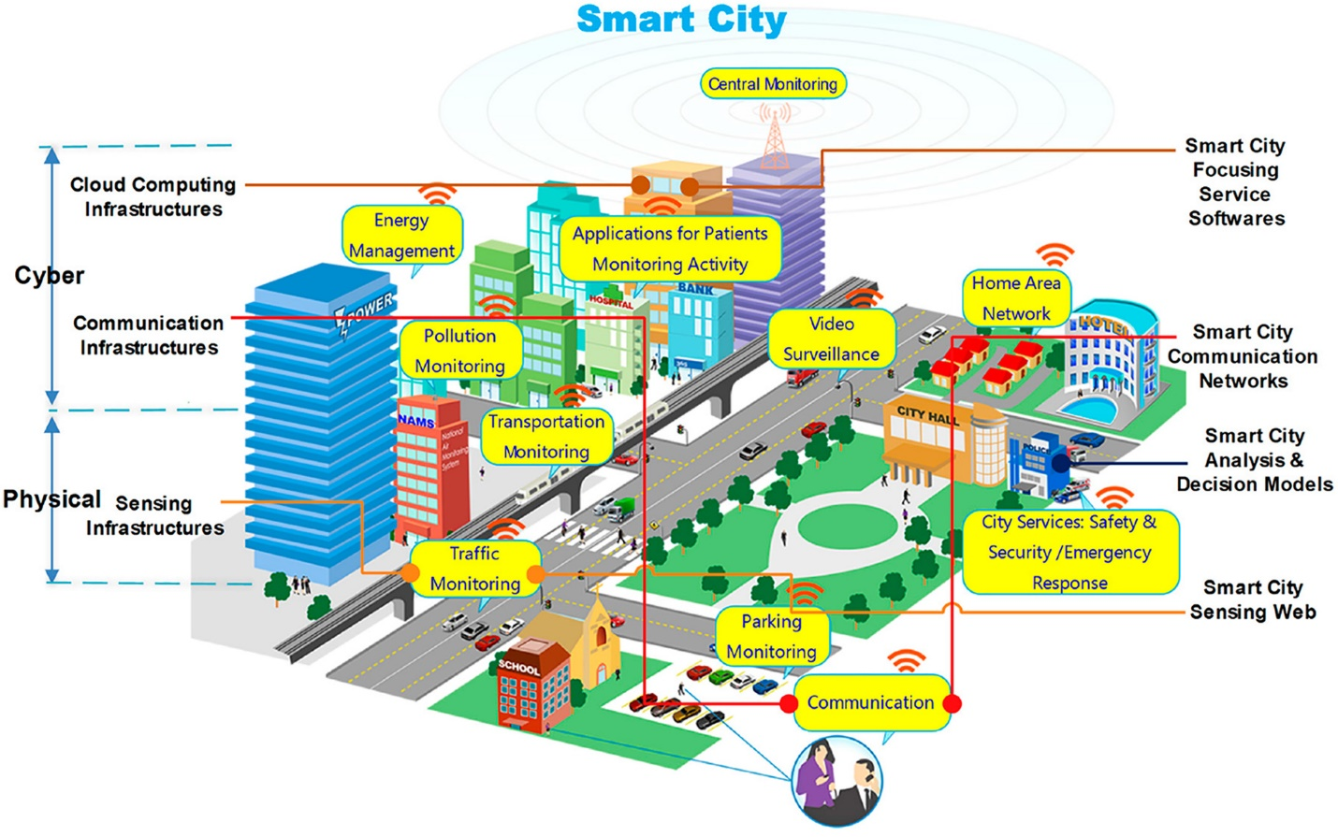Conceptual Illustration of an operational smart city

When the smart buildings are interconnected into a smart city network, the smart building itself can impact the behavior of the other smart buildings or infrastructure because it becomes a consistent outside environment element influencing the other elements of the network. When confronted with complicated environmental challenges and vast amounts of data, AI systems have the ability to make knowledge-based judgments that balance the city's environmental results against its people's social and economic well-being. AI systems may be used to detect environmental changes like temperature, moisture, emissions, water pollutants, noise, and other environmental indicators. AI systems can detect such abnormalities to react to the changes and swiftly implement solutions to any problems. Most importantly, disaster management in cities improved with these AI-driven variation detection systems. Toyota is currently constructing a 175-acre smart city in Japan , and Terminus Group, a Chinese technology firm, is planning to build an AI city in the Chongqing Hi-Tech Industrial Development Zone.

**ADVANTAGES AND DISADVANTAGES**

Al (Artificial Intelligence) has become increasingly popular in the construction and

manufacturing industry, providing a range of benefits and challenges. Here are some of the advantages and disadvantages of Al in construction and manufacturing:

**Advantages:**

**1. Increased Efficiency:** Al can help streamline processes and automate repetitive tasks,reducing the time and cost involved in manufacturing and construction.

**2. Enhanced Safety:** Al can help identify potential hazards and reduce accidents by using sensors and monitoring equipment.

**3. Improved Quality Control:** Al can identify and rectify quality issues in real-time, helping to reduce wastage and improve the overall quality of the end product.

**4. Predictive Maintenance:** Al can analyze data and predict when maintenance is required,reducing downtime and minimizing disruptions to production.

**5.Enhanced Decision-Making:** Al can analyze large amounts of data and provide insights that help decision-makers make informed decisions about manufacturing processes, materials, and equipment**.**

**Disadvantages:**

**1. Cost:** The initial investment required for Al implementation can be high, and ongoing maintenance and upgrades can be costly.

**2. Technical Complexity.** Al systems are complex and require specialized knowledge to operate and maintain, which can be a challenge for smaller manufacturing and

construction firms.

**3. Workforce Disruption:** Al can automate tasks traditionally performed by human workers, leading to job losses and workforce disruption.

**4. Security and Privacy Risks:** Al systems collect and process sensitive data, which can be vulnerable to hacking and data breaches.

**5. Ethical Concerns**: Al systems can make decisions that have ethical implications, such as the use of Al in automated weapons or the potential for Al to perpetuate biases in decision-making. Overall, while Al offers significant benefits to the construction and manufacturing industry, it is important to carefully consider the potential drawbacks and risks before implementing these technologies.

* ***Overall, while Al offers significant benefits to the construction and manufacturing industry, it is important to carefully consider the potential drawbacks and risks before implementing these technologies.***

**CORROSION DETECTION TOOL**

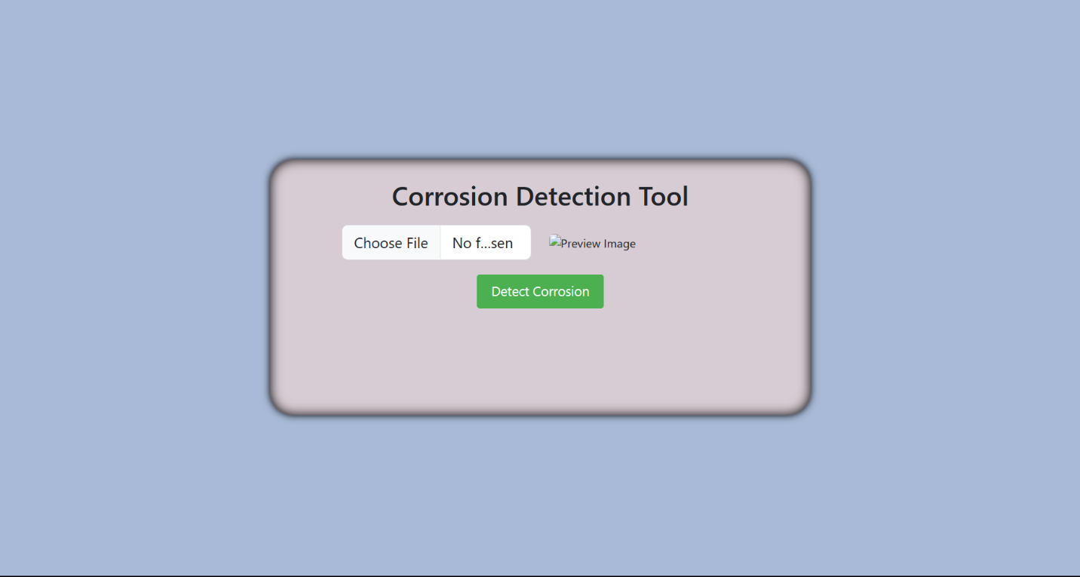

* This is the front page of corrosion detection tool initially It’s showing no image is selected. After selecting any image related to AI in construction and manufacturing then the percentage of corrosion will detect .

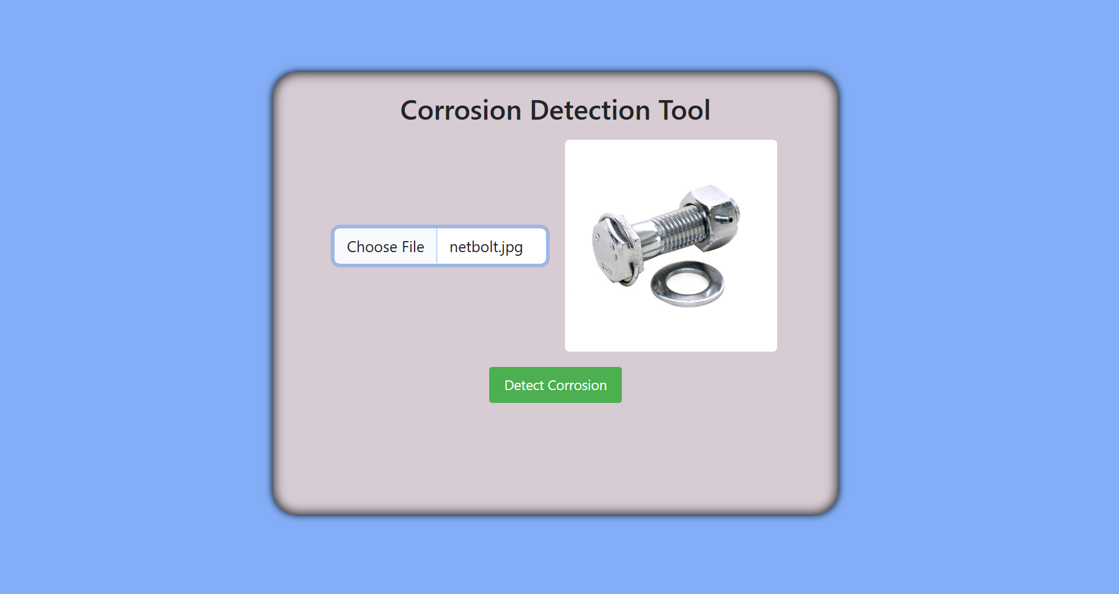

* This particular corrosion detection tool is to be using AI, but rather a simple algorithm to detect corrosion based on image analysis. However, AI can certainly be used for corrosion detection and prevention in construction and manufacturing, and there are a variety of potential uses and advantages:

1. **Non-destructive testing:** One of the main benefits of using AI for corrosion detection is that it can allow for non-destructive testing methods. By using sensors and other data sources to monitor the performance and condition of materials, AI algorithms can detect early signs of corrosion without requiring physical inspections that may damage or disturb the materials in question.
2. **Improved accuracy and efficiency**: With AI, corrosion detection can be performed more accurately and efficiently than with manual inspections. AI algorithms can quickly analyze large amounts of data from multiple sources to identify potential corrosion issues, allowing for faster and more effective maintenance and repair.
3. **Predictive maintenance:** AI algorithms can also be used for predictive maintenance, which involves analyzing data from various sensors and other sources to predict when maintenance will be needed before a problem occurs. This can help to prevent corrosion and other issues before they cause significant damage or downtime.
4. **Cost savings:** By detecting and preventing corrosion early, AI can help to save costs associated with maintenance and repair, as well as prevent downtime and other disruptions that can impact productivity and profitability.
5. **Increased safety:** Corrosion can be a safety hazard in many industries, particularly in construction and manufacturing. By detecting and preventing corrosion, AI can help to improve overall safety and reduce the risk of accidents and other incidents.

* ***Overall, the use of AI for corrosion detection and prevention in construction and manufacturing can provide a range of benefits, including improved accuracy and efficiency, cost savings, and increased safety. However, it is important to note that AI is not a silver bullet and should be used in conjunction with other methods and strategies to ensure the best possible outcomes.***

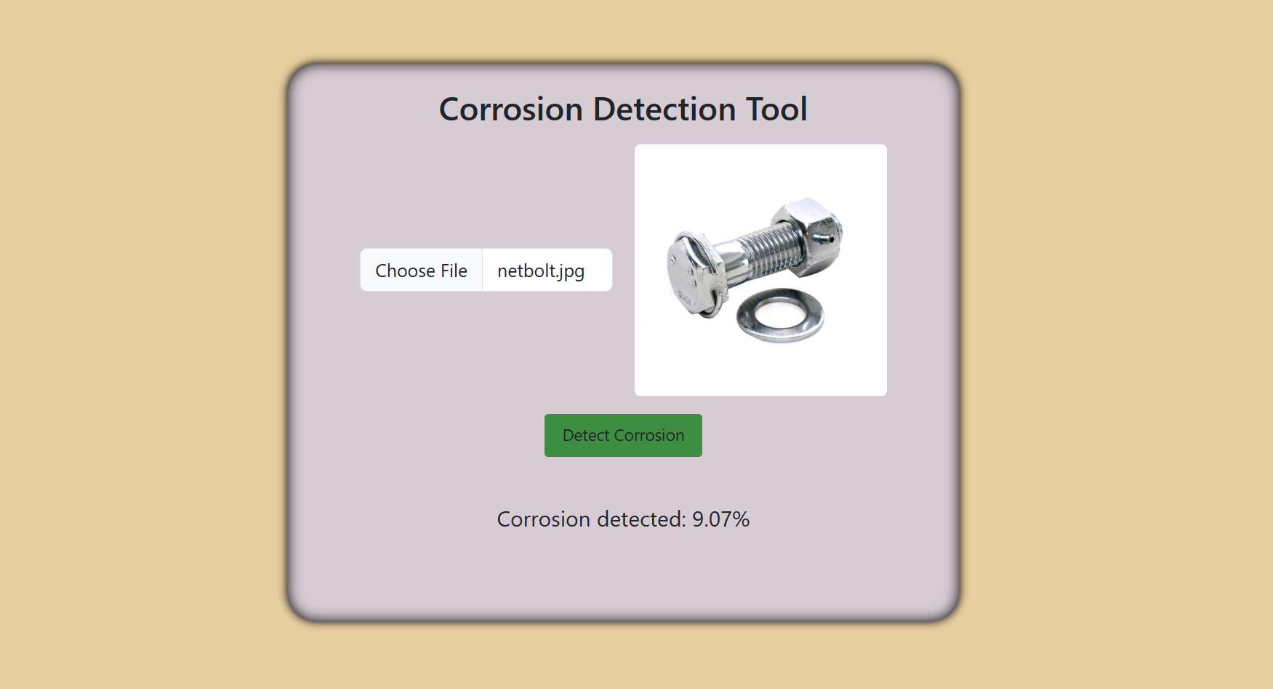

* This is the final one in which particular image related to construction etc.like net bolt, or any other things which are using in construction etc can give the exact corrosion in percentage so we can use another one for the construction etc like above fig:
* **There are several potential applications of Al in these industries that are currently being explored, such as:**

1. **Robotics:** Al can be used to control robots in construction and manufacturing processes, reducing the need for human labor and improving safety.

**2. Building Information Modeling (BIM):** Al can be used to analyze BIM data and create simulations to optimize construction processes, resulting in more efficient workflows and reduced costs.

3. **Supply Chain Management**: Al can be used to optimize supply chain management by predicting demand, reducing waste, and improving logistics.

**Challenges and Risks:**

While the potential benefits of Al in construction and manufacturing are significant, there are also challenges and risks associated with its implementation. Some of these challenges include:

**1. Data Privacy and Security:** The use of Al requires large amounts of data, which must be protected from unauthorized access and misuse.

2**. Technical Complexity.** Implementing Al systems requires specialized technical skills and knowledge, which may not be readily available.

**3. Ethical Concerns:** The use of Al raises ethical concerns regarding the displacement of workers, bias in decision-making.

**Conclusion:**

Al has the potential to transform the construction and manufacturing in improving efficiency, productivity, and safety. While there are challenges associated with its implementation, these can be mitigated through careful planning and collaboration between industry stakeholders, policymakers, and technical experts. As such,the adoption of Al in construction and manufacturing is a promising avenue for innovation and growth in these industries

• Al has the potential to transform the construction and manufacturing industries by improving efficiency, reducing costs, and increasing safety. Despite the many benefits of Al, there are also some challenges and limitations to its implementation. These include concerns about job displacement, data privacy and security, and the need for continued investment in Al research and development.

• As Al technology continues to evolve and become more widely adopted, it will be

important for stakeholders in the construction and manufacturing industries to stay up-to-date with the latest trends and best practices in order to remain competitive and maximize the benefits of Al.

Going forward, it will be important for policymakers, industry leaders, and other

stakeholders to work together to ensure that Al is deployed in a way that maximizes its benefits while minimizing its risks and ensuring that it is accessible and equitable for all.Overall, the report highlights the potential for Al to transform the construction and manufacturing industries, but also emphasizes the need for continued research, investment,and collaboration in order to fully realize these benefits.

**REFERENCES**

**1.** Saxena, A., & Gupta, R. K. (2018). Artificial intelligence in construction industry. A review. Journal of Construction Engineering and Management, 144(6), 04018034.

**2**. Zhu, Y., Li, k, Li, Q., & Li, J. (2020). A review on the application of artificial intelligence in construction management. Automation in Construction,

119, 103337.

**3.** Islam, M. S., Shen, G. Q., Yang, R. J., & Wang, Y. (2019). A review of artificial intelligence applications in construction project risk management. Safety Science, 120, 268-279.

**4.** Zhang, Y., & Liu, Y. (2020). Intelligent construction based on artificial intelligence and internet of things. Construction Management and Economics, 38(4), 365-380.

**5.** Alom, M. Z., Yakopcic, C., Taha, T. M., & Asari, V. K. (2018). Applications of deep learning and reinforcement learning to construction engineering and management. Journal of Computing in Civil Engineering, 32(6), 04018044.