23/11/2023 IN/C100101954/2023

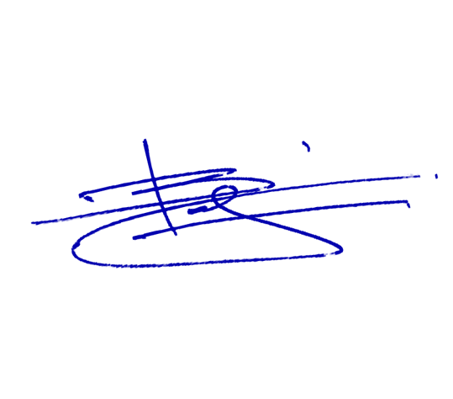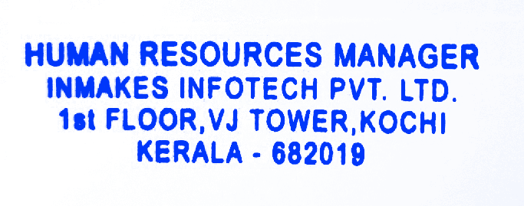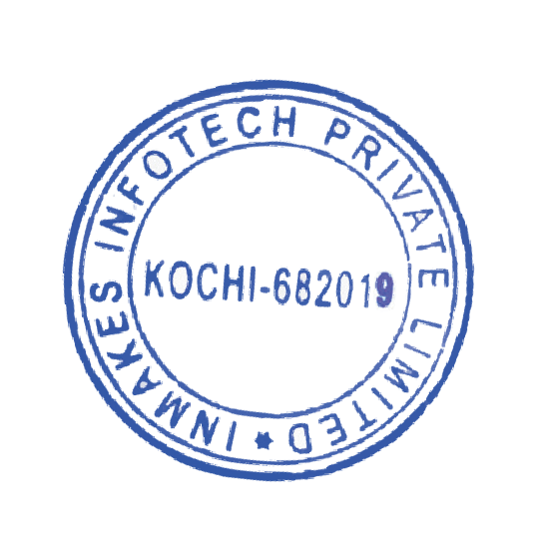

INTERNSHIP CERTIFICATE

TO WHOMSOEVER IT MAY CONCERN

This is to certify that **Mr. Rajesh R** has worked as a **Software Testing Intern** from

# 19/08/2023 to 18/11/2023 at Inmakes Infotech Pvt. Ltd.

During these 3 months, he has worked tremendously well. He remains continually updated with technologies available in the market and took interest in the development of strategies for our projects in Software Testing.

During his internship period, we found him to be a sincere, honest, hardworking and dedicated employee with a professional attitude and exceptional knowledge of software testing. He demonstrated a thorough understanding and proficient application of software testing methodologies and techniques in completing his assigned projects and ensuring that important deadlines were met.

We Team Inmakes wish him all the success in his future endeavors!!

For

Inmakes Infotech Pvt.Ltd.

# Beji Joseph

Human Resources Manager [hr@inmakes.in](mailto:hr@inmakes.in)

[mail@inmakes.com](mailto:mail@inmakes.com)

[www.inmakes.com](http://www.inmakes.com/) Inmakes Infotech Pvt.Ltd.

First Floor, VJ Tower, Kochi, Kerala 682019