AI-ASSISTED CODING

NAME : GUJJA RAJU

Ht. no.:2403A52018

ASSIGNMENT 5.2

TASK 1:

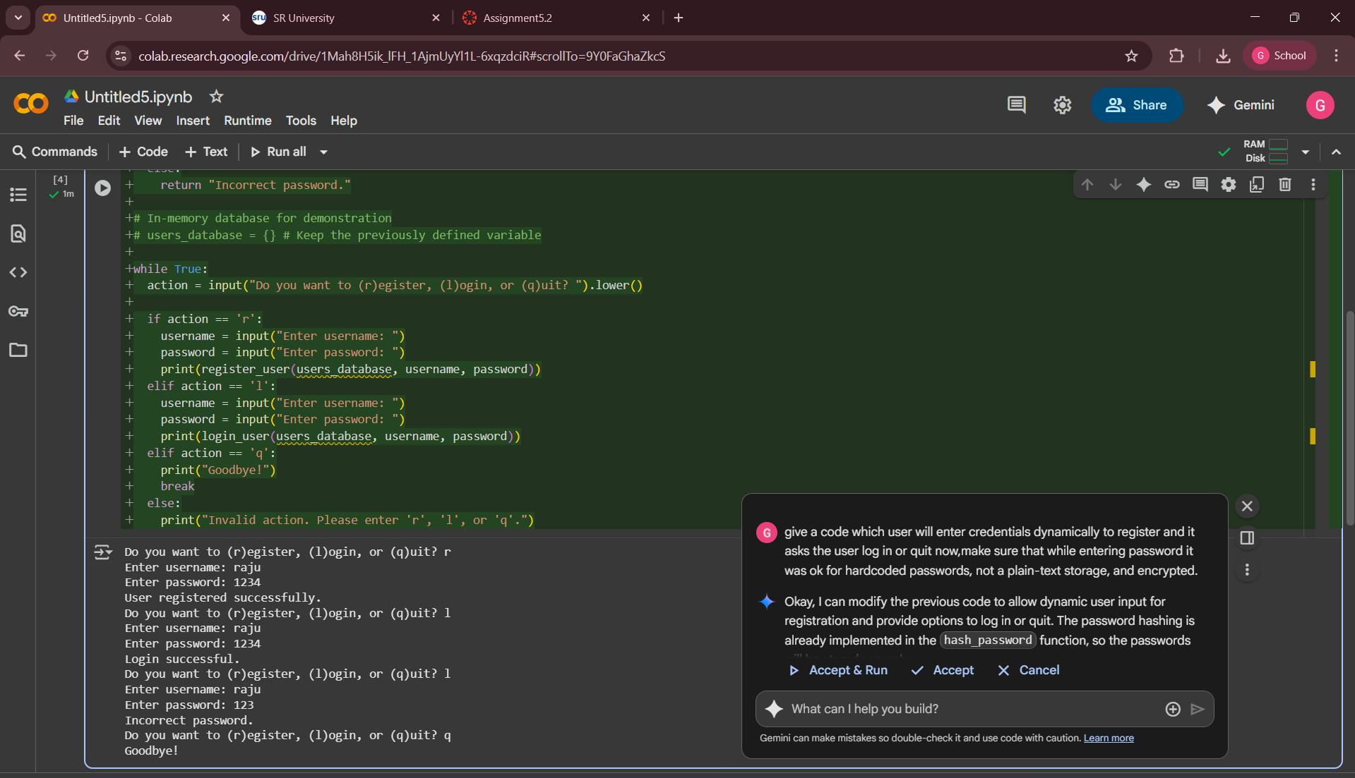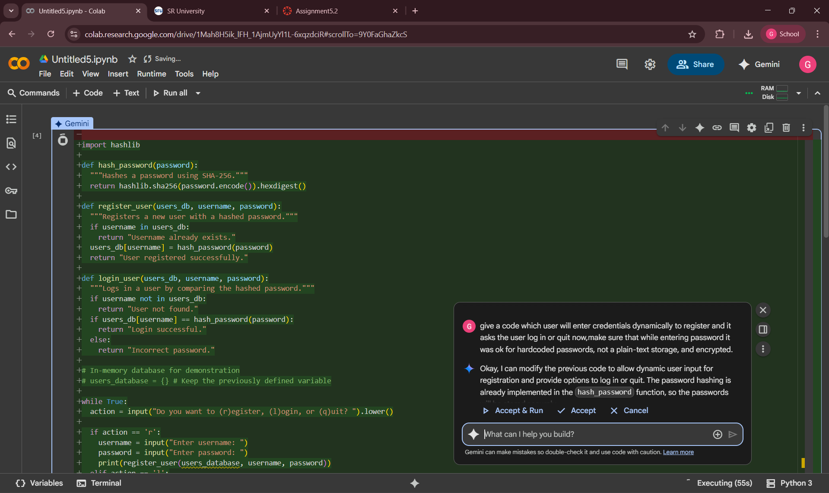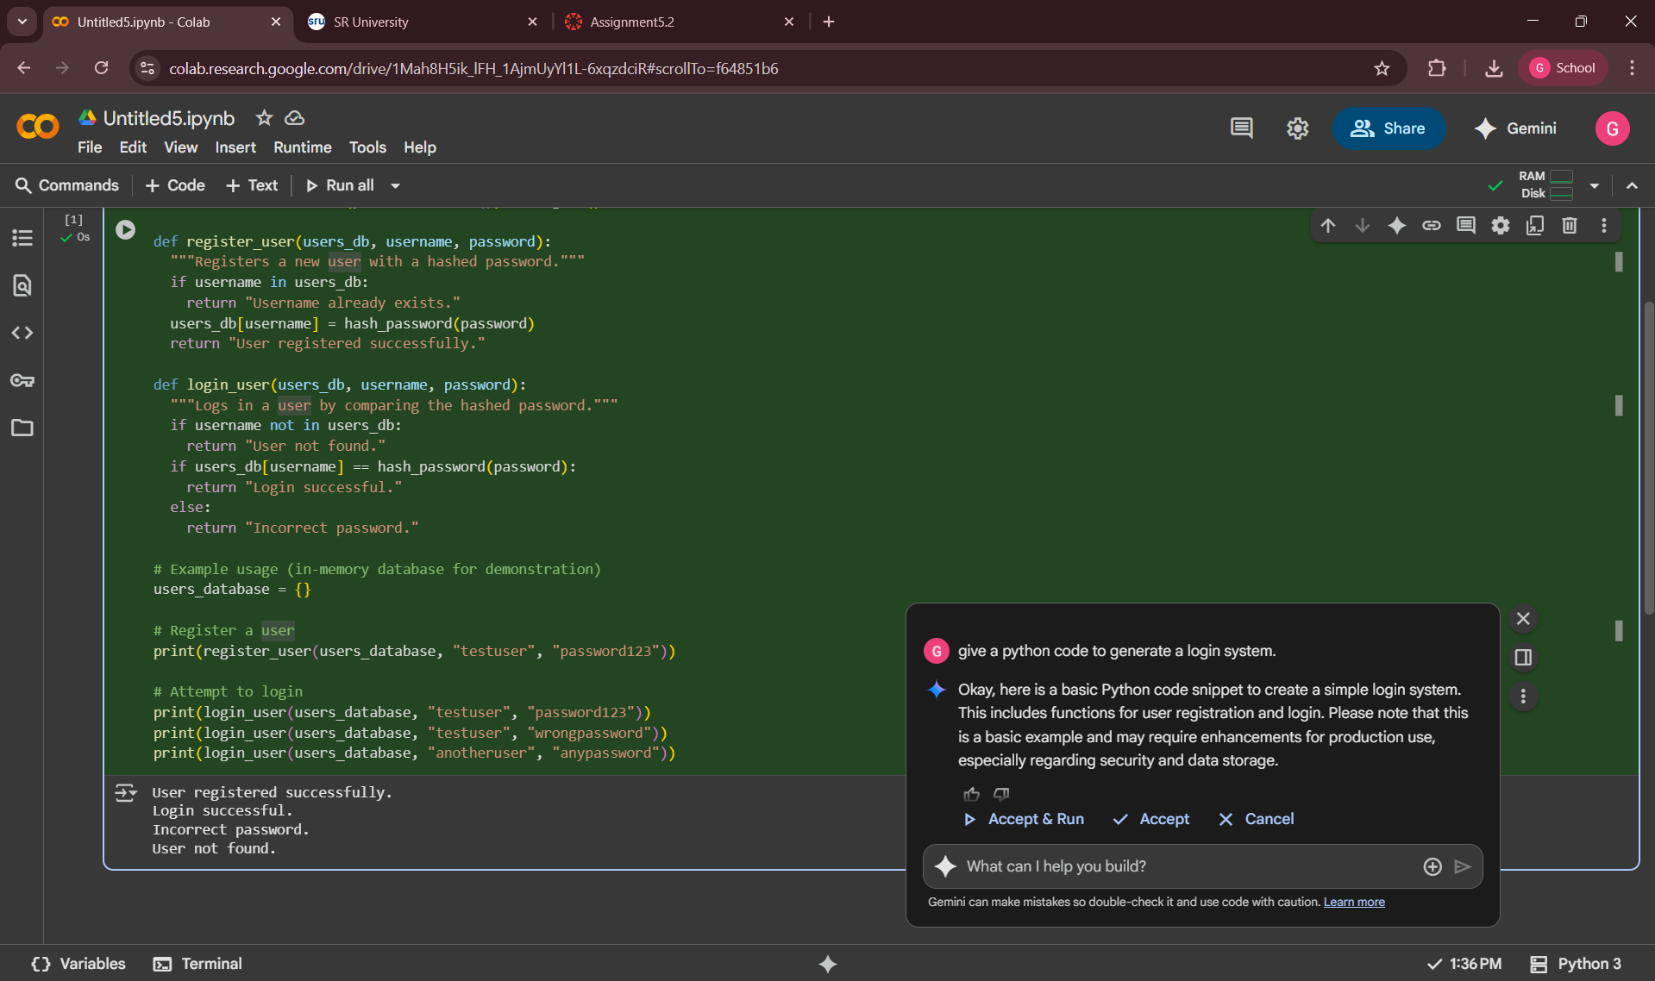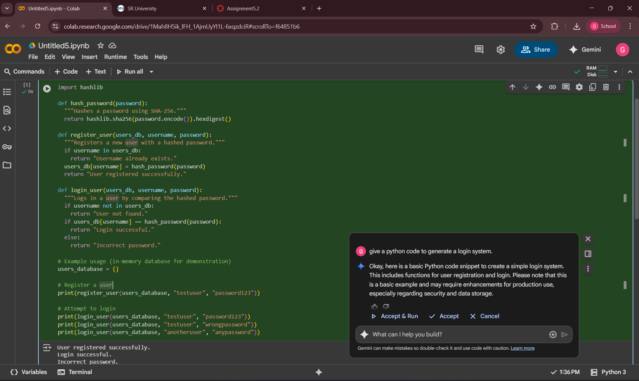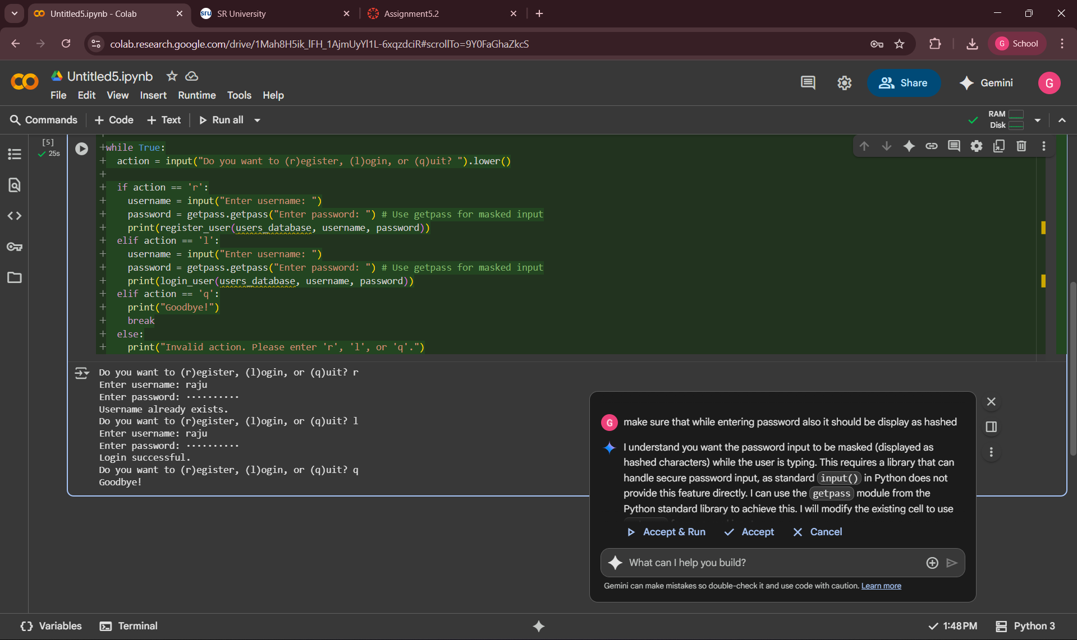EXPLANATION:

By giving only by the exact prompt , the gemini was giving the hardcoded passwords and encrypted , the using of AI-generated directly in real projects is not recommended due to it’s response was not suitable , the prompt giving us was important to generate code suitable for encrypted one.

TASK 2:

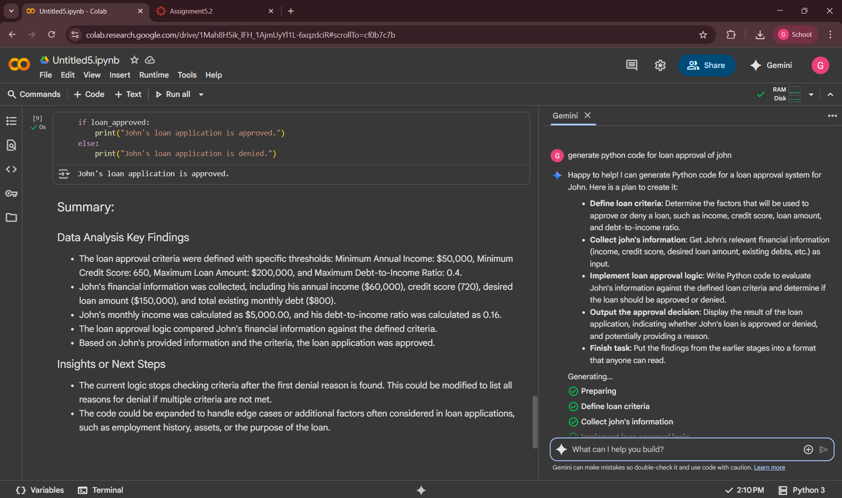

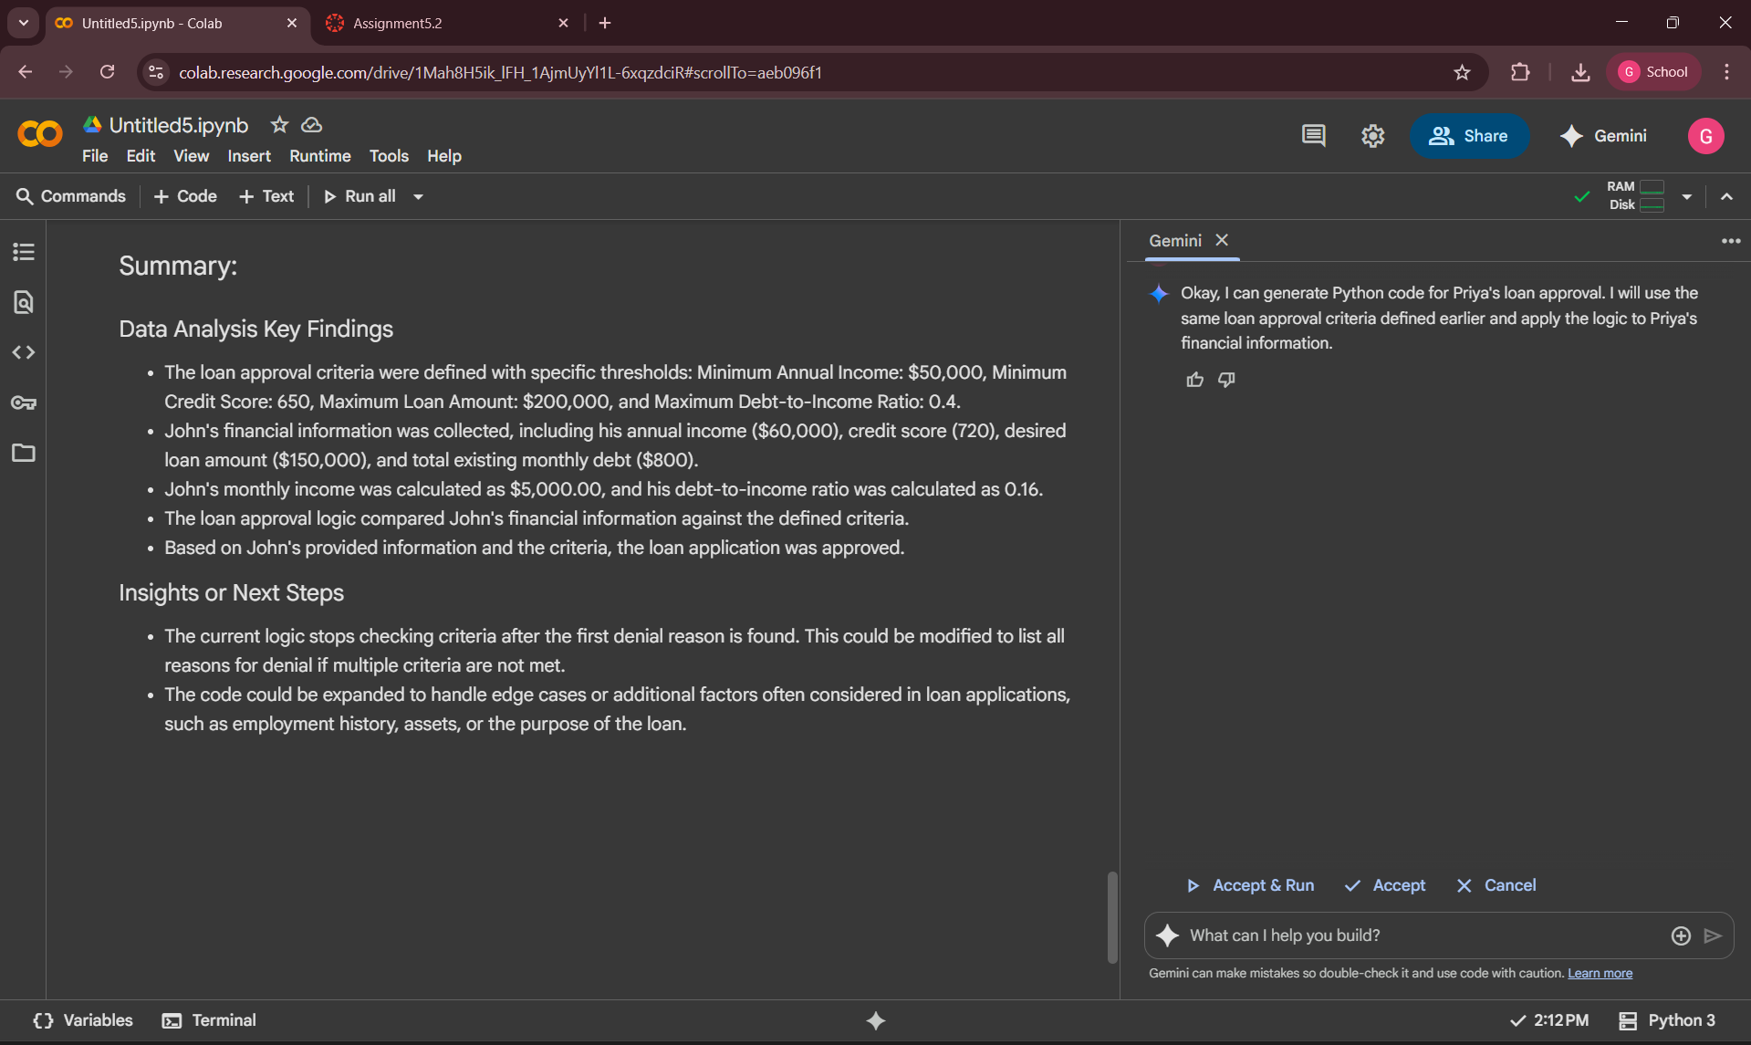

EXPLANATION:

No, there are nothing any gender bias for the AI , it provides the same conditions for both the male and female , but in some conditions it may be irrelatable , so using this code directly not recommendale , the AI doesn’t shown any gender bias in this but it may show irresponsive in any other , the user had to must check.

TASK 3:

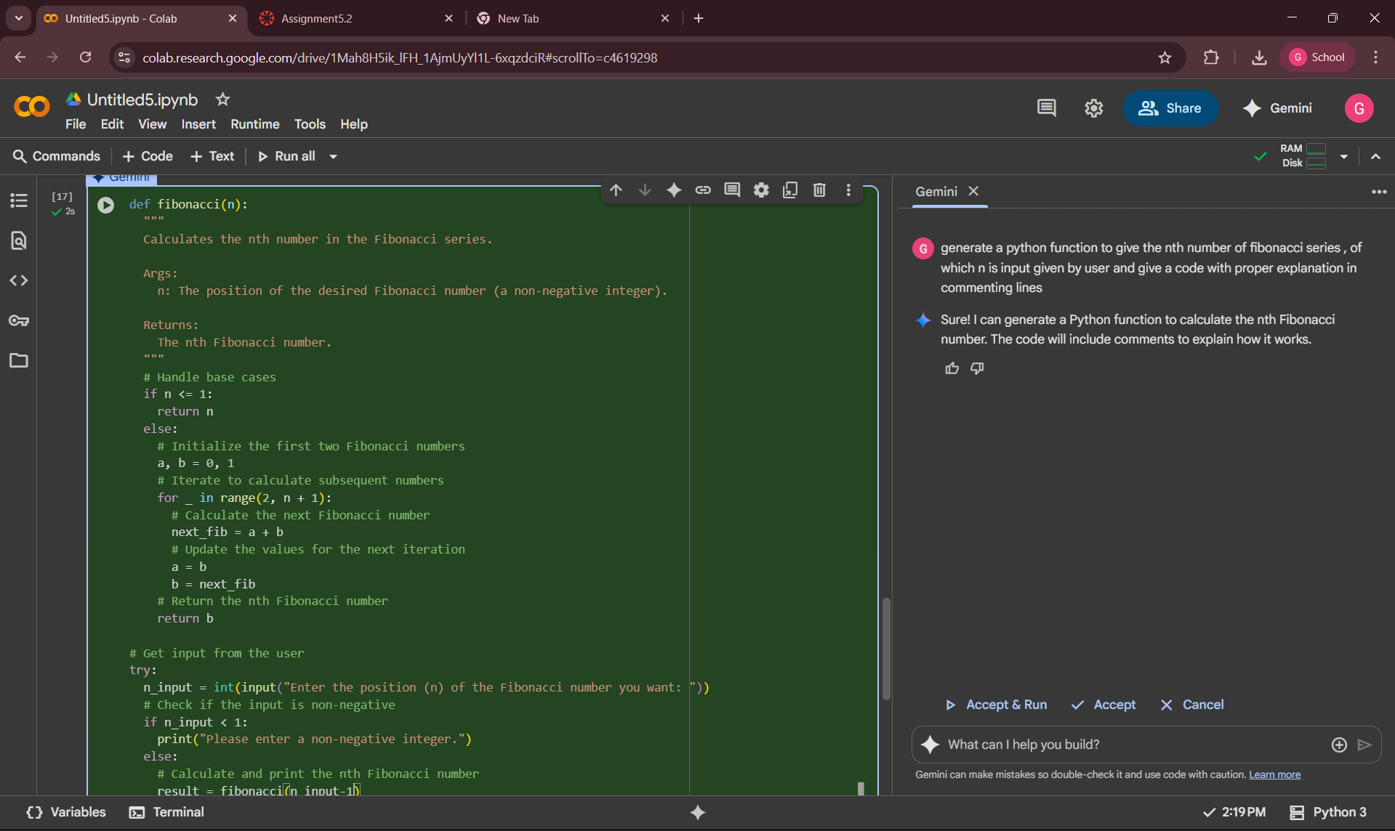

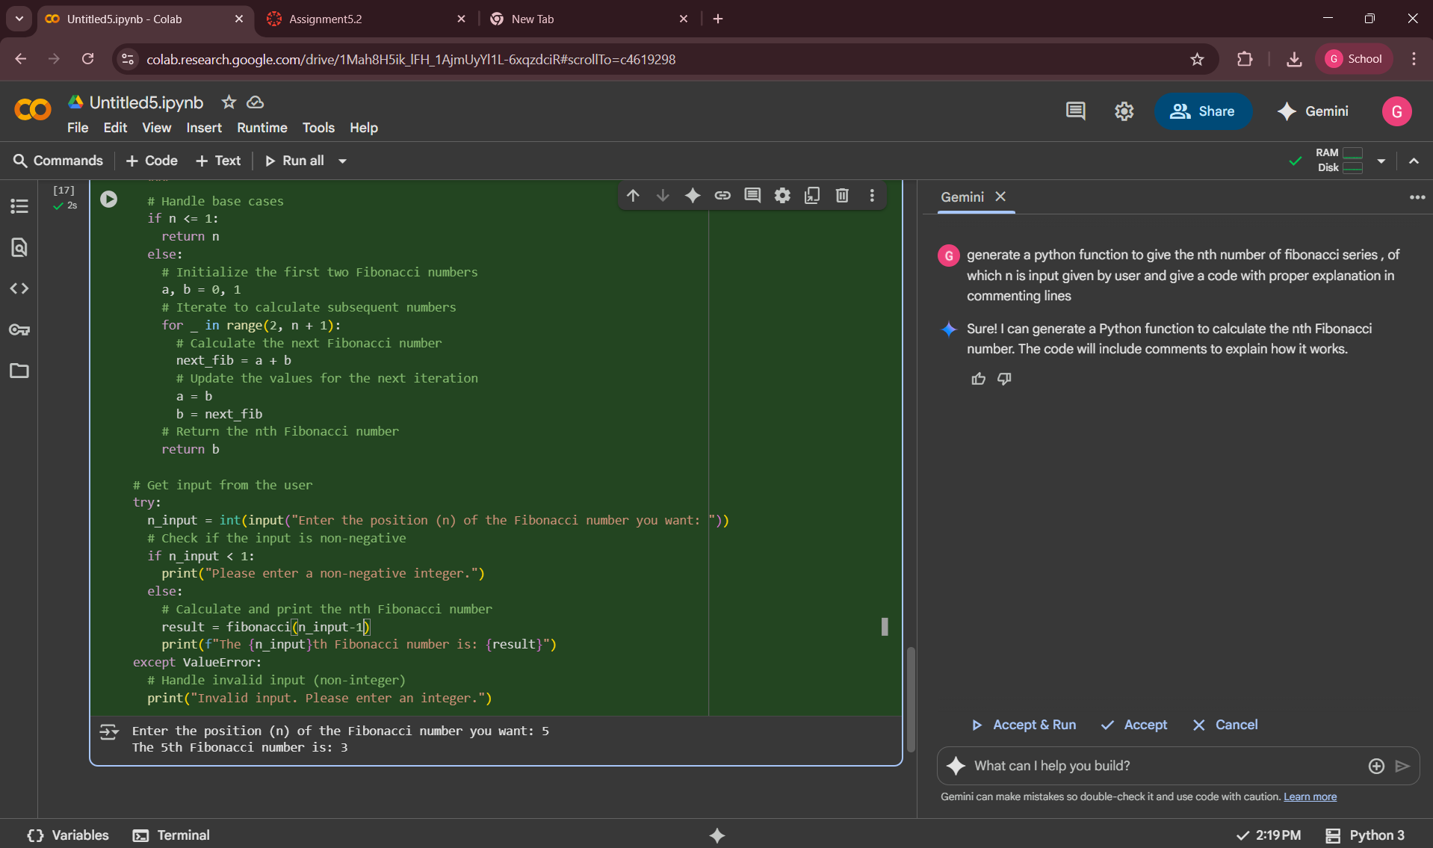

EXPLANATION:

The comment lines which was given by the AI code was clearly understandable and the Fibonacci series was clearly understandable by the above comment lines , which was given by AI as we were mentioned in a prompt. The code will understandable easily user-friendly by those lines.

TASK 4:

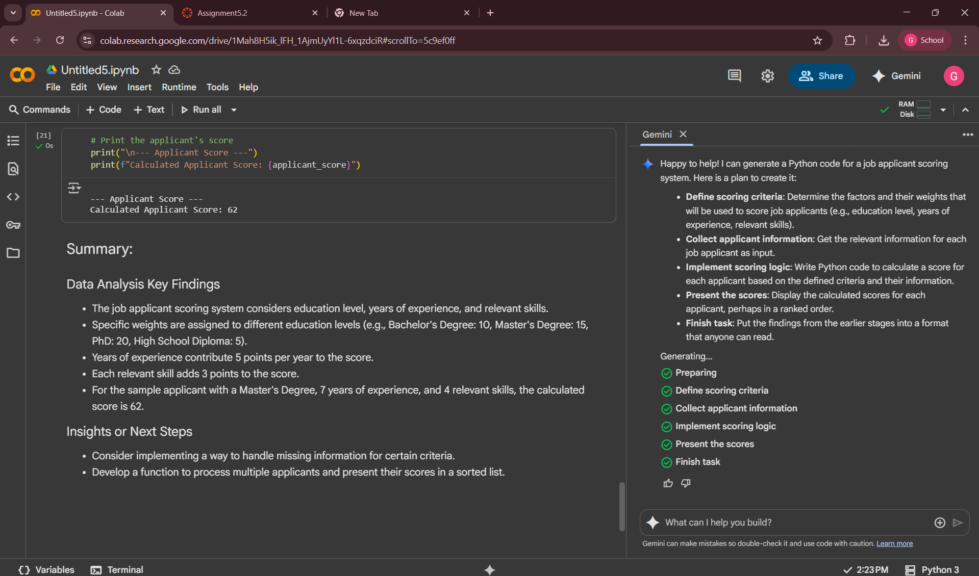

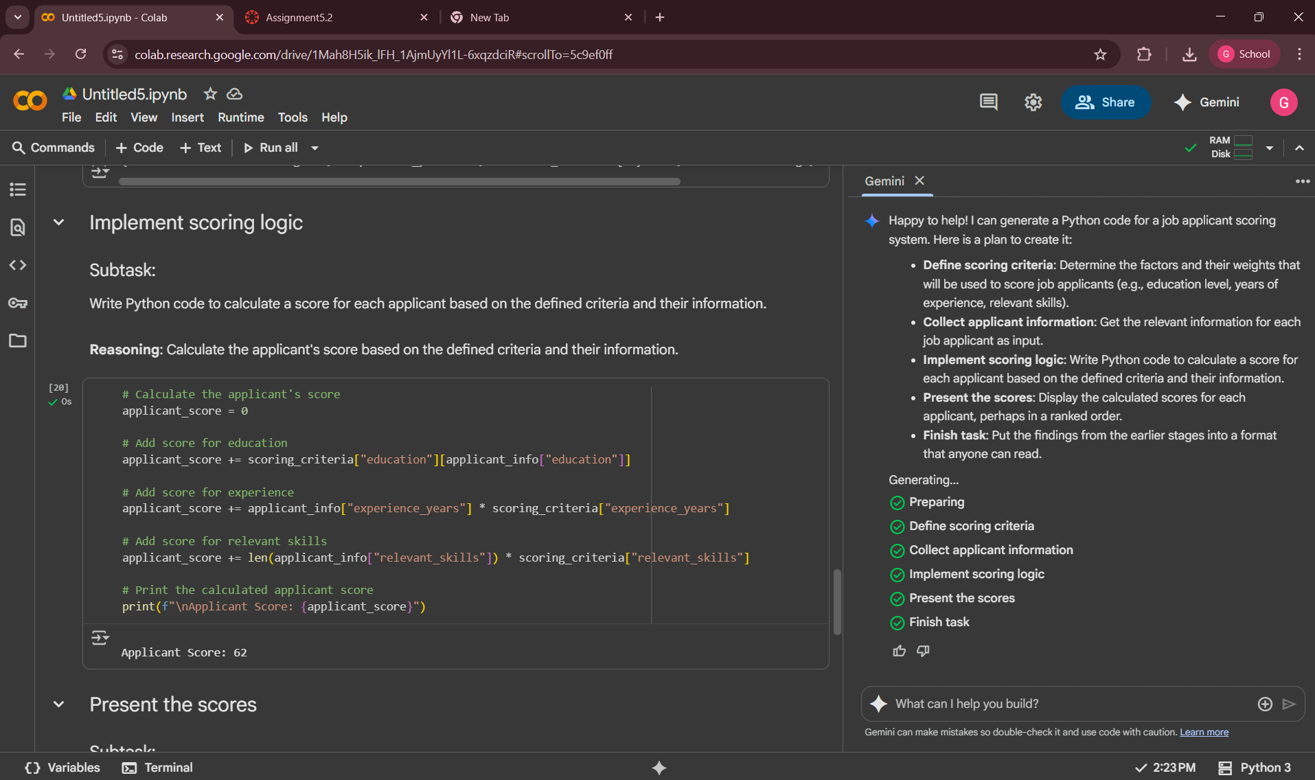

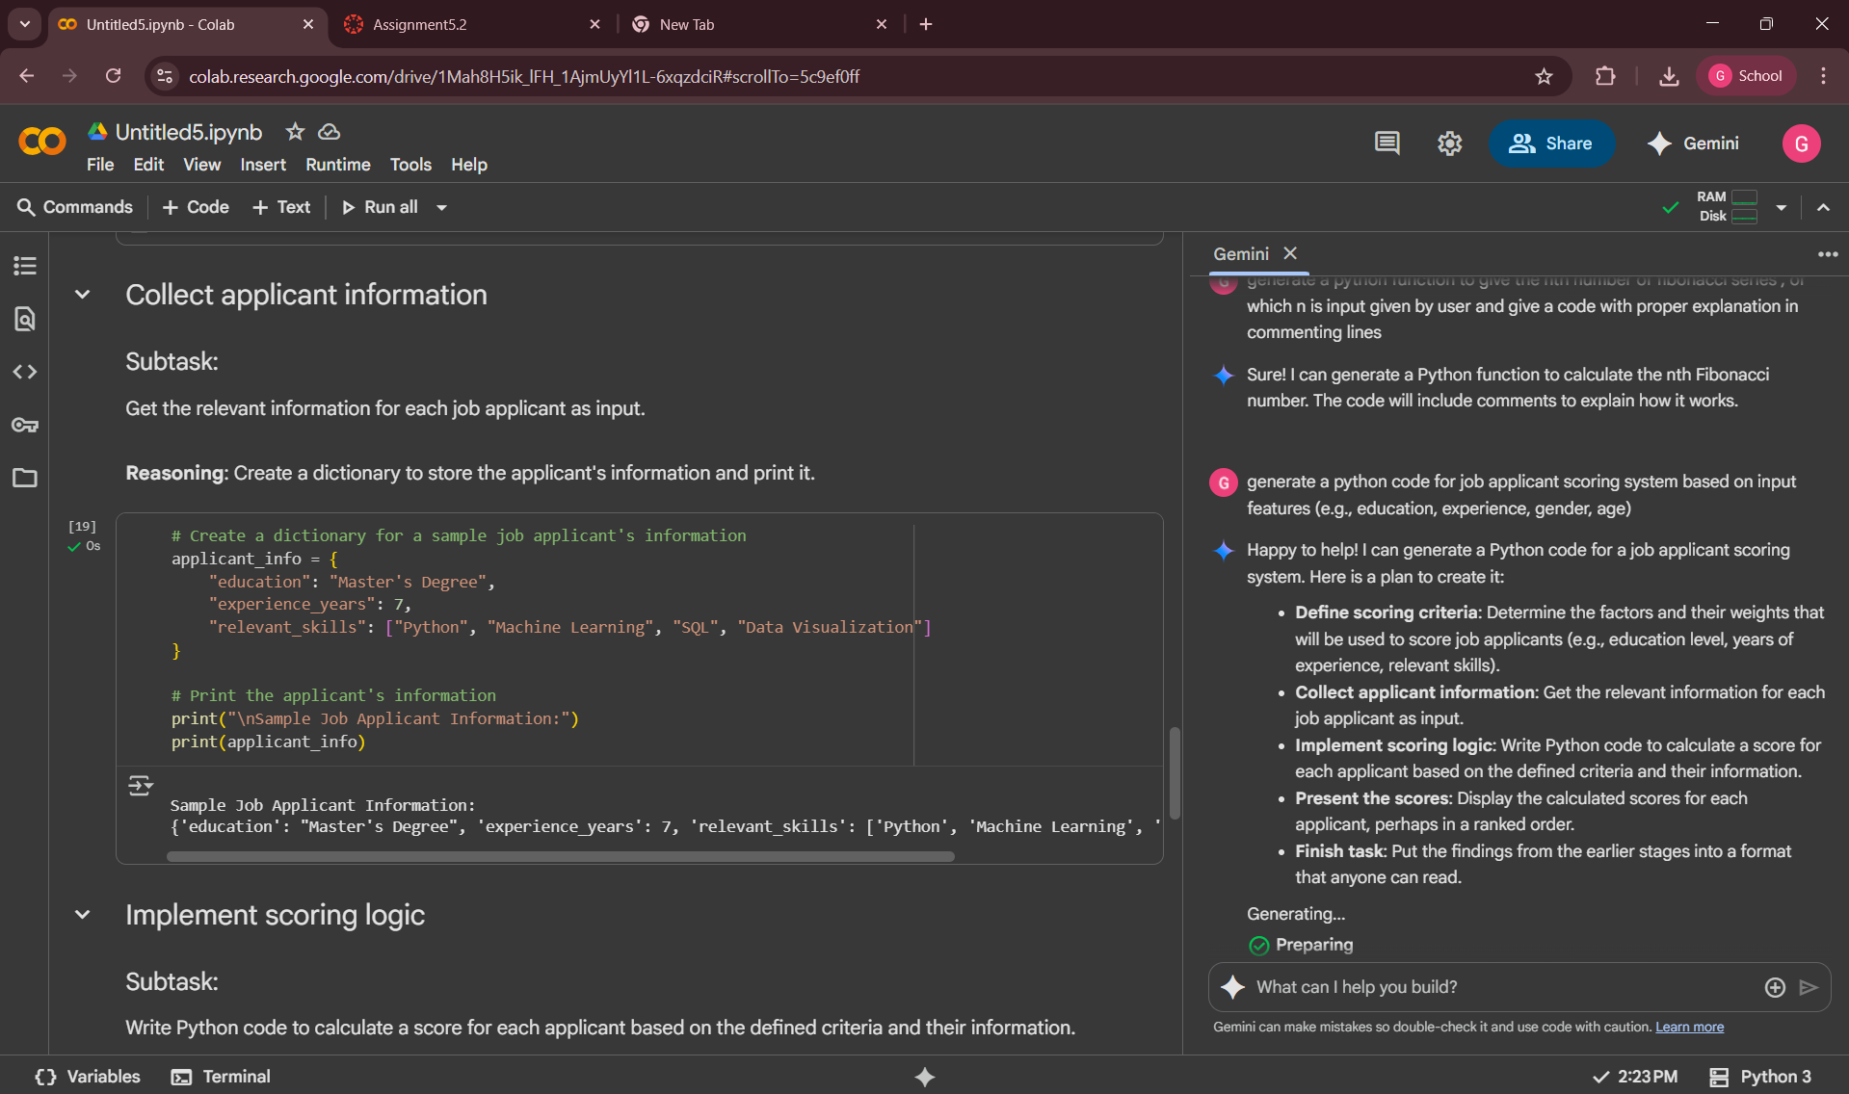

EXPLANATION:

When you give an AI a prompt without any explicit conditions, it will default to what it has learned from its training data, show gender bias when given prompts without any specific conditions. This is not due to a malicious intent, but rather a reflection of the biased data they were trained on. The responsibility to create unbiased outputs currently lies with both the AI developers and the users, who can provide more specific and inclusive prompts to get more balanced results.

TASK 5:

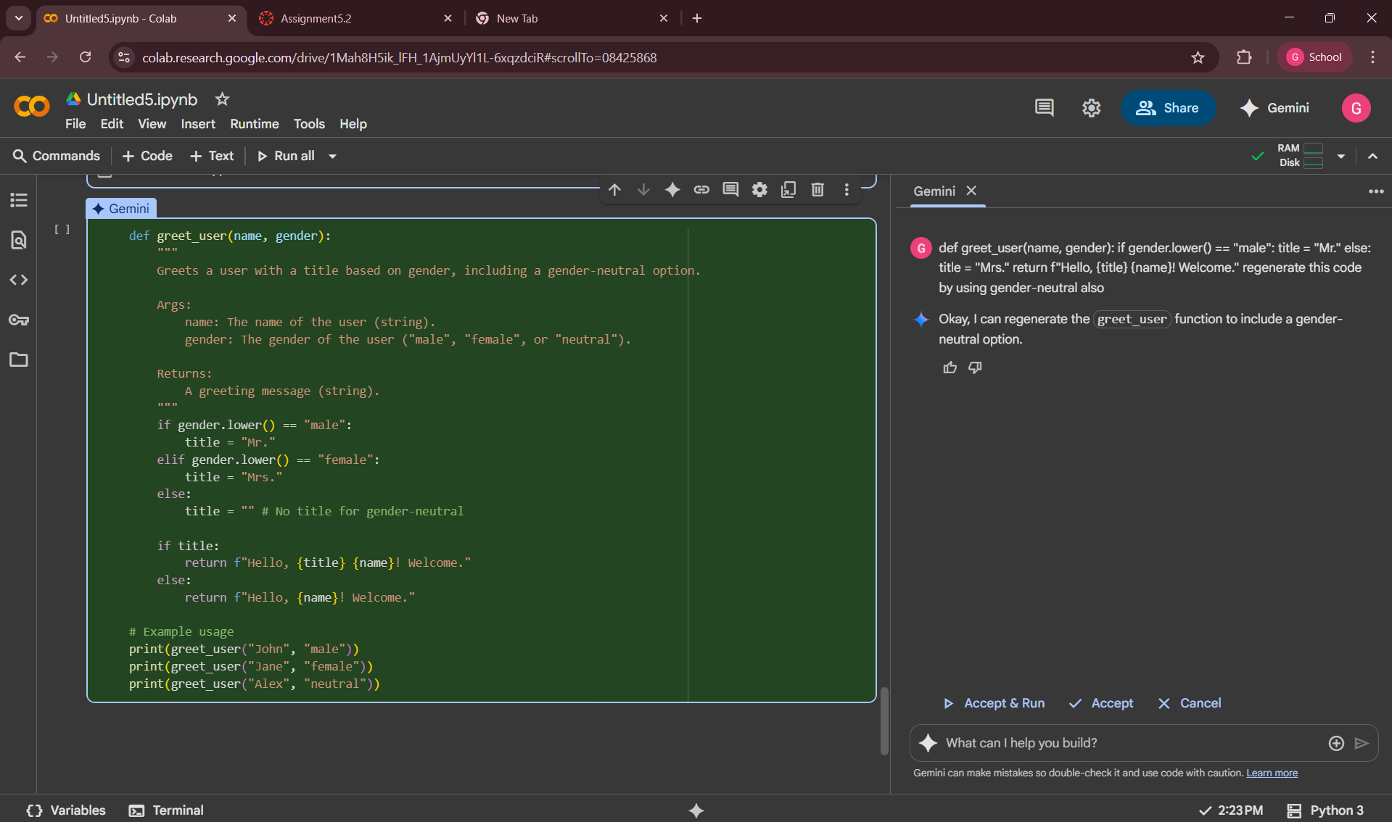

EXPLANATION:

The AI generates as above , that nothing will needed for the neutral -gender.