AI-ASSISTED CODING

NAME : GUJJA RAJU

Ht. no.:2403A52018

ASSIGNMENT 6.3

TASK 1:

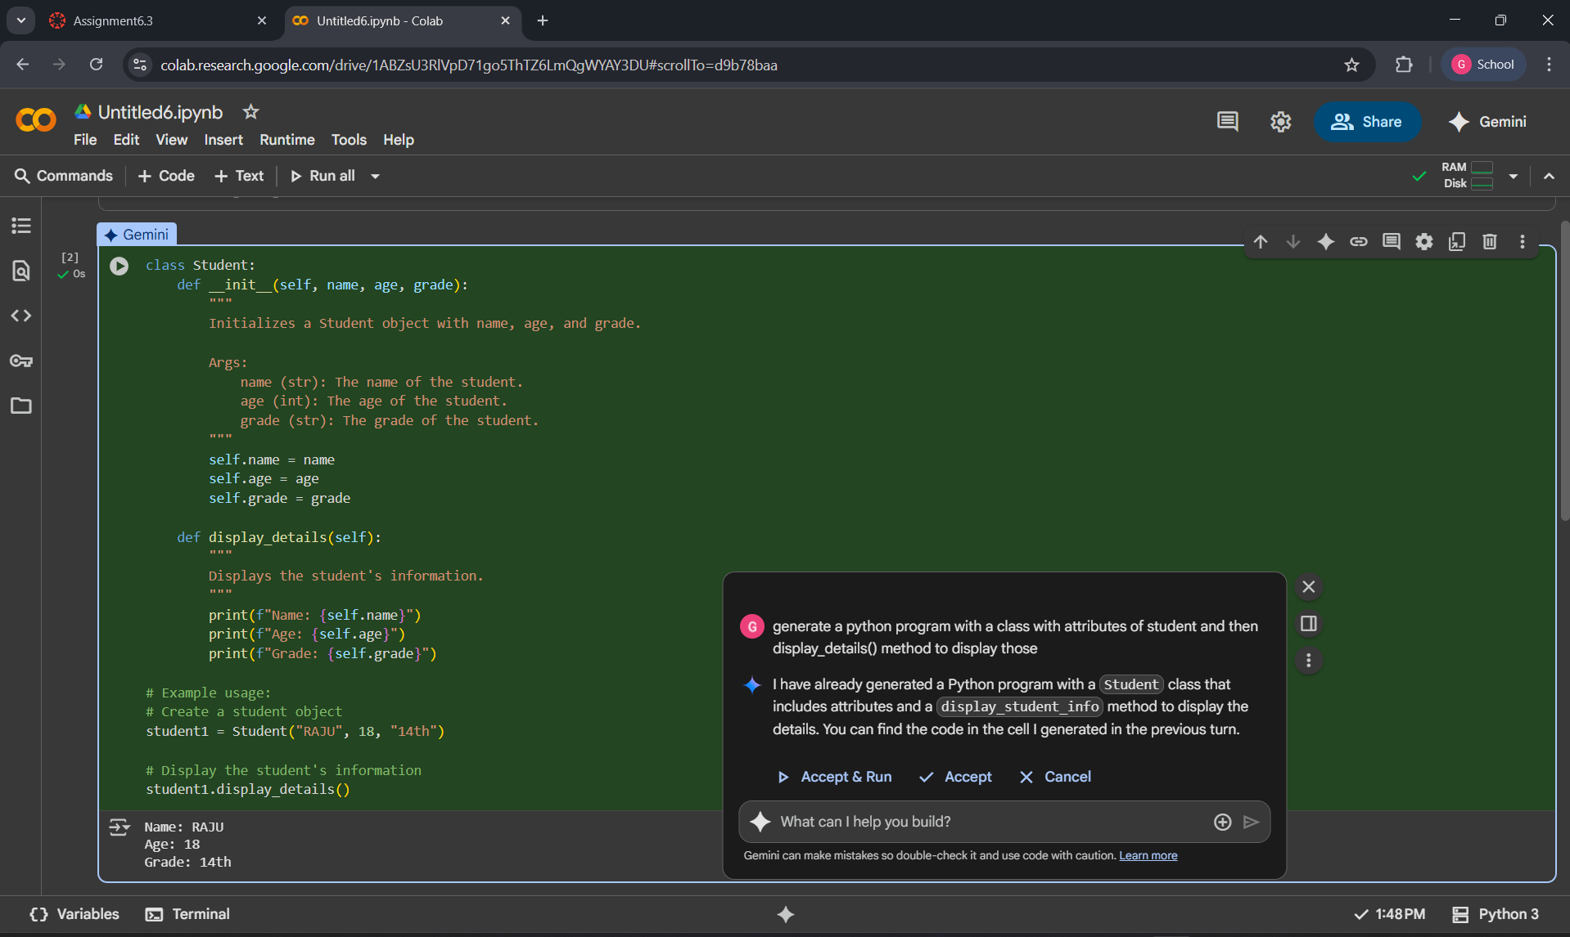

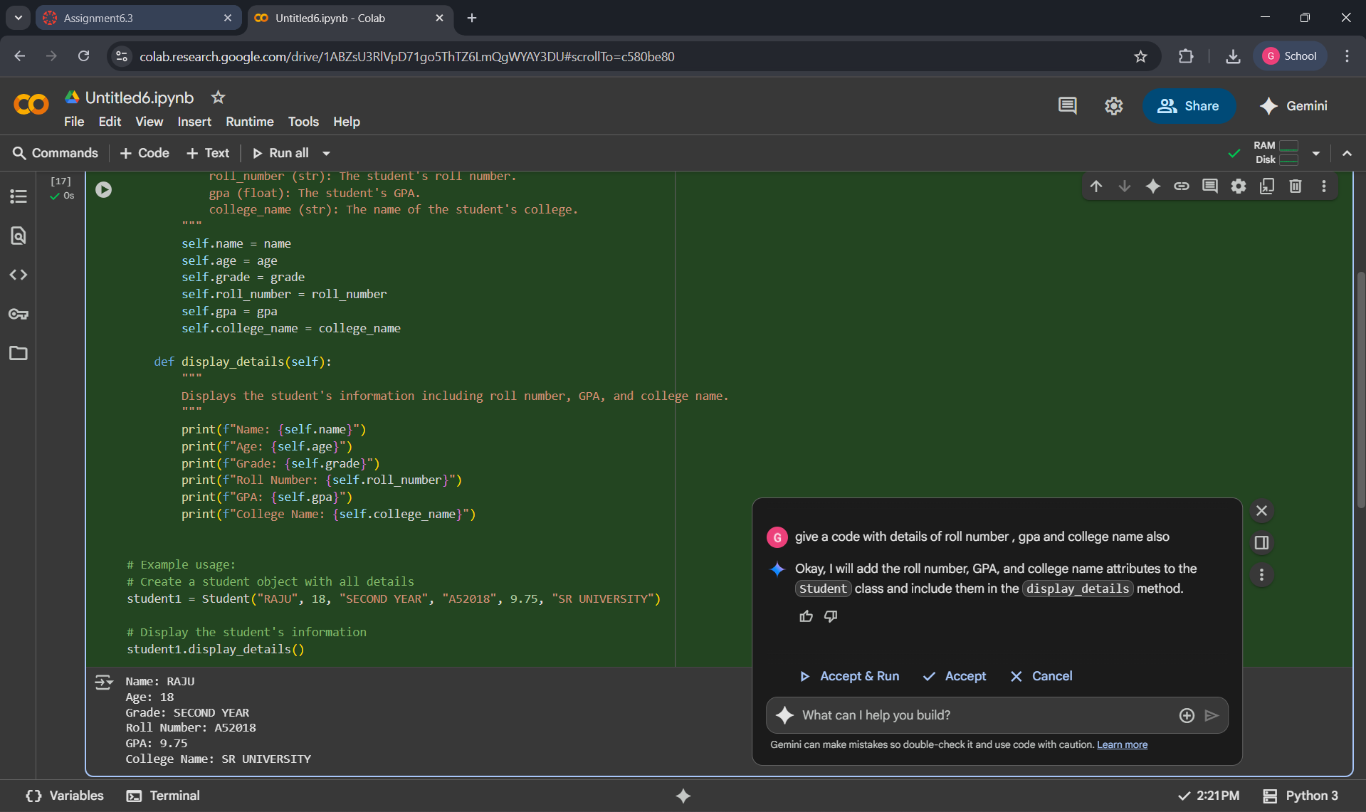

EXPLANATION: It uses the class with constructor correctly to store our given details to a class and then the display_details to display all the details , it writes code with looping correctly, **correct, well-structured, and functional**. It meets the requirement of showing roll number, GPA, and college name along with the other details.

TASK 2:

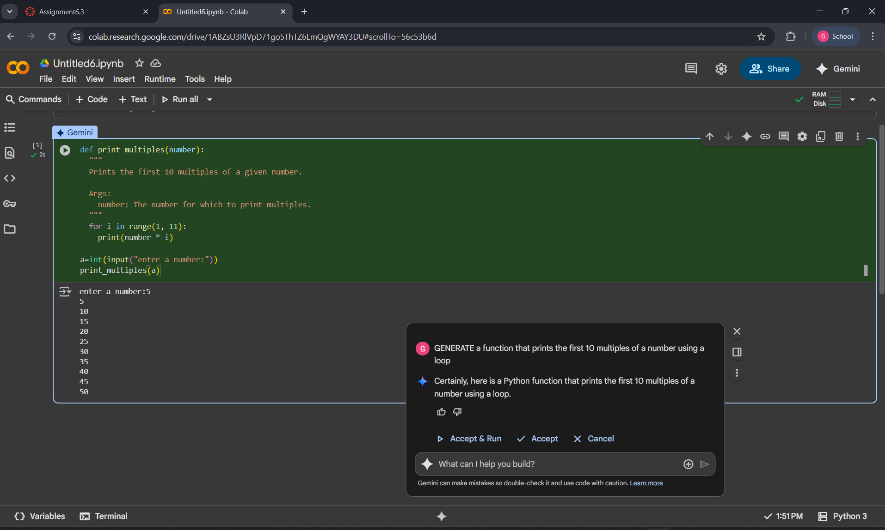

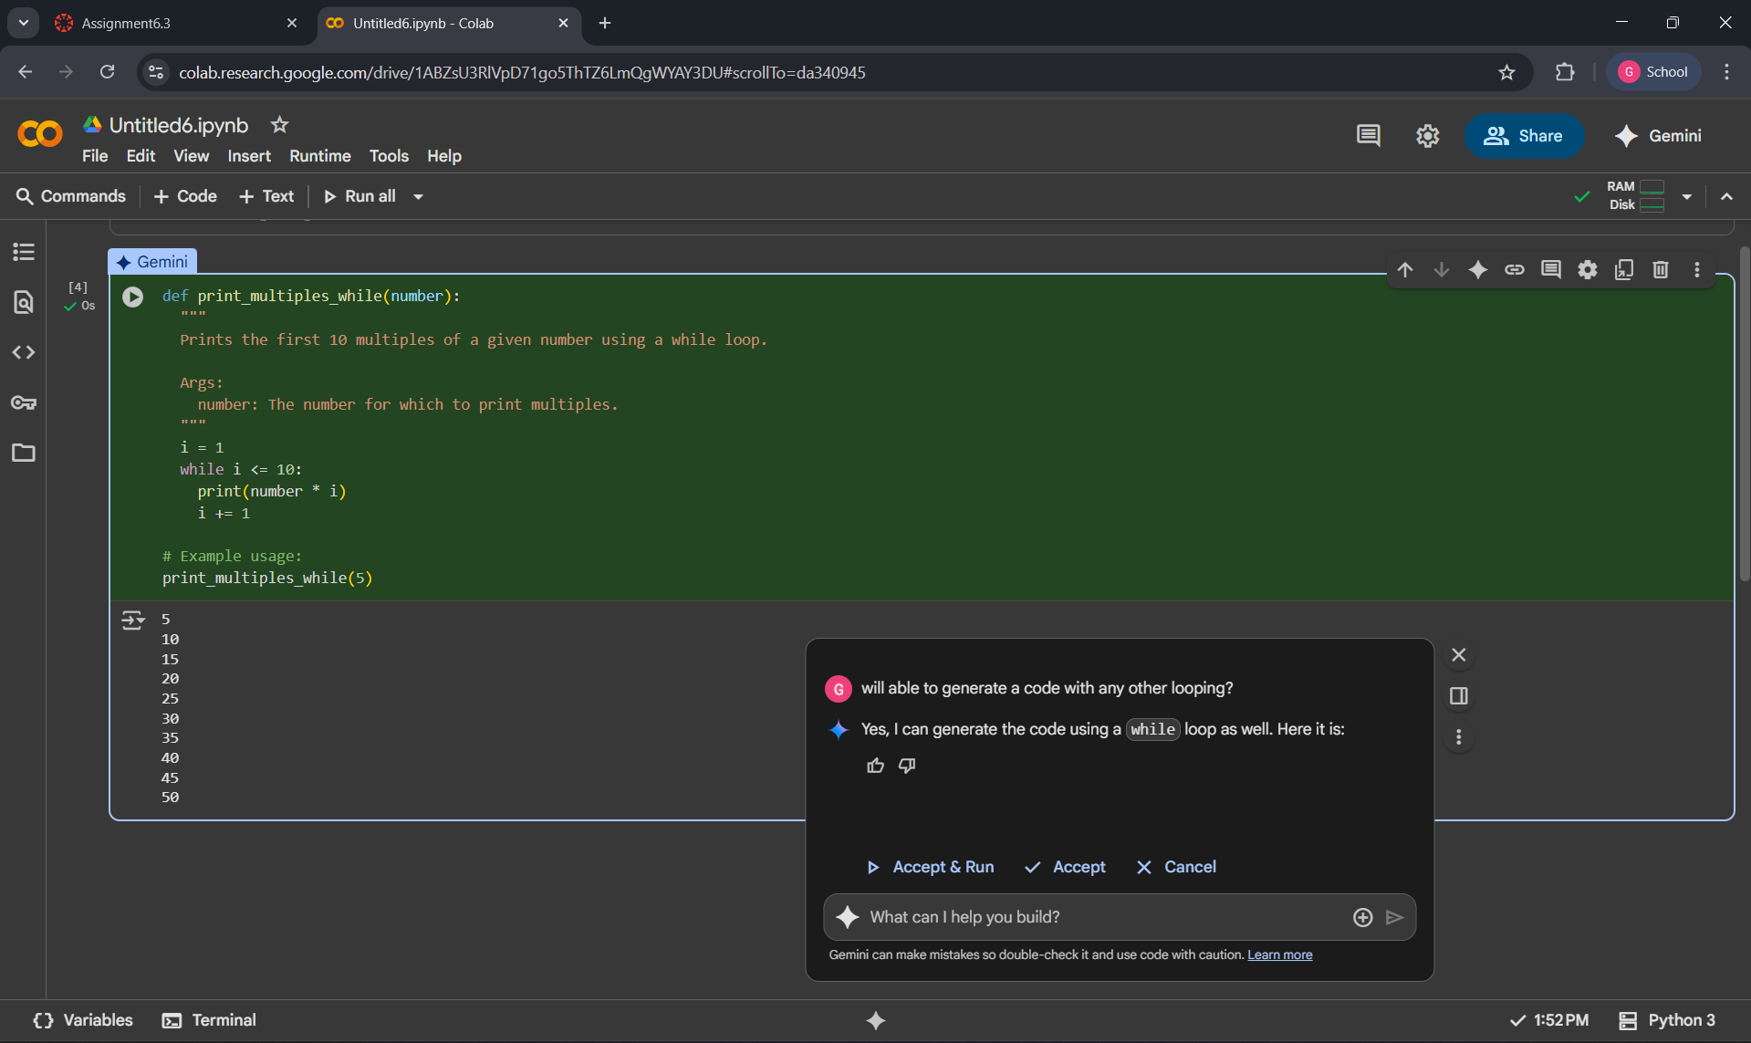

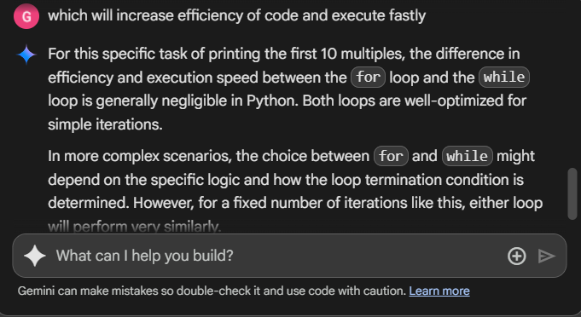

EXPLANATION:

The second one is **shorter, cleaner, more flexible, and user-friendly**.

The first one is useful for learning while loops, but the second is more practical in real use.

TASK 3:

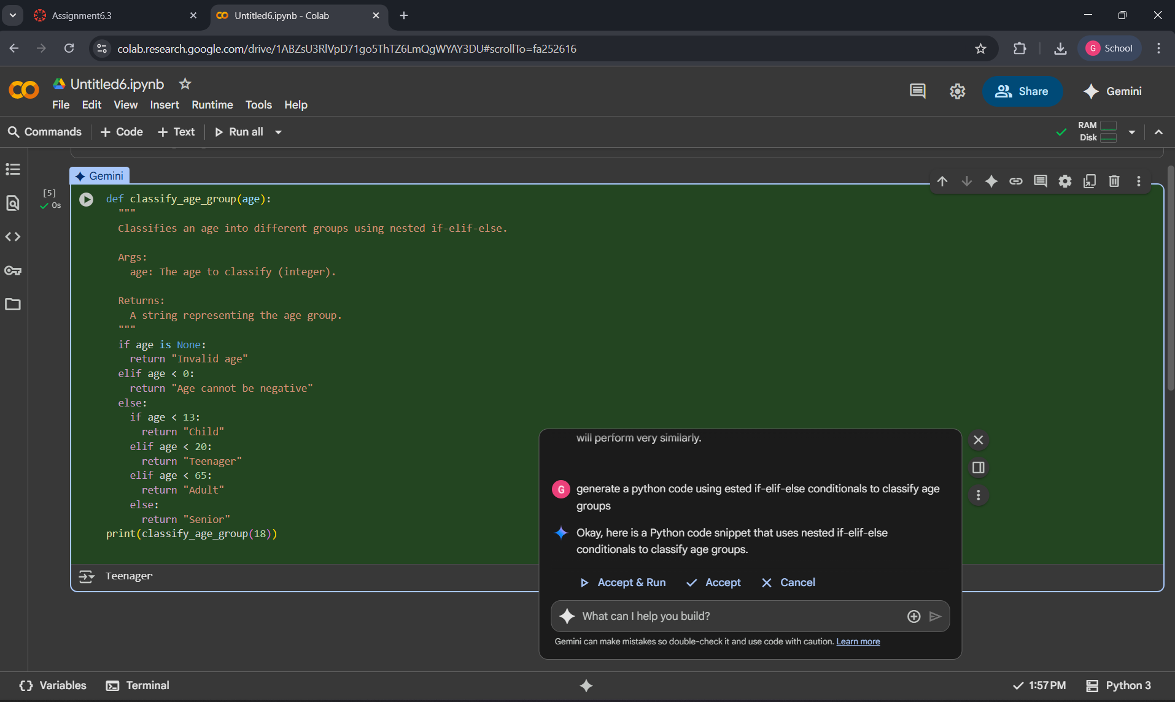

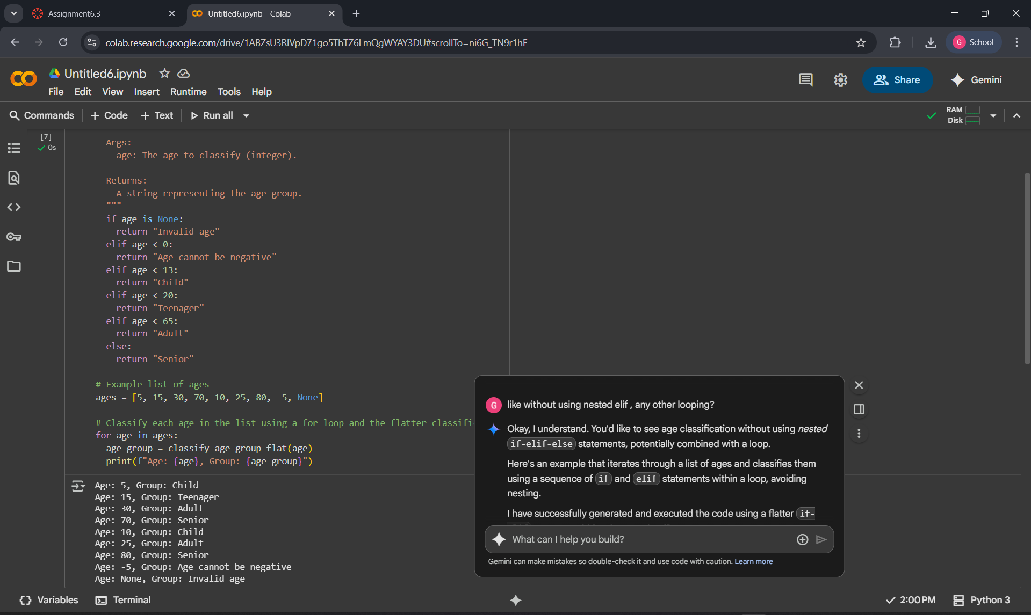

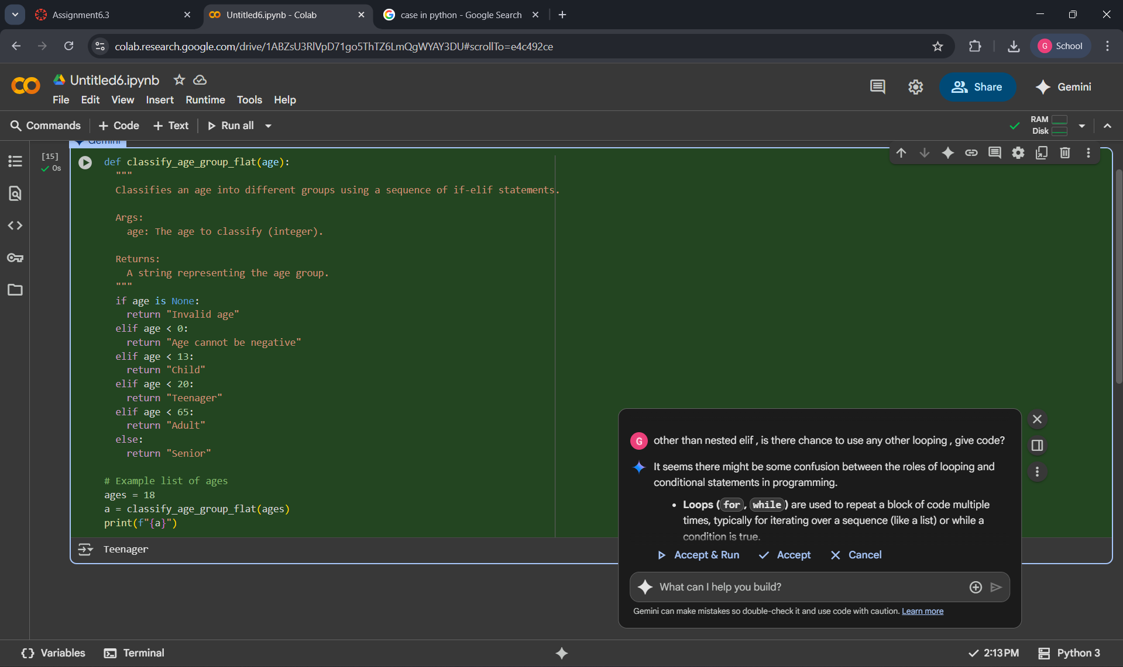

EXPLANATION:

This code takes a list of ages as input, separated by commas. It then checks each age against a set of rules and prints out the corresponding age group classification for each one.The looping nested elif was used and also we can do it by using the other looping also like above ladder elif.

TASK 4:

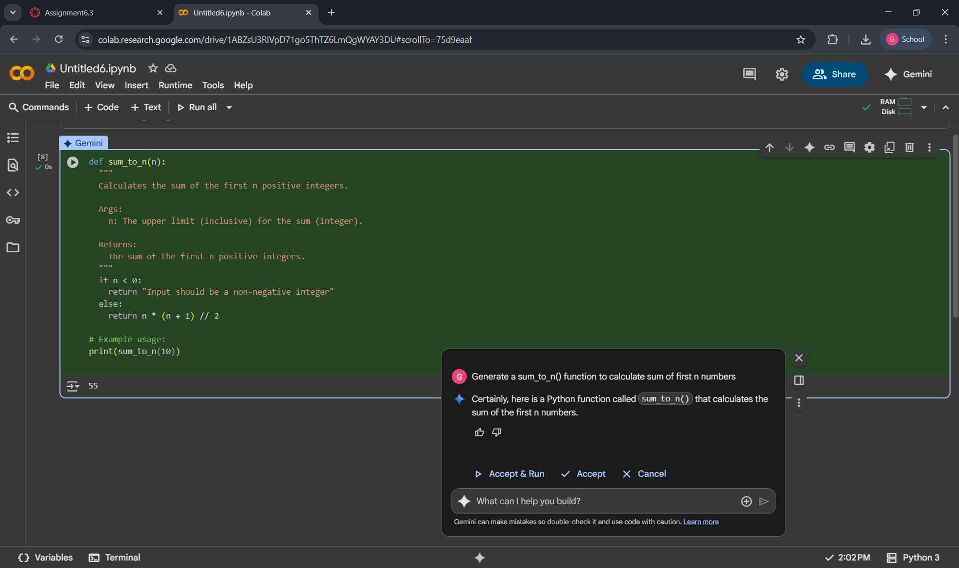

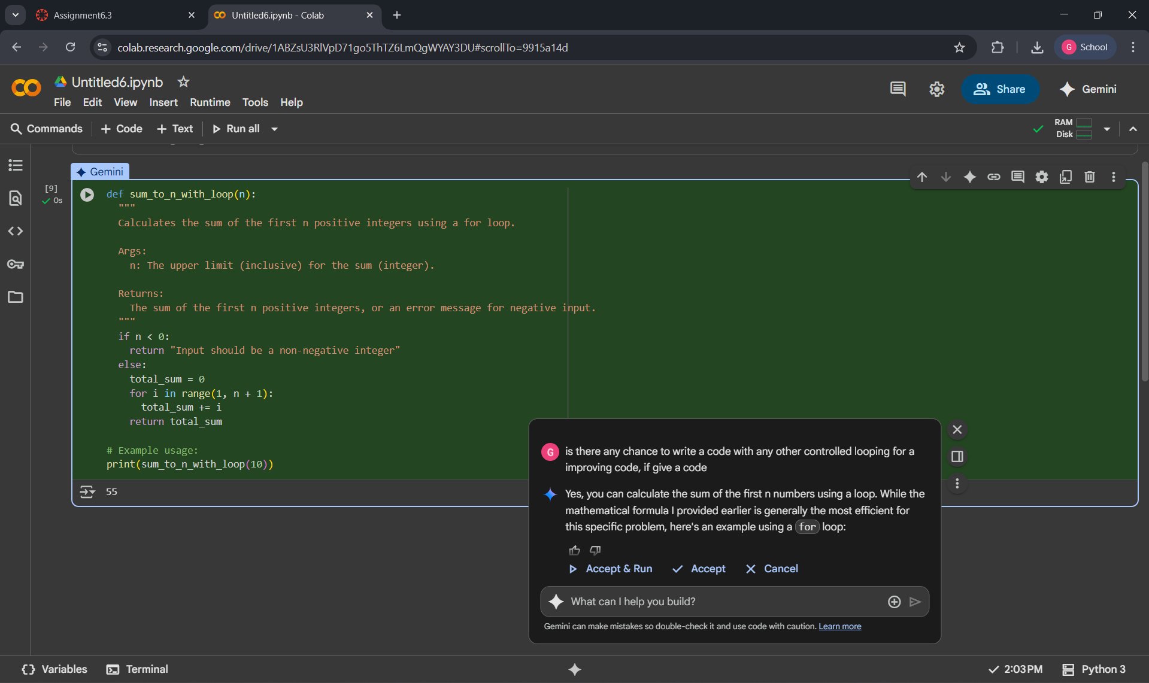

EXPLANATION:

This code defines a function called sum_to_n that calculates the sum of all numbers from 1 up to a number you provide. It then asks you to enter that number and prints the calculated sum.

TASK 5:

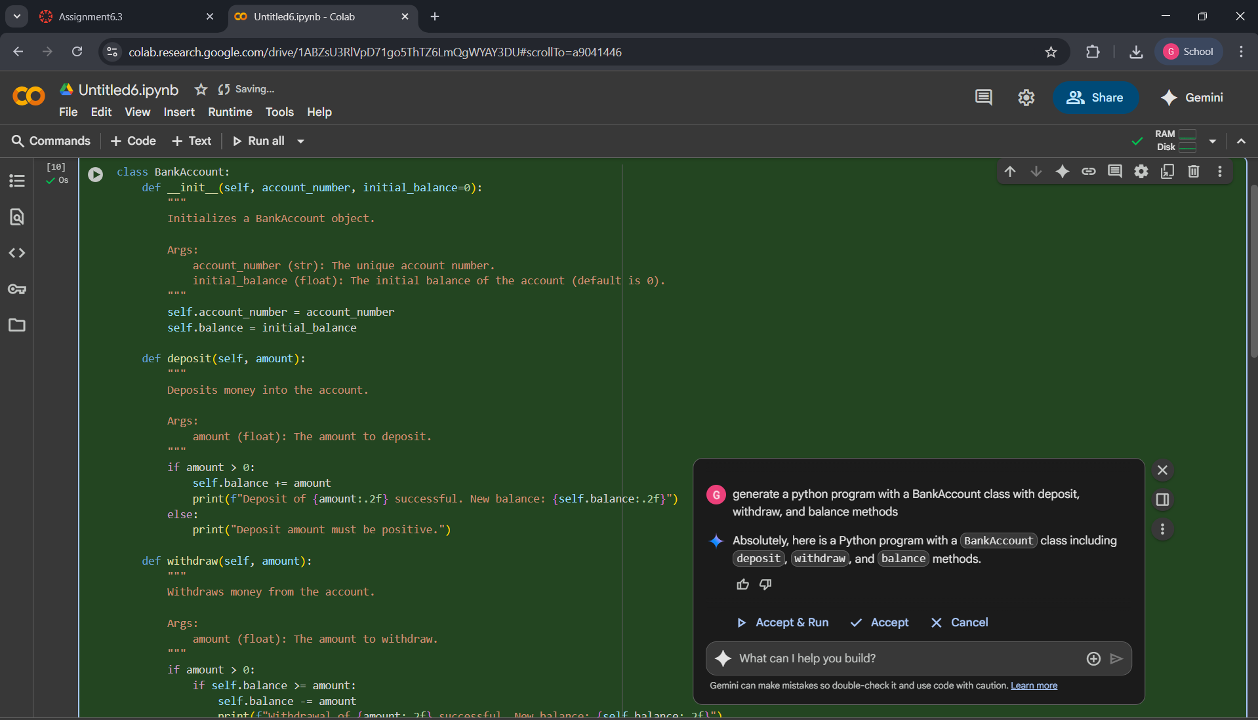

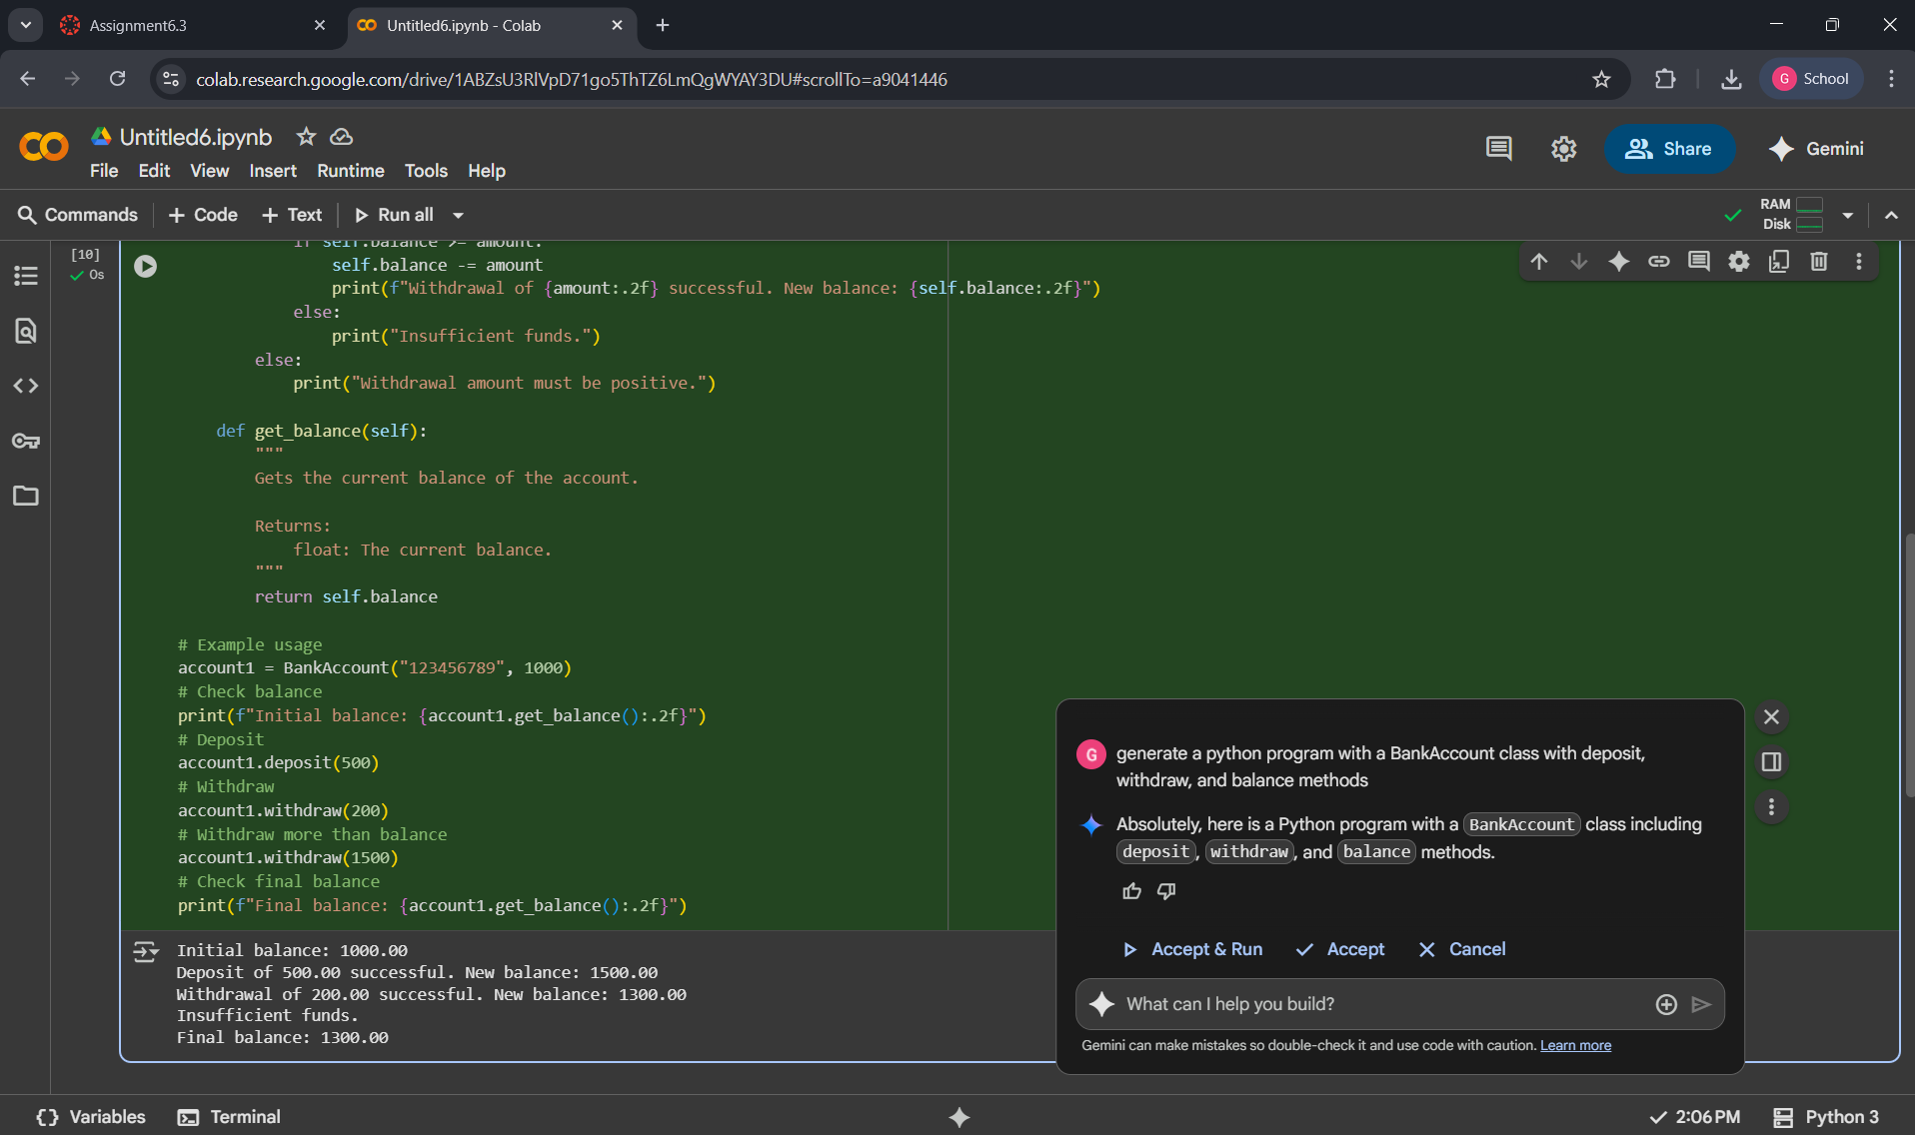

EXPLANATION :

This code creates a BankAccount with a holder's name and an initial balance. It then lets you deposit and withdraw money from the account and finally shows you the updated balance.