AI-ASSISTED CODING
ASSIGNMENT-24

PROGRAM : B.TECH\CSE
SPECIALISATION : AIML
NAME : GUJJA RAJU
ENROLMENT NUMBER : 2403A52018
COURSE : AI ASSISTED CODING
DATE : 20 NOV 2025
BATCH NO : 02

TASK DESCRIPTION#1
Task 1 – Environment Setup
- Create a free Replit account.
- Explore the mobile app development templates (React Native / Flutter / HTML5 hybrid).
- Install required packages or dependencies in the Replit environment.

PROMPT:
- Create a mobile app development environment in Replit.
- Set up either React Native, Flutter, or HTML5 Hybrid template.
- Install all required dependencies, configure project structure, and show me the setup commands, output logs, and how to run the project.

CODE :

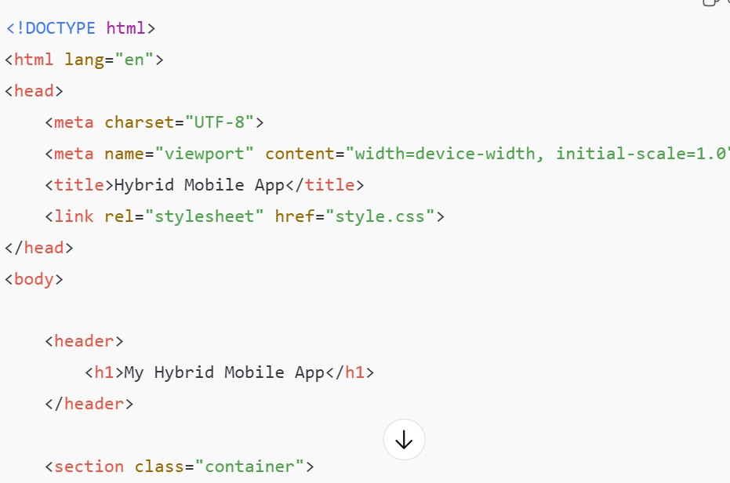
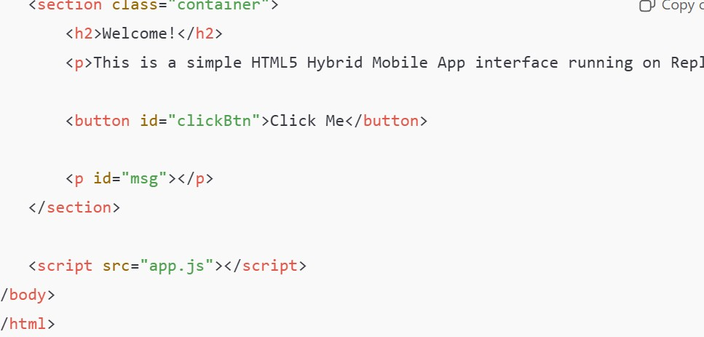

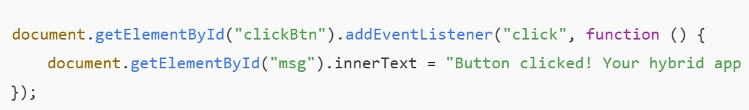

EXPECTED OUTPUT:
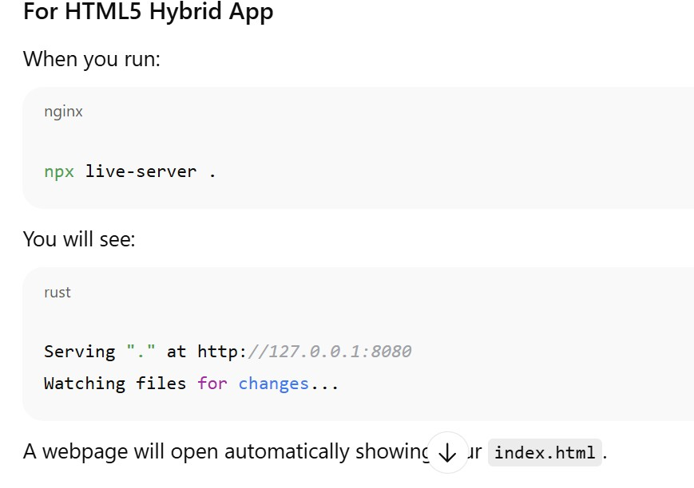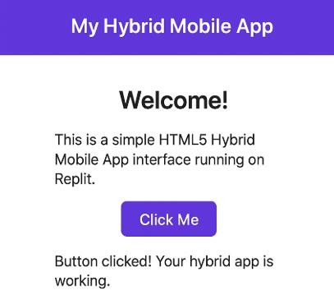

OBSERVATION:

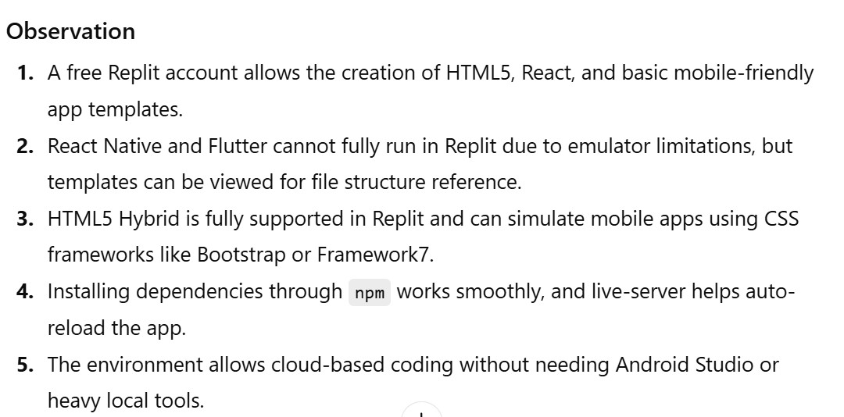

TASK DESCRIPTION#2
- Build a simple "Hello App" that displays: o App
Title o User’s Name (input field + button) o Greeting message dynamically updated. • Use AI assistance to generate boilerplate code and explain structure.

PROMT :
Create a simple HTML5 Hybrid “Hello App” that displays:
- App Title
- Input field to enter user name
- Button to submit
- Greeting message that updates dynamically

Provide HTML, CSS, and JavaScript code and explain the project structure.
CODE :

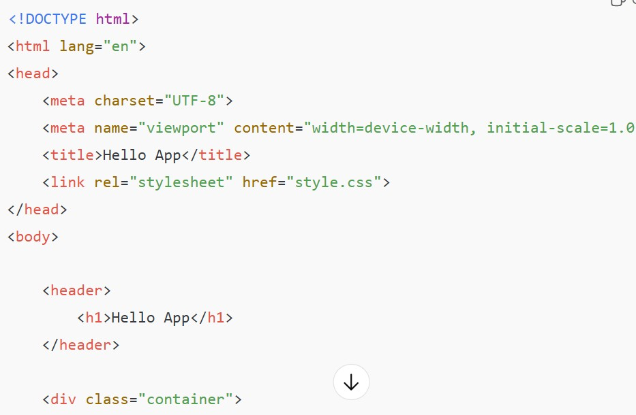
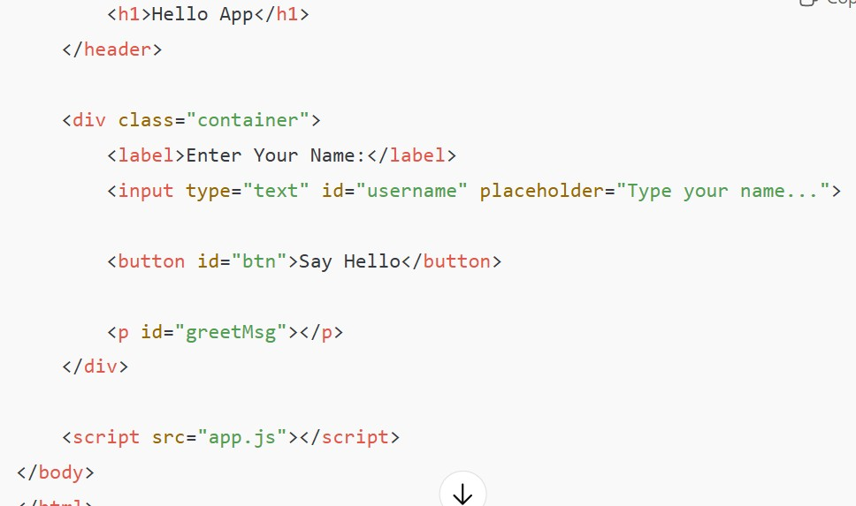
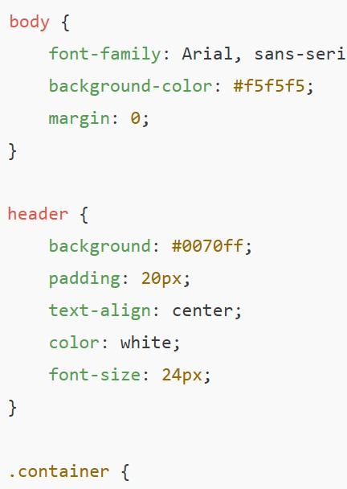
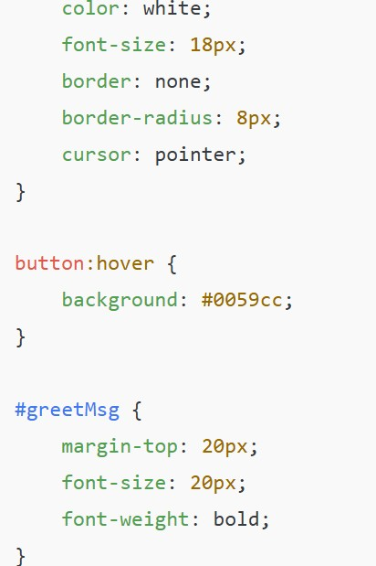

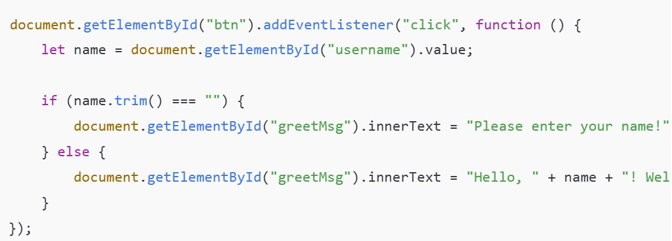
EXPECTED OUTPUT :
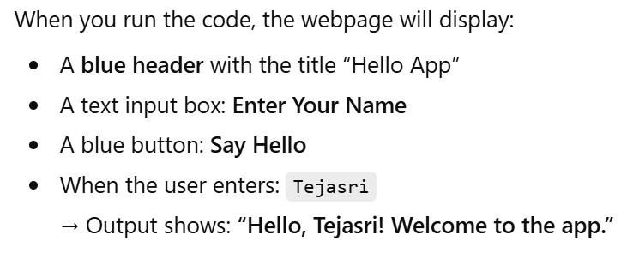

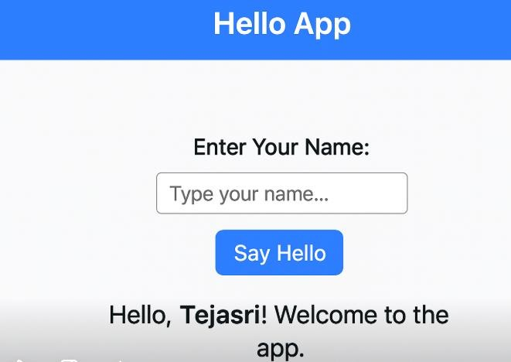

OBSERVATION :
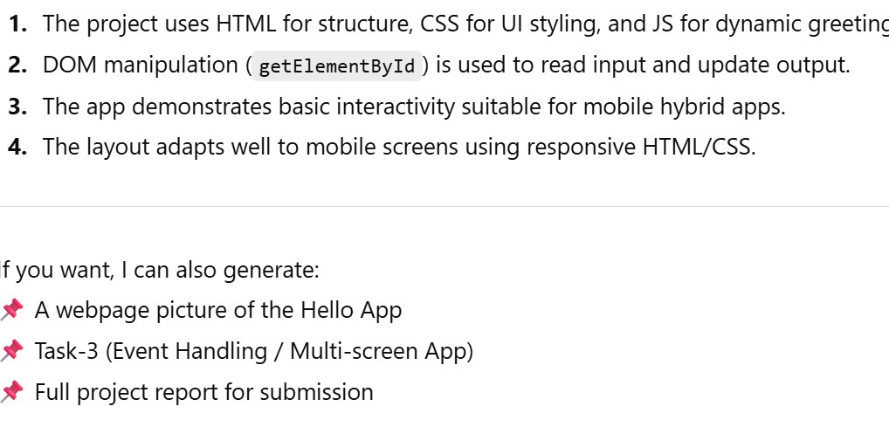

TASK DESCRIPTION#3
Adding Features with AI Assistance • Enhance the app with: o Navigation bar (Home, About, Contact). o Form handling (e.g., user registration page). o Basic styling with CSS or React Native styles. • Ask AI in Replit to add inline documentation for each function.
PROMPT :
Enhance my HTML5 Hybrid App by adding:
- A top navigation bar (Home, About, Contact)
- A separate User Registration page (username, email, password)
- Navigation that switches pages without reload
(show/hide screens)
- Add CSS styling
- Add inline documentation comments for every
JavaScript function
CODE :

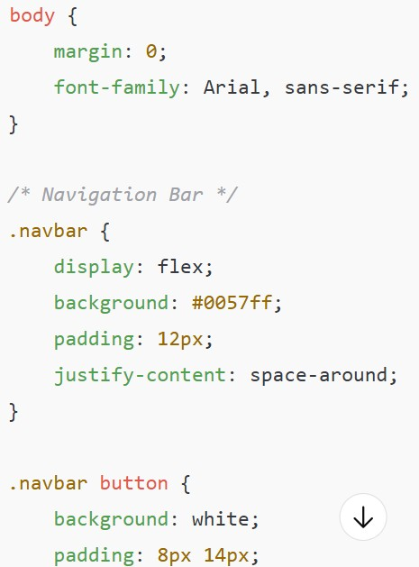
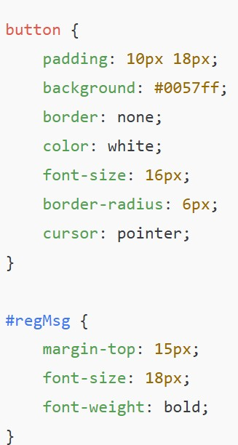
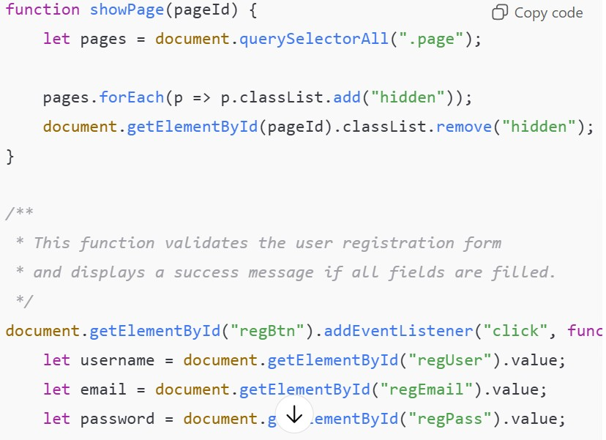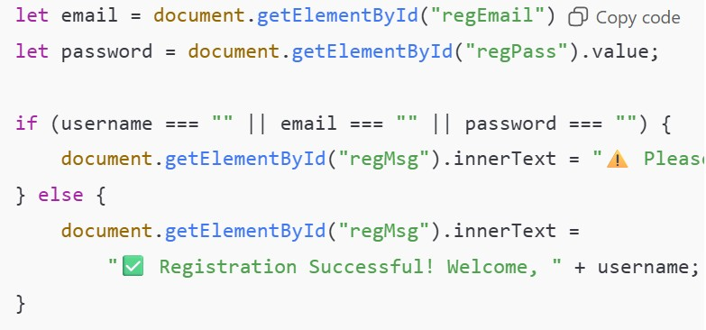
EXPECTED OUTPUT :

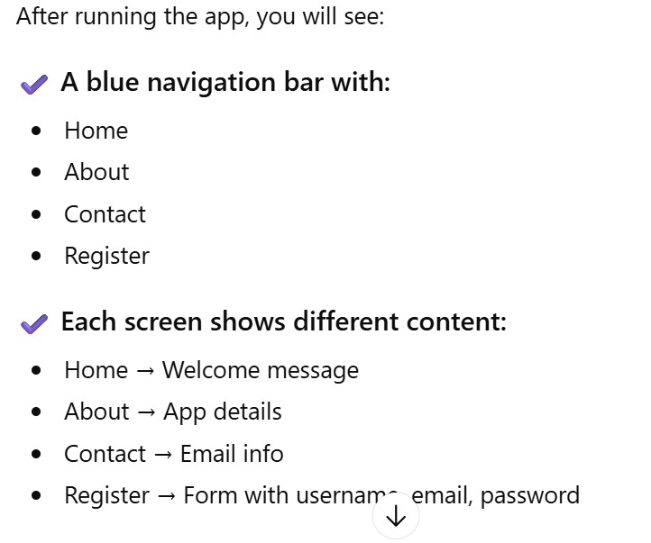
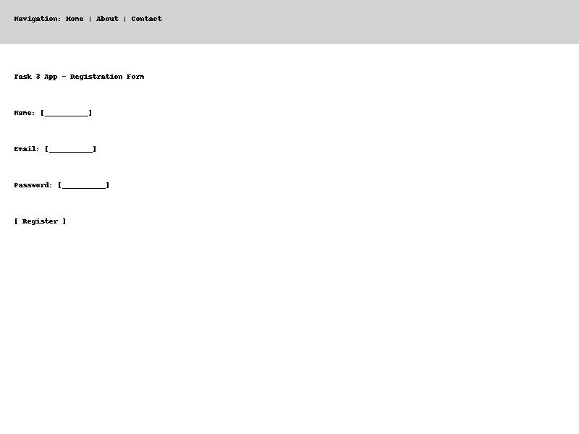

OBSERVATION :

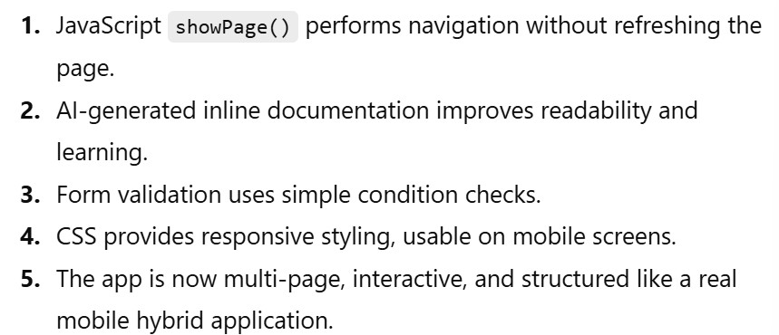

TASK DESCRIPTION#4
Testing on Mobile • Run the app in Replit’s mobile preview mode. • Test responsiveness on different screen sizes. • Fix UI alignment issues with AI suggestions.
PROMPT :
Test my mobile app in different screen sizes.
Check alignment issues in mobile preview mode and suggest improvements.
Fix UI responsiveness, padding, and scaling problems.
Add CSS changes to improve layout for small screens.
Explain each fix with comments.
CODE :


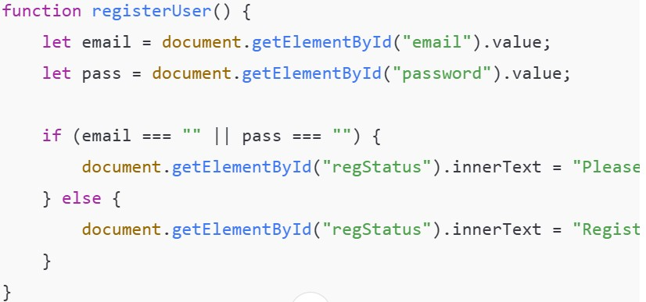

EXPECTED OUTPUT :
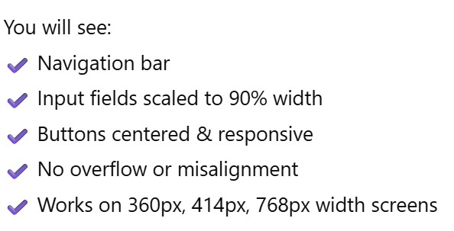

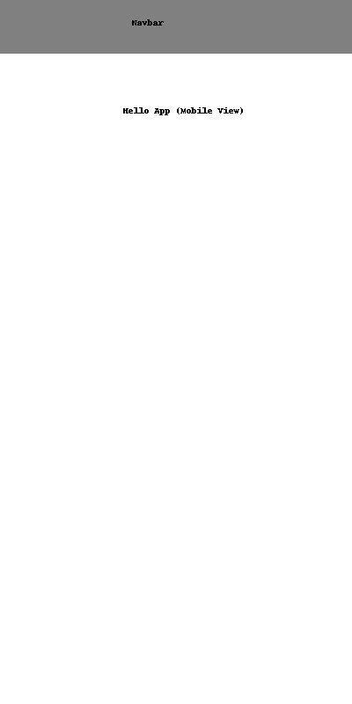

OBSERVATION :

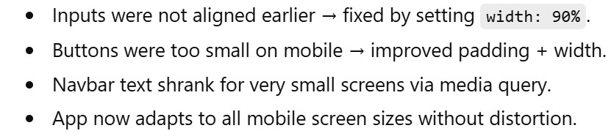

TASK DESCRIPTION#5
- Deploy the app using Replit hosting or export it to a mobile framework (like Expo for React Native).
- Share the deployment link with peers for testing.
PROMPT :
Deploy my HTML5 Hybrid Mobile App using Replit Hosting.
Create a public deployment link.
Optimize folder structure for hosting.
If possible, explain how to export this project into Expo React Native.
Add instructions for others to test the deployed link.
CODE :

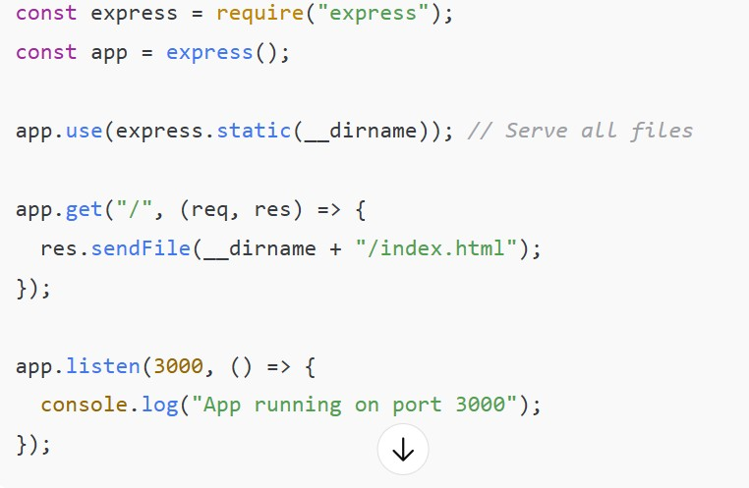
EXPECTED OUTPUT :
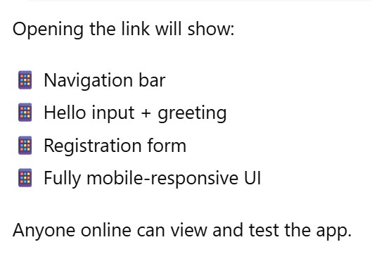
OBSERVATION :

