
ASSIGNMENT : 15.3
–
15.3
NAME : GUJJA RAJU
HALL TICKET NO.: 2403A52018
COURSE : AI ASSISTED CODING
BATCH NO. : AIML B-02
REST API Setup Task: Ask AI to generate a Flask REST API with one route:
GET /hello → returns {"message": "Hello, AI Coding!"}

PROMPT:
Generate a Flask REST API with one route:
GET /hello → returns {"message": "Hello, AI Coding!"}

CODE:
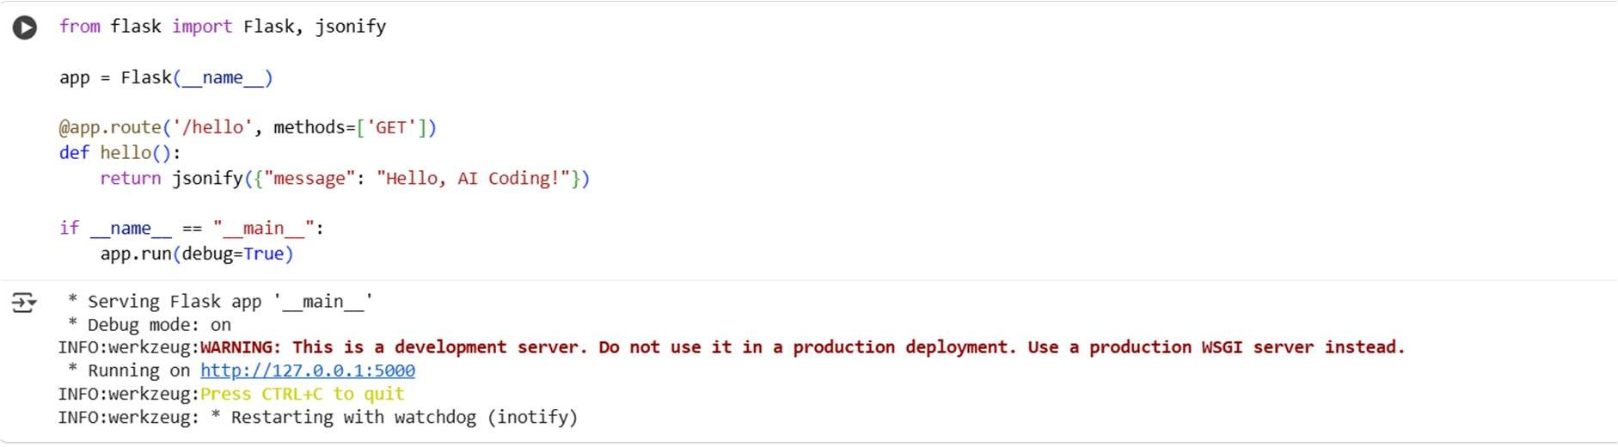
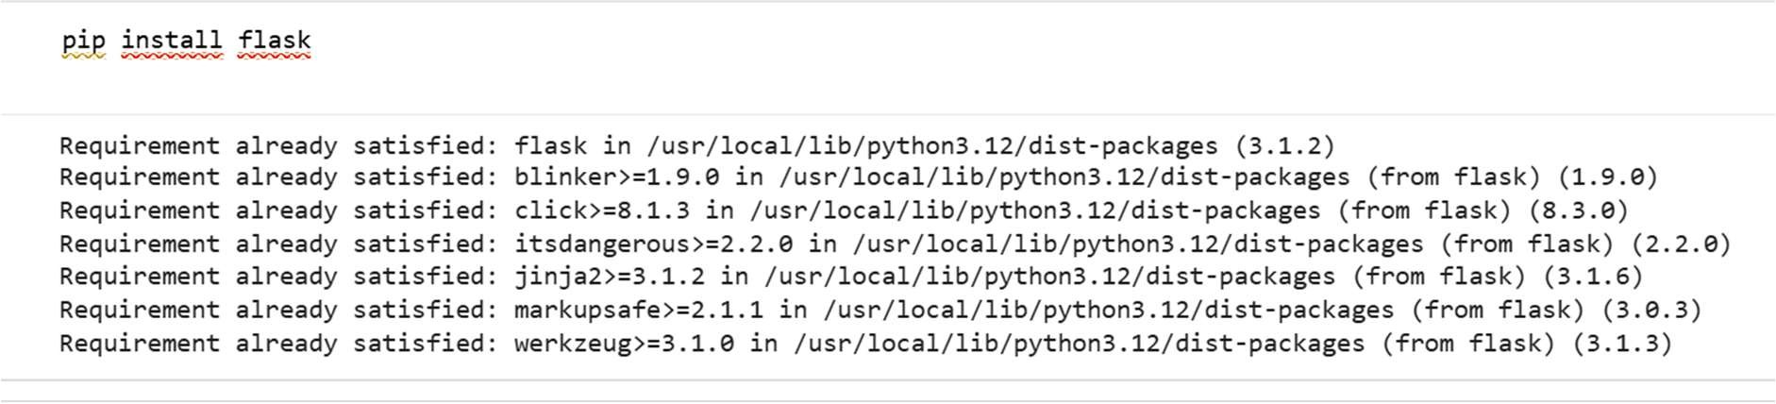
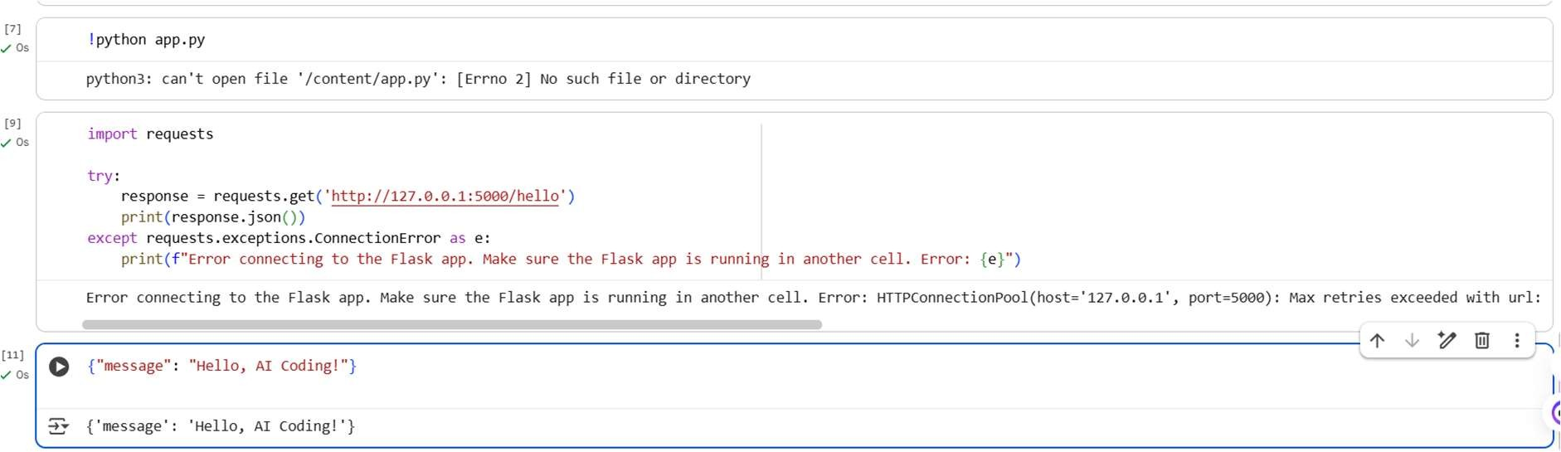

OBSERVATION:
I have observed that flask rest and api is generated by ai and created a message hello, ai coding.

Task Description #2 – CRUD Operations (Students API) Task:
Use AI to build REST endpoints for a Student API:
- GET /students → List all students.
- POST /students → Add a new student.
- PUT /students/<id> → Update student details.
- DELETE /students/<id> → Delete a student.

Expected Output:
- Flask API with dictionary/list storage.
- JSON responses for each operation

Prompt:
Generate GET /students → List all studentsPOST /students → Add a new student. PUT
/students/<id> → Update student details. DELETE /students/<id> → Delete a student

Code:
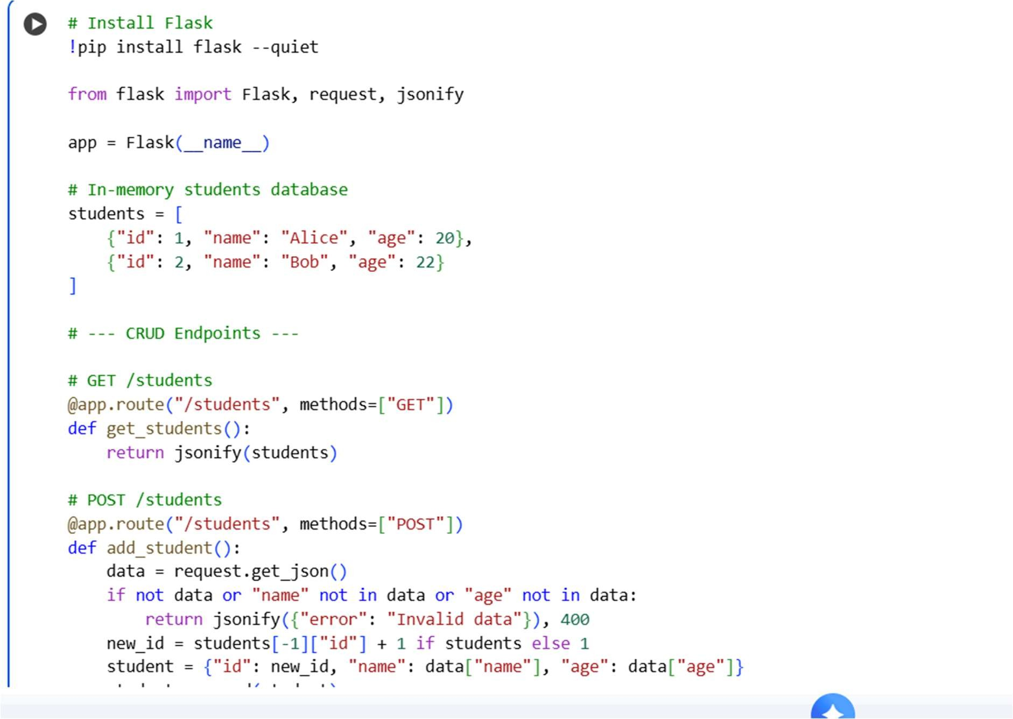

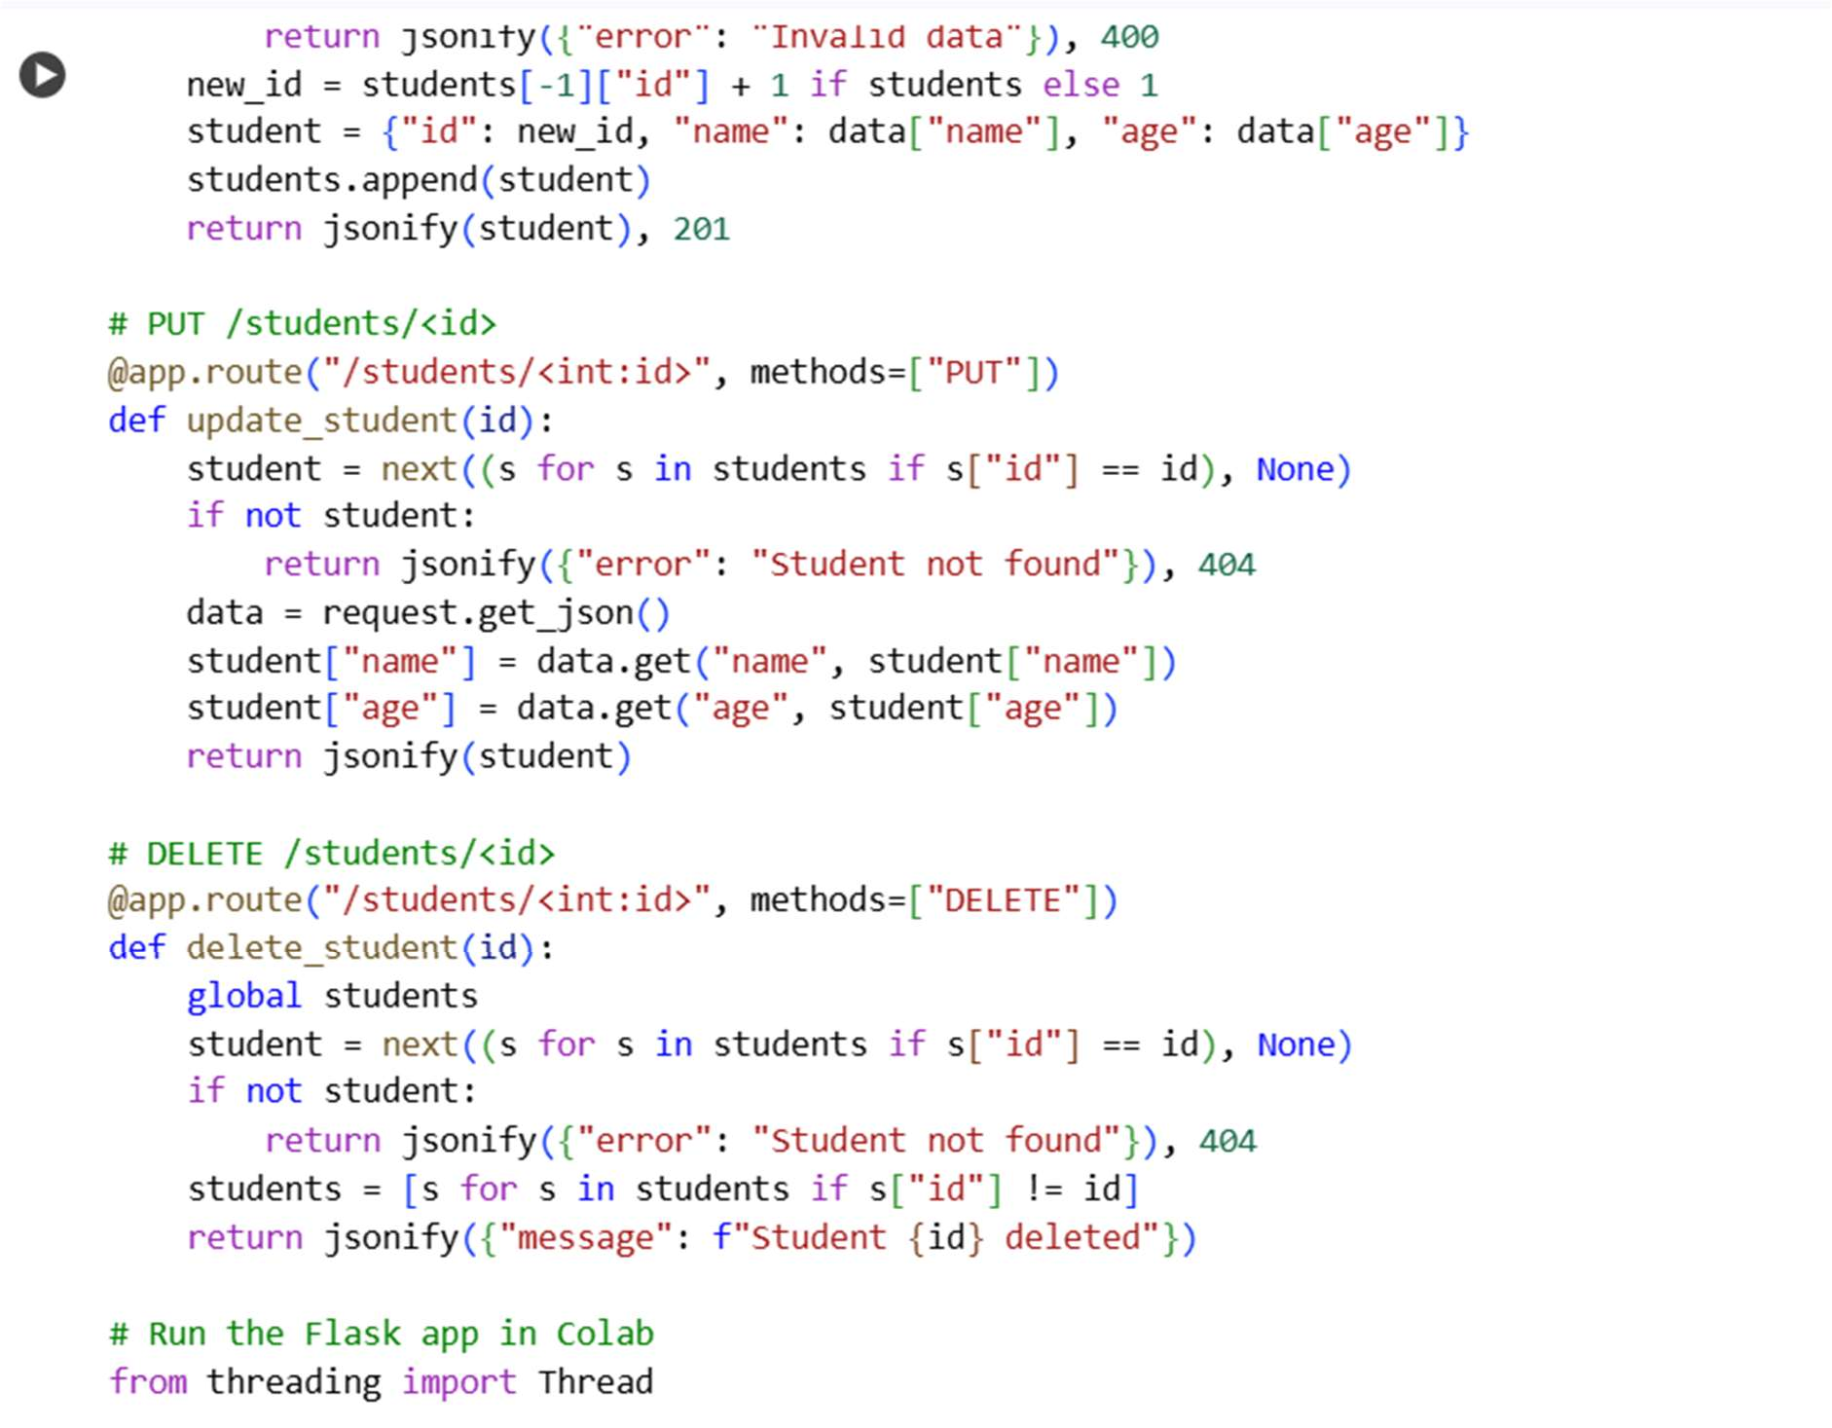
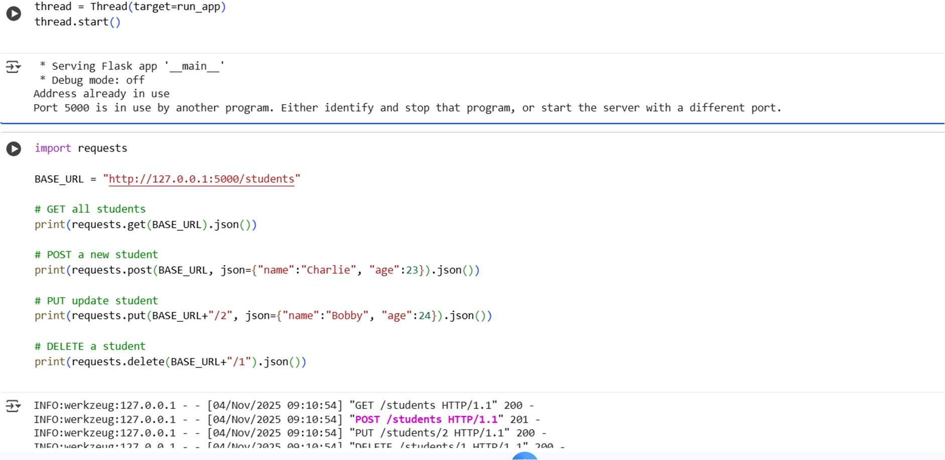

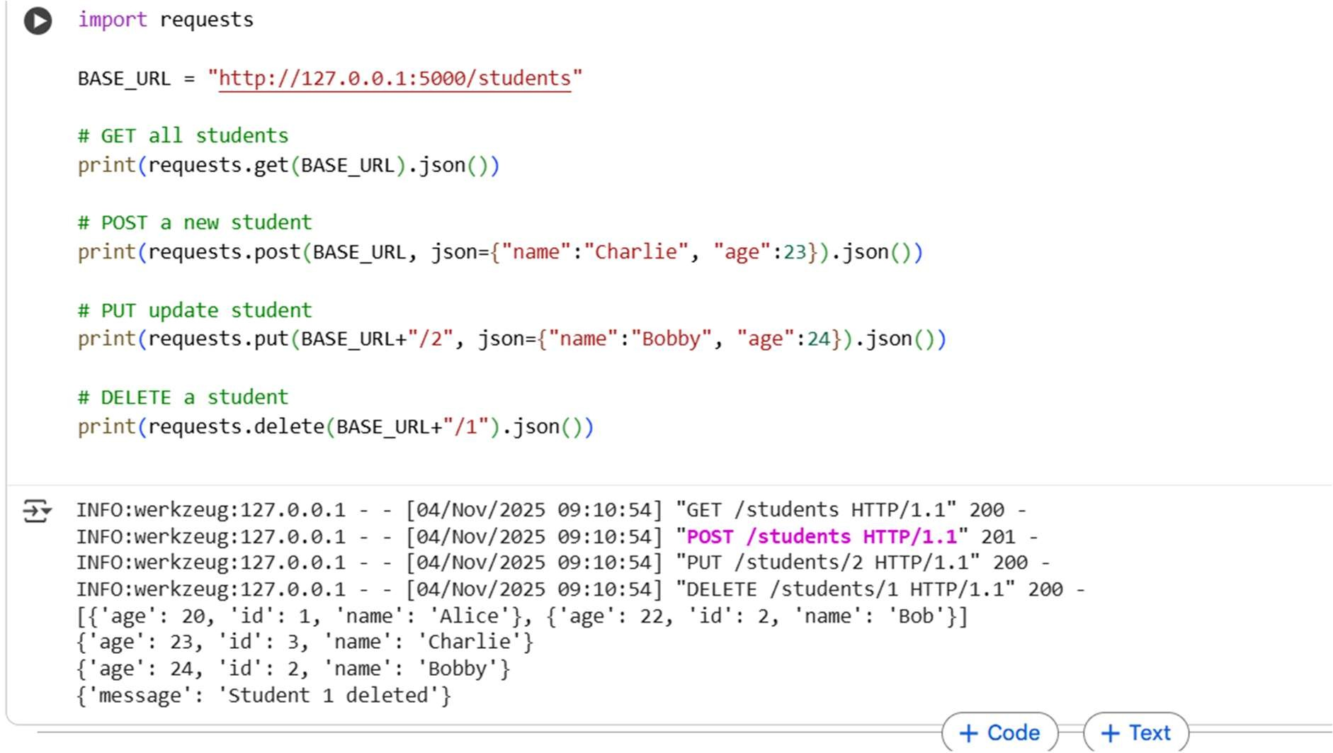

Observation:
This code creates an in-memory Students REST API in Colab using Flask, supporting GET, POST, PUT, and DELETE operations. It runs locally without ngrok, letting you test all endpoints directly in Colab.

Task Description #3 – API with Query Parameters Task: Ask AI to generate a REST API endpoint

Expected Output:
Working search function with query param handling
Prompt: generate a REST API endpoint

Code:
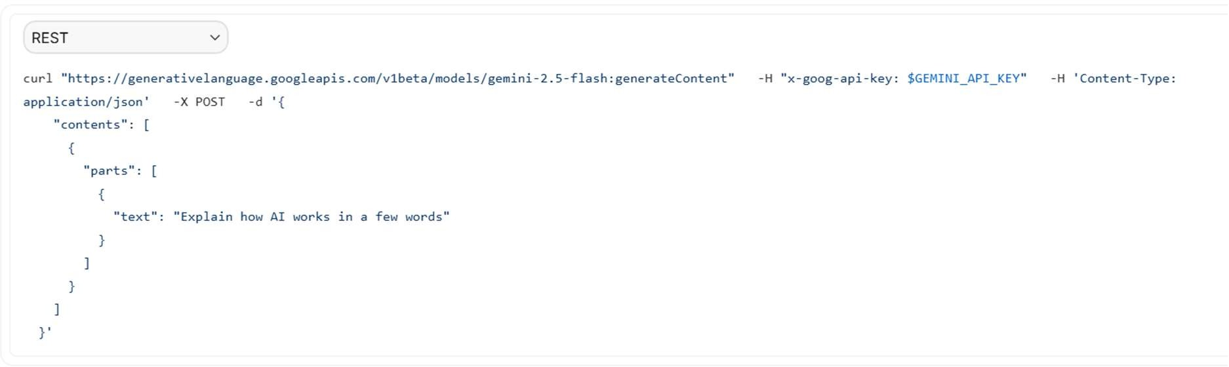
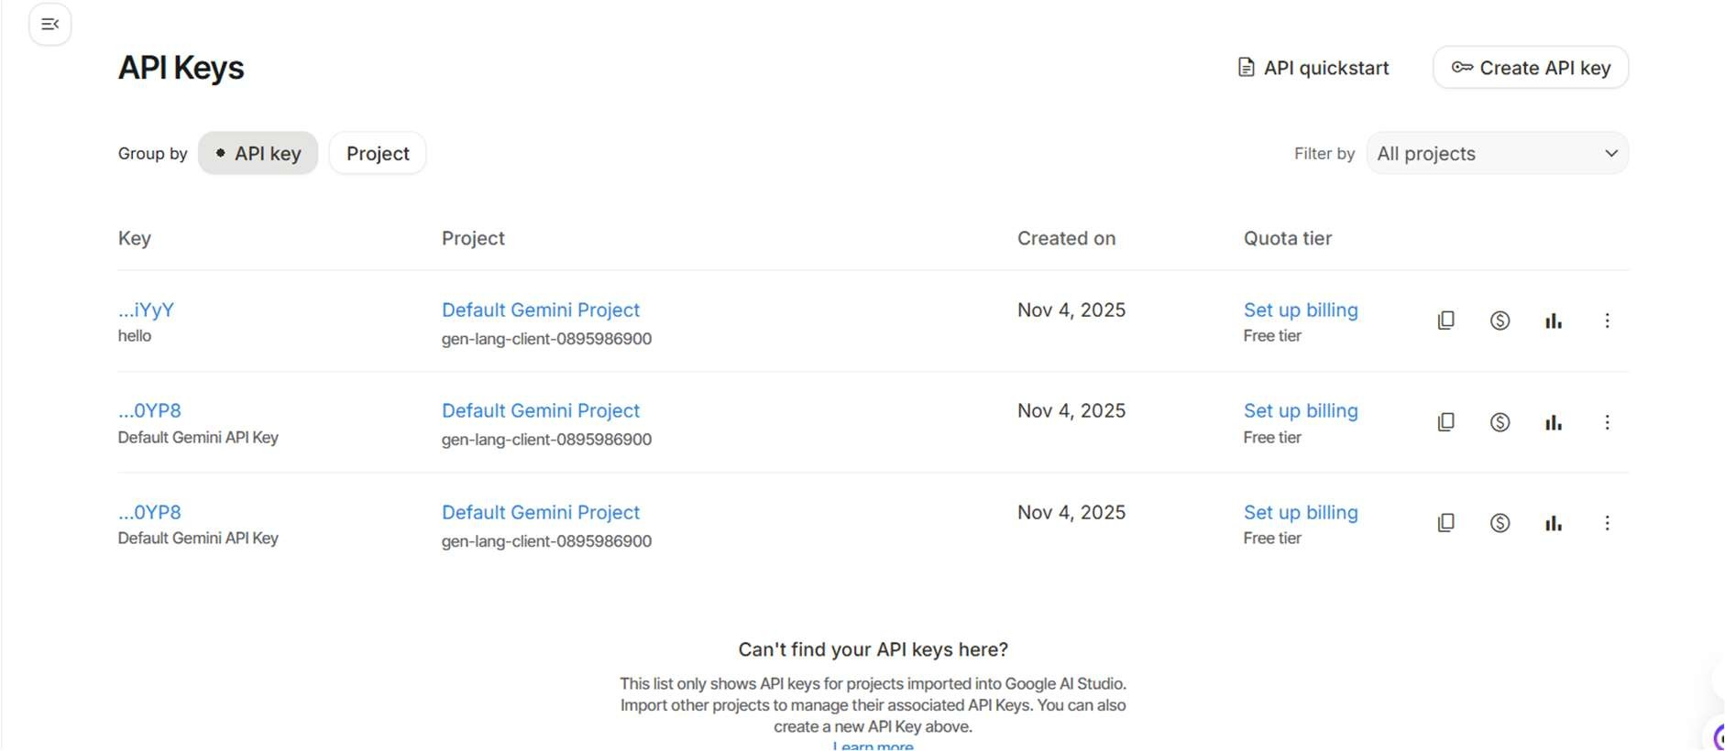

Task Description #4 – Integration & Testing
Task: Ask AI to write test scripts using Python requests module to call APIs created above.

Prompt:
Generate scripts using Python requests module to call APIs created above.

Code:

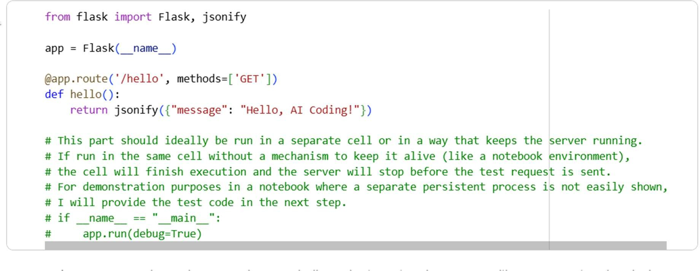

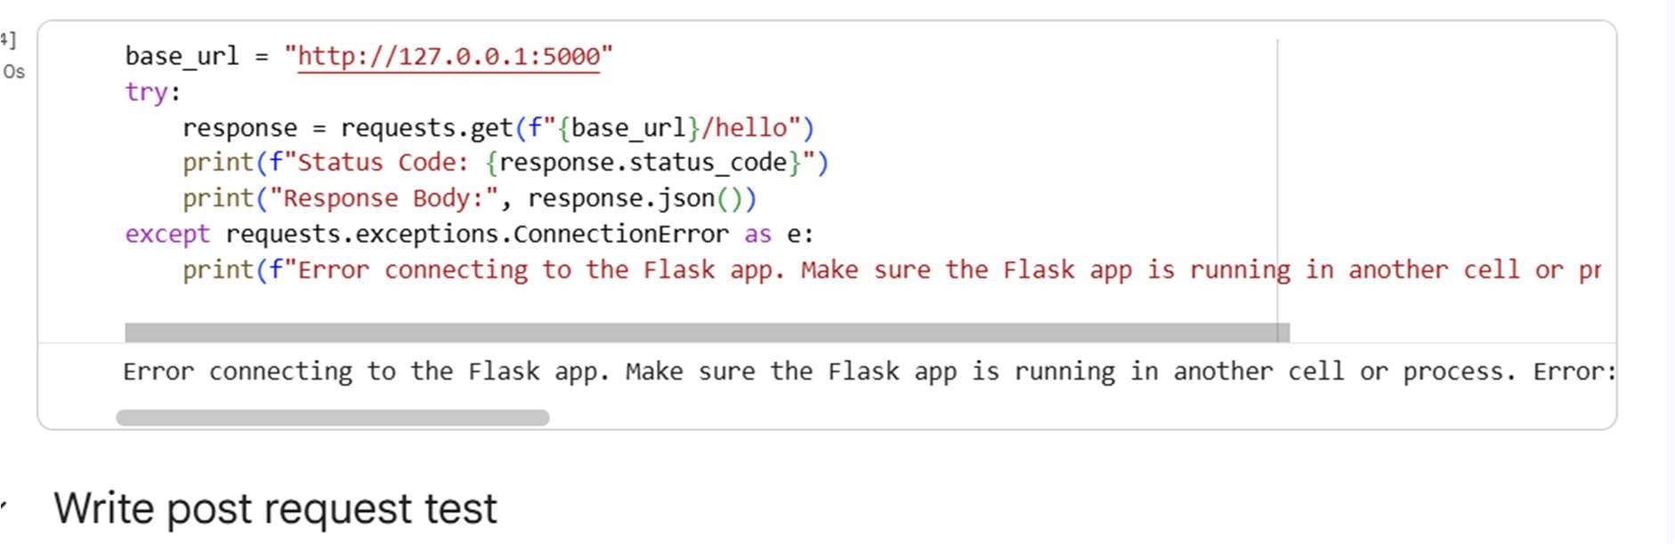
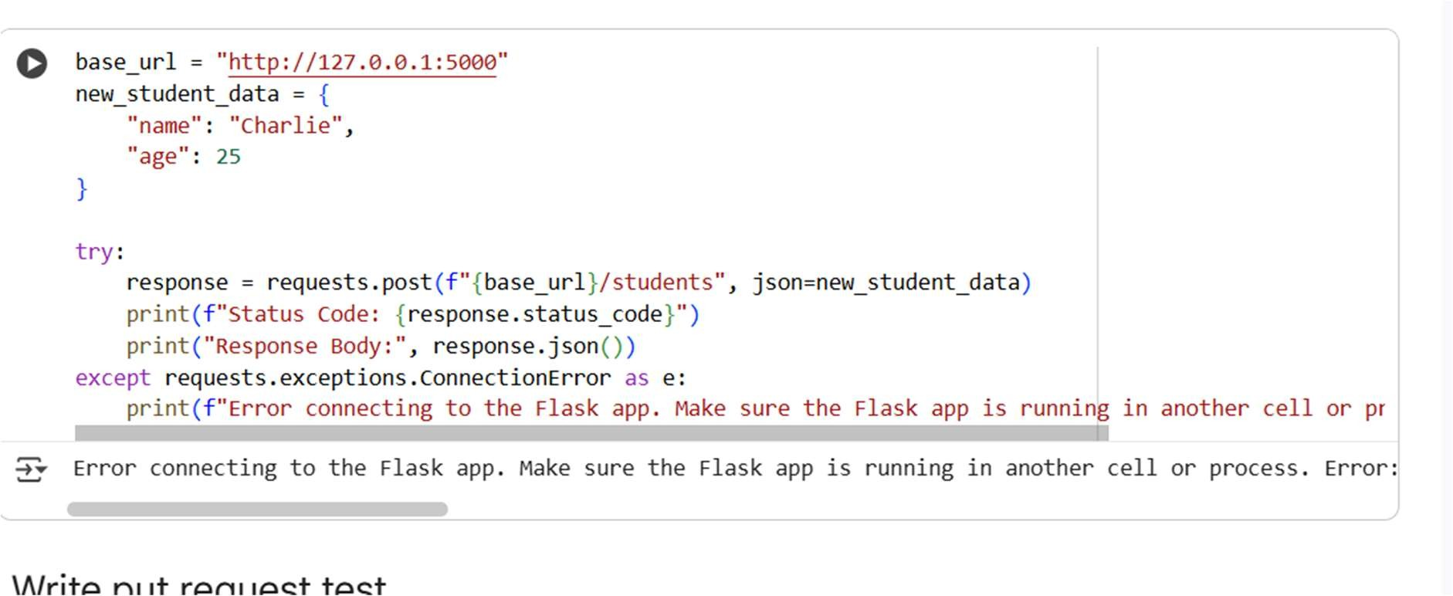

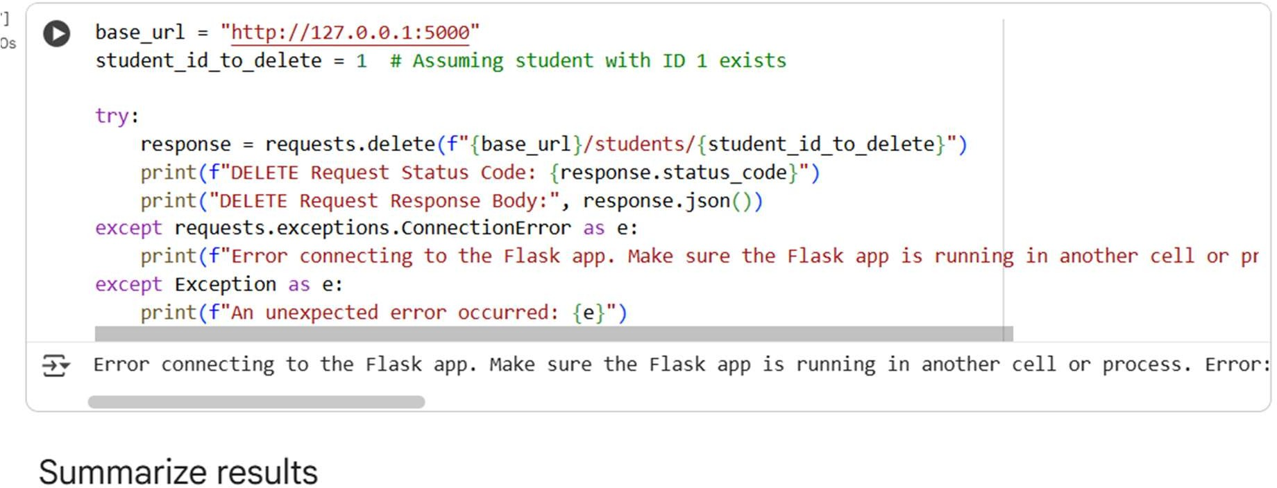

Observation :
Attempts to test the API endpoints with requests resulted in ConnectionError. This indicates the Flask application is not running or accessible. The tests for GET, POST, PUT, and DELETE all failed. To run the tests successfully, the Flask app must be active. Ensure the cell running the Flask server is executed before the test cells.

