LAB ASSIGNMENT-19.2

Program :B.tech(CSE)
Specialization :AIML
Course Title :AI Assisted Coding

Course Code :24CS002PC215
Semester :3rd semester Academic Session :2025-2026 Name of Student : GUJJA RAJU
Enrollment No. :2403A52018
Batch No. 02
Date :11/11/2025

#TASK DESCRIPTION-1:
Sorting Algorithm Translation
You are part of a multinational development team. The backend is written in
Java, but a new module requires a Python implementation of the same algorithm for integration with a data science pipeline.
- Task 1: Use AI-assisted coding to translate a given Java bubble sort program into Python. Verify that the translated code works correctly.
- Task 2: Introduce errors in the Python version to check if the input list is empty or contains non-numeric values.

#PROMPT:

Write a Python program that translates a Java Bubble Sort program into Python. The program should include the original Java code, the correctly translated Python version, and a modified version with error handling
that checks if the input list is empty or contains non-numeric values. Display sample outputs for both successful and error cases. Keep the code clean, simple, well-commented, and easy to understand.
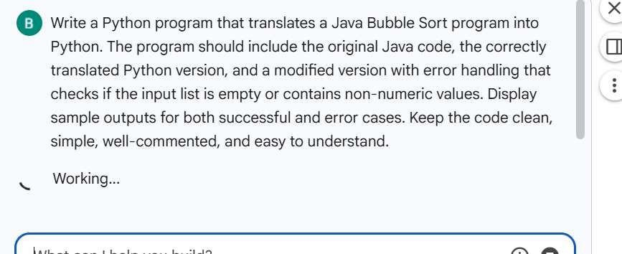

#CODE:

public class BubbleSort {
public static void bubbleSort(int[] arr) { int n = arr.length;
for (inti= 0; i < n - 1; i++) {
for (int j = 0; j < n - i - 1; j++) { if (arr[j] > arr[j + 1]) {
// Swap arr[j] and arr[j+l] int temp= arr[j];
arr[j] = arr[j + 1];
arr[j + l] = temp;
}
}
}
}

public static void main(String[] args) { int[] arr= {64, 34, 25, 12, 22, 11, 90};
bubbleSort(arr); System.out.println("Sorted array: ");
for (inti= 0; i < arr.length; i++) { Mii::ii:il
System.out.println("Sorted array: ");
for (inti= 0; i < arr.length; i++) {
System.out.print(arr[i] +" ");
}
System.out.println();
}
}

def bubble_sort_python(arr):

Sorts a list using the Bubble Sort algorithm. This is a direct translation of the Java version.

n = len(arr)
# Traverse through all array elements for i in range(n - 1):
# Last i elements are already in place
for j in range(n - i - 1):
# Traverse the array from 0 to n-i-1
# Swap if the element found is greater than the next element if arr[j] > arr[j + 1]:
arr[j], arr[j + 1] = arr[j + 1], arr[j] # Pythonic swap

# Sample usage:
my_list = [64, 34, 25, 12, 22, 11, 90)
print("Original list:", my_list) bubble_sort_python(my_list) print("Sorted list (Python):", my_list)

my_list_2 = [5, 1, 4, 2, 8] print("Original list 2:", my_list_2) bubble_sort_python(my_list_2)
print( "Sorted list 2 (Python):", my_list_2) Mi4%:ii:ih
def robust_bubble_sort(arr):
Sorts a list using the Bubble Sort algorithm with error handling. Args:
arr (list): The list of numbers to be sorted.

Raises:
ValueError: If the list is empty or contains non-numeric values.

Returns:
list: The sorted list.

if not isinstance(arr, list):
raise ValueError("Input must be a list.")

if not arr:
raise ValueError("Input list cannot be empty.")

# Check if all elements are numeric for item in arr:
if not isinstance(item, (int, float)):
raise ValueError("List contains non-numeric values. All elements must be numbers.")
LM!&&UL!&

n = len(arr)
# Create a copy to avoid modifying the original list if the user prefers
# Or, if modifying in-place is desired, remove the copy.
# For this example, we'll sort in-place as per typical sort functions.

for i in range(n - 1):
for j in range(n - i - 1):
if arr(j] > arr(j + 1]:
arr[j], arr[j + 1] = arr[j + 1], arr[j]
return arr

- # --- Successful Cases --­ print("\n--- Successful Cases ---")

# Case 1: Standard numeric list list_success_l = [64, 34, 25, 12, 22, 11, 90] print("Original list 1:", list_success_l) try:
sorted_list = robust_bubble_sort(list_success_l) print("Sorted list 1:", sorted_list)
except ValueError as e:
print(f"Error sorting list 1: {e}")

# Case 2: List with floats
list_success_2 = [3.14, 1.618, 2.718, 0.577] print( "Original list 2:", list_success_2) try:
sorted_list = robust_bubble_sort(list_success_2) print("Sorted list 2:", sorted_list)
except ValueError as e:
print(f"Error sorting list 2: {e}")

# Case 3: Already sorted list list_success_3 = [1, 2, 3, 4, 5] print("Original list 3:", list_success_3)
try: Toggle Gemini

# Case 3: Already sorted list list_success_3 = [1, 2, 3, 4, 5] print("Original list 3:", list_success_3) try:
sorted_list robust_bubble_sort(list_success_3) print( "Sorted list 3: ", sorted_list)
except ValueError as e:
print(f"Error sorting list 3: {e}")

# Case 4: List with negative numbers list_success_4 = [-5, -2, -8, 0, 3] print("Original list 4:", list_success_4) try:
sorted_list robust_bubble_sort(list_success_4) print("Sorted list 4:", sorted_list)
except ValueError as e:
print(f"Error sorting list 4:{e}")

# --- Error Cases --­ print("\n--- Error Cases---")

# Case 5: Empty list list_error_l = []
print("Original list (empty):", list_error _1)
try:
sorted_list = robust_bubble_sort(list_error_l) print("Sorted list:", sorted_list)
except ValueError as e:
print(f"Expected error for empty list: {e}")

# Case 6: List with non-numeric values (string) list_error_2 = [1, 5, 'a', 3, 7]
print("Original list (with string):", list_error_2) try:
sorted_list robust_bubble_sort(list_error_2)
print("Sorted list:", sorted_list) except ValueError as e:
print(f"Expected error for non-numeric element: {e}")

# Case 7: List with non-numeric values (None) list_error_3 = [10, None, 20]
-
print("Original list (with None):", list_error_3)
try: U?i&+:ii:ii

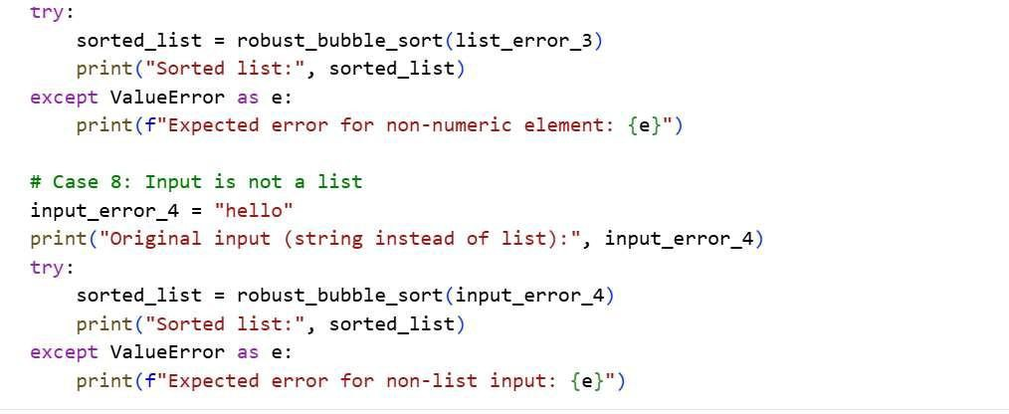

# OUTPUT:
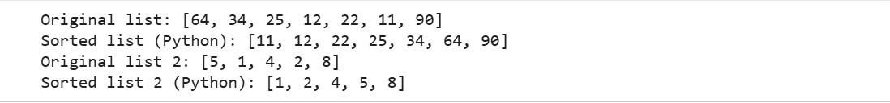

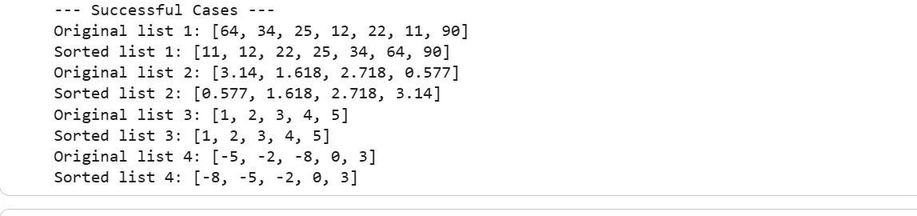
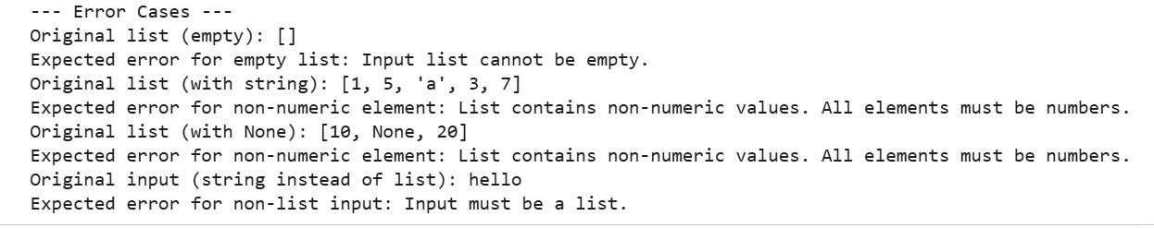

#TASK DESCRIPTION-2:
File Handling Translation

A company’s legacy codebases stores and processes files in C++, but the analytics team needs an equivalent program in JavaScript (Node.js) for
integration with a web dashboard.
- Task 1: Translate a given C++ file read-and-write program into JavaScript using AI assistance. Ensure the script reads a text file and writes processed output to a new file.
- Task 2: Add error handling in the JavaScript version to gracefully handle missing files or permission errors.

#PROMPT:
Write a JavaScript (Node.js) program that translates a given C++ file read-and-write program. The script should read a text file, process its
content, and write the output to a new file. Then, modify the JavaScript version to include error handling that gracefully handles missing files or permission errors. Keep the code clean, simple, well-commented, and
easy to understand, and include sample inputs and outputs to demonstrate both normal execution and error cases.
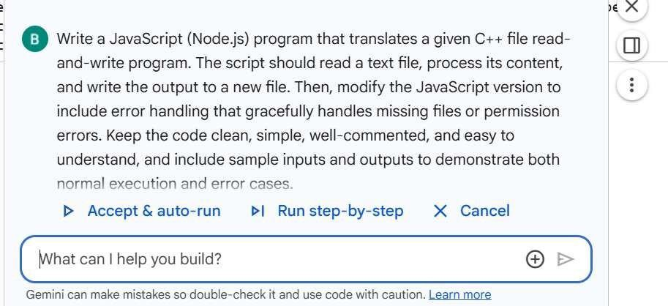

#CODE:

%%writefile file_io.cpp
#include <fstream> // Required for file stream operations (ifstream, ofstream) #include <iostream> // Required for standard input/output operations (cout, cerr) #include <string>// Required for using std::string

int main(){
// 3. Declare std::string variables for input and output filenames std::string inputFilename = "input.txt";
std::string outputFilename = "output.txt";

// 4. Create an std::ifstream object for the input file and open it std::ifstream inputFile(inputFilename);

// 5. Check if the input file was successfully opened if (!inputFile.is_open()) {
std::cerr << "Error: Could not open input file '" << inputFilename << "'.\n"; return l; // Exit with an error code
}

// 6. Create an std::ofstream object for the output file and open it std::ofstream outputFile(outputFilename);

II 7. Check if the output file was successfully opened if (loutputFile.is_open()) {
std::cerr << "Error: Could not open output file '" << outputFilename << "'.\n";

inputFile.close(); II Close the input file if it was opened return 1; II Exit with an error code
}

II 8. Read content line by line from input file and write to output file std::string line;
while (std:: getline( inputFile, line)) {
outputFile <<line<< '\n'; II Write the line and a newline character
}

II 9. Close both the input and output files inputFile.close{);
outputFile.close();

II 10. Print a success message
std::cout << "Content successfully copied from '" << inputFilename
« '" to "' « output Filename « "". \n";

return 0; II Indicate successful execution
}

Writing file_io.cpp

%%writ,efile input.txt Hello from input.txt! This is the second line.
And a third line for good measure.

Writing input.txt

import subprocess

compile_command = "g++ file_io.cpp -o file_io" try:
subprocess.run(compile_command, shell=True, check=True, capture_output=True) print( "C++ program compiled successfully.")
except subprocess.CalledProcessError as e: print(f"Error compiling C++ program: {e}") print(f"Stdout: {e.stdout.decode()}")
print(f"Stderr: {e.stderr.decode()}") C++ program compiled successfully.

import subprocess

execute_command = "./file_io" try:
subprocess.run(execute_command, shell=True, check=True, capture_output=True)
print("C++ program executed successfully.") except subprocess.CalledProcessError as e:
print(f"Error executing C++ program: {e}") print(f"Stdout: {e.stdout.decode()}")
print(f"Stderr: {e.stderr.decode()}") C++ program executed successfully.
import os

output_filename = "output.txt"

if os.path.exists(output_filename):
with open(output_filename, 'r') as f: content= f.read()
print(f"Content of '{output_filename}':\n{content}") else:
print(f"Error: '{output_filename}' was not created.")

Content of 'output.txt': Hello from input.txt!
This is the second line.
And a third line for good measure.

%%writefile file_io.js
-
canst fs = require('fs'); II Import the built-in Node.js 'fs'(file system) module

canst inputFilename = 'input.txt'; canst outputFilename = 'output.txt';

try {
II Read the content from the input file synchronously
II 'utf8' encoding is specified to read the content as text
canst fileContent = fs.readFileSync(inputFilename, 'utf8');

II Write the content to the output file synchronously
II If output.txt doesn't exist, it will be created.
II If it exists, its content will be overwritten. fs.writeFileSync(outputFilename, fileContent, 'utfB');

console.log('Content successfully copied from '${inputFilename}' to '${outputFilename}''. );
} catch (error) {
II Basic error handling: if any operation fails, catch the error and log it.
II Similar to c++'s 'if (!file.is_open())' checks. console.error('Error during file operation: ${error.message}"); process.exit(l); II Exit with an error code
} MM-i::ii:ih

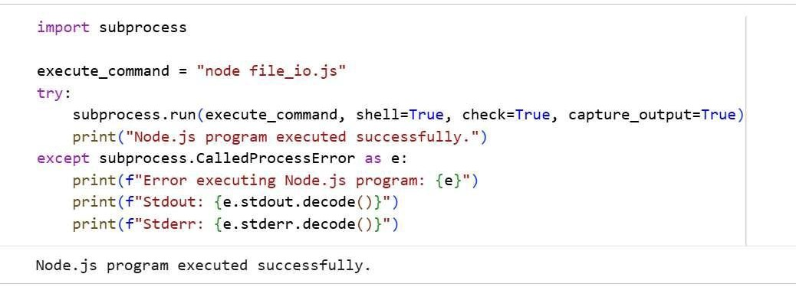

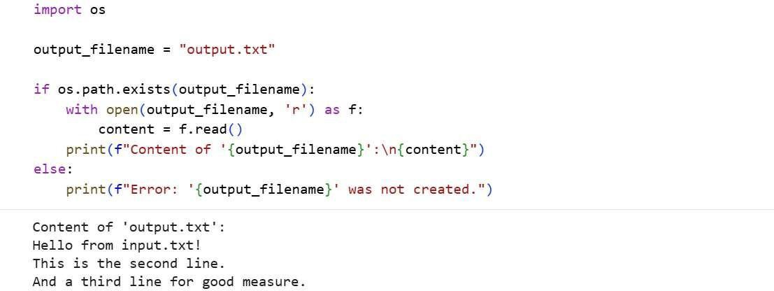

#OUTPUT:
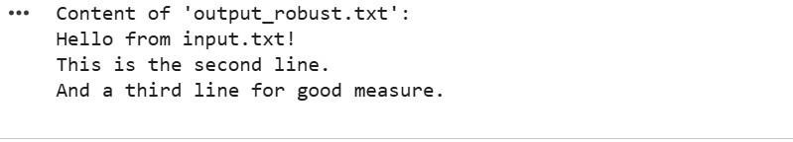

#TASK DESCRIPTION-3:
API Call Translation

Your team developed a prototype in Python to fetch weather data from an API, but the production environment only supports Java.
- Task 1: Translate the Python script (that makes an API call and prints the response) into Java using AI-assisted coding. Ensure
equivalent functionality.
- Task 2: Add proper error handling in the Java version for cases such as invalid API key, request timeout, or no internet connection.

#PROMPT:
Write a Java program that translates a given Python script which fetches weather data from an API and prints the response. Ensure the Java
version has equivalent functionality. Then, enhance the Java program to include proper error handling for cases such as an invalid API key, request timeout, or no internet connection. Keep the code clean, simple, well-commented, and easy to understand, and include sample outputs demonstrating both successful API calls and error scenarios.

#CODE:

import requests# For making HTTP requests

import json import os
# For parsing JSON responses
# For environment variables (API key)

# --- Configuration ---
# 1. Identify OpenWeatherMap as the chosen weather API.
API_KEY = os.environ.get('OPENWEATHER_API_KEY') # It's good practice to get API keys from environment variables if not API_KEY:
print("Warning: OPENWEATHER_API_KEY environment variable not set. Please set it to your OpenWeatherMap API key.")
# For demonstration, a placeholder API key can be used, but this is not secure for production.
# For local testing, you might hardcode it here temporarily: API_KEY = "YOUR_OPENWEATHERMAP_API_KEY"

# 2. Define the base URL for the OpenWeatherMap current weather endpoint. SASE_URL = "http://api.openweathermap.org/data/2.5/weather"

def get_weather_data(city_name, api_key, units="metric"):
Fetches current weather data for a given city from OpenWeatherMap API. Args:
city_name (str): The name of the city. api_key (str): Your OpenWeatherMap API key.
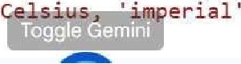
units (str): Units of measurement ('metric' for for Fahrenheit).

# 3. List the necessary query parameters params = {
'q': city_name, 'appid': api_key, 'units': units

try, I
# 5. Describe the high-level logic: making an HTTP GET request to the AP response= requests.get(BASE_URL, params=params)
response.raise_for_status() # Raise an exception for HTTP errors (4xx or Sxx)

# parsing the JSON response data= response.json()

# 4. Specify the key weather data points to be extracted weather_info = {
'city': data.get('name'),
'temperature': data.get('main', {}).get('temp'),
'humidity': data.get('main', {}).get('humidity'),
'description': data.get('weather', [{}])[0].get('description') if data.get('weather') else None
}
return weather_info

except requests.exceptions.HTTPError as http_err: MG::ii:ih

except requests.exceptions.HTTPError as http_err:
print(f"HTTP error occurred: {http_err} (Status Code: {response.status_code})") except requests.exceptions.ConnectionError as conn_err:
print(f"Connection error occurred: {conn_err}") except requests.exceptions.Timeout as timeout_err:
print(f"Timeout error occurred: {timeout_err}") except requests.exceptions.RequestException as req_err:
print(f"An unexpected request error occurred: {req_err}") except json.JSONDecodeError as json_err:
print(f"Error decoding JSON response: {json_err}") except Exception as e:
print(f"An unknown error occurred: {e}") return None
# --- Sample Usage
# Example city. Replace with your desired city. CITY "London"

if API_KEY and API_KEY != "YOUR_OPENWEATHERMAP_API_KEY": # Check if API_KEY is set print(f"Fetching weather for {CITY}...")
weather_data = get_weather_data(CITY, API_KEY)

if weather_data:
print("\n--- Current Weather ---") print(f"City: {weather_data['city']}")
print(f"Temperature: {weather_data['temperature']} °C") print(f"Humidity: {weather_data['humidity']}%") print(f"Description: {weather_data['description'].capitalize()}")
else:
print(f"Could not retrieve weather data for {CITY}.")
else:
print("Skipping weather data fetch: OPENWEATHER_API_KEY is not configured or is a placeholder.")

1 %%writefile WeatherFetcher. java import java net.URI;
import java net.http.HttpClient;
import java net.http.HttpRequest; import java net.http.HttpResponse; import java. io. IOException;

// Assuming org.json library is available in the classpath.
// For exampleJ if using Maven, add:
// <dependency>
I I <groupid>org. json</groupid>
// <arti factid>j son</arti factid>
// <version>20231013</version>
I I </dependency>
import org.json.JSONObject; public class WeatherFetcher {
// 4. Declare constants for the OpenWeatherMap API base URL and define a placeholder for the API key. private static final String API_BASE_URL = "http://api.openweathermap .org/data/2. 5/weather";
// Placeholder for API key. In a real application., retrieve from environment variables or a config file.
// For local testing, you might temporarily hardcode it here: private static final String API_KEY = "YOUR_OPENWEATHERMAP_API_KEY";

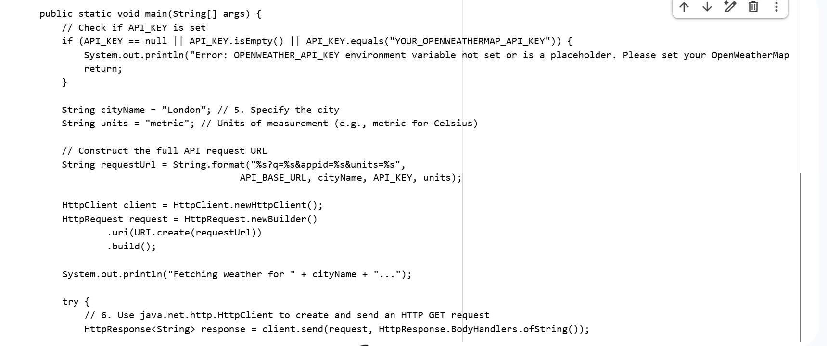

#OUTPUT:
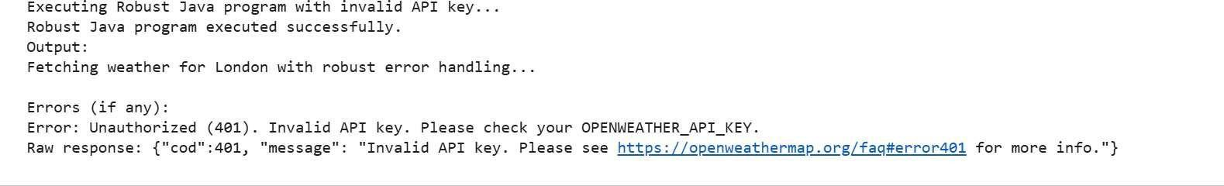

-------- Thank You-------

