Problem statement A: Meeting Action Items Tracker (mini workspace)
Build a web app where I can:
- paste a meeting transcript (text is enough)
- get a list of action items (task + owner if possible + due date if found)
- edit, add, and delete action items
- mark items as done
- See a simple history of the last 5 transcripts I processed
Make it your own: for example, add filters (open/done), tags, or a better editor.

What to include
- A simple home page with clear steps
- A status page that shows health of backend, database, and llm connection.
- Basic handling for empty/wrong input
- A short README: how to run, what is done, what is not done
- A short AI_NOTES.md: what you used AI for, and what you checked yourself. Which LLM and provider does your app use and why.
- Put your name and resume in ABOUTME.md
- A PROMPTS_USED.md, with records of your prompts used for app developemnt. Don’t include agent responses, api keys, etc.
Hosting requirement
- Hosting is important for this role.
- Keep the app live after you submit.
- If you truly cannot host, you may submit without hosting only if:
- the repo runs with one command using Docker, and
- you explain why hosting was not possible
- This will be scored lower than a hosted submission.
- If your link is down during review, you get one chance to fix it.
Rules for Github repo
- Do not put API keys or passwords in the code.
- Use an .env.example file for settings.
How we review
we will open the live link and try a few actions. Then we will read your GitHub repo. We look for:
- it works and is easy to use
- clean code
- basic checks and testing
- sensible use of AI (not blind copy-paste)

Frontend
- Nextjs, React
- React flow / @xyflow/react
- framer-motion
- clsx
- Lucide React
- tailwind-merge
Backend
- Nextjs App router

Database
- Postgresql – Neon Tech
- Prisma
- Graphql
- Apollo Graphql
Testing
- Jest and React Testing Library
- Playwright
- @welldone-software/why-did-you-render
LLM API Provider
- Grok console
- Models
  - Gemma / Llama
Stock and Assets
- React Fluid Icons
- Lottie files
- Freepik
- Canva
Deployement
- AWS [App runner]

System Components
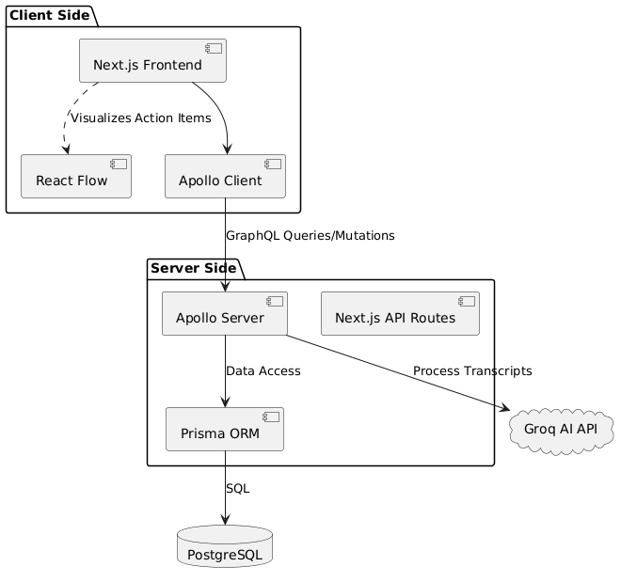

System Architecture
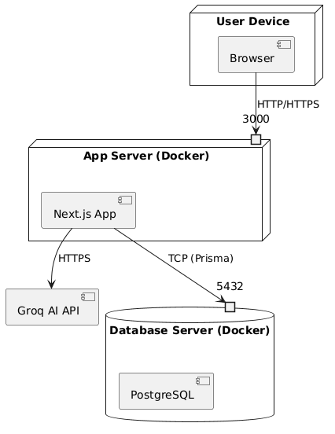

Data Flow
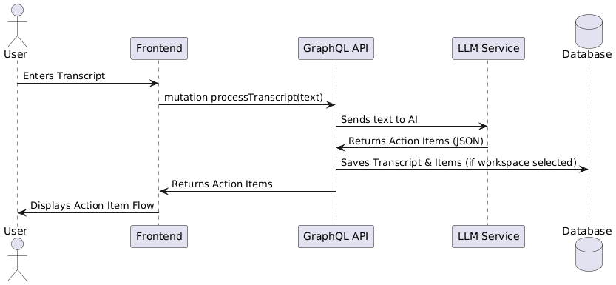

User Flow
