 **Report & Insights**

Task: Identify the five oldest users on Instagram from the provided database.

**SQL Query:**

select * from users

order by created_at asc

limit 5;

**Result:**

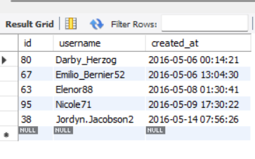

Task: Task: Identify users who have never posted a single photo on Instagram.

**SQL Query:**

SELECT * FROM users as u

LEFT JOIN photos as p

ON u.id = p.user_id

WHERE p.user_id is null;

**Result:**

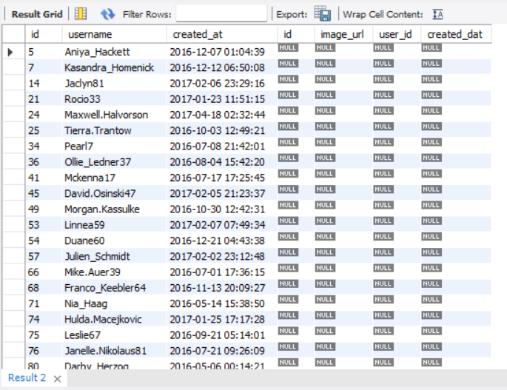

Task: Determine the winner of the contest and provide their details to the team

**SQL Query:**

select username, count('id') as most_likes from users

right join likes

on users.id=likes.user_id

group by users.username

order by most_likes desc

limit 1;

**Result:**

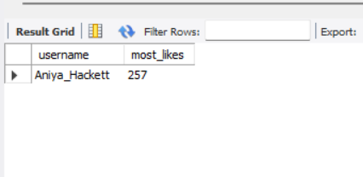

Task: Identify and suggest the top five most commonly used hashtags on the platform.

**SQL Query:**

select tag_name, count('id') as most_popular from photo_tags

right join tags

on tags.id = photo_tags.tag_id

group by tags.tag_name

order by most_popular desc

limit 5;

**Result:**

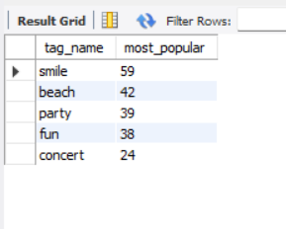

Task: Determine the day of the week when most users register on Instagram. Provide insights on when to schedule an ad campaign.

**SQL Query:**

select date_format(created_at,'%W') as 'Days',count(*) as Registrations from users

group by Days

order by Registrations desc;

**Result:**

