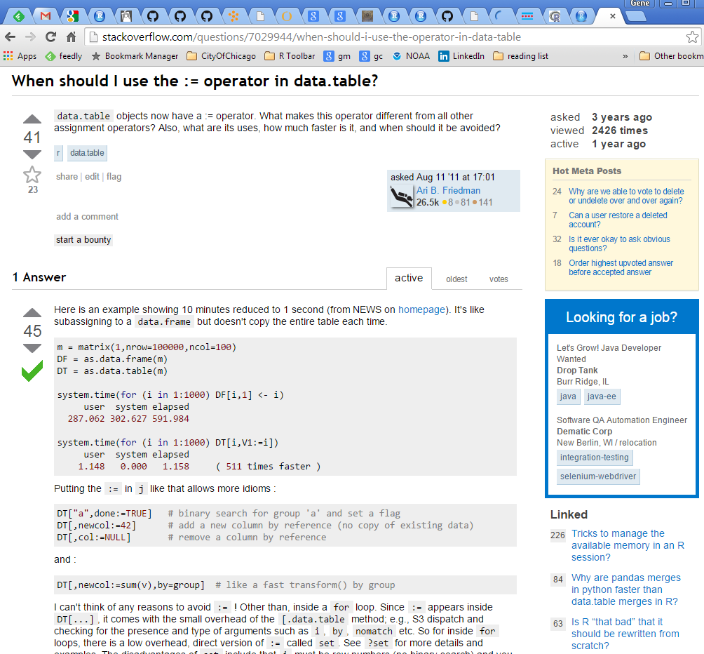

Comments…

Words, pictures, and code for a fully reproducible answer, with language specific formatting

Is your question answered somewhere else?

Is this a “good” question worth reading?

Who answered it? Was the answer edited?

Who wrote it? Are they a beginner?

Is this question relevant now