Comprehensive Exam Template
This template demonstrates all supported question types, including images in questions and options.

1. What is the functional unit of life?
A) Atom
B) Cell (Correct)
C) Molecule
D) Organ

2. Identify the shape shown in the diagram below:
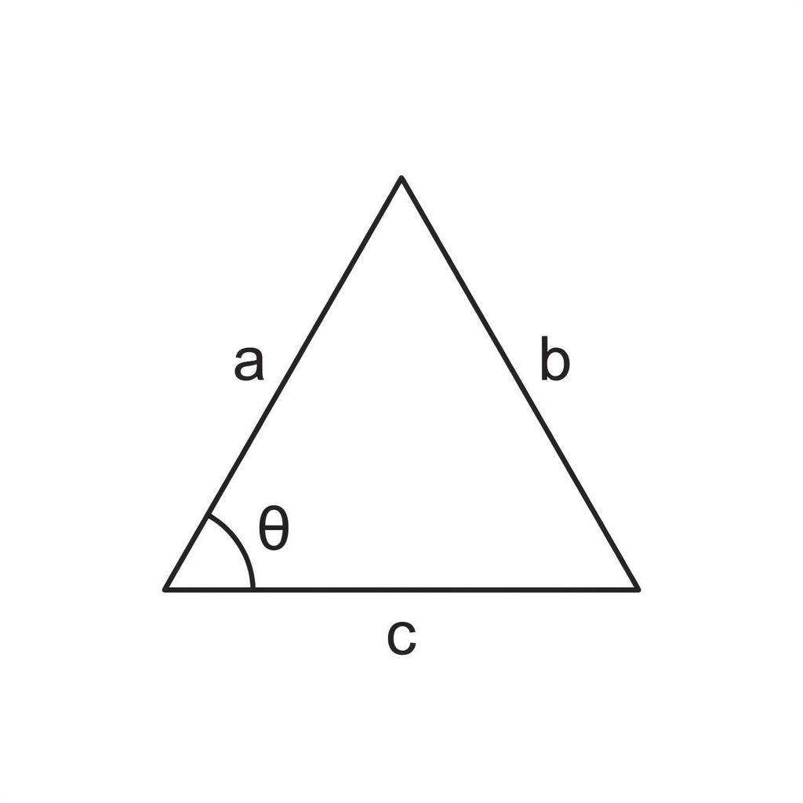
A) Square
B) Circle
C) Triangle (Correct)
D) Rectangle

3. Which of the following symbols represents a "Correct" action?
A) Symbol Alpha:

(Correct)
B) Symbol Beta:

C) Symbol Gamma: Empty Circle
D) Symbol Delta: Square Box

Q: Which mountain is the highest in the world?
A) K2
B) Mount Everest (Correct)
C) Kangchenjunga
D) Lhotse

