**Lab Activity 4**

# 2024-HD02-COS80021

# Web Application Development

Submitted by:

Raju Dahal

104055570@student.swin.edu.au

Submitted to:

Dr. Mohammad Ahmadi

Lecturer

Web Application Development

Exercises

Inventory

* Create a MySQL database table named ‘inventory’ in MySQL Monitor, a command-line program. The structure of inventory table is the shown in the lecture slides for Week 4(slide #24).

*create database if not exists inventory;*

*use inventory;*

*CREATE TABLE inventory ( item_number int NOT NULL AUTO_INCREMENT, make char(20) NOT NULL, model varchar(30) NOT NULL, price double NOT NULL, quantity int NOT NULL, PRIMARY KEY (item_number));*

* Insert at least 5 records into the table

*INSERT INTO inventory(make, model, price, quantity) VALUES ('Yamaha', 'xcy101', 28000, 1);*

*INSERT INTO inventory(make, model, price, quantity) VALUES ('Mazda', 'abc123', 5000, 13);*

*INSERT INTO inventory(make, model, price, quantity) VALUES ('Honda', 'ssd123', 7958, 6);*

*INSERT INTO inventory(make, model, price, quantity) VALUES ('Audi', 'pre115', 39000, 3);*

*INSERT INTO inventory(make, model, price, quantity) VALUES ('Tesla', 'xy12ab', 37000, 18);*

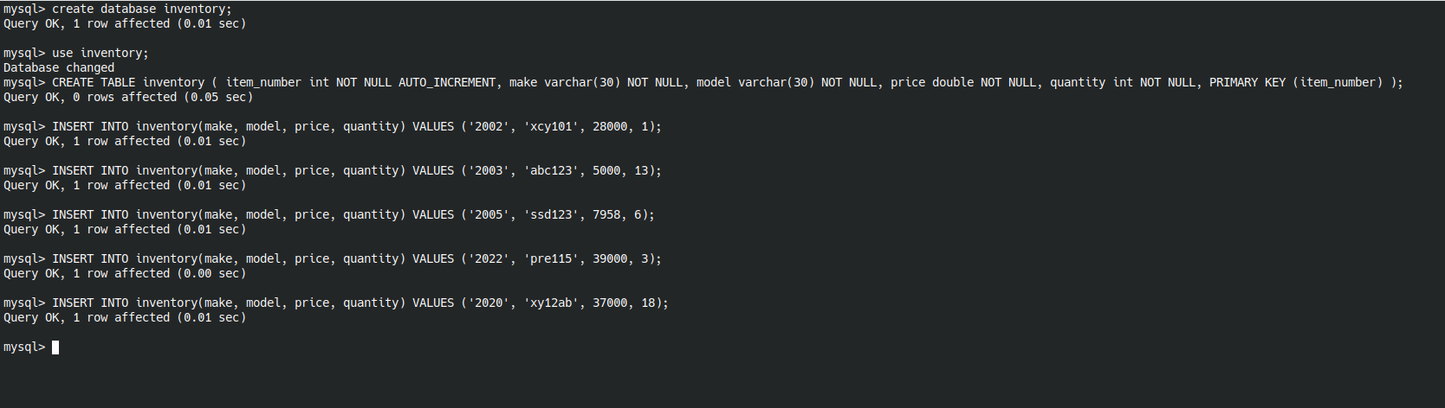

* Write a query that return all records of the table

*select * from inventory;*

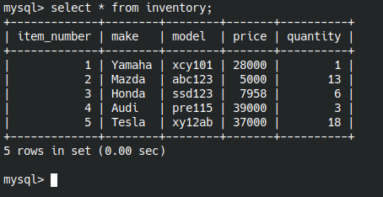

* Update an existing table row using ‘update’ statement

*UPDATE inventory SET price = 5055 WHERE item_number = 2;*

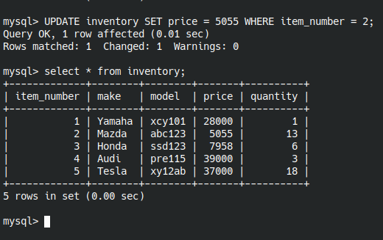

# Employees

* Create a MySQL database table named ‘Employees’ in phpMyAdmin. The structure of Employees table is the shown in the lecture slides for Week 4 (slide #3). Then, similar to a), use this web interface to insert some data into this tableand write SQL codes to query/update the table

*create table employees(last_name varchar(15) not null, first_name varchar(15) not null, address varchar(45) not null, city varchar(30) not null, state varchar(15) not null, zip int(8) not null);*

*insert into employees (last_name, first_name, address, city, state, zip) values*

*('Bolver', 'Maire', '02117 Barby Court', 'Sydney', 'NSW', '1130'),*

*('Revening', 'Aubert', '92978 Pawling Trail', 'Albuquerque', 'NM', '87140'),*

*('Lumox', 'Trevor', '111 Morrow Hill', 'Sydney', 'NSW', '1196'),*

*('Gilberthorpe', 'Ulrika', '62166 Morrow Pass', 'Melbourne', 'VIC', '8045'),*

*('Leither', 'Harriett', '84952 Briar Crest Street', 'Albuquerque', 'NM', '87140'),*

*('Lindblad', 'Brien', '5 Upham Crossing', 'Sydney', 'NSW', '1196'),*

*('Darkins', 'Ada', '090 Grayhawk Crossing', 'Adelaide Mail Centre', 'SA', '5889'),*

*('Baldwin', 'Darleen', '06464 Rowland Point', 'Sydney', 'NSW', '1109'),*

*('Abercromby', 'Mattias', '7402 Clemons Alley', 'Albuquerque', 'NM', '87140'),*

*('Balazin', 'Jeannette', '686 Gateway Place', 'Sydney', 'NSW', '1120');*

*select * from employees;*

*update employees set city = "newcastle", zip = "123456" WHERE last_name = "Balazin";*

*select * from employees;*

*Create and Display:*

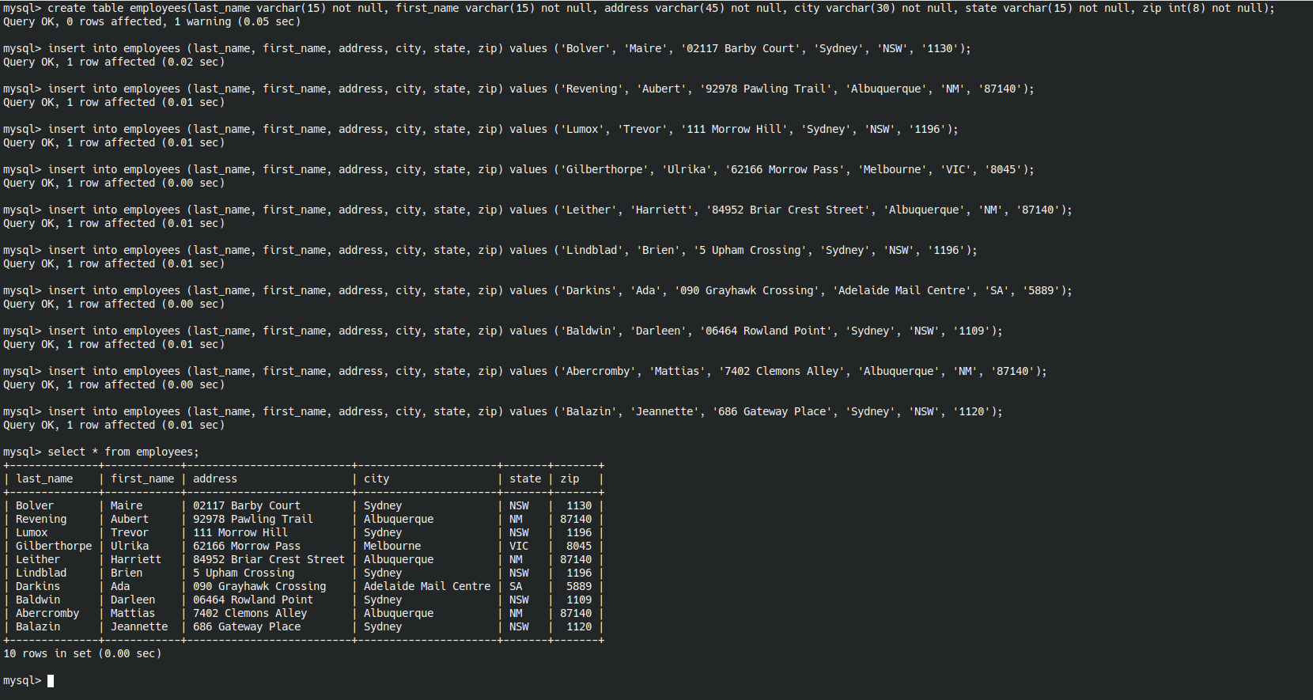Update:

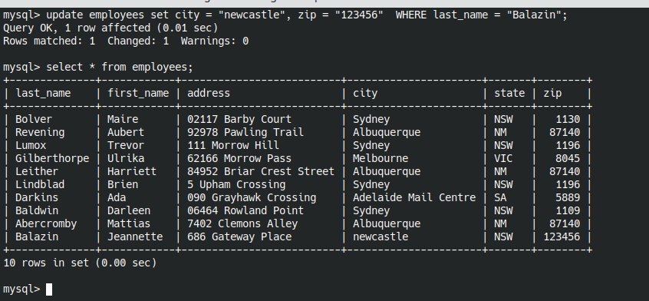

# Inventory UI

* Write a PHP page to retrieve records from the ‘inventory’ table created in a), and display them neatly in an html table.You need to provide an html select control on the page (see Figure 1). The content of this select control are names of all makes that can be found in the inventory table.User can select to show the data of a specific make or show the data of all makes(see Figure 2).

Answer: See attached file **c.php**

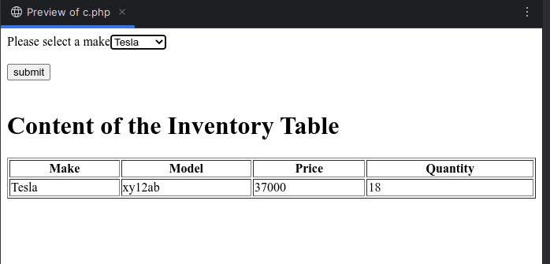

# Employees UI

* Modify the page in c) to allow user insert new data row from the web page (see Figure 3). After the user input the content of new row and press the ‘add’ button, the input data will be inserted into MySQL database. Then the page will display the updated content of the ‘inventory’ table (see Figure 4).

Answer: see attached file **d.php**

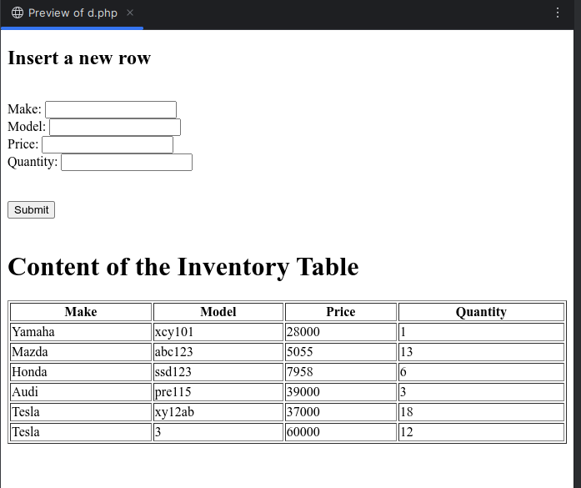

# Working with data across multiple tables

The following three tables are created with some data in a database called person_db.

Employees(employee_id, last_name, first_name, address, city, state, zip);

Experience(employee_id, language_id, years);Languages(language_id, language);

Rather than creating new table for employees, the existing employee table was used. ID column was added as a primary key and set as auto increment. The following command was used.

*ALTER TABLE employees ADD COLUMN id INT AUTO_INCREMENT PRIMARY KEY FIRST;*

Then created the required two tables:

*CREATE TABLE languages (language_id INT AUTO_INCREMENT PRIMARY KEY, language VARCHAR(30));*

*CREATE TABLE experience (employee_id INT, language_id INT, years INT, FOREIGN KEY (employee_id) REFERENCES employees(id), FOREIGN KEY (language_id) REFERENCES languages(language_id));*

**I have used https://www.mockaroo.com/ to generate 100 random data.**

insert into experience (employee_id, language_id, years) values

(7, 1, 8),(7, 4, 4),(9, 1, 10),(3, 7, 6),(4, 2, 7), (10, 9, 8),(6, 7, 8),(6, 9, 5),(10, 2, 5),(4, 9, 6),(8, 9, 7),(5, 6, 10),(1, 7, 6),(2, 2, 7),(8, 8, 8),(6, 1, 1),(7, 8, 6),(4, 4, 3),(1, 4, 10),(2, 4, 7),(1, 8, 10),(2, 8, 7),(5, 4, 6),(2, 9, 6),(7, 3, 9),(4, 10, 6),(10, 7, 6),(5, 1, 3),(6, 8, 1),(9, 10, 10),(9, 3, 4),(3, 5, 6),(7, 6, 4),(10, 4, 9),(6, 5, 5),(9, 5, 4),(5, 10, 8),(5, 3, 2),(8, 6, 8),(8, 7, 7),(8, 3, 3),(2, 6, 4),(5, 2, 3),(4, 6, 6),(3, 3, 10),(3, 4, 9),(1, 6, 7),(10, 3, 5),(1, 10, 7),(6, 6, 8),(3, 2, 5),(10, 8, 4),(6, 10, 8),(10, 5, 5),(9, 7, 8),(2, 3, 10),(10, 1, 1),(5, 8, 5),(5, 9, 4),(6, 3, 5),(8, 5, 4),(7, 7, 8),(7, 10, 7),(10, 6, 6),(9, 2, 5),(9, 6, 5),(7, 9, 8),(3, 1, 1),(1, 9, 3),(3, 6, 9),(10, 10, 8),(4, 7, 4),(1, 2, 9),(9, 4, 9),(8, 10, 7),(5, 7, 10),(8, 2, 3),(7, 2, 7),(9, 8, 6),(1, 5, 10),(9, 9, 5),(2, 7, 4),(7, 5, 8),(8, 1, 6),(3, 8, 10),(3, 9, 9),(4, 8, 10),(3, 10, 10),(6, 4, 2),(4, 3, 4),(1, 1, 5),(2, 10, 7),(2, 1, 4),(2, 5, 2),(6, 2, 7),(4, 5, 4),(5, 5, 1),(1, 3, 7),(4, 1, 9),(8, 4, 6);

1. Write the SQL query statement to retrieve those employees (with their items: first_name, last_name, language, years, city) who have 5 years’ experience in “PHP” and live in the city “Melbourne”.

*SELECT e.first_name, e.last_name, l.language, x.years, e.city FROM employees e, experience x, languages l WHERE e.id=x.employee_id and x.language_id=l.language_id and l.language = 'PHP' AND x.years >= 5 AND e.city = 'Melbourne';*

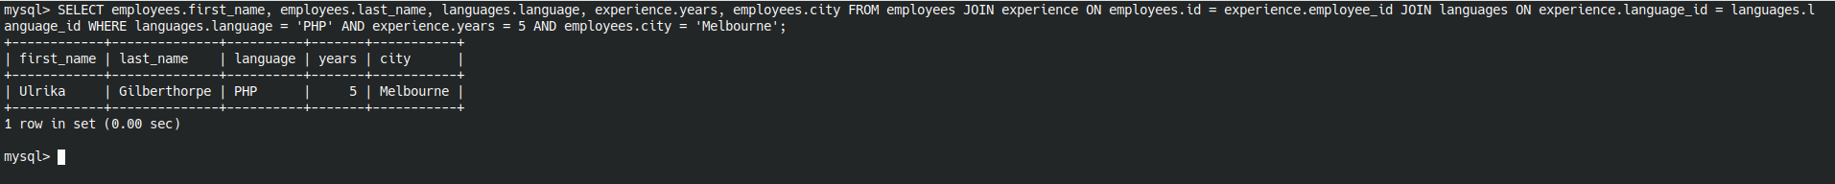

# SearchSkill

* Modify the code SearchSkill.phpintroduced in Lecture 4 (download Lec4Examples.zipfrom Blackboard) to get city, language, and years from the interface and output the search result as belowby using the similar SQL query in e):

See attached file **searchSkill.php**

# Simple Quiz

* Change the simple online quiz PHP page that you wrote for exercise (e) in Lab2and exercise (c) in Lab3. Instead of hard coding the questions on the HTML pageor store them in a file, you need to store them in one or moreMySQL database tables. You need to design the table structure to storequestions and answers properly. When the page is loaded, it will read the questions from the database and display them on the screen. So if questions/answers are changed, thisprogram can be used without modifying any of PHP codes.

See attached file **quiz.php**