Python & SQL Coding Assessment

Python Section (3 Questions)

Q1. String Cleaning & Transformation
Write a Python function that takes a sentence and performs the following:
- Removes all vowels (a, e, i, o, u)
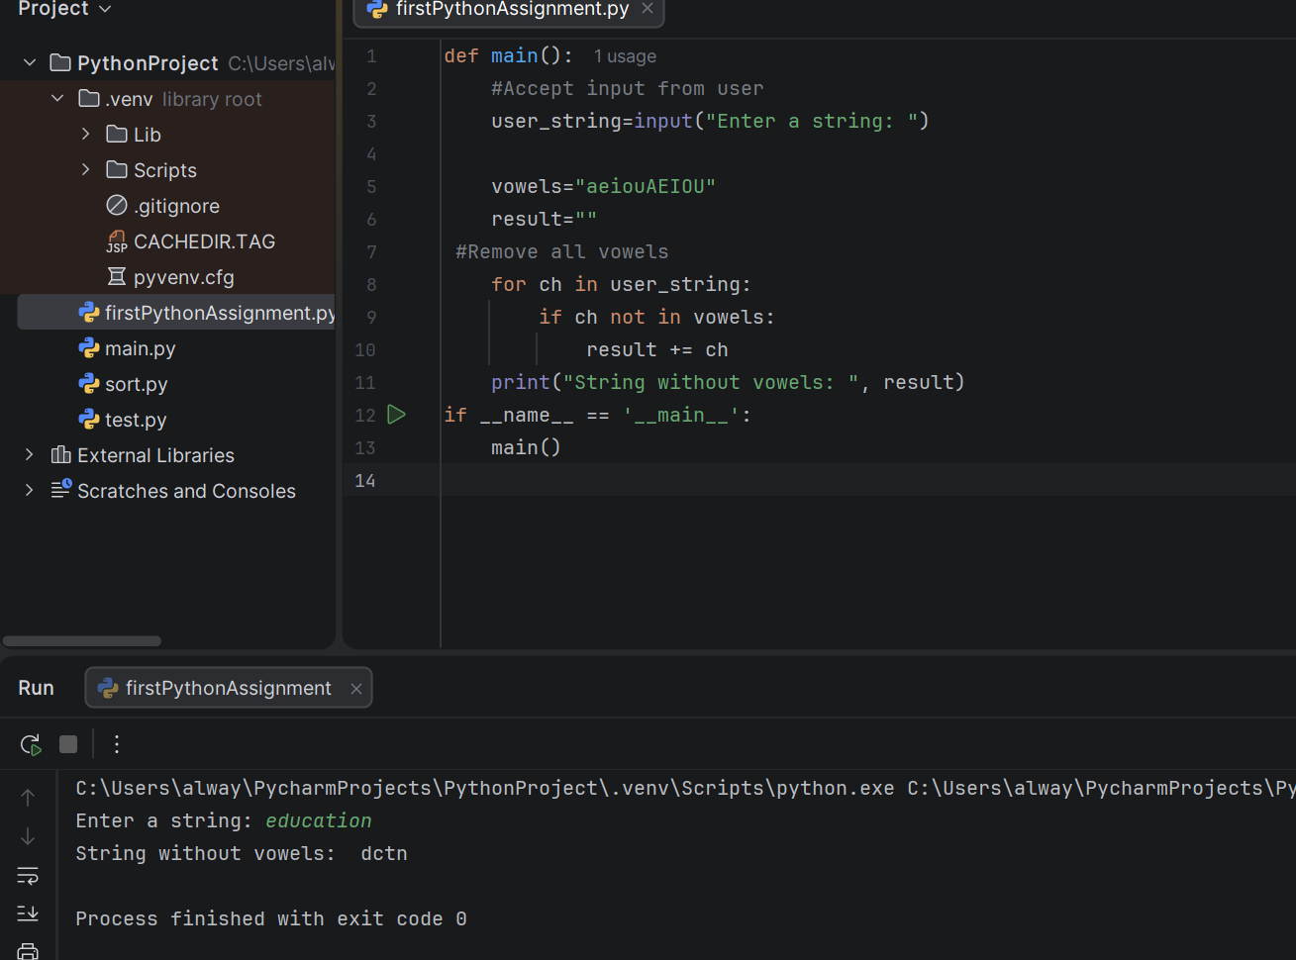

- Replaces spaces with underscores _
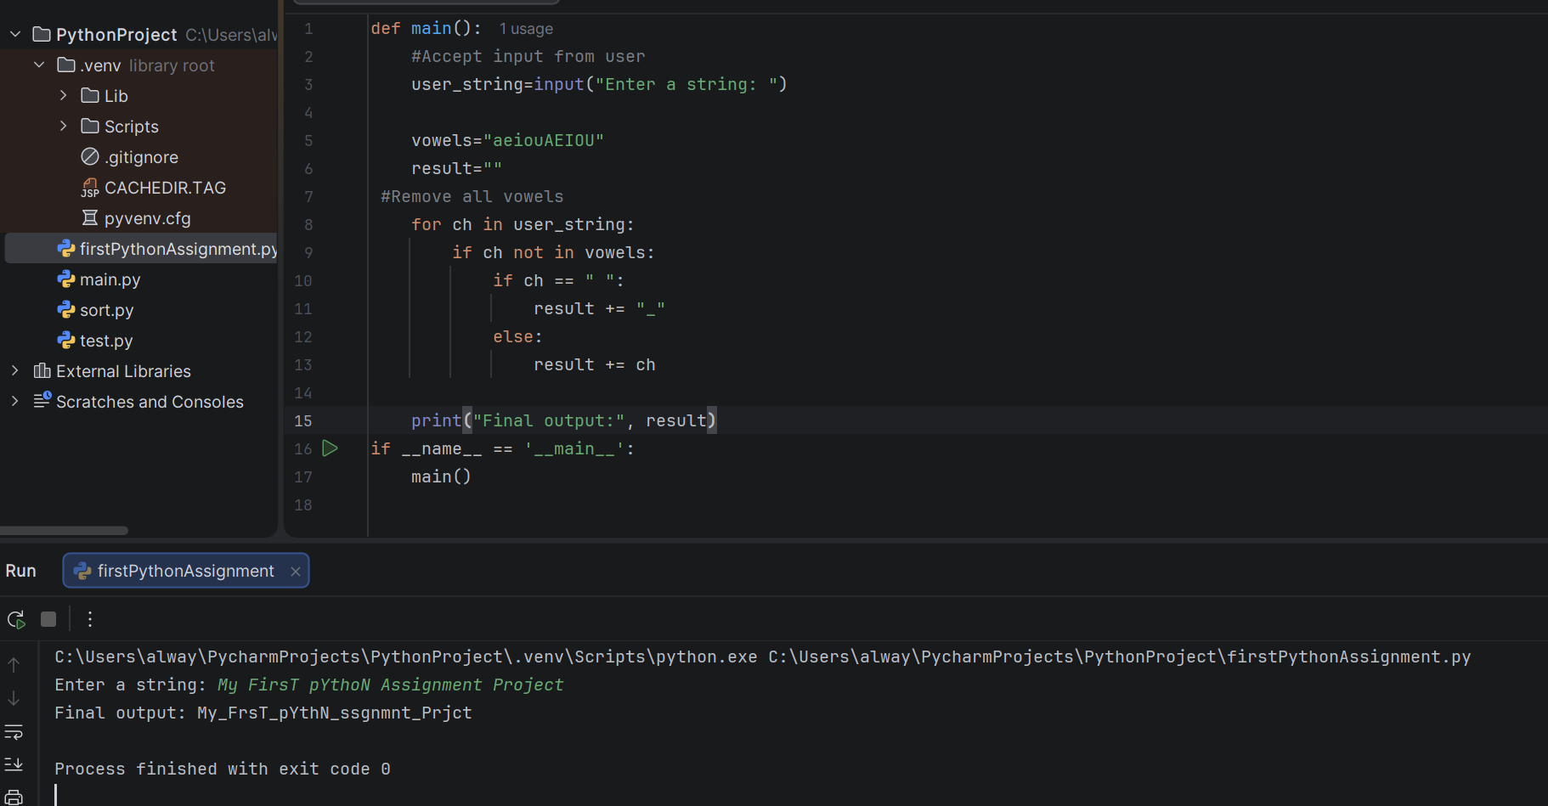

- Converts it to title case (first letter of each word capitalized)
- 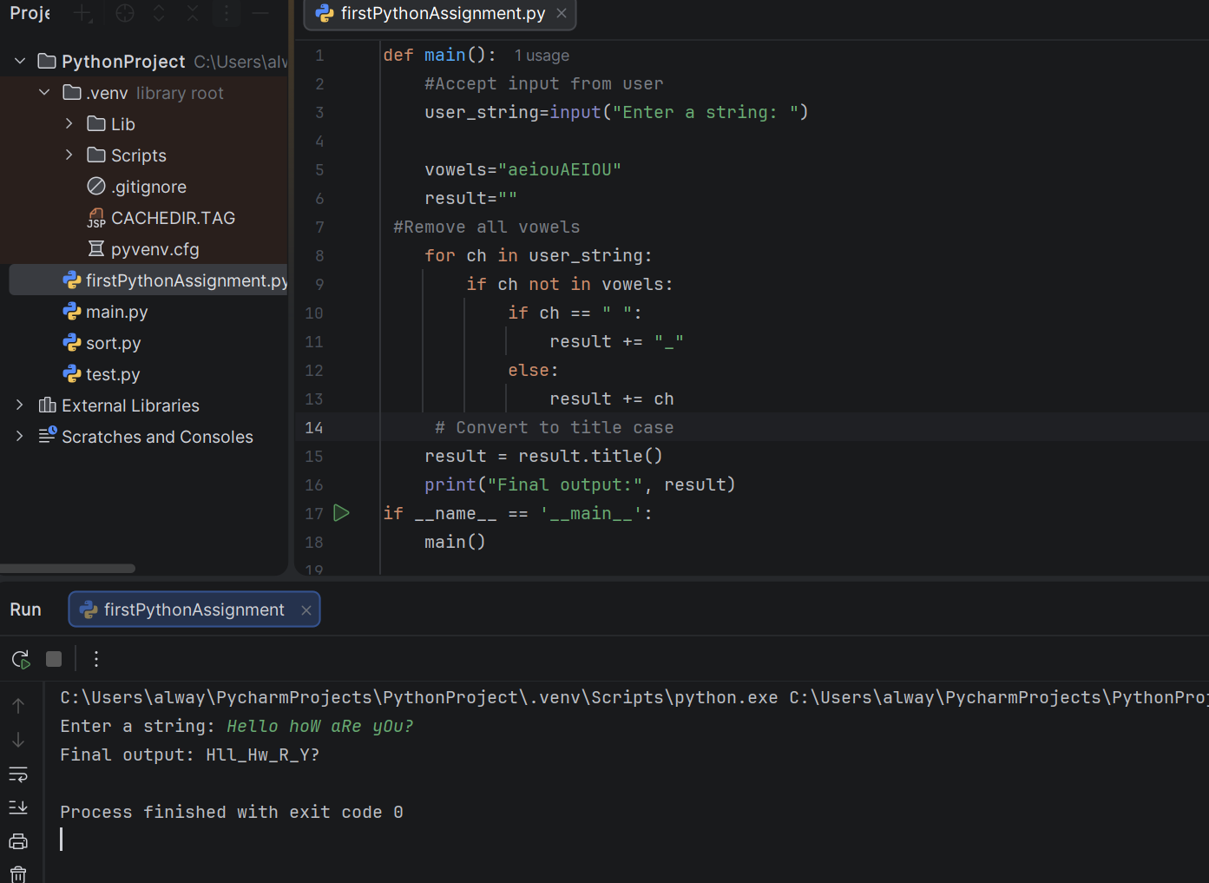

Example:
Input: "data engineering rocks"
Output: "Dt_Engnrng_Rcks"

Q2. Dictionary Aggregation
Given a list of dictionaries representing sales transactions:
sales = [
{"product": "Pen", "amount": 10},
{"product": "Book", "amount": 20},
{"product": "Pen", "amount": 15},
{"product": "Pencil", "amount": 5}
]

Write a Python program to calculate total sales per product and print the result as:
Pen: 25
Book: 20
Pencil: 5

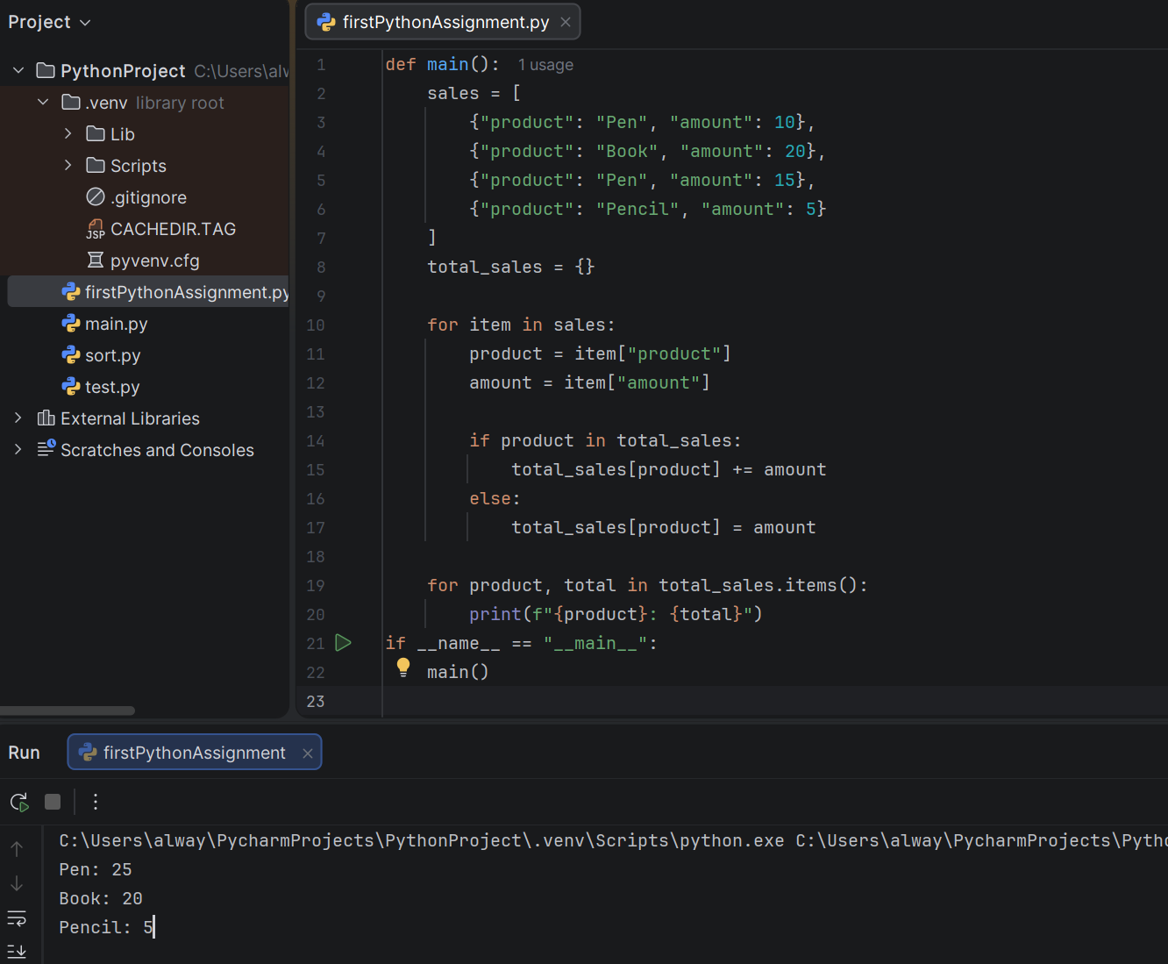

Q3. Unique Numbers in List
Write a Python function that takes a list of integers and returns a new list containing elements that appear exactly once.
Example:
Input: [4, 5, 4, 6, 7, 5, 8]
Output: [6, 7, 8]
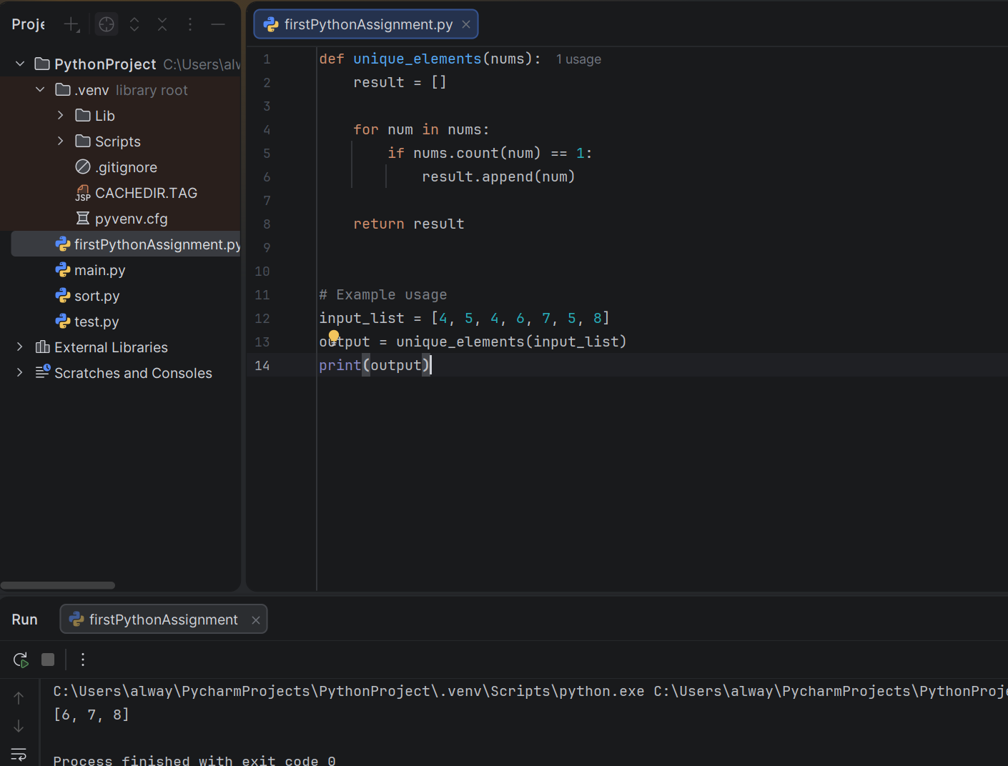

SQL Section (2 Questions)

Q4. Find the Second Highest Salary
Table: employees
id | name | salary
1 | Alice | 90000
2 | Bob | 85000
3 | Charlie | 85000
4 | David | 80000
5 | Eva | 70000
Requirement:
Write a SQL query to find the second highest distinct salary.
Expected Output:
second_highest_saly
85000
Answer:
SELECT salary as second_highest_saly
FROM (
SELECT DISTINCT salary, ROW_NUMBER() OVER (ORDER BY salary DESC) AS rn
FROM employees
) AS ranked_salaries

WHERE rn = 2;

Q5. Find Customers with No Orders
customers
customer_id | customer_name
1 | Alice
2 | Bob
3 | Charlie
orders
order_id | customer_id | amount
1 | 1 | 200
2 | 2 | 150
Write a SQL query to find customers who have not placed any orders.
Expected Output:
customer_nae
Charlie
Answers:
SELECT c.customer_name
FROM customers c
LEFT JOIN orders o
ON c.customer_id = o.customer_id
WHERE o.customer_id IS NULL;

