# [**Interfacing Flame Sensor with Arduino to Build a Fire Alarm System**](https://circuitdigest.com/microcontroller-projects/arduino-flame-sensor-interfacing)

Group Members: Kautilya Tripathi (B116022)

Vipul Chaurasia (B116063)

K.R.K.Raju (B116043)

Aim: Build Fire Alarm System by using Arduino and flame sensor.

Components Required: 1) Arduino 2) Flame sensor 3) LED 4) Buzzer

5) Resistor 6) Jumper wires

Circuit Diagram:

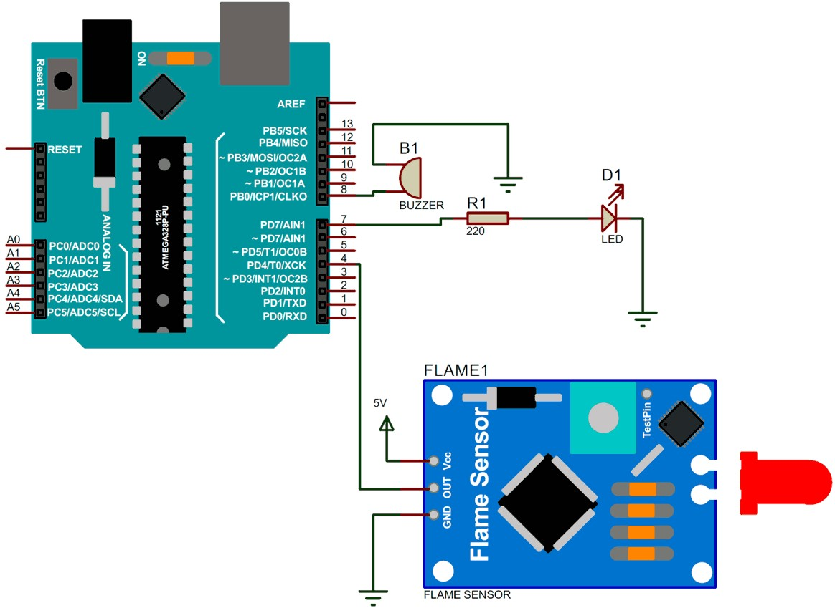

Working: Flame sensor module has photodiode to detect the light and op-amp to control the sensitivity. It is used to detect fire and provide HIGH signal upon the detection. Arduino reads the signal and provides alert by turning on buzzer and LED. Flame sensor used here is an IR based flame sensor.

The flame sensor detects the presence of fireor flame based on the Infrared (IR) wavelength emitted by the flame. It gives logic 1 as output if flame is detected, otherwise it gives logic 0 as output. Arduino Uno checks the logic level on the output pin of the sensor and performs further tasks such as activating the buzzer and LED, sending an alert message.

Flame sensor module consists of a photodiode (IR receiver), resistor, capacitor, potentiometer, and LM393 comparator in an integrated circuit.

Arduino Uno has 14 digital pins (out of which 6 pins can be used as PWM outputs), 6 analog inputs, on board voltage regulators etc. Arduino Uno has 32KB of flash memory, 2KB of SRAM and 1KB of EEPROM. It operates at the clock frequency of 16MHz. Arduino Uno supports Serial, I2C, SPI communication for communicating with other devices.

A data file is created by Arduino and is constantly updated with real-time data which is collected from the sensor. We will add a configuration which will trigger a program when fire is detected as the program will be continuously listening to the file changes. If fire is detected, we will send the data along with an alert to a webhook. The webhook send alerts in messaging app like Slack where all the employees or members of an organization will be notified about the fire.

**Applications of flame sensors**

* Hydrogen stations
* Combustion monitors for burners
* Oil and gas pipelines
* Automotive manufacturing facilities
* Nuclear facilities