

**MICROPROCESSOR AND 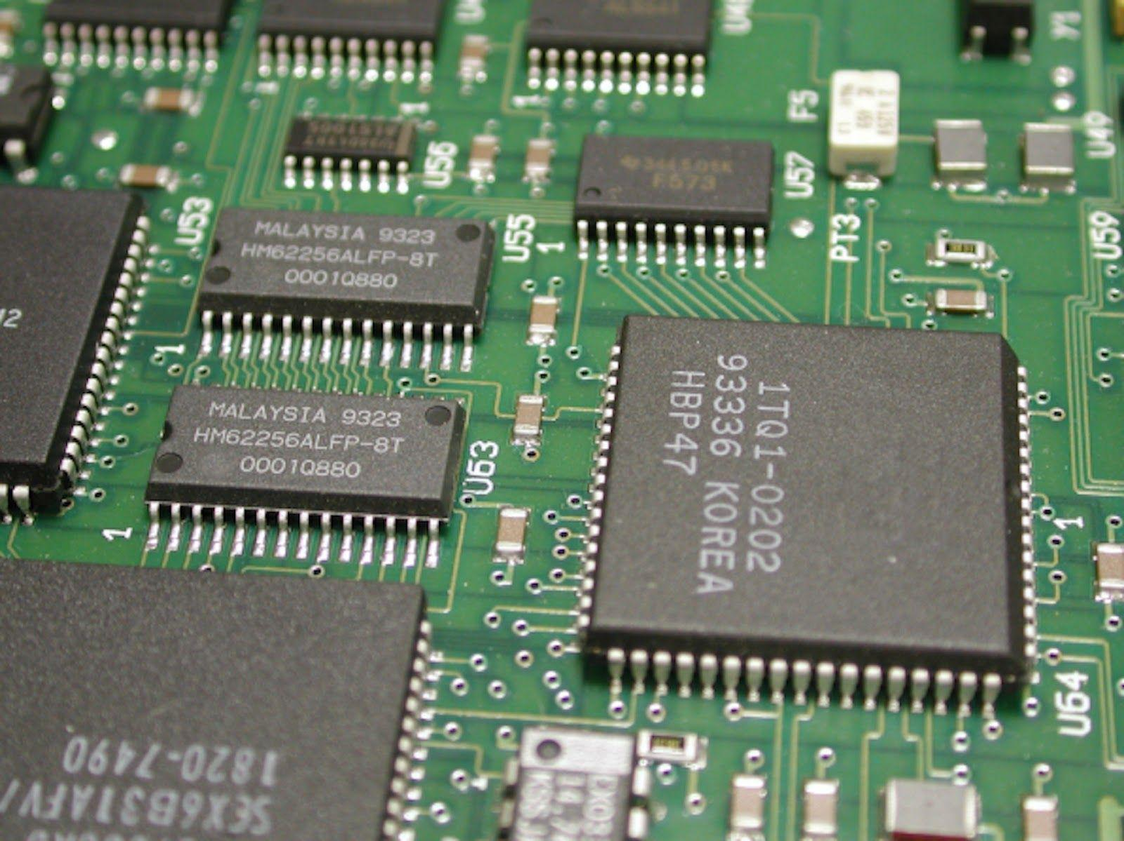MICROCONTROLLER LAB**

ACKNOWLEDGEMENT:

This project is completed with the guidance of the faculties of our college. We are grateful to our visiting faculty RAM NARAYAN PATRA for the time and patience he invested on us and his continuous help and support throughout the project work.

We will also like to express our gratitude to lab faculty SHUKLA SIR.

PROJECT WORK:

# [**Interfacing Flame Sensor with Arduino to Build a Fire Alarm System**](https://circuitdigest.com/microcontroller-projects/arduino-flame-sensor-interfacing)

Submitted By:



Kautilya Tripathi B116022

|  |  |
| --- | --- |
| K.R.K.Raju B116043 | B216039 |
| Vipul Chaurasia B116063 | B516057 |

**INDEX**

* Objective of the project
* Introduction
* Circuit diagram and components used
* Arduino Code
* Simulation Samples
* Applications
* References

**Objective-** Build Fire Alarm System by using Arduino and flame sensor.

**Introduction:-**

Flame sensor module has photodiode to detect the light and op-amp to control the sensitivity. It is used to detect fire and provide HIGH signal upon the detection. Arduino reads the signal and provides alert by turning on buzzer and LED. Flame sensor used here is an IR based flame sensor.

The flame sensor detects the presence of fireor flame based on the Infrared (IR) wavelength emitted by the flame. It gives logic 1 as output if flame is detected, otherwise it gives logic 0 as output. Arduino Uno checks the logic level on the output pin of the sensor and performs further tasks such as activating the buzzer and LED, sending an alert message.

Flame sensor module consists of a photodiode (IR receiver), resistor, capacitor, potentiometer, and LM393 comparator in an integrated circuit. Serial communication is used to send the data.

A data file is created by Arduino and is constantly updated with real-time data which is collected from the sensor. We will add a configuration which will trigger a program when fire is detected as the program will be continuously listening to the file changes. If fire is detected, we will send the data along with an alert to a webhook. The webhook send alerts in messaging app like Slack where all the employees or members of an organization will be notified about the fire.

**Components:-**

1. Arduino Uno
2. Flame Sensor
3. 5V Buzzer
4. 1KΩ Resistor
5. Connecting Wires
6. Power Supply
7. LED

**C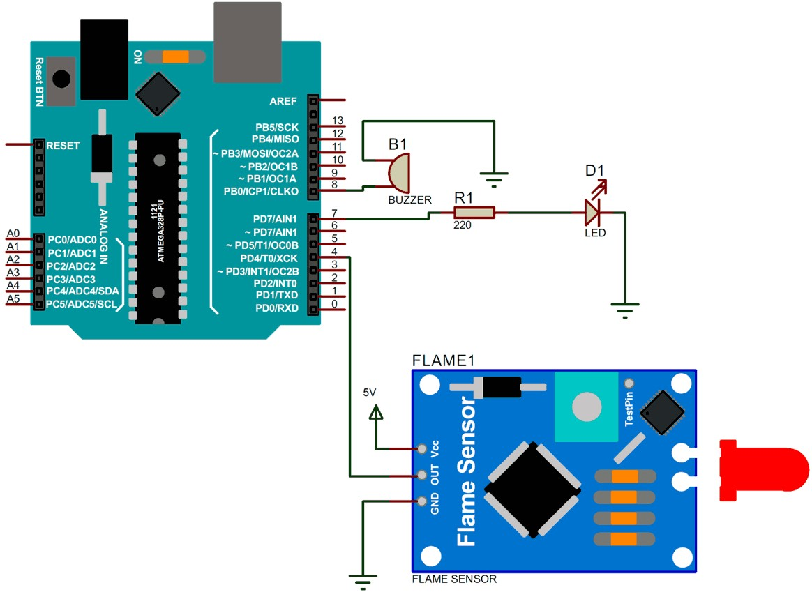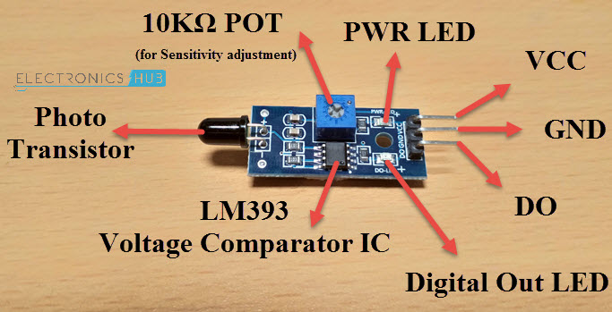ircuit diagram**

**Arduino Code:-**

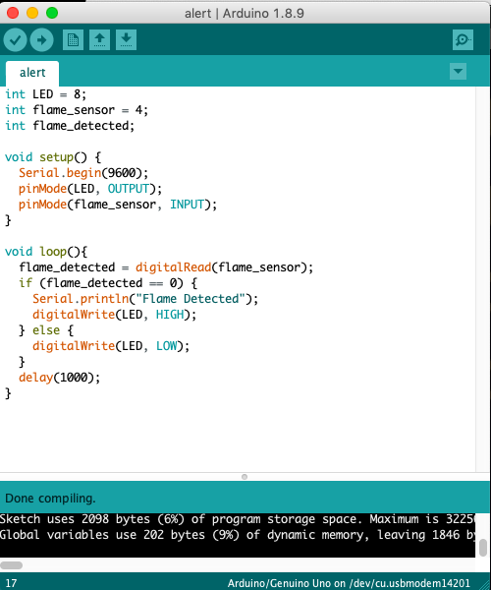

**Simulation Samples:-**

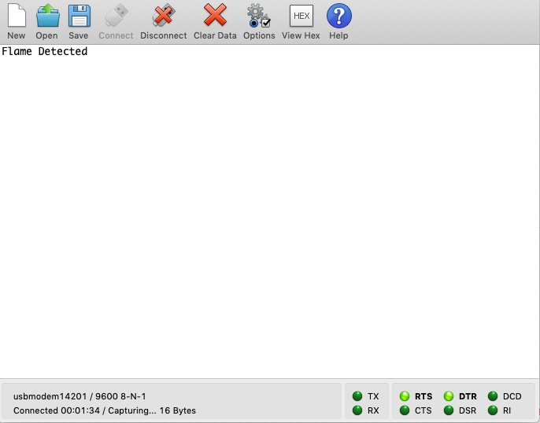



**Applications of flame sensors**

1. Hydrogen stations
2. Combustion monitors for burners
3. Oil and gas pipelines
4. Automotive manufacturing facilities
5. Nuclear facilities

**References:-**

<https://electronics.stackexchange.com/questions/54/saving-arduino-sensor-data-to-a-text-file>

<https://www.electronicshub.org/arduino-flame-sensor-interface/>