API TESTING

1.Swagger Testing
Swagger UI was used to test all backend APIs. It provides an interactive interface to execute API requests and verify responses.
  - Product API Testing
- POST METHOD

POST : api/products Creates a new Product in the Database

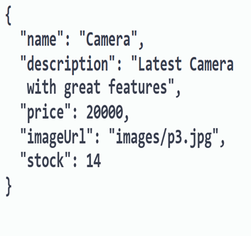

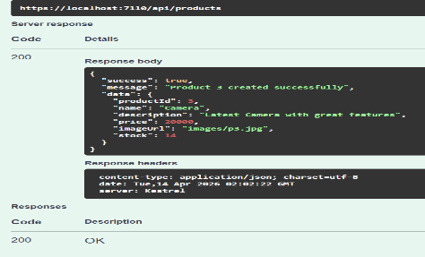

- GET METHOD

GET : api/products Retrieves all Products

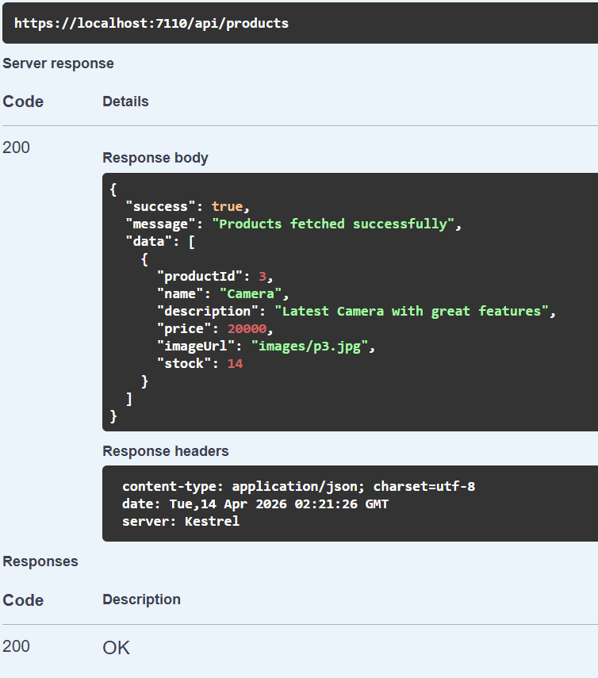

- GET BY ID

GET : api/products/3 Fetches Product using Id

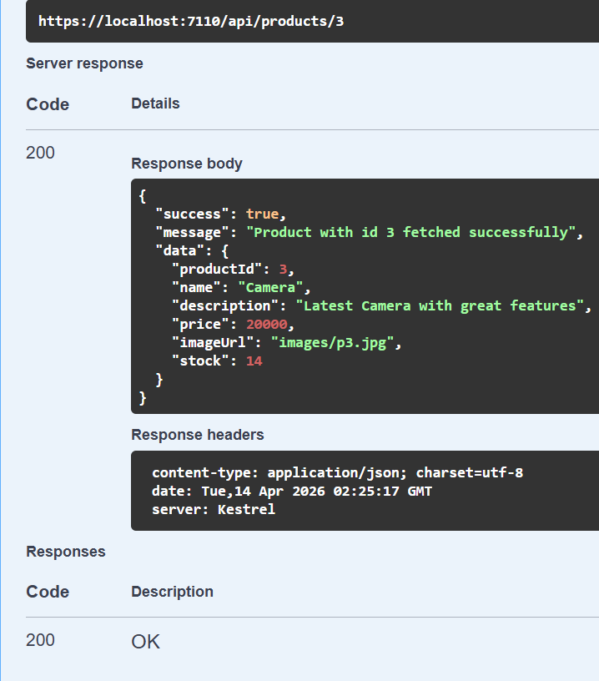

- PUT METHOD

PUT : api/products/3 Updates Product Details

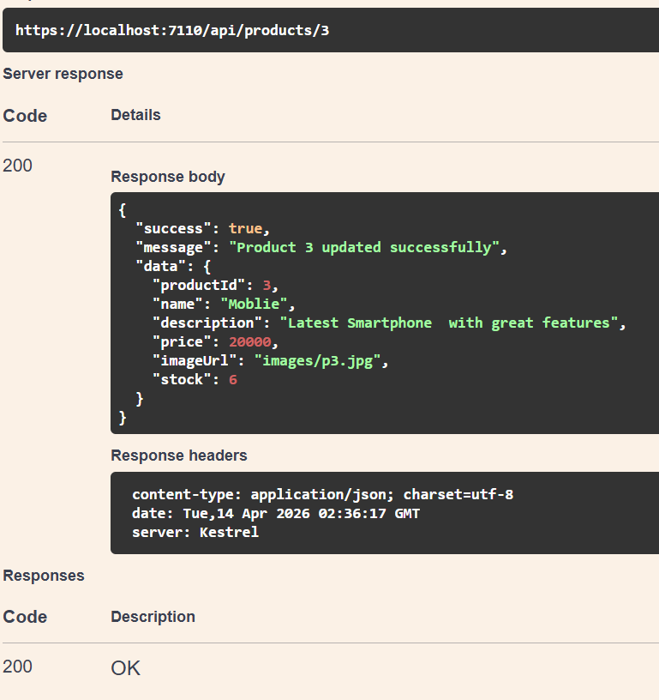

- DELETE METHOD

DELETE : api/products/3 Delete Product by id

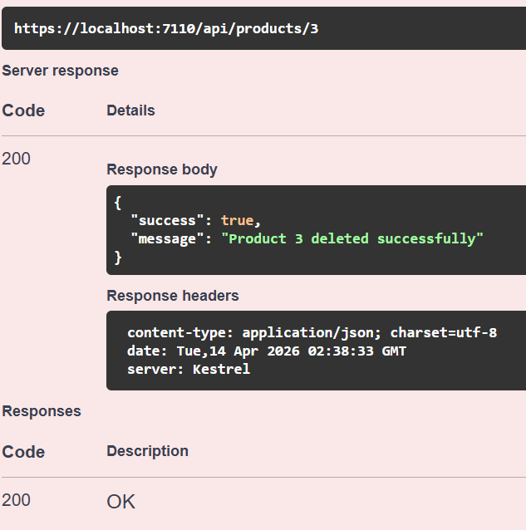

1.2 Order API Testing
- POST METHOD

POST : api/orders Creates order from cart items and calculates total

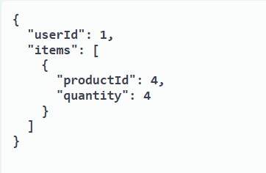

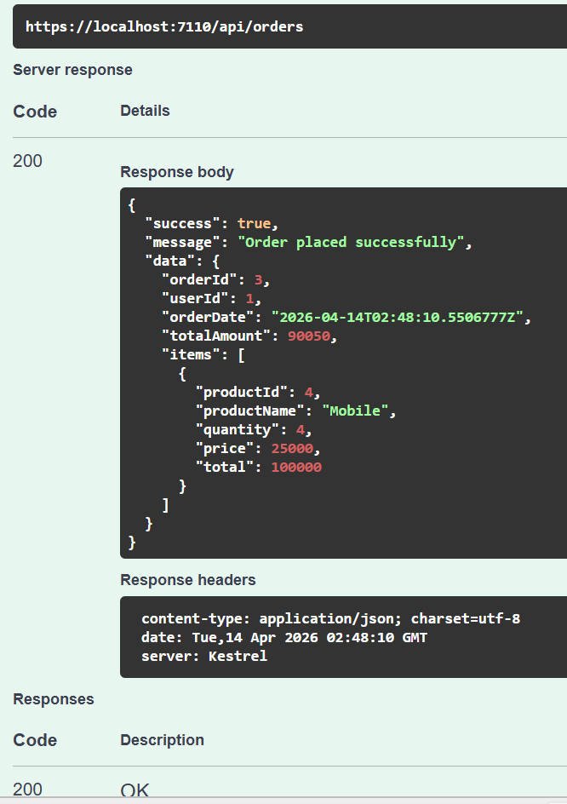

- GET METHOD

GET : api/orders Retrieves all orders

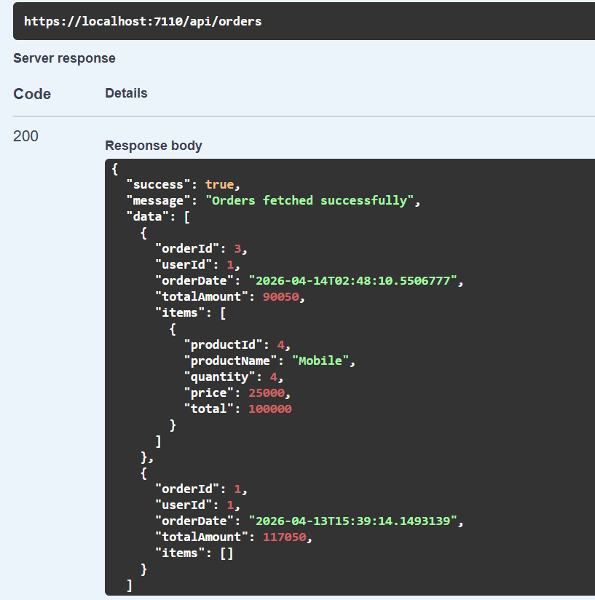

- GET ORDER BY ID

GET : api/orders/1 Fetches specific order by id

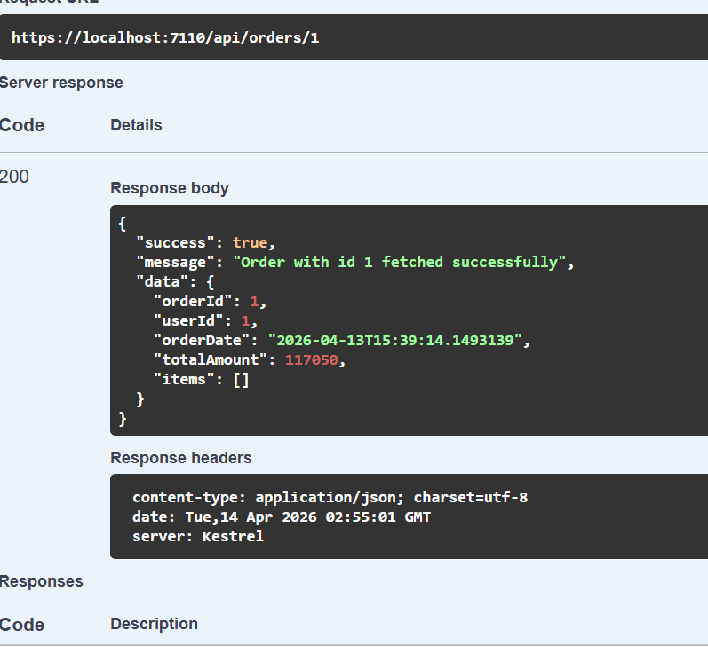

1.3 Users API Testing
- GET METHOD

GET : api/users Retrieves all Users

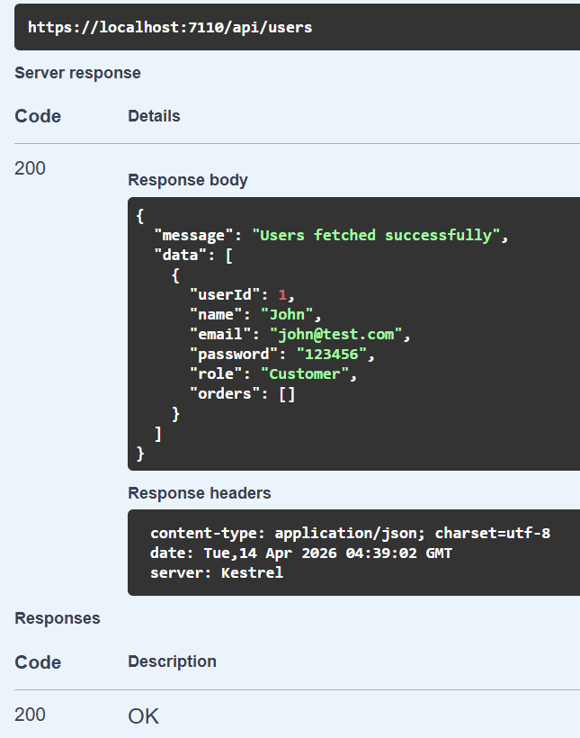

- POST METHOD

POST : api/users Create Users.

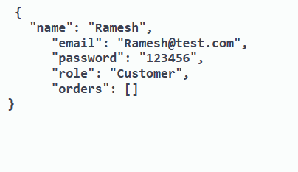

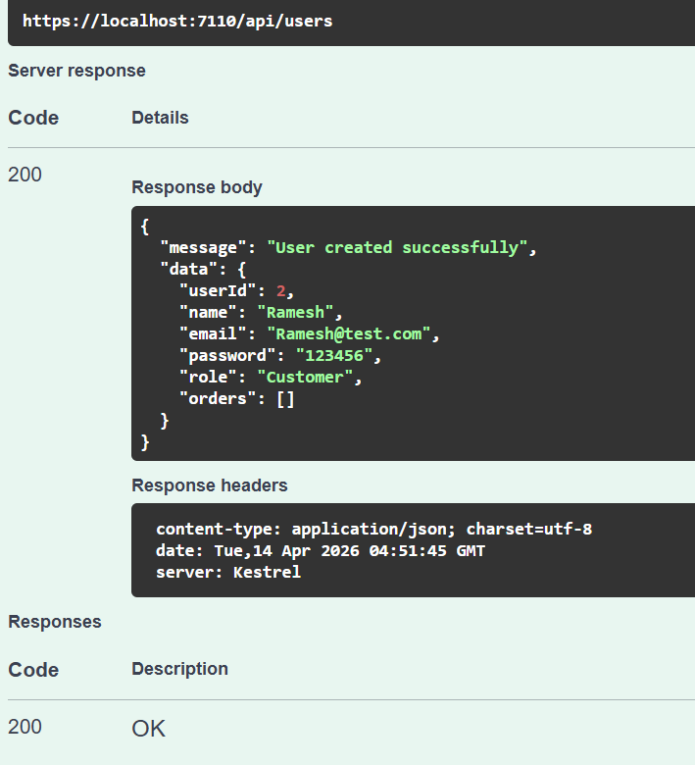
1.4 VALIDATION
Case 1: Product with same name exists.

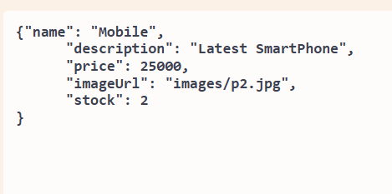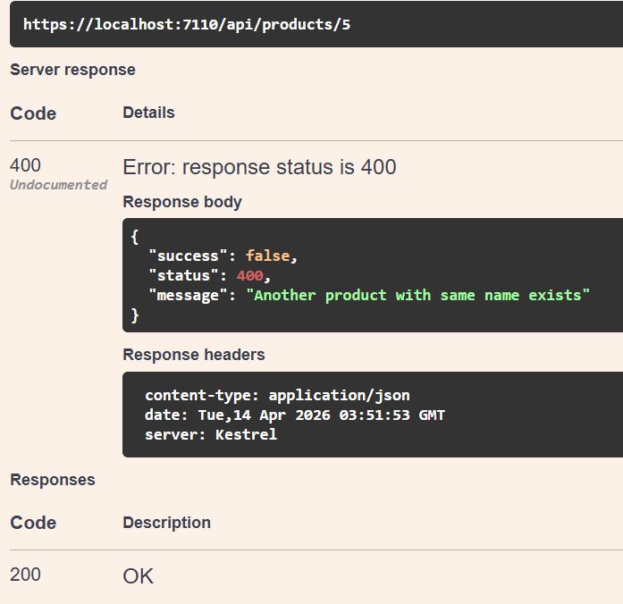

Case 2: Product id not Found.

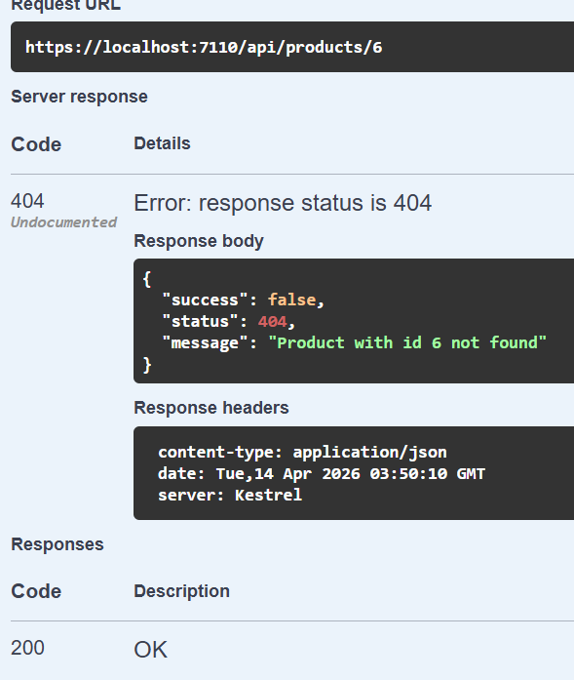

Case 3 : Quantity is given range .
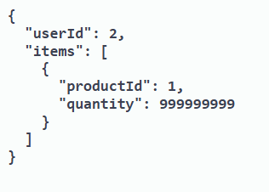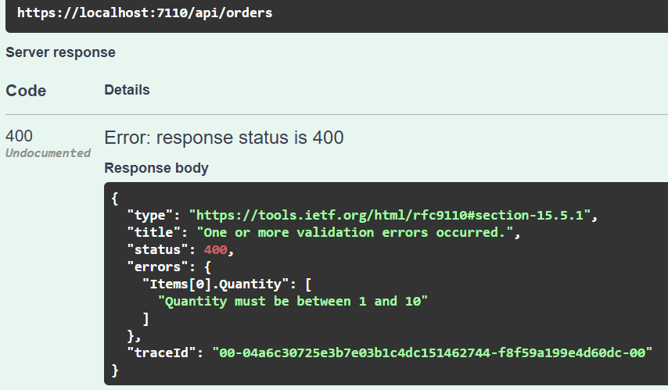

Case 4: Empty Order cart.

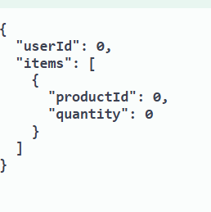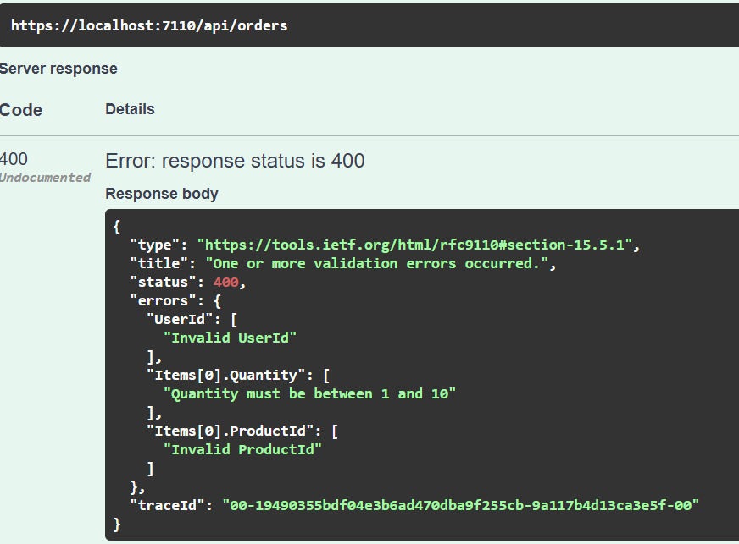

2. Postman Testing
Postman was used to test APIs externally by sending HTTP requests and validating responses.
  - Products API Testing
- GET METHOD

GET : https://localhost:7110/api/products

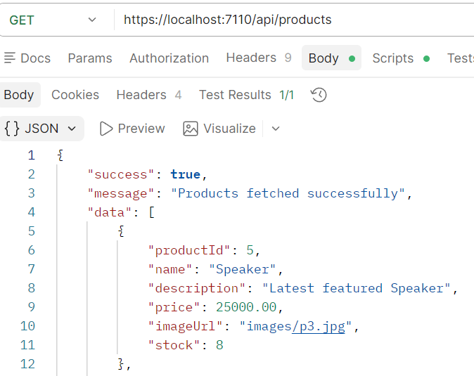
- POST METHOD

POST : https://localhost:7110/api/products

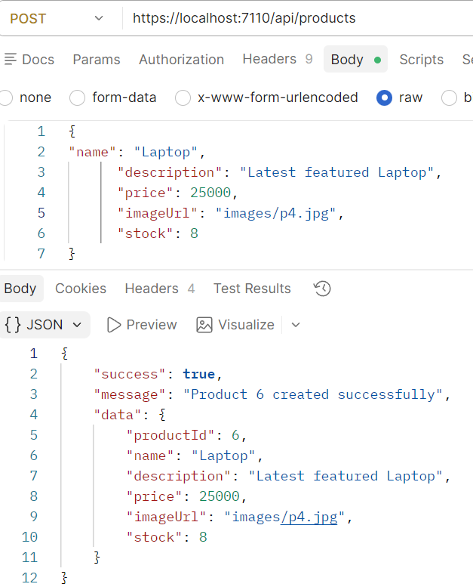
- PUT METHOD

PUT : https://localhoast:7110/api/products/4

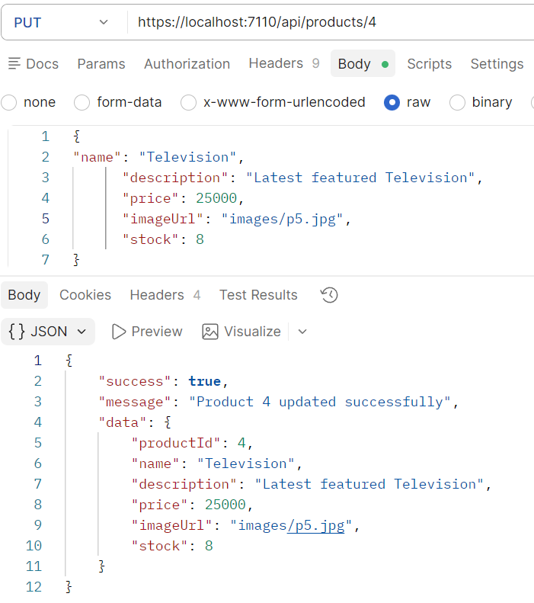

- DELETE METHOD

DELETE : https://localhost:7110/api/products/4

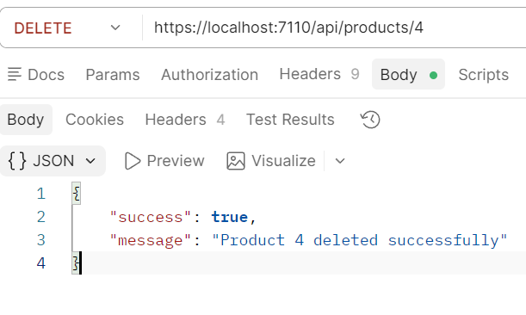

  - Order API Testing

- POST METHOD

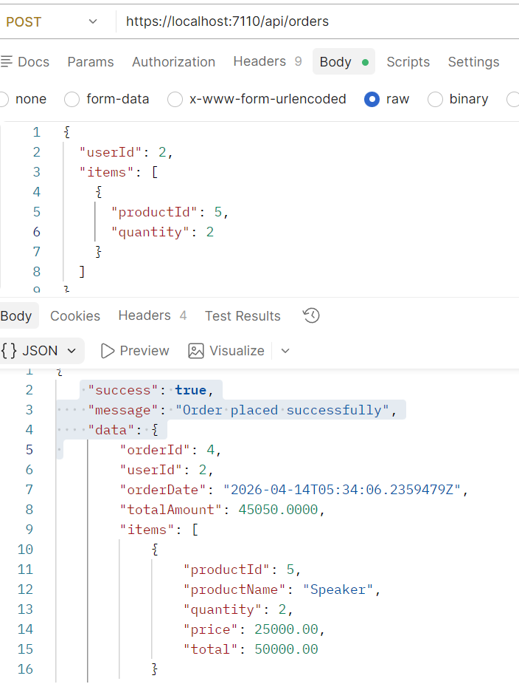

- GET METHOD

GET : https://localhost:7110/api/orders

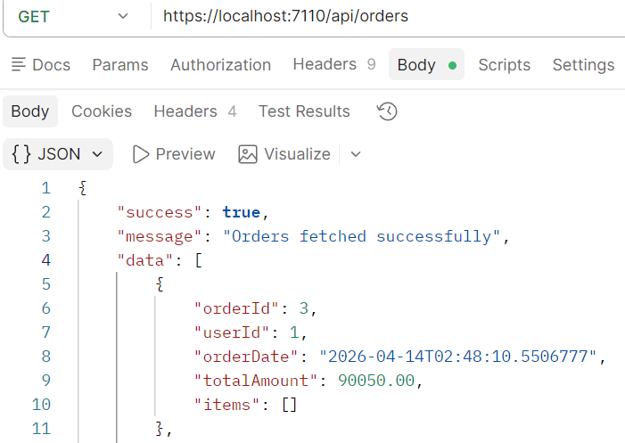

- User API Testing

- GET Method

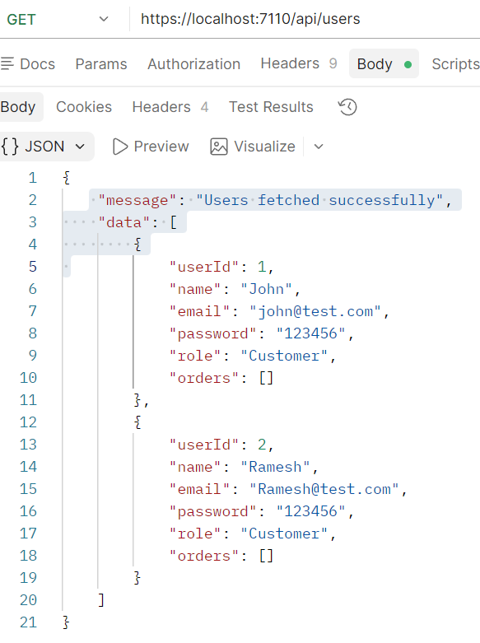

Summary :

All APIs were successfully tested using Swagger and Postman. The application correctly handles CRUD operations, order processing, and validations. Proper error messages are returned for invalid inputs, ensuring robustness of the system.

