Q2:

TABLE STRUCTURE:

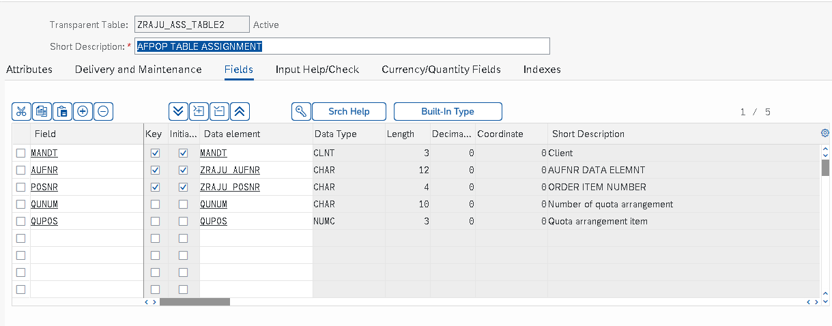

INSERTING DATA THROUGH TMG:

