# A project report

# on

'Logical assistance of Data Structure'

**MADHAV INSTITUTE OF TECHNOLOGY AND SCIENCE**



**Submitted to**

**Department of Computer Science & Engineering and IT**

**MITS, Gwalior (M.P.)**

**(An Autonomous Institution Under RGPV, Bhopal)**

# Under the Guidance of-

# Prof. Jaimala Jha Prof. Rajeev Kumar Singh

# Submitted By-

# Raju Raghuwanshi

# CS11045

# Hitendra Garg

# CS11029

**ACKNOWLEDGEMENT**

Preparing any project requires views of many people but we suspect that technical projects are more different than others. A great many people are involved in various stages of the project prepration who shared their knowledge and experience.

Before we get into thick of things we would like to add a few heartfelt words for the people who are part of this project in numerous ways people who gave un-ending support right from the stage idea was concieved.

It is our proud privilege to express a deep sense of gratitude and regard to our Project Guides **Prof. Jaimala Jha** and **Prof. Rajeev Kumar Singh** for the opportunity, they given us for carrying out the project. Their initiative, keen intrest, expert guidance at every step provided a constant source of inspiration and encouragement to us for intense studies in the subject. We are deeply indebted to him.

We shall be failing in our duty , if we do  not express our heart felt gratitude to **Dr. R.K.Gupta** (Professor & Head) Department Of CSE & IT, M.I.T.S. Gwalior for his support in the project.

We acknowledge with gratitude the benediction of our institution and Director, MITS, Gwalior who extended all facilities and co-operation in the completion of this project.

We also express sincere gratitude **Mr. Imtiaz Hussain** for providing us the facilities which are at their disposal in the department computer laboratories. We owe our gratitude to our family and friends without whose co-operation and constant encouragement this work would not have been successful.

Our sincere thanks to all those who directly or indirectly helped us in the development and evolution of thoughts.

**Raju Raghuwanshi**

**CS11045**

**Hitendra Garg**

**CS11029**

**Contents of Report**

1. **Introduction 1-2**

* Overview
* Goal and Purposes
* Need of the Software
* Scope of the Project
* Program Specification Deployment

1. **Project Descriptions 3-5**

* ER Diagrams
* Data Flow Diagrams
* Gantt Charts
* User Summary
* Application Context

1. **Implementation 6-16**

* Work Partition
* Project Quick Look
* Technical Specifications

1. **Testing 11-14**

* Unit Testing
* Validation Testing
* Other Testing’s

1. **Technologies Used 16-20**

* Software
* Hardware

1. **Results and Challenges 20-22**

* Results
* Challenges

1. **Conclusion 23**

* Future Prospects

## Introduction

### Overview

Developing world and unparalleled growth of technological advancement has brought the world to an era where everyone and everything is working with a direct or indirect touch of technology. One such field is the education field where technology is expanding its shadow.

"**Logical Assistance of Data Structure**" is a software application which supports the advancement of technology in education field. It is designed to ease the work and labour of students as well as professors by providing an application where the user can get the theory, programs, algorithms, examples and also the scope to practice questions and prepare self-notes with test paper.

### Goal and Purposes

* Support for virtual learning
* Availability of maximum available data at a single place.
* Reduce the use of pen-paper.
* Reduce time wasted in writing the matter on a notebook or board and make take time more productive.

### Need of the Software

* To provide an application to keep up with the changes in way of education delivery i.e. onscreen lectures, use of projectors etc.
* To provide an application to reduce the trouble of searching for study matter over various places and to make it such that it’s easy to save the work done by one at the same place for future review.

### Scope of the Project

The current scope is limited to teacher and students of Engineering Computer Science Engineer’s, but the future possibilities of this software are vast. From a school to university to various companies, this software can be used to educate to learn and teach various disciplines and sub divisions of it. The project can also be used to teach confidential topics by creating private accounts.

### Platform Specification- Deployment

**Hardware Specifications**

1. CPU : DUAL CORE OR ABOVE

2. RAM : 2 GB OR ABOVE

3. HDD : 10 GB OR ABOVE

**Software Specifications**

1. OPERATING SYSTEM : Platform Independent

2. SOFTWARE : JDK and JRE

**Project Description**

After carefully analysing the requirements and functionality of the system, we had two important diagrams by the end of the analysis phase. They are the ER diagram and Data flow diagram (DFD) which is the basis for finding out entities and relationships between them, the flow of information and the direction of the data flow.

Another important analysis results in the formation of Pert chart and Gantt chart which shows how the desired software was formulated using standard descriptions and existing models.The Gantt chart states the duration in which project gets completed.

### ER Diagrams

Student

Use

Software

Teacher

Use

Software

### Data Flow Diagrams(Context level Diagram)

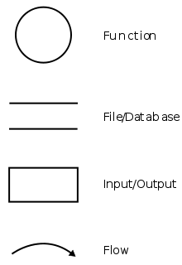

Leads to

Read/Write Notes

E-Learning

Student/Teacher

Developed Programs

Demanded request

Documents

Notes

Internet

Books

Software

Students

Professors

### Gantt Chart

26/11 03/11 10/12 17/12 12/01 20/01 23/02 03/03 24/04

Preliminary

Investigation

Write Report

Interview

Training

Evaluation

Final Report

### User Summary

**USER PROFILE:**

The user has to start the application and firstly registered his/her name then he/she can directly access multiple available options as learn Data Structure, Prepare Notes, Creates Test, prepare notes and also developed programs used by given compiler.

### Application Context

6. Make Changes attendences.

8. Exit

3. prepare notes

4. prepare test

5. Develop Programs

1. Start Software

2. Learn Data Structure

Structur

Student/Teacher

## Implementation

7. User created Notes

### Work Partition

|  |  |  |
| --- | --- | --- |
| **Sr.No.** | **EVENT** | **Result of event** |
| 1. | Start | To start the software |
| 2. | Select Options | To select the any options i.e. Learn Data Structure, Prepare Notes, Creates Test, prepare notes and also developed programs |
| 3. | Select any field | Select Unit or Topic to read or prepare notes. |
| 4. | Select Chapter | Select chapter of a Unit |
| 5. | Chose out of Theory | To study |
| 6. | Choose to developed programs | Open the Compiler mentioned in upper side(Two compilers are provided by default in software i.e. Dev, Turbo c) |
| 7. | Select Compiler | if user want to remove any compiler he/she can do it. |
| 8. | Prepare Notes | Use of Notepad to prepare notes |

### Project Quick Look

Below is the Front page of my Software Project which gives options to a user about the type of action he/she wants to perform.

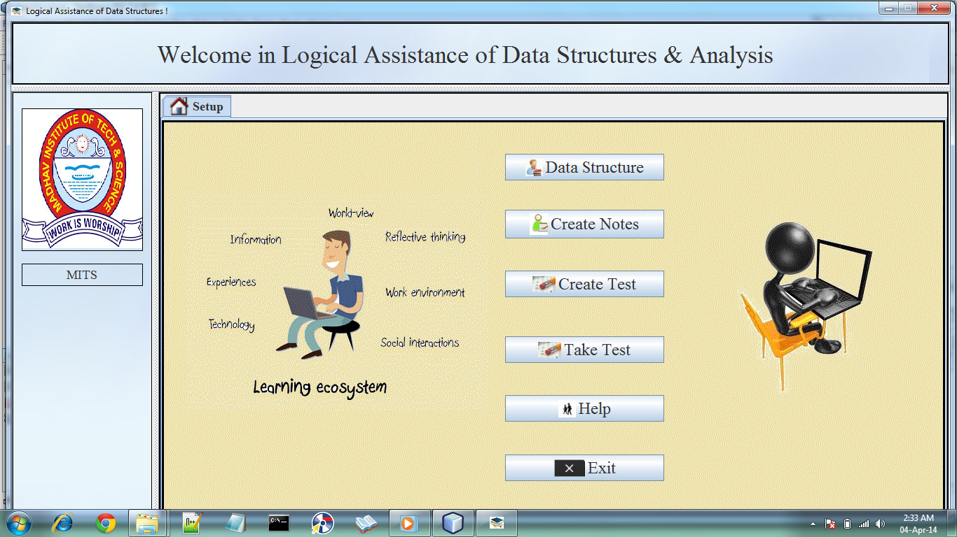

The application software thus shown also contained various submenus and sub windows and also user made tools. There were also the uses of some premade software’s as Compiler, adobe reader etc.

These are some images which contains -

* Sub Windows
* User Made tools
* Sub Menus

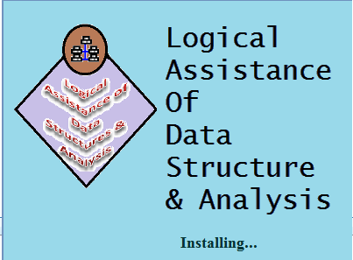

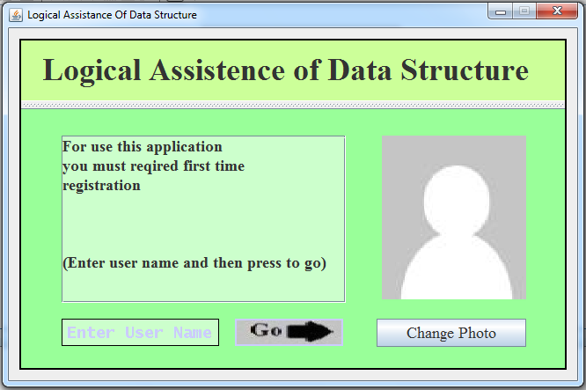



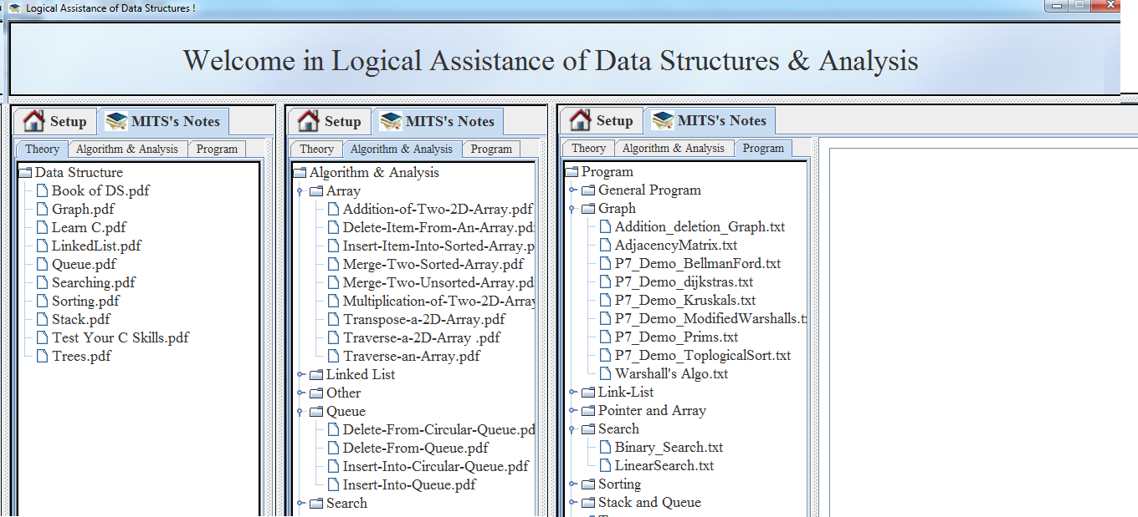

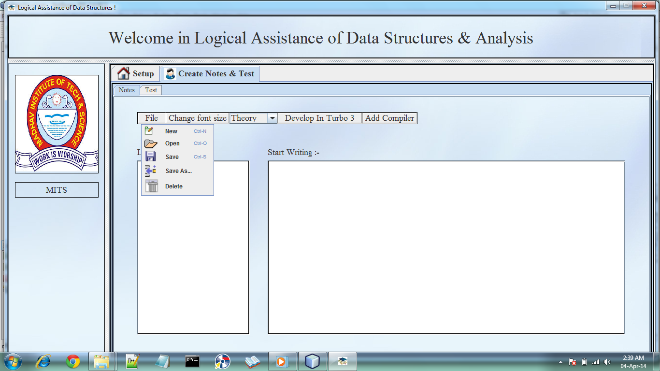

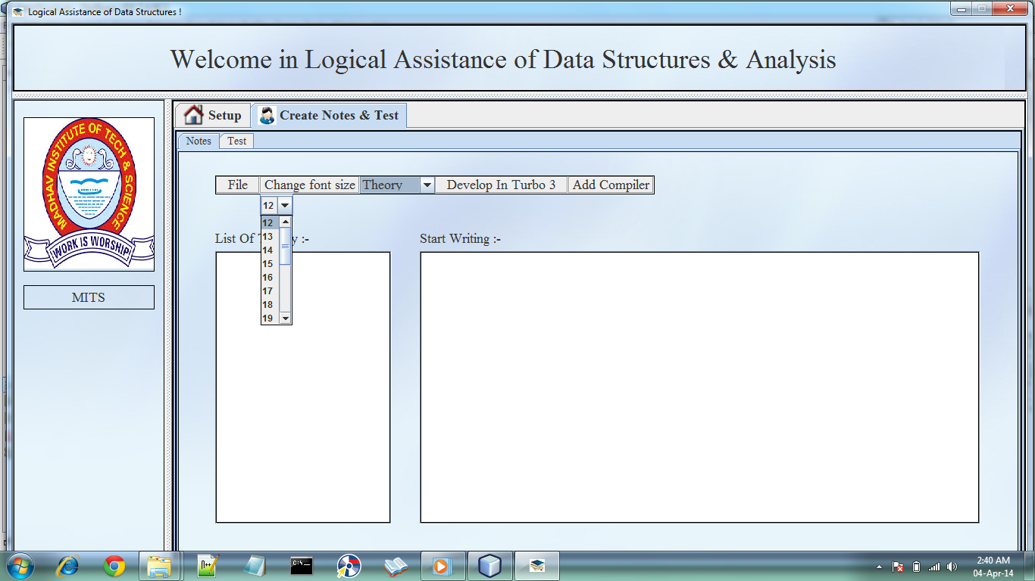

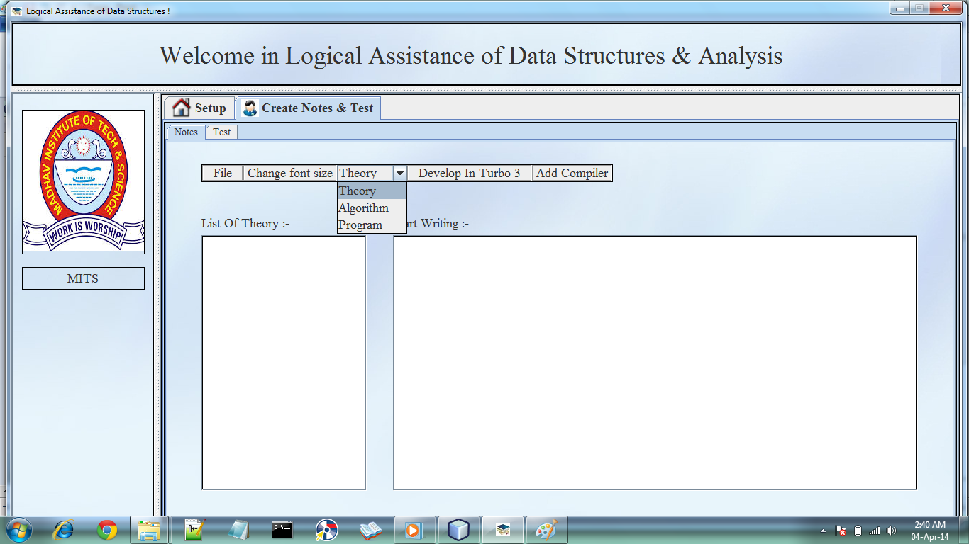

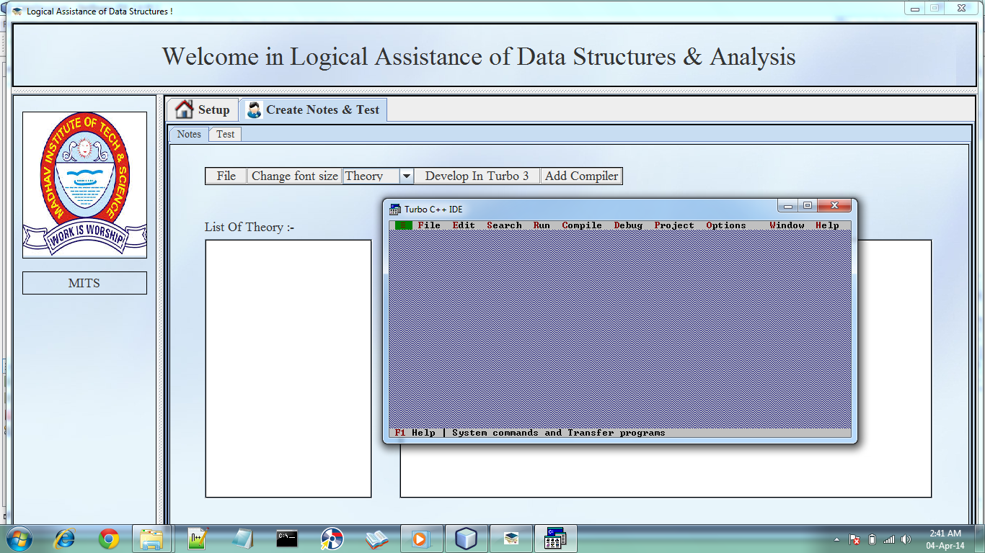

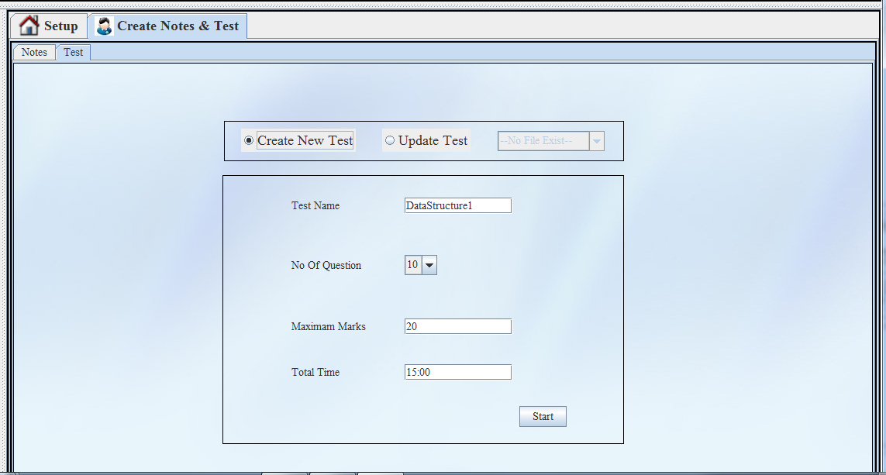

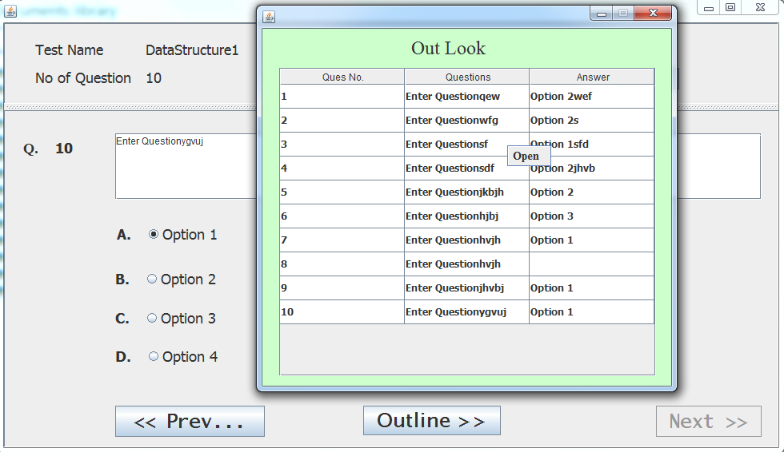

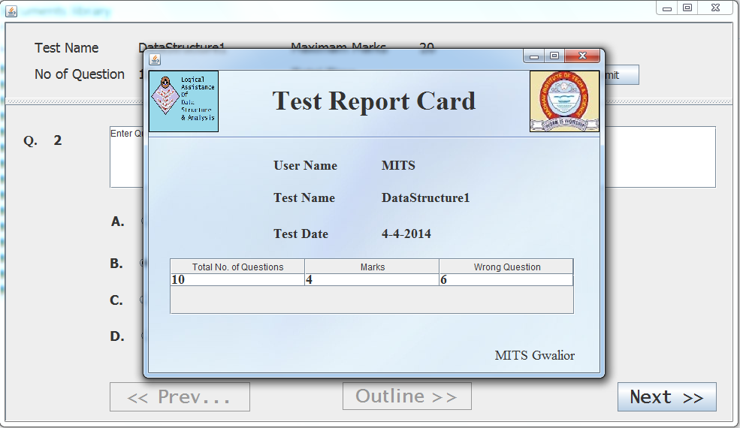

### Technical Specifications

It is based on the desktop user model. The user has to make use of various features like read, prepare notes, develop programs, view file etc. each user has such kind of authority. Using the software services the work of a student becomes easier.

The users should be able to view the complete specification of the product and various files and can prepares own notes and develop programs. They should be able to print out the files like text, and pdf format..

**Front End**

The NETBEANS platform was used for the GUI tools in JAVA.

The various GUI tools rich NETBEANS provided the support which made the user friendly application possible. It gave proper tools like text-boxes, labels, command-buttons and its drag and drop system further eased the construction of the front end of the software

## TESTING

Software testing is a process of running with intent of finding errors in software. It represents final review of other phases of software like specification, design, code generation, etc.

### Unit Testing

Unit testing emphasizes the verification effort on the smallest unit of software design i.e.; a software component or module. Unit testing is a dynamic method for verification, where program is actually compiled and executed. Unit testing is performed in parallel with the coding phase. Unit testing tests units or modules not the whole software. We have tested each view/module of the application individually. As the modules were built up testing was carried out simultaneously, tracking out each and every kind of input and checking the corresponding output until module is working correctly. 20 The functionality of the modules was also tested as separate units. Each of the three modules was tested as separate units. In each module all the functionalities were tested in isolation.

In the user login module ,when a user has tried to login into the server side by using a user id and password to access the services provided by the server and has clicked the submit button, it has been made sure that he is using a valid user name and password field also matches with this user id. And in any case if the user id and password does not get matched with the one provided by the user, a message should be displayed informing about the mismatching of the fields. In another case when a new user has tried to log in and has clicked the new user button, a registration form should get opened. When a registration form has been opened by the user it is made sure that all the fields are filled properly, otherwise a respective warning message should be displayed after each field indicating that the field is not properly filled. Now if the user has successfully logged in , a home page for that user should get opened containing all the required services provided by the server to the user .

And on selecting a service related page or information should get displayed and if any changes have been done by the user in a page then the page should get refreshed or updated automatically. It should also be checked that if the whole page refreshes or the partial page update happens. It should also  be ensured that all the information at both the user and server site are secured. Various method have been created for the purpose of unit testing using java and test cases are automatically generated for these methods. The methods are written to retrieve the information from the database, strings that matches with the certain search term and operation , check for the validity of user , all the operations performed by him using the server site services. The unit tests are automatically generated for these methods and it should be ensured that the test have been passed. 

### Validation Testing

It provides final assurances that software meets all functional, behavioral & performance requirement. Black box testing techniques are used. There are three main components.

- Validation test criteria (no. in place of no. & char in place of char)

- Configuration review (to ensure the completeness of s/w configuration.)

- Alpha & Beta testing-Alpha testing is done at developer’s site i.e. at home & Beta testing once it is deployed. Since we have not deployed my application, we could not do the Beta testing.   
   
White Box Testing

In white box testing knowing the internal working of the product, tests can be conducted to ensure that internal operations are performed according to specification and all internal components have been adequately exercised. In white box testing logical path through the software are tested by providing test cases that exercise specific sets of conditions and loops. Using white-box testing software developer can derive test case that

• Guarantee that all independent paths within a module have been exercised at least once.

• Exercise all logical decisions on their true and false side.

• Exercise all loops at their boundaries and within their operational bound.

• Exercise internal data structure to ensure their validity.

At every stage of project development I have tested the logics of the program by supplying the invalid inputs and generating the respective error messages. All the loops and conditional statements are tested to the boundary conditions and validated properly.

### Other Testing Techniques

**Functional Testing:**

In this type of testing, the software is tested for the functional requirements. The tests are written in order to check if the application behaves as expected.

**Stress Testing:**

The application is tested against heavy load such as complex numerical values, large number of inputs, large number of queries etc. which checks for the stress/load the applications can withstand.

**Load Testing:**

The application is tested against heavy loads or inputs such as testing of web sites in order to find out at what point the web-site/application fails or at what point its performance degrades.

**Ad-hoc Testing:**

This type of testing is done without any formal Test Plan or Test Case creation. Ad-hoc testing helps in deciding the scope and duration of the various other testing and it also helps testers in learning the application prior starting with any other testing.

**Exploratory Testing:**

This testing is similar to the ad-hoc testing and is done in order to learn/explore the application.

Usability Testing:

This testing is also called as ‘Testing for User-Friendliness’. This testing is done if User Interface of the application stands an important consideration and needs to be specific for the specific type of user.

**Recovery Testing:**

Recovery testing is basically done in order to check how fast and better the application can recover against any type of crash or hardware failure etc. Type or extent of recovery is specified in the requirement specifications.

**Volume Testing:**

Volume testing is done against the efficiency of the application. Huge amount of data is processed through the application (which is being tested) in order to check the extreme limitations of the system.

**TECHNOLOGIES USED**

### Software requirement

1. Operating System - Platform Independent
2. Languages Used - JAVA
3. File Handling - Adobe PDF reader
4. JRE and JDK

### Hardware Requirement (MINIMUM)

1. System with Dual core Processor
2. 2 GB RAM
3. SVGA Monitor
4. 101 Keyboard
5. Two Button mouse
6. 10 GB HDD

**Result and Challenges**

### Result

This application can be used for any E-Learning purpose like in institutions and schools, with the exception of subjects varying rather than just Mathematics. Its ease of access and user friendliness makes learning more fun and GUI involvement makes it rather simple with less troubles.

### Challenges

* Using a layered approach in developing the application which would make the application maintainable.
* Learning new technologies like using JAVA for program development and coding.
* The overall idea of doing this project is to get a real time experience & learn new technologies.
* Use of Net beans Software so as to make it graphically more user friendly.

**Conclusion**

In the unveiling era of computers and technology, the software we have thus so far achieved will be able to improve the education level and further open gates for new and better models.

This software is a desktop application but its scope can be varied and extended in web applications as well.

### Future Work

Developing functions and methods to make this software more and more dynamic i.e. increasing the user involvement by providing space for user to input values and thus receive results based on the calculations done.

Also expand this software to web use also.