AWS CLI IN WINDOWS -01

- configure MFA for aws account:
- Open AWS account
- Go to Security crendiatials
- Add MFA device
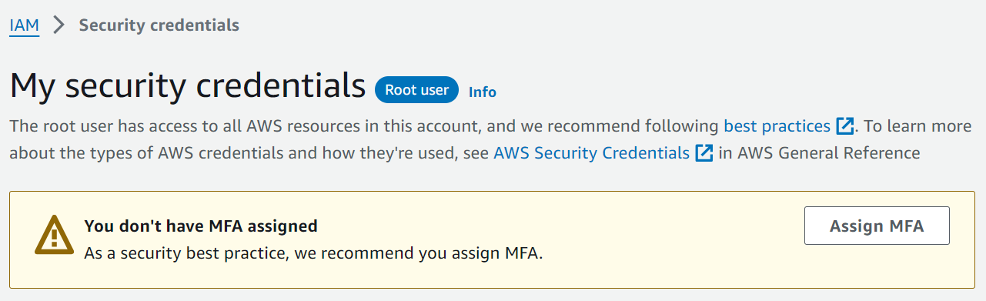

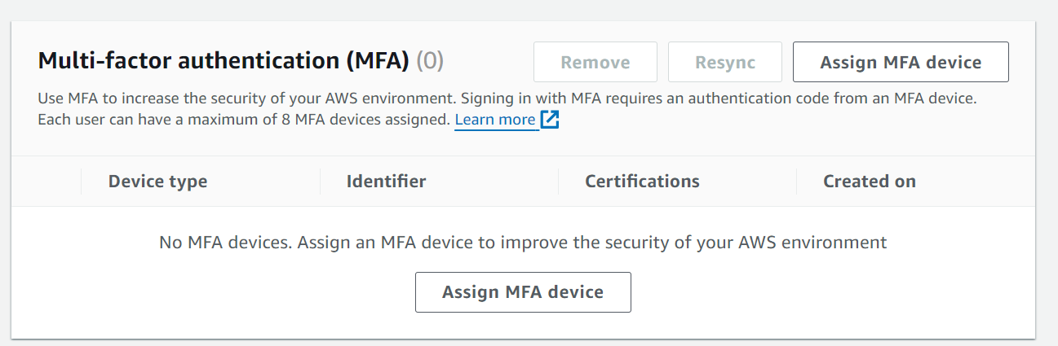

3)Install aws CLI in windows:
- Open AWS account
- Go to Security crendiatials
- Create access key
- Region:US-EAST-1

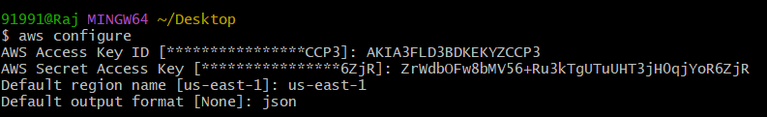

4)Setup ec2 in N.virginia region using aws CLI command:
- Open AWS account
- Go to Security crendiatials
- Create access key
- Region:US-EAST-1(N.virginia)

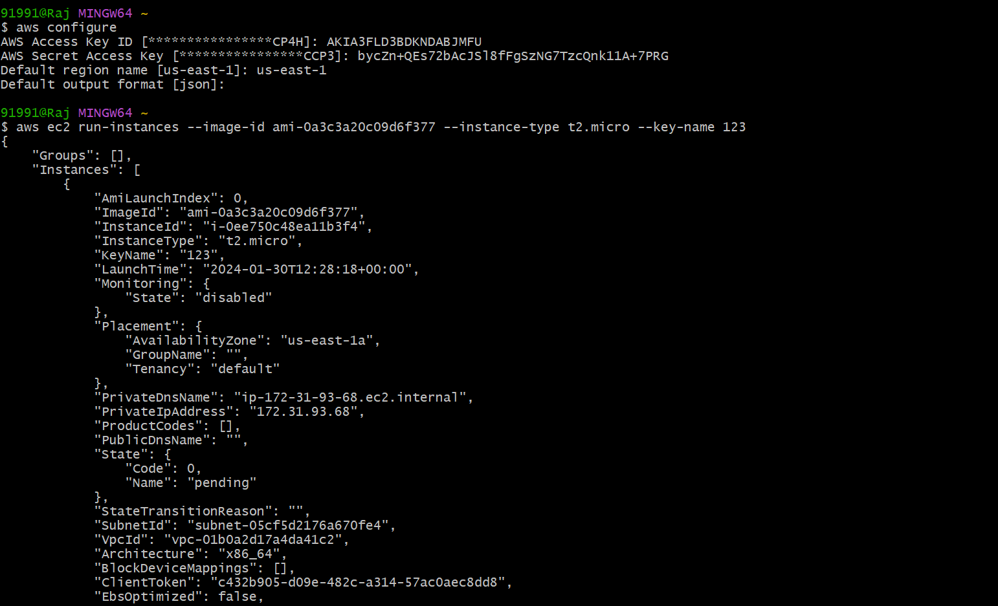
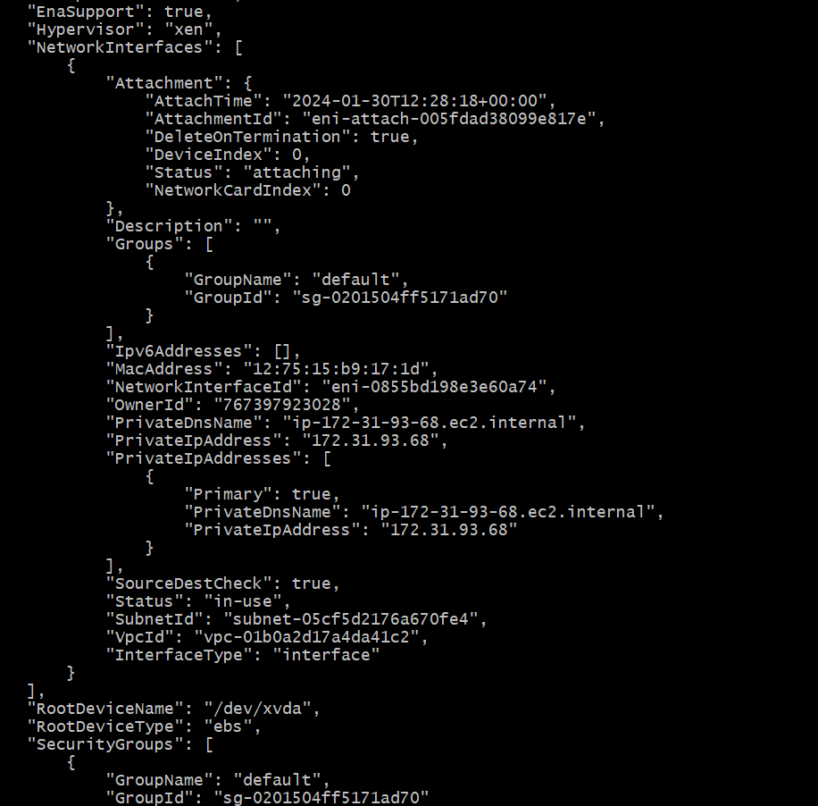

5) Setup security group in ohio region with name - sg and open port 22:

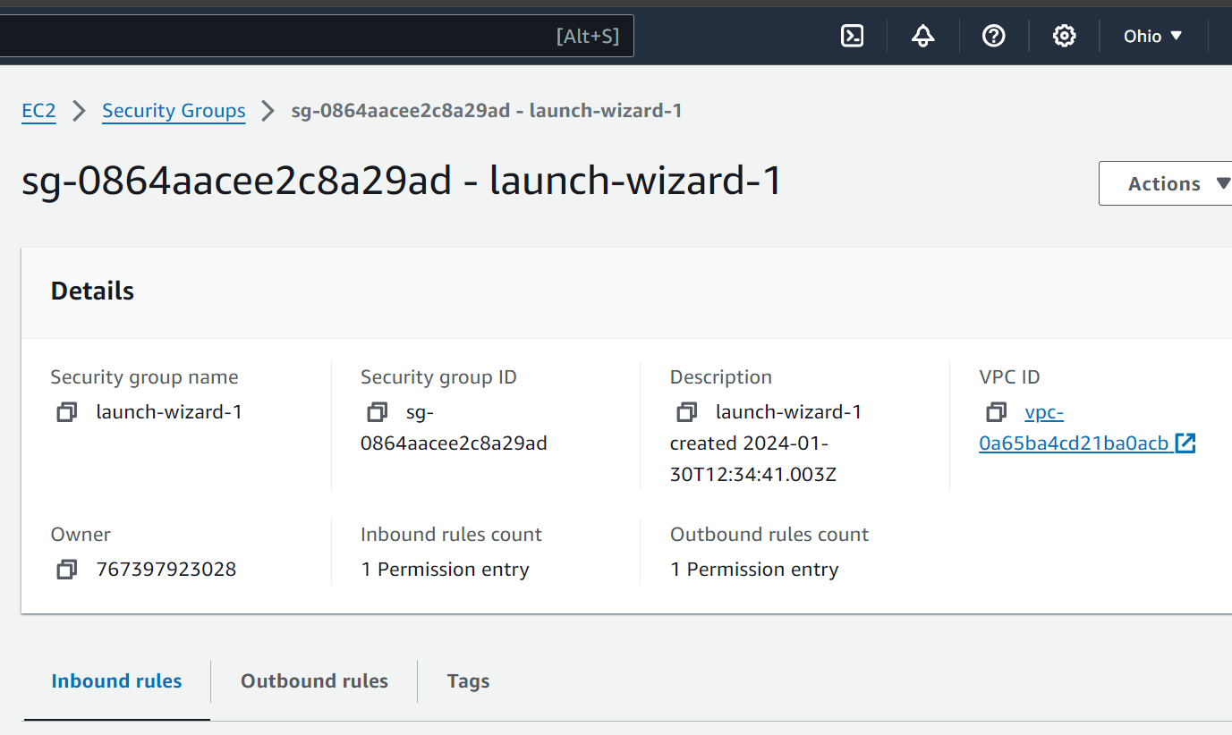

- setup ec2,security group in Mumbai region using single aws CLI command:
- Open AWS account
- Create Region ap-south-1(Mumbai)
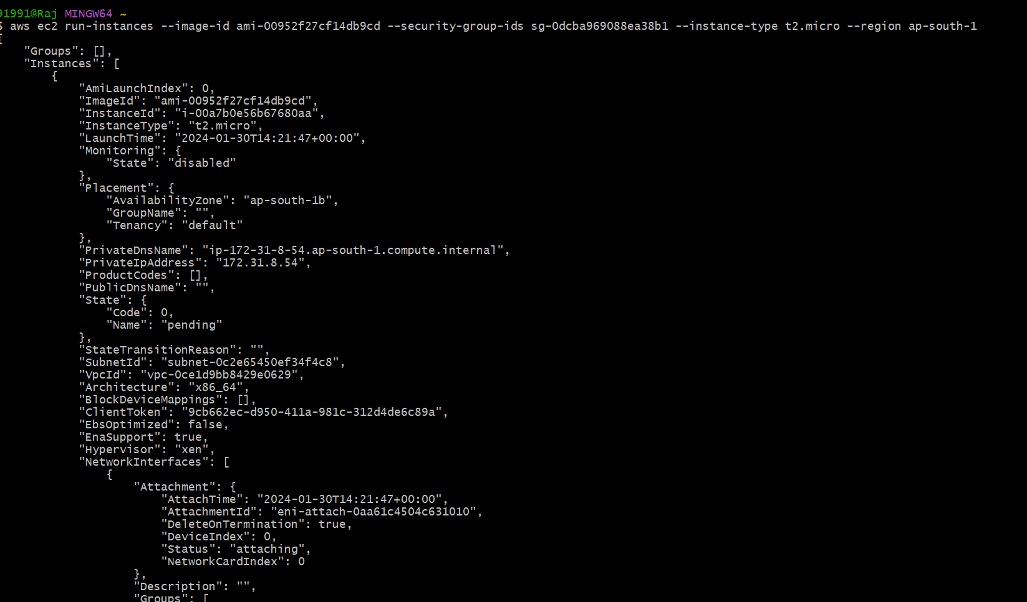
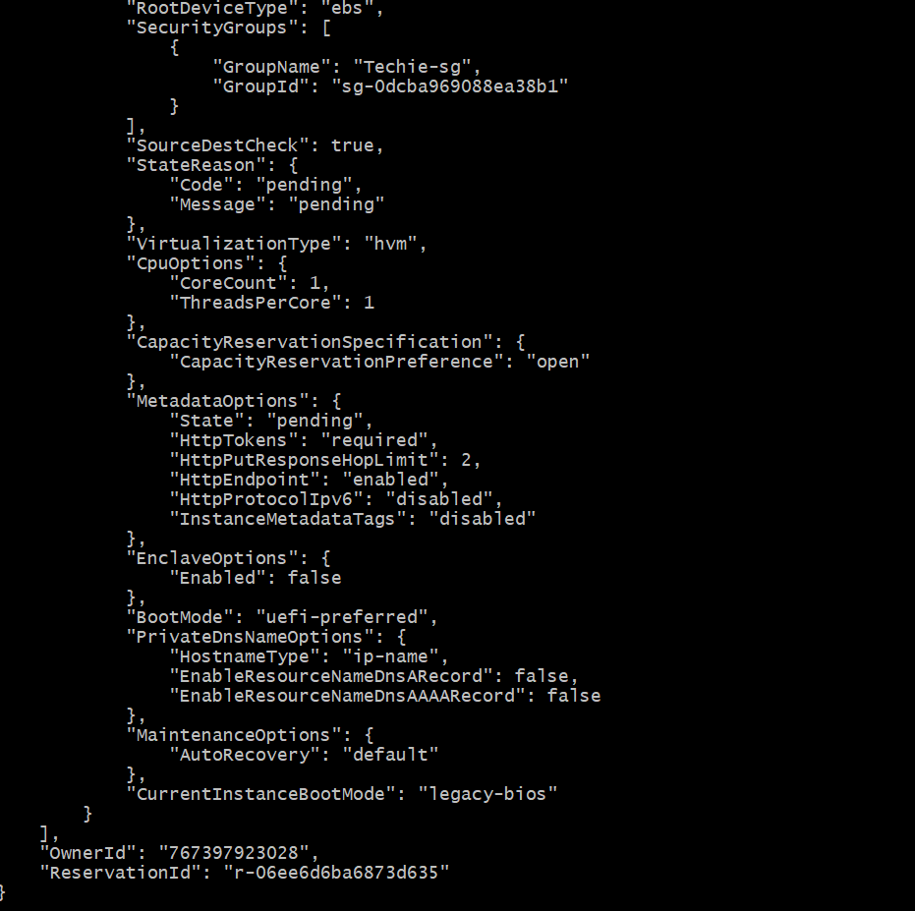
- Security group in Mumbai region:

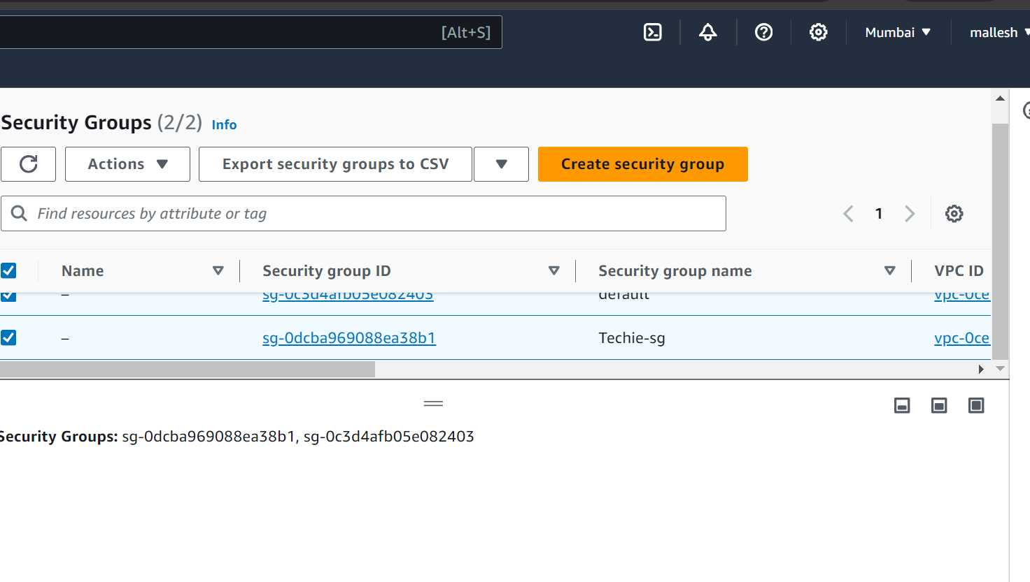

1) Watch the video and write down notes.
2) configure MFA for aws account
3) Install aws cli in windows.
4) Setup ec2 in N.virginia region using aws cli command.
5) Setup security group in ohio region with name - Techie-sg and open port 22
6) setup ec2,security group in Mumbai region using single aws cli command.

