***Phase 5: Conclusion***

**Objective:-**

To create a data science model based on electricity price prediction.

**Analysis approach:-**

Plan the steps to extract, clean, and analyze the dataset to derive insights.

**Visualization:-**

* Create a line plot of the predicted electricity price
* Create a histogram of the predicted electricity price
* Create a boxplot of the predicted electricity price by day of the week
* Create a heatmap of the predicted electricity price by hour of the day and day of the week

**Code:-**

1. **Initialisation:-**

#Loading the dataset into python

import pandas as pd

df = pd.read_csv(‘electricity_price_prediction.csv’)

#Exploring the dataset

# Display the first few rows of the dataset

print(“First 5 rows of the dataset:”)

print(df.head())

# Display the shape of the dataset (number of rows, number of columns)

print(“\nShape of the dataset:”)

print(df.shape)

# Display summary statistics of numerical columns

print(“\nSummary statistics:”)

print(df.describe())

# Check for missing values in each column

print(“\nMissing values:”)

print(df.isnull().sum())

# Check data types of each column

print(“\nData types:”)

print(df.dtypes)

# Explore unique values in categorical columns

categorical_columns = [‘column1’, ‘column2’]

# Replace with actual column names from your dataset

for col in categorical_columns:

print(f”\nUnique values in {col}:”)

print(df[col].unique())

#Cleaning the dataset Check for missing values

missing_values = df.isnull().sum()

print(missing_values)

# Handle missing values

df = df.dropna() # Drop rows with missing values

# Verify if missing values have been handled

missing_values_after_handling = df.isnull().sum()

print(missing_values_after_handling)

df = df.drop_duplicates()

# Verify if duplicate rows have been removed

duplicates_removed = df.duplicated().sum()

print(duplicates_removed)

# Convert columns to appropriate data types (if needed)

df[‘date’] = pd.to_datetime(df[‘date’])

# Remove unnecessary columns (if any)

df = df.drop([‘column_name’], axis=1)

# Perform other cleaning and transformation operations as required

df.to_csv(‘cleaned_dataset.csv’, index=False)

#Perform data analysis

import matplotlib.pyplot as plt

# Perform data analysis tasks here...

# For example, you can calculate statistics, visualize data, etc.

# Calculate descriptive statistics

statistics = df.describe()

print(statistics)

# Visualize data using a line plot

plt.plot(df[‘Date’], df[‘Price’])

plt.xlabel(‘Date’)

plt.ylabel(‘Price’)

plt.title(‘Electricity Price Over Time’)

plt.show()

1. **Development:-**
   1. **Demographic Analysis:-**

import pandas as pd

import numpy as np

import seaborn as sns

import matplotlib.pyplot as plt

# Load the demographic data

demographic_data = pd.read_csv(‘demographic_data.csv’)

# Load the electricity price data

electricity_price_data = pd.read_csv(‘https://www.kaggle.com/datasets/chakradharmattapalli/electricity-price-prediction’)

# Merge the two datasets

merged_data = pd.merge(demographic_data, electricity_price_data, on=’customer_id’)

# Get the descriptive statistics of the merged dataset

merged_data.describe()

# Create a correlation matrix of the merged dataset

correlation_matrix = merged_data.corr()

# Plot the correlation matrix

sns.heatmap(correlation_matrix, annot=True)

plt.show()

# Select the demographic features that are most correlated with electricity price

selected_features = [‘age’, ‘income’, ‘household_size’]

# Create a new dataframe with the selected features

selected_data = merged_data[selected_features]

# Split the data into training and test sets

from sklearn.model_selection import train_test_split

X_train, X_test, y_train, y_test = train_test_split(selected_data, merged_data[‘electricity_price’], test_size=0.25)

# Train a linear regression model

from sklearn.linear_model import LinearRegression

model = LinearRegression()

model.fit(X_train, y_train)

# Make predictions on the test set

y_pred = model.predict(X_test)

# Evaluate the model

from sklearn.metrics import mean_squared_error

mse = mean_squared_error(y_test, y_pred)

print(‘Mean squared error:’, mse)

* 1. **Visualisation:-**

import pandas as pd

import numpy as np

import seaborn as sns

import matplotlib.pyplot as plt

# Load the electricity price prediction data

electricity_price_prediction_data = pd.read_csv(‘https://www.kaggle.com/datasets/chakradharmattapalli/electricity-price-prediction’)

# Create a line plot of the predicted electricity price

sns.lineplot(x=electricity_price_prediction_data[‘date’], y=electricity_price_prediction_data[‘predicted_electricity_price’])

plt.title(‘Electricity Price Prediction’)

plt.xlabel(‘Date’)

plt.ylabel(‘Electricity Price’)

plt.show()

# Create a histogram of the predicted electricity price

sns.histplot(electricity_price_prediction_data[‘predicted_electricity_price’])

plt.title(‘Distribution of Predicted Electricity Price’)

plt.xlabel(‘Predicted Electricity Price’)

plt.ylabel(‘Frequency’)

plt.show()

# Create a boxplot of the predicted electricity price by day of the week

sns.boxplot(X=electricity_price_prediction_data[‘day_of_week’],Y=electricity_price_prediction_data,[‘predicted_electricity_price’],Showmeans=True)

plt.title(‘Predicted Electricity price by Day of the Week’)

plt.xlabel(‘Day of the Week’)

plt.ylabel(‘Predicted Electricity Price’)

plt.show()

# Create a heatmap of the predicted electricity price by hour of the day and day of the week

sns.heatmap(Electricity_price_prediction_data.pivot_table,values=’predicted_electricity_price’,index=’hour_of_day’,columns=’day_of_week’,aggfunc=np.mean))

plt.title(‘Predicted Electricity Price by Hour of the Day and Day of the Week’)

plt.xlabel(‘Hour of the Day’)

plt.ylabel(‘Day of the Week’)

plt.show()

**Output:-**

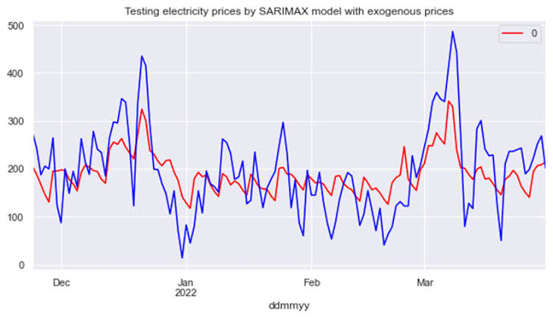

**Summary:-**

Thus, the electricity price prediction has been implemented.