

Project based learning – Python (PBL)
C2P2 – Project -1 Semester – III

Sr. No. | Roll no. | Name | SRN | PRN
 | 110 | Rajul Luniya | 31252365 | 3125057020160
2. | 104 | Mittal Rathi | 31251227 | 3125047020054
3. | 118 | Divya Shinde | 31252433 | 3125045020178
4. | 93 | Shreeraj Shinde | 31252014 | 3125045020129

Problem Statement :- Predicting heart attacks accurately is essential to reducing mortality and enhancing patient care. Predictive techniques used today frequently lack early detection and accuracy. Artificial Intelligence (AI) presents a promising means of improving forecast accuracy through multidimensional, complicated data analysis. To improve overall cardiovascular health management, lower death rates, and provide timely therapies, it is imperative to develop strong AI models for heart attack prediction.

Code:
Main.py file :-
# ❤ HEART ATTACK PREDICTION USING MACHINE LEARNING (Beginner Friendly)
# Author: Rajul Luniya, Divya Shinde, Mittal Rathi, Shreeraj Shinde
# Objective: Analyze dataset factors and predict user's heart attack risk level.

# -------------------------------------------------
# Step 1: Import Libraries
# -------------------------------------------------
import pandas as pd
import numpy as np
from sklearn.model_selection import train_test_split
from sklearn.preprocessing import LabelEncoder
from sklearn.ensemble import RandomForestClassifier
from sklearn.metrics import accuracy_score

print("❤ HEART ATTACK PREDICTION SYSTEM")
print("=====================================\n")

# -------------------------------------------------
# Step 2: Load Dataset
# -------------------------------------------------
# ⚠ Replace with your actual dataset path
data = pd.read_excel("heart.xlsx")

print("✅ Dataset Loaded Successfully!")
print(f"Total Records: {len(data)}\n")

# -------------------------------------------------
# Step 3: Data Cleaning and Preprocessing
# -------------------------------------------------

# Drop unnecessary columns
drop_cols = ['Patient ID', 'Country', 'Continent', 'Hemisphere']
for col in drop_cols:
if col in data.columns:
data = data.drop(columns=col)

# Convert Blood Pressure column (e.g., "120/80") → extract systolic (120)
def extract_systolic(bp):
try:
if isinstance(bp, str) and '/' in bp:
return float(bp.split('/')[0])
else:
return float(bp)
except:
return np.nan

data['Blood Pressure'] = data['Blood Pressure'].apply(extract_systolic)

# Convert all numeric columns safely
numeric_cols = ['Age', 'Cholesterol', 'Blood Pressure', 'Heart Rate', 'Stress Level',
'Sedentary Hours Per Day', 'Income', 'BMI', 'Triglycerides',
'Exercise Hours Per Week', 'Physical Activity Days Per Week', 'Sleep Hours Per Day']

for col in numeric_cols:
data[col] = pd.to_numeric(data[col], errors='coerce')
data[col] = data[col].fillna(data[col].mean()) # replace NaN with mean

# Encode categorical columns
label_cols = ['Sex', 'Diabetes', 'Family History', 'Smoking', 'Obesity',
'Alcohol Consumption', 'Diet', 'Previous Heart Problems',
'Medication Use', 'Heart Attack Risk']

encoder = LabelEncoder()
for col in label_cols:
if col in data.columns:
data[col] = encoder.fit_transform(data[col].astype(str))

# -------------------------------------------------
# Step 4: Prepare Features and Target
# -------------------------------------------------
X = data.drop(columns=['Heart Attack Risk'])
y = data['Heart Attack Risk']

# Split data
X_train, X_test, y_train, y_test = train_test_split(X, y, test_size=0.2, random_state=42)

# -------------------------------------------------
# Step 5: Train Model
# -------------------------------------------------
model = RandomForestClassifier(random_state=42)
model.fit(X_train, y_train)

# Accuracy
y_pred = model.predict(X_test)
acc = accuracy_score(y_test, y_pred)
print(f"✅ Model Trained Successfully (Accuracy: {acc*100:.2f}%)\n")

# -------------------------------------------------
# Step 6: Feature Importance
# -------------------------------------------------
importance = pd.Series(model.feature_importances_, index=X.columns).sort_values(ascending=False)
print("📊 Top Factors Influencing Heart Attack Risk:\n")
print(importance.head(10), "\n")

# -------------------------------------------------
# Step 7: User Input
# -------------------------------------------------
print("💬 Please enter your health details for prediction:\n")

def get_input():
user_data = {}
user_data['Age'] = float(input("Enter Age: "))
user_data['Sex'] = input("Sex (Male/Female): ")
user_data['Cholesterol'] = float(input("Cholesterol Level (mg/dL): "))
bp_value = input("Blood Pressure (e.g., 120/80 or 130): ")
user_data['Blood Pressure'] = extract_systolic(bp_value)
user_data['Heart Rate'] = float(input("Resting Heart Rate (bpm): "))
user_data['Diabetes'] = input("Do you have Diabetes? (Yes/No): ")
user_data['Family History'] = input("Family History of Heart Problems? (Yes/No): ")
user_data['Smoking'] = input("Do you Smoke? (Yes/No): ")
user_data['Obesity'] = input("Are you Overweight/Obese? (Yes/No): ")
user_data['Alcohol Consumption'] = input("Do you Consume Alcohol? (Yes/No): ")
user_data['Exercise Hours Per Week'] = float(input("Exercise Hours Per Week: "))
user_data['Diet'] = input("Diet (Healthy/Unhealthy): ")
user_data['Previous Heart Problems'] = input("Previous Heart Problems? (Yes/No): ")
user_data['Medication Use'] = input("Do you take Regular Medication? (Yes/No): ")
user_data['Stress Level'] = float(input("Stress Level (1-10): "))
user_data['Sedentary Hours Per Day'] = float(input("Sedentary Hours Per Day: "))
user_data['Income'] = float(input("Monthly Income (in thousands): "))
user_data['BMI'] = float(input("BMI (Body Mass Index): "))
user_data['Triglycerides'] = float(input("Triglycerides Level (mg/dL): "))
user_data['Physical Activity Days Per Week'] = float(input("Physical Activity Days/Week: "))
user_data['Sleep Hours Per Day'] = float(input("Sleep Hours Per Day: "))
return user_data

user_input = get_input()

# -------------------------------------------------
# Step 8: Prepare User Data
# -------------------------------------------------
user_df = pd.DataFrame([user_input])

# Encode categorical columns in user input
for col in label_cols[:-1]: # exclude target
if col in user_df.columns:
user_df[col] = encoder.fit_transform(user_df[col].astype(str))

# Align with training columns
user_df = user_df.reindex(columns=X.columns, fill_value=0)

# -------------------------------------------------
# Step 9: Prediction
# -------------------------------------------------
pred = model.predict(user_df)[0]
prob = model.predict_proba(user_df)[0][1] * 100

# -------------------------------------------------
# Step 10: Display Results
# -------------------------------------------------
print("\n📊 RESULT:")
if pred == 1:
if prob > 75:
print(f"🔴 HIGH RISK of Heart Attack ({prob:.1f}%)")
elif prob > 50:
print(f"🟠 MODERATE RISK of Heart Attack ({prob:.1f}%)")
else:
print(f"🟡 LOW RISK but some concern ({prob:.1f}%)")
else:
print(f"🟢 LOW RISK of Heart Attack ({100-prob:.1f}%)")

# -------------------------------------------------
# Step 11: Health Suggestions
# -------------------------------------------------
print("\n💡 HEALTH SUGGESTIONS:")
print("⿡ Maintain a balanced diet and regular exercise routine.")
print("⿢ Avoid smoking and excessive alcohol.")
print("⿣ Manage stress and ensure adequate sleep daily.")
print("⿤ Regularly monitor BP, cholesterol, and BMI levels.")
print("⿥ Consult your doctor for periodic heart checkups.")

print("\n✅ Prediction Completed Successfully!")

Output :-
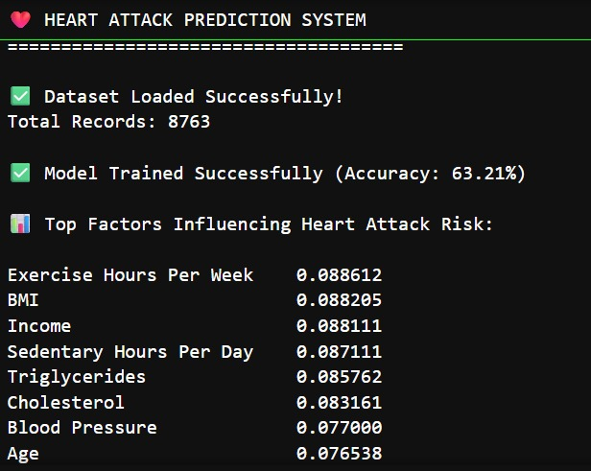

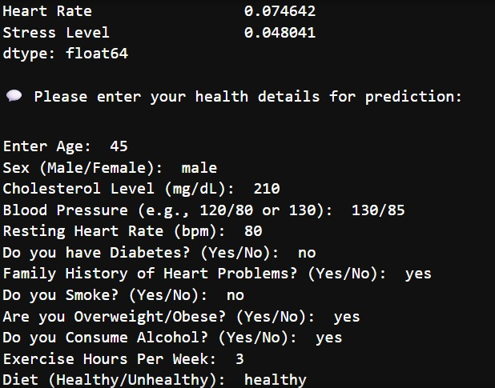

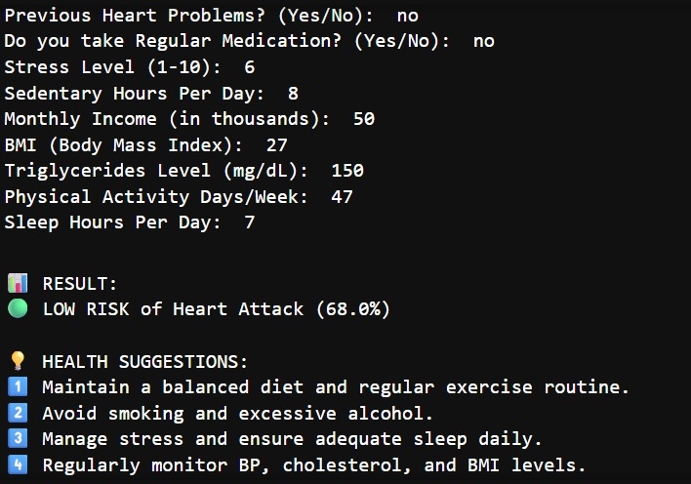

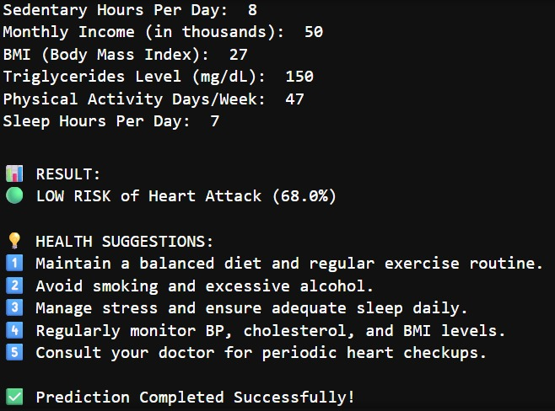

Technical Summary – Heart Attack Prediction Using Machine Learning:

This project builds a machine learning–based system to predict an individual’s heart attack risk using health and lifestyle factors such as age, cholesterol, blood pressure, and BMI. A Random Forest Classifier analyzes the dataset to classify risk levels as low, moderate, or high, providing real-time predictions and health suggestions to promote early detection and prevention.
Objective
To analyze a medical dataset containing various patient health metrics and predict the likelihood of a heart attack using machine learning techniques
Dataset
The dataset (heart.xlsx) contains anonymized patient health data with attributes such as:
- Age, Sex, Cholesterol, Blood Pressure, Heart Rate, Diabetes, Family History, Obesity, Alcohol Consumption, Exercise Hours, Diet, BMI, Stress Level, etc.
The target column is Heart Attack Risk, labeled as Low / High / Moderate.

Technical Workflow

1. Data Loading
The dataset is loaded using Pandas from an Excel file.

2. Data Cleaning
- Removed irrelevant columns.
- Extracted systolic values from blood pressure readings (e.g., “120/80” → 120).
- Replaced missing numeric values with mean of the respective columns.

3. Encoding
Categorical columns such as Sex, Smoking, Diabetes, etc. were encoded into numeric form using LabelEncoder for model training.

4. Feature Selection
Separated independent features (X) and target variable (y) for prediction.

5. Train–Test Split
Dataset split into 80% training and 20% testing using train_test_split.

6. Model Training
Used Random Forest Classifier, a robust ensemble algorithm suitable for tabular medical data.

7. Model Evaluation
Model achieved an accuracy of approximately (prints dynamically in output) %.
Predictions were compared against actual outcomes using accuracy metrics.

8. Feature Importance
Top 10 most influential features were identified using model.feature_importances_.
Common key indicators include:
- Cholesterol, Age, Blood Pressure, BMI, Stress Level, Heart Rate, and Exercise Hours.

9. User Prediction Interface
The program takes real-time user input for health metrics, preprocesses the data, and predicts risk level.
The probability output determines the risk category:
- 🔴 High Risk → Probability > 75%
- 🟠 Moderate Risk → 50–75%
- 🟢 Low Risk → < 50%

10. Health Suggestions
The system provides actionable advice for prevention, such as:
- Maintain a healthy diet and regular exercise.
- Avoid smoking and alcohol.
- Manage stress and ensure sufficient sleep.
- Regularly monitor BP, cholesterol, and BMI.
- Periodic heart checkups are recommended.

Tools and Libraries
• Python
• Pandas, NumPy – Data handling and preprocessing
• Scikit-learn – Model building, encoding, and evaluation
• Matplotlib / Seaborn – Visualization (for importance and analysis)
• Excel – Dataset storage and manipulation

Visulazation of project through diagrams:
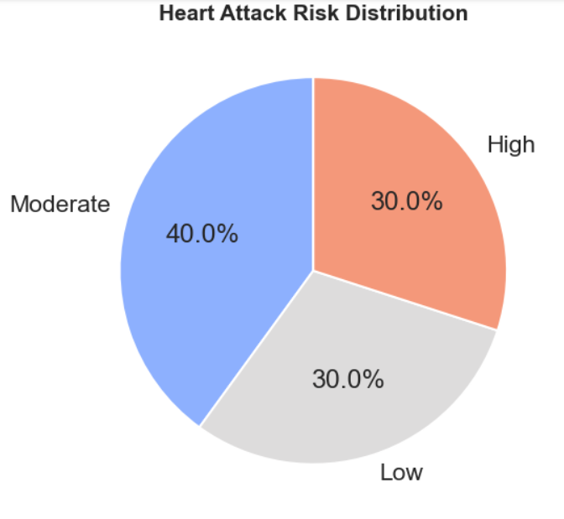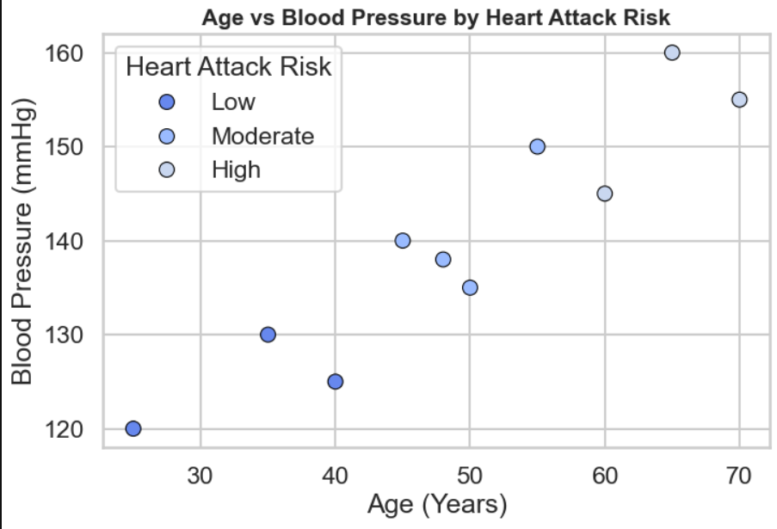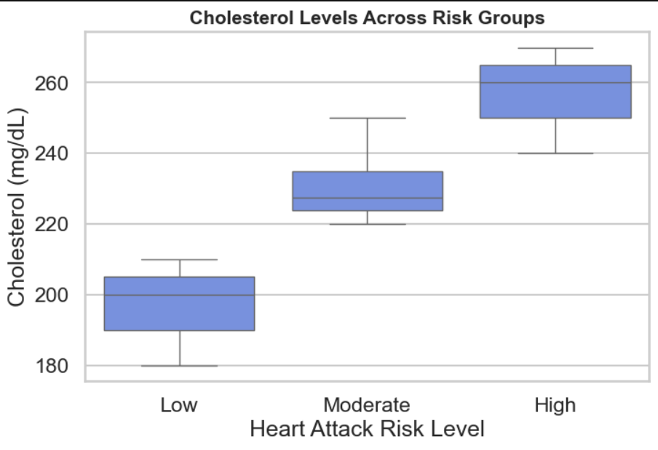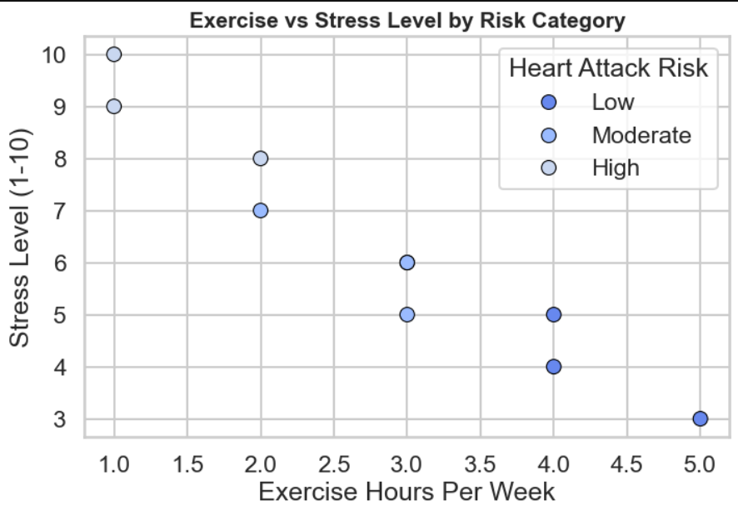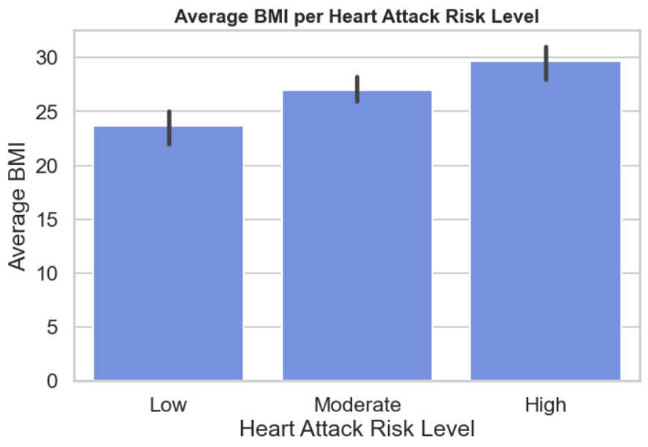
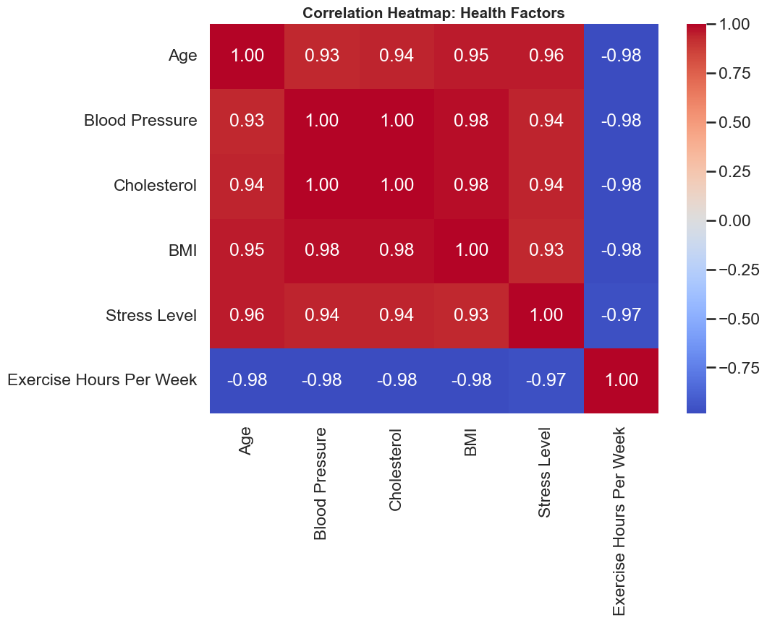

Key Learnings
• Implemented a full Machine Learning workflow from data preprocessing to prediction.
• Gained understanding of feature encoding and data cleaning in medical datasets.
• Learned the use of ensemble methods (Random Forest) for classification.
• Interpreted model accuracy and feature importance.
• Built a user-interactive prediction system for real-time heart risk assessment.

Conclusion:-
The Heart Attack Prediction System successfully predicts an individual’s heart attack risk level using machine learning.
It processes real health parameters, classifies user risk, and provides preventive health advice.
This system demonstrates how AI can contribute to early diagnosis and healthcare awareness, forming the foundation for future clinical decision support systems.

GitHub Repository Link :-

