Insurance Premium Prediction

Wireframe Document

Homepage

Homepage consists of single page having different input sections and submit button. The page designed in such way that user can inserts their inputs according to their health information. There are 6 input sections in the homepage where the user will have to enter their health status and other information.

On the navbar we have added some links related to the project like source code, about, and GitHub.

After filling the information webpage looks like

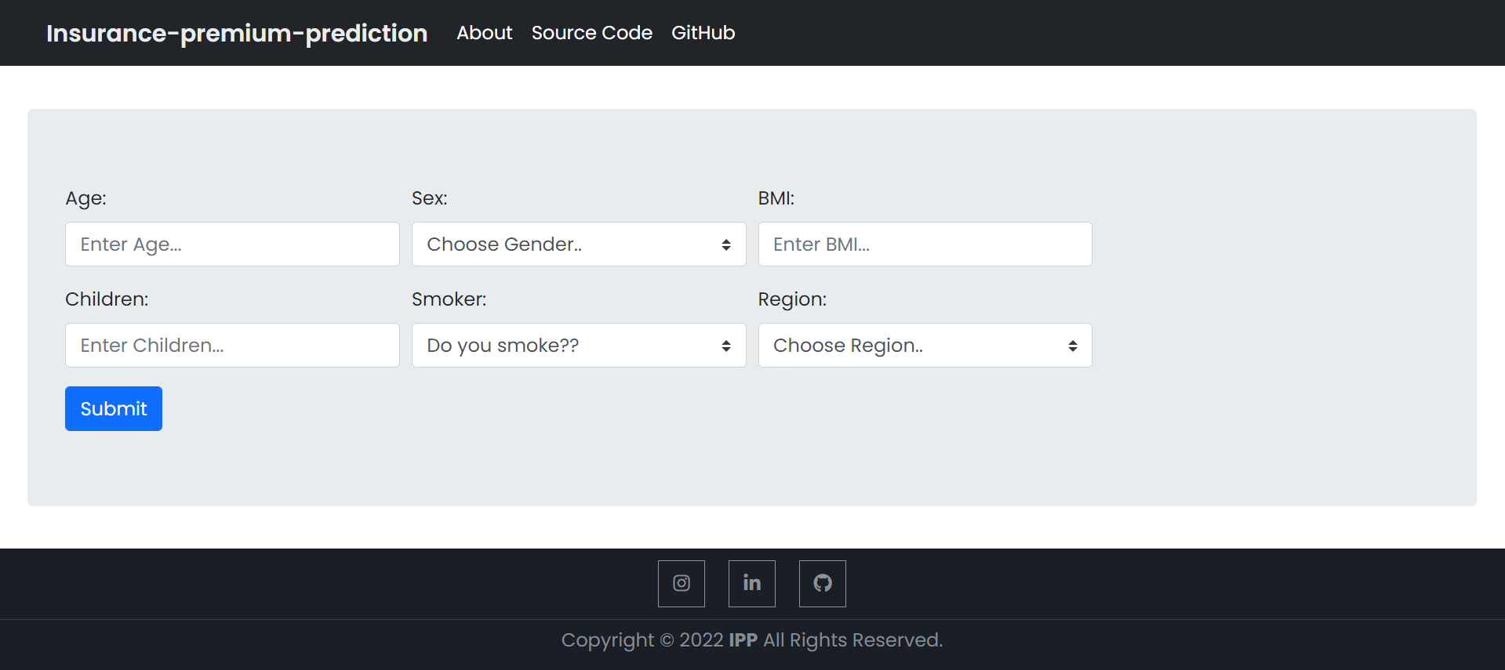

Prediction Page

Based on User’s input, our insurance model will predict the output of expense of premium insurance on the predict page.

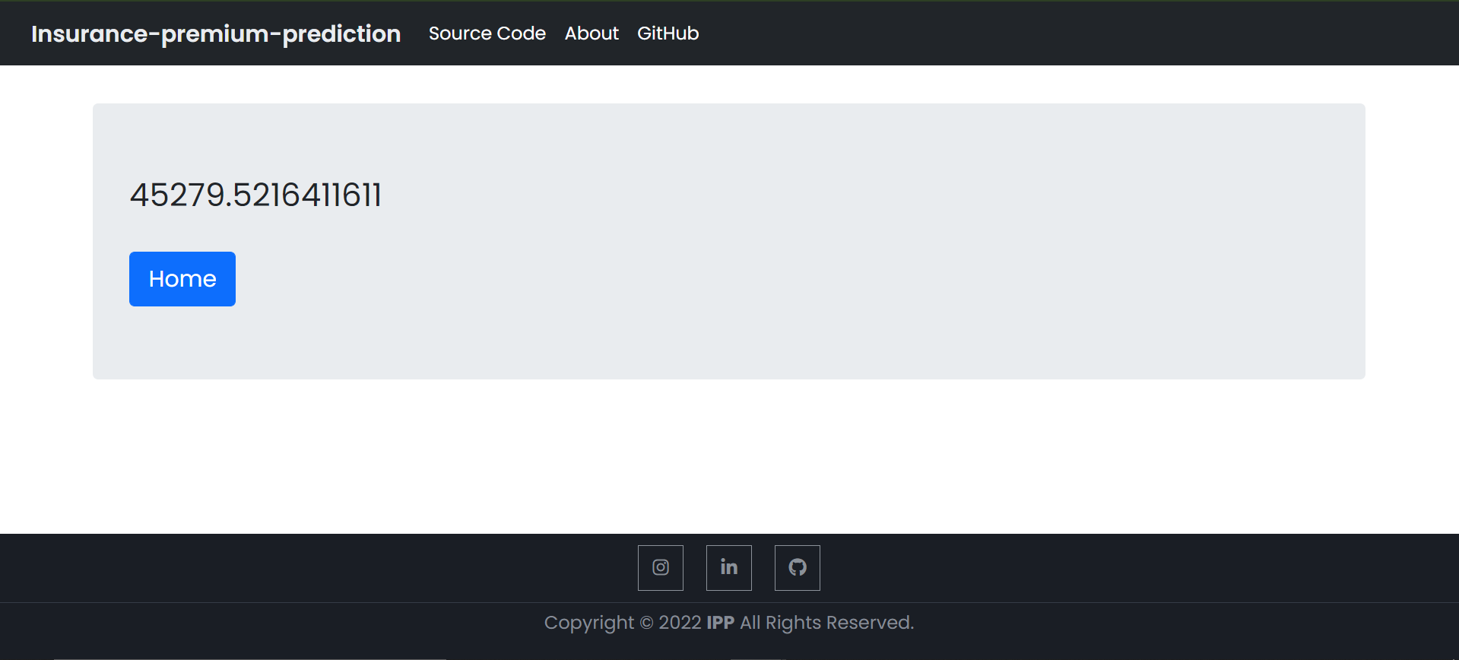

This is how the prediction page will look like after clicking or submit button. Here, we also add some links in header and footer.

About Page

In about page, we have some information about the project like what approaches we had used in the project like this.

