# ACKNOWLEDGEMENT

We would like to extend our sincere gratitude to all those who supported the completion of this report on the Transaction Processing System (TPS) for eSewa. Special thanks to our instructor, Mr. Sushant Poudel, for his valuable guidance and motivation throughout the development of this report. We also acknowledge the resources and documentation that helped us understand the technical and practical applications of eSewa as a payment gateway.

# ABSTRACT

This report, titled 'Transaction Processing System for eSewa', provides a comprehensive overview of Nepal’s first digital wallet and payment gateway system. eSewa has revolutionized the digital transaction landscape in Nepal by providing secure, real-time, and accessible payment services to users across the country. The study explores the technical and operational structure of eSewa's Transaction Processing System (TPS), its integration via APIs, and the challenges faced during implementation. It highlights the advantages such as financial transparency, reduced cash dependency, and secure transactions. By examining eSewa's functionality, this report presents how TPS has enhanced the financial ecosystem, making it more efficient, data-driven, and secure.

Table of Contents

ACKNOWLEDGEMENT ii

ABSTRACT iii

CHAPTER ONE: INTRODUCTION v

1.1 Introduction of the Report and the Organization v

1.2 Introduction to the System v

1.3 Methodology for Transaction Processing System Report for eSewa vi

1.4 Project Framework vi

1.5 Tools Used vii

CHAPTER TWO: TASK AND ACTIVITIES PERFORMED viii

2.1 Analysis of Task and Activities viii

2.2 Analysis of Problems viii

2.3 Additional Tasks and Activities ix

2.4 Requirement Analysis ix

Use Case Diagram for Transaction Processing System (TPS) x

2.5 SWOT Analysis xi

CHAPTER THREE: DISCUSSION AND CONCLUSION xii

3.1 Discussion xii

3.2 Conclusion xiii

REFERENCES xiv

# CHAPTER ONE: INTRODUCTION

## 1.1 Introduction of the Report and the Organization

A Management Information System (MIS) is a structured combination of people, processes, and technology used by organizations to support operations, management, and decision-making. eSewa, launched in 2009, is Nepal’s first and most widely used digital wallet and online payment gateway. It plays a critical role in Nepal’s transition towards a cashless economy by facilitating electronic transactions through mobile and web platforms.  
  
This report explores how eSewa utilizes its Transaction Processing System (TPS) as part of its broader MIS to support secure, real-time payment processing. TPS in eSewa handles large volumes of transaction data, enabling users to pay utility bills, perform mobile top-ups, purchase tickets, and transfer funds electronically.  
  
Through this report, we examine the inner workings of eSewa’s TPS, analyze its features, and discuss the impact on Nepal’s digital economy.

## 1.2 Introduction to the System

The Transaction Processing System (TPS) of eSewa is the core engine responsible for processing and recording financial transactions across its platform. Designed to manage both synchronous and asynchronous operations, the TPS supports a wide range of transactions such as peer-to-peer transfers, merchant payments, government fee submissions, and more.   
  
The TPS includes several subsystems like API transaction handlers, verification modules, and fraud detection mechanisms. It is integrated with banks and merchants through secure APIs, ensuring seamless transaction execution and confirmation. Users interact with the system through a web interface or mobile app, which communicates with the backend servers via secure channels.

## ****1.3 Methodology for Transaction Processing System Report for eSewa****

To develop this report on the Transaction Processing System of eSewa, a structured methodology was employed. The process began with detailed literature review and case study analysis, focusing on digital payment systems in Nepal. The data was primarily derived from the eSewa developer documentation, academic resources, and historical records of payment system evolution in Nepal.

The research involved qualitative and technical analysis of API documentation, system testing environments, and integration protocols used by eSewa. Techniques such as SWOT analysis and problem identification were applied to understand the strengths, limitations, and future opportunities of eSewa’s TPS.

## ****1.4 Project Framework****

The **project framework** outlines the structured approach taken during the development and study of eSewa’s **Transaction Processing System (TPS)**.

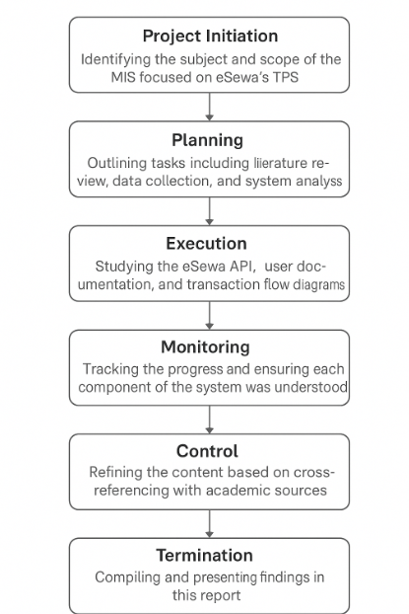

**Figure 1.2: Project Framework**

The project followed a typical research framework comprising six key stages:

1. **Project Initiation** – Identifying the subject and scope of the MIS focused on eSewa’s TPS.
2. **Planning** – Outlining tasks including literature review, data collection, and system analysis.
3. **Execution** – Studying the eSewa API, user documentation, and transaction flow diagrams.
4. **Monitoring** – Tracking the progress and ensuring each component of the system was understood.
5. **Control** – Refining the content based on cross-referencing with academic sources.
6. **Termination** – Compiling and presenting findings in this report.

## ****1.5 Tools Used****

The following tools and technologies were relevant in the development and understanding of the eSewa TPS:

* **Visual Studio Code**: Used for writing and testing code snippets including HTML, CSS, and PHP.
* **HTML/CSS/PHP**: Languages used to demonstrate integration and verification of eSewa API.
* **eSewa Developer API Hub**: Provided documentation, parameters, test environment, and transaction flow.
* **Draw.io**: Used to model the system architecture and flow diagrams.
* **UAT and Production Portals**: Accessed to simulate the transaction process and observe system behavior.

# 

# ****CHAPTER TWO: TASK AND ACTIVITIES PERFORMED****

This chapter outlines the steps and processes involved in analyzing the Transaction Processing System (TPS) of eSewa. It highlights the research activities, system evaluations, and data collection performed to understand how eSewa’s digital infrastructure functions in practice.

## ****2.1 Analysis of Task and Activities****

A detailed evaluation of eSewa's operational workflow was conducted through case study analysis of its API documentation and transaction flow structure. The following were identified:

* **System Evaluation**: Studied the structure and logic behind eSewa’s transaction flow—initiating, verifying, and confirming transactions via its API.
* **Transaction Test Environment**: Executed transaction samples in the test environment (uat.esewa.com.np) to monitor system behavior.
* **Integration Steps**: Observed merchant setup requirements, including success and failure redirection paths, product ID parameters, and transaction verification.
* **Developer Guide Study**: Assessed how API calls are formed, transmitted, and verified with secure endpoints.

## ****2.2 Analysis of Problems****

Although eSewa is an advanced platform in Nepal, some challenges in its TPS implementation were noted:

* **Merchant Onboarding Complexity**: The setup process for new merchants could be simplified for better adoption.
* **Test-to-Production Transition**: Some inconsistencies between the test and live environments require attention during integration.
* **Fraud Detection Limitations**: While IPN (Instant Payment Notification) exists, the absence of AI-driven fraud monitoring poses a risk.
* **Duplicate (pid) Values**: Reusing the same product ID during testing leads to transaction failure, requiring more dynamic ID generation logic.
* **Limited Error Transparency**: Error messages returned by the system can sometimes lack clarity for developers or users.

## ****2.3 Additional Tasks and Activities****

To gain further insight into TPS performance and structure, the following were performed:

* **System Performance Testing**: Verified how the test environment handles multiple transactions under load.
* **User Flow Simulation**: Followed the complete flow from transaction initiation to success/failure response handling.
* **Security Review**: Reviewed the HTTPS protocol and encryption mechanisms in transaction communication.
* **Documentation Review**: Compared official documentation against real-time API behavior to identify inconsistencies.
* **Response Message Customization**: Explored how success/failure messages can be customized for the merchant environment.

## ****2.4 Requirement Analysis****

Requirement analysis involves identifying what the system should do (functional requirements) and how it should perform (non-functional requirements). For eSewa’s TPS, the analysis is as follows:

#### a) ****Functional Requirements****

* **Transaction Management**: Users and merchants should be able to initiate, view, and complete transactions.
* **API Communication**: Secure API endpoints must allow verification, transaction initiation, and redirection.
* **Merchant Integration**: Support for merchant onboarding, with unique credentials, merchant codes, and product IDs (pid).
* **Payment Verification**: Must support Instant Payment Notification (IPN) and verification via secure channels.
* **Response Handling**: Ability to customize success (su) and failure (fu) URLs for post-transaction redirection.
* **Testing Environment**: Should include UAT (User Acceptance Testing) with identical behavior to production mode.

## Use Case Diagram for Transaction Processing System (TPS)

Below is a use case diagram for the TPS of Esewa, showing the primary actors and their interactions with the system.

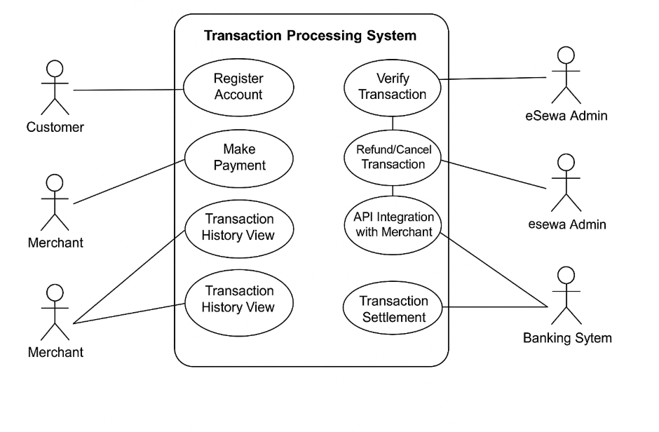

**Figure 1.4: Use case diagram of Transaction Processing System of esewa**

#### b) ****Non-Functional Requirements****

* **Security**: Encrypted communication (HTTPS), verified merchant credentials, and fraud protection mechanisms.
* **Reliability**: Should support high transaction volume with minimum failure rate.
* **Scalability**: Must scale with increasing users, merchants, and transaction volume.
* **Usability**: Should be easy for both developers (integration) and users (payments) to use.
* **Maintainability**: APIs and systems should be well-documented and regularly updated.

## ****2.5 SWOT Analysis****

An assessment of eSewa's Transaction Processing System using SWOT reveals the following:

#### ****Strengths****

* **Pioneer in Nepal**: First digital wallet and payment gateway licensed by Nepal Rastra Bank.
* **User Base**: Over 6 million users, with high adoption in urban and semi-urban areas.
* **Multi-Platform Access**: Available via mobile apps (Android & iOS) and web portal.
* **API Integration**: Provides robust API and testing tools for merchant integration.

#### ****Weaknesses****

* **Limited AI-based Fraud Detection**: Relies on rule-based verification instead of predictive analysis.
* **Error Transparency**: System-generated error messages are often too generic for debugging.
* **Merchant Dependence**: Heavy reliance on merchants to implement proper redirection and validation logic.

#### ****Opportunities****

* **Rural Expansion**: Potential to expand digital payment use in rural areas through local partnerships.
* **Feature Enhancements**: Can add recurring billing, subscription models, and more detailed analytics.
* **Cross-Border Integration**: Future integration with international gateways can extend eSewa’s usability.

#### ****Threats****

* **Market Competition**: Strong competition from ConnectIPS, Khalti, and emerging fintech apps.
* **Cybersecurity Risks**: As a financial platform, it is a frequent target for fraud and hacking attempts.
* **Regulatory Changes**: May be impacted by new government regulations on digital finance.

# ****CHAPTER THREE: DISCUSSION AND CONCLUSION****

## ****3.1 Discussion****

The Transaction Processing System (TPS) of eSewa serves as the backbone of Nepal’s most widely adopted digital wallet. It has dramatically transformed the nation’s financial ecosystem by enabling real-time digital payments and reducing dependency on physical cash.

The TPS supports various transaction types, including utility payments, mobile top-ups, e-commerce purchases, and P2P transfers. It is designed with a modular architecture that integrates seamlessly with merchants through secured APIs. Features like Instant Payment Notification (IPN), success/failure URL redirection, and payment verification ensure that transactions are not only efficient but also secure.

A major accomplishment of eSewa’s TPS is its UAT (User Acceptance Testing) environment, which allows merchants and developers to test their integrations before going live. The system’s layered architecture supports multi-level verification, encryption, and transaction logging.

Despite its achievements, the system also faces challenges such as potential fraud risks, limited clarity in error reporting, and competitive pressure from newer fintech platforms. Improvements in user experience, machine-learning-based fraud detection, and multilingual support can significantly enhance the system’s reliability and inclusivity.

The TPS structure reflects a well-developed MIS, where data is centralized, accessible, and actionable—helping administrators, merchants, and users make informed decisions with confidence.

## ****3.2 Conclusion****

eSewa’s Transaction Processing System (TPS) is a benchmark example of how MIS can be effectively applied in the digital payment sector. It not only ensures accurate, fast, and secure handling of financial transactions but also supports national goals of transparency and digital inclusion.

Through an efficient MIS backed by real-time transaction tracking and API-based integration, eSewa has laid the foundation for Nepal's transition to a cashless society. The system enables operational efficiency for both users and merchants, helping improve data accuracy and security while enhancing decision-making at every level.

In conclusion, eSewa’s TPS is not just a technical infrastructure—it is a digital enabler of economic growth and transformation in Nepal.

# 

# ****REFERENCES****

* Belbase, P. (2021). A Case Study on the E-Sewa Online Payment Gateway. Centria University of Applied Sciences.
* eSewa. (2019). Developer API Documentation. Retrieved from: <https://developer.esewa.com.np/>
* Timilsina, S. (2019). Payments Systems Development in Nepal. ResearchGate.
* Ten, M. (2004). ePayment – The Digital Exchange. Google Books.
* Socialnomics. (2020). The Future of Mobile Payment Technology. Retrieved from: <https://socialnomics.net/2020/02/29/the-future-of-mobile-payment-technology/>
* AltexSoft. (2019). What is API: Definition, Types, Specification, Documentation. Retrieved from: <https://www.altexsoft.com/blog/engineering/what-is-api-definition-types-specifications-documentation/>
* W3Schools. (2021). HTML, CSS, PHP Documentation. Retrieved from: <https://www.w3schools.com/>
* Guru99. (2021). API Testing Tutorial: What is API Test Automation? How to test? Retrieved from: <https://www.guru99.com/api-testing.html>