Practical No. 1

Aim: HDFS: List of Commands (mkdir, touchz, copy from local/put, copy to local/get, move from local, cp, rmr, du, dus, stat).

- -mkdir: To create a directory.
hadoop fs -mkdir /user/cloudera/thursday
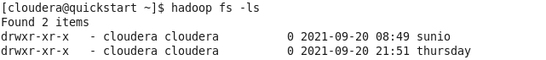

- -touchz: It creates an empty file.
hadoop fs -touchz /user/cloudera/thursday/sample.txt
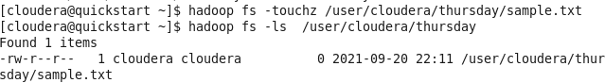

- CopyFromLocal: To copy files/folders from local file system to hdfs store.
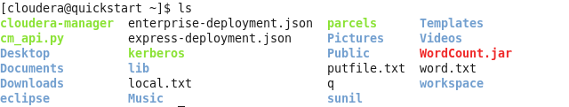
hadoop fs -copyFromLocal local.txt /user/cloudera/thursday
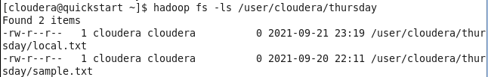

- put
hadoop fs -put /home/cloudera/putfile.txt /user/cloudera/thursday
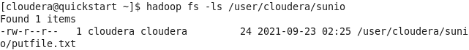
- CopyToLocal: To Copy files/folders from hdfs store to local file system.
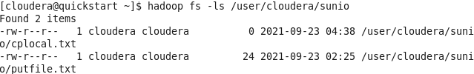
hadoop fs -copyToLocal /user/cloudera/sunio/cplocal.txt /home/cloudera/sunil
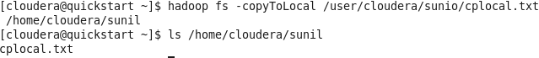
- get
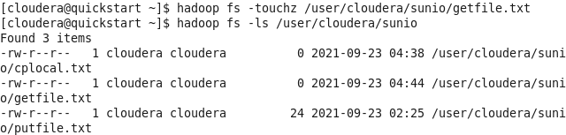
hadoop fs -get /user/cloudera/sunio/getfile.txt /home/cloudera/sunil
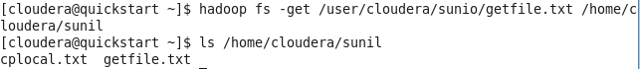
- moveFromLocal: This command will move file from local to hdfs.
hadoop fs -moveFromLocal /home/cloudera/sunil/mvfromlocal.txt /user/cloudera/sunio
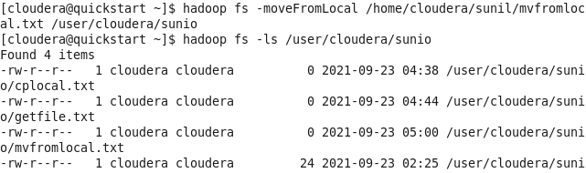
- cp: This command is used to copy files within hdfs.
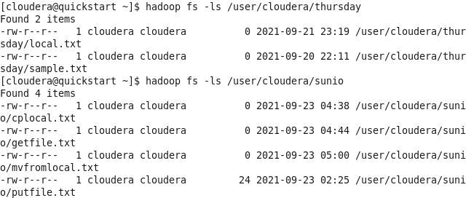
hadoop fs -cp /user/cloudera/sunio/cplocal.txt /user/cloudera/sunio
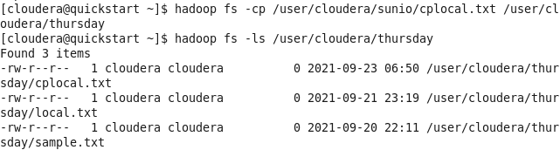
- rmr: This Command delete a file from HDFS recursively.
hadoop fs -rmr /user/cloudera/thursday

- du: It will give the size of each file in directory.
hadoop fs -du /user/cloudera/sunio
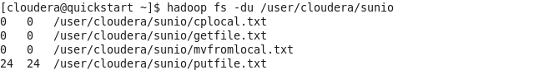
- dus: This command will give the total size of the directory/file.
hadoop fs -dus /user/cloudera/sunio
- stat: It will give the last modified time of directory or path.
hadoop fs -stat /user/cloudera/sunio

