Practical No. 2

- Aim: Write a program in Map Reduce for Word Count operation.
Code:
import java.io.IOException;
import java.util.StringTokenizer;
import org.apache.hadoop.conf.Configuration;
import org.apache.hadoop.fs.Path;
import org.apache.hadoop.io.IntWritable;
import org.apache.hadoop.io.Text;
import org.apache.hadoop.mapreduce.Job;
import org.apache.hadoop.mapreduce.Mapper;
import org.apache.hadoop.mapreduce.Reducer;
import org.apache.hadoop.mapreduce.lib.input.FileInputFormat;
import org.apache.hadoop.mapreduce.lib.output.FileOutputFormat;

public class WordCount
{
public static class TokenizerMapper extends Mapper<Object, Text, Text, IntWritable>
{
private final static IntWritable one=new IntWritable(1);
private Text word=new Text();

public void map(Object key,Text Value,Context context)throws IOException,InterruptedException
{
StringTokenizer itr=new StringTokenizer(Value.toString());
while(itr.hasMoreTokens())
{
word.set(itr.nextToken());
context.write(word, one);
}
}
}
public static class IntSumReducer extends Reducer<Text, IntWritable,Text,IntWritable>
{
private IntWritable result=new IntWritable();

public void reduce(Text key,Iterable<IntWritable>values,Context context)throws IOException,InterruptedException
{
int sum=0;
for(IntWritable val:values)
{
sum=sum+val.get();
}
result.set(sum);
context.write(key, result);
}
}
public static void main(String[] args)throws Exception
{
Configuration conf=new Configuration();
Job job=Job.getInstance(conf,"word count");
job.setJarByClass(WordCount.class);
job.setMapperClass(TokenizerMapper.class);
job.setReducerClass(IntSumReducer.class);
job.setCombinerClass(IntSumReducer.class);
job.setOutputKeyClass(Text.class);
job.setOutputValueClass(IntWritable.class);

FileInputFormat.addInputPath(job,new Path(args[0]));
FileOutputFormat.setOutputPath(job, new Path(args[1]));
System.exit(job.waitForCompletion(true)?0:1);
}
}
Input File:
Output:
hadoop jar WordCounr.jar WordCount /idata/word.txt/output1.txt
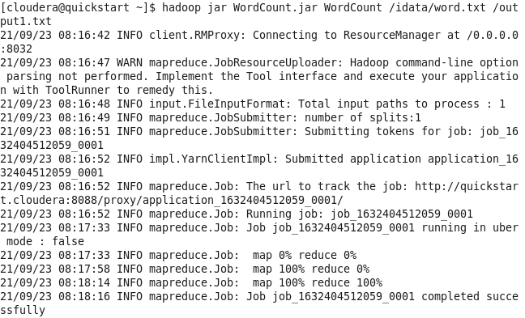
hadoop fs -cat /output1/part-r-00000
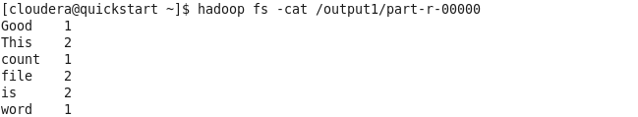

- Aim: Write a program in Map Reduce for Union operation.
Code:
import java.io.*;
import java.util.StringTokenizer;
import org.apache.hadoop.conf.Configuration;
import org.apache.hadoop.fs.Path;
import org.apache.hadoop.fs.FileSystem;
import org.apache.hadoop.io.LongWritable;
import org.apache.hadoop.io.IntWritable;
import org.apache.hadoop.io.Text;
import org.apache.hadoop.mapreduce.Job;
import org.apache.hadoop.mapreduce.Mapper;
import org.apache.hadoop.mapreduce.Reducer;
import org.apache.hadoop.mapreduce.lib.input.MultipleInputs;
import org.apache.hadoop.mapreduce.lib.input.TextInputFormat;
import org.apache.hadoop.mapreduce.lib.input.FileInputFormat;
import org.apache.hadoop.mapreduce.lib.output.FileOutputFormat;
import org.apache.hadoop.util.GenericOptionsParser;

public class Union {
public static class MultipleMaps extends Mapper<LongWritable,Text,Text,IntWritable>
{
private final static IntWritable one=new IntWritable(1);
private Text keyEmit=new Text();

public void map(LongWritable k,Text value,Context context)throws IOException, InterruptedException
{
StringTokenizer itr=new StringTokenizer(value.toString());
while(itr.hasMoreElements())
{
keyEmit.set(itr.nextToken());
context.write(keyEmit, one);
}
}
}
public static class MultipleReducer extends Reducer<Text,IntWritable,Text,IntWritable>
{
private IntWritable result=new IntWritable();
public void reduce(Text key,Iterable<IntWritable>values,Context context)throws IOException, InterruptedException
{
int sum=0;
for(IntWritable val:values)
{
sum +=val.get();
}
result.set(sum);
context.write(key, result);
}
}

public static void main(String[] args)throws Exception
{
if(args.length!=3)
{
System.err.println("No of arguments should be 3");
System.exit(0);
}
Configuration c=new Configuration();
String[] files=new GenericOptionsParser(c,args).getRemainingArgs();
Path p1=new Path(files[0]);
Path p2=new Path(files[1]);
Path p3=new Path(files[2]);
FileSystem fs=FileSystem.get(c);

if(fs.exists(p3)){
fs.delete(p3,true);
}

Job job=Job.getInstance(c,"Union");
job.setJarByClass(Union.class);

MultipleInputs.addInputPath(job,p1,TextInputFormat.class,MultipleMaps.class);
MultipleInputs.addInputPath(job,p2,TextInputFormat.class,MultipleMaps.class);

job.setReducerClass(MultipleReducer.class);
job.setCombinerClass(MultipleReducer.class);
job.setOutputKeyClass(Text.class);
job.setOutputValueClass(IntWritable.class);

FileOutputFormat.setOutputPath(job, p3);
boolean success=job.waitForCompletion(true);
System.exit(success?0:1);

}
}
Input File:
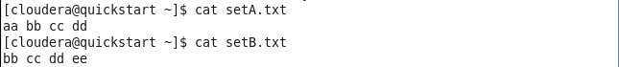
Output:
hadoop jar Union.jar Union /user/cloudera/inputfile/SetA.txt /user/cloudera/inputfile/SetB.txt /output_union
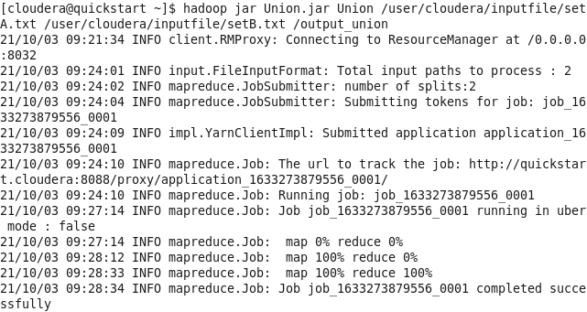
hadoop fs -cat /output_union/part-r-00000
