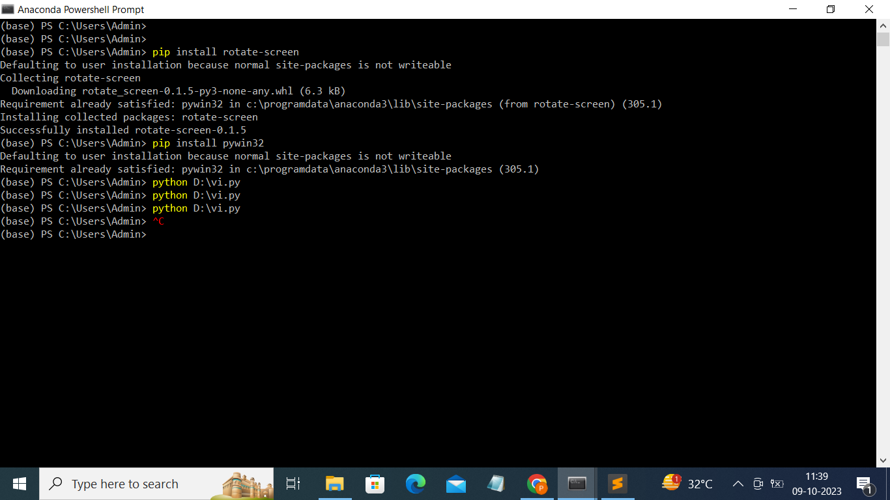

import time, rotatescreen as rs
pd = rs.get_primary_display()
angel_list = [90,180,270,0]
for i in range(3):
for x in angel_list:
pd.rotate_to(x)
time.sleep(0.5)

