

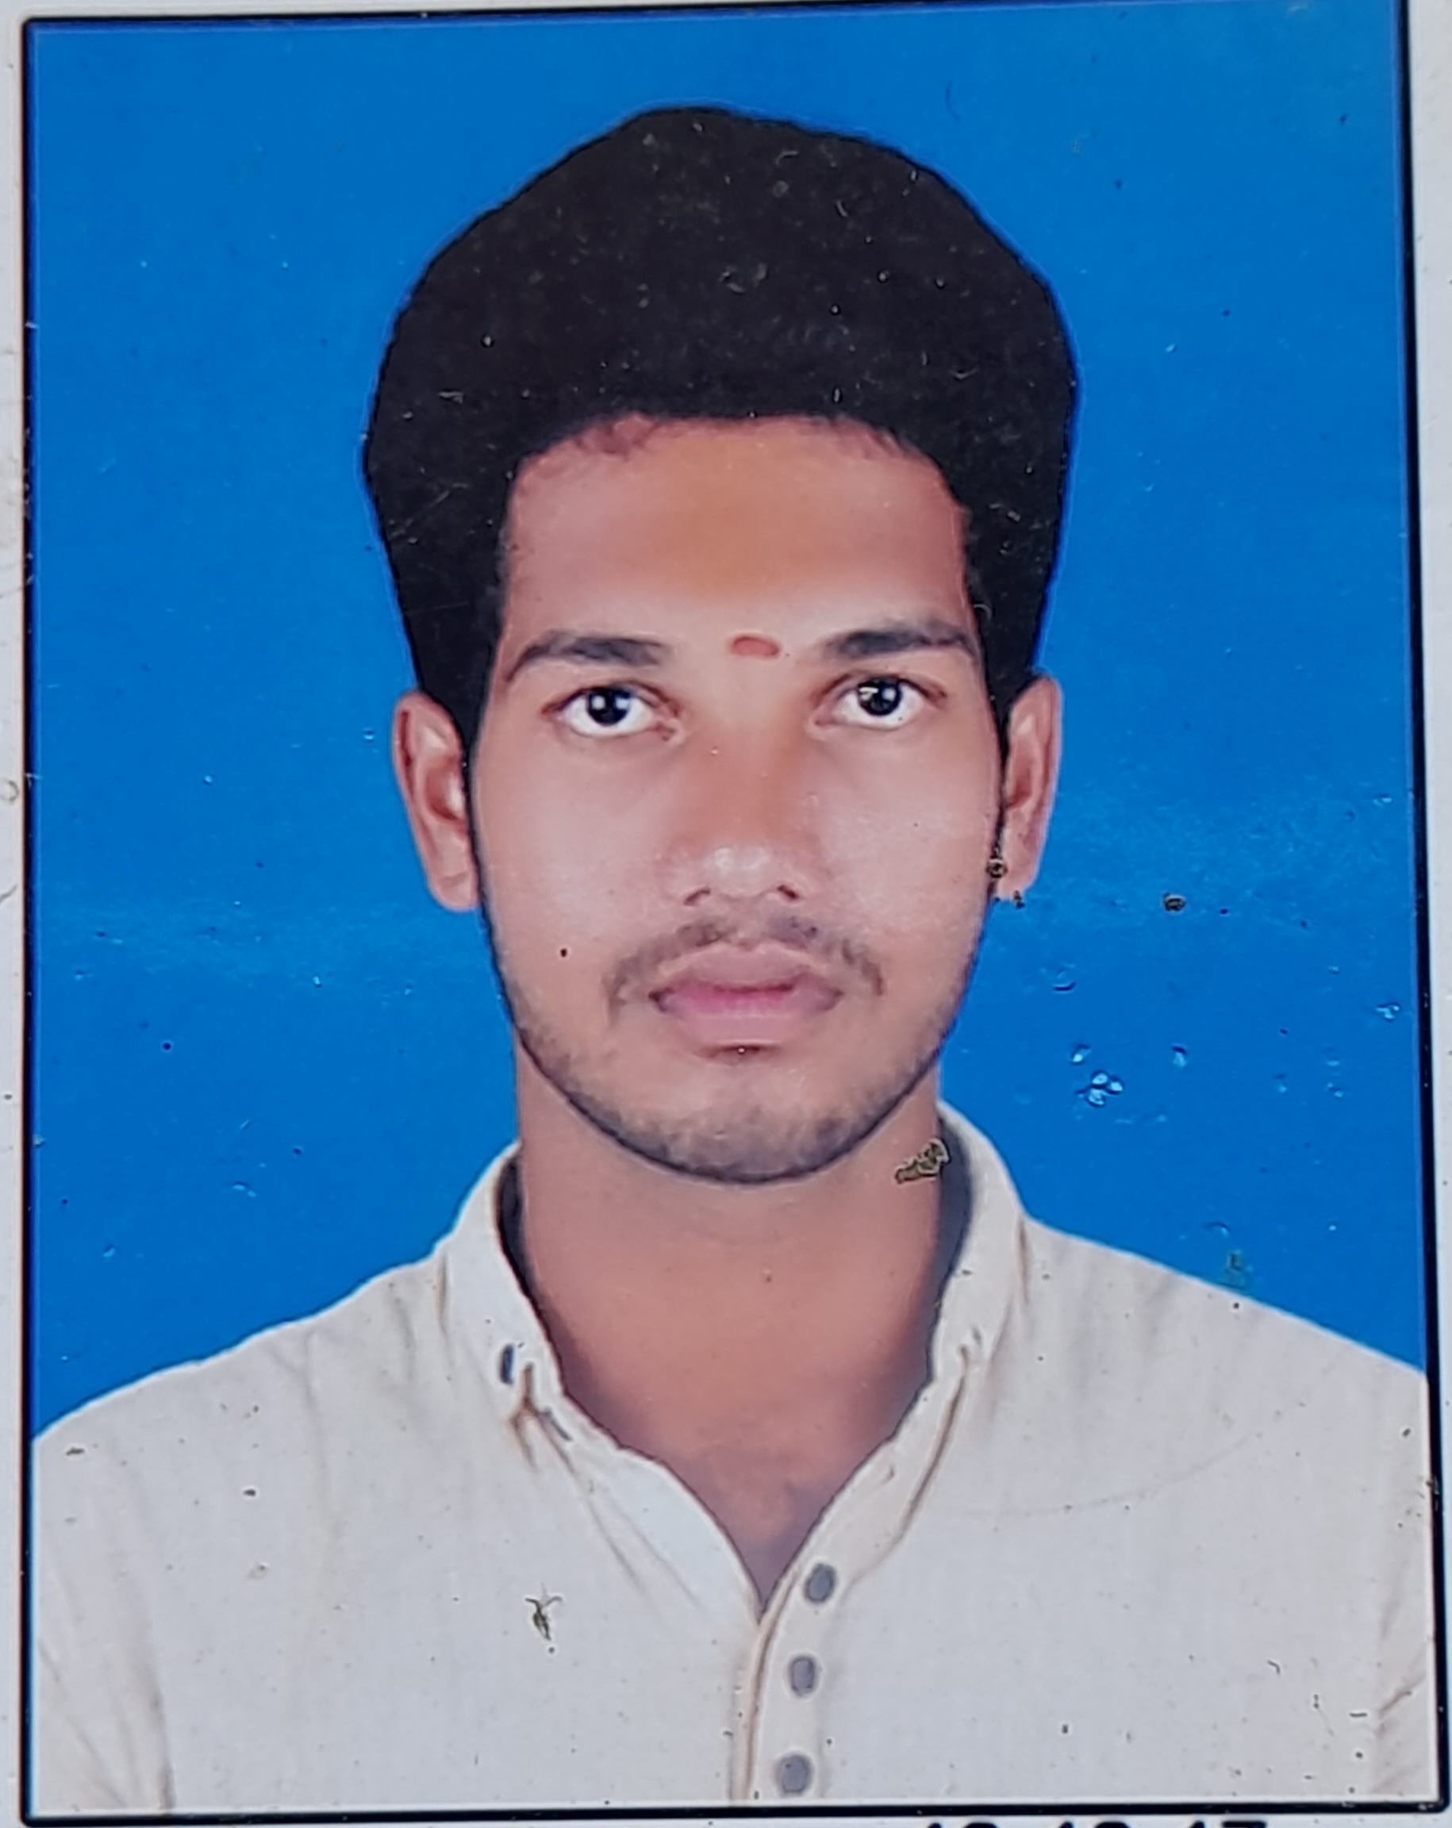

**Raju Avula**

**Address:**  H.NO: 11-3/2 kojankothur, Ibrahimpatnam (505450)

**Phone No:** 9542149139

**Email ID**: rajurj6987@gmail

**CAREER OBJECTIVE**

To be able to work for an encouraging and stable company that will assist me in developing, improving, and obtaining the necessary skills in order to become the best engineer possible. I am looking forward to challenging my potential and be worthy of Management trust and confidence.

**ACADMIC QUALIFICATION**

|  |  |  |  |  |
| --- | --- | --- | --- | --- |
| **Qualification** | **Institution** | **University/Board** | **Year of Passing** | **Percentage** |
| Bsc | Narendra degree college | Satavahana university  Karimnagar | 2019 | 85 |
| Intermediate | Aurora junior college | Board of Intermediate | 2016 | 67 |
| SSC | Zilla Parishad High School | S.S.C | 2014 | 65 |

**Technical** **Skills**

* HMTL, CSS, Python

**PERSONAL PROFILE**

Father Name : Ramesh

Date of Birth : 24/08/1998

Marital status : Un married

Gender : Male

Religion : Hindu

Nationality : Indian

Languages Known : Telugu, English

**DECLLERATION**

I hereby declare that the details above are correct and true to the best of my knowledge.

**Place:** kojankothur **Signature**

**Date:** 25-01-2023 A.Raju