TestNG :- is a framework as well as it is an execution engine.

What is testNG-: it is a framework [unit testing framework] Junit[ is not used that much] both TestNG and Junit –are unit testing framework

Why use TestNG instead of Junit –TestNG has better reporting system

Index.html

Emailable reports

Paramterization

Parallel execution

Testcases

Test suite

How to install testing ?

1)Go to eclipse and help menu bar 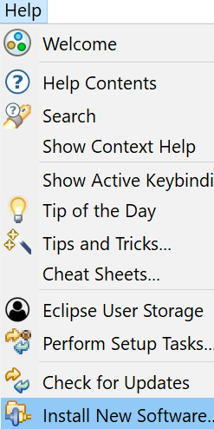

2) go to https://testng.org/doc/download.html

3) copy this URL < <https://testng.org/testng-eclipse-update-site>>

