Deepfake Analyzer: An Uncertainty-Aware Synthetic Media Risk Assessment System Using Gemini and Hugging Face Classifiers
Rajvardhan Patil, Kartik Patil, Hardhwardhan Patil, Bhavesh Patil
Information Technology - D
Vishwakarma Institute of Technology, Pune
The use of Deepfake Analyzer combines cloud-based Gemini vision analysis with an optional local Hugging Face fake/real classifier to screen uploaded images and videos for signs of synthetic media or visual manipulation. The system accepts common image and video formats, validates file extension and size, extracts sampled frames for videos when the local detector is enabled, and sends the original media to Gemini for a cautious visual review. Unlike a simple binary detector, the application returns a structured risk report containing a label, numerical risk score, confidence level, evidence items, limitations, detector signal, and recommended next steps. The method emphasizes uncertainty because classifier outputs and vision-model judgments can both fail on low-resolution portraits, compressed social-media files, edited photographs, or unseen generator families. Validation in the repository covers schema correctness, Gemini fallback behavior, detector calibration, temporary failure handling, and safeguards against high-confidence authenticity claims for low-information face images. The intended use is educational, research, moderation-support, and preliminary review workflows; the system is not designed to provide final forensic proof or legal conclusions.
Index Terms--deepfake detection, synthetic media analysis, Gemini vision, Hugging Face classifier, FastAPI, Pydantic schema, risk calibration, uncertainty-aware AI.

I. INTRODUCTION
Deepfake images and videos are increasingly difficult to identify through casual viewing because modern generative systems can reproduce realistic faces, plausible lighting, smooth skin, coherent backgrounds, and natural-looking motion. At the same time, ordinary media processing can introduce artifacts that look suspicious even when no malicious manipulation exists. A practical analyzer must therefore avoid a simplistic fake-versus-real conclusion and instead explain the level of risk, the evidence behind the assessment, and the limits of the available media.
Deepfake Analyzer is implemented as a screening system for this uncertain setting. Its purpose is to help a user decide whether an uploaded image or video requires deeper provenance checking, source comparison, or expert review. The project exposes the same analysis logic through a FastAPI endpoint, a static web interface, and a command-line interface. This allows the system to be used interactively in a browser, programmatically through JSON, or locally from a terminal during testing.
The remainder of this paper explains the design of the system, the role of the optional local classifier, the Gemini prompt strategy, the schema used to constrain outputs, the calibration logic used when signals disagree, and the validation approach used in the current repository.
II. RELATED WORK
Synthetic media detection systems commonly rely on either visual artifact analysis, learned fake/real classifiers, metadata inspection, or human review. Learned classifiers are useful because they can detect patterns that are not obvious to a human reviewer. However, they may also overfit to the generator families, compression settings, and image domains seen during training. A classifier that performs well on one benchmark may become less reliable when a new generator, editing pipeline, or camera distribution appears.
Vision-language models offer a different kind of signal. They can describe visible anomalies, quality limits, and temporal concerns in natural language, but they are not forensic instruments and can hallucinate unsupported observations if prompted carelessly. Deepfake Analyzer combines these two families of signals while deliberately framing both as uncertain evidence. The local classifier becomes a supporting clue, while Gemini supplies a structured visual review that is forced into a Pydantic report schema.
III. PROPOSED SYSTEM
The proposed system follows a seven-stage pipeline. First, a user submits an image or video through the web UI, API, or CLI. Second, the file name, extension, file size, and media type are validated before any model call occurs. Third, if the Hugging Face detector is enabled, the system scores the image directly or extracts evenly spaced video frames and scores each frame. Fourth, the validated media file is uploaded to Gemini and analyzed with a prompt that asks for concrete visual or temporal evidence. Fifth, Gemini is required to return JSON matching the report schema. Sixth, the response is parsed and validated with Pydantic. Finally, the report is calibrated when a strong detector signal conflicts with a low-risk visual result or when a low-resolution portrait would otherwise be described as highly authentic.
This design separates evidence collection from final presentation. The detector is not allowed to prove authenticity, and Gemini is not allowed to return unconstrained prose. The final report includes both evidence and limitations so that a reviewer can understand why the result was produced and what should be checked next.

IV. METHODOLOGY
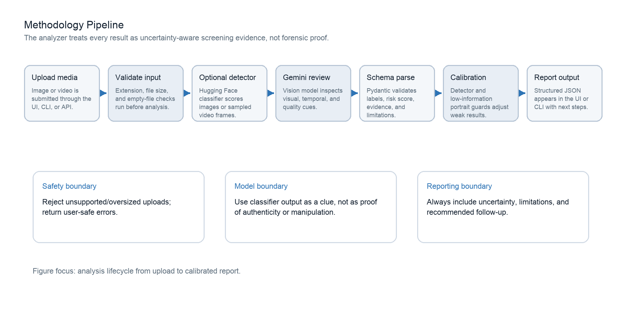
Fig. 1. Methodology pipeline used by Deepfake Analyzer.
The methodology begins with input control. The analyzer accepts only a small set of media formats: .jpg, .jpeg, .png, and .webp for images, and .mp4, .mov, .mkv, and .webm for videos. The default file limit is 100 MB. This validation protects the service from unsupported inputs and prevents unnecessary calls to external models when the upload is empty, too large, or not a recognized media type.
For image inputs, the local detector can classify the uploaded file directly. For videos, OpenCV is used to select evenly spaced frames. The number of sampled frames is controlled by HF_DETECTOR_VIDEO_FRAMES and clamped to a safe range. Each frame receives fake and real probabilities. For multi-frame inputs, the implementation averages the highest fake-probability frames so that a short suspicious segment is not completely diluted by clean-looking frames.
The Gemini prompt is designed as a cautious visual inspection checklist. It asks the model to look for face-boundary artifacts, lighting and shadow inconsistency, unnatural skin texture, distorted eyes, teeth, ears, hair, glasses, jewelry, synthetic background blur, lip-sync mismatch, abnormal blinking, gaze problems, temporal flicker, identity inconsistency, compression artifacts, and visible metadata clues. The prompt also tells the model not to invent observations and to lower confidence when media quality is insufficient.
The output of the model is not accepted as plain text. The analyzer requests a JSON response matching the DeepfakeReport schema. This schema requires a risk label, risk score, confidence value, summary, evidence list, limitations, and recommended next steps. The detector_signal field is removed from the Gemini schema request because the application adds it after validation. This prevents the language model from fabricating detector information.
V. SYSTEM ARCHITECTURE
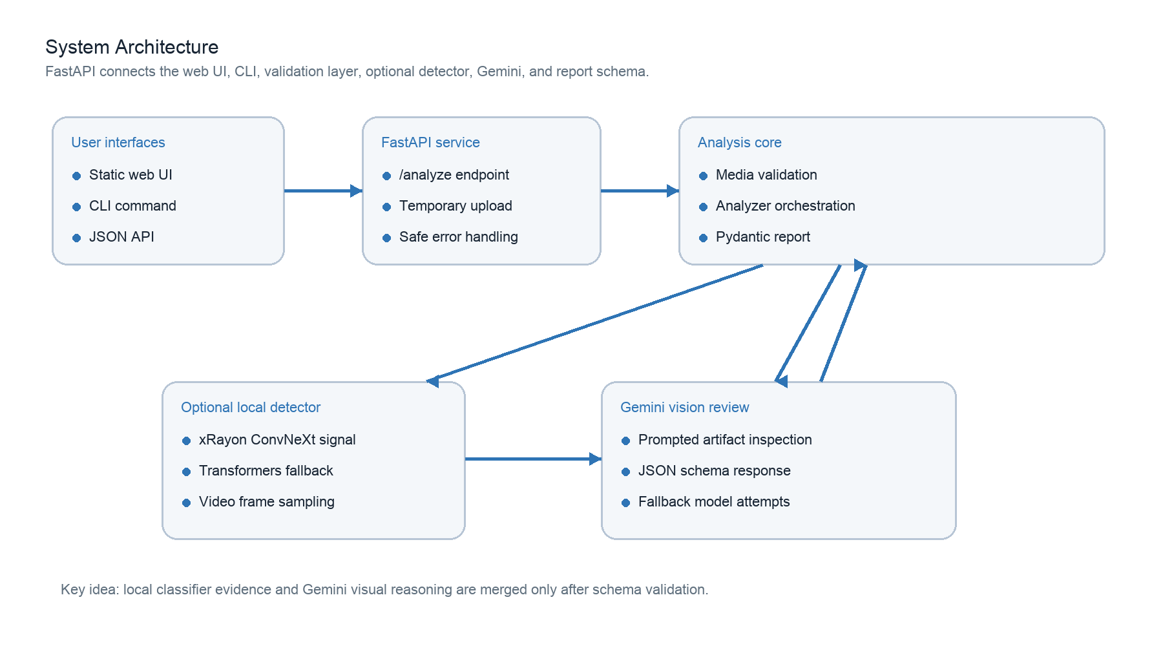
Fig. 2. High-level architecture of the application.
The architecture is divided into interface, service, validation, analysis, detector, and schema layers. The interface layer consists of the static browser UI and CLI. The service layer is implemented in FastAPI and exposes the health endpoint, static application routes, and POST /analyze. The validation layer lives in media_utils.py, where filename, extension, size, type, and video frame extraction behavior are defined. The analysis core in analyzer.py handles Gemini client creation, fallback model attempts, prompt assembly, JSON parsing, and calibration.
This separation makes the system easier to test because model calls, file validation, and schema validation can be mocked or asserted independently. It also improves safety: upload errors become 400-level validation messages, missing API keys become configuration errors, malformed Gemini responses become bad-gateway errors, and temporary overload becomes a retryable service-unavailable response.

VI. IMPLEMENTATION DETAILS
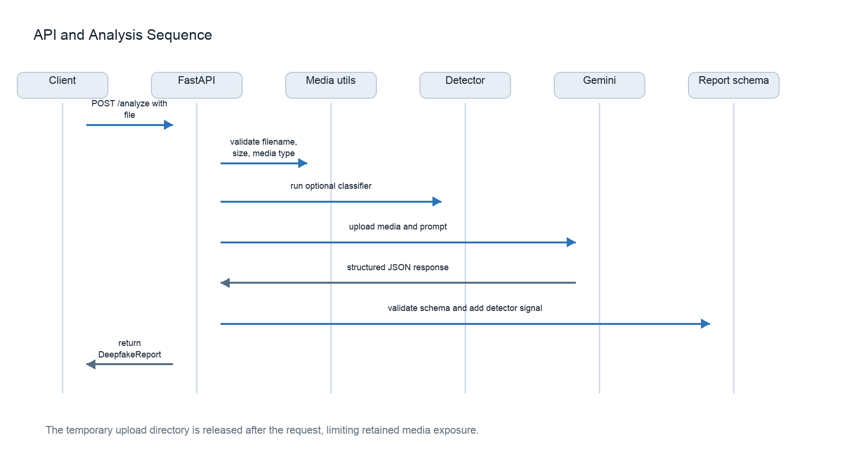
Fig. 3. API sequence for the analysis request.
The FastAPI endpoint receives an UploadFile object and saves it into a temporary directory using a normalized extension. The upload is streamed in chunks so that the size limit can be enforced while the file is being written. If the total number of bytes exceeds the maximum allowed size, the request fails before model analysis begins. The temporary directory is released after the request completes, which reduces retained media exposure during normal operation.
The analyzer creates a Google GenAI client using GEMINI_API_KEY. The default model configured in the repository is gemini-3.5-flash, with fallback models gemini-2.5-pro, gemini-2.5-flash, and gemini-2.5-flash-lite. Only transient API errors are retried across fallback models. The implementation treats status codes 429, 500, 503, and 504 as temporary conditions. Non-transient API errors are reported as request rejection problems so the user can check model access, quota, or uploaded media.
The optional Hugging Face detector is controlled by environment variables. HF_DETECTOR_ENABLED turns the detector on or off. HF_DETECTOR_MODEL selects the model. HF_DETECTOR_VIDEO_FRAMES controls how many video frames are sampled. HF_DETECTOR_FAKE_THRESHOLD determines the fake-label threshold and is clamped to avoid unsafe extremes. If detector loading fails or dependencies are unavailable, the detector path returns no signal and the Gemini analysis continues.
A. Detector Model Path
The default detector model is xRayon/convnext-ai-images-detector. For this path, the code loads a ConvNeXtV2 architecture through timm, downloads the checkpoint from Hugging Face, applies a 288-pixel resize, a 256-pixel center crop, tensor conversion, and ImageNet-style normalization. A Transformers-compatible fallback model can also be selected. In both paths, probabilities are normalized with softmax and converted into a DetectorSignal object.
B. Response Schema
The DeepfakeReport schema constrains the final result to four labels: likely_authentic, uncertain, suspicious, and likely_manipulated. It also restricts risk_score to 0 through 100, confidence to low, medium, or high, and evidence severity to low, medium, or high. Extra fields are forbidden. This is important because model-generated JSON can otherwise drift over time and silently change the application contract.

VII. RISK CALIBRATION
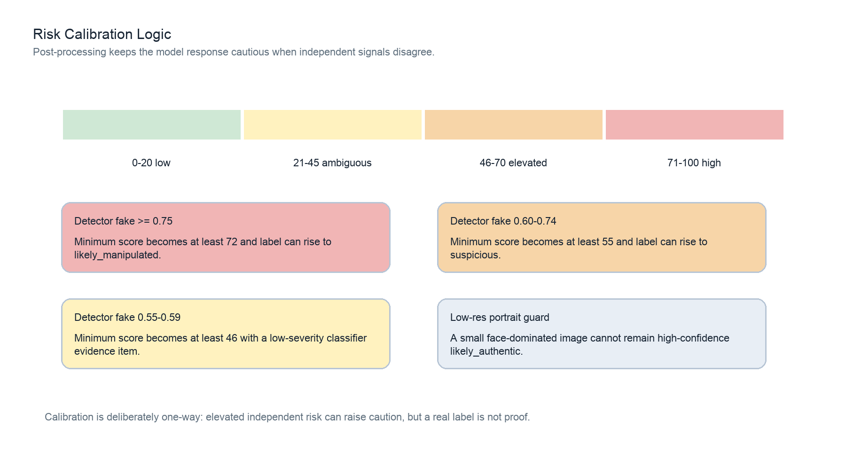
Fig. 4. Calibration thresholds used after Gemini analysis.
Calibration is applied after Gemini produces a valid report. The purpose is not to replace Gemini's visible-evidence reasoning, but to prevent the final result from being undercautious when an independent classifier finds elevated synthetic-media probability. If the detector label is not fake or the fake probability is below 0.55, the report is returned with the detector signal attached but without risk escalation.
When fake probability is at least 0.75, the calibrated risk score becomes at least 72 and the target label can rise to likely_manipulated. When fake probability is between 0.60 and 0.74, the score becomes at least 55 and the target label can rise to suspicious. When fake probability is between 0.55 and 0.59, the score becomes at least 46 and the classifier evidence is marked low severity. These thresholds create a conservative one-way caution mechanism.
The code also contains a low-information portrait guard. If an image is small and dominated by a detected face, and Gemini reports it as likely_authentic with a low score, the result can be shifted to uncertain with reduced confidence. This guard reflects an important deepfake-analysis reality: the absence of visible artifacts in a low-resolution face portrait is weak evidence. Compression, cropping, and scaling can erase exactly the visual cues the model needs.
Condition / Calibration Action
Fake >= 0.75: Raise minimum score to high risk; label may become likely_manipulated.
Fake 0.60-0.74: Raise minimum score to elevated risk; label may become suspicious.
Fake 0.55-0.59: Raise minimum score to elevated caution with low-severity classifier evidence.
Real label: Attach signal but do not treat as proof of authenticity.
Low-res portrait: Avoid high-confidence likely_authentic results when evidence is weak.

VIII. API, CLI, AND USER OUTPUT
The system exposes the same report through all user surfaces. The web UI renders upload controls, detector-signal information, risk labels, evidence, limitations, and recommended next steps. The JSON API makes the same report available to other tools. The CLI prints the report as formatted JSON so it can be used in local workflows, demonstrations, and tests.
The report is intentionally reviewer-oriented. The summary gives a concise interpretation, while evidence items provide concrete observations such as lighting inconsistency, facial-boundary artifacts, temporal flicker, or classifier evidence. Limitations explain why a result should not be overtrusted. Recommended next steps guide the user toward provenance review, original-file comparison, or manual inspection.
Field / Meaning
label: Overall category from likely_authentic to likely_manipulated.
risk_score: Integer score from 0 to 100 for ordered review priority.
confidence: Model confidence bucket: low, medium, or high.
evidence: Specific observations with category, severity, and optional timestamp.
detector_signal: Optional local fake/real classifier probability.
limitations: Media quality, false-positive, and method caveats.
next_steps: Recommended follow-up actions for the reviewer.
IX. VALIDATION AND TESTING
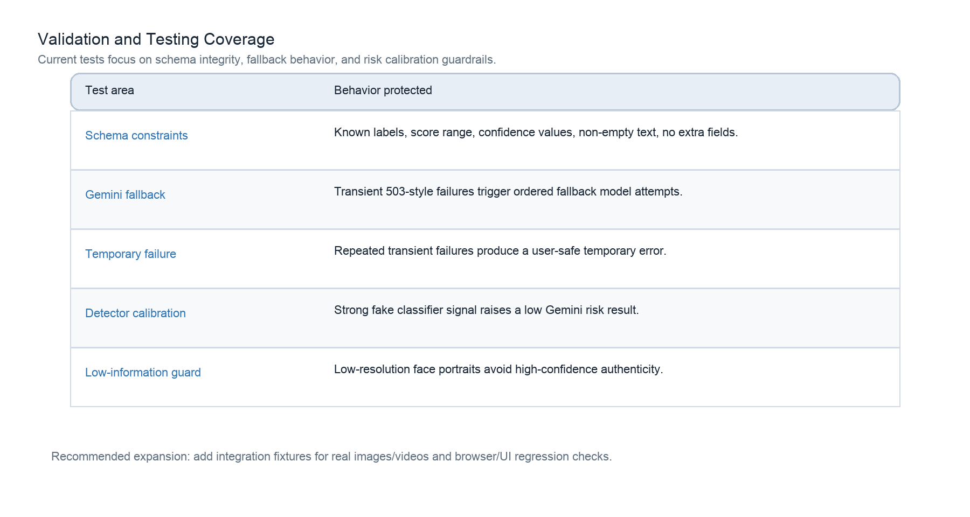
Fig. 5. Current validation coverage in the repository.
The automated tests focus on control logic and safety properties. Schema tests confirm that invalid labels, invalid confidence values, out-of-range scores, empty evidence text, and extra fields are rejected. Analyzer tests mock Gemini responses to verify fallback behavior after transient errors. Additional tests confirm that all fallback models are tried before a temporary error is raised.
Calibration tests verify that a high fake-probability detector signal raises a low-risk Gemini report. Low-resolution portrait tests verify that a small face-dominated image is not left as high-confidence likely_authentic. These tests are important because they protect the system's uncertainty-aware behavior even when model outputs vary.

X. EVALUATION PROTOCOL
The repository does not yet claim a benchmark detection accuracy. A proper evaluation should use a balanced media fixture set containing authentic camera images, AI-generated portraits, ordinary edited images, low-resolution screenshots, compressed social-media images, short manipulated clips, and authentic videos. The evaluation should report precision, recall, false-positive rate, false-negative rate, uncertain-rate, and calibration behavior across media quality groups.
A useful evaluation should not measure only the final label. It should also score whether the evidence is grounded in the media, whether limitations are appropriate, and whether next steps are useful. For example, a report that labels a file suspicious but invents unsupported metadata should fail even if the final risk category happens to match the ground truth. This is because the tool is meant to guide human review, and unsupported reasoning can be as harmful as an incorrect label.
Evaluation Area / Recommended Measurement
Classification: Precision, recall, false positives, false negatives, uncertain rate.
Calibration: Whether score ranges match observed review priority.
Evidence quality: Human rating of whether observations are visible and specific.
Robustness: Performance under compression, crop, blur, and resolution changes.
Video behavior: Whether sampled frames detect short suspicious segments.
Safety: Absence of identity, intent, criminality, or unsupported certainty claims.
XI. RESULTS AND DISCUSSION
Based on source-level inspection, the strongest result of the project is its disciplined output contract. The model is not allowed to freely produce inconsistent prose; instead, it must satisfy the DeepfakeReport schema. The detector signal is also added by application code rather than by the language model, which prevents fabricated classifier metadata. This makes the system more reliable for demonstrations, classroom use, and future integration.
The second important result is the fallback and calibration design. Transient Gemini failures are handled with ordered fallback attempts, and detector disagreement is handled by raising risk rather than ignoring the classifier. At the same time, a real detector label is not treated as proof of authenticity. This asymmetry is appropriate for screening because a high-risk signal should prompt review, while a low-risk signal should not end verification.
The current weakness is that empirical accuracy has not yet been measured on a curated benchmark. The project tests whether the software behaves safely and consistently, but it does not yet answer how often the system detects specific deepfake families. This should be the next major development step.

XII. DEPLOYMENT AND REVIEWER WORKFLOW
A practical deployment of Deepfake Analyzer should treat the application as a controlled review assistant rather than a public truth oracle. In a local classroom or research setting, a reviewer can run the FastAPI server, upload media through the static interface, and inspect the structured report. In a hosted setting, the same endpoint can be protected behind authentication, rate limiting, upload-size controls, and logging policies. The project already separates configuration from code through environment variables, which supports safe deployment without hard-coding API keys.
The recommended reviewer workflow has five steps. First, the reviewer uploads the media and checks whether the detector_signal field is present. Second, the reviewer reads the summary and label but does not stop there. Third, the reviewer inspects the evidence list and asks whether each observation is visible in the media. Fourth, the reviewer reads limitations to understand whether compression, low resolution, short duration, or missing provenance weakens the result. Finally, the reviewer follows the recommended next steps, such as comparing against the original source, reviewing upload history, or asking for a higher-quality file.
Operational security should focus on media handling. Uploaded files can contain faces, locations, private events, and metadata. The current implementation stores uploads only in a temporary directory for the duration of the request, but production systems should also specify retention policy, access permissions, audit logging, deletion behavior, and whether uploaded media is sent to external services. Users should be told when Gemini analysis is used because media leaves the local machine during that stage.
Deployment Concern / Recommended Control
API key safety: Store GEMINI_API_KEY in environment variables or a secret manager, not in code.
Upload privacy: Use temporary storage, retention limits, and clear user notice before analysis.
Access control: Restrict hosted deployments with authentication and request limits.
Review quality: Require users to read evidence and limitations before acting on the label.
Auditability: Record model name, detector model, thresholds, app version, and prompt version.
Failure handling: Show retryable temporary errors separately from validation or configuration errors.
For institutional use, the output should be stored with context rather than as an isolated verdict. A useful review record would include the original upload name, hash of the media file if permitted, time of analysis, model configuration, report JSON, reviewer comments, and any follow-up evidence. This preserves the distinction between automated screening and human decision-making.

XIII. LIMITATIONS
The system is not a forensic detector. It does not preserve chain-of-custody evidence, verify camera provenance, perform cryptographic authenticity checks, or compare the upload against an original source. It screens visible media and reports model-based risk. Therefore, a high score should be treated as a reason to investigate, and a low score should not be treated as proof that the media is authentic.
The optional Hugging Face detector can fail silently by design. If dependencies are missing, the model checkpoint cannot be loaded, or inference fails, the analyzer continues without a detector signal. This is useful for deployment resilience but should be visible in user documentation because a report without detector_signal has less independent evidence.
Video handling is another limitation. The local detector samples frames rather than analyzing every frame or modeling motion directly. A manipulation that appears only briefly can be missed if it does not appear in sampled frames. Gemini may still describe temporal issues, but future versions should support timeline evidence, frame-level reporting, and richer video-specific summaries.
Finally, all model-backed systems face distribution shift. New synthetic media generators, editing tools, compression pipelines, and camera devices can change the artifact patterns that detectors learn. The system should therefore be re-tested when model versions, prompts, thresholds, or detector checkpoints change.
XIV. ETHICAL CONSIDERATIONS
Deepfake detection tools can create harm if they are used to accuse people, authenticate media carelessly, or replace human judgment. Deepfake Analyzer reduces this risk through cautious language, explicit limitations, and recommended next steps. The prompt instructs the model not to claim that a person is lying, criminal, or malicious. Deployments should preserve this wording and avoid turning the score into an accusation.
Privacy is also important because uploaded media can contain faces, private locations, and sensitive context. The current implementation uses temporary upload storage during request handling, but production deployments should define retention, access control, logging, and deletion policies. If the tool is used in education or moderation support, users should be told that outputs are screening signals and not final judgments.

XV. FUTURE SCOPE
Future development should first add a curated evaluation dataset. The dataset should include authentic images, generated images from multiple model families, edited but authentic photographs, compressed platform downloads, low-resolution portraits, authentic videos, and manipulated videos. The evaluation should record not only labels and scores but also evidence quality and limitation quality.
Second, the interface can be improved with a timeline view for video evidence. Instead of a single detector_signal summary, the UI could show sampled frames, per-frame fake probabilities, and Gemini-localized timestamps. This would help reviewers see whether risk is concentrated in one segment or distributed across the clip.
Third, model versioning should be added to the report. Each result should record the Gemini model name, detector model name, threshold configuration, prompt version, and application version. This would make reports easier to audit when models or prompts change.
Fourth, privacy controls should be expanded for deployment. Possible improvements include configurable media retention, audit logs, optional local-only analysis modes, and clearer user notices before upload. These changes would make the analyzer safer for sensitive media review.
XVI. CONCLUSION
Deepfake Analyzer provides a practical and responsible foundation for synthetic media screening. The project combines Gemini vision review, optional Hugging Face classifier evidence, strict Pydantic validation, fallback model handling, and conservative calibration logic. Its main value is not that it proves whether a file is fake, but that it gives reviewers a structured, uncertainty-aware report that explains what was observed and what should be checked next.
The system is strongest as a triage assistant for education, moderation support, newsroom-style verification, or security-awareness workflows. With benchmark evaluation, richer video evidence, model versioning, and deployment privacy controls, it can become a more complete research prototype for responsible media authenticity review.
XVII. REFERENCES
[1] deepfake-analyzer repository README, supported media, report structure, detector configuration, and runtime instructions.
[2] app/analyzer.py, Gemini orchestration, fallback model handling, detector calibration, and low-resolution portrait guard.
[3] app/detector.py, Hugging Face classifier loading, frame sampling, image scoring, probability aggregation, and confidence bucketing.
[4] app/schemas.py, Pydantic models for DeepfakeReport, EvidenceItem, and DetectorSignal.
[5] app/media_utils.py, media validation, supported extension definitions, upload size checks, and OpenCV frame extraction.
[6] app/main.py, FastAPI routing, temporary upload handling, response model declaration, and user-safe exception mapping.
[7] tests/test_analyzer.py, mocked Gemini fallback tests, temporary error tests, detector calibration tests, and low-resolution portrait guard tests.
[8] tests/test_schemas.py, schema validation tests for label, score, confidence, evidence text, detector signal, and extra-field rejection.

