Name : Rajvardhan Reddy
Reg No : 180905093
Sec : B
Roll No : 19

CN LAB - 4 : STUDY OF NETWORK DEVICES IN GNS3

P4.1)
Design network configuration shown in Figure 4.1 for all parts. Connect all four VMs to a single Ethernet segment via a single hub as shown in Figure 4.1. Configure the IP addresses for the PCs as shown in Table 4.1.

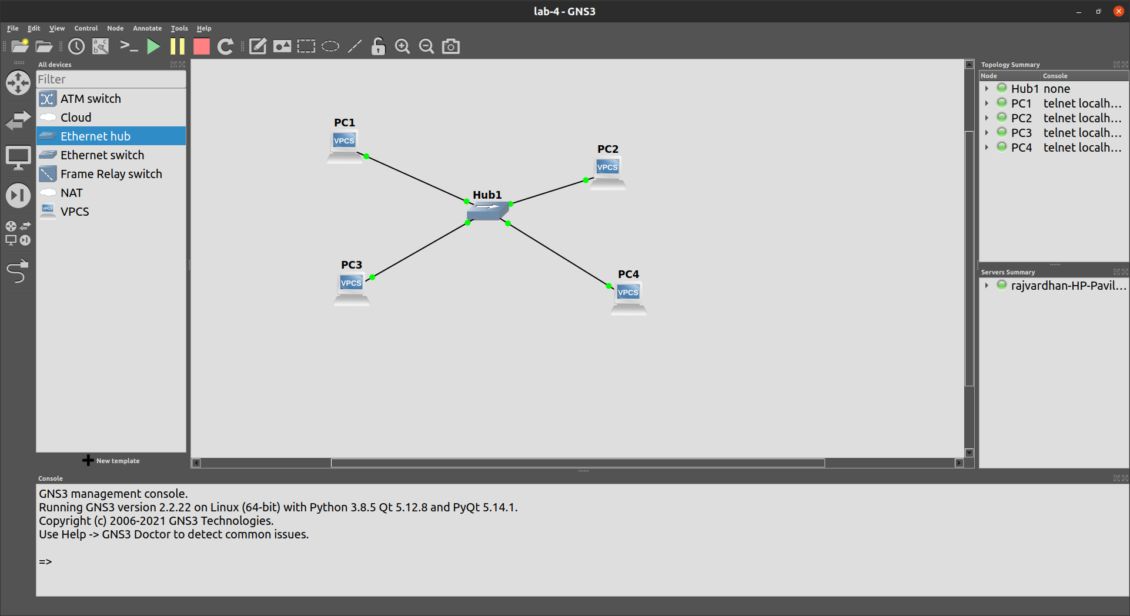

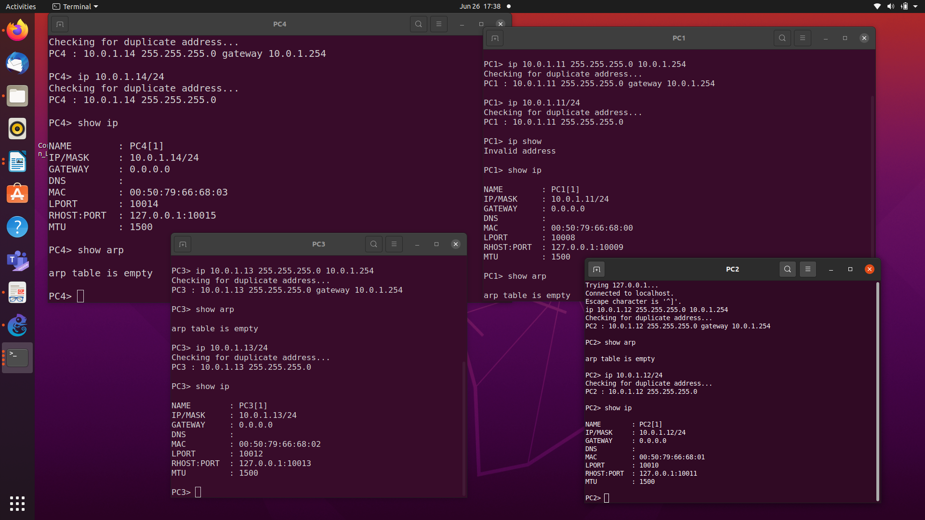
IP address configuration FOR THE 4 pcs and show arp:

a. On PC1, view the ARP cache with showarp
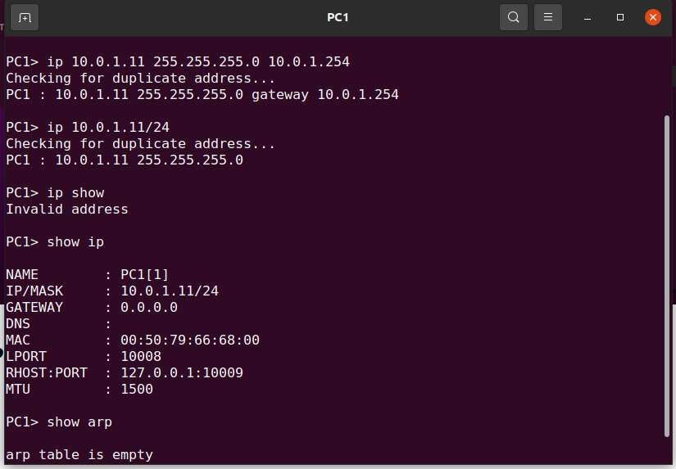

b) Start Wireshark on PC1-Hub1 link with a capture filter set to the IP address:
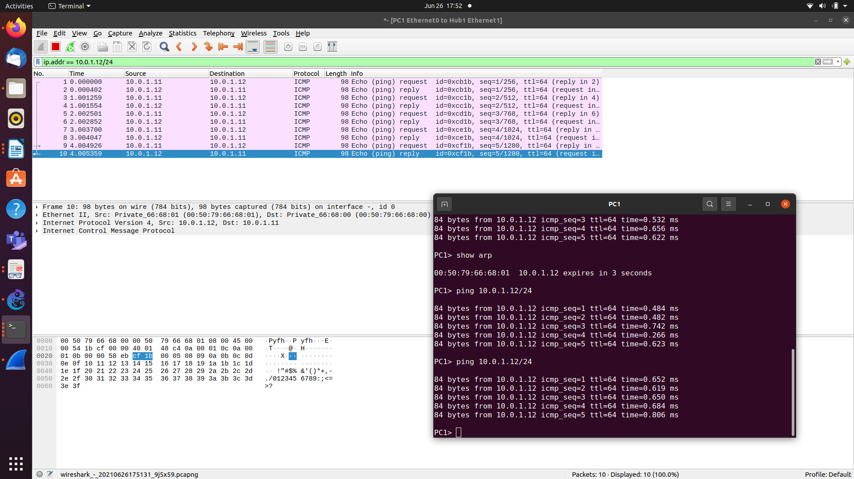

C) Issue a ping command from PC1toPC2:
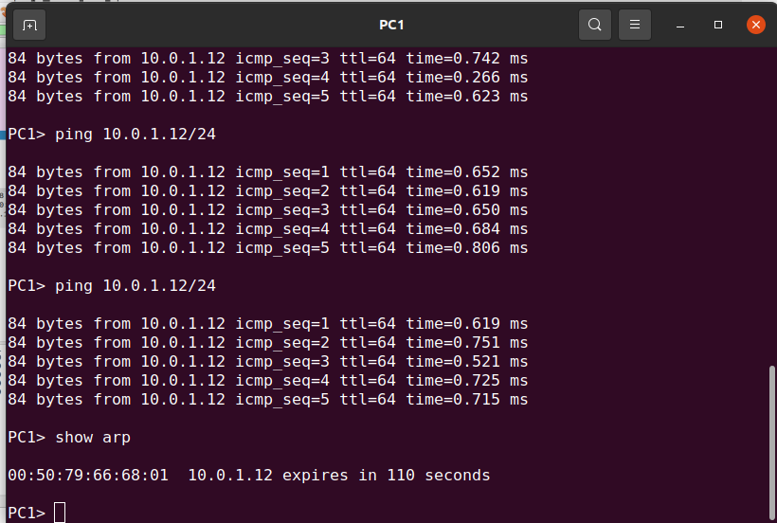

d. View the ARP cache again with the command arp -a. Note that ARP cache
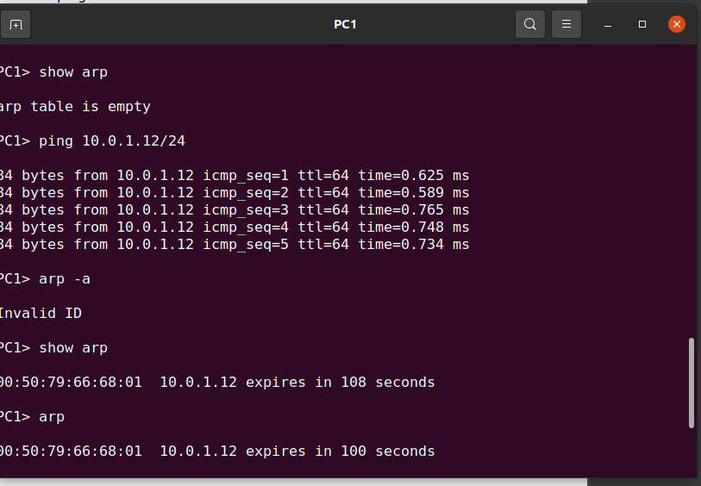

e)Saved the results of Wireshark and
uploaded the file on teams

_____________________________________________________________________________

Q 4.2
To test the effects of changing the netmask of a network configuration. Design the configuration as Q4.1 and replace the hub with a switch, two hosts (PC2 and PC4) have been assigned different network prefixes.

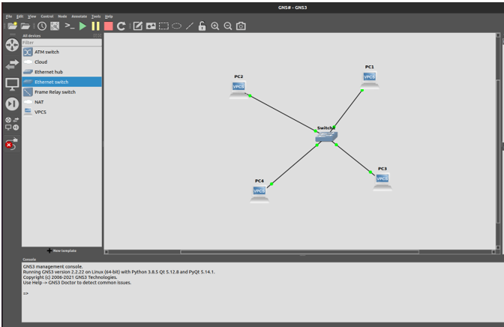Run Wireshark on PC1-Switch1 link and capture the packets for the following scenarios
i. From PC1 ping PC3.
Ping was successful
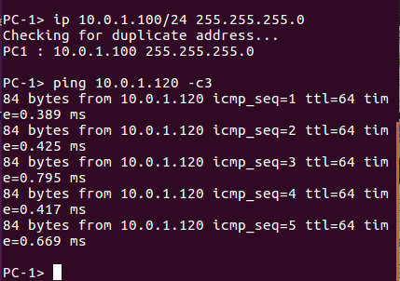

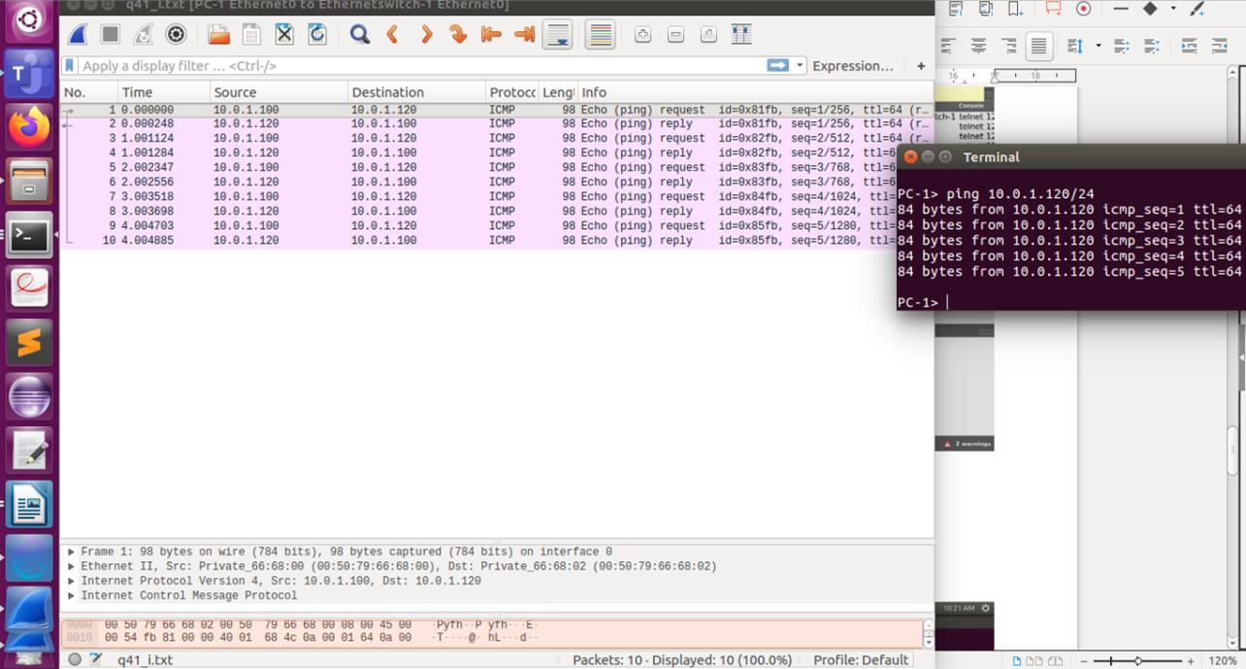

ii. From PC1 pingPC2.
Ping was successful
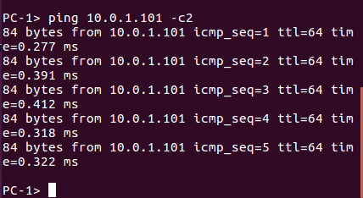

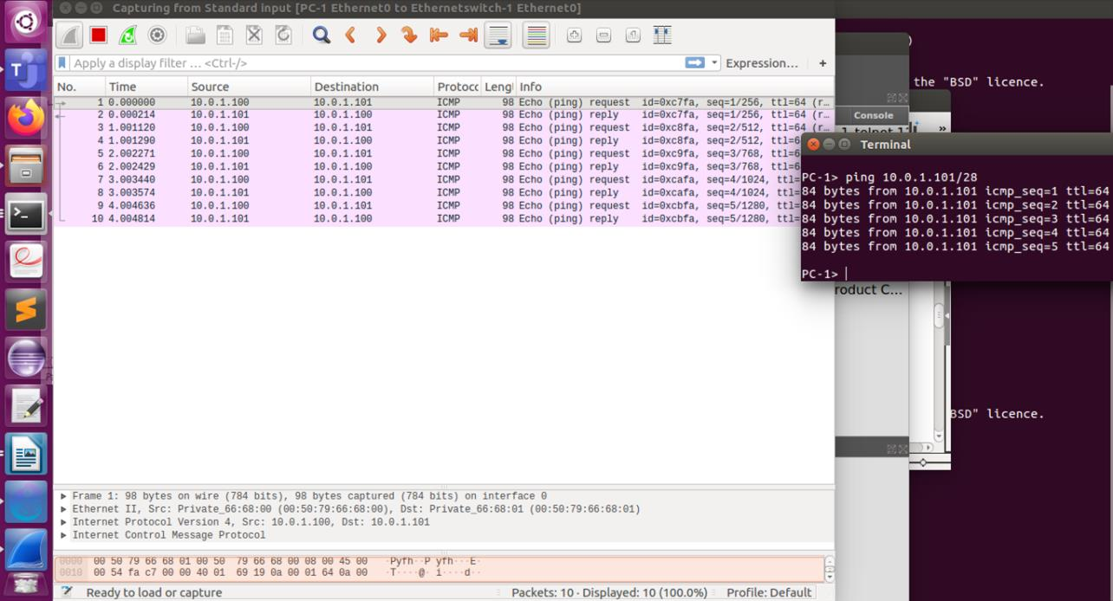
iii. From PC1
pingPC4.
The pings was not successful

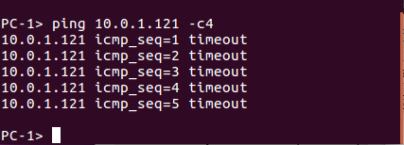
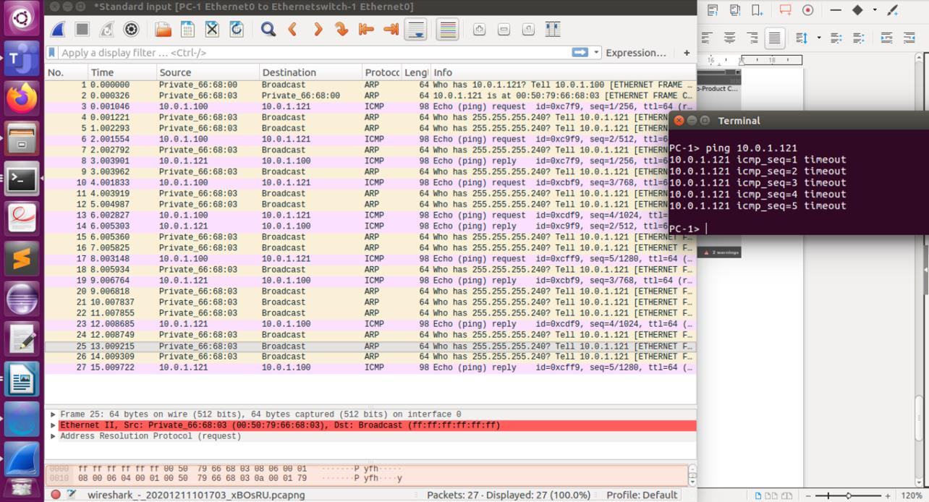

iv. From PC4 pingPC1.
Shows error message.
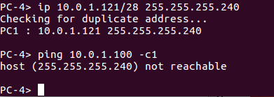
host (255.255.255.240) not reachable

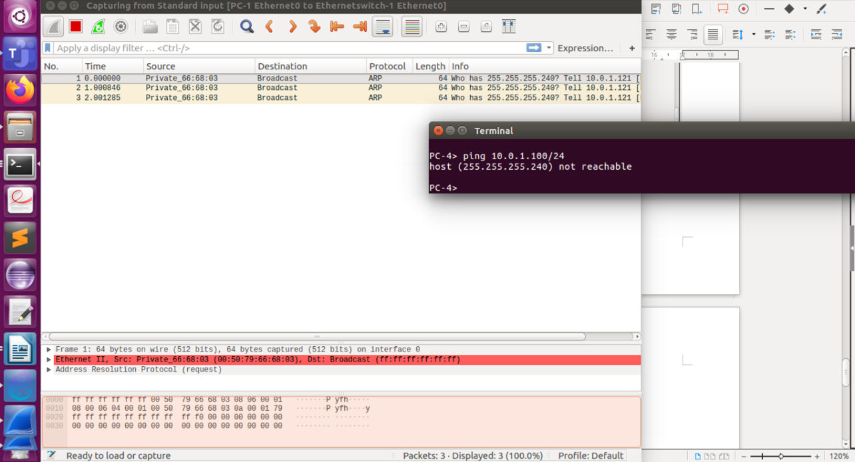

v. From PC2 ping PC4.
From PC2 ping PC4.
host (255.255.255.240) not reachable

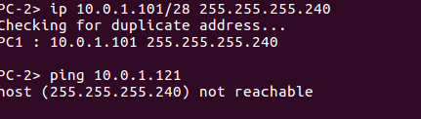

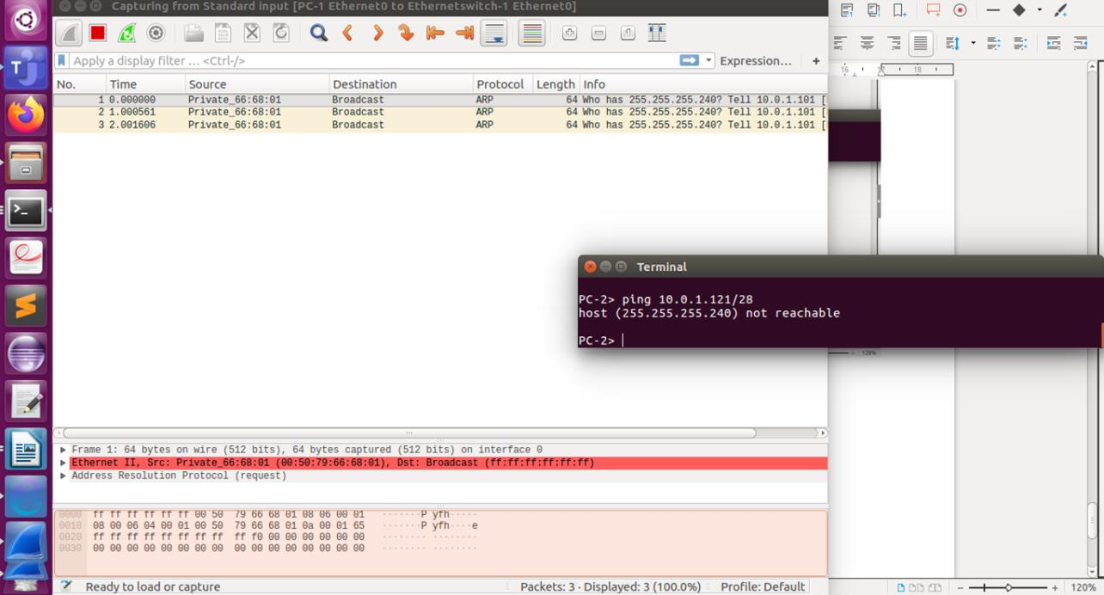

vi. From PC2 ping PC3.
host (255.255.255.240) not reachable

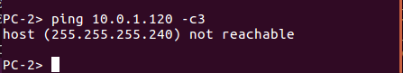

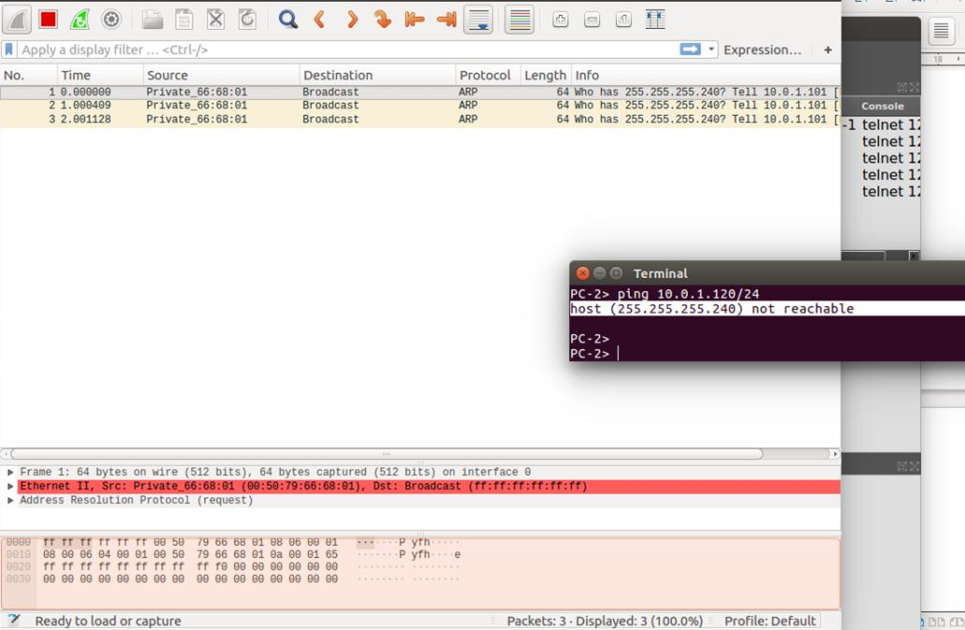

Wireshark output: Overall
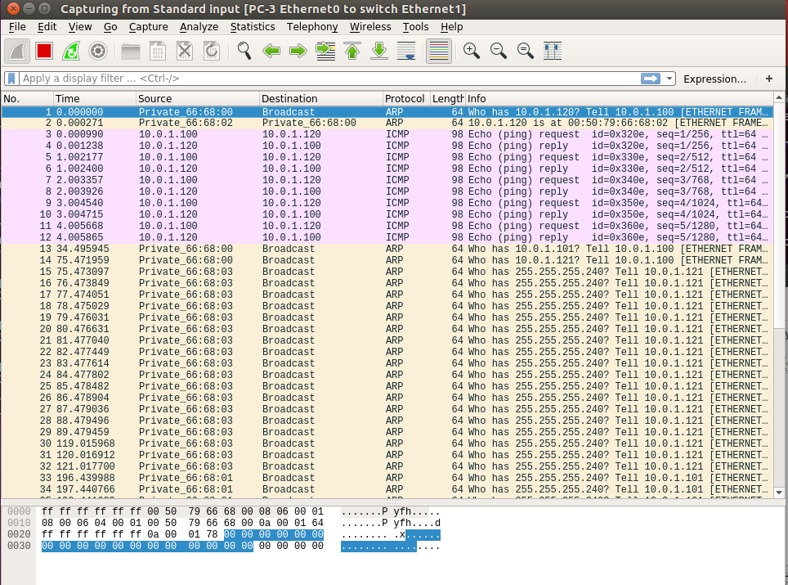

_____________________________________________________________________________
P4.6)
i. check the connectivity by pinging from PC1 toPC2.
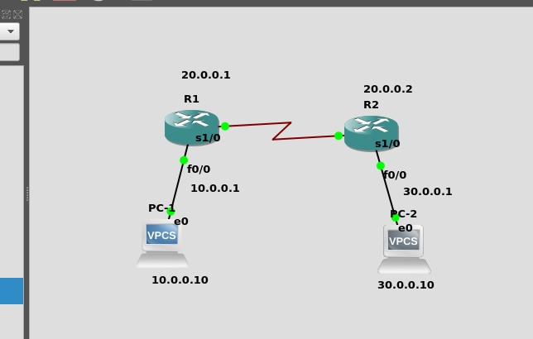

No gateway found for pings. And ARP table was empty.

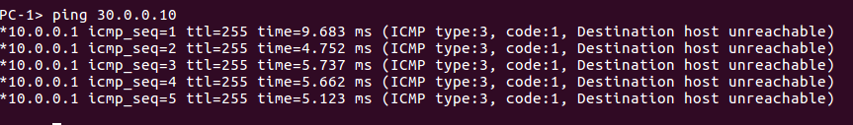

ii. Analyse ARP exchanges between various network components.

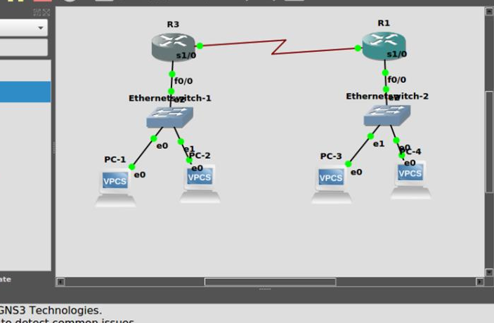

ping from pc2 on router 3 to pc 3 on router 1.
ping success full.

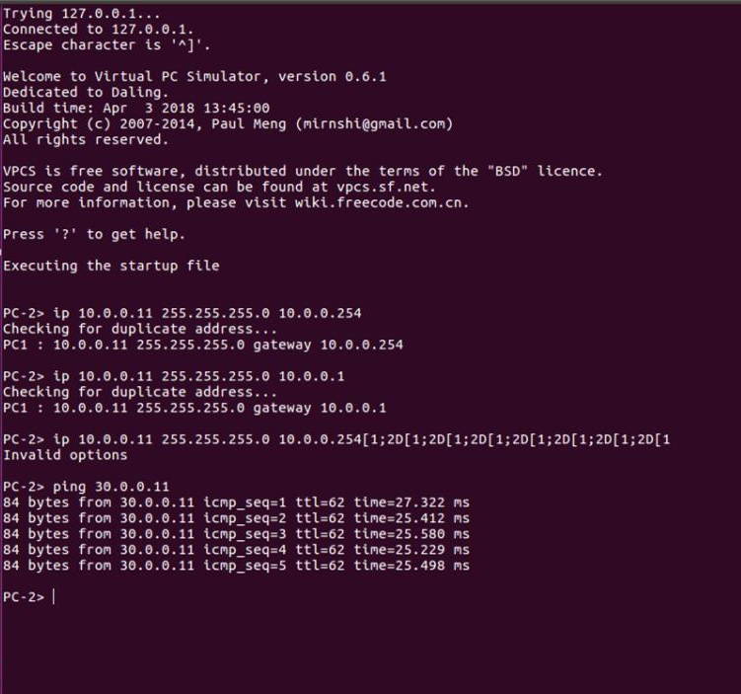

Ping from pc4 on router1 to pc1 on router 3
ping successfull
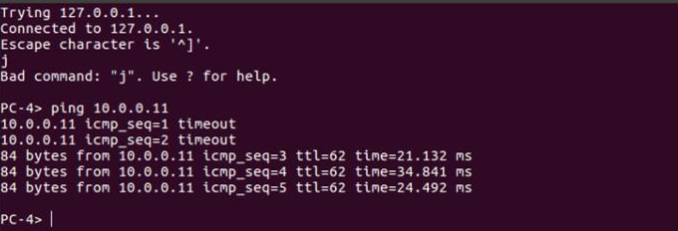

b)show arp for both cases:
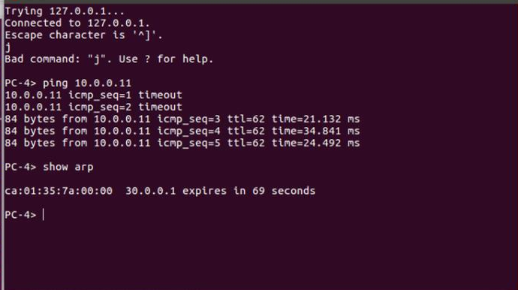

All the ping requests were succesful.
This is because, the IP address provided by P1 for the ping request was found by ARP by the process of Broadcasting. Hence, every subsequent request has been forwarded to the correct destination and hence we also got the right responses as well.

