Name : Rajvardhan Reddy
Reg No : 180905093
Sec : B
Roll No : 19

CN LAB – 6 : STUDY OF DHCP

Q7.1) Configure two VMs that will be used to test connectivity from end to end and R1 will serve as a DHCP server to distribute IP addresses. The diagram below details the current setup:
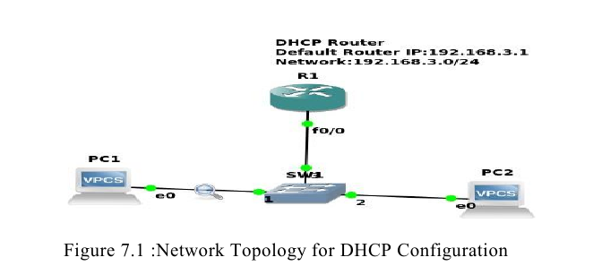

1. In order to configure our router as a DHCP server the following commands were used.
R1(config)#IP dhcp pool NAME
R1(dhcp-config)#Network 192.168.3.0 255.255.255.0
R1(dhcp-config)#Default-router 192.168.3.1
The commands above create a DHCP pool, adds the network that we want to assign IP addresses from, and specifies the default gateway for this subnet.
Note: There are many other parameters that go into configuring a DHCP server, but this will suffice for our test environment. That should be it for the DHCP configuration.
2.The next thing that you want to do is configure the fastethernet 0/0 interface which will connect to our switch.
R1(config)#Interface fastEthernet 0/0
R1(config-if)#No shutdown

R1(config-if)#ip address 192.168.3.1 255.255.255.0
The commands above will turn the interface on and assign an IP address.
3. Turn on the VPCS. In PC1 and PC2 type dhcp
That is,
PC1>dhcp
PC2>dhcp
4. Let’s analyse some of the traffic patterns using Wireshark.
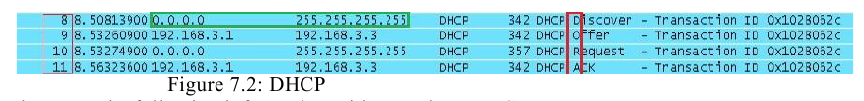
We see a discover message followed by an offer, request, and an acknowledgement. This is
the process that clients go through in order to obtain an IP address via DHCP. The mnemonic for the steps above is DORA and it should help in memorizing the order of the steps.

Solution :
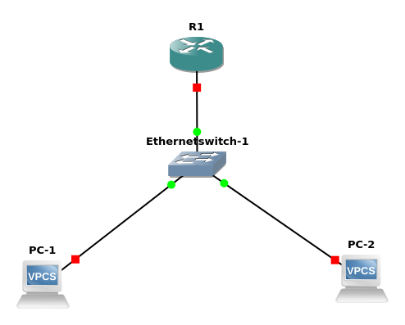

Router Configeration :

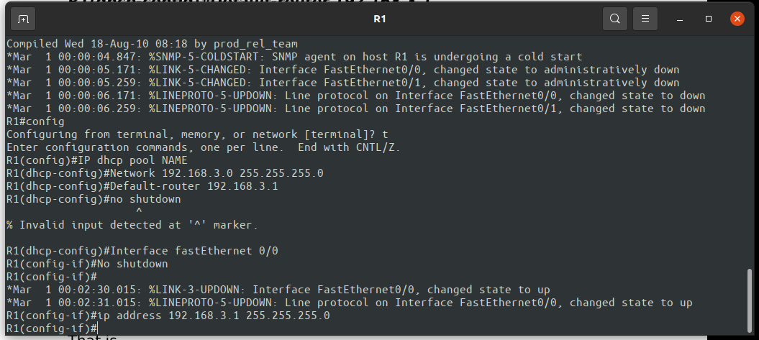

PC’s Configeration :

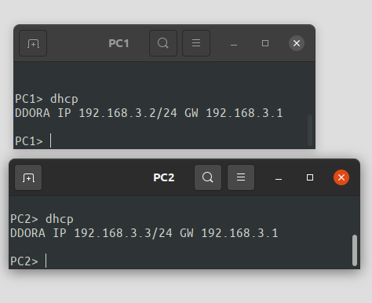

Capturing packets through DHCP Protocol in Wireshark :
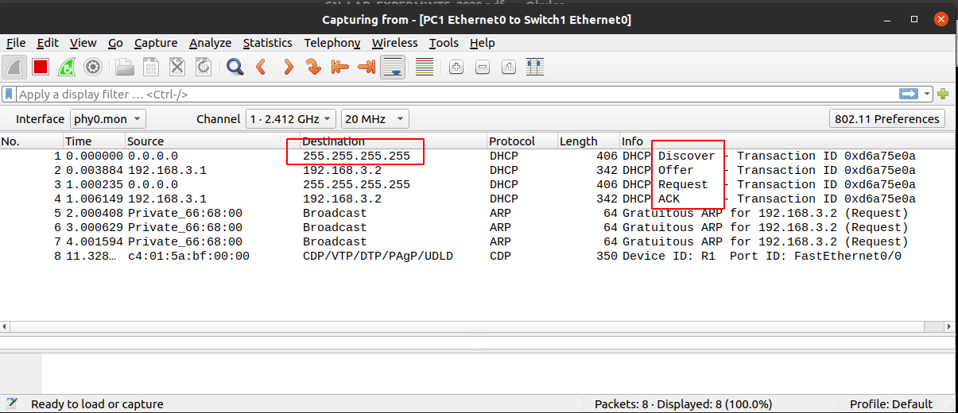

Q7.2) Configure DHCP server at R1 for the PART 2 Q2 Subnet configuration and topology.

Solution :
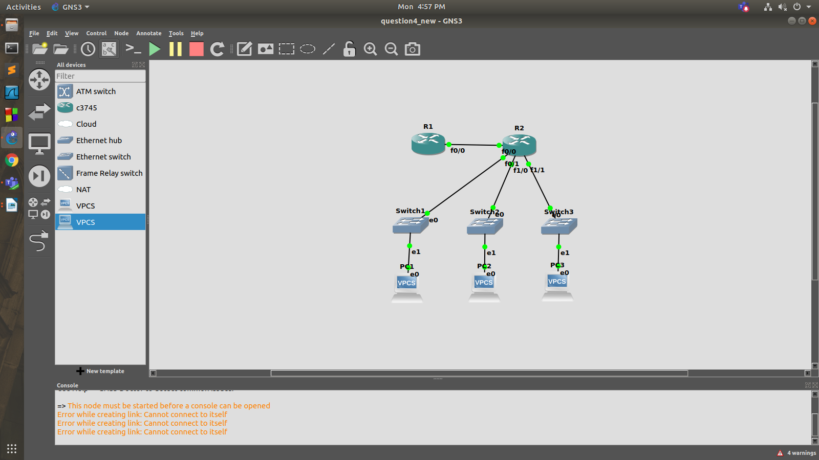

R1:
R1#enable
R1#conf t
Enter configuration commands, one per line. End with CNTL/Z.
R1(config)#ip dhcp pool lan1
R1(dhcp-config)#network 10.0.1.0 255.255.255.0
R1(dhcp-config)#default-router 10.0.1.1
R1(dhcp-config)#exit
R1(config)#ip dhcp pool lan2
R1(dhcp-config)#network 10.0.2.0 255.255.255.0
R1(dhcp-config)#default-router 10.0.2.1
R1(dhcp-config)#exit
R1(config)#ip dhcp pool lan3
R1(dhcp-config)#network 10.0.3.0 255.255.255.0
R1(dhcp-config)#default-router 10.0.3.1
R1(dhcp-config)#exit
R1(config)#ip route 10.0.1.0 255.255.255.0 30.0.0.2
R1(config)#ip route 10.0.2.0 255.255.255.0 30.0.0.2
R1(config)#ip route 10.0.3.0 255.255.255.0 30.0.0.2
R1(config)#exit
*Mar 1 00:03:37.071: %SYS-5-CONFIG_I: Configured from console by console
R1#write
Building configuration...
[OK]

R2:
R2#enable
R2#conf t
Enter configuration commands, one per line. End with CNTL/Z.
R2(config)#int f0/0
R2(config-if)#ip helper-address 30.0.0.1
R2(config-if)#no shutdown
R2(config-if)#
*Mar 1 00:03:02.495: %LINK-3-UPDOWN: Interface FastEthernet0/0, changed state to up
*Mar 1 00:03:03.495: %LINEPROTO-5-UPDOWN: Line protocol on Interface FastEthernet0/0, changed state to up
R2(config-if)#end
R2#wr
*Mar 1 00:03:07.323: %SYS-5-CONFIG_I: Configured from console by console
R2#write
Building configuration...
[OK]
R2#conf t
Enter configuration commands, one per line. End with CNTL/Z.
R2(config)#int f1/0
R2(config-if)#ip add 10.0.1.1 255.255.255.0
R2(config-if)#ip helper-address 30.0.0.1
R2(config-if)#no shutdown
R2(config-if)#
*Mar 1 00:05:05.671: %LINK-3-UPDOWN: Interface FastEthernet1/0, changed state to up
*Mar 1 00:05:06.671: %LINEPROTO-5-UPDOWN: Line protocol on Interface FastEthernet1/0, changed state to up
R2(config-if)#exit
R2(config)#int e2/0
R2(config-if)#ip add 10.0.2.1 255.255.255.0
R2(config-if)#ip helper-address 30.0.0.1
R2(config-if)#no shutdown
R2(config-if)#
*Mar 1 00:06:03.051: %LINK-3-UPDOWN: Interface Ethernet2/0, changed state to up
*Mar 1 00:06:04.051: %LINEPROTO-5-UPDOWN: Line protocol on Interface Ethernet2/0, changed state to up
R2(config-if)#exit
R2(config)#int e2/1
R2(config-if)#ip add 10.0.3.1 255.255.255.0
R2(config-if)#ip helper-address 30.0.0.1
R2(config-if)#no shutdown
R2(config-if)#
*Mar 1 00:06:45.915: %LINK-3-UPDOWN: Interface Ethernet2/1, changed state to up
*Mar 1 00:06:46.915: %LINEPROTO-5-UPDOWN: Line protocol on Interface Ethernet2/1, changed state to up
R2(config-if)#exit
R2(config)#int f0/0
R2(config-if)#ip add 30.0.0.2 255.255.255.0
R2(config-if)#no shutdown
R2(config-if)#end
R2#write
Building configuration...
[OK]
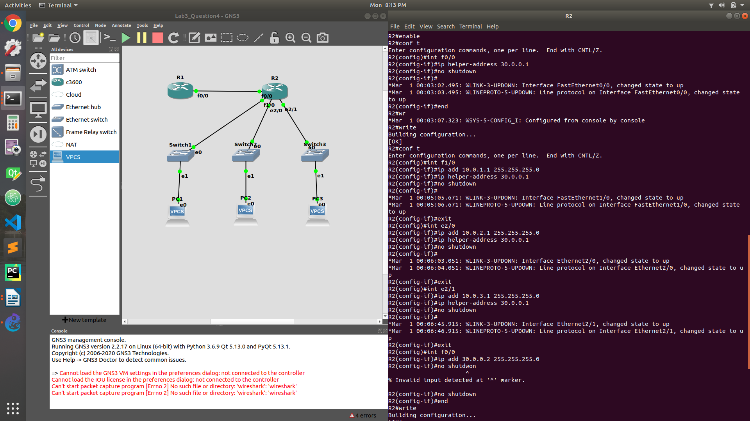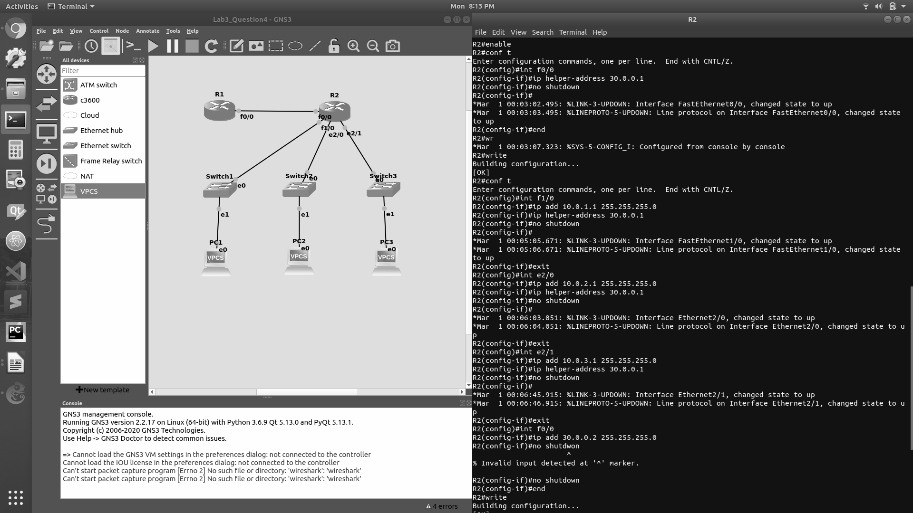

DHCP on Pcs :
PC1> dhcp
DDORA IP 10.0.1.2/24 GW 10.0.1.1

PC3> dhcp
DDORA IP 10.0.3.2/24 GW 10.0.3.1

