Name : Rajvardhan Reddy
Reg No : 180905093
Sec : B
Roll No : 19

CN Lab Session1: Socket programming

P1) Write a c program to demonstrate the working of UDP echo Client/Server.

Server program :

// server program for udp connection
#include <stdio.h>
#include <strings.h>
#include <sys/types.h>
#include <arpa/inet.h>
#include <sys/socket.h>
#include<netinet/in.h>
#define PORT 5000
#define MAXLINE 1000

int main()
{
char buffer[100];
int servsockfd, len,n;
struct sockaddr_in servaddr, cliaddr;
bzero(&servaddr, sizeof(servaddr));

// Create a UDP Socket
servsockfd = socket(AF_INET, SOCK_DGRAM, 0);
servaddr.sin_addr.s_addr = htonl(INADDR_ANY);
servaddr.sin_port = htons(PORT);
servaddr.sin_family = AF_INET;

// bind server address to socket descriptor
bind(servsockfd, (struct sockaddr*)&servaddr, sizeof(servaddr));

//receive the datagram
len = sizeof(cliaddr);
n = recvfrom(servsockfd, buffer, sizeof(buffer),0, (struct sockaddr*)&cliaddr,&len);
buffer[n] = '\0';
puts(buffer);
//Echoing back to the client
sendto(servsockfd, buffer, n, 0, (struct sockaddr*)&cliaddr, sizeof(cliaddr));
getchar();
}

Client program :

// udp client driver program

#include <stdio.h>
#include <strings.h>
#include <sys/types.h>
#include <arpa/inet.h>
#include <sys/socket.h>
#include<netinet/in.h>
#include<unistd.h>
#include<stdlib.h>

#define PORT 5000
#define MAXLINE 1000

// Driver code
int main()
{
char buffer[100];
char *message = "Hello Server";
int sockfd, n,len;
struct sockaddr_in servaddr, cliaddr;

// clear servaddr
bzero(&servaddr, sizeof(servaddr));
servaddr.sin_addr.s_addr = htonl(INADDR_ANY);
servaddr.sin_port = htons(PORT);
servaddr.sin_family = AF_INET;

// create datagram socket
sockfd = socket(AF_INET, SOCK_DGRAM, 0);
sendto(sockfd, message, MAXLINE, 0, (struct sockaddr*)&servaddr, sizeof(servaddr));
len=sizeof(cliaddr);
// waiting for response
n=recvfrom(sockfd, buffer, sizeof(buffer), 0, (struct sockaddr*)&cliaddr,&len );
buffer[n]='\0';
printf("message from Server is %s \n",buffer);
getchar();

// close the descriptor
close(sockfd);
}

Output :

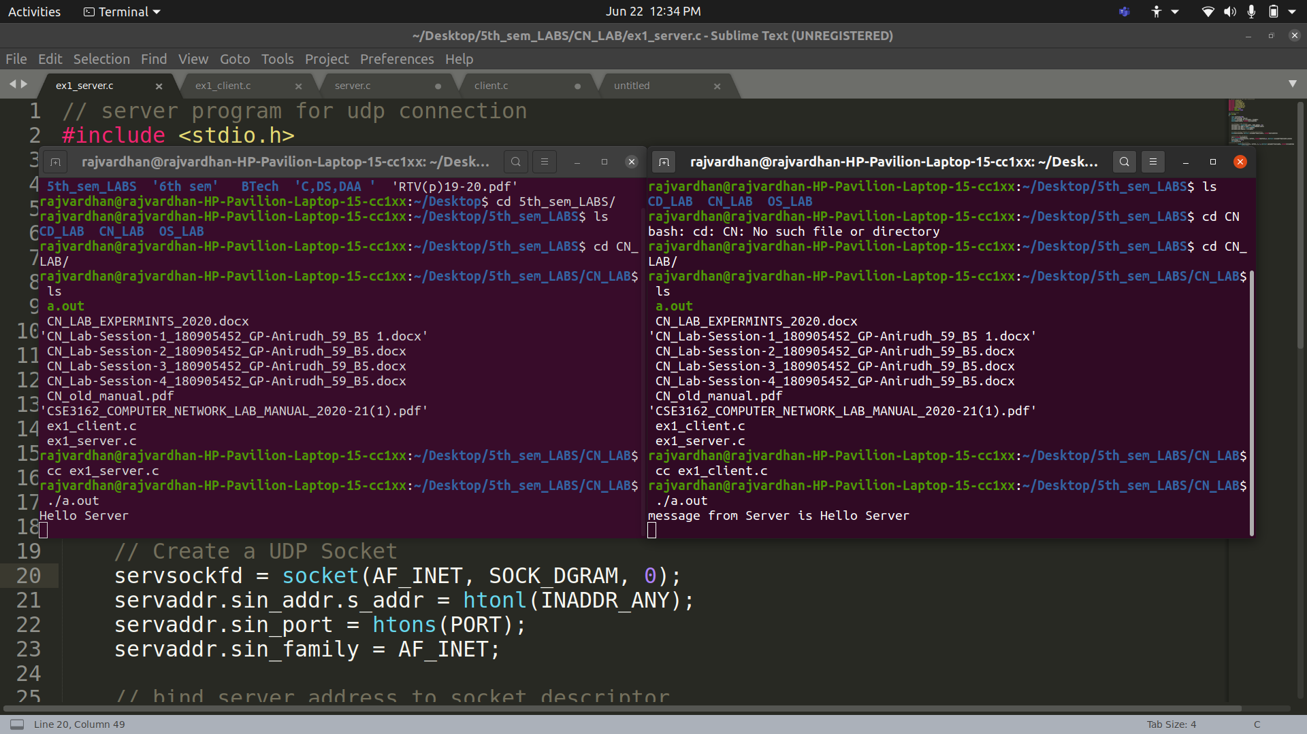

P2) Write a c program to demonstrate the working of TCP client server as follows: After connection set up client send a message. Server will reply to this. If server decides to close the program then it will send a message exit to client then closes itself. Client will close after receiving this message.. ( Note: In each program there is a function that handles the client and server function and main program is responsible for socket creation and connection setup.)

Server program :

#include <stdio.h>
#include <netdb.h>
#include <netinet/in.h>
#include <stdlib.h>
#include <string.h>
#include <sys/socket.h>
#include <sys/types.h>
#define MAX 80
#define PORT 8080
#define SA struct sockaddr

// Function designed for chat between client and server.
void servfunc(int sockfd)
{
char buff[MAX];
int n;
// infinite loop for chat
for (;;) {
bzero(buff, MAX);

// read the message from client and copy it in buffer
read(sockfd, buff, sizeof(buff));
// print buffer which contains the client contents
printf("From client: %s\t To client : ", buff);

bzero(buff, sizeof(buff));
// Read server message from keyboard in the buffer
n=0;
while ((buff[n++] = getchar()) != '\n')
;
// and send that buffer to client
write(sockfd, buff, sizeof(buff));

// if msg contains "Exit" then server exit and session ended.
if (strncmp("exit", buff, 4) == 0) {
printf("Server Exit...\n");
break;
}
}
}

// Driver function
int main()
{
int sockfd, connfd, len;
struct sockaddr_in servaddr, cli;

// socket create and verification
sockfd = socket(AF_INET, SOCK_STREAM, 0);
if (sockfd == -1) {
printf("socket creation failed...\n");
exit(0);
}
else
printf("Socket successfully created..\n");
bzero(&servaddr, sizeof(servaddr));

// assign IP, PORT
servaddr.sin_family = AF_INET;
servaddr.sin_addr.s_addr = htonl(INADDR_ANY);
servaddr.sin_port = htons(PORT);

// Binding newly created socket to given IP and verification
if ((bind(sockfd, (SA*)&servaddr, sizeof(servaddr))) != 0) {
printf("socket bind failed...\n");
exit(0);
}
else
printf("Socket successfully binded..\n");

// Now server is ready to listen and verification
if ((listen(sockfd, 5)) != 0) {
printf("Listen failed...\n");
exit(0);
}
else
printf("Server listening..\n");
len = sizeof(cli);

// Accept the data packet from client and verification
connfd = accept(sockfd, (SA*)&cli, &len);
if (connfd < 0) {
printf("server acccept failed...\n");
exit(0);
}
else
printf("server acccept the client...\n");

// Function for chatting between client and server
servfunc(connfd);

// After sending exit message close the socket
close(sockfd);

Client program :
#include <netdb.h>
#include <stdio.h>
#include <stdlib.h>
#include <string.h>
#include <sys/socket.h>
#define MAX 80
#define PORT 8080
#define SA struct sockaddr
void clifunc(int sockfd)
{
char buff[MAX];
int n;
for (;;) {
bzero(buff, sizeof(buff));
printf("Enter the string : ");
n = 0;
while ((buff[n++] = getchar()) != '\n')
;
write(sockfd, buff, sizeof(buff));
bzero(buff, sizeof(buff));
read(sockfd, buff, sizeof(buff));
printf("From Server : %s", buff);
if ((strncmp(buff, "exit", 4)) == 0) {
printf("Client Exit...\n");
break;
}
}
}

int main()
{
int sockfd, connfd;
struct sockaddr_in servaddr, cli;

// socket create and verification
sockfd = socket(AF_INET, SOCK_STREAM, 0);
if (sockfd == -1) {
printf("socket creation failed...\n");
exit(0);
}
else
printf("Socket successfully created..\n");
bzero(&servaddr, sizeof(servaddr));

// assign IP, PORT
servaddr.sin_family = AF_INET;
servaddr.sin_addr.s_addr = inet_addr("127.0.0.1");
servaddr.sin_port = htons(PORT);

// connect the client socket to server socket
if (connect(sockfd, (SA*)&servaddr, sizeof(servaddr)) != 0) {
printf("connection with the server failed...\n");
exit(0);
}
else
printf("connected to the server..\n");

// function for client
clifunc(sockfd);

// close the socket
close(sockfd);
}

Output :
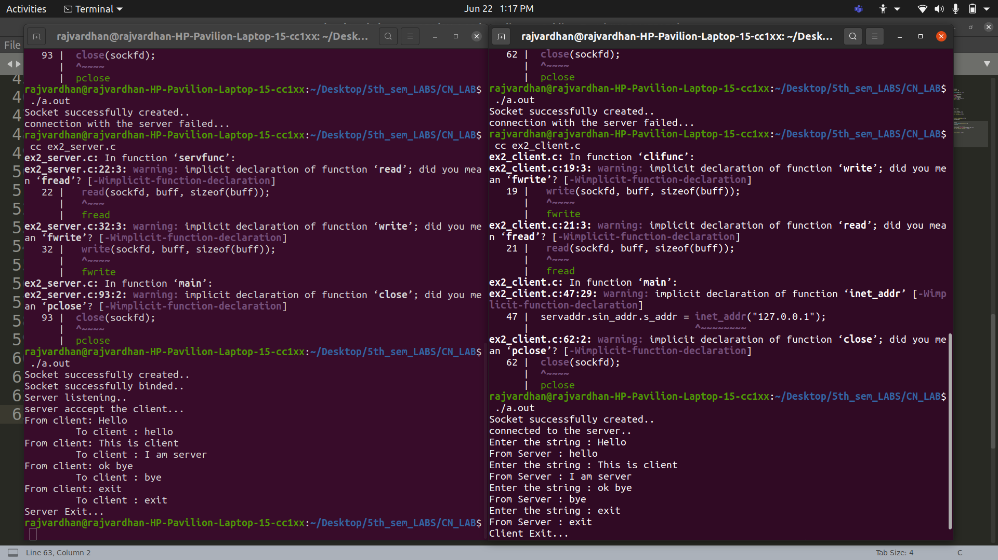

P3) Write a UDP client-server program where client sends rows of a matrix to the server combines them together as a two dimensional matrix and display the same.

Server program :
#include <stdio.h>
#include <strings.h>
#include <sys/types.h>
#include <arpa/inet.h>
#include <sys/socket.h>
#include <netinet/in.h>
#define PORT 5000
#define MAXLINE 1000
// Server code
int main()
{
char buffer[100];
int servsockfd, len, n;
struct sockaddr_in servaddr, cliaddr;
bzero(&servaddr, sizeof(servaddr));
// Create a UDP Socket
servsockfd = socket(AF_INET, SOCK_DGRAM, 0);
servaddr.sin_addr.s_addr = htonl(INADDR_ANY);
servaddr.sin_port = htons(PORT);
servaddr.sin_family = AF_INET;
// bind server address to socket descriptor
bind(servsockfd, (struct sockaddr *)&servaddr, sizeof(servaddr));
//receive the datagram
while(1)
{
bzero(buffer, sizeof(buffer));
len = sizeof(cliaddr);
n = recvfrom(servsockfd, buffer, sizeof(buffer), 0, (struct sockaddr *)&cliaddr, &len);
// buffer[n] = '\0';
//Echoing back to the client
if ((strncmp(buffer, "exit", 4)) == 0)
{
printf("Client Exit\n");
break;
}
for(int i = 0; i < n; i++)
printf("%c", buffer[i]);
// sendto(servsockfd, buffer, n, 0, (struct sockaddr *)&cliaddr, sizeof(cliaddr));
// getchar();
}
// close the descriptor
// close(servsockfd);
}

Client program :
#include <stdio.h>
#include <strings.h>
#include <sys/types.h>
#include <arpa/inet.h>
#include <sys/socket.h>
#include <netinet/in.h>
#include <unistd.h>
#include <stdlib.h>
#define PORT 5000
#define MAXLINE 1000
// Driver code
int main()
{
char buffer[100];
//char *message = "";
int sockfd, n, len;
struct sockaddr_in servaddr, cliaddr;
// clear servaddr
bzero(&servaddr, sizeof(servaddr));
servaddr.sin_addr.s_addr = htonl(INADDR_ANY);
servaddr.sin_port = htons(PORT);
servaddr.sin_family = AF_INET;
// create datagram socket
sockfd = socket(AF_INET, SOCK_DGRAM, 0);
char buff[100];
for(;;)
{
bzero(buff, sizeof(buff));
printf("Enter The Elements of the Matrix Row : ");
n = 0;
while ((buff[n++] = getchar()) != '\n');
buff[n] = '\0';
sendto(sockfd, &buff, MAXLINE, 0, (struct sockaddr *)&servaddr, sizeof(servaddr));
if(strncmp(buff, "exit", 4) == 0)
{
printf("Closing client\n");
break;
}
bzero(buff, sizeof(buff));
len = sizeof(cliaddr);
}
// close the descriptor
close(sockfd);
}

Output :

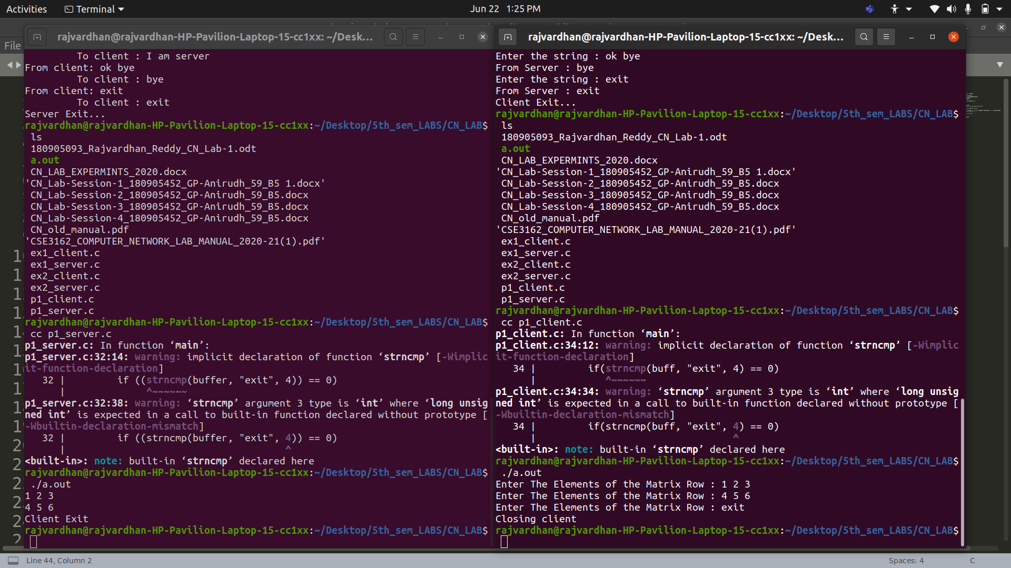
P4) Write a TCP client which sends a string to a server program. Server displays the string along with client IP and ephemeral port number. Server then responds to the client by echoing back the string in uppercase. The process continues until one of them types “QUIT”.

Server program :
#include <stdio.h>
#include <stdlib.h>
#include <unistd.h>
#include <sys/socket.h>
#include <sys/types.h>
#include <netinet/in.h>
#include <arpa/inet.h>
#include <string.h>
#include <ctype.h>
#define PORT 7000
#define sa struct sockaddr
int main()
{
int sockid = socket(AF_INET, SOCK_STREAM, 0);
int m = 0, n = 0, data_len, sockid_new;
char buff[100];
unsigned int len;
struct sockaddr_in serv_addr, cli_addr;
bzero(&serv_addr, sizeof(serv_addr));
serv_addr.sin_family = AF_INET;
serv_addr.sin_port = htons(PORT);
serv_addr.sin_addr.s_addr = htonl(INADDR_ANY);
if (bind(sockid, (sa *)&serv_addr, sizeof(serv_addr)) < 0)
{
printf("Could not bind socket");
exit(0);
}
listen(sockid, 5);
len = sizeof(cli_addr);
sockid_new = accept(sockid, (sa *)&cli_addr, &len);
printf("Client with IP %s and port %d\n", inet_ntoa(cli_addr.sin_addr), ntohs
(cli_addr.sin_port));
for(;;)
{
bzero(buff, sizeof(buff));
read(sockid_new, buff, sizeof(buff));
printf("Received Message from Client is: %s\n", buff);
for (int i = 0; i < strlen(buff); i++)
buff[i] = toupper(buff[i]);
// write(sockid_new, buff, sizeof(buff));
printf("Uppercase is: %s\n", buff);
if (strncmp(buff, "QUIT", 4) == 0)
break;
}
printf("Server connection closed\n");
close(sockid);
return 0;
}

Client program :
#include <stdio.h>
#include <stdlib.h>
#include <unistd.h>
#include <netinet/in.h>
#include <arpa/inet.h>
#include <sys/socket.h>
#include <sys/types.h>
#include <string.h>
#define PORT 7000
#define sa struct sockaddr
int main()
{
int sockid = socket(AF_INET, SOCK_STREAM, 0);
int data_len;
unsigned int len;
struct sockaddr_in serv_addr, temp;
bzero(&serv_addr, sizeof(serv_addr));
serv_addr.sin_family = AF_INET;
serv_addr.sin_port = htons(PORT);
serv_addr.sin_addr.s_addr = htonl(INADDR_ANY);
connect(sockid, (sa *)&serv_addr, sizeof(serv_addr));
char buff[100], line[100];
for(;;)
{
printf("Enter Message to send to Server or QUIT: \n");
bzero(line, sizeof(line));
bzero(buff, sizeof(buff));
scanf("%s", line);
write(sockid, line, strlen(line));
// read(sockid, buff, sizeof(buff));
// printf("\nServer says: %s\n", buff);
if (strncmp(buff, "QUIT", 4) == 0)
break;
}
printf("Client connection closed\n");
close(sockid);
return 0;
}

Output :
