import com.mongodb.client.*;
import com.mongodb.client.model.Filters;
import com.mongodb.client.model.Updates;
import org.bson.Document;

public class MongoCRUDExample {

public static void main(String[] args) {

// Connect to MongoDB
MongoClient mongoClient = MongoClients.create("mongodb://localhost:27017");

// Access database
MongoDatabase database = mongoClient.getDatabase("CollegeDB");

// Access collection
MongoCollection<Document> collection =
database.getCollection("Students");

// ==========================
// CREATE (Insert)
// ==========================
Document student = new Document("id", 101)
.append("name", "Rahul Sharma")
.append("department", "CSE")
.append("cgpa", 7.4)
.append("year", 3)
.append("email", "rahul.sharma@college.edu");

collection.insertOne(student);
System.out.println("Document Inserted Successfully");

// ==========================
// READ (Find All)
// ==========================
System.out.println("\nStudent Records:");

FindIterable<Document> students = collection.find();

for (Document doc : students) {
System.out.println(doc.toJson());
}

// ==========================
// UPDATE
// ==========================
collection.updateOne(
Filters.eq("id", 101),
Updates.combine(
Updates.set("cgpa", 8.1),
Updates.set("year", 4)
)
);

System.out.println("\nDocument Updated Successfully");

// ==========================
// READ Updated Record
// ==========================
Document updatedStudent =
collection.find(Filters.eq("id", 101)).first();

System.out.println("\nUpdated Record:");
System.out.println(updatedStudent.toJson());

// ==========================
// DELETE
// ==========================
collection.deleteOne(Filters.eq("id", 101));

System.out.println("\nDocument Deleted Successfully");

// Verify Deletion
Document deletedCheck =
collection.find(Filters.eq("id", 101)).first();

if (deletedCheck == null) {
System.out.println("Verification: Record with id=101 no longer exists.");
}

// Close connection
mongoClient.close();
System.out.println("\nConnection Closed.");
}
}

db.Students.insertOne({
id: 101,
name: "Rahul Sharma",
department: "CSE",
cgpa: 7.4,
year: 3,
email: "rahul.sharma@college.edu"
})
{
"acknowledged": true,
"insertedId": ObjectId("665f3a1c2e4b7d001a2b3c4d")
}
db.Students.find().pretty()
{
"_id": ObjectId("665f3a1c2e4b7d001a2b3c4d"),
"id": 101,
"name": "Rahul Sharma",
"department": "CSE",
"cgpa": 7.4,
"year": 3,
"email": "rahul.sharma@college.edu"
}
db.Students.updateOne(
{ id: 101 },
{
$set: {
cgpa: 8.1,
year: 4
}
}
)
{
"acknowledged": true,
"matchedCount": 1,
"modifiedCount": 1,
"upsertedCount": 0,
"upsertedId": null
}
db.Students.find({ id: 101 }).pretty()
{
"_id": ObjectId("665f3a1c2e4b7d001a2b3c4d"),
"id": 101,
"name": "Rahul Sharma",
"department": "CSE",
"cgpa": 8.1,
"year": 4,
"email": "rahul.sharma@college.edu"
}
db.Students.deleteOne({ id: 101 })
{
"acknowledged": true,
"deletedCount": 1
}
db.Students.find({ id: 101 }).pretty()

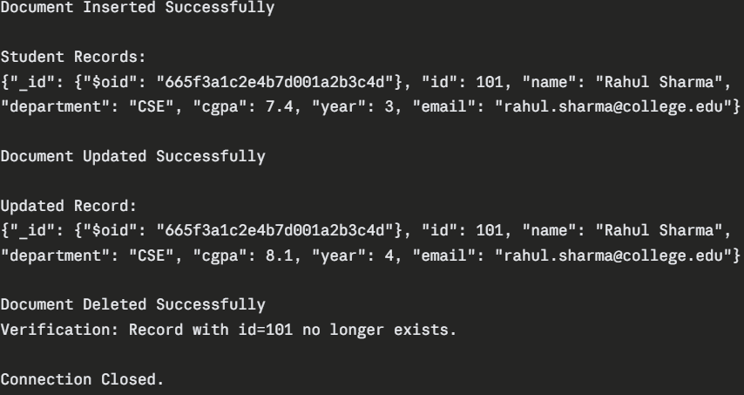

import com.mongodb.client.*;
import com.mongodb.client.model.Filters;
import com.mongodb.client.model.Updates;
import org.bson.Document;
import java.util.Arrays;
import java.util.List;

public class MongoBulkCRUD {

public static void main(String[] args) {

// Connect to MongoDB
MongoClient mongoClient = MongoClients.create("mongodb://localhost:27017");

// Access database
MongoDatabase database = mongoClient.getDatabase("CollegeDB");

// Access collection
MongoCollection<Document> collection =
database.getCollection("Students");

// ==========================
// INSERT MANY
// ==========================
List<Document> studentList = Arrays.asList(
new Document("id", 101)
.append("name", "Rahul")
.append("department", "CSE")
.append("cgpa", 7.4)
.append("year", 2),

new Document("id", 102)
.append("name", "Raj")
.append("department", "ECE")
.append("cgpa", 8.2)
.append("year", 3),

new Document("id", 103)
.append("name", "Suhani")
.append("department", "CSE")
.append("cgpa", 6.9)
.append("year", 2),

new Document("id", 104)
.append("name", "Sumeet")
.append("department", "MECH")
.append("cgpa", 7.8)
.append("year", 4),

new Document("id", 105)
.append("name", "Mahi")
.append("department", "CSE")
.append("cgpa", 5.5)
.append("year", 1)
);

collection.insertMany(studentList);
System.out.println("Multiple Documents Inserted Successfully");
System.out.println("Total Inserted: " + studentList.size());

// ==========================
// READ ALL AFTER INSERT
// ==========================
System.out.println("\nAll Student Records After Insert:");
for (Document doc : collection.find()) {
System.out.println(doc.toJson());
}

// ==========================
// UPDATE MANY
// ==========================
collection.updateMany(
Filters.eq("department", "CSE"),
Updates.combine(
Updates.inc("cgpa", 0.5),
Updates.set("status", "active")
)
);

System.out.println("\nAll CSE Department Records Updated Successfully");

// ==========================
// READ UPDATED CSE RECORDS
// ==========================
System.out.println("\nUpdated CSE Student Records:");
for (Document doc : collection.find(Filters.eq("department", "CSE"))) {
System.out.println(doc.toJson());
}

// ==========================
// DELETE MANY
// ==========================
collection.deleteMany(Filters.lt("cgpa", 7.0));

System.out.println("\nAll Students with CGPA < 7.0 Deleted Successfully");

// ==========================
// READ REMAINING RECORDS
// ==========================
System.out.println("\nRemaining Student Records After Delete:");
for (Document doc : collection.find()) {
System.out.println(doc.toJson());
}

// Close connection
mongoClient.close();
System.out.println("\nConnection Closed.");
}
}

db.Students.insertMany([
{ id: 101, name: "Rahul", department: "CSE", cgpa: 7.4, year: 2 },
{ id: 102, name: "Raj", department: "ECE", cgpa: 8.2, year: 3 },
{ id: 103, name: "Suhani", department: "CSE", cgpa: 6.9, year: 2 },
{ id: 104, name: "Sumeet", department: "MECH", cgpa: 7.8, year: 4 },
{ id: 105, name: "Mahi", department: "CSE", cgpa: 5.5, year: 1 }
])
{
"acknowledged": true,
"insertedIds": {
"0": ObjectId("665f3a1c2e4b7d001a2b3c01"),
"1": ObjectId("665f3a1c2e4b7d001a2b3c02"),
"2": ObjectId("665f3a1c2e4b7d001a2b3c03"),
"3": ObjectId("665f3a1c2e4b7d001a2b3c04"),
"4": ObjectId("665f3a1c2e4b7d001a2b3c05")
}
}
db.Students.find().pretty()
{ "_id": ObjectId("...01"), "id": 101, "name": "Rahul", "department": "CSE", "cgpa": 7.4, "year": 2 }
{ "_id": ObjectId("...02"), "id": 102, "name": "Raj", "department": "ECE", "cgpa": 8.2, "year": 3 }
{ "_id": ObjectId("...03"), "id": 103, "name": "Suhani", "department": "CSE", "cgpa": 6.9, "year": 2 }
{ "_id": ObjectId("...04"), "id": 104, "name": "Sumeet", "department": "MECH", "cgpa": 7.8, "year": 4 }
{ "_id": ObjectId("...05"), "id": 105, "name": "Mahi", "department": "CSE", "cgpa": 5.5, "year": 1 }
db.Students.updateMany(
{ department: "CSE" },
{
$inc: { cgpa: 0.5 },
$set: { status: "active" }
}
)
{
"acknowledged": true,
"matchedCount": 3,
"modifiedCount": 3,
"upsertedCount": 0,
"upsertedId": null
}
db.Students.find({ department: "CSE" }).pretty()
{ "_id": ObjectId("...01"), "id": 101, "name": "Rahul", "department": "CSE", "cgpa": 7.9, "year": 2, "status": "active" }
{ "_id": ObjectId("...03"), "id": 103, "name": "Suhani", "department": "CSE", "cgpa": 7.4, "year": 2, "status": "active" }
{ "_id": ObjectId("...05"), "id": 105, "name": "Mahi", "department": "CSE", "cgpa": 6.0, "year": 1, "status": "active" }
db.Students.deleteMany({ cgpa: { $lt: 7.0 } })
{
"acknowledged": true,
"deletedCount": 1
}
db.Students.find().pretty()
{ "_id": ObjectId("...01"), "id": 101, "name": "Rahul", "department": "CSE", "cgpa": 7.9, "year": 2, "status": "active" }
{ "_id": ObjectId("...02"), "id": 102, "name": "Raj","department": "ECE", "cgpa": 8.2, "year": 3 }
{ "_id": ObjectId("...03"), "id": 103, "name": "Suhani", "department": "CSE", "cgpa": 7.4, "year": 2, "status": "active" }
{ "_id": ObjectId("...04"), "id": 104, "name": "Sumeet", "department": "MECH", "cgpa": 7.8, "year": 4 }

