Project title: Intelligent Hostel Resource Allocation and Resident Management System
Name: Rajvardhan Singh Gahlaut
Reg. No.: 23BEC0081

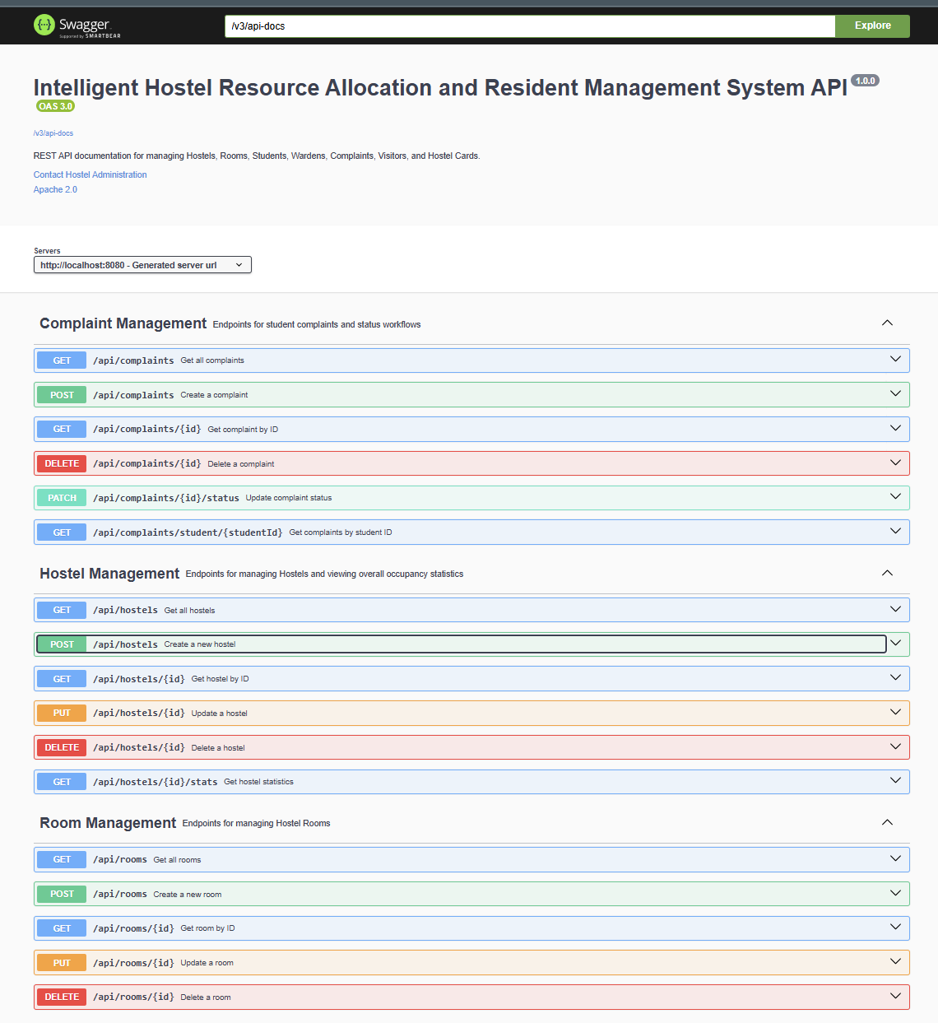
Swagger homepage:

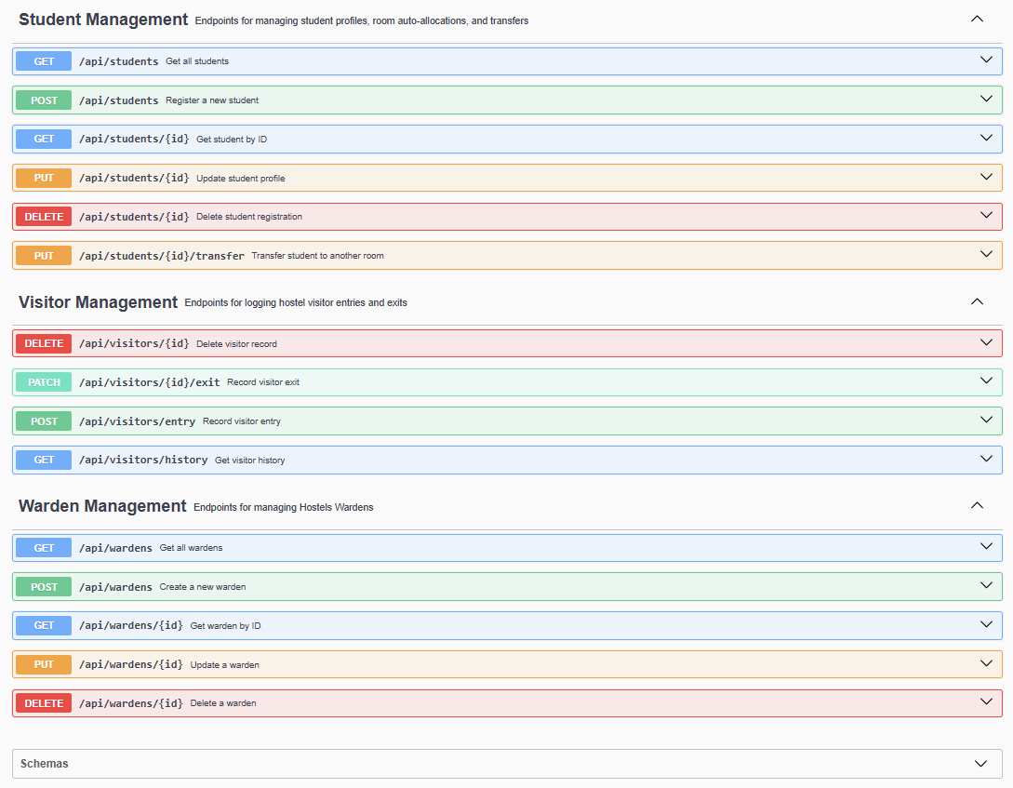

Created 4 Hostels:
{
"hostelName": "Boys Hostel A",
"hostelType": "BOYS",
"totalRooms": 100
}
{
"hostelName": "Boys Hostel B",
"hostelType": "BOYS",
"totalRooms": 120
}
{
"hostelName": "Girls Hostel A",
"hostelType": "GIRLS",
"totalRooms": 90
}
{
"hostelName": "International Hostel",
"hostelType": "COED",
"totalRooms": 50
}
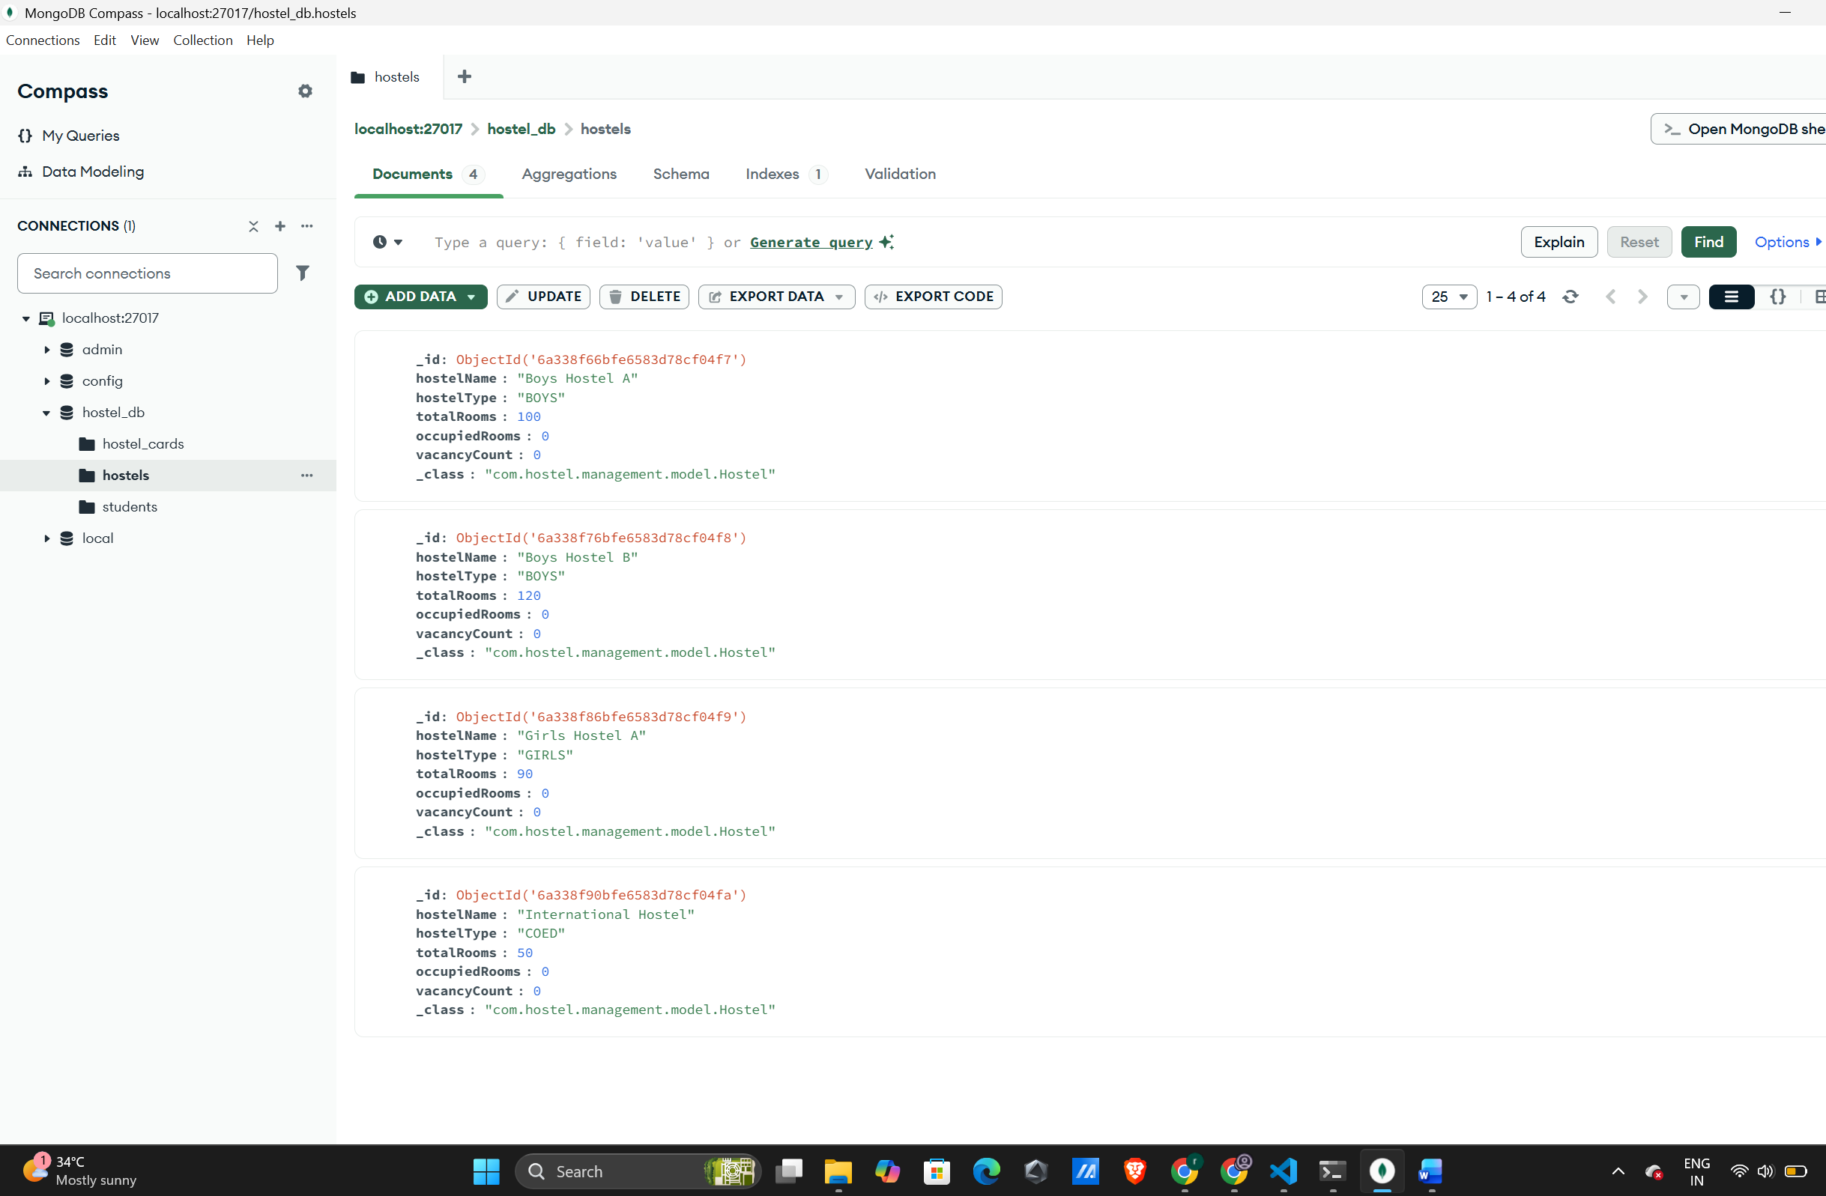
Warden Creation:
{
"wardenId": "6a3395e0bfe6583d78cf04fc",
"name": "Rajesh Kumar",
"email": "rajesh@hostel.com",
"phoneNumber": "9876543210",
"hostelId": "6a338f66bfe6583d78cf04f7"
}
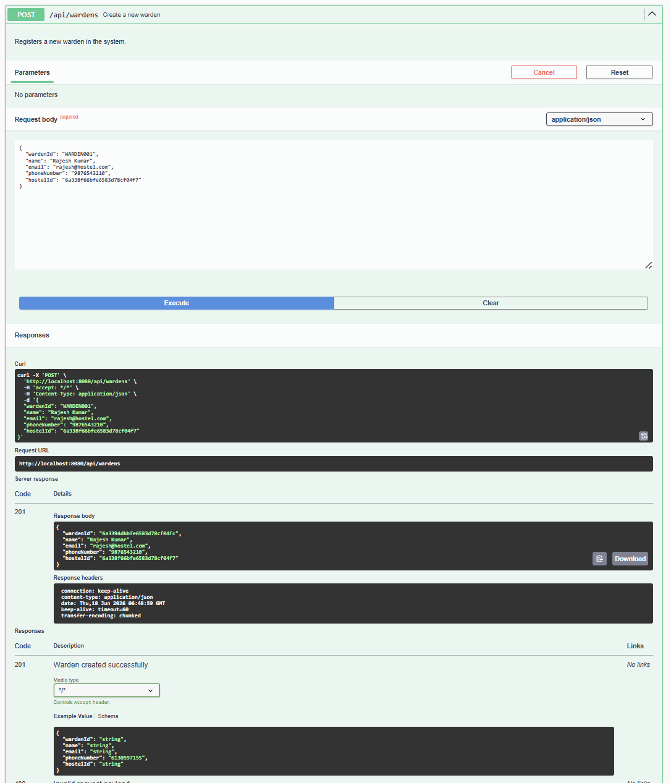
Like this more are created:
{
"wardenId": "6a3395c8bfe6583d78cf04fd",
"name": "Priya Sharma",
"email": "priya@hostel.com",
"phoneNumber": "9876543211",
"hostelId": "6a338f76bfe6583d78cf04f8"
}
{
"wardenId": "6a3395d7bfe6583d78cf04fe",
"name": "Amit Patel",
"email": "amit@hostel.com",
"phoneNumber": "9876543212",
"hostelId": "6a338f86bfe6583d78cf04f9"
}
{
"wardenId": "6a3395e0bfe6583d78cf04ff",
"name": "Sneha Gupta",
"email": "sneha@hostel.com",
"phoneNumber": "9876543213",
"hostelId": "6a338f90bfe6583d78cf04fa"
}
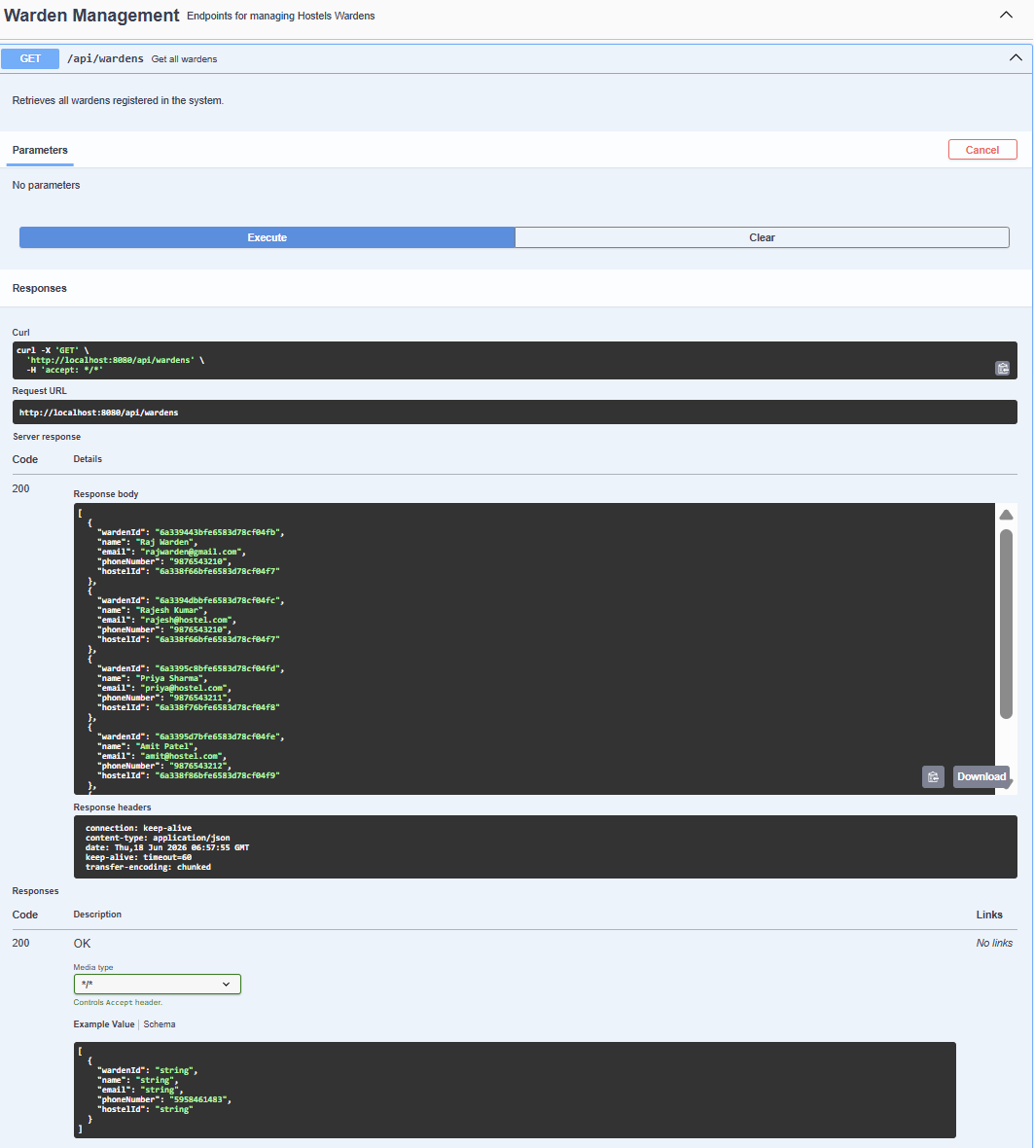
Rooms are created:
{
"roomId": "ROOM001",
"roomNumber": "A101",
"capacity": 4,
"currentOccupancy": 0,
"roomType": "BOYS",
"hostelId": "6a338f66bfe6583d78cf04f7",
"wardenId": "6a3394dbbfe6583d78cf04fc"
}
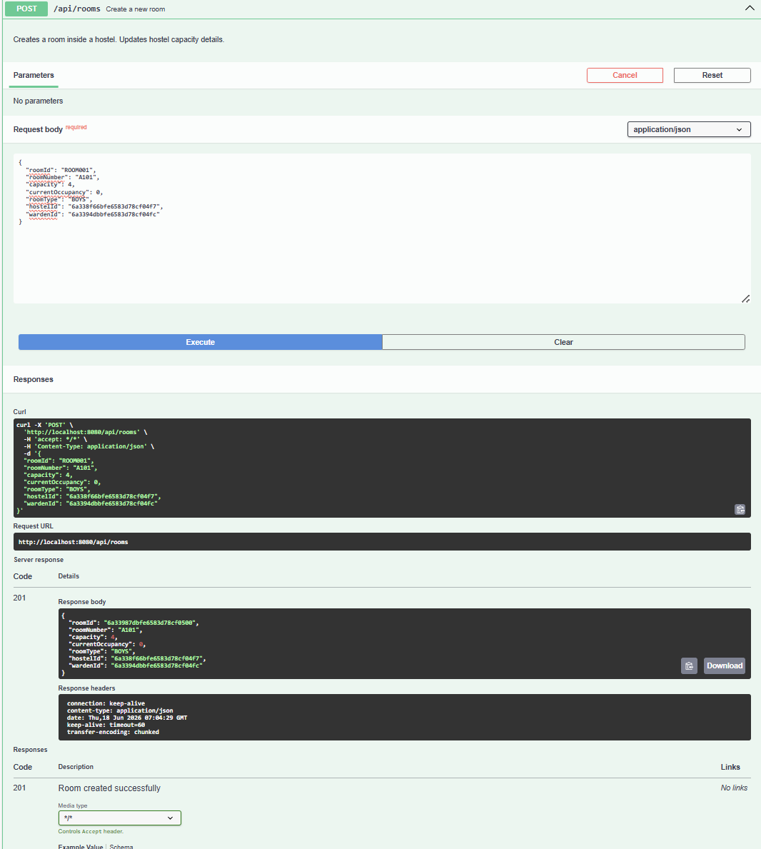

3 more rooms created:
{
"roomId": "ROOM002",
"roomNumber": "A102",
"capacity": 4,
"currentOccupancy": 0,
"roomType": "BOYS",
"hostelId": "6a338f66bfe6583d78cf04f7",
"wardenId": "6a3395c8bfe6583d78cf04fd"
}
{
"roomId": "ROOM003",
"roomNumber": "A103",
"capacity": 4,
"currentOccupancy": 0,
"roomType": "BOYS",
"hostelId": "6a338f66bfe6583d78cf04f7",
"wardenId": "6a3395d7bfe6583d78cf04fe"
}
{
"roomId": "ROOM004",
"roomNumber": "A104",
"capacity": 4,
"currentOccupancy": 0,
"roomType": "BOYS",
"hostelId": "6a338f66bfe6583d78cf04f7",
"wardenId": "6a3395e0bfe6583d78cf04ff"
}
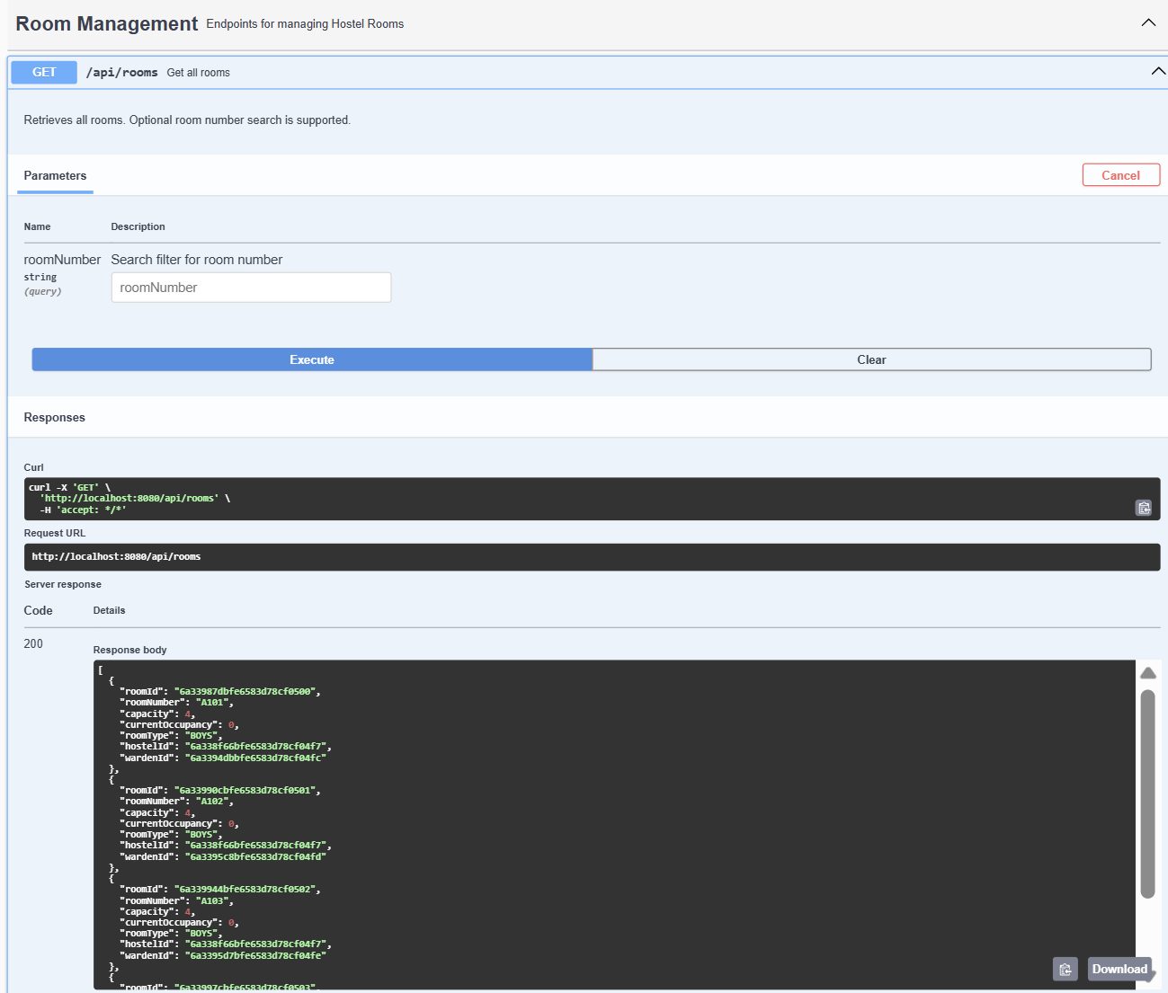

Students are created:
{
"studentId": "STU001",
"registrationNumber": "22BCE1001",
"name": "Rajvardhan Gahlaut",
"email": "raj@example.com",
"phoneNumber": "9876543210",
"gender": "MALE",
"department": "ECE",
"roomId": "6a33987dbfe6583d78cf0500",
"hostelId": "6a338f66bfe6583d78cf04f7",
"hostelCardId": ""
}
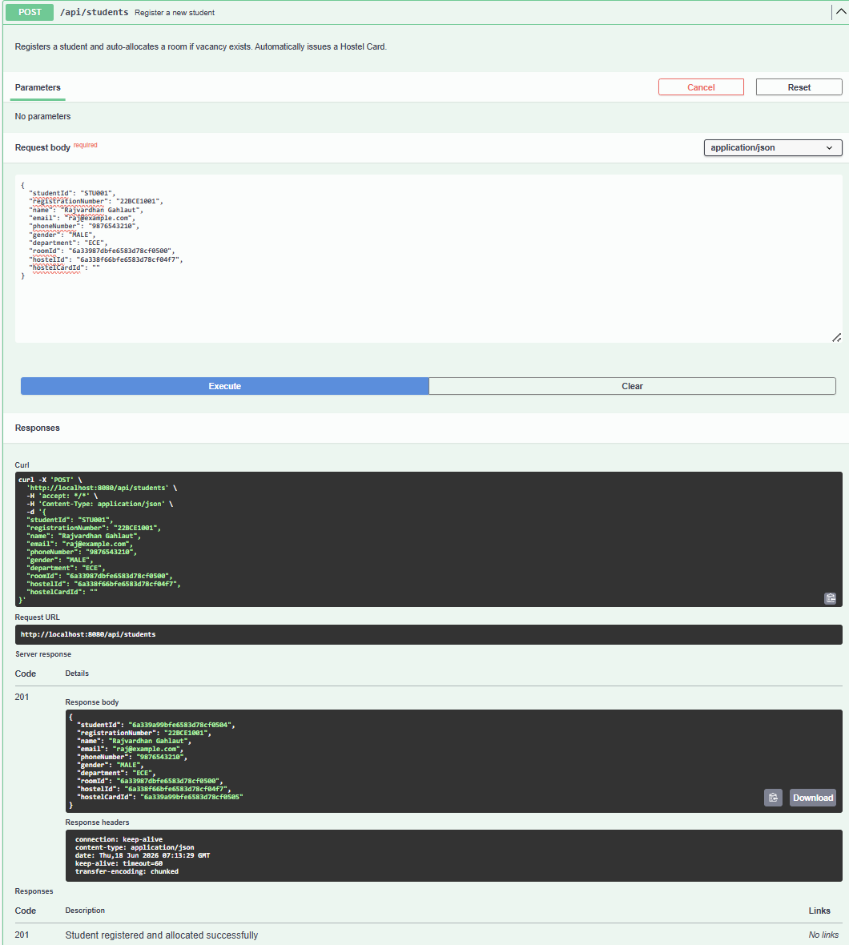
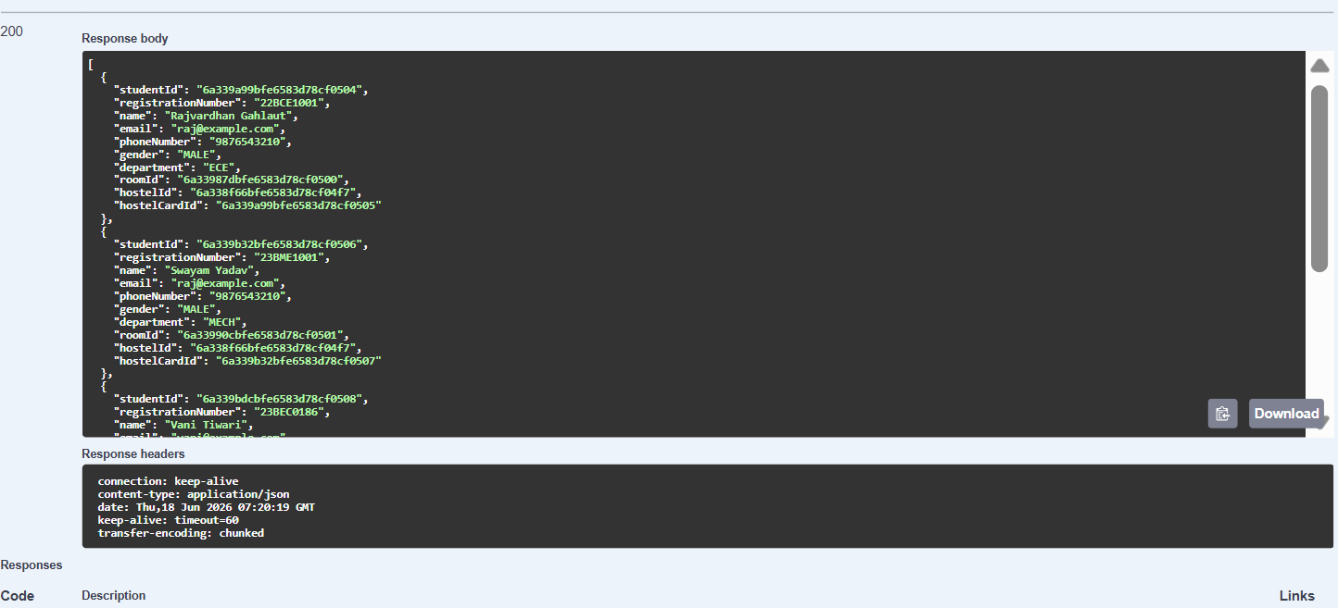

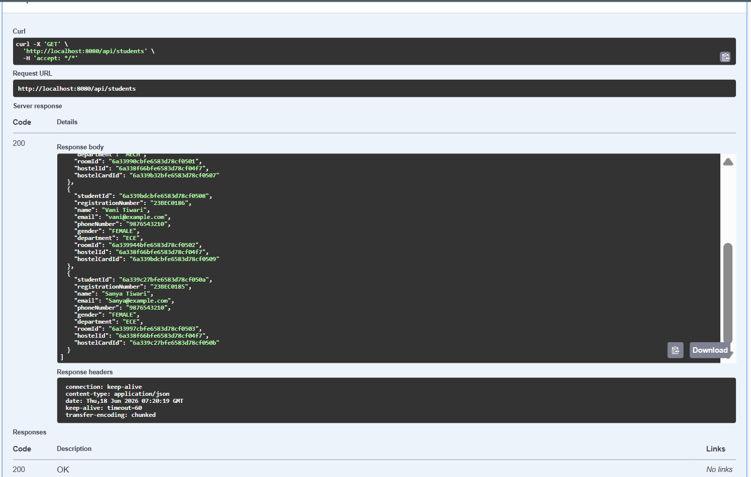

Students:
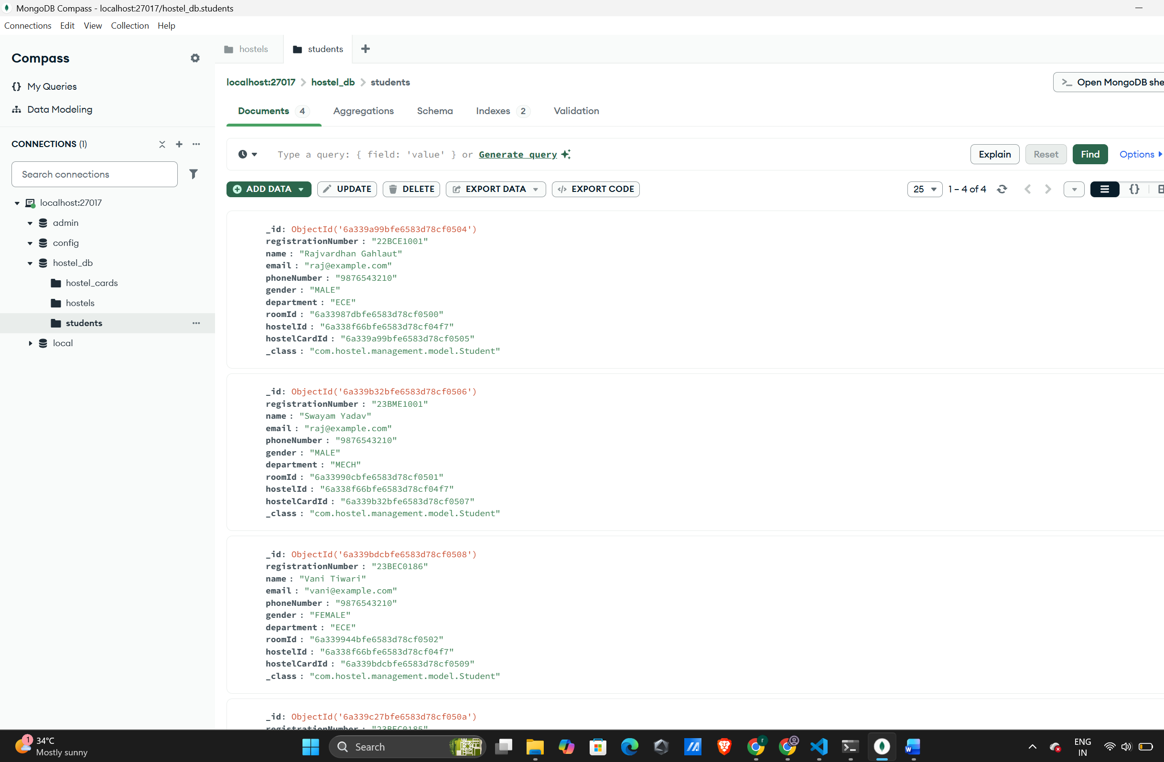

Hostel Cards:
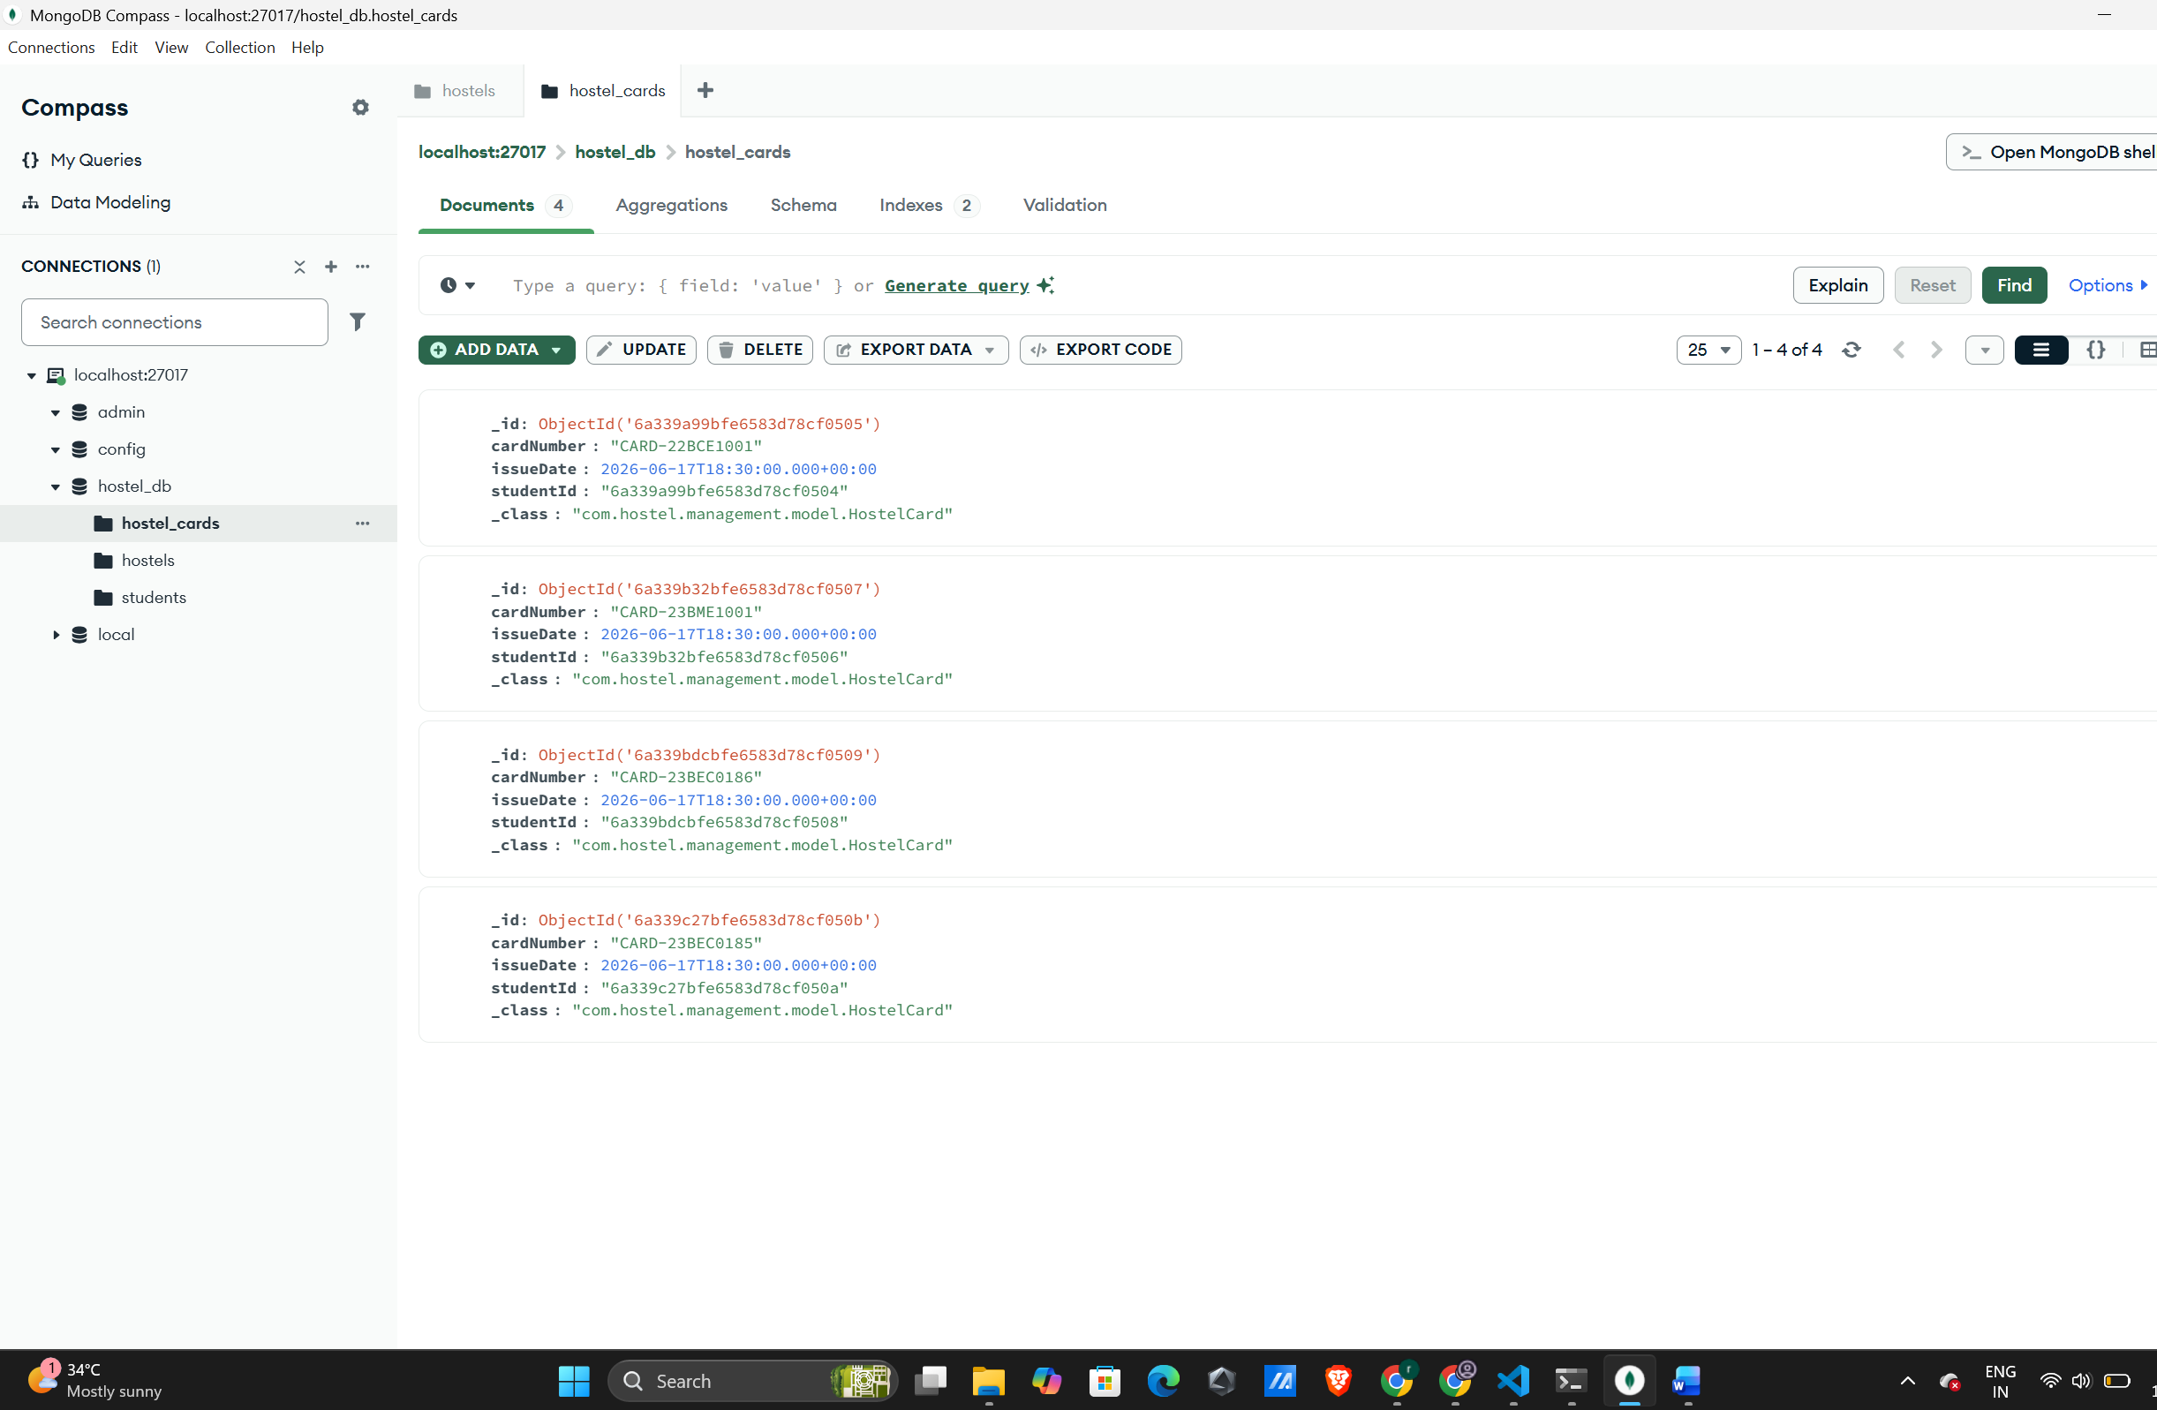

VS Code Screenshot:
