Step:-1 Registration in GIT

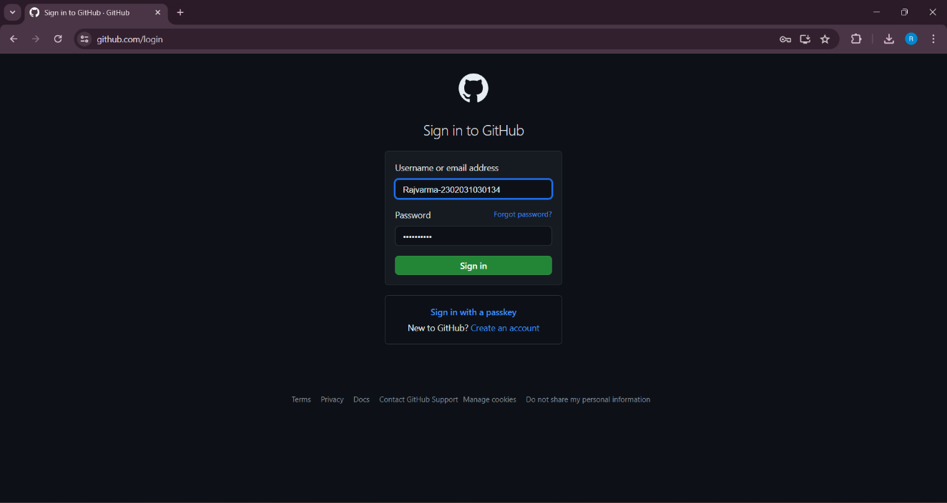

Step:-2 Create repository in Git

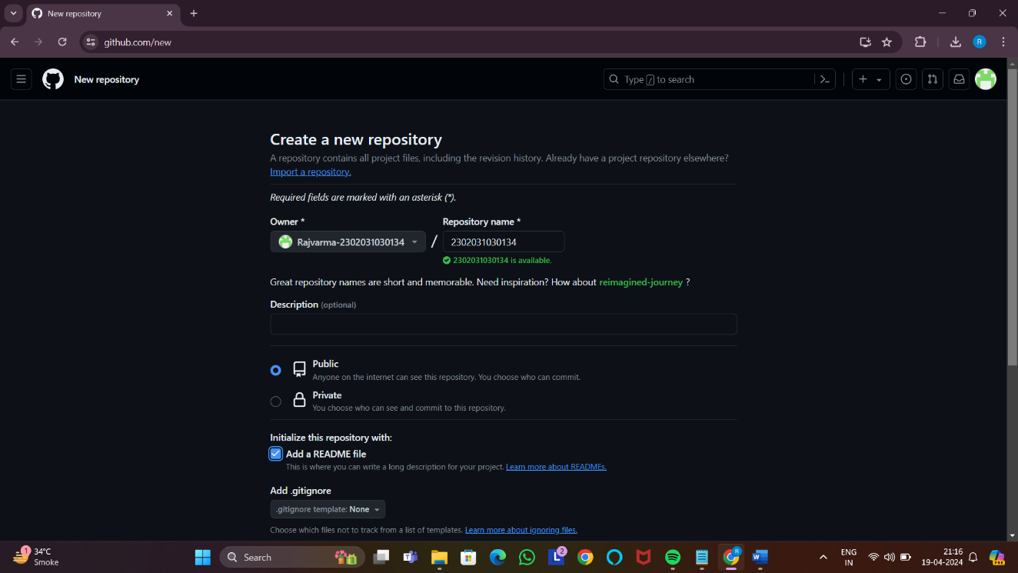

Step:-3 Creating folder Assigment1 and Assigment2

