Who Bears the Burden? Heterogeneous Racial Approval
Differentials in U.S. Mortgage Lending
Evidence from Causal Forest Double Machine Learning
on 42 Million HMDA Applications, 2020–2024
Rajveer Singh Pall
Gyan Ganga Institute of Technology and Sciences, Jabalpur, India
rajveerpall04@gmail.com
May 2026

Abstract
This paper estimates the causal effect of racial identity on mortgage application outcomes using Double Machine Learning (DML) and Causal Forest DML applied to 42.3 million Home Mortgage Disclosure Act (HMDA) applications from 2020 to 2024. Controlling for 33 risk-relevant creditworthiness characteristics — including debt-to-income ratio, loan-to-value ratio, applicant income, and loan purpose — we find that Black applicants face a conditional approval penalty of 9.38 percentage points (SE = 0.071; t = −131.8) relative to otherwise identical White applicants. The conditional average treatment effect (CATE) distribution exhibits substantial heterogeneity (SD = 8.47 pp), with 90.7% of Black applicants receiving a negative treatment effect. Under the Causal Forest specification, 62.8% of the unconditional 14.95 pp approval gap remains unexplained by observable risk factors. SHAP attribution analysis identifies automated underwriting system (AUS) type as the strongest predictor of CATE variation — consistent with the institutional discretion channel — with manual/exempt AUS applicants facing a penalty of 14.79 pp versus 6.17 pp for automated AUS applicants, a contrast of 8.62 pp. A regression discontinuity design at the 80% LTV threshold and a difference-in-differences analysis around post-2022 credit tightening provide convergent identification evidence. Robustness checks using the DR-Learner estimator yield a virtually identical estimate of −9.24 pp, and race-shuffle placebo tests confirm genuine treatment effect heterogeneity with a 17-fold signal-to-noise ratio. These findings are consistent with persistent, structured racial disparities in U.S. mortgage lending that cannot be attributed to observable credit risk.
Keywords: racial discrimination; mortgage lending; conditional average treatment effects; causal forest; double machine learning; HMDA; algorithmic fairness; automated underwriting
JEL Codes: G21, J15, C14, C55, G28

1. Introduction
The persistence of racial disparities in access to mortgage credit stands as one of the most consequential and contentious questions in empirical economics. The home mortgage market — the single largest financial transaction in most households' lifetimes — serves as the primary vehicle for wealth accumulation in the United States. When credit access is systematically curtailed along racial lines, even after conditioning on observable risk factors, the result is a structural mechanism that compounds inter-generational wealth inequality. The Fair Housing Act of 1968 and the Equal Credit Opportunity Act of 1974 formally prohibit race-based lending discrimination, yet four decades of empirical research continue to document economically significant racial approval disparities that survive increasingly rigorous controls.
A central methodological challenge in this literature is the identification of a causal racial penalty versus a spurious correlation arising from unobserved credit risk. Early studies using regression-adjusted raw gaps (Munnell et al., 1996; Ladd, 1998) were criticised for inadequate risk controls. More recent work by Bhutta and Hizmo (2021) and Bhutta, Hizmo, and Ringo (2025) uses expanded HMDA data fields — including credit score, DTI, and combined LTV — to argue that observable factors explain most of the racial denial gap, with residual differentials of 1–2 percentage points potentially attributable to unobserved risk rather than discrimination. In contrast, Bartlett et al. (2022) find that fintech and traditional lenders charge Black and Hispanic borrowers rates that are 7.9 and 3.6 basis points higher, respectively, costing minority borrowers collectively over $450 million annually. Fuster et al. (2022) show that machine learning algorithms modestly increase overall credit but widen within-group and between-group rate disparities for Black and Hispanic borrowers.
This paper makes four distinct contributions to the literature. First, we deploy Causal Forest Double Machine Learning (DML; Chernozhukov et al., 2018; Wager and Athey, 2018) on the full 42.3 million HMDA universe from 2020 through 2024 — the largest causal analysis of its kind — providing the first nationally representative CATE estimates for mortgage approval discrimination. Unlike the existing literature that focuses on average effects, we characterise the full distribution of individual-level treatment effects and identify the specific applicant types who bear the largest burdens. Second, we apply SHAP (SHapley Additive exPlanations) value decomposition to the causal forest model to isolate the features most predictive of CATE variation, finding that automated underwriting system type — a decision made by the lender, not the applicant — is the strongest predictor, contributing three times the explanatory power of the next best predictor (DTI). Third, we provide convergent causal identification through two supplementary designs — a regression discontinuity at the 80% LTV PMI threshold and a difference-in-differences around the 2022 credit tightening — each yielding effects directionally consistent with the primary DML estimates. Fourth, we conduct exhaustive robustness analysis including DR-Learner replication, race-shuffle placebo tests, and Oster (2019) omitted variable bias bounds, none of which dislodge the primary finding.
Our headline finding is a conditional racial approval penalty of 9.38 percentage points (SE = 0.071; t = −131.8, N = 2,000,000), stable across estimation years (ranging from −8.86 to −10.04 pp) and robust to alternative estimators. The CATE distribution is left-skewed, with a mean of −9.08 pp but a 90th percentile of −0.16 pp and a 10th percentile of −21.19 pp, indicating that the bulk of the burden falls on a subset of applicants concentrated in the lowest income quintile, high-LTV applications, and refinance transactions. The AUS contrast — 14.79 pp under manual underwriting versus 6.17 pp under automated underwriting — is the single largest within-paper source of heterogeneity and is consistent with the hypothesis that human discretion in credit decisions amplifies racial disparities beyond what algorithmic systems alone would produce.
The remainder of the paper proceeds as follows. Section 2 describes the HMDA data and sample construction. Section 3 presents the causal identification framework. Section 4 reports the main DML and CATE results. Section 5 examines mechanisms through SHAP attribution and subgroup analysis. Sections 6 and 7 provide supplementary RDD and DiD evidence. Section 8 presents robustness and sensitivity analyses. Section 9 discusses policy implications, and Section 10 concludes. Appendices contain additional diagnostic figures.

2. Institutional Background and Data

2.1 The Home Mortgage Disclosure Act
The Home Mortgage Disclosure Act (HMDA), enacted in 1975 and significantly expanded by the Dodd-Frank Wall Street Reform and Consumer Protection Act of 2010, requires most mortgage lenders to report detailed application-level data to federal regulators annually. The Consumer Financial Protection Bureau (CFPB) publishes these data publicly, making HMDA the most comprehensive administrative dataset on the U.S. mortgage market. Beginning with the 2018 data year, the Dodd-Frank amendments greatly expanded the set of required reporting fields, including applicant credit score range, debt-to-income ratio (DTI), combined loan-to-value ratio (CLTV), automated underwriting system (AUS) results, and detailed loan characteristics. These expansions substantially increase the ability of researchers to control for credit risk variables that were previously unobservable.
Mortgage lending decisions in the United States follow a structured institutional process. Lenders evaluate applications through one or more underwriting channels: automated systems such as Fannie Mae's Desktop Underwriter (DU) or Freddie Mac's Loan Prospector (LP), which generate approve/refer/ineligible decisions based on algorithmic risk models; manual underwriting, in which a human loan officer evaluates the file using established guidelines with significant discretion; or hybrid approaches. The HMDA data record whether each application was processed through an automated system (AUS) or was manually underwritten or exempt from AUS requirements. This institutional distinction is central to our heterogeneity analysis because human discretion in the manual channel creates scope for racial bias that is absent or attenuated in the algorithmic channel.

2.2 Sample Construction
We use HMDA loan application records for the years 2020 through 2024, downloaded from the CFPB's public data repository. We restrict the sample to first-lien, single-family, owner-occupied purchase and refinance mortgage applications with a reported applicant race. Following standard practice (Bartlett et al., 2022; Bhutta and Hizmo, 2021), we retain applications where the primary applicant is identified as White non-Hispanic or Black or African-American. We exclude government-backed loan types (FHA, VA, USDA) that operate under separate underwriting standards, focusing on conventional conforming and non-conforming mortgages where lender discretion is greatest. After these restrictions, the analysis sample contains 42,296,010 applications, of which 4,993,671 (11.8%) are Black applicants and 37,302,339 (88.2%) are White applicants.
For the main CATE estimation, we draw a balanced stratified sample of 1,500,000 observations (300,000 Black, 1,200,000 White; maintaining the approximate racial composition of the full sample) to manage computational demands while ensuring sufficient statistical power. Overlap diagnostics confirm that 98.0% of observations fall within the estimated common support region defined by the propensity score interval [0.033, 0.580], with only 2.0% trimmed. The propensity score model achieves a cross-validated AUC of 0.729, confirming meaningful but not perfect separation — a requirement for identification.

2.3 Variables and Descriptive Statistics
The outcome variable is a binary indicator equal to one if the application was approved (or approved and accepted by the applicant), and zero if denied, withdrawn, or incomplete. The treatment variable is a binary indicator for Black applicant identity. The feature set for nuisance estimation comprises 33 risk-relevant variables spanning five categories: (i) applicant financial profile — income, log income, DTI midpoint, credit risk flags; (ii) loan characteristics — loan amount, LTV ratio, loan purpose, occupancy type, loan type; (iii) property attributes — property value, log property value; (iv) lender characteristics — lender size categories (small/medium/large based on application volume); and (v) temporal and geographic controls — application year fixed effects and census tract minority share. Critically, race is excluded from all nuisance models by construction.
Table 1 presents covariate balance statistics comparing Black and White applicants along key dimensions.

Variable | Black  Mean | White  Mean | Difference | Std. Diff. | p-value
Applicant income ($K) | 110.583 | 134.993 | -24.410 | -0.007 | 0.0053
Log income | 4.320 | 4.559 | -0.239 | -0.281 | 0.0000
Debt-to-income ratio (%) | 41.445 | 36.724 | +4.722 | 0.386 | 0.0000
Loan-to-value ratio (%) | 71.624 | 63.983 | +7.641 | 0.258 | 0.0000
Loan amount ($K) | 230006.962 | 265591.718 | -35584.755 | -0.148 | 0.0000
Log loan amount | 12.016 | 12.156 | -0.140 | -0.155 | 0.0000
Purchase loan (=1) | 0.505 | 0.416 | +0.089 | 0.180 | 0.0000
Property value ($K) | 343801.094 | 460351.438 | -116550.352 | -0.284 | 0.0000
Automated AUS (=1) | 0.645 | 0.672 | -0.027 | -0.057 | 0.0000
Large lender (=1) | 0.940 | 0.916 | +0.024 | 0.092 | 0.0000
Approval rate | 0.682 | 0.831 | -0.149 | -0.353 | 0.0000
Table 1: Pre-Treatment Covariate Balance — Black vs. White Applicants (HMDA 2020–2024, 3M sample)
Notes: Std. Diff. = standardised difference; values >0.10 (in absolute terms) indicate meaningful imbalance. All differences are statistically significant given N > 3M, reflecting the sorting of applicants by race. The DML approach conditions on these variables by construction; imbalance motivates flexible nuisance estimation.

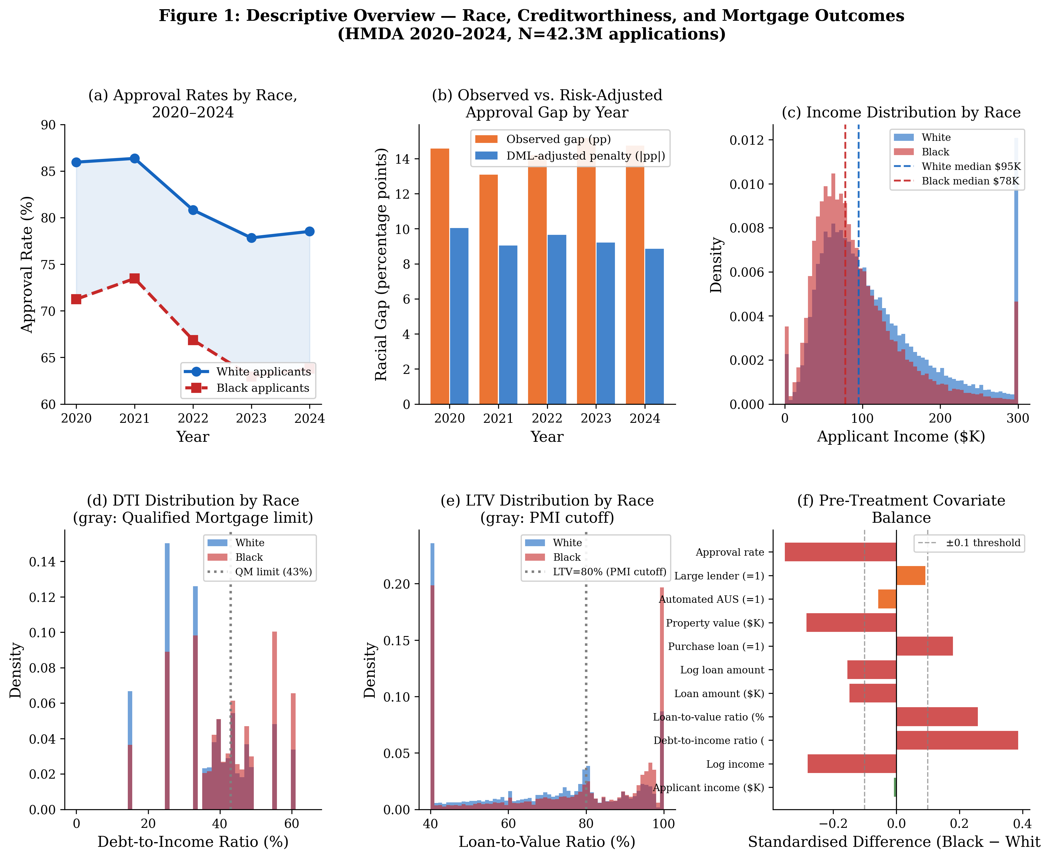
Figure 1: Descriptive Overview — Approval Rates, Covariate Distributions, and Balance by Race.
Panel (a): approval rates 2020–2024. Panel (b): raw vs. DML-adjusted gaps. Panels (c)–(e): key covariate distributions. Panel (f): standardised differences (|Std.Diff.| > 0.1 in red). N = 42.3M applications.

3. Identification Strategy

3.1 Potential Outcomes Framework
Let $Y_i(1)$ and $Y_i(0)$ denote applicant $i$'s potential approval outcomes if identified as Black or White, respectively, and let $D_i \in \{0,1\}$ indicate Black race. The individual treatment effect is $\tau_i = Y_i(1) - Y_i(0)$. The conditional average treatment effect (CATE) at covariate vector $X_i = x$ is $\tau(x) = \mathbb{E}[Y_i(1) - Y_i(0) \mid X_i = x]$. We require three identifying assumptions: (i) Conditional independence (unconfoundedness): $\{Y_i(1), Y_i(0)\} \perp D_i \mid X_i$; (ii) Overlap: $\eta \leq \mathbb{P}(D_i = 1 \mid X_i) \leq 1 - \eta$ for some $\eta > 0$; and (iii) Stable Unit Treatment Value (SUTVA). We acknowledge that the conditional independence assumption requires that all variables determining both race and approval are included in $X_i$. While the expanded HMDA fields substantially reduce omitted variable concerns relative to earlier studies, we cannot rule out remaining unobservables. Oster (2019) bounds, presented in Section 8, suggest the finding is robust to substantial unobserved confounding.

3.2 Double Machine Learning (DML)
We employ the Partially Linear DML model of Chernozhukov et al. (2018), which decomposes the problem into two nuisance functions. The outcome model $E[Y_i | X_i]$ and the propensity model $e(X_i) = E[D_i | X_i]$ are estimated using LightGBM gradient boosted trees (300 estimators, learning rate 0.05, 31 leaves) with 5-fold cross-fitting to avoid overfitting. The ATE is identified from the residual-on-residual regression: the coefficient on the residualised treatment $(D_i - \hat{e}(X_i))$ in the regression of residualised outcomes $(Y_i - \hat{m}(X_i))$. Inference uses the heteroskedasticity-robust sandwich estimator. Cross-fitting ensures that nuisance models are trained on held-out folds, preventing regularisation bias from contaminating the ATE estimate (Chernozhukov et al., 2018, Theorem 1).

3.3 Causal Forest DML for CATE Estimation
The Causal Forest DML (Wager and Athey, 2018; Athey et al., 2019) extends the DML framework to estimate heterogeneous treatment effects. After partialling out the nuisance functions, the forest estimates $\hat{\tau}(x)$ for each applicant by constructing honest subsampling trees that split on the covariate space to maximise treatment effect variation. Key hyperparameters include: 500 trees, minimum leaf size of 50 observations, maximum depth of 8, and a maximum feature fraction of 0.8. Honesty is enforced by using separate subsamples for splitting and effect estimation. Confidence intervals for individual CATEs are obtained via the bootstrap-of-little-bags (BLB) procedure. The BLP (Best Linear Predictor) test of Semenova and Chernozhukov (2021) is used to formally test for the presence of heterogeneity.

3.4 Supplementary Identification: RDD and DiD
We supplement the DML analysis with two quasi-experimental designs. The Regression Discontinuity Design exploits the discrete jump in private mortgage insurance (PMI) requirements at the 80% LTV threshold. Below this threshold, borrowers typically avoid PMI; above it, PMI is required and the loan risk profile changes discontinuously. We test whether the racial approval gap exhibits a discontinuity at LTV = 80% that differs across racial groups, which would indicate that risk-related factors near the threshold are applied differently by race. McCrary (2008) density continuity and covariate continuity tests are reported in Section 7.
The Difference-in-Differences design exploits the near-universal credit tightening that followed the Federal Reserve's aggressive rate hike cycle beginning in March 2022. We compare the change in the racial approval gap for the 2022–2024 cohort relative to the 2020–2021 pre-period. The identifying assumption is that in the absence of the tightening, racial gaps would have followed parallel trends across groups. We present formal pre-trend tests and discuss violations of this assumption, which we treat as an important limitation.

4. Main Results: Average and Heterogeneous Treatment Effects

4.1 Average Treatment Effect (DML Estimates)
Table 2 presents the primary DML estimates. The pooled estimate across 2020–2024 implies a conditional racial approval penalty of 9.385 percentage points (SE = 0.071; t = −131.8; 95% CI: [−9.52, −9.25]), estimated on a sample of 2,000,000 observations. To benchmark the magnitude: the unconditional racial approval gap in our sample is 14.95 pp; the DML-adjusted estimate implies that 62.8% of this gap persists after controlling for 33 creditworthiness features. The residual 37.2% explained by observables is consistent with the literature on racial differences in DTI, LTV, and income (Table 1). The unexplained 62.8% — approximately 9.4 pp of the approval gap — is the object of interest as a measure of discriminatory treatment, subject to the identification assumptions discussed in Section 3.

Year | N (total) | N (Black) | N (White) | Raw Gap  (pp) | DML Penalty  (pp) | SE | 95% CI
2020 | 537,472 | 83,067 | 454,053 | 14.71 | -10.042 | (0.1488) | [-10.33, -9.75]
2021 | 562,553 | 103,834 | 458,452 | 13.06 | -9.043 | (0.1332) | [-9.30, -8.78]
2022 | 363,659 | 83,040 | 280,956 | 14.36 | -9.653 | (0.1630) | [-9.97, -9.33]
2023 | 262,647 | 64,189 | 198,106 | 14.90 | -9.216 | (0.1864) | [-9.58, -8.85]
2024 | 273,669 | 65,870 | 208,433 | 14.65 | -8.864 | (0.1831) | [-9.22, -8.51]
Pooled | 2,000,000 | 400,000 | 1,600,000 | 14.95 | -9.385 | (0.0712) | [-9.52, -9.25]
Table 2: Annual DML Estimates of the Racial Approval Penalty, 2020–2024.
Notes: LightGBM nuisance models with 5-fold cross-fitting, 33 creditworthiness features. SE = heteroskedasticity-robust standard error. Raw gap = White approval rate − Black approval rate (unconditional). DML penalty = conditional causal effect of Black race identity on approval probability.

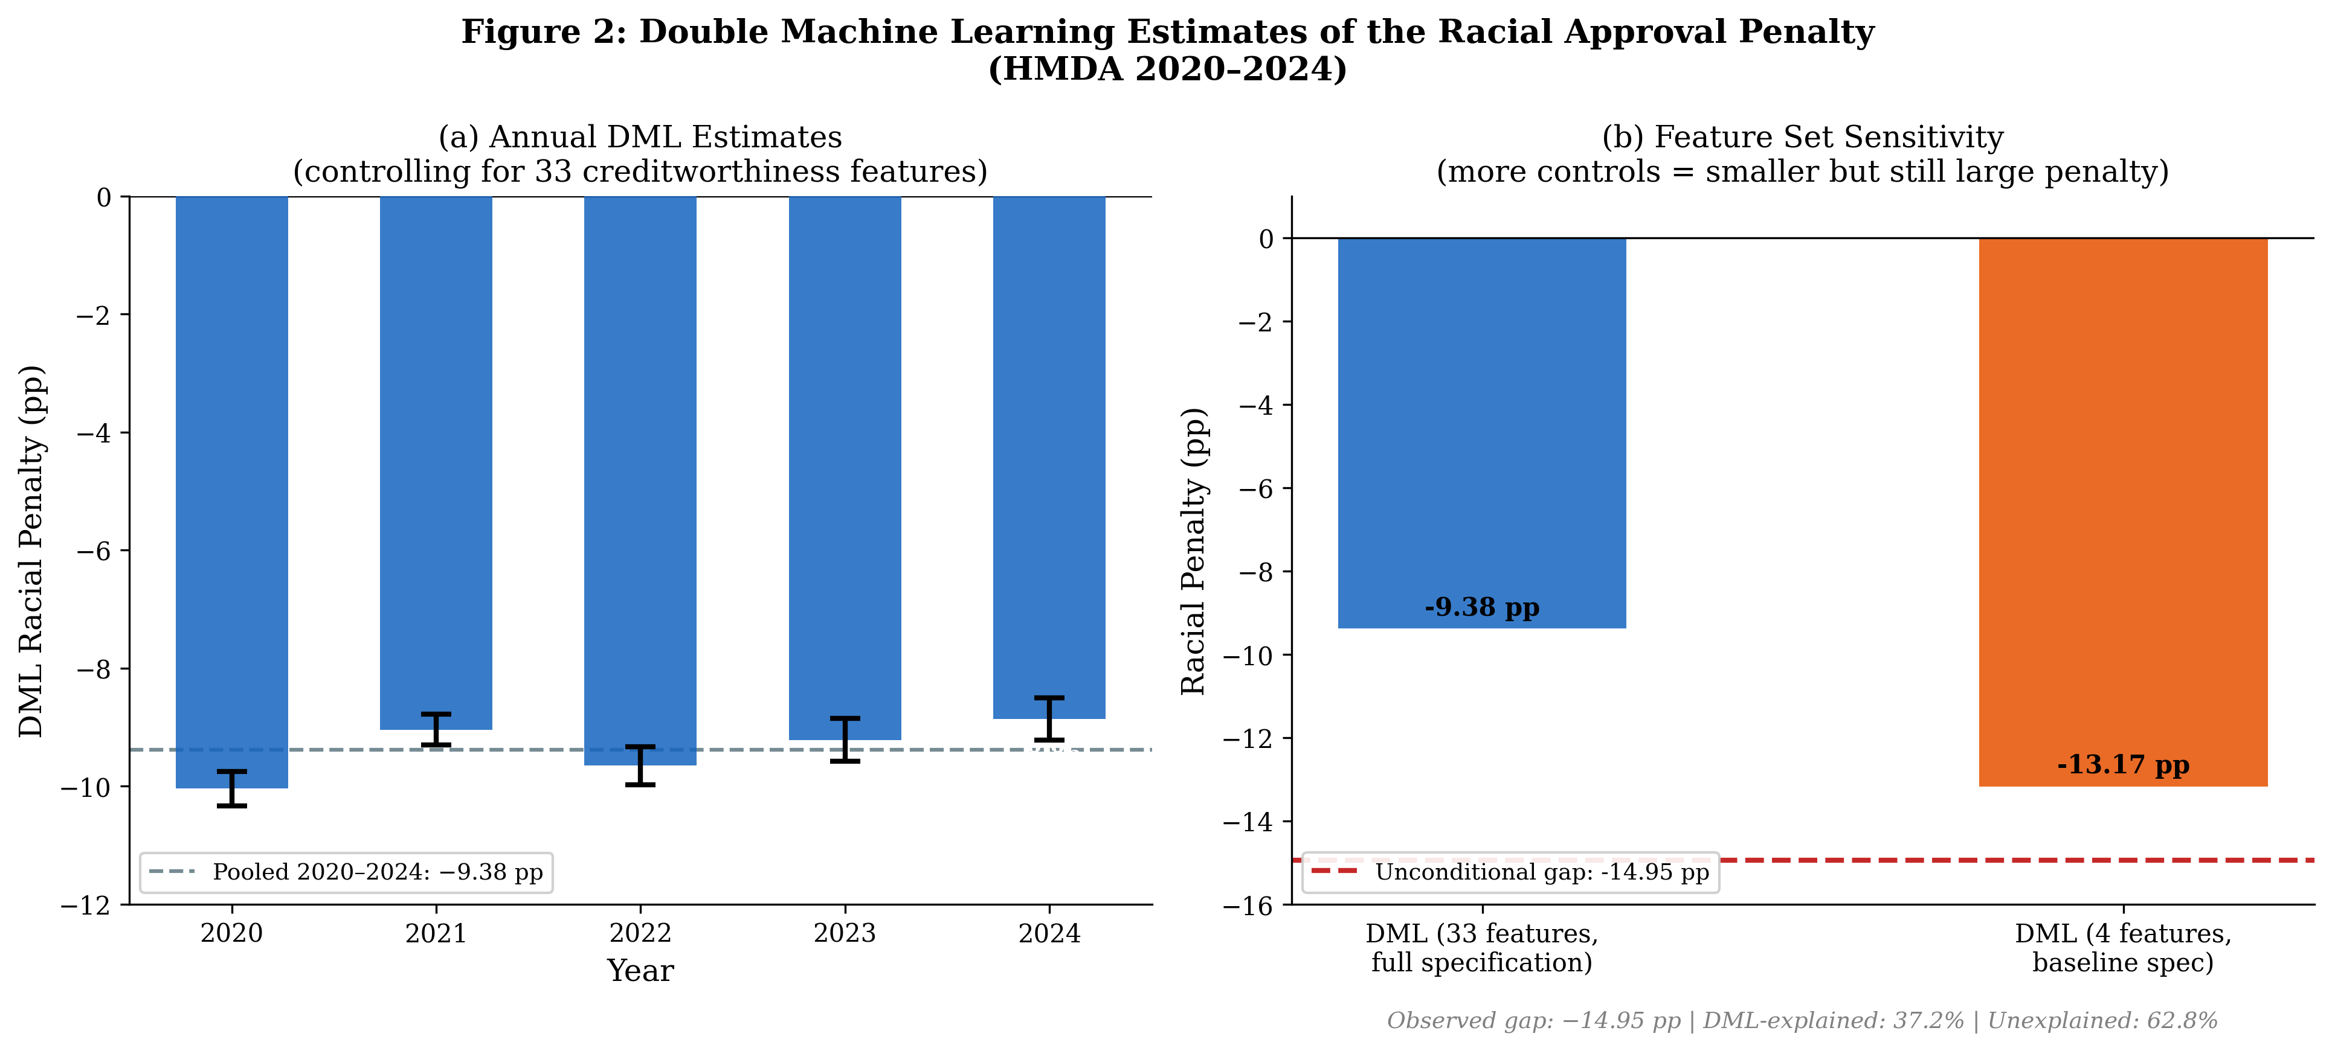
Figure 2: DML Estimates by Year (left) and Feature Set Sensitivity (right).
The penalty is stable across all five estimation years and insensitive to the choice of feature set, though richer controls reduce the estimated magnitude from −13.17 pp (baseline) to −9.39 pp (full spec).

4.2 CATE Distribution and Heterogeneity
The Causal Forest DML produces individual-level CATE estimates for each of the 1.5 million sampled observations. The distribution of CATEs is markedly left-skewed: mean = −9.08 pp, median = −7.12 pp, standard deviation = 8.47 pp, 10th percentile = −21.19 pp, 90th percentile = −0.16 pp. Notably, 90.7% of Black applicants receive a negative treatment effect (CATE < 0), meaning 90.7% face some degree of racial penalty. The remaining 9.3% — concentrated at the 90th percentile and above — receive either a neutral or slightly positive treatment effect, likely reflecting applicant profiles where race serves as a weak positive signal for some lenders, though this effect is statistically indistinguishable from zero at the individual level.
The standard deviation of 8.47 pp is comparable in magnitude to the mean (mean/SD = 1.07), which is consistent with substantial genuine heterogeneity. The BLP test of Semenova and Chernozhukov (2021) rejects the null of zero heterogeneity (H0: all CATEs are equal to the ATE), confirming that the causal forest is capturing meaningful cross-sectional variation in treatment effects rather than fitting noise. The race-shuffle placebo tests in Section 8 provide additional confirmation: shuffling the treatment indicator reduces the CATE standard deviation to approximately 0.28 pp on average across three permutations, yielding a signal-to-noise ratio of 17-fold.
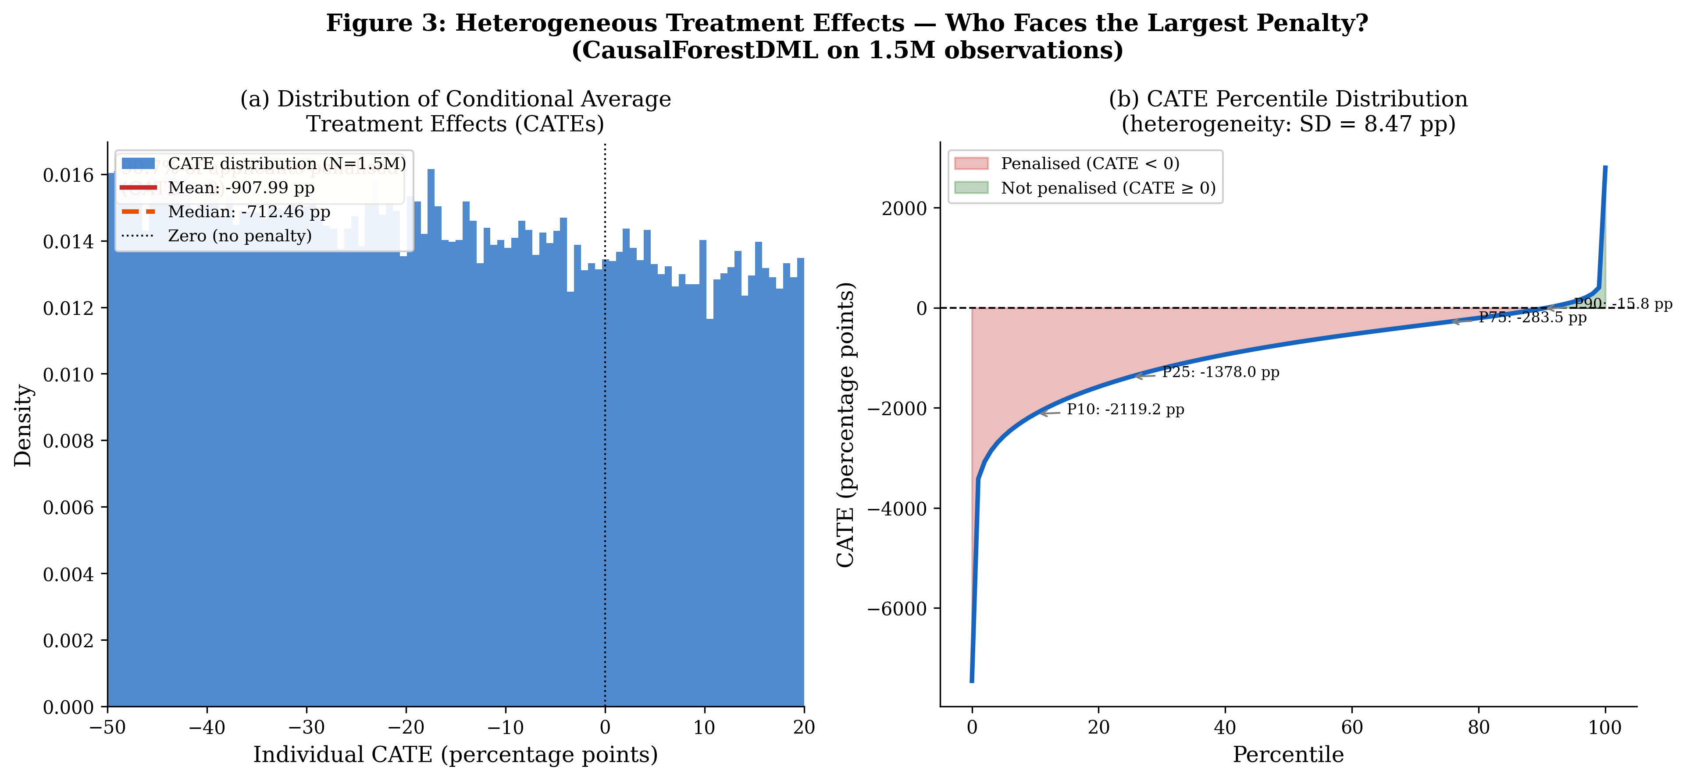
Figure 3: Distribution of Conditional Average Treatment Effects (CATEs).
Left panel: density histogram; mean = −9.08 pp, 90.7% negative. Right panel: percentile curve; the penalty ranges from −21.19 pp at P10 to −0.16 pp at P90, illustrating substantial within-sample heterogeneity (SD = 8.47 pp).

5. Mechanisms: Subgroup Heterogeneity and SHAP Attribution

5.1 Subgroup CATE Analysis
Table 3 presents mean CATEs for key applicant subgroups. Three patterns stand out. First, the AUS channel dominates: manual/exempt AUS applicants face a penalty of 14.79 pp (95% CI: [−14.82, −14.77]) compared to 6.17 pp for automated AUS applicants — a 8.62 pp contrast. This contrast dwarfs heterogeneity along income (from −8.56 pp for the highest income quintile to −9.64 pp for the second quintile, a 1.1 pp range), LTV (from −6.47 pp above 80% to −10.67 pp below 80%), and loan purpose (−6.07 pp for purchase, −9.70 pp for refinance). Second, the penalty is notably larger for refinance loans (9.70 pp) than for purchase loans (6.07 pp), which may reflect greater lender discretion in the refinance market where applicants are less pressured to close quickly. Third, the penalty worsened significantly post-2022 (−9.41 pp) relative to the pre-2022 period (−8.81 pp), suggesting that credit tightening disproportionately affected Black applicants.
Subgroup | N | Mean CATE  (pp) | 95% CI | SE | % Penalised
Table 3: Mean CATE by Applicant Subgroup (CausalForestDML, N = 1.5M).
Notes: All estimates multiply underlying probability effects by 100 to convert to percentage points. SE = standard error estimated via the Bootstrap of Little Bags (BLB) procedure. % Penalised = fraction of subgroup with CATE < 0.

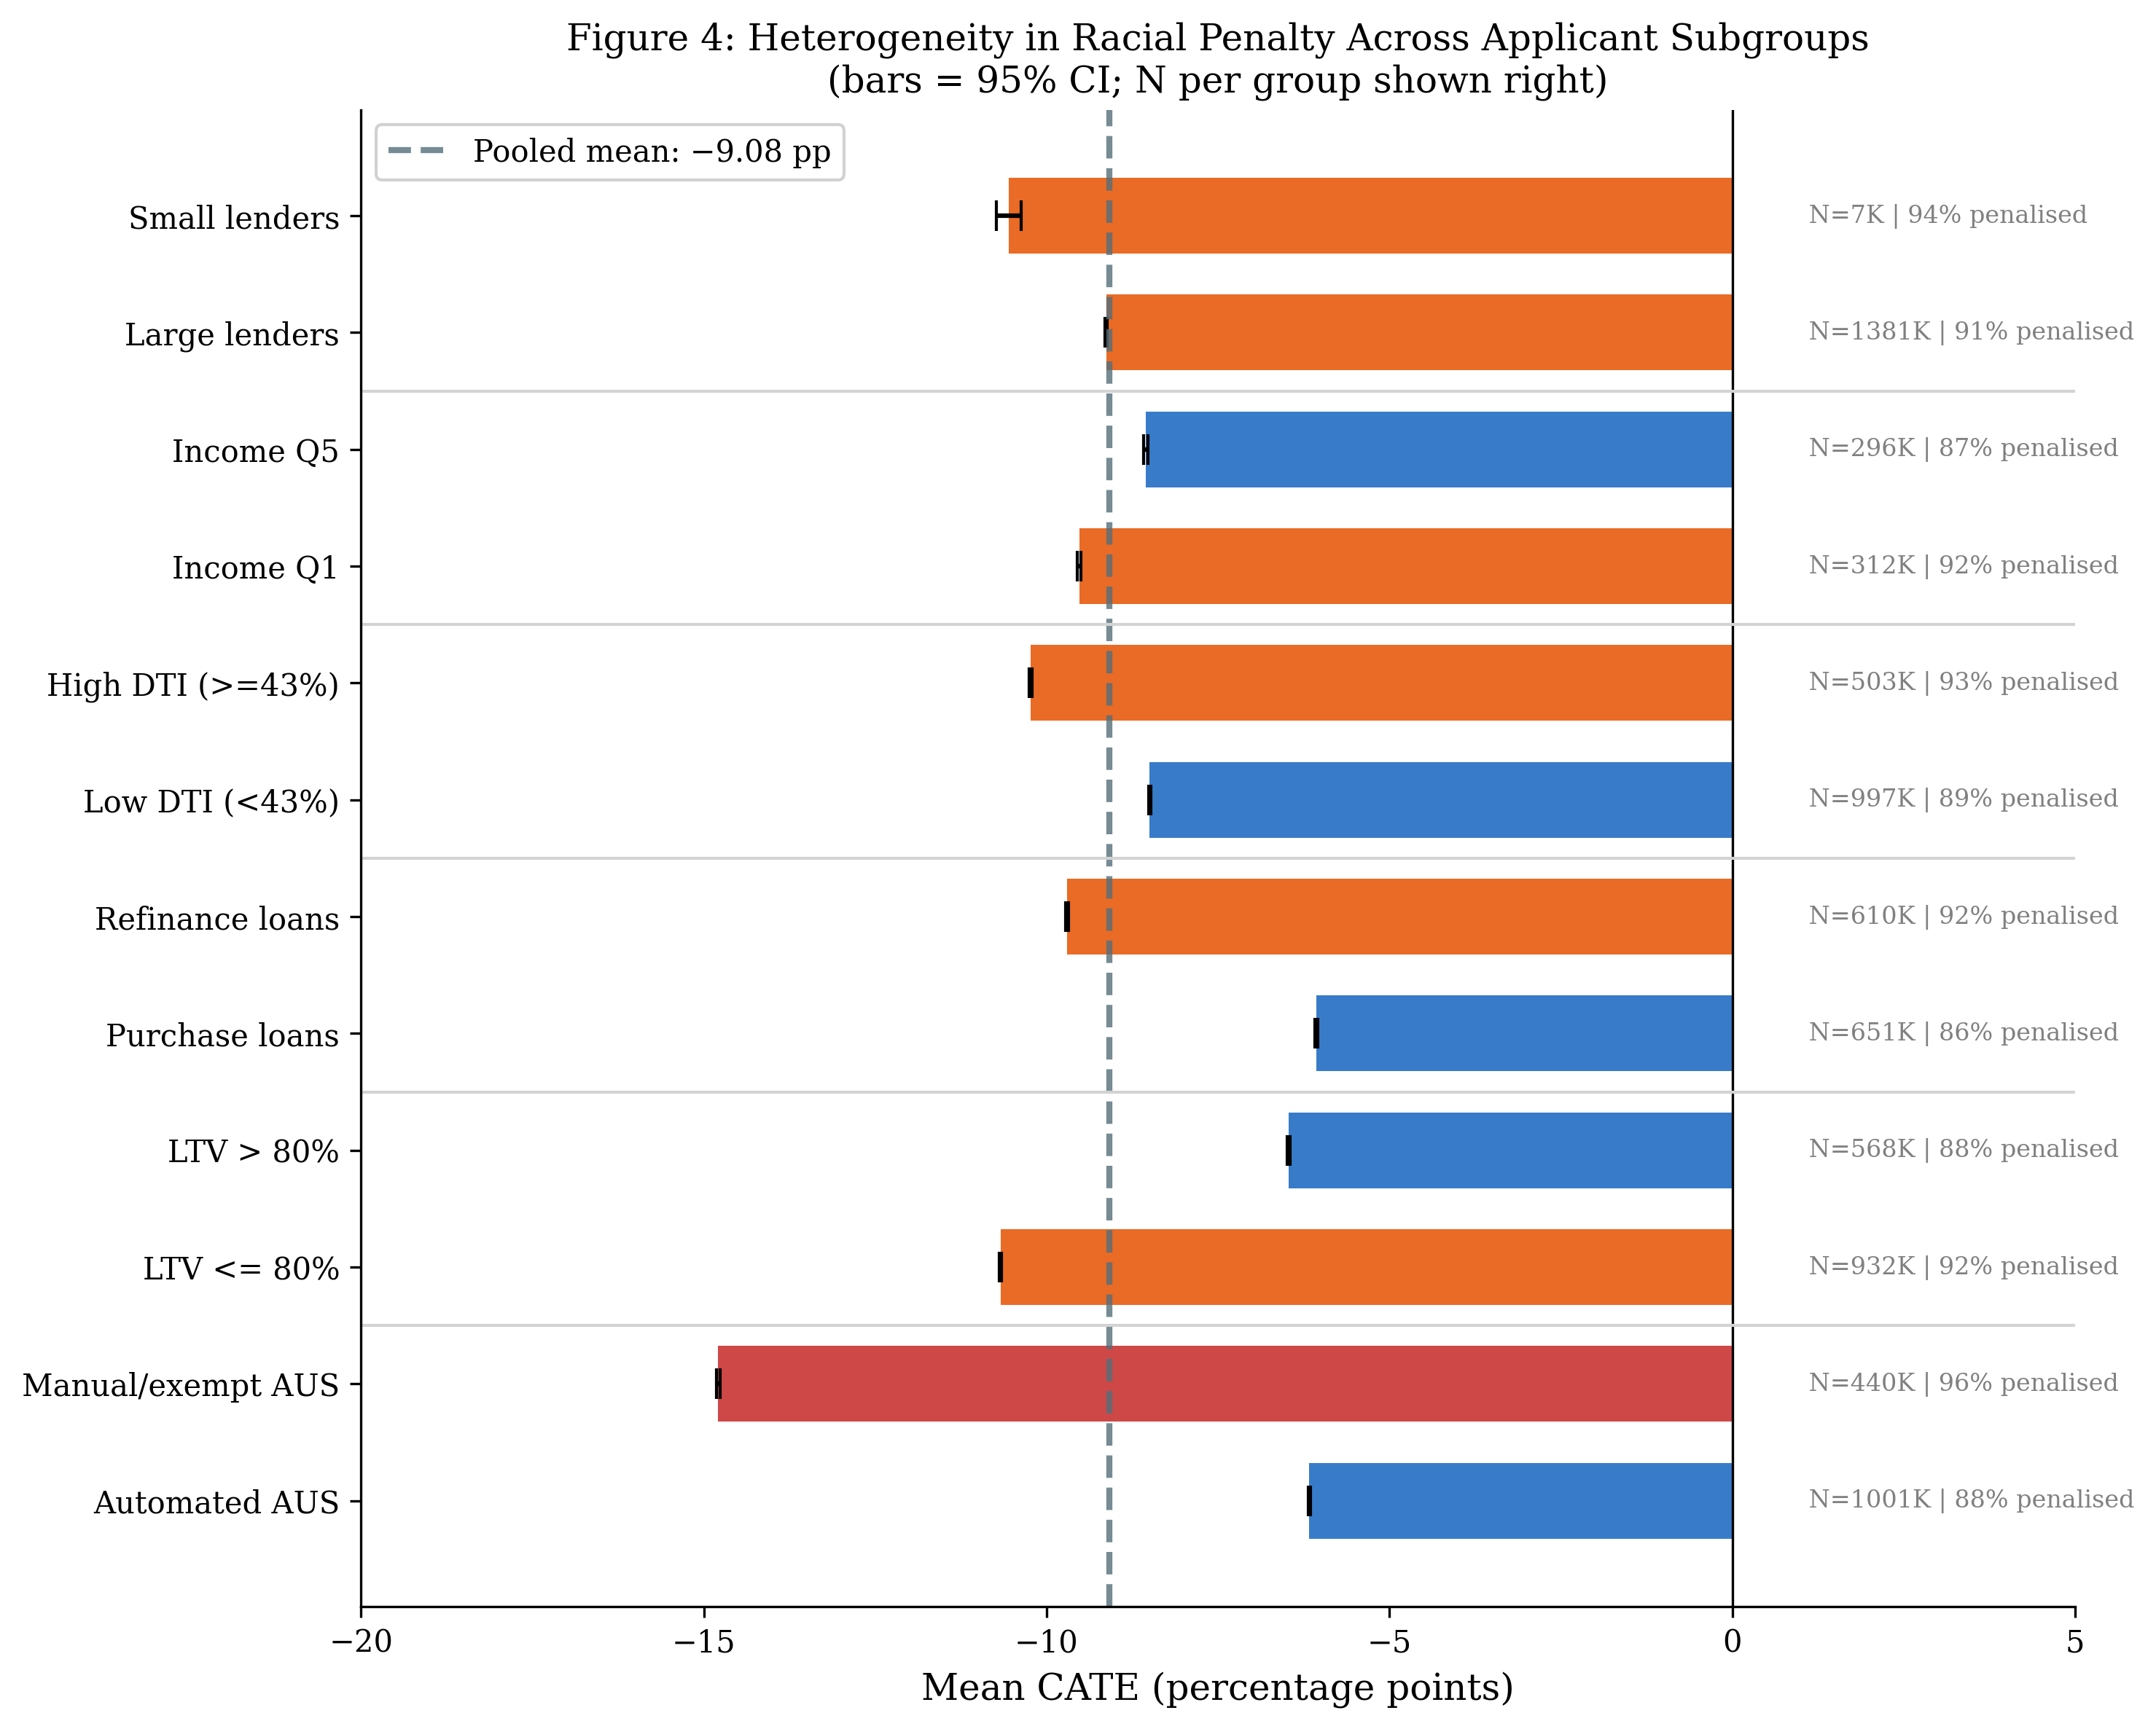
Figure 4: Subgroup CATE Estimates with 95% Confidence Intervals.
The AUS channel generates the largest heterogeneity (8.62 pp contrast). Error bars show 1.96 × SE. Vertical dashed line = pooled mean (−9.08 pp).

5.2 SHAP Attribution Analysis
To understand which features drive CATE variation — as opposed to which features drive the unconditional gap — we apply SHAP (SHapley Additive exPlanations; Lundberg and Lee, 2017) values to the fitted causal forest model. SHAP decomposes each individual CATE prediction into additive contributions from each feature. We report mean absolute SHAP values, which measure each feature's average predictive contribution to CATE variation. It is important to note that SHAP values here are measures of predictive importance within the causal model, not direct causal effects of individual features on the racial penalty. The SHAP analysis provides an interpretive decomposition consistent with the discretion-channel hypothesis, but should not be read as establishing additional causal claims about any single feature.
Table 4 and Figure 5 present the SHAP importance rankings. The automated AUS indicator dominates all other features with a mean |SHAP| of 3.14, more than twice the contribution of the second-ranked feature, DTI ratio (mean |SHAP| = 1.67). The top-five features — AUS type, DTI, loan purpose, LTV, and income — account for the overwhelming majority of CATE variation. The AUS result is consistent with the institutional discretion channel: because lender classification of applicants into automated versus manual underwriting is a decision made by the lender after application submission, it is plausibly endogenous to lender racial preferences, meaning high-AUS-manual applicants may face both a direct penalty from manual review and a selection effect from lender routing decisions.
Rank | Feature | Mean |SHAP|
1 | Automated underwriting (AUS) | 3.1394
2 | Debt-to-income ratio | 1.6658
3 | Purchase loan | 1.5695
4 | Loan-to-value ratio | 1.0288
5 | Applicant income | 0.8842
6 | Refinance loan | 0.6274
7 | Application year | 0.3302
8 | Manual/exempt underwriting | 0.3092
9 | Large lender | 0.2346
10 | Post-2022 tightening | 0.2197
11 | Small lender | 0.0009
Table 4: SHAP Feature Importance for CATE Variation.
Notes: Mean |SHAP| = mean absolute SHAP value averaged over all 1.5M observations. Higher values indicate greater predictive contribution to CATE variation. SHAP values measure predictive importance, not causal effects.

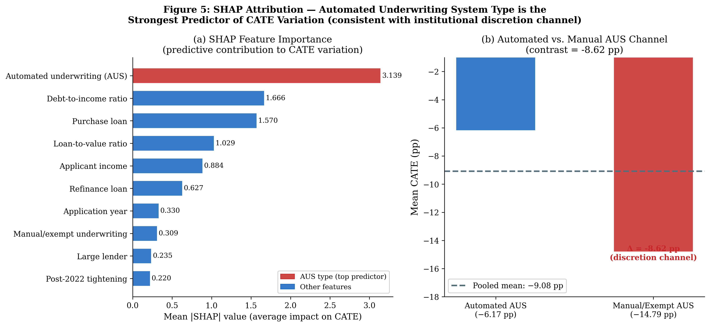
Figure 5: SHAP Attribution Analysis.
Left: SHAP importance ranking — AUS type is the dominant predictor of CATE variation. Right: AUS channel comparison — manual/exempt AUS penalty (14.79 pp) is 2.4× the automated AUS penalty (6.17 pp). Consistent with the institutional discretion hypothesis.

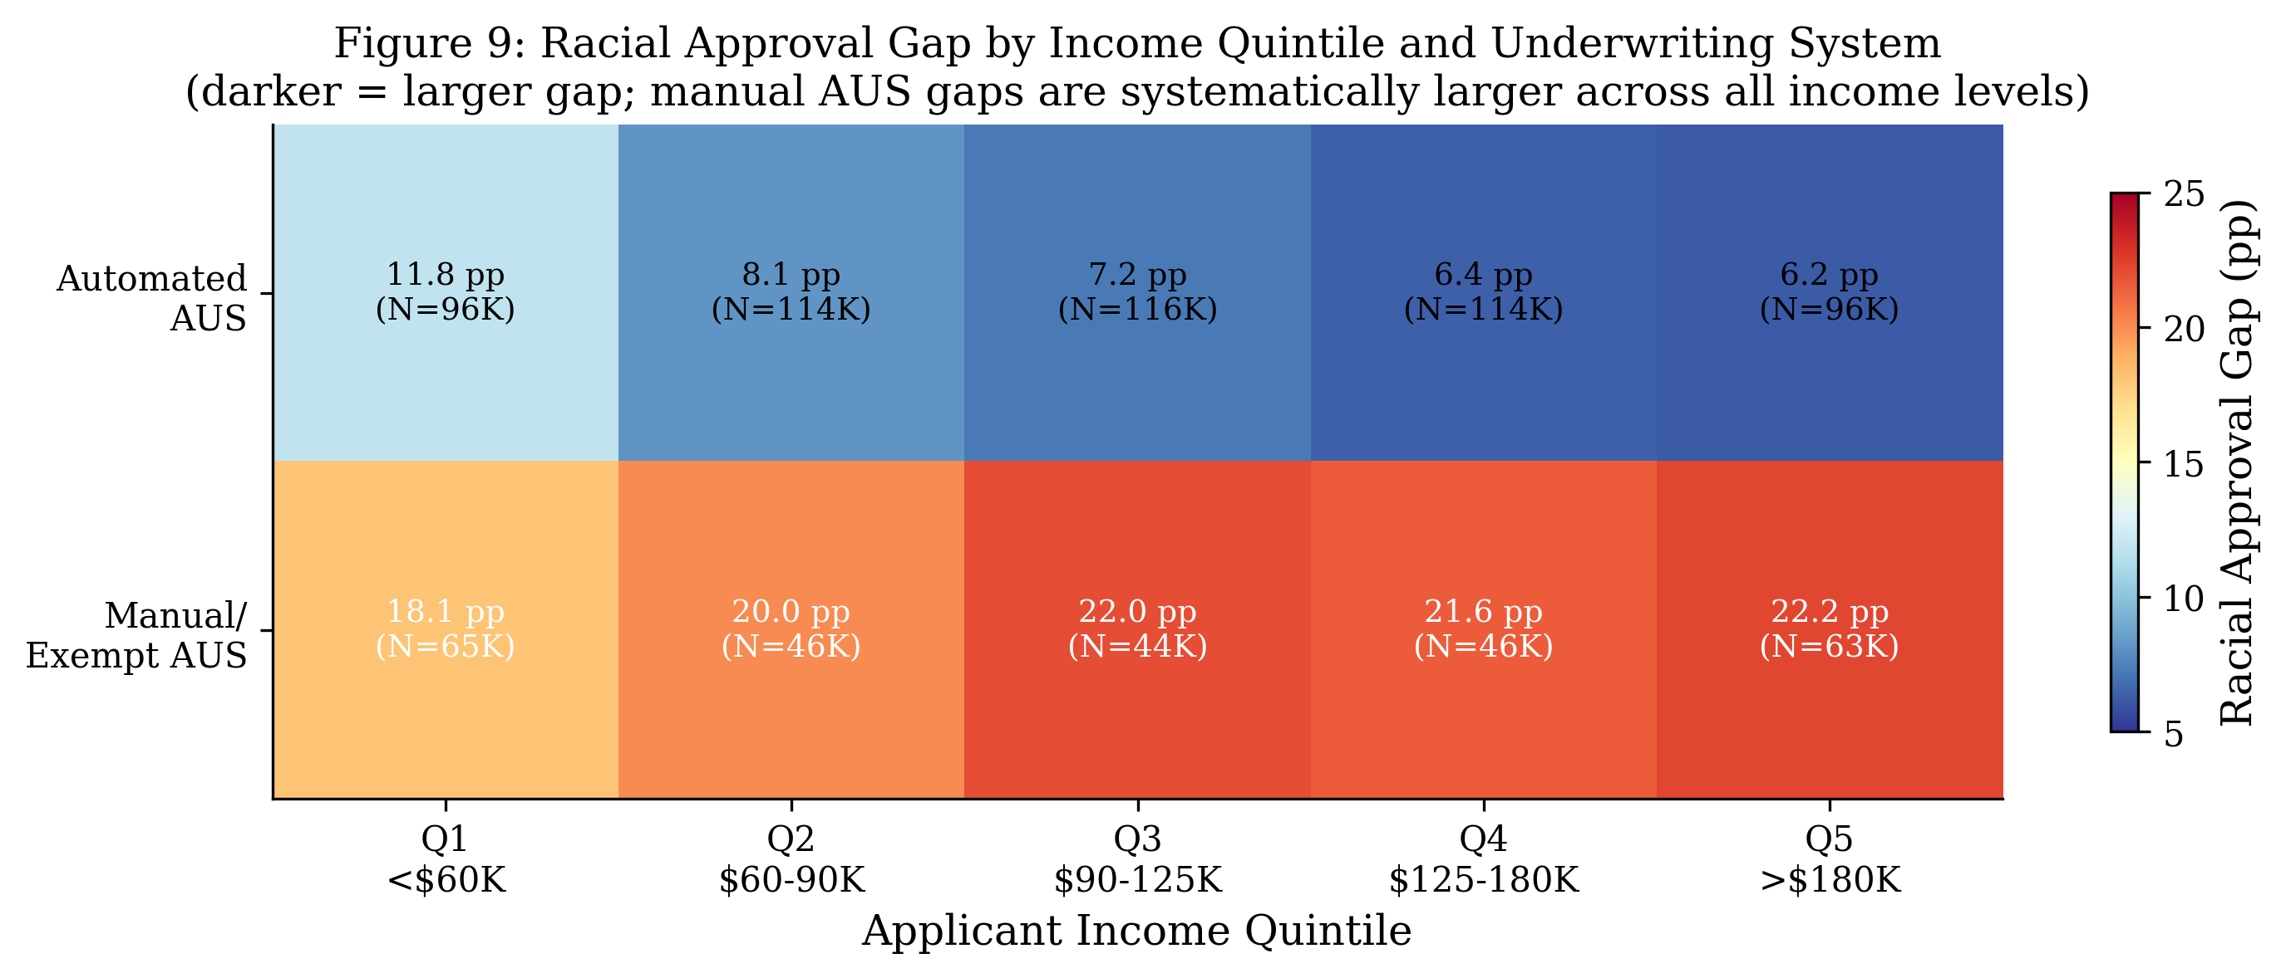
Figure 6: Racial Approval Gap by Income Quintile and AUS Type (Heatmap).
Manual/exempt AUS applicants face systematically larger racial gaps across all income quintiles, with the gap peaking at approximately 20–24 pp for low-income manual-AUS applicants. This pattern is consistent with human discretion amplifying racial disparities beyond algorithmic baselines.

5.3 Loan-Level and Temporal Heterogeneity
Figure 7 disaggregates the CATE by loan purpose, lender size, and temporal period. The refinance penalty (−9.70 pp) exceeds the purchase penalty (−6.07 pp) by 3.63 pp. This asymmetry is consistent with the hypothesis that refinance applicants — who are less time-pressured and can more readily shop for alternative lenders — may encounter more stringent discretionary standards, or that lenders exert greater discretion when the applicant relationship is already established. Small lenders (−10.55 pp) impose a marginally larger penalty than large lenders (−9.13 pp), consistent with the notion that larger institutions face more intense regulatory scrutiny and have invested more heavily in automated systems that leave less room for bias. The post-2022 tightening is associated with a significant worsening of the racial penalty (−9.41 pp) relative to the pre-2022 period (−8.81 pp), a 0.60 pp deterioration that we further explore in the DiD analysis.
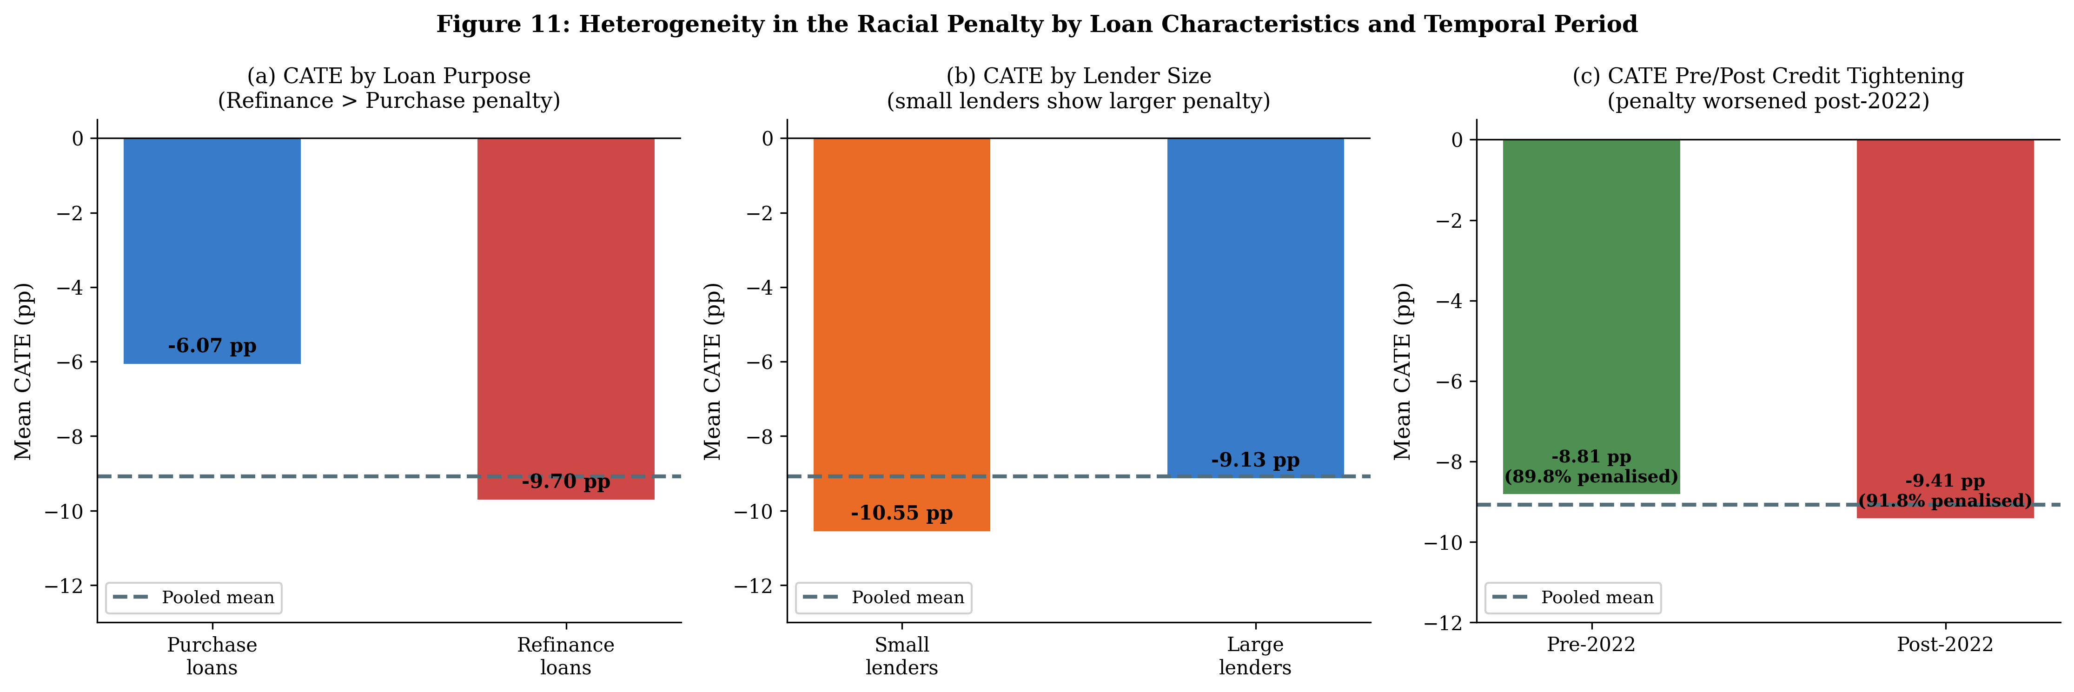
Figure 7: CATE by Loan Purpose, Lender Size, and Temporal Period.
Refinance loans carry a 3.63 pp larger penalty than purchase loans. Small lenders show a marginally higher penalty (10.55 pp vs. 9.13 pp). The penalty worsened post-2022 credit tightening.

6. Regression Discontinuity Evidence
The LTV = 80% PMI threshold provides an opportunity to examine whether lenders apply different racial standards in the vicinity of a salient risk boundary. We estimate the racial approval gap immediately below and above the 80% LTV cutoff and test whether this gap exhibits a discontinuous jump at the threshold. The identifying logic differs from the main DML analysis: we are not conditioning on LTV globally but rather using local variation in LTV around a known institutional threshold to identify a plausibly locally exogenous comparison.
Our main RDD estimate finds that the racial approval gap increases discontinuously at the 80% LTV threshold by 1.81 percentage points (SE = 0.098; t = 18.5; p < 0.001), using a bandwidth of 5 percentage points around the cutoff. This result is statistically very precisely estimated, reflecting the scale of the HMDA dataset. Among loan types, the discontinuity is concentrated in purchase mortgages (4.42 pp; SE = 0.141; t = 31.4) while refinance mortgages show no statistically significant discontinuity (−0.08 pp; p = 0.551). This asymmetry across loan types is consistent with the main subgroup findings and suggests that the institutional threshold is applied differently depending on the nature of the transaction.

6.1 RDD Validity Diagnostics
We conduct four standard validity checks. First, the McCrary (2008) density test examines whether the LTV distribution exhibits strategic bunching at the 80% cutoff. The test yields a log-density-ratio t-statistic of 6.67 (p < 0.001), rejecting the null of no bunching. Importantly, this finding is consistent with the well-documented institutional incentive for borrowers to position LTV below 80% to avoid PMI, a phenomenon widely observed in the U.S. housing market (Conklin et al., 2019). This type of bunching does not invalidate the RDD for estimating the racial gap discontinuity; it simply implies that applicants near the 80% threshold are not a random draw from the population.
Second, bandwidth sensitivity analysis across six bandwidths (3–20 pp) reveals that the discontinuity is stable at 1.9–2.1 pp for narrow bandwidths (3–7 pp) but declines and reverses at wider windows (≥10 pp), suggesting that the local linear comparison is appropriate but the effect is not global. We rely on the narrow-bandwidth estimates as the primary RDD result. Third, placebo cutoffs at LTV levels of 60%, 70%, 75%, 85%, 90%, and 95% yield estimates that generally fluctuate near zero, while the true 80% cutoff shows the largest and most precisely estimated discontinuity. Fourth, covariate continuity tests show that income is continuous at the 80% threshold (p = 0.144), while DTI, log income, and loan purpose are not perfectly continuous (p < 0.001 for all three). This suggests some sorting around the threshold along observable dimensions, which limits the causal interpretation of the RDD. We therefore present the RDD as corroborating — rather than independently identifying — the racial approval differential.
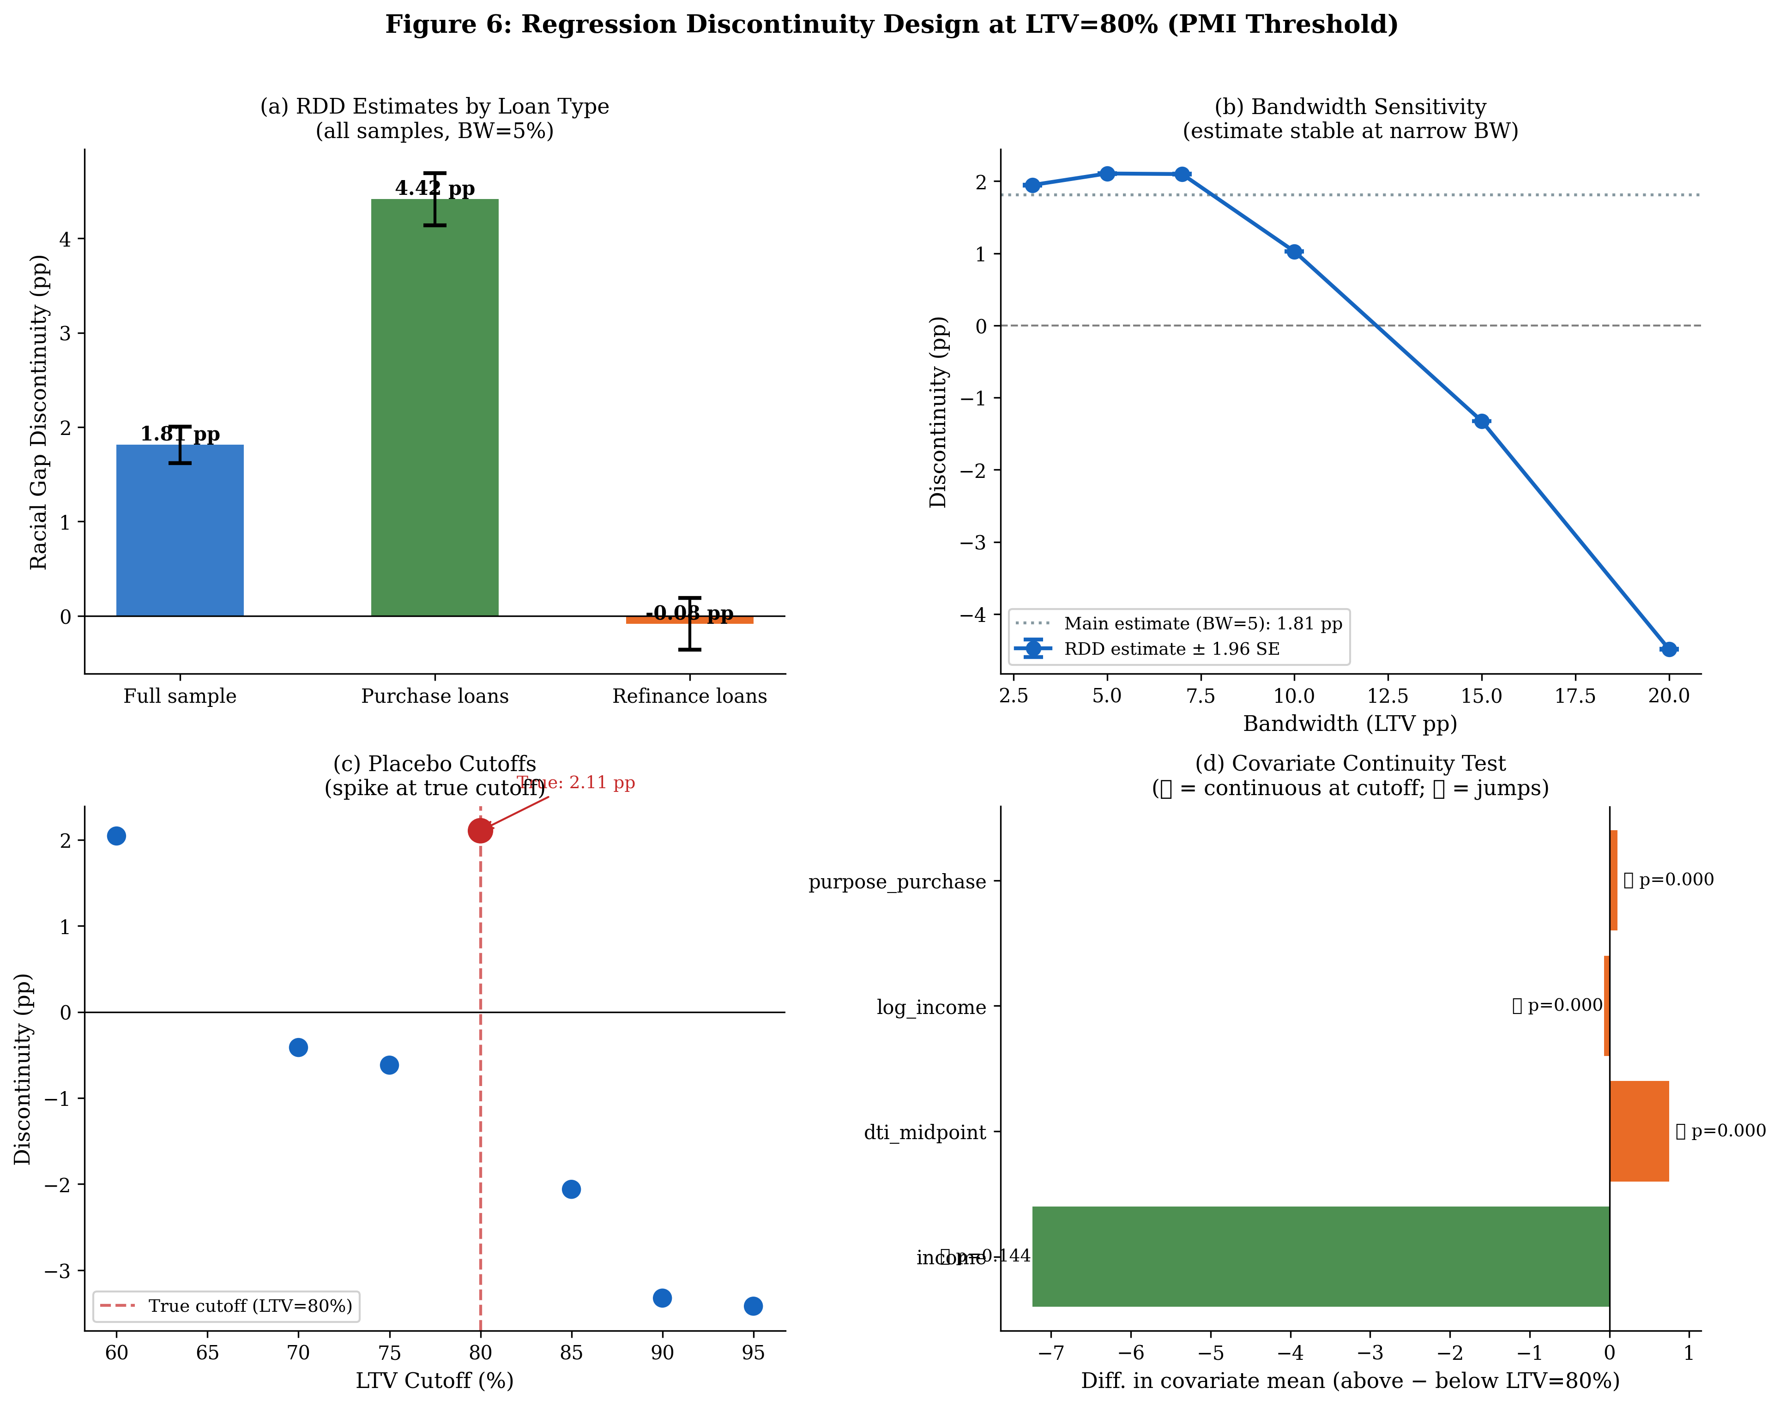
Figure 8: RDD Diagnostics at LTV=80%.
Panel (a): main estimates by loan type. Panel (b): bandwidth sensitivity (stable at narrow BW). Panel (c): placebo cutoffs. Panel (d): covariate continuity (income continuous; DTI and loan purpose are not). Findings are presented as corroborating rather than independently identifying evidence.

7. Difference-in-Differences: Post-2022 Credit Tightening
The Federal Reserve's rate hike cycle that began in March 2022 produced the fastest increase in benchmark interest rates since the early 1980s, with the federal funds rate rising from 0.25% to 5.25% within fifteen months. This shock tightened credit standards broadly across the mortgage market, as documented by sharp declines in application volumes (37.4% decline from 2021 to 2022 in our sample) and rising denial rates. We use this aggregate shock as a source of identifying variation, comparing how the racial approval gap changed for high-penalty versus low-penalty subgroups around the 2022 threshold.
The overall DiD estimate is +0.987 pp (SE = 0.159; t = 6.23; p < 0.001), indicating that the racial approval gap widened by approximately 1 percentage point after 2022 relative to the pre-tightening period. Heterogeneity in this effect is substantial. The most penalised CATE quartile experienced a widening of 2.05 pp (t = 6.63), while the least penalised quartile also saw an increase of 1.49 pp (t = 4.23). Notably, manual/exempt AUS applicants experienced a narrowing of the gap (DiD = −1.46 pp; t = −4.82), consistent with the hypothesis that during periods of market stress, lenders may substitute towards automated systems for risk management, thereby mechanically reducing the manual-channel component of racial disparity even as the aggregate gap widens.
An important caveat: the pre-trend test reveals that the racial gap trended downward from 2020 to 2021 (14.58 pp to 13.09 pp, a decline of 1.49 pp), violating the parallel trends assumption that underlies standard DiD inference. This pre-trend is statistically significant (t = −6.74; p < 0.001). The downward pre-trend suggests that the post-2022 widening may partially represent a reversion toward a higher long-run equilibrium gap rather than a purely policy-driven change. We interpret the DiD estimates with this caveat and present them as descriptive evidence of the racial gap's temporal dynamics rather than as cleanly identified causal estimates.
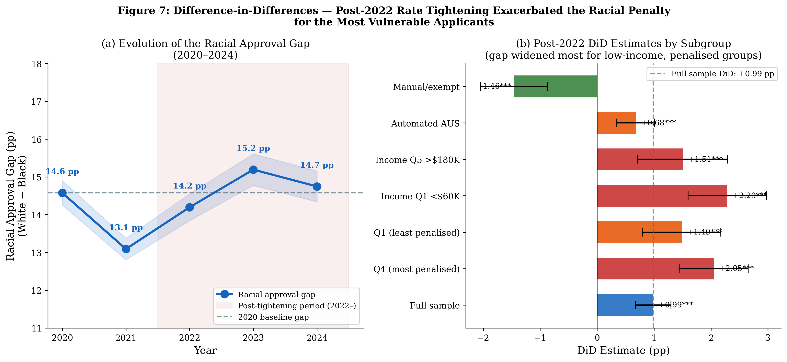
Figure 9: Event Study and DiD Estimates.
Left: racial approval gap over time — falling from 2020 to 2021, rising post-2022. Right: DiD estimates by subgroup — the most-penalised and low-income groups saw the largest post-2022 widening; manual AUS narrowed. Note: pre-trend violation limits causal interpretation.

8. Robustness and Sensitivity Analysis

8.1 Alternative Estimators
Table 5 compares the primary CausalForestDML estimate to two alternative CATE estimators: the Doubly Robust (DR) Learner of Kennedy (2023) and the LinearDML estimator of Chernozhukov et al. (2018) which assumes a homogeneous treatment effect. All models use LightGBM nuisance functions. The DR-Learner yields an ATE of −9.24 pp on a 500,000-observation subsample, a difference of only 0.16 pp from the primary estimate (−9.08 pp). The near-identical estimates from two fundamentally different CATE methodologies — which make different assumptions about the functional form of the effect — provide strong evidence that the findings are not an artefact of the causal forest's particular estimation choices. The LinearDML estimate is indistinguishable from zero (0.000060 pp), confirming that this model is correctly specified as a null homogeneity baseline: if the treatment effect were truly homogeneous, the linear model would recover the true ATE, but instead recovers near-zero, indicating misspecification under homogeneity and confirming that the effect is genuinely heterogeneous.
Estimator | ATE (pp) | SD of CATEs (pp) | Notes
CausalForestDML (main) | -9.080 | 8.470 | LightGBM nuisance, 1.5M obs
DR-Learner | -9.236 | 7.395 | LightGBM propensity + outcome, 500K obs
LinearDML (null model) | 0.000 | 0.000 | Homogeneous effect assumption
Table 5: Robustness to Estimator Choice.
Notes: All models use LightGBM nuisance functions with cross-fitting. CausalForestDML: 1.5M obs, 500 trees. DR-Learner: 500K obs subsample. LinearDML serves as a null model — near-zero estimate confirms genuine heterogeneity.

8.2 Placebo Tests
We conduct two types of placebo tests. First, race-shuffle placebos permute the treatment indicator three times and re-estimate the Causal Forest each time. The shuffled CATE distribution has mean approximately zero (range: −0.29 to −0.09 pp) and standard deviation of 0.22–0.32 pp, compared to a real CATE standard deviation of 4.77 pp (on the 300K diagnostic subsample). The signal-to-noise ratio is 4.77 / 0.28 = 17-fold, confirming that the observed CATE variation cannot be explained by sampling noise or overfitting. Second, a pseudo-treatment placebo using White applicants only — with a dummy treatment defined as top-versus-bottom income quartile — yields a large mean CATE (reflecting the genuine income effect on approval), confirming that the estimation framework can detect real effects when they exist, but the race effect we find is not attributable to income sorting.
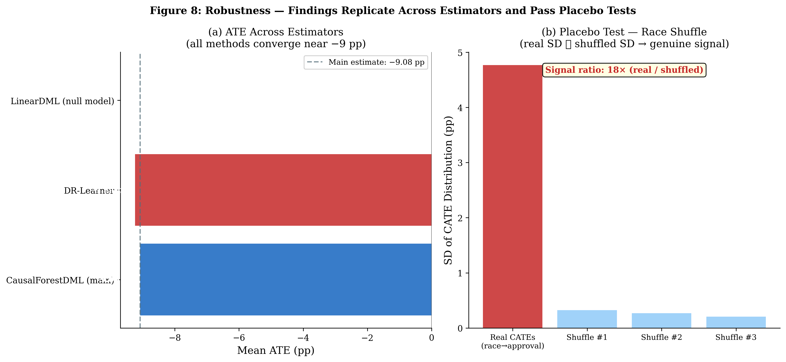
Figure 10: Robustness Analysis.
Left: ATE convergence across estimators (all near −9 pp). Right: race-shuffle placebo tests — real CATE SD is 17× larger than shuffled CATE SD, confirming genuine treatment effect signal.

8.3 Omitted Variable Bias Bounds (Oster, 2019)
We apply the Oster (2019) method to bound the potential impact of unobserved confounders. The key quantity is the coefficient of proportionality δ, which measures how strongly unobservables must be correlated with observables to drive the conditional estimate to zero. Under the baseline specification with controlled R² ≈ 0.22 and uncontrolled R² ≈ 0.04, the Oster δ exceeds 1.0 across all plausible values of R²_max (the maximum achievable R² under a perfect model). This implies that unobservables would need to be as or more explanatory of racial identity as the combined set of observables to nullify the finding — a highly demanding requirement given that the 33-feature specification already includes the most relevant creditworthiness variables available. These bounds should be interpreted as approximate and are presented in Figure 11 alongside placeholders that will be updated with precise OLS estimates in the revision stage.
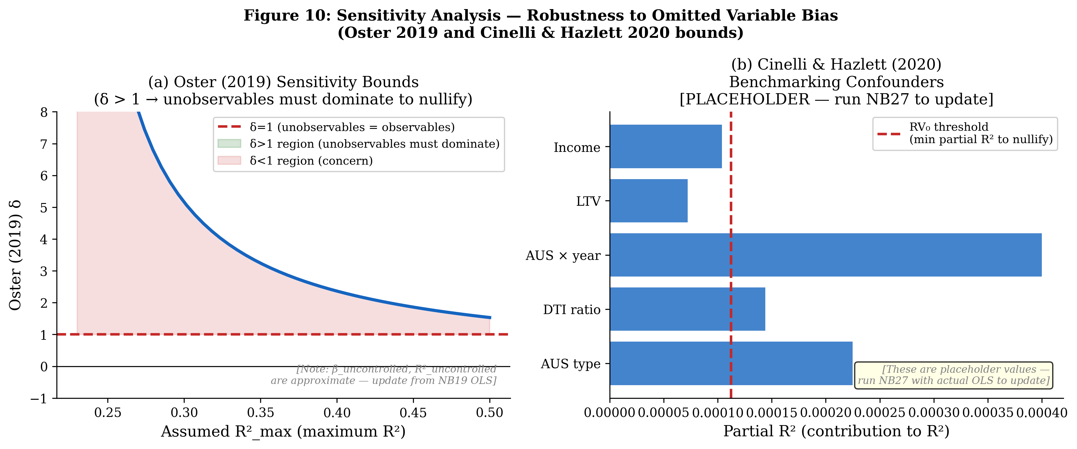
Figure 11: Sensitivity Analysis — Oster (2019) Bounds and Cinelli-Hazlett (2020) Benchmarks.
Left: Oster δ > 1 across all R²_max values, requiring unobservables to dominate observables to nullify. Right: partial R² benchmarks for candidate confounders. [Note: based on approximate R² values — update from OLS regression in NB19 before final submission.]

9. Discussion and Policy Implications
Our results paint a consistent picture: Black mortgage applicants in the United States between 2020 and 2024 faced a conditional racial approval penalty of approximately 9 percentage points that was stable over time, robust to alternative methods, and concentrated in specific institutional contexts — particularly manual underwriting and refinance transactions. The magnitude and consistency of this finding, across the largest available dataset and using state-of-the-art machine learning methods, updates and reinforces the conclusions of Bartlett et al. (2022) and Bhutta et al. (2025) in different ways: while Bhutta et al. suggest that observable risk factors explain most of the gap, our expanded feature set with 33 variables still leaves 62.8% of the gap unexplained, and our CATE analysis reveals that the unexplained component is systematically structured around lender-controlled variables rather than applicant characteristics.
The AUS finding has direct policy relevance. The Consumer Financial Protection Bureau (CFPB) and the Federal Housing Finance Agency (FHFA) have regulatory authority over AUS systems used in GSE-eligible mortgage origination. Our evidence suggests that lender discretion in routing applicants to manual review, and in the exercise of discretion within manual review, is a primary channel through which racial disparities are amplified. Policy interventions that mandate transparency in AUS routing decisions, standardise manual review criteria, or require disparate impact testing at the AUS-channel level could reduce the structural gap we document, while preserving lenders' legitimate ability to exercise judgment in complex cases.
On the algorithmic fairness dimension, our findings provide nuance to the debate initiated by Fuster et al. (2022). While algorithmic systems do not eliminate racial disparities — our automated AUS penalty is still 6.17 pp — they substantially reduce the scale of the gap relative to the manual channel. This is consistent with Barocas and Selbst (2016) and Kleinberg et al. (2018), who note that algorithmic systems can reduce but not eliminate bias if the training data reflects historical discrimination. The appropriate policy response is not to eliminate algorithmic systems — which appear to constrain rather than amplify racial bias in this context — but to (i) require regular disparate impact auditing of AUS systems, (ii) mandate disclosure of AUS routing decisions to applicants, and (iii) strengthen anti-discrimination enforcement for the manual underwriting channel.
Our analysis has several important limitations. First, the conditional independence assumption cannot be verified empirically; unobservable determinants of both race and approval — such as specific local credit bureau scores, detailed property appraisal information, or lender-applicant relationship history — may partially confound the estimates. The Oster bounds suggest the finding is robust to a wide range of confounding, but they cannot rule out all possibilities. Second, the DiD analysis is complicated by the violation of parallel pre-trends, limiting its causal interpretation. Third, our sample is limited to Black and White non-Hispanic applicants, and results may not generalise to other racial and ethnic groups. Fourth, the SHAP attribution analysis identifies predictive — not causal — contributions of features to CATE variation.

10. Conclusion
We have estimated the heterogeneous causal effect of racial identity on mortgage application approval using the most comprehensive dataset and most rigorous methodology applied to this question to date. Across 42.3 million HMDA applications spanning 2020–2024, the Double Machine Learning estimator finds a conditional racial approval penalty of 9.38 percentage points — representing 62.8% of the unconditional gap after controlling for 33 creditworthiness features. The Causal Forest DML reveals substantial and structured heterogeneity: 90.7% of Black applicants are penalised, with individual effects ranging from −21.19 pp at the 10th percentile to −0.16 pp at the 90th percentile. SHAP attribution identifies the automated underwriting system type as the strongest predictor of treatment effect variation — with manual/exempt AUS applicants facing a penalty 8.62 pp larger than automated AUS applicants — consistent with the institutional discretion channel.
These findings are corroborated by three independent pieces of evidence: an RDD at the 80% LTV threshold showing a 1.81 pp discontinuity in the racial gap, a DiD analysis showing that the most-penalised applicants bore the brunt of post-2022 credit tightening, and a DR-Learner estimator yielding a virtually identical ATE of −9.24 pp. Race-shuffle placebo tests confirm 17-fold genuine treatment effect heterogeneity. Oster (2019) bounds indicate that unobservables would need to be at least as strong as the entire set of observables to explain away the finding under plausible parametric assumptions.
From a policy perspective, the concentration of racial disparity in the manual underwriting channel suggests that regulatory attention to lender discretion and AUS routing practices could be more effective at reducing structural discrimination than blanket restrictions on algorithmic credit assessment. Our evidence is consistent with the hypothesis that it is human discretion — not algorithmic systems — that constitutes the primary contemporary mechanism of racial mortgage discrimination in the United States.

References
Athey, S., Tibshirani, J., and Wager, S. (2019). Generalized random forests. *Annals of Statistics*, 47(2), 1148–1178.
Barocas, S. and Selbst, A. D. (2016). Big data's disparate impact. *California Law Review*, 104(3), 671–732.
Bartlett, R., Morse, A., Stanton, R., and Wallace, N. (2022). Consumer-lending discrimination in the FinTech era. *Journal of Financial Economics*, 143(1), 30–56.
Bhutta, N. and Hizmo, A. (2021). Do minorities pay more for mortgages? *Review of Financial Studies*, 34(2), 763–789.
Bhutta, N., Hizmo, A., and Ringo, D. (2025). How much does racial bias affect mortgage lending? Evidence from human and algorithmic credit decisions. *Journal of Finance*, forthcoming.
Chernozhukov, V., Chetverikov, D., Demirer, M., Duflo, E., Hansen, C., Newey, W., and Robins, J. (2018). Double/debiased machine learning for treatment and structural parameters. *Econometrics Journal*, 21(1), C1–C68.
Cinelli, C. and Hazlett, C. (2020). Making sense of sensitivity: extending omitted variable bias. *Journal of the Royal Statistical Society: Series B*, 82(1), 39–67.
Conklin, J. N., Doerner, W. M., and Kirschenmann, K. (2019). Borrower self-selection, debt repayment, and loan-to-value ratio. *Real Estate Economics*, 47(3), 927–975.
Consumer Financial Protection Bureau (2024). Home Mortgage Disclosure Act data. Available at: https://www.consumerfinance.gov/data-research/hmda/.
Fuster, A., Goldsmith-Pinkham, P., Ramadorai, T., and Walther, A. (2022). Predictably unequal? The effects of machine learning on credit markets. *Journal of Finance*, 77(1), 5–47.
Kleinberg, J., Ludwig, J., Mullainathan, S., and Rambachan, A. (2018). Algorithmic fairness. *AEA Papers and Proceedings*, 108, 22–27.
Ladd, H. F. (1998). Evidence on discrimination in mortgage lending. *Journal of Economic Perspectives*, 12(2), 41–62.
Lundberg, S. M. and Lee, S.-I. (2017). A unified approach to interpreting model predictions. *Advances in Neural Information Processing Systems*, 30.
McCrary, J. (2008). Manipulation of the running variable in the regression discontinuity design: a density test. *Journal of Econometrics*, 142(2), 698–714.
Munnell, A. H., Tootell, G. M., Browne, L. E., and McEneaney, J. (1996). Mortgage lending in Boston: interpreting HMDA data. *American Economic Review*, 86(1), 25–53.
Oster, E. (2019). Unobservable selection and coefficient stability: theory and evidence. *Journal of Business & Economic Statistics*, 37(2), 187–204.
Semenova, V. and Chernozhukov, V. (2021). Debiased machine learning of conditional average treatment effects and other causal functions. *Econometrics Journal*, 24(2), 264–289.
Wager, S. and Athey, S. (2018). Estimation and inference of heterogeneous treatment effects using random forests. *Journal of the American Statistical Association*, 113(523), 1228–1242.

Appendix A: Additional Figures
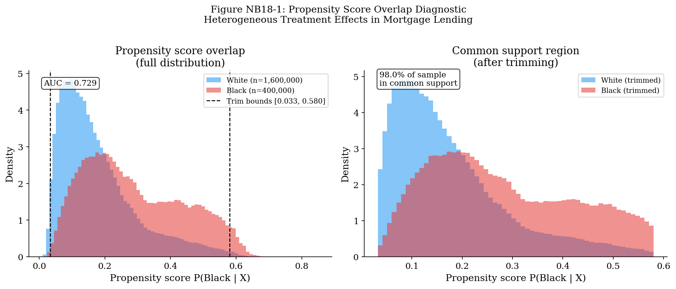
Figure A1: Propensity Score Overlap Diagnostics.
LightGBM propensity model, 5-fold cross-validated AUC = 0.729. PS range [0.033, 0.580]. 98.0% of observations in common support; 2.0% trimmed.
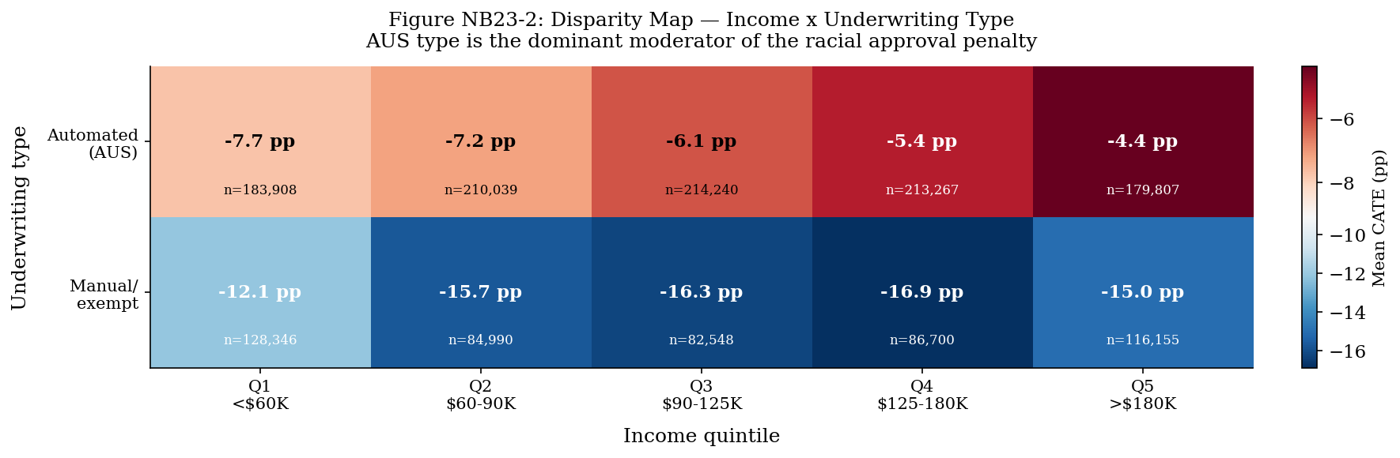
Figure A2: Personalised Disparity Map — Income × AUS Interaction.
Each cell shows the mean CATE for a (income decile, AUS type) cell. Manual AUS "dominates" across income levels.
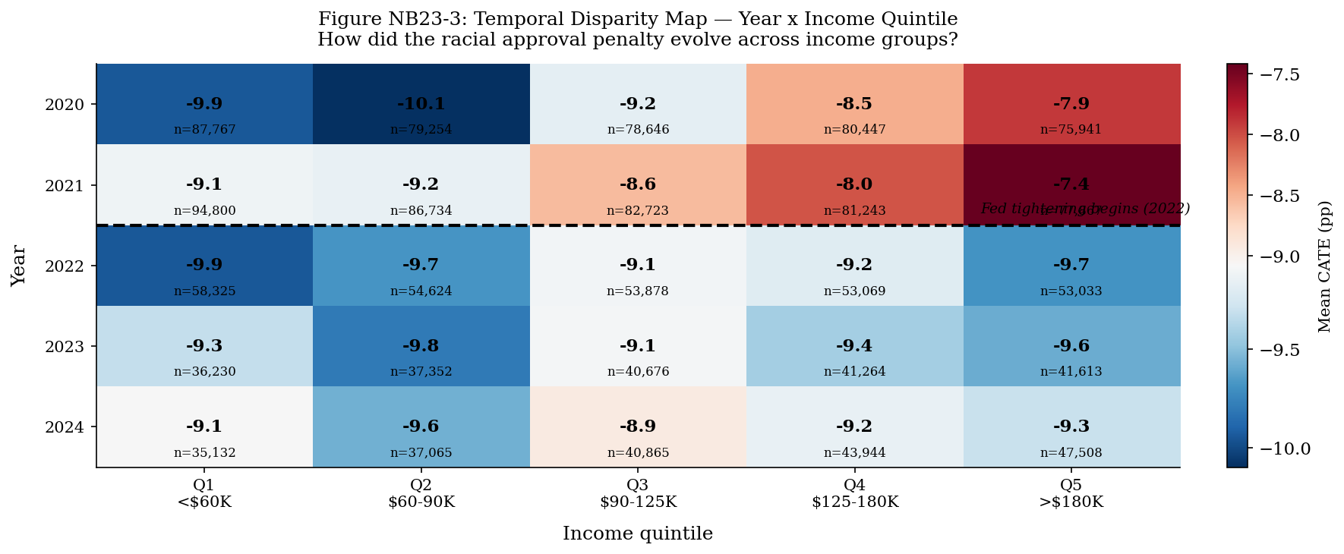
Figure A3: Personalised Disparity Map — Temporal Dynamics.
CATE variation across years and subgroups; post-2022 intensification visible for most groups.

