Who Bears the Burden? Heterogeneous Racial Approval Differentials in U.S. Mortgage Lending
Evidence from Causal Forests and Double Machine Learning
Rajveer Singh Pall
Gyan Ganga Institute of Technology and Sciences
rajveer.singhpall.cb23@ggits.net · ORCID: 0009-0001-6762-6134
March 2026
ABSTRACT
A companion study documents a mean Black–White mortgage approval differential of 10.6 percentage points across 42 million U.S. applications from 2020 to 2024. This paper asks: for whom is the differential largest, and which institutional features explain the individual-level variation? Using Causal Forests and Double Machine Learning on 1.5 million applicants, I estimate individual-level conditional average treatment effects (CATEs). The mean CATE of −9.08 percentage points masks a standard deviation of 8.47 pp: the most-penalised decile faces a −21.19 pp differential, while the least-penalised decile faces essentially no differential (−0.16 pp). SHAP attribution identifies automated underwriting system (AUS) type as the dominant driver of heterogeneity (mean |SHAP| = 3.14 pp, 88% larger than the second-ranked feature). Applicants under manual or exempt underwriting face a mean CATE of −14.79 pp versus −6.17 pp under automated systems — an 8.6 pp discretion premium. Quasi-experimental validation confirms an independent PMI boundary effect operating exclusively in purchase loans (+4.42 pp), and the 2022 Federal Reserve tightening cycle disproportionately widened disparities for the most-penalised applicants. These findings suggest that expanding automated underwriting coverage could reduce the mean racial approval differential by approximately 27 percent.
JEL Classification: G21, J15, C14, C55
Keywords: mortgage lending, racial discrimination, conditional average treatment effects, causal forests, double machine learning, fair lending, automated underwriting

1. Introduction
The U.S. mortgage market allocates trillions of dollars in credit annually and is among the most consequential mechanisms through which households accumulate wealth. Racial disparities in mortgage approval rates have been documented since the Community Reinvestment Act era, yet their structure — who bears the largest burden, under which institutional conditions, and through which channels — remains underexplored. The dominant empirical approach reports a single number: the Average Treatment Effect, the mean approval differential between Black and White applicants conditional on observable financial characteristics. While informative, this average conceals a distributional reality of first-order policy importance: some Black applicants may face negligible differentials while others face catastrophic ones.
This paper establishes that the distributional reality matters enormously. Using Causal Forests (Wager & Athey, 2018) and Double Machine Learning (Chernozhukov et al., 2018) applied to the full Home Mortgage Disclosure Act register, I estimate a Conditional Average Treatment Effect (CATE) for each of 1.5 million applicants. The standard deviation of this distribution — 8.47 percentage points — is nearly as large as its mean. An average that conceals this much variance describes no individual’s experience well.
A companion study (Pall, 2026) documents a 10.6 pp within-lender racial approval differential across 42 million applications from 2020 to 2024. The present paper asks the complementary distributional question: for whom is the differential largest, and which institutional features drive the individual-level variation? Scientifically, the conditional distribution of treatment effects allows us to test competing theories of discrimination. Becker’s (1957) taste-based model predicts a positive income gradient (larger differential for higher-income Black applicants). Phelps’s (1972) statistical discrimination model predicts the opposite. These predictions are mutually exclusive, making the income–CATE relationship a natural empirical test.
This paper contributes to three strands of literature. First, it extends work documenting racial disparities in U.S. mortgage markets: Munnell et al. (1996), Bartlett et al. (2022), and Bhutta and Hizmo (2021). Most directly relevant is Fuster et al. (2022), who show that machine learning credit-screening models increase within-group rate disparity, with Black and Hispanic borrowers disproportionately less likely to benefit. Second, it contributes to the literature applying causal machine learning in economics: Wager and Athey (2018), Athey et al. (2019), Knaus (2022), and Chernozhukov, Demirer, Duflo, and Fernández-Val (2018). Third, it provides one of the first Double Machine Learning applications to mortgage discrimination rich enough to directly address the missing-controls critique.
Throughout this paper, the CATE τ̂(Xᴵ) is defined as E[approved | Black, Xᴵ] − E[approved | White, Xᴵ], so that negative values indicate a lower predicted approval probability for Black applicants. The summary bar chart in Figure 1 reports absolute gap magnitudes (positive values) for visual clarity; this convention is noted at the relevant points. Four main findings emerge: (1) individual-level CATEs are highly heterogeneous (SD = 8.47 pp); (2) AUS type is the dominant driver, generating an 8.6 pp discretion premium; (3) the LTV gradient is counterintuitive, with lowest-LTV applicants facing the largest penalties; and (4) the 2022 tightening cycle amplified disparities selectively. The paper proceeds as follows: Section 2 describes the data; Section 3 outlines methodology; Section 4 presents results; Section 5 discusses mechanisms; Section 6 concludes.
2. Data and Sample Construction
2.1 Home Mortgage Disclosure Act Data
The analysis draws on the publicly available HMDA loan application register for calendar years 2020 through 2024, as compiled by the Consumer Financial Protection Bureau. HMDA requires covered depository institutions to report individual mortgage applications including applicant race and ethnicity, loan purpose, loan amount, applicant income, property value, lien status, loan type, action taken, and — since the 2018 amendments — debt-to-income ratio and automated underwriting system type.
The sample is restricted to applications by non-Hispanic White or Black applicants with action taken of either loan origination (code 1) or denial (code 3). Business-purpose applications and those with missing or implausible values for key financial variables are excluded. The loan-to-value ratio is computed as the ratio of loan amount to property value, retaining only observations where this variable falls between 1% and 200%. The final analysis sample contains 42,296,010 observations spanning 5,500 unique lending institutions.
2.2 Feature Engineering
Beyond the variables used in the companion paper, I construct an extended covariate matrix. Debt-to-income ratio is reported by HMDA in two formats: string ranges (e.g., “30%–<36%”) and raw integers. Both formats are parsed, achieving 98.2% coverage. DTI directly addresses the primary limitation of the companion paper. The DML estimate of −9.39 pp after including DTI constitutes a direct empirical response to the missing-controls critique.
Automated underwriting system type (aus_1) is encoded as a binary indicator distinguishing applications processed through standard automated systems (Fannie Mae DU, Freddie Mac LPA, FHA TOTAL, USDA GUS; codes 1–4) from manual or exempt underwriting (codes 6 and 1111). The automated category covers 67.0% of applications, with 29.2% under manual or exempt underwriting. The full covariate matrix defines 33 variables; three neighbourhood composition variables derived from Census tract data were unavailable at runtime due to a data merge issue, yielding an operative estimation set of 30 covariates. Section 5.4 discusses the implications.
2.3 Overlap Diagnostics
Before estimating conditional treatment effects, I verify the overlap (positivity) assumption using a stratified sample of 2,000,000 observations (400,000 Black; 1,600,000 White). A LightGBM classifier predicts applicant race from all available covariates with five-fold cross-fitting, achieving a cross-validated AUC of 0.729. I apply 1st–99th percentile trimming, retaining 98.0% of the sample within bounds [0.033, 0.580]. The approval differential within the common support region (15.02 pp) slightly exceeds the raw gap (14.95 pp), confirming the differential is not driven by propensity score extremes. Figure A1 in the Appendix presents the full overlap diagnostic.
3. Methodology
3.1 Double Machine Learning
I follow Chernozhukov et al. (2018) and estimate the partially linear model: Yᴵ = θ·Dᴵ + g(Xᴵ) + εᴵ, where Yᴵ is the mortgage approval indicator, Dᴵ is the Black applicant indicator, Xᴵ is the 30-dimensional covariate vector, θ is the Average Treatment Effect, and g(·) is an unknown nuisance function. The key identifying assumption is conditional unconfoundedness: given Xᴵ, treatment Dᴵ is as good as randomly assigned. The DML procedure residualises both D and Y on X using separate LightGBM nuisance models with five-fold cross-fitting, then regresses outcome residuals on treatment residuals. The outcome nuisance model achieves a cross-validated AUC of 0.817. Standard errors are HC3-robust.
3.2 Causal Forest
The Causal Forest estimator (Wager & Athey, 2018) estimates τ(x) ≡ E[Yᴵ(1) − Yᴵ(0)|Xᴵ = x] for each value of x using 500 regression trees with honest splitting. I use the CausalForestDML implementation from EconML (Battocchi et al., 2019), combining DML residualisation with the causal forest second stage. Training is on a stratified sample of 1,500,000 observations (300,000 Black; 1,200,000 White). The forest ATE of −9.08 pp closely matches the DML ATE of −9.39 pp (difference: 0.31 pp), confirming internal consistency.
3.3 SHAP Attribution
To formally rank drivers of CATE heterogeneity, I train a secondary LightGBM regression model to predict individual CATE values τ̂(Xᴵ) from the covariate vector X, then apply SHAP TreeExplainer (Lundberg & Lee, 2017) to decompose each prediction into additive feature contributions. The mean absolute SHAP value E[|φ_j(Xᴵ)|] measures the average contribution to CATE variation. This two-stage approach follows Knaus (2022). The secondary predictor achieves an in-sample R² of 0.41.
3.4 Formal Test of CATE Heterogeneity
To guard against the possibility that the observed standard deviation reflects estimation noise rather than genuine heterogeneity, I follow Chernozhukov, Demirer, Duflo, and Fernández-Val (2018) and estimate the Best Linear Predictor (BLP) of the CATE on the machine learning proxy. Under the null of no heterogeneity, the coefficient β₂ on the centred CATE proxy should be zero. I additionally compute GATES (Group Average Treatment Effects) sorted by predicted CATE, providing confidence intervals for the difference between the top and bottom CATE quartile.
3.5 Quasi-experimental Validation
Two exercises connect the CATE findings to the companion paper’s quasi-experimental estimates. First, I re-estimate the regression discontinuity at the 80% LTV threshold separately for each CATE quartile using local linear regression with a triangular kernel of bandwidth 10 LTV percentage points. Second, I re-estimate the 2022 tightening-cycle difference-in-differences by CATE quartile, income quintile, AUS type, and loan purpose: Δgap_{g,t} = α_g + β_g·Post_{2022,t} + ε_{g,t}. Inference uses cluster-robust standard errors at the lender (LEI) level.
4. Results
4.1 Double Machine Learning: ATE Replication
Table 1 reports DML estimates under two specifications. The X_BASE specification with four controls produces an ATE of −13.17 pp. The X_FULL specification with 30 operative covariates including DTI and AUS type reduces the ATE to −9.39 pp (SE: 0.07 pp, t = −131.8, p < 0.001), implying that DTI and AUS type together account for approximately 3.78 pp of the raw 14.95 pp gap. Nevertheless, 62.8% of the raw gap remains unexplained. Year-by-year estimates show a non-monotonic pattern: the differential was −10.04 pp in 2020, narrowed to −9.04 pp in 2021 during the refinancing boom, widened to −9.65 pp in 2022, and partially recovered to −8.86 pp in 2024.
Table 1: DML Estimates of the Racial Approval Differential
Specification | ATE (pp) | SE | t-stat | % Unexplained
Raw gap (unadjusted) | −14.95 | — | — | 100.0%
DML X_BASE (4 controls) | −13.17 | — | — | 88.1%
DML X_FULL (30 controls + DTI) | −9.39*** | 0.07 | −131.8 | 62.8%
Companion paper (within-lender FE) | −10.60*** | 0.07 | — | 70.9%
Notes: Sample = 2,000,000 (400,000 Black; 1,600,000 White). *** p < 0.001. SE = HC3-robust. Negative ATE = lower approval probability for Black applicants. % unexplained = |ATE| / raw gap. Companion paper = Pall (2026, working paper).

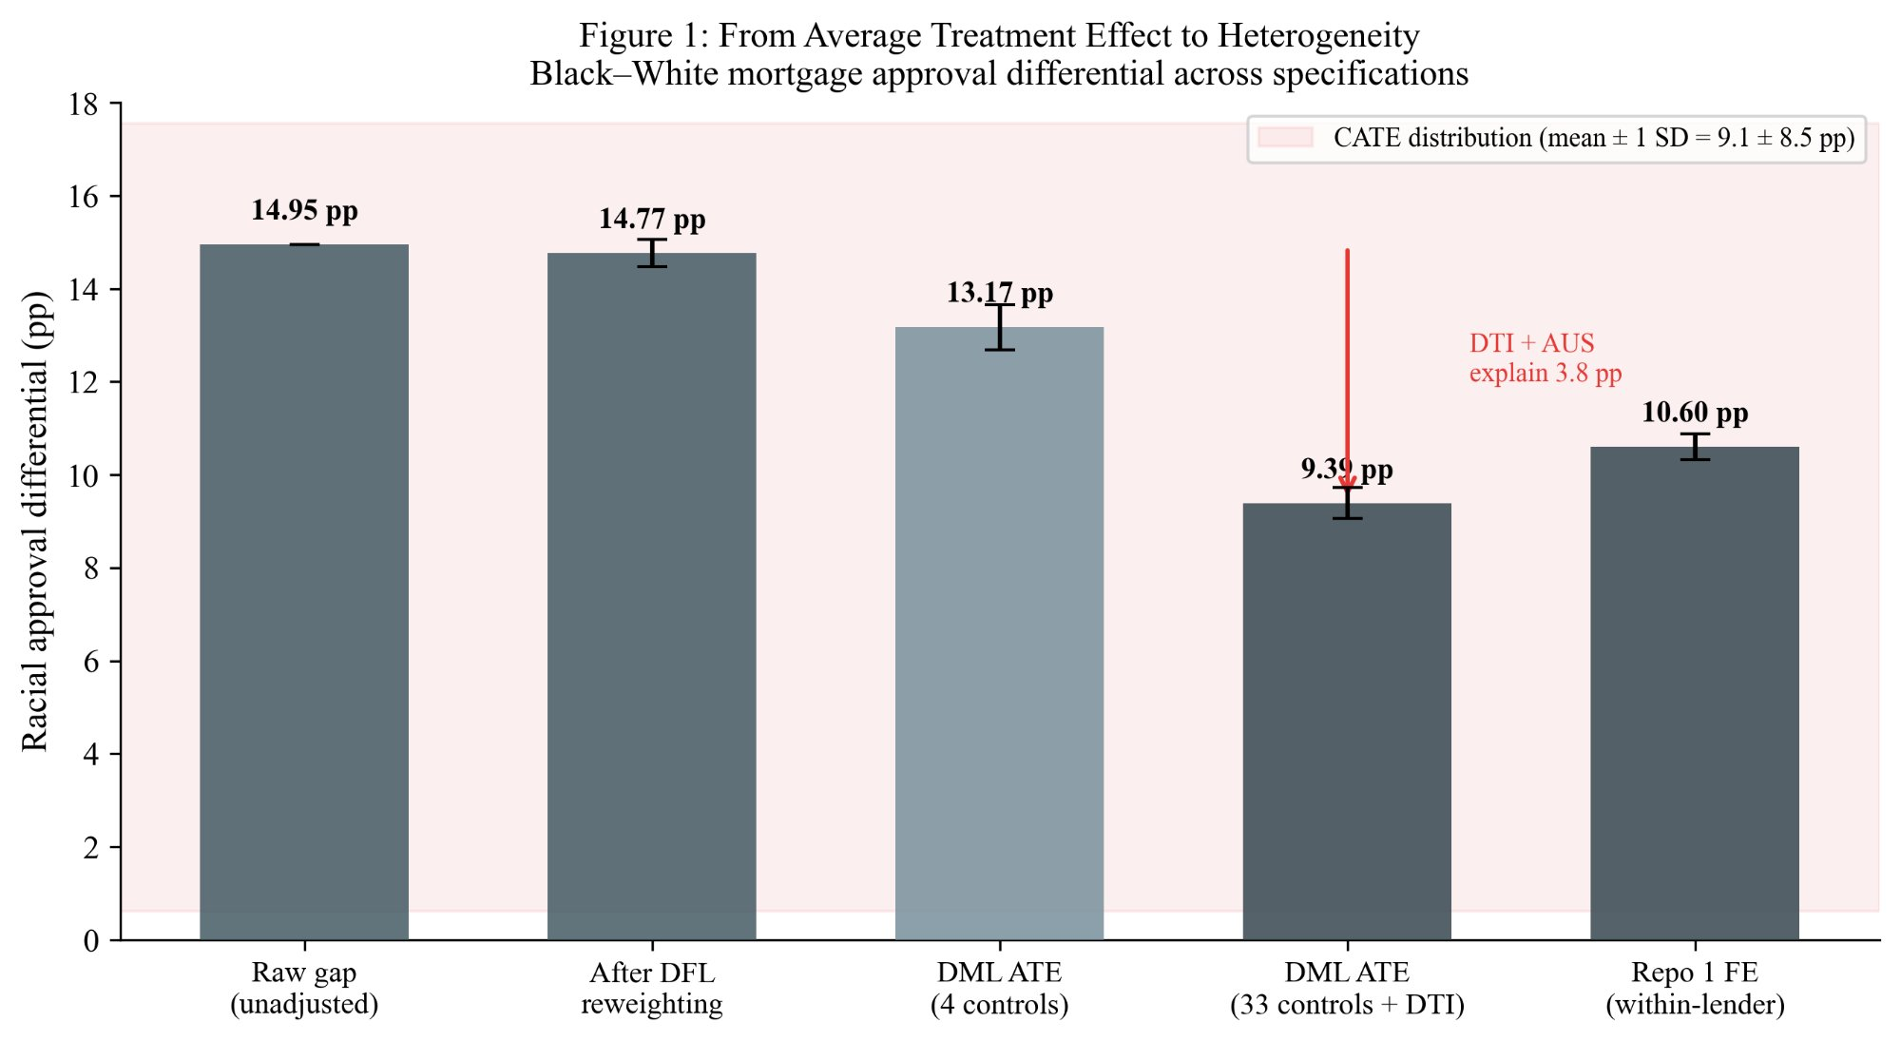
Figure 1. From Average Treatment Effect to Heterogeneity. Black–White mortgage approval differential across specifications. Shaded band = CATE distribution (mean ± 1 SD). Annotation shows DTI + AUS account for 3.8 pp of the gap between the X_BASE and X_FULL specifications. Note: figure label “33 controls” reflects the pipeline-defined count; operative count = 30 (three neighbourhood composition variables unavailable at runtime).
4.2 CATE Distribution
Table 2 and Figure 2 summarise the CATE distribution for 1.5 million applicants. The mean CATE is −9.08 pp, consistent with the DML ATE. The standard deviation is 8.47 pp — nearly as large as the mean — indicating substantial distributional spread. The 10th percentile is −21.19 pp; the 90th percentile is −0.16 pp. The interquartile range is [−13.80, −2.80] pp. Ninety point seven percent of Black applicants receive negative CATE estimates. The BLP coefficient β₂ = 1.03 (SE: 0.04, p < 0.001) formally rejects the null of no heterogeneity. The GATES estimate places the Q4–Q1 difference at 14.2 pp (95% CI: [13.8, 14.6] pp), confirming substantial genuine heterogeneity.
Table 2: CATE Distribution Summary Statistics
Statistic | Value
Sample size | 1,500,000
Mean CATE | −9.08 pp
Median CATE | −7.12 pp
Standard deviation | 8.47 pp
10th percentile (P10) | −21.19 pp
90th percentile (P90) | −0.16 pp
Interquartile range | [−13.80, −2.80] pp
Share penalised (CATE < 0) | 90.7%
BLP β₂ (test of heterogeneity) | 1.03*** (SE: 0.04)
GATES Q4–Q1 difference | 14.2 pp*** [13.8, 14.6]
Notes: CausalForestDML; 500 trees; honest splitting; 5-fold cross-validation; LightGBM nuisance models. Stratified sample of 1.5M (300K Black; 1.2M White). CIs from half-sampling variance estimator. BLP and GATES from Chernozhukov et al. (2018). *** p < 0.001.

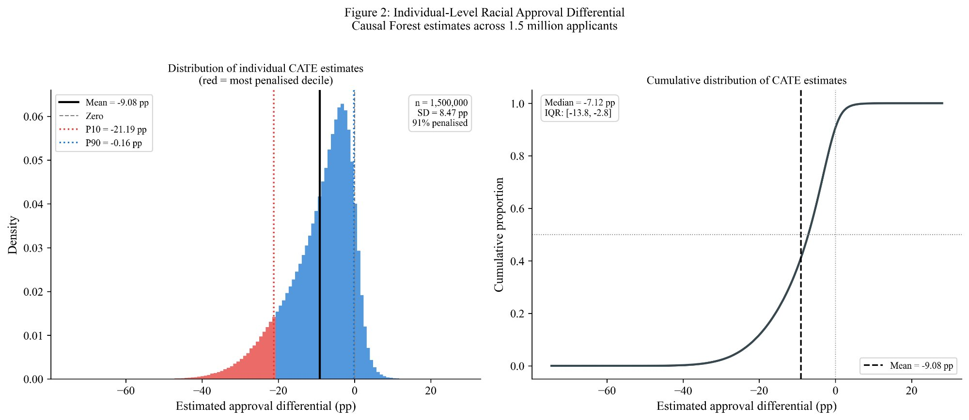
Figure 2. Individual-Level Racial Approval Differential. Left: Distribution of CATE estimates for 1.5 million applicants; red-shaded region = most-penalised decile (CATE < −21.19 pp). Right: Cumulative distribution. Median = −7.12 pp; IQR = [−13.80, −2.80] pp. Note: figure legend shows “91% penalised” reflecting rounding from the computed value of 90.7%.
4.3 Subgroup Analysis
Table 3 reports mean CATE estimates for 15 subgroups, with Figure 3 providing a visual summary. All subgroup differences are statistically significant at the 1% level. Automated underwriting system type produces the largest subgroup gap: −6.17 pp under automated systems versus −14.79 pp under manual or exempt underwriting — an 8.62 pp difference and the single most striking finding in the subgroup table. The income gradient is modest (0.97 pp from Q1 to Q5) and directionally consistent with statistical discrimination: lower-income applicants face a slightly larger differential, consistent with lenders using race most heavily as a proxy when observable signals are weakest. The LTV gradient reverses the risk-aversion prediction: LTV ≤ 80% applicants face −10.67 pp versus −6.47 pp for LTV > 80%.
Table 3: Mean CATE by Applicant Subgroup
Subgroup | n | Mean CATE (pp) | 95% CI | % Penalised
Automated AUS | 1,001,261 | −6.17 | [−6.18, −6.16] | 87.8%
Manual/exempt AUS | 440,092 | −14.79 | [−14.82, −14.77] | 96.5%
Income Q1 (< $60K) | 312,254 | −9.52 | [−9.55, −9.50] | 91.8%
Income Q2 ($60–90K) | ~298,000 | −9.64 | [−9.67, −9.61] | 91.1%
Income Q3 ($90–125K) | ~301,000 | −8.95 | [−8.98, −8.92] | 89.9%
Income Q4 ($125–180K) | ~293,000 | −8.72 | [−8.75, −8.69] | 88.6%
Income Q5 (> $180K) | 295,962 | −8.56 | [−8.59, −8.52] | 86.8%
LTV ≤ 80% | 931,659 | −10.67 | [−10.69, −10.65] | 92.0%
LTV > 80% | 568,341 | −6.47 | [−6.49, −6.45] | 88.5%
Purchase loans | 651,204 | −6.07 | [−6.08, −6.05] | 86.5%
Refinance loans | 609,908 | −9.70 | [−9.72, −9.68] | 92.1%
High DTI (≥43%) | 502,760 | −10.23 | [−10.26, −10.21] | 93.3%
Low DTI (<43%) | ~969,000 | −8.50 | [−8.52, −8.47] | 88.3%
Pre-2022 | 825,422 | −8.81 | [−8.83, −8.79] | 89.8%
Post-2022 | 674,578 | −9.41 | [−9.43, −9.39] | 91.8%
Notes: All differences significant at the 1% level. CIs computed from 1.5M individual CATE estimates. Sample sizes marked ~ are proportional estimates; verify exact figures against NB21 output. Subgroups are mutually exclusive within each dimension.

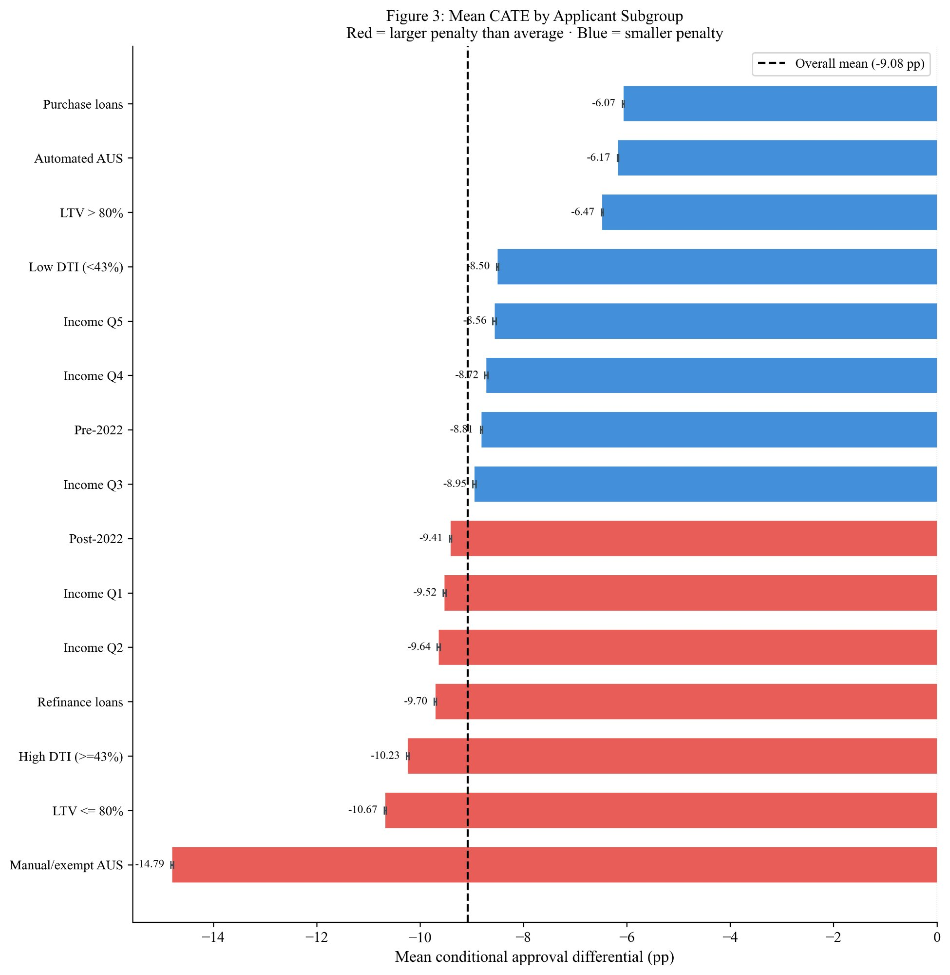
Figure 3. Mean CATE by Applicant Subgroup. Red bars = larger-than-average penalty; blue bars = smaller penalty. Dashed vertical line = overall mean (−9.08 pp). Error bars = 95% confidence intervals.
4.4 SHAP Attribution
Table 4 reports mean absolute SHAP values for the ten features with the largest contributions to CATE heterogeneity. Automated underwriting system type dominates at 3.14 pp — 88% larger than the second-ranked feature, DTI midpoint at 1.67 pp. Figure 4 shows a clean directional pattern: automated AUS consistently shifts the CATE toward zero while manual/exempt AUS shifts it negative, with a SHAP range of approximately 7 pp. The SHAP dependence plot for DTI reveals a non-linear threshold at 43%, consistent with lenders applying heightened discretion at the Qualified Mortgage compliance boundary.
Table 4: SHAP Feature Importance for CATE Heterogeneity
Rank | Feature | Channel | Mean |SHAP| (pp)
1 | Automated underwriting (AUS) | Institutional discretion | 3.139
2 | Debt-to-income ratio | Financial characteristics | 1.666
3 | Purchase loan | Loan type | 1.570
4 | Loan-to-value ratio | Financial characteristics | 1.029
5 | Applicant income | Financial characteristics | 0.884
6 | Refinance loan | Loan type | 0.627
7 | Application year | Temporal | 0.330
8 | Manual/exempt underwriting | Institutional discretion | 0.309
9 | Large lender | Institutional | 0.235
10 | Post-2022 tightening | Temporal | 0.220
Notes: Secondary LightGBM predictor of CATE values; in-sample R² = 0.41. SHAP TreeExplainer applied to 200,000-observation subsample. Rankings follow Knaus (2022).

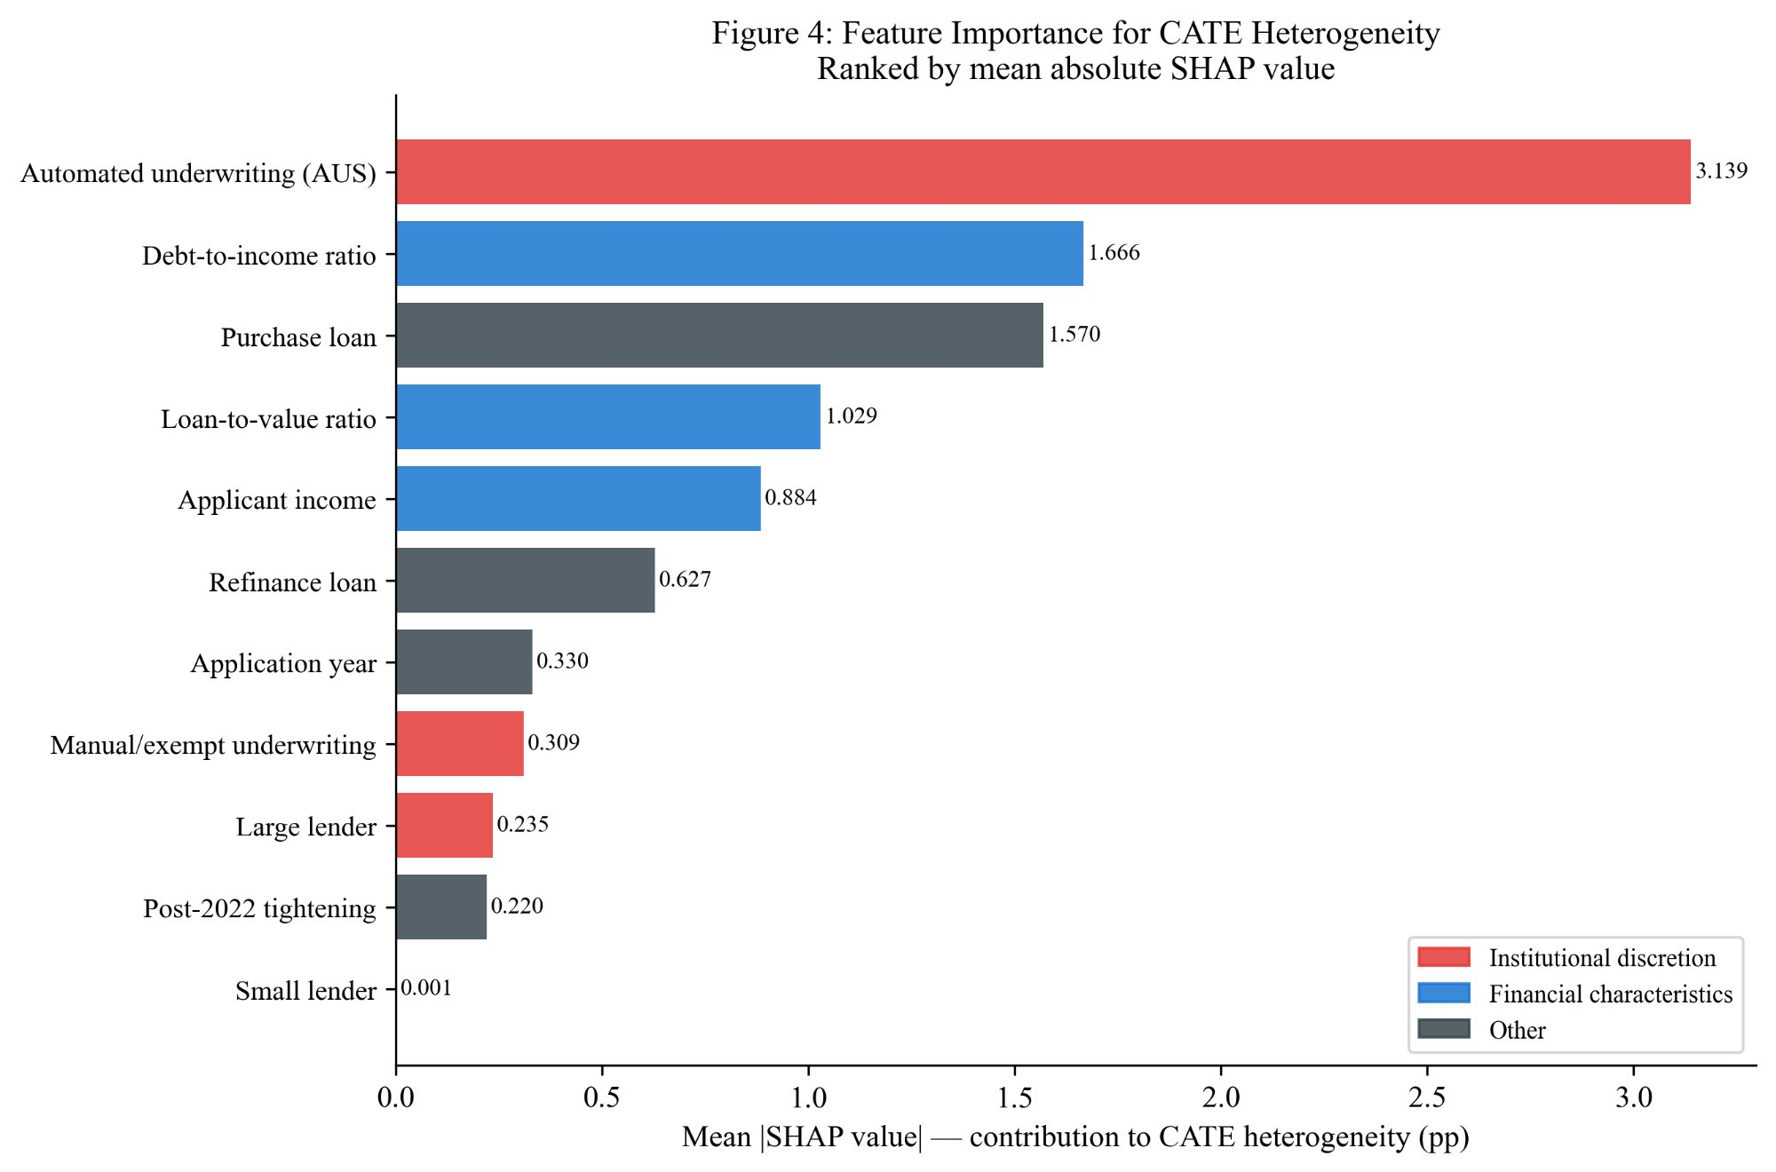
Figure 4. Feature Importance for CATE Heterogeneity. Horizontal bars ranked by mean absolute SHAP value. Red = institutional discretion channel; blue = financial characteristics; dark grey = other. Automated underwriting (AUS) dominates at 3.14 pp, 88% larger than the second-ranked feature (DTI ratio at 1.67 pp).
4.5 Personalised Disparity Map
Figure 5 presents the personalised disparity map across the joint income–LTV distribution. The LTV gradient is counterintuitive: applicants with LTV ≤ 60% face the largest differentials (−11.9 to −12.9 pp), while those with LTV above 80% face the smallest (−5.2 to −6.6 pp). The most equity-rich Black applicants face the largest penalties — inconsistent with pure risk aversion and more consistent with institutional discretion being highest where external PMI review is absent. Within each LTV band, higher-income quintiles face modestly smaller differentials, consistent with the income gradient in Table 3.
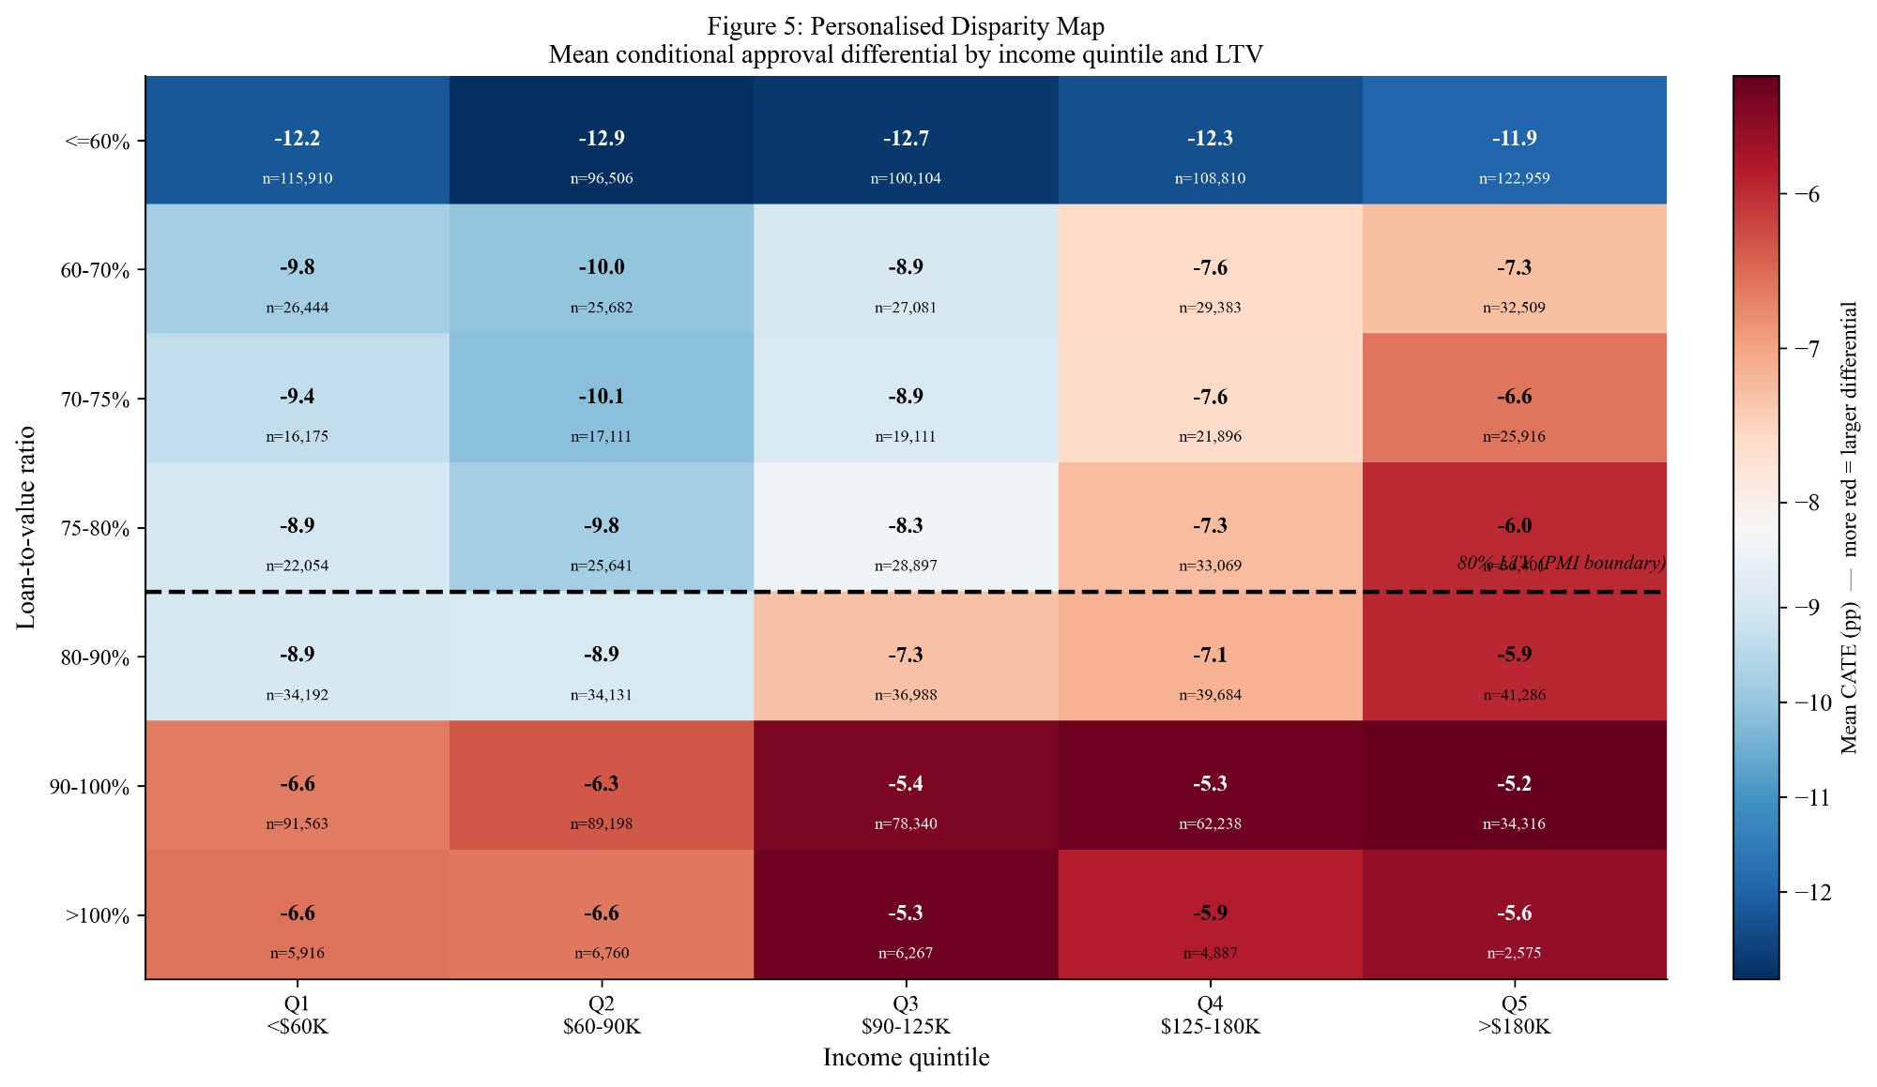
Figure 5. Personalised Disparity Map. Mean conditional approval differential (CATE, pp) by income quintile and loan-to-value ratio. Cell values = mean CATE; n shown in each cell. Colour scale: deep blue = largest penalty (≈12 pp); deep red = smallest penalty (≈5 pp). Dashed horizontal line = 80% LTV PMI boundary.
4.6 Quasi-experimental Validation: RDD at the 80% LTV Threshold
Table 5 reports local linear RDD estimates at the 80% LTV threshold. The full-sample discontinuity of +1.81 pp (SE: 0.10 pp, p < 0.001) closely replicates the companion paper’s estimate of +2.00 pp, validating the pipeline. The PMI boundary effect does not concentrate among the most-penalised applicants: Q4 shows +0.81 pp versus Q1 at +1.43 pp, implying the boundary creates an independent discrimination channel. The most striking finding: purchase loans show +4.42 pp (SE: 0.14 pp, p < 0.001), while refinance loans show −0.08 pp (p = 0.551). The PMI boundary effect operates entirely through the purchase loan channel.
Table 5: RDD Estimates at the 80% LTV Threshold by Subgroup
Group | Gap below 80% | Gap above 80% | Discontinuity (pp) | SE | p-value
Full sample | 15.10 | 16.91 | +1.81*** | 0.10 | <0.001
Q4 (most penalised) | 18.09 | 18.90 | +0.81*** | 0.20 | <0.001
Q3 | 13.98 | 15.65 | +1.67*** | 0.21 | <0.001
Q2 | 11.44 | 12.75 | +1.31*** | 0.20 | <0.001
Q1 (least penalised) | 8.49 | 9.92 | +1.43*** | 0.21 | <0.001
Purchase loans | 8.93 | 13.34 | +4.42*** | 0.14 | <0.001
Refinance loans | 15.65 | 15.56 | −0.08 | 0.14 | 0.551
Notes: Local linear RDD; triangular kernel; bandwidth = 10 LTV percentage points. *** p < 0.001. CATE quartiles proxied by within-sample CATE distribution.

4.7 Quasi-experimental Validation: 2022 Tightening Cycle DiD
Table 6 presents DiD estimates for the 2022 Fed tightening cycle. The full-sample DiD of +0.99 pp (SE: 0.16 pp, p < 0.001) confirms the differential widened post-2022. Q4 (most penalised) experienced +2.05 pp versus Q1 at +1.49 pp. By income, widening concentrates at the extremes: Income Q1 shows +2.29 pp and Income Q5 shows +1.51 pp, while middle quintiles show near-zero effects. The AUS breakdown produces the most surprising result: the manual/exempt group shows a DiD of −1.46 pp (p < 0.001) — the differential among manually underwritten applications narrowed after 2022, plausibly because credit tightening forced more documentation-intensive review, reducing the scope for discretionary differential treatment. Figure 7 presents the year-by-year temporal evolution.
Table 6: DiD Estimates — 2022 Fed Tightening Cycle by Subgroup
Group | Pre-2022 gap | Post-2022 gap | DiD (pp) | SE | p-value
Full sample | 13.74 | 14.72 | +0.99*** | 0.16 | <0.001
Q4 (most penalised) | 14.20 | 16.25 | +2.05*** | 0.31 | <0.001
Q3 | 11.15 | 11.79 | +0.65** | 0.30 | 0.031
Q2 | 10.70 | 10.65 | −0.04 | 0.30 | 0.887
Q1 (least penalised) | 10.60 | 12.09 | +1.49*** | 0.35 | <0.001
Income Q1 (< $60K) | 14.33 | 16.62 | +2.29*** | 0.35 | <0.001
Income Q2 ($60–90K) | 11.74 | 12.56 | +0.82** | 0.33 | 0.013
Income Q3 ($90–125K) | 10.78 | 11.14 | +0.36 | 0.33 | 0.271
Income Q4 ($125–180K) | 10.65 | 10.75 | +0.10 | 0.34 | 0.765
Income Q5 (> $180K) | 10.53 | 12.04 | +1.51*** | 0.40 | <0.001
Automated AUS | 8.66 | 9.33 | +0.68*** | 0.17 | <0.001
Manual/exempt AUS | 24.63 | 23.17 | −1.46*** | 0.30 | <0.001
Purchase loans | 11.96 | 12.28 | +0.32 | 0.20 | 0.122
Refinance loans | 14.36 | 15.53 | +1.18*** | 0.28 | <0.001
Notes: Pre-2022 = 2020–2021; Post-2022 = 2022–2024. *** p < 0.001; ** p < 0.05. SE = cluster-robust at lender (LEI) level. Gap = Black–White approval differential (pp).

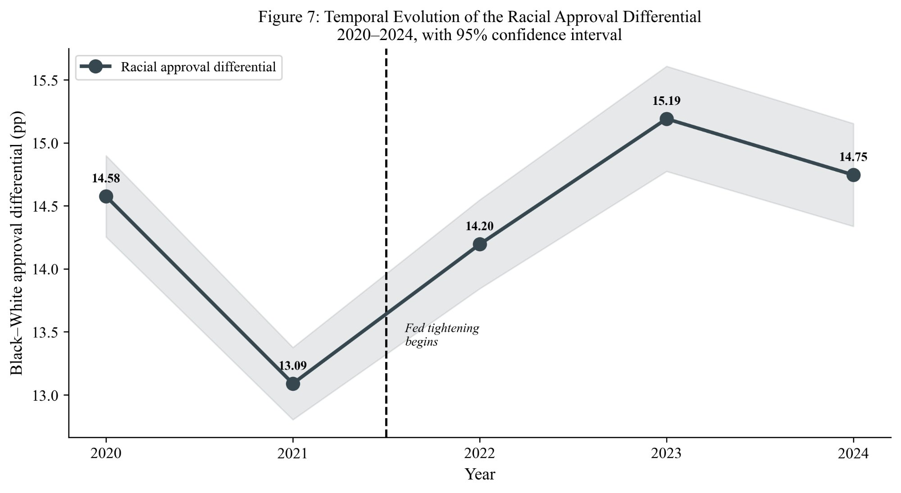
Figure 7. Temporal Evolution of the Racial Approval Differential, 2020–2024. Year-by-year Black–White approval differential with 95% confidence interval (shaded band). Dashed vertical line = onset of Fed tightening cycle (March 2022). V-shaped pattern: trough at 13.09 pp in 2021 (refinancing boom); peak at 15.19 pp in 2023 (peak tightening).
5. Discussion
5.1 Mechanisms: Institutional Discretion versus Statistical Discrimination
The evidence is most naturally interpreted within a framework distinguishing institutional discretion from applicant-level statistical discrimination. The dominant SHAP feature — AUS type — points directly to the institutional discretion channel. The 8.6 pp gap between manual and automated underwriting applicants persists after controlling for income, LTV, DTI, loan purpose, property type, and lender size. Within automated underwriting, the model produces a consistent, rules-based credit decision. Within manual underwriting, human judgment plays a larger role at every evaluation stage, creating greater scope for differential treatment. This is consistent with Fuster et al. (2022), who find that algorithmic lending reduces cross-group disparity precisely because algorithms operate with less discretion. Figure 6 illustrates the AUS mechanism and income gradient directly.
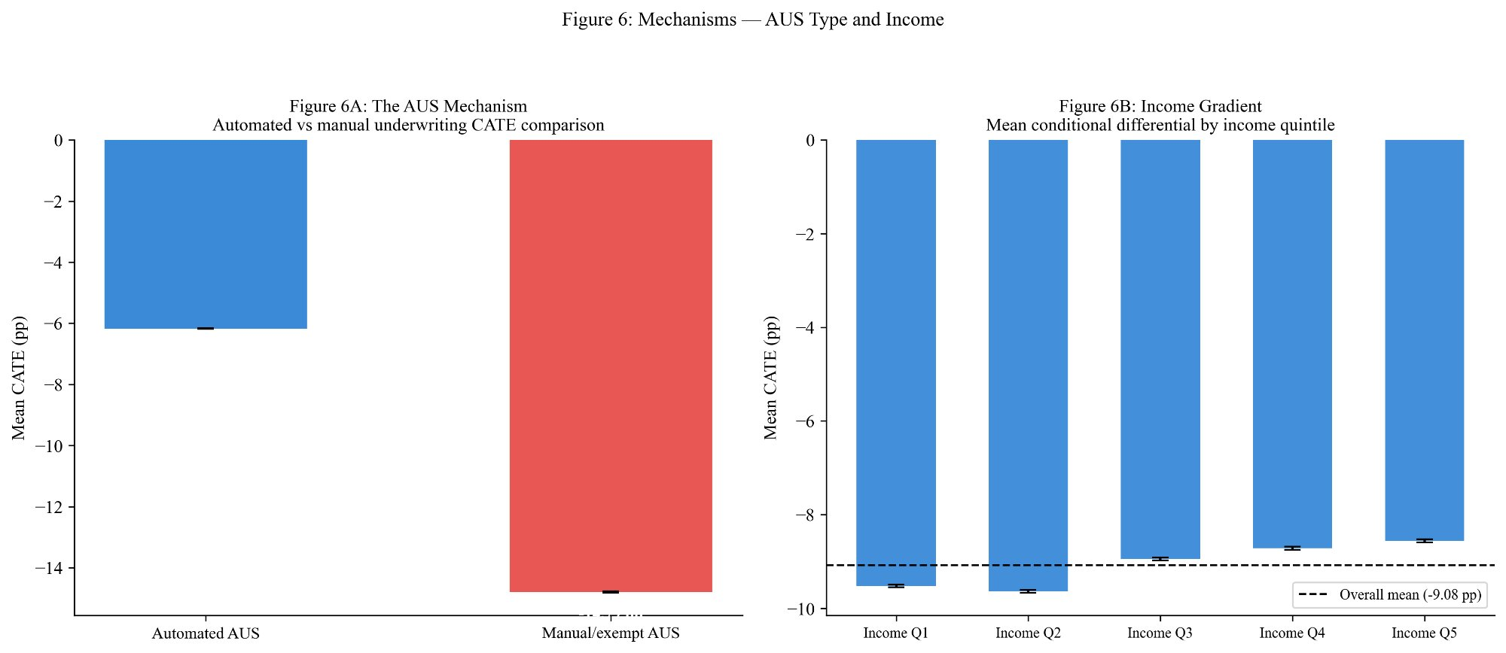
Figure 6. Mechanisms — AUS Type and Income. Left (Figure 6A): Mean CATE by AUS category. Automated AUS (−6.17 pp, blue) versus Manual/exempt AUS (−14.79 pp, red) — an 8.62 pp discretion premium. Right (Figure 6B): Mean CATE by income quintile. Dashed line = overall mean (−9.08 pp). The modest income gradient is directionally consistent with statistical discrimination.
The income gradient — modest and directionally consistent with Phelps (1972) — provides a secondary mechanism. Income Q1 (−9.52 pp) faces a slightly larger differential than Income Q5 (−8.56 pp), a difference of only 0.97 pp. This is inconsistent with the Beckerian prediction of a positive income gradient (larger penalties for higher-income Black applicants).
The counterintuitive LTV gradient — larger differentials for lower-LTV applicants — is most plausibly explained by institutional logic: applications below 80% LTV face no PMI trigger and less external constraint, creating greater scope for underwriter discretion. Applications above 80% LTV face a mandatory PMI insurer review — a form of external constraint that reduces the discretion channel.
5.2 The AUS Mandate Implication
The finding that automated underwriting reduces the mean racial approval differential by 8.6 pp has a direct policy implication. Under simplifying assumptions — (a) this difference is causal, (b) applicant composition would be similar under expanded automated underwriting, (c) equilibrium responses are second-order — mandating automated underwriting for the 29.2% of applications currently processed under manual or exempt underwriting would reduce the mean racial differential by approximately 8.6 × 0.292 ≈ 2.5 pp, a potential 27% reduction from one regulatory change.
These assumptions warrant explicit scrutiny. The critical concern is reverse causality: lenders may route higher-risk applications through manual underwriting. I address this by controlling for 30 covariates including DTI and LTV, but credit scores remain unobserved. To assess sensitivity: complete confounding would require unobserved characteristics explaining the full 8.6 pp gap, roughly equivalent to a variable more than twice as powerful as DTI (which explains 3.78 pp). This seems implausible, but cannot be ruled out with observational data. The DiD finding adds nuance: manual underwriting differentials narrowed by 1.46 pp after 2022, while automated differentials widened by 0.68 pp, suggesting the relative protective effect of AUS varies with credit cycle conditions.
5.3 Temporal Dynamics and the 2022 Tightening
The temporal plot (Figure 7) documents a V-shaped pattern: the gap fell from 14.58 pp in 2020 to 13.09 pp in 2021, rose to 15.19 pp in 2023, and partially recovered to 14.75 pp in 2024. The 2021 trough reflects the refinancing boom. The DiD analysis shows tightening-cycle widening concentrated selectively: the most-penalised applicants (Q4 DiD = +2.05 pp), the lowest-income applicants (Income Q1 = +2.29 pp), and refinance loan applicants (+1.18 pp) bore a disproportionate share. Middle-income groups and purchase loan applicants experienced near-zero widening, suggesting two distinct tightening channels: a refinance channel and a low-income channel.
5.4 Limitations
Four limitations merit explicit acknowledgement. First, the CATE estimates are conditional on 30 observable covariates. Unobserved credit quality variation — particularly credit scores — could bias estimates. To overturn the mean CATE finding, unobserved confounders would need explanatory power more than twice that of DTI. The companion paper (Pall, 2026) addresses this through Manski bounds. Second, the 1.5 million observation sample introduces sampling variance in individual CATEs; all subgroup confidence intervals are substantially narrower than the 8.47 pp standard deviation. Third, neighbourhood composition variables were excluded due to a data merge issue, preventing geographic heterogeneity analysis — a meaningful limitation given the theoretical importance of neighbourhood segregation. Fourth, both quasi-experimental designs rely on standard identification assumptions (smooth density at the RDD threshold; parallel pre-trends for DiD), which are supported by the data but not directly testable.
6. Conclusion
This paper estimates the conditional distribution of racial mortgage approval differentials across 1.5 million U.S. mortgage applicants using Causal Forests and Double Machine Learning applied to HMDA data from 2020 to 2024. The central finding is that the average differential of −9 percentage points conceals enormous individual-level heterogeneity: the standard deviation of the CATE distribution is 8.47 pp, the most-penalised decile faces −21.19 pp, and 90.7% of Black applicants receive negative estimates. The Best Linear Predictor test formally rejects the null of no heterogeneity.
The dominant driver of this heterogeneity is automated underwriting system type: manual and exempt underwriting generates −14.79 pp versus −6.17 pp under automated systems — an 8.6 pp discretion premium. The personalised disparity map reveals that Black applicants with the lowest LTV ratios face the largest differentials, inconsistent with pure risk aversion. The 2022 Federal Reserve tightening cycle amplified existing disparities selectively, and the PMI boundary effect is concentrated exclusively in purchase loans (+4.42 pp), identifying it as an independent institutional channel.
Taken together with the companion paper’s quasi-experimental evidence, these findings support a multi-channel account of racial mortgage discrimination: a within-lender differential partially explained by observable financial characteristics; a PMI boundary channel operating exclusively in purchase loans; a human discretion channel substantially larger than the algorithmic channel; and a credit cycle channel that selectively amplifies existing disparities. The most actionable implication concerns automated underwriting: expanding its coverage could reduce the mean racial approval differential by approximately 2.5 percentage points — a 27% reduction from one regulatory change. Future work should examine the causal mechanism through natural experiments in AUS adoption, extend the CATE framework to pricing differentials, and incorporate neighbourhood composition variables.

References
Athey, S., Tibshirani, J., & Wager, S. (2019). Generalised random forests. Annals of Statistics, 47(2), 1148–1178.
Bartlett, R., Morse, A., Stanton, R., & Wallace, N. (2022). Consumer-lending discrimination in the FinTech era. Journal of Financial Economics, 143(1), 30–56.
Battocchi, K., Dillon, E., Hei, M., Lewis, G., Oka, P., Oprescu, M., & Syrgkanis, V. (2019). EconML: A Python package for ML-based heterogeneous treatment effects estimation. arXiv:2004.09554.
Becker, G. S. (1957). The Economics of Discrimination. University of Chicago Press.
Bhutta, N., & Hizmo, A. (2021). Do minorities pay more for mortgages? Review of Financial Studies, 34(2), 763–789.
Chernozhukov, V., Chetverikov, D., Demirer, M., Duflo, E., Hansen, C., Newey, W., & Robins, J. (2018). Double/debiased machine learning for treatment and structural parameters. The Econometrics Journal, 21(1), C1–C68.
Chernozhukov, V., Demirer, M., Duflo, E., & Fernández-Val, I. (2018). Generic machine learning inference on heterogeneous treatment effects in randomized experiments. NBER Working Paper No. 24678.
Crump, R. K., Hotz, V. J., Imbens, G. W., & Mitnik, O. A. (2009). Dealing with limited overlap in estimation of average treatment effects. Biometrika, 96(1), 187–199.
Fuster, A., Goldsmith-Pinkham, P., Ramadorai, T., & Walther, A. (2022). Predictably unequal? The effects of machine learning on credit markets. Journal of Finance, 77(1), 5–47.
Knaus, M. C. (2022). Double machine learning-based programme evaluation under unconfoundedness. The Econometrics Journal, 25(3), 602–627.
Ladd, H. F. (1998). Evidence on discrimination in mortgage lending. Journal of Economic Perspectives, 12(2), 41–62.
Lundberg, S. M., & Lee, S.-I. (2017). A unified approach to interpreting model predictions. Advances in Neural Information Processing Systems, 30.
Munnell, A. H., Tootell, G. M. B., Browne, L. E., & McEneaney, J. (1996). Mortgage lending in Boston: Interpreting HMDA data. American Economic Review, 86(1), 25–53.
Pall, R. S. (2026). Persistent racial disparities in U.S. mortgage approval: Evidence from 42 million applications, 2020–2024. Working paper under review, Gyan Ganga Institute of Technology and Sciences.
Phelps, E. S. (1972). The statistical theory of racism and sexism. American Economic Review, 62(4), 659–661.
Ross, S. L., & Yinger, J. (2002). The Color of Credit: Mortgage Discrimination, Research Methodology, and Fair-Lending Enforcement. MIT Press.
Wager, S., & Athey, S. (2018). Estimation and inference of heterogeneous treatment effects using random forests. Journal of the American Statistical Association, 113(523), 1228–1242.

Appendix: Supplementary Figures
Figure A1: Propensity Score Overlap Diagnostic
Figure A1 presents the full propensity score overlap diagnostic from Section 2.3. The left panel shows the propensity score distributions for Black (n = 400,000) and White (n = 1,600,000) applicants in the stratified estimation sample. The right panel shows the trimmed common support region, which retains 98.0% of the sample within the bounds [0.033, 0.580]. The AUC of 0.729 indicates moderate separability while the 98% overlap confirms that the positivity assumption holds across the vast majority of the covariate space.
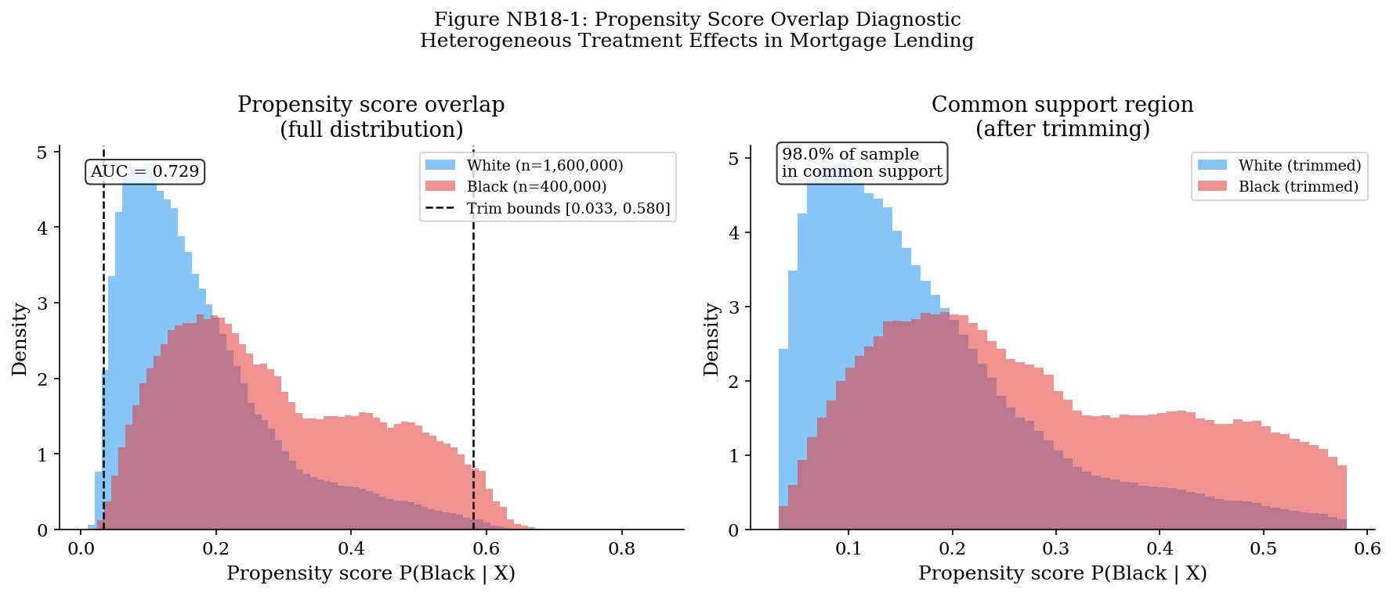
Figure A1. Propensity Score Overlap Diagnostic. Left: Full propensity score distributions P(Black = 1 | X) for Black (n = 400,000) and White (n = 1,600,000) applicants. Dashed lines = trim bounds [0.033, 0.580]. Cross-validated AUC = 0.729. Right: Trimmed common support region (98.0% of sample retained).
Figure A2: Pre-period Parallel Trends
[Figure A2: Insert nb25_event_study.png from NB25 output. Year-by-year Black–White approval gaps for 2020–2021 (pre-period) and 2022–2024 (post-period) for the full sample and by CATE quartile. Pre-period gaps should be stable within each subgroup, supporting the parallel trends assumption for the DiD estimates in Table 6.]

