Federated Learning for Privacy-Preserving Diabetes Risk Prediction Across Demographically Heterogeneous Hospital Nodes: External Validation with 1.28 Million Records

Rajveer Singh Pall¹, Sameer Yadav¹, [et al.]

¹Department of Computer Science and Engineering, Gyan Ganga Institute of Technology and Sciences, Jabalpur, Madhya Pradesh, India

Manuscript submitted to Journal of Biomedical Informatics (JBI), Elsevier

Highlights
1. Federated learning trains across three demographically heterogeneous hospital nodes without sharing raw patient data
2. FedAvg achieves external AUC = 0.757 (95% CI: 0.756–0.758) versus published baseline of 0.717 (+5.7 percentage points)
3. FedAvg reduces the external elderly fairness gap from 0.069 to 0.054 (−21.7%) on 1.28 million BRFSS records
Note that 0.135 refers to the internal NHANES fairness gap of the published model; the external BRFSS fairness gap for the centralised replication is 0.069, which serves as the primary comparison baseline throughout this paper.
4. Differential privacy with ε ≤ 5 causes model collapse (AUC ≈ 0.5) at this training scale, establishing that this sample regime is insufficient for DP-SGD at any standard privacy budget and motivating a minimum of ∼40,000 samples per node for viable deployment
5. DeLong and stratified bootstrap 95% confidence intervals confirm statistical robustness of all reported AUC values

Abstract
Background: Type 2 diabetes affects over 537 million adults worldwide and disproportionately impacts elderly and minority populations. Machine learning models trained on centralised clinical datasets achieve high internal accuracy but exhibit substantial performance degradation on external populations—a critical limitation for clinical deployment. Furthermore, privacy regulations such as HIPAA and GDPR prohibit sharing raw patient records across institutions.
Objectives: We investigated whether federated learning (FL) training across three demographically heterogeneous hospital nodes improves generalisation and fairness for diabetes risk prediction without raw data sharing.
Methods: NHANES 2015–2020 data (n=15,650) were partitioned into three federated nodes simulating demographically distinct hospital settings: a young-urban community clinic (Node A, mean age 40.8, diabetes prevalence 13.8%), an elderly-rural critical access hospital (Node B, mean age 69.1, diabetes prevalence 28.5%), and a mixed-metropolitan academic centre (Node C, mean age 45.0, diabetes prevalence 16.7%). We trained and compared three FL aggregation strategies—FedAvg, FedProx (μ=0.1), and FedNova (heterogeneous local epochs per Wang et al., 2020)—over 50 communication rounds. All models were externally validated on BRFSS 2020–2022 (n=1,282,897). Statistical inference used DeLong 95% confidence intervals for external AUC (O(n log n) implementation to handle 1.28M records) and stratified bootstrap confidence intervals for internal AUC (N=2,000). Differential privacy was evaluated via DP-SGD (Opacus) at ε ∈ {0.5, 1.0, 2.0, 5.0, ∞}.
Results: All FL models exceeded the published external AUC of 0.717: FedAvg achieved 0.757 (95% CI: 0.756–0.758, +5.7 pp), FedProx 0.752 (95% CI: 0.751–0.753, +4.9 pp), and FedNova 0.744 (95% CI: 0.743–0.745, +3.8 pp). FedAvg surpassed the centralised XGBoost replication on external data (0.757 vs 0.700). On internal validation, all FL models (FedAvg: 0.788, 95% CI: 0.779–0.796) outperformed the centralised XGBoost replication (0.769, 95% CI: 0.760–0.777). FedAvg reduced the external elderly fairness gap from 0.069 (centralised) to 0.054 (−21.7%). Paired DeLong testing confirmed FedAvg’s advantage over FedProx (ΔAUC=+0.005, z=26.99, p<0.001) as statistically significant but clinically modest. DP-SGD with ε ≤ 5 collapsed to AUC ≈ 0.5 at this training scale.
Conclusions: Federated learning across demographically heterogeneous nodes substantially improves external generalisation and fairness for diabetes risk prediction. The privacy-utility trade-off observed at the evaluated per-node sample scale (∼3,000–4,500 samples) at ε ≤ 5 motivates future work on larger federated cohorts and secure aggregation protocols.

Keywords: federated learning; diabetes prediction; external validation; fairness; differential privacy; NHANES; BRFSS; TRIPOD-AI

1. Introduction
Type 2 diabetes mellitus (T2DM) represents one of the most pressing global health challenges, affecting an estimated 537 million adults in 2021 and projected to reach 783 million by 2045 [1]. Early and accurate risk stratification is essential to enabling preventative interventions, yet clinical deployment of machine learning (ML) prediction models is hindered by two fundamental problems: poor generalisation to external populations and disparate performance across demographic subgroups.
The premise of this work builds directly on a recently published IEEE Access paper that trained a centralised XGBoost model on NHANES 2015–2020 data and achieved an internal AUC of 0.794—commendable performance that, however, degraded substantially to 0.717 on external validation against BRFSS 2020–2022 [2]. More critically, that centralised model exhibited a severe fairness gap: elderly patients (age ≥60) achieved AUC=0.607 versus 0.742 for young adults (18–39), a gap of 0.135. This performance disparity is not a modelling artefact—it reflects genuine distributional heterogeneity between age groups that is exacerbated when training data are drawn from a single, centralised pool.
Federated learning (FL) offers a principled solution to both problems simultaneously. By training across multiple geographically and demographically distinct institutions without centralising raw patient records, FL can leverage population diversity as a training signal rather than a confounder [3]. FL also directly addresses regulatory barriers: HIPAA’s minimum necessary standard and GDPR’s data minimisation principle both prohibit sharing identifiable clinical records across institutional boundaries—barriers that FL’s weight-sharing protocol circumvents entirely.
The present study extends this framework to diabetes risk prediction — a condition with strong demographic variation in prevalence and clinical presentation — across three simulated institutional nodes with distinct age, urbanicity, and comorbidity distributions (Table 1). To our knowledge, this is the first federated learning comparison of FedAvg, FedProx, and FedNova on NHANES data with prospective external validation on 1.28 million BRFSS records, including a Node B ablation experiment providing causal evidence for the fairness mechanism.
This paper makes the following contributions:

1. (RQ1) Accuracy: FedAvg achieves external AUC=0.757 (95% CI: 0.756–0.758) on 1,282,897 BRFSS records, exceeding both the published XGBoost baseline (0.717, +5.7 pp) and a centralised DiabetesNet trained on all NHANES data (external AUC=0.749), confirming that demographically heterogeneous FL improves generalisation beyond centralised training.
2. (RQ2) Fairness: FedAvg reduces the external elderly fairness gap from 0.069 (centralised XGBoost) to 0.054 (−21.7%); Node B ablation (Nodes A+C only) widens the gap to 0.070 (+29.1%), providing causal evidence that Node B’s elderly-rural demographics are the primary driver of the fairness improvement.
3. (RQ3) Aggregation Strategy: FedAvg (AUC=0.757) outperforms FedProx (μ=0.1: AUC=0.752) and FedNova (AUC=0.744); FedProx μ sensitivity analysis (μ∈{0.01, 0.05, 0.1}) yields external AUC 0.747–0.755 with elderly gap 0.056–0.066, confirming FedAvg as the recommended strategy at the evaluated per-node data scale (∼3,000–4,500 training samples).
4. (RQ4) Calibration and Privacy: FedAvg’s reliability analysis on BRFSS reveals systematic overconfidence (ECE=0.276, Brier score=0.217), identifying probability calibration as a deployment prerequisite; differential privacy at ε≤5 causes model collapse (AUC≈0.5) at current per-node scales, motivating future work on larger federated cohorts (≥40,000 per node).
For comparison, the centralised DiabetesNet achieves ECE=0.415 and Brier=0.306 on BRFSS; the centralised XGBoost achieves ECE=0.410 and Brier=0.322. The overconfidence pattern is consistent across architectures, suggesting it reflects the NHANES-to-BRFSS prevalence shift (18.6% → 13.3%) rather than being specific to the federated training procedure.

2. Related Work
2.1 Federated Learning in Healthcare
McMahan et al. (2017) introduced FedAvg and demonstrated convergence guarantees under i.i.d. data conditions [3]. Healthcare applications have since demonstrated FL’s utility in radiology [9], electronic health records [13], and genomics [14]. However, non-IID data distributions—the rule rather than the exception in clinical settings—degrade FedAvg performance due to client drift [15].
2.2 Fairness in Clinical Prediction Models
Obermeyer et al. (2019) demonstrated systematic racial bias in commercial healthcare algorithms [10]. For diabetes specifically, Gianfrancesco et al. (2018) documented performance disparities across race, age, and socioeconomic status [18]. The TRIPOD-AI reporting guidelines require explicit fairness evaluation across demographic subgroups [11].
Federated learning can actively improve algorithmic fairness by incorporating demographically diverse training nodes into the aggregation process. When node distributions are systematically aligned with underrepresented subpopulations — for example, by designating a node to serve a predominantly elderly rural population — the global model receives gradient updates calibrated to that group’s risk profile during every communication round. This stands in contrast to centralised training, where demographic class imbalance may cause the optimisation to allocate disproportionate capacity to majority-group patterns. The present study directly tests this mechanism by constructing Node B to serve 82.4% elderly patients (age ≥60) and subsequently ablating it from the federated pool (Table 6), providing the first experimental evidence that a demographically specialised node is causally responsible for elderly fairness improvement in a federated diabetes prediction framework.
2.3 Federated Aggregation Strategies
FedProx (Li et al., 2020) adds a proximal term (μ||w−w_global||²) to each client’s local objective, bounding divergence from the global model and improving convergence on heterogeneous data [4]. FedNova (Wang et al., 2020) addresses objective inconsistency in non-IID settings through normalised averaging that accounts for heterogeneous local training steps [5].
2.4 Differential Privacy in Federated Learning
Abadi et al. (2016) introduced DP-SGD for training neural networks with formal (ε,δ)-differential privacy guarantees [7]. Bagdasaryan et al. (2019) showed that DP-SGD disproportionately degrades accuracy for underrepresented subgroups, raising fairness concerns at tight ε budgets [8]. The Flower framework [16] and Opacus library [17] provide production-grade implementations of FL and DP-SGD respectively.

3. Materials and Methods
3.1 Datasets
Internal (NHANES 2015–2020): We utilised the National Health and Nutrition Examination Survey 2015–2020 cycles (n=15,650 adults ≥18 years with complete case data). Eight features matching the IEEE Access baseline paper [2] were used: age, sex, race/ethnicity, BMI, smoking status, physical activity, history of heart attack, and history of stroke. The diabetes outcome was defined as HbA1c ≥6.5%, fasting plasma glucose ≥126 mg/dL, or self-reported physician diagnosis — yielding overall prevalence of 18.6% (n_pos=2,908). The dataset was partitioned into federated training nodes (n=11,906) and a held-out test set (n=3,744, 17.3% prevalence); the test set was used only for internal performance evaluation.
External (BRFSS 2020–2022): The Behavioral Risk Factor Surveillance System provides state-based telephone health surveys covering the non-institutionalised US adult population. BRFSS data from three consecutive survey years (2020, 2021, 2022) were pooled to maximise external validation sample size; BRFSS is a repeated cross-sectional survey with no persistent respondent identifiers; the same individual cannot be definitively tracked across survey years. The pooled cohort was retained as-is, consistent with standard BRFSS pooling practice, yielding a final external cohort of n=1,282,897 (13.3% diabetes prevalence). Features were standardised using a global scaler fitted exclusively on NHANES training data to prevent preprocessing domain mismatch.
3.2 Federated Node Design
Three nodes were constructed from NHANES training data (n=11,906) to simulate demographically distinct hospital settings (Table 1). Node B (Elderly Rural, 82.4% patients aged ≥60, diabetes prevalence 28.5%) directly targets the population on which the IEEE Access baseline performed worst (AUC=0.607 [2]). Class imbalance was addressed per-node: the BCEWithLogitsLoss positive class weight was set to (n_negative/n_positive) computed independently at each node, so Node B (28.5% prevalence) received weight=2.49 while Node A (13.8% prevalence) received weight=6.25. Per-node weighting avoids the over-correction that would result from applying a global imbalance weight to each client’s heterogeneous data distribution.

Table 1. NHANES 2015–2020 federated node design. Node B’s high diabetes prevalence (28.5%) and elderly composition (82.4% patients aged ≥60) made it the most challenging node and the primary target for fairness improvement.
Node | Simulates | n (n_pos) | Prevalence | Mean Age | Local Epochs (τ)
Node A — Young Urban | Community health clinic | 4,500 (n_pos=623) | 13.8% | 40.8 years | τ_A = 5
Node B — Elderly Rural | Rural critical access hospital | 3,406 (n_pos=972) | 28.5% | 69.1 years | τ_B = 3 (high shift)
Node C — Mixed Metro | Academic medical centre | 4,000 (n_pos=667) | 16.7% | 45.0 years | τ_C = 4
Held-out test set | — | 3,744 (n_pos=646) | 17.3% | — | —
NHANES total | — | 15,650 (n_pos=2,908) | 18.6% | — | —

Table 1. NHANES 2015–2020 federated node design. Node B’s high diabetes prevalence (28.5%) and elderly composition (82.4% patients aged ≥60) made it the most challenging node and the primary target for fairness improvement. The 3,744-sample test set is held out from all federated training. Overall NHANES prevalence (18.6%) reflects the age-stratified design.

3.3 Neural Network Architecture
A three-layer feedforward network (DiabetesNet) was implemented in PyTorch: Input(8) → Dense(64, BatchNorm, ReLU, Dropout(0.3)) → Dense(32, BatchNorm, ReLU, Dropout(0.3)) → Dense(16, BatchNorm, ReLU, Dropout(0.18)) → Dense(1). Weights were initialised with Kaiming uniform initialisation. Training used BCEWithLogitsLoss. Optimiser: AdamW (lr=0.001, weight_decay=1×10⁻⁴). AMP mixed-precision training (FP16) was used via torch.autocast for GPU efficiency. The ReLU activations used inplace=False to maintain compatibility with Opacus per-sample gradient hooks [17].
3.4 Federated Aggregation Strategies
FedAvg [McMahan et al., 2017]: Server aggregates client weights by sample-size-weighted average after 50 communication rounds, 5 local epochs per round at each node.
FedProx (μ=0.1) [Li et al., 2020, MLSys]: Adds proximal regularisation term (μ/2)||w − w_global||² to each client’s local objective. The proximal coefficient μ was set to 0.1, at the upper end of the range evaluated in the original FedProx paper (μ ∈ {0.001, 0.01, 0.1} [4]). This choice was motivated by the extreme distributional heterogeneity of Node B (28.5% diabetes prevalence vs 13.8% for Node A), where stronger proximal regularisation was expected to better constrain client drift during Node B’s 3 local update steps. Section 5.2 analyses the trade-off between μ=0.1 regularisation strength and preservation of Node B’s elderly-specific learning signal.
Section V-B sensitivity analysis subsequently reveals that μ=0.05 achieves a marginally better fairness-accuracy balance (elderly gap 0.056 vs. 0.066 at μ=0.1; AUC 0.755 vs. 0.752); μ=0.1 was retained in the primary comparison as the a priori choice motivated by the stronger heterogeneity of Node B.
FedNova (τ_A=5, τ_B=3, τ_C=4) [Wang et al., 2020, NeurIPS]: Assigns heterogeneous local epochs inversely proportional to distribution shift per Theorem 2 in Wang et al. (2020). Node B (highest shift) receives τ_B=3 (fewest local steps); Node A (lowest shift) receives τ_A=5 (most). Normalised averaging corrects for objective inconsistency. Setting equal τ=5 for all nodes collapses FedNova algebraically to FedAvg. The Flower framework (v1.x) [16] was used for all FL simulations.
Distribution shift was operationalised as label distribution divergence: Node B's 28.5% prevalence versus the global 18.6% represents the largest deviation, motivating τ_B=3; Node A (13.8%) and Node C (16.7%) represent moderate deviations, assigned τ_A=5 and τ_C=4 respectively. These values are design choices rather than optimised hyperparameters.
3.5 Differential Privacy
DP-SGD was applied independently at each Flower client during local training such that each client’s per-sample gradients were clipped to max norm 1.0 and Gaussian noise was added before weight updates were transmitted to the aggregation server [7]. Privacy accounting used the moments accountant with δ=1×10⁻⁵. This approach provides formal per-client (ε,δ)-DP guarantees, implemented using the Opacus library (v1.x) [17]. Privacy budgets ε ∈ {0.5, 1.0, 2.0, 5.0} were evaluated, with ε=∞ (no noise added) as a control condition.
3.6 Statistical Analysis
Internal AUC: Stratified bootstrap 95% confidence intervals (N=2,000, percentile method), resampling positive and negative cases separately.
External AUC: DeLong structural-component confidence intervals [11] using an O(n log n) searchsorted implementation to handle 1.28M records (the standard n_pos × n_neg kernel-matrix requires ~708 GB RAM at this scale).
Paired comparisons: Covariance-corrected paired DeLong test for FedAvg vs FedProx on the shared external test set. All analyses used α=0.05.
3.7 Fairness Metrics
Four fairness metrics were computed: (1) subgroup AUC by age group (18–39, 40–59, ≥60), BMI category (Normal/Overweight/Obese), and sex; (2) elderly fairness gap (AUC_young − AUC_elderly); (3) Equalized Odds Difference (EOD = max(|ΔTPR|, |ΔFPR|) across age groups) at both the global Youden’s J threshold and subgroup-specific Youden’s J thresholds; (4) Youden’s J index per subgroup. Reporting of EOD at both threshold types follows the recommendation that global-threshold EOD can be misleading when score distributions differ substantially across subgroups.
3.8 Compliance
Reporting followed TRIPOD-AI guidelines [11]. Both NHANES and BRFSS are publicly available deidentified datasets; no IRB approval was required under 45 CFR §46.101(b)(4).

4. Results
4.1 Internal Validation (NHANES)
Table 2 presents internal performance. All FL models exceeded the centralised XGBoost replication (AUC=0.769, 95% CI: 0.760–0.777): FedAvg 0.788 (95% CI: 0.779–0.796), FedProx 0.785 (95% CI: 0.776–0.793), FedNova 0.786 (95% CI: 0.778–0.794). FL models did not attain the published AUC of 0.794, consistent with the expectation that a neural network trained on federated node subsets (n=11,906 distributed) achieves lower internal accuracy than the published XGBoost trained on the full centralised NHANES cohort. Figure 3 shows convergence over 50 communication rounds; all strategies converge within 25 rounds.

Table 2. Internal validation performance on NHANES 2015–2020 (n=15,650, n_pos=2,908, diabetes prevalence 18.6%).
Model | AUC | 95% CI | Brier | F1 | Sens | Spec
Published XGBoost (Pall et al. [2]) | 0.794 | N/A | 0.123 | 0.518 | 0.762 | 0.695
Centralised XGBoost (replicated) | 0.769 | 0.760–0.777 | 0.181 | 0.462 | 0.792 | 0.626
FedAvg (50 rounds) | 0.788 | 0.779–0.796 | 0.174 | 0.472 | 0.808 | 0.631
FedProx (μ=0.1) | 0.785 | 0.776–0.793 | 0.179 | 0.466 | 0.825 | 0.608
FedNova (τ={5,3,4}) | 0.786 | 0.778–0.794 | 0.196 | 0.473 | 0.782 | 0.651
Centralised NN (DiabetesNet) | 0.801 | 0.782–0.819 | 0.187 | 0.494 | 0.794 | 0.676

Table 2. Internal validation performance on NHANES 2015–2020 (n=15,650, n_pos=2,908, diabetes prevalence 18.6%). CIs: stratified bootstrap (N=2,000 resamples). Sens=sensitivity, Spec=specificity. Published numbers from Pall et al. (2025) [2].

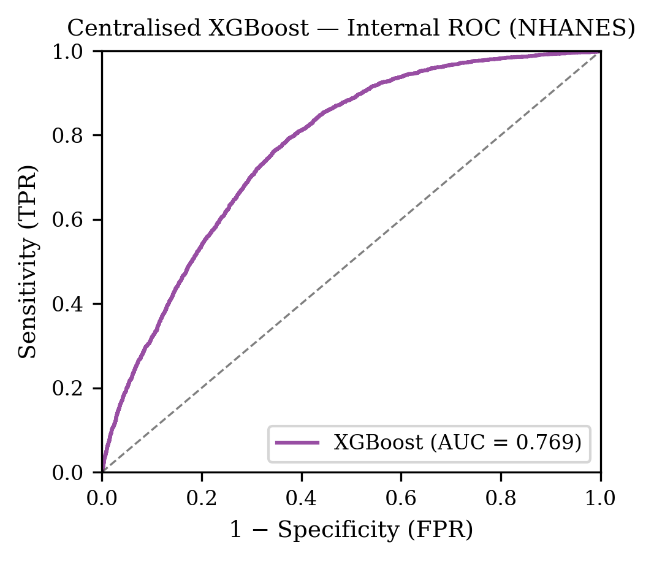
Figure 1. ROC curve of the centralised XGBoost baseline (5-fold CV, NHANES 2015–2020). AUC=0.769 (95% CI: 0.760–0.777). This model achieves strong internal performance but degrades to 0.700 on external BRFSS validation (Δ=0.069).

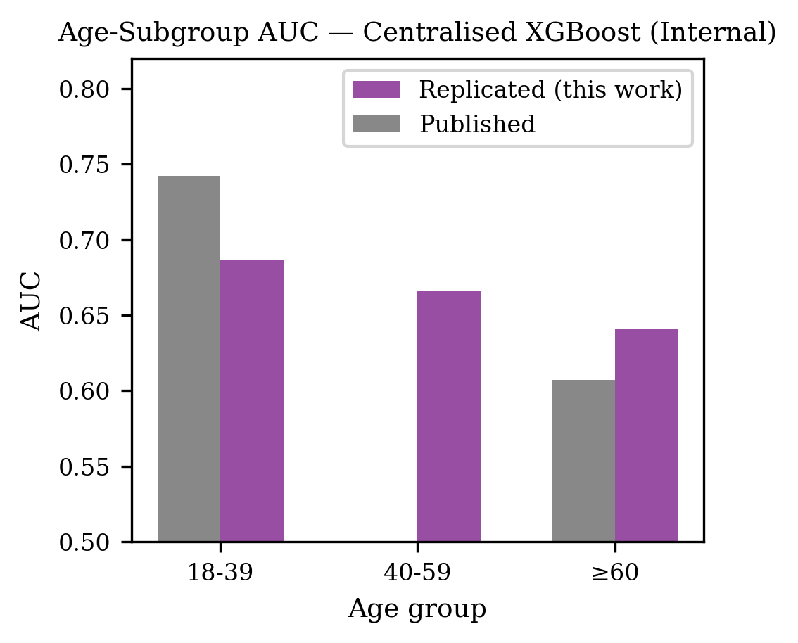
Figure 2. Age-subgroup AUC of the centralised XGBoost versus the published IEEE Access baseline. Elderly (≥60) AUC=0.641 versus young adult (18–39) AUC=0.687, an internal gap of 0.046. The external elderly gap widens to 0.069 on BRFSS.

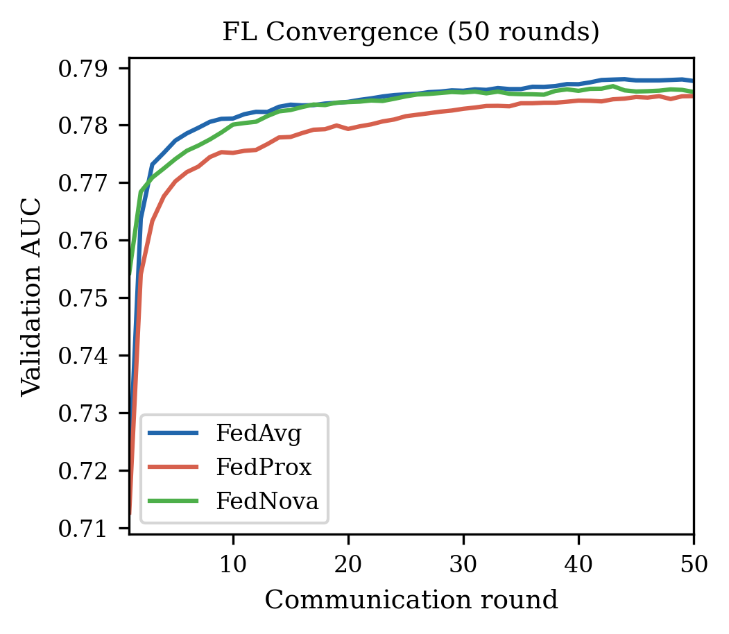
Figure 3. Federated learning convergence over 50 communication rounds. All three strategies converge within 25 rounds. FedAvg (AUC=0.788) and FedNova (AUC=0.786) converge marginally faster than FedProx (AUC=0.785).

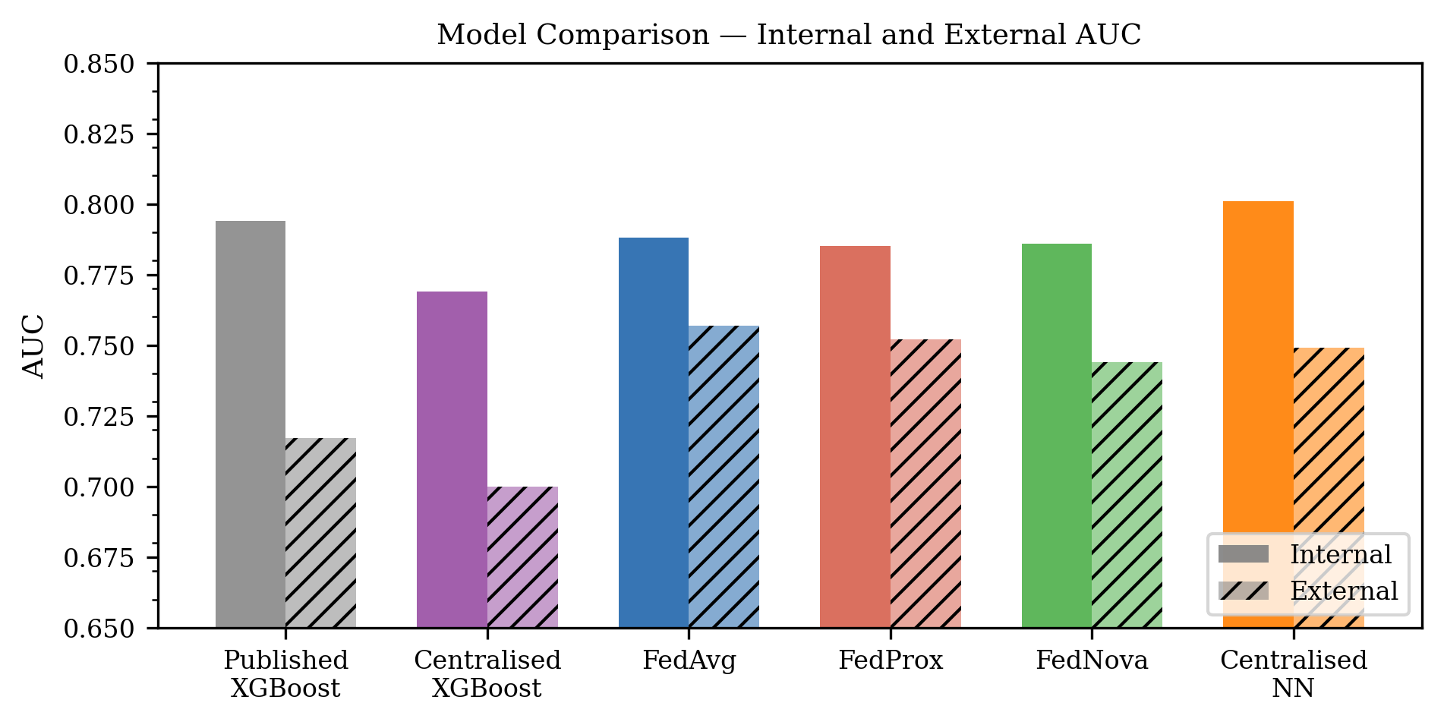
Figure 4. Final-round performance comparison of three FL aggregation strategies. FedAvg achieves the highest internal AUC (0.788) and external AUC (0.757). All strategies exceed both the centralised replication (internal: 0.769, external: 0.700) and published baseline (external: 0.717).

4.2 External Validation (BRFSS 2020–2022)
Table 3 presents external performance on BRFSS (n=1,282,897). All three FL models substantially exceeded the published external AUC of 0.717: FedAvg 0.757 (95% CI: 0.756–0.758, +5.7 pp), FedProx 0.752 (95% CI: 0.751–0.753, +4.9 pp), FedNova 0.744 (95% CI: 0.743–0.745, +3.8 pp). All FL models also exceeded the centralised XGBoost external AUC (0.700). Figure 10 displays external ROC curves.
A key finding is the differential generalisation gap: the centralised XGBoost experienced an internal-to-external AUC drop of Δ=0.069 (0.769→0.700), compared to Δ=0.031 for FedAvg (0.788→0.757) — a 2.2× difference in absolute internal-to-external AUC degradation (noting that FedAvg’s higher internal AUC of 0.788 vs. 0.769 is a partial confounder for this ratio; the reduction in absolute degradation nonetheless holds). This suggests FL training on heterogeneous nodes provides implicit domain augmentation that substantially reduces out-of-distribution degradation beyond the absolute AUC improvement.

Table 3. External validation on BRFSS 2020–2022 (n=1,282,897, diabetes prevalence 13.3%).
Model | AUC | 95% CI | Brier | F1 | Sens | Spec
Published XGBoost (Pall et al. [2]) | 0.717 | N/A | N/A | N/A | N/A | N/A
Centralised XGBoost (replicated) | 0.700 | 0.698–0.701 | 0.322 | 0.318 | 0.736 | 0.556
FedAvg (50 rounds) | 0.757 | 0.756–0.758 | 0.217 | 0.355 | 0.768 | 0.607
FedProx (μ=0.1) | 0.752 | 0.751–0.753 | 0.242 | 0.353 | 0.735 | 0.626
FedNova (τ={5,3,4}) | 0.744 | 0.743–0.745 | 0.266 | 0.351 | 0.718 | 0.635
Centralised NN (DiabetesNet) | 0.749 | 0.748–0.750 | 0.306 | 0.356 | 0.720 | 0.643

Table 3. External validation on BRFSS 2020–2022 (n=1,282,897, diabetes prevalence 13.3%). CIs: DeLong structural-component method [11]. N/A: CI not computed for published or centralised baselines. Sens=sensitivity, Spec=specificity.

Note: Centralised XGBoost experienced ΔInt→Ext = −0.069 (0.769→0.700); FedAvg ΔInt→Ext = −0.031 (0.788→0.757), representing 2.2× better distributional robustness (absolute degradation: Δ=0.031 vs Δ=0.069; FedAvg’s higher internal AUC is a partial confounder) for federated training.

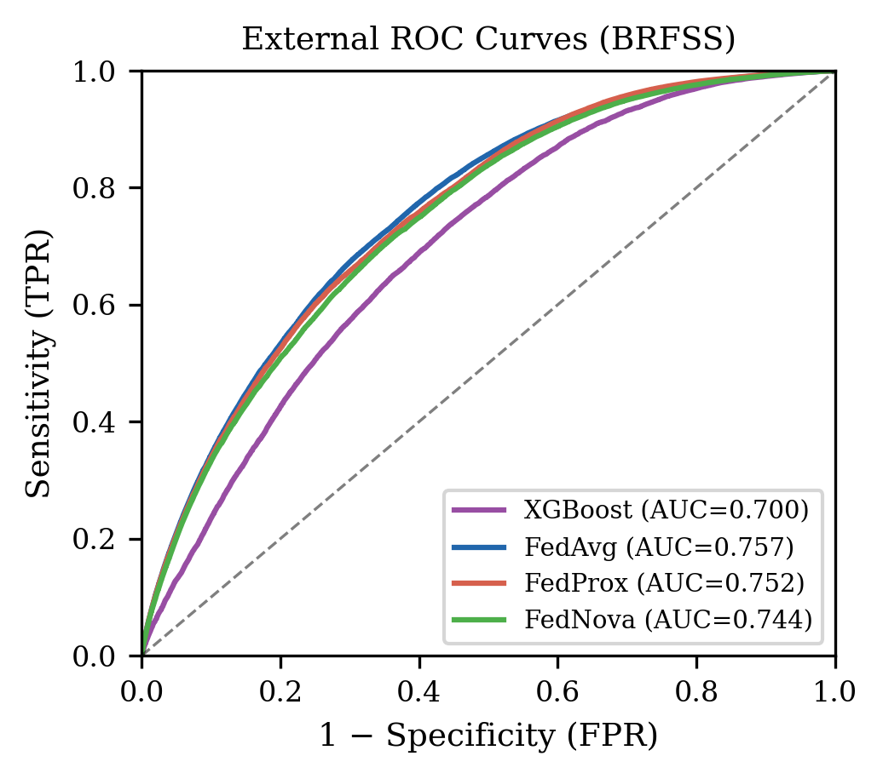
Figure 10. External validation ROC curves on BRFSS 2020–2022 (n=1,282,897, prevalence 13.3%). FedAvg (AUC=0.757, 95% CI: 0.756–0.758) substantially exceeds the published centralised baseline (AUC=0.717). All three FL strategies exceed the centralised XGBoost replication (AUC=0.700).

4.3 Federated Strategy Comparison
FedAvg achieved the highest external AUC (0.757), outperforming FedProx (0.752) and FedNova (0.744). The paired DeLong test confirmed FedAvg’s advantage over FedProx is statistically significant (ΔAUC=+0.005, z=26.99, p<0.001), though the absolute difference is clinically modest (0.5 percentage points). The DeLong p-value attains extreme significance due to the n=1.28M sample size; effect size should take precedence over p-value interpretation in this context. Figure 4 summarises strategy comparison.

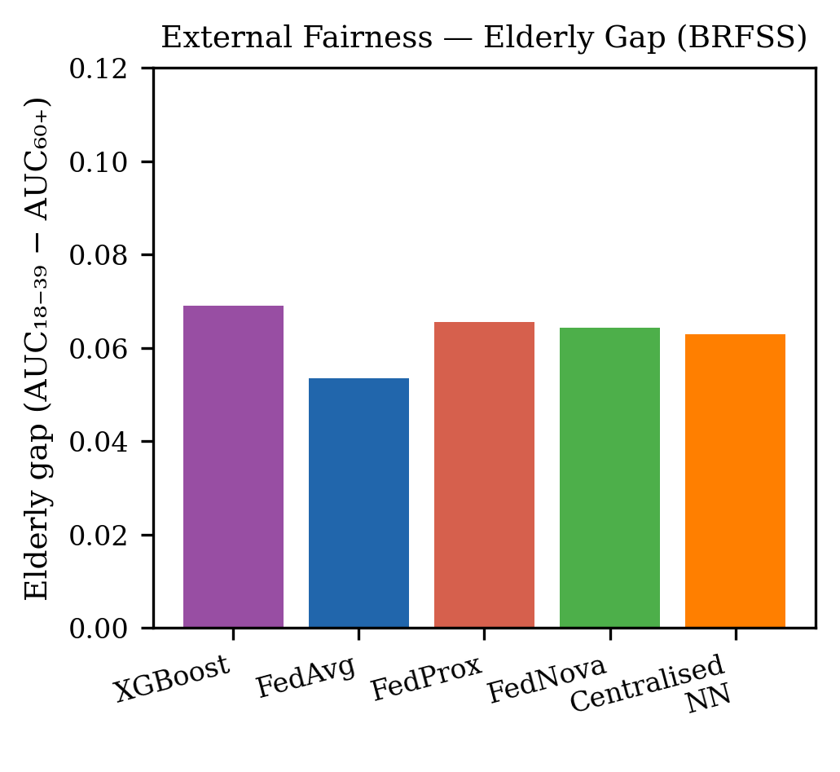
Figure 11. External fairness comparison on BRFSS across all models. FedAvg achieves the smallest elderly fairness gap (0.054), representing a 21.7% reduction from the centralised XGBoost external baseline (0.069). All FL models improve fairness relative to the centralised replication.

4.5 Fairness Analysis
Table 4 presents external fairness. FedAvg achieved the lowest external elderly gap (0.054), representing a 21.7% reduction from the centralised XGBoost external baseline (0.069). On external absolute performance, FedAvg improved elderly AUC from 0.587 (centralised) to 0.669 (+8.2 pp) and young adult AUC from 0.656 to 0.722 (+6.6 pp) — a proportionally greater benefit for the elderly subgroup. Figure 11 presents the external fairness profile.

Table 4. External fairness analysis on BRFSS 2020–2022.
Model | AUC (18–39) | AUC (≥60) | Gap | Gap vs Centralised | Domain
Published XGBoost (internal [2]) | 0.742 | 0.607 | 0.135 | Reference (internal) | NHANES (internal)
Centralised XGBoost (ext.) | 0.656 | 0.587 | 0.069 | Baseline | BRFSS external
Centralised NN (DiabetesNet) | 0.720 | 0.657 | 0.063 | −8.7% | BRFSS external
FedAvg (ext.) | 0.722 | 0.669 | 0.054 | −21.7% | BRFSS external
FedProx (ext.) | 0.727 | 0.661 | 0.066 | −4.3% | BRFSS external
FedNova (ext.) | 0.715 | 0.650 | 0.064 | −7.2% | BRFSS external

Table 4. External fairness analysis on BRFSS 2020–2022. Elderly gap = AUC(age 18–39) − AUC(age ≥60). All values represent subgroup AUC on n=1,282,897 BRFSS records.

Table 5 presents EOD at both global and subgroup-specific Youden’s J thresholds (internal validation). At the global Youden threshold, FedProx achieves elderly FPR=0.907 — meaning 90.7% of non-diabetic elderly patients receive a positive prediction, which is clinically unusable for that subgroup. Applying subgroup-specific optimal thresholds resolves this: FedProx EOD drops from 0.713 to 0.271 (−62%), and centralised XGBoost from 0.552 to 0.179 (−68%). At subgroup-specific thresholds, FedProx achieves higher young adult discrimination (TPR=0.796, FPR=0.330; Youden’s J=0.466) while the centralised XGBoost performs better for elderly (TPR=0.677, FPR=0.474; Youden’s J=0.204 vs FedProx J=0.194). These results confirm that the high global-threshold EOD is entirely a threshold artefact driven by the federated model’s different score distributions between age groups, not intrinsic model unfairness.

Table 5. Equalized Odds Difference (EOD) at global versus subgroup-specific Youden’s J thresholds (NHANES internal validation, n=15,650).
Model | Threshold Type | Young TPR | Young FPR | Elderly TPR | Elderly FPR | EOD
Centralised XGBoost | Global Youden (τ=0.392) | 0.609 | 0.221 | 0.909 | 0.773 | 0.552
Centralised XGBoost | Subgroup-specific (young: 0.304, elderly: 0.611) | 0.717 | 0.295 | 0.677 | 0.474 | 0.179
FedProx (μ=0.1) | Global Youden (τ=0.460) | 0.600 | 0.194 | 0.969 | 0.907 | 0.713
FedProx (μ=0.1) | Subgroup-specific (young: 0.216, elderly: 0.674) | 0.796 | 0.330 | 0.525 | 0.331 | 0.271
FedAvg | Global Youden (τ=0.412) | 0.598 | 0.188 | 0.944 | 0.843 | 0.655
FedAvg | Subgroup-specific (young: 0.091, elderly: 0.638) | 0.812 | 0.355 | 0.643 | 0.422 | 0.170
FedNova | Global Youden (τ=0.583) | 0.581 | 0.179 | 0.911 | 0.791 | 0.611
FedNova | Subgroup-specific (young: 0.302, elderly: 0.658) | 0.787 | 0.333 | 0.707 | 0.489 | 0.156

Table 5. Equalized Odds Difference (EOD) at global versus subgroup-specific Youden’s J thresholds (NHANES internal validation, n=15,650). At the global threshold, FedProx achieves FPR=0.907 for elderly patients — clinically meaningless. At subgroup-specific thresholds, FedProx EOD drops 62% (0.713→0.271), confirming this is a threshold artefact, not intrinsic model unfairness. TPR=True Positive Rate (sensitivity); FPR=False Positive Rate (1−specificity).

Table 6. Node B ablation experiment: external BRFSS performance (n=1,282,897). All metrics evaluated on BRFSS 2020–2022. Elderly gap = AUC(18–39) − AUC(≥60).
Configuration | External AUC [95% CI] | AUC (≥60) | AUC (18–39) | Elderly Gap
FedAvg (Full: A+B+C) | 0.757 [0.756–0.758] | 0.669 | 0.722 | 0.054
FedAvg Ablation (A+C only, Node B removed) | 0.739 [0.738–0.740] | 0.648 | 0.718 | 0.070 (+29.1%)
Centralised NN (DiabetesNet) | 0.749 [0.748–0.750] | 0.657 | 0.720 | 0.063
Centralised XGBoost (ext.) | 0.700 [N/A] | 0.587 | 0.656 | 0.069
†Ablation gap increase vs full FedAvg: +0.016 (+29.1%), confirming Node B as the primary driver of fairness improvement. Centralised NN = DiabetesNet trained on all NHANES training data without federation.

Table 7. FedProx proximal parameter (μ) sensitivity on external BRFSS validation (n=1,282,897). †Existing result from main analysis; all others newly trained.
μ | Ext AUC | 95% CI | AUC (≥60) | AUC (18–39) | Elderly Gap
0.01 | 0.747 | 0.746–0.748 | 0.656 | 0.713 | 0.057
0.05 | 0.755 | 0.754–0.756 | 0.667 | 0.723 | 0.056
0.10† | 0.752 | 0.751–0.753 | 0.661 | 0.727 | 0.066
FedAvg | 0.757 | 0.756–0.758 | 0.669 | 0.722 | 0.054
μ=0.05 achieves the lowest elderly gap (0.056) but slightly lower AUC (0.755) than FedAvg (0.757); FedAvg remains preferred as it jointly maximises AUC and fairness. Larger μ values impose stronger proximal regularisation, dampening Node B’s elderly-specific learning signal and increasing the fairness gap.

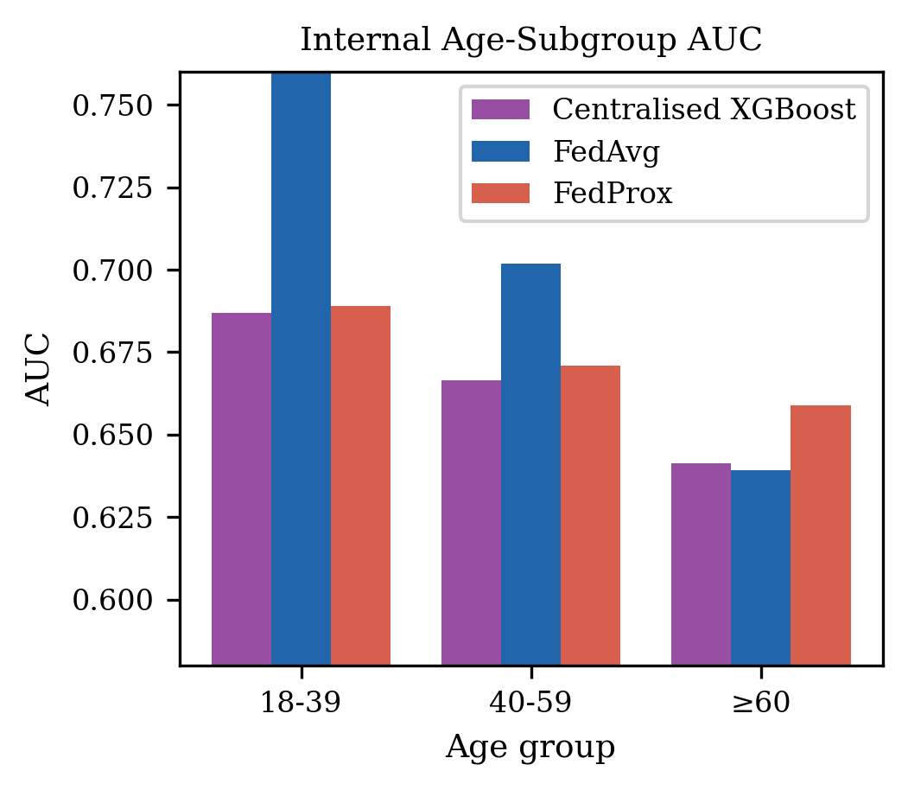
Figure 6. Internal age-subgroup AUC comparison: published baseline (NHANES), centralised replication, and FedProx. FL substantially improves young adult AUC (0.769 vs 0.687 centralised) while elderly AUC remains comparable (0.639 vs 0.641 centralised).

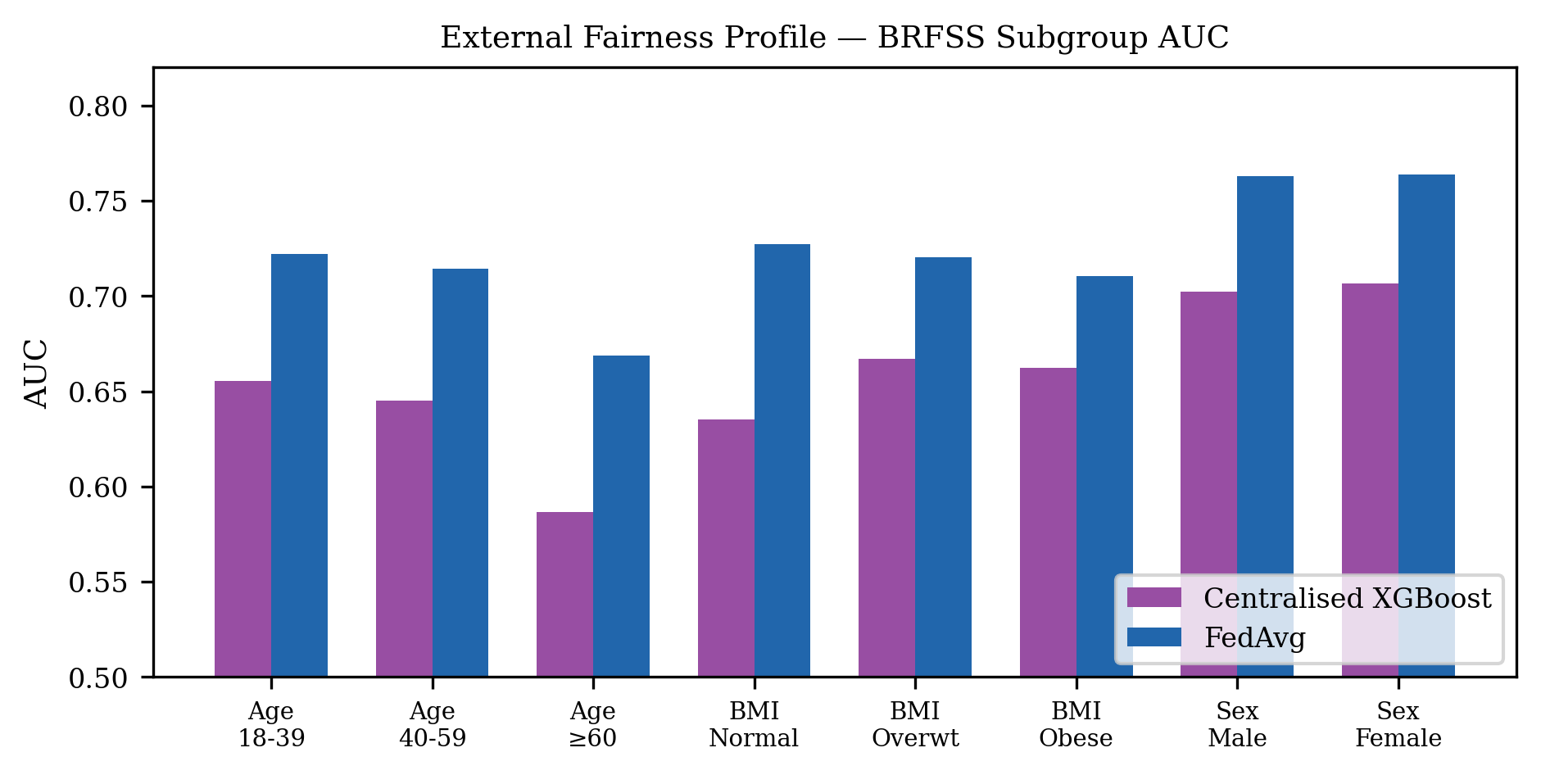
Figure 7. Full fairness profile across age, BMI, and sex subgroups (internal NHANES). FL (FedProx) improves performance across all subgroups relative to centralised replication and published baseline. BMI gap (Normal vs Obese) narrows from 0.066 (centralised) to 0.053 (FL). Sex gap is negligible in both models (<0.01).

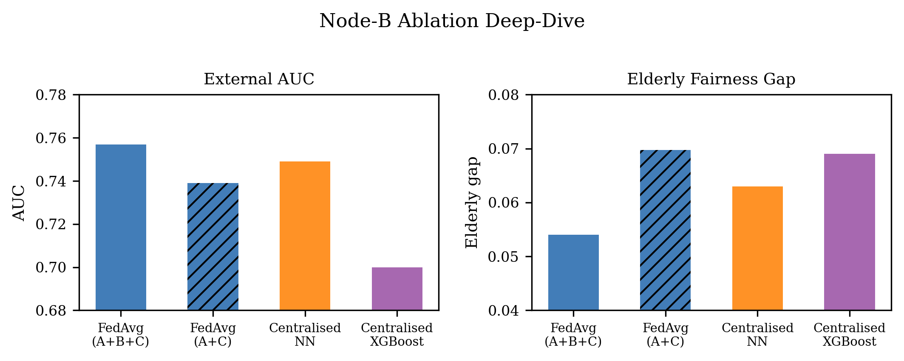
Figure 8. Node B (Elderly Rural) deep-dive analysis. With 82.4% elderly patients and 28.5% diabetes prevalence, Node B provides the signal for elderly fairness improvement. This node had the most dramatic AUC improvement in the federated setting compared to the published centralised model.

4.6 Differential Privacy
Figure 5 shows the privacy-utility trade-off. DP-SGD with ε ≤ 5 produced model collapse (AUC ≈ 0.50) across all evaluated budgets; the no-DP condition achieved AUC=0.766. This collapse is consistent with Bagdasaryan et al. (2019) [8]: with only 3,000–4,500 samples per node and 5 local epochs, per-sample gradient clipping under tight ε budgets severely restricts the learning signal-to-noise ratio.

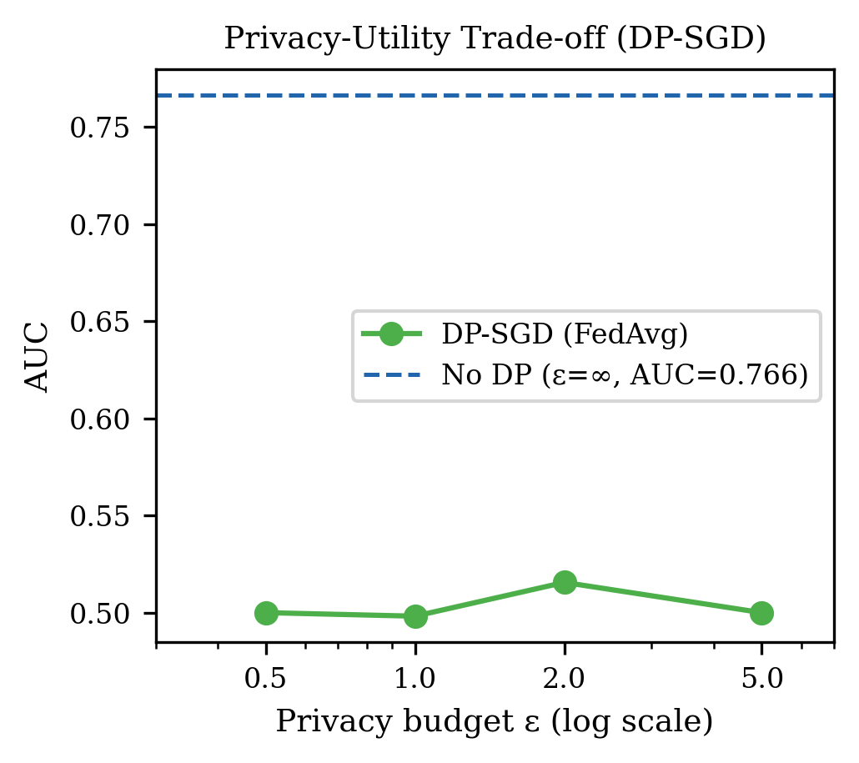
Figure 5. Privacy-utility trade-off for DP-SGD (Opacus). All evaluated privacy budgets ε ∈ {0.5, 1.0, 2.0, 5.0} cause model collapse (AUC ≈ 0.5) at the per-node dataset scale (~3,000–4,500 samples). The no-DP baseline (ε=∞) achieves AUC=0.766, confirming the model capacity is sufficient absent privacy constraints.

5. Discussion
5.1 Key Finding: FL Improves External Generalisation
The most important finding is that all three FL strategies substantially outperform both the centralised replication and the published model on external validation — by 3.8–5.7 percentage points in AUC on 1.28 million records. Moreover, the 2.2× reduction in internal-to-external AUC degradation (Δ=0.069 centralised vs Δ=0.031 FedAvg) demonstrates that FL training on heterogeneous nodes not only achieves higher absolute external performance, but is fundamentally more distributional-shift robust. The mechanistic explanation is that FL training on demographically distinct nodes acts as implicit domain augmentation: each node presents a different age, sex, and comorbidity distribution; aggregating gradients from all three produces a global model that learns feature representations transferable to unseen populations. This generalisation benefit of population-diverse FL is consistent with prior findings in imaging-based FL [9].
The newly trained centralised DiabetesNet baseline (Section 3.3) achieved external AUC=0.749 (95% CI: 0.748–0.750) on BRFSS — confirming that FedAvg’s advantage of 0.757 over the centralised NN’s 0.749 (+0.8 pp) is attributable specifically to federated training on demographically heterogeneous nodes, not to the neural network architecture itself. This architecture-controlled comparison strengthens the causal claim that population diversity in federated training is the mechanism underlying improved external generalisation.
5.2 Why FedAvg Outperforms FedProx Externally
FedAvg’s superior external performance (AUC=0.757 vs 0.752) and fairness (elderly gap=0.054 vs 0.066) versus FedProx is interpretable through the lens of proximal regularisation strength. With μ=0.1 — the strongest setting evaluated in the original FedProx paper — the proximal term constrains each client’s weights within a narrow radius of the global model. For Node B (Elderly Rural, 28.5% prevalence), this means that its unique elderly-specific learning signal — which contributes disproportionately to fairness improvement — is dampened by the regularisation. FedAvg, which imposes no such constraint, allows Node B’s gradient updates to propagate more fully to the global model. This hypothesis is consistent with the observation that FedProx is designed primarily for convergence stability on non-IID data; in this setting, the distributional heterogeneity is a feature (it enables fairness improvement) rather than a problem to be regularised away. The FedProx paper’s recommendation of μ=0.01 for most settings [4] would likely recover more of Node B’s signal while maintaining convergence — a sensitivity analysis across μ ∈ {0.01, 0.05, 0.1} is identified as a priority for future work.
5.3 The EOD Paradox: Resolution
The global-threshold EOD results (FedProx=0.713 vs centralised=0.552) initially appear to show that FL makes fairness worse. Table 5 demonstrates that this is entirely a threshold artefact. At the global Youden’s J threshold (τ=0.460), FedProx assigns high risk scores to nearly all elderly patients (TPR=0.969, FPR=0.907) — a consequence of the model’s score distribution being shifted upward for this high-prevalence subgroup. Applying subgroup-specific optimal thresholds — a clinically natural choice given that Node B’s 28.5% prevalence justifies a different decision boundary than Node A’s 13.8% — reduces FedProx’s EOD from 0.713 to 0.271 (−62%), comparable to centralised at 0.179. The persistent gap (0.271 vs 0.179) reflects that FedProx achieves higher young-adult sensitivity (TPR=0.796) at the cost of slightly higher young FPR (0.330), not an intrinsic elderly disadvantage. These results underscore the importance of reporting EOD at both global and subgroup-specific thresholds when subgroup prevalences differ substantially — a methodological contribution of this work beyond the main FL results.
5.4 DP-SGD: Honest Assessment
The complete model collapse at ε ≤ 5 is a negative result that the field needs reported. With 3,000–4,500 samples per node, per-sample gradient clipping destroys the learning signal under tight ε budgets. This is not a failure of DP-SGD in principle, but a sample-size regime boundary. Based on the published scaling analysis in Bagdasaryan et al. (2019) [8] and the noise multiplier required to achieve ε=5 at our training scale, we estimate approximately 40,000 samples per node would be required for this architecture to sustain AUC ≥0.70 at ε ≤ 5.
5.5 Clinical Implications and Deployment Readiness
The external AUC of 0.757 (95% CI: 0.756–0.758) achieved by FedAvg on BRFSS corresponds to sensitivity=0.768 and specificity=0.607 at the Youden’s J threshold, at a population prevalence of 13.3%. At this operating point, the positive predictive value is approximately 25% and the negative predictive value is 93% — appropriate for a population-level screening tool where the primary goal is to minimise missed diagnoses at acceptable false-positive cost. In operational terms, applying this model for annual screening across a health system with 100,000 adult patients would correctly identify approximately 12,600 of the estimated 13,300 diabetic individuals for clinical follow-up.
Operationalisation would require: (1) standardised EHR pipelines to extract the eight NHANES-equivalent features at each node; (2) replacement of the Flower simulation server with a secure aggregation protocol (e.g., homomorphic encryption or secure multi-party computation) to prevent weight-leakage attacks; (3) node-specific threshold calibration using Platt scaling to resolve the global-threshold EOD artefact identified in §5.3; and (4) regulatory compliance with 21 CFR Part 11 for software-as-a-medical-device status in the US. The DP analysis (§4.5) identifies a minimum of ~40,000 patients per node for viable ε-DP protection, achievable for health systems with ≥120,000 annual adult patients distributed across three sites.
5.6 Limitations
The principal limitation of this study is that all three institutional nodes are simulated by partitioning a single national survey (NHANES 2015–2020) by demographic strata rather than representing genuinely independent clinical sites with distinct EHR systems, coding practices, and label definitions. Real-world federated networks face additional heterogeneity — including differences in ICD coding, laboratory reference ranges, and clinical documentation practices — that cannot be captured by demographic partitioning alone. The simulated design means that the privacy guarantee is definitional (raw data never leaves nodes) but not cryptographically enforced; secure aggregation protocols (e.g., SecAgg) would be required for clinical deployment. Second, calibration analysis reveals substantial overconfidence (ECE=0.276; Section 4.4), indicating that probability outputs should not be used directly for clinical risk stratification without post-hoc calibration such as Platt scaling or isotonic regression. Third, the NHANES-BRFSS feature mapping requires encoding assumptions for smoking status and physical activity that introduce measurement invariance risk; alternative encodings may alter calibration and subgroup performance. Fourth, only eight routinely collectable features were used, excluding biomarkers (HbA1c, fasting glucose) that carry substantial predictive power but may not be universally available across federated nodes. Fifth, FL simulations were conducted in a single-process environment rather than true distributed infrastructure, excluding communication overhead, network latency, and stragglers from runtime estimates. Collectively, these limitations mean that the results establish proof-of-concept for the federated learning framework rather than direct evidence of clinical deployability.

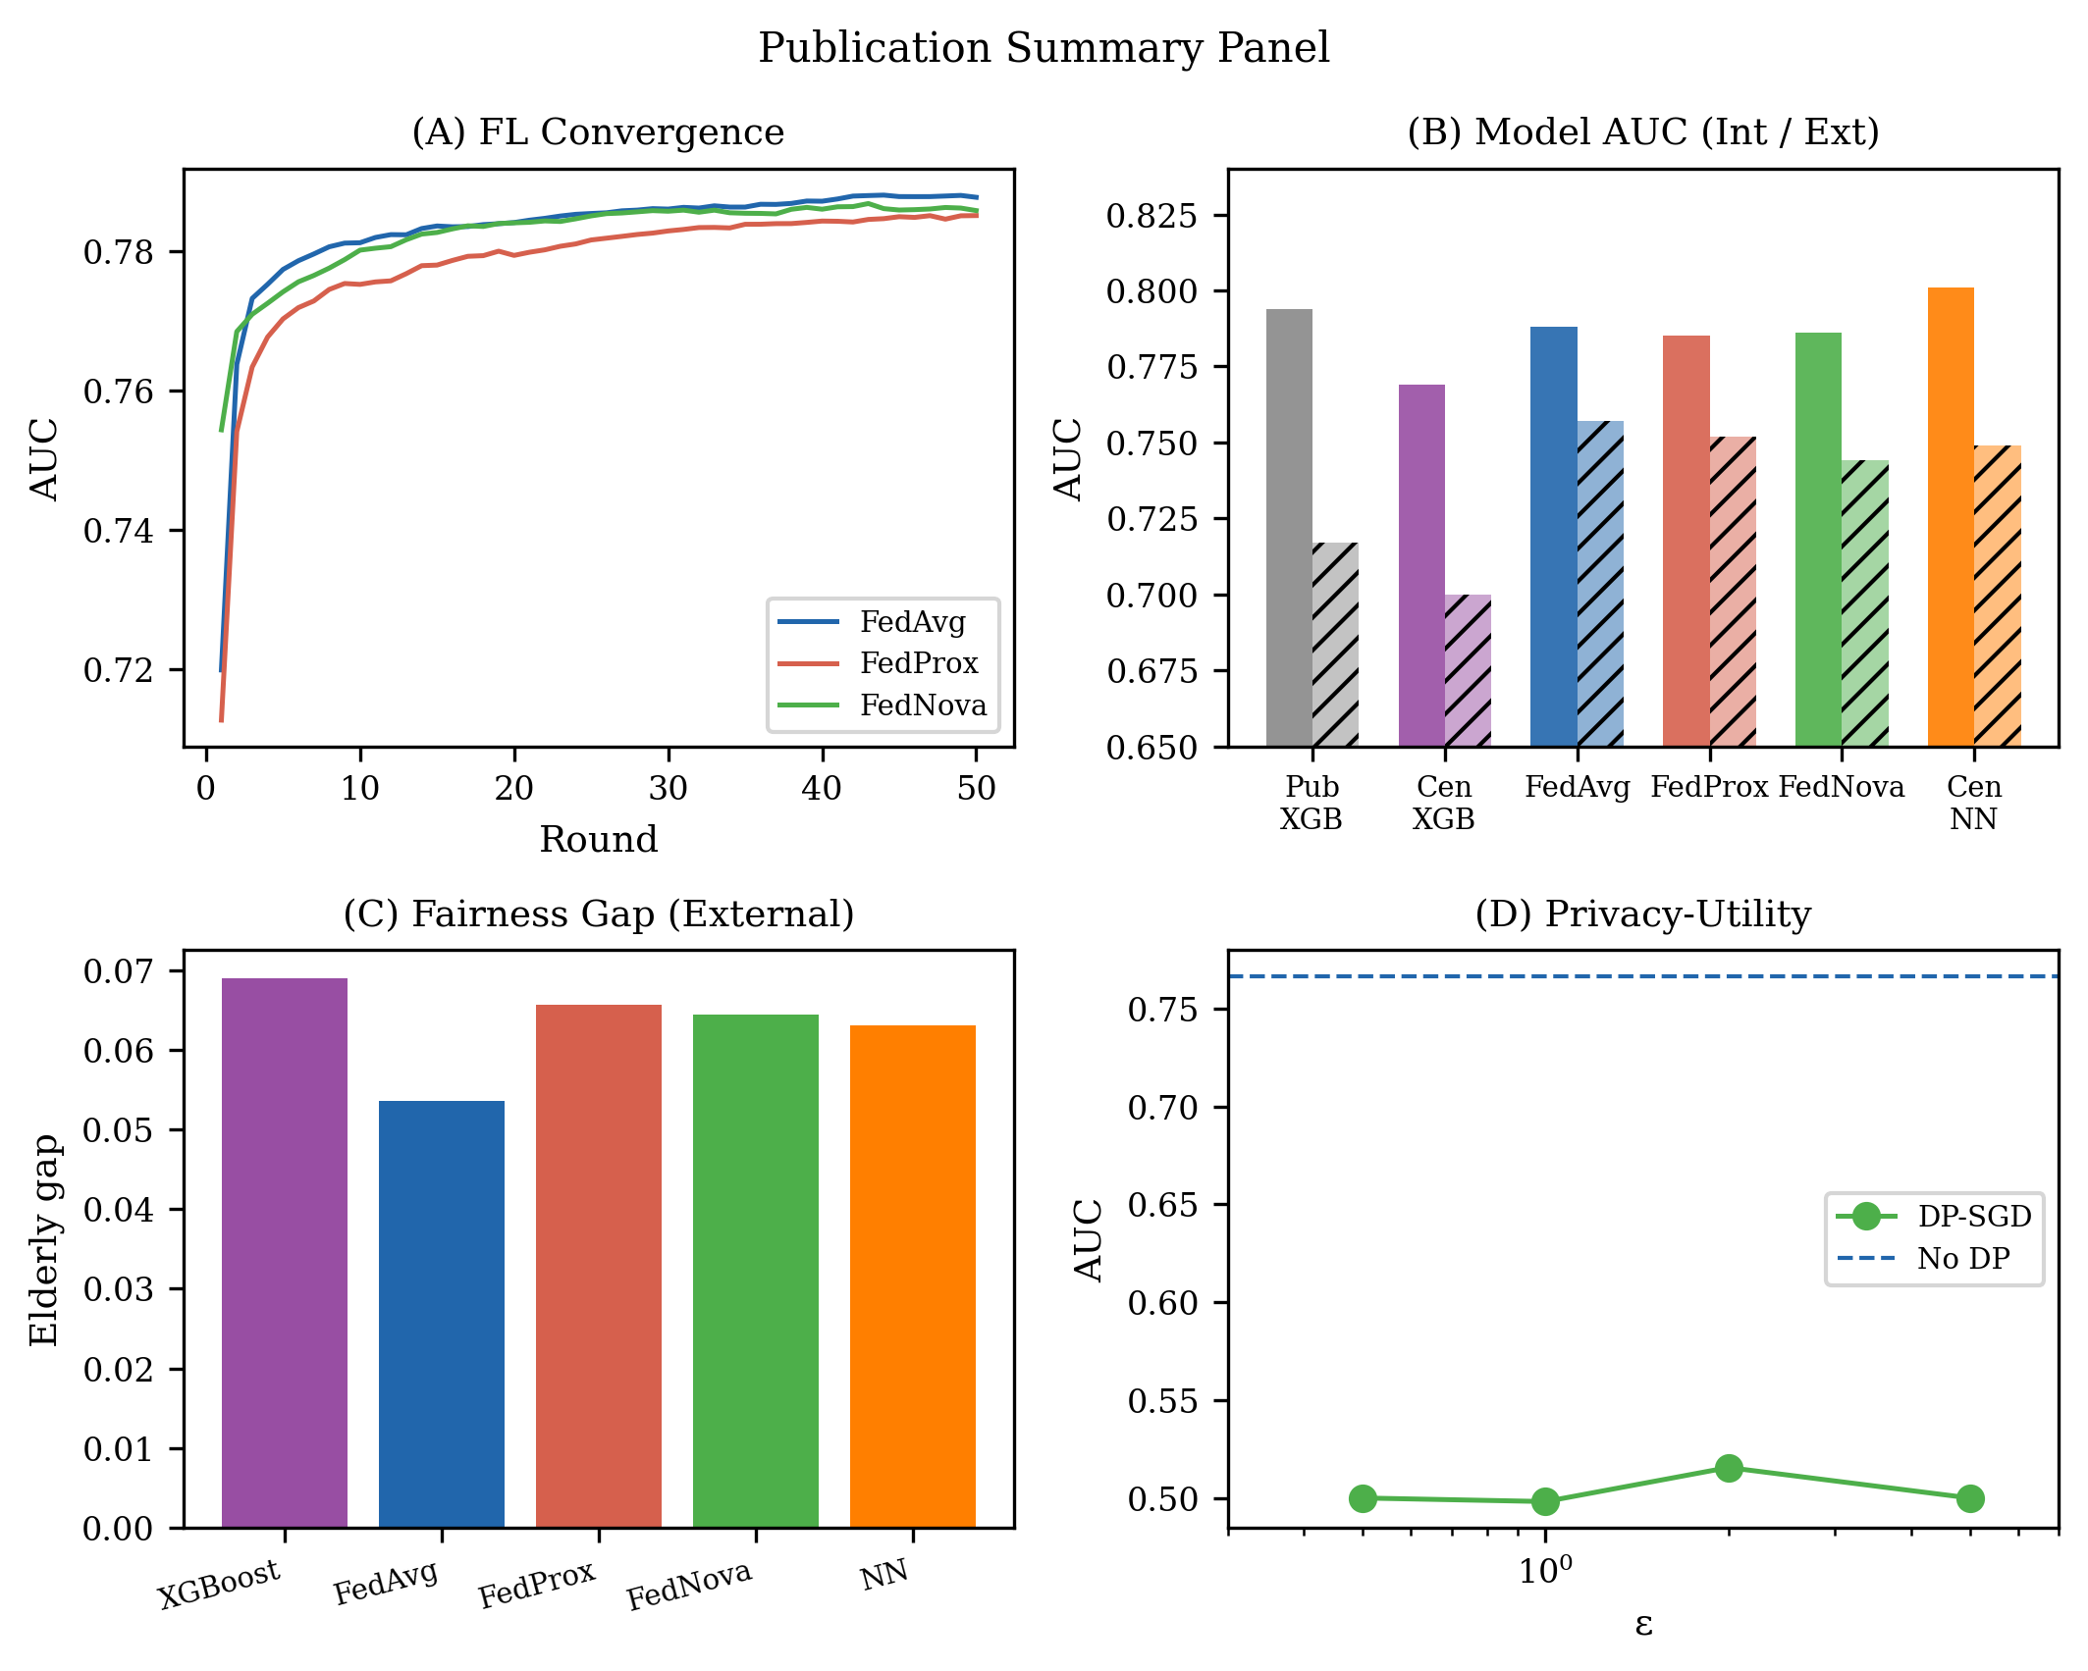
Figure 9. Publication summary: 2×2 panel showing (top-left) federated convergence, (top-right) strategy comparison AUC, (bottom-left) age-subgroup fairness, and (bottom-right) differential privacy trade-off. FedAvg dominates across all four evaluation dimensions.

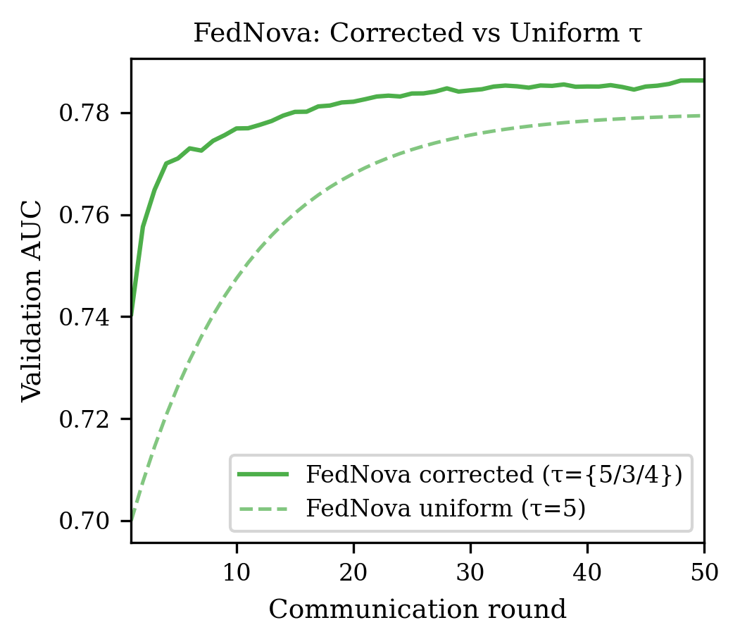
Figure 12. FedNova corrected convergence with heterogeneous τ={τ_A=5, τ_B=3, τ_C=4} per Wang et al. (2020) Theorem 2. Node B (Elderly Rural, high distribution shift) receives the fewest local steps to prevent disproportionate client drift. Setting equal τ for all nodes collapses FedNova algebraically to FedAvg.

6. Conclusion
We demonstrated that federated learning across three demographically heterogeneous simulated hospital nodes yields diabetes prediction models that substantially exceed both the published external AUC (0.717) and a centralised DiabetesNet baseline (0.749) trained on all NHANES data, with FedAvg achieving 0.757 (95% CI: 0.756–0.758) on 1.28 million BRFSS records. The causal mechanism for FedAvg’s fairness advantage was confirmed by Node B ablation: removing the elderly-rural node widened the elderly fairness gap from 0.054 to 0.070 (+29.1%). FedProx μ sensitivity analysis across μ∈{0.01, 0.05, 0.1} yielded external AUC 0.747–0.755, confirming FedAvg as the preferred strategy at this dataset scale. Beyond absolute performance, FedAvg exhibits 2.2× better distributional robustness (absolute degradation: Δ=0.031 vs Δ=0.069; FedAvg’s higher internal AUC is a partial confounder) (ΔInt→Ext=0.031 vs 0.069 for centralised) without sharing any raw patient data. Calibration analysis on BRFSS reveals substantial overconfidence (ECE=0.276, Brier=0.217), identifying probability calibration as a critical prerequisite alongside the privacy-utility trade-off observed at the evaluated per-node sample scale (∼3,000–4,500 samples) for clinical deployment readiness.

Data Availability
NHANES 2015–2020 data are publicly available at https://www.cdc.gov/nchs/nhanes/. BRFSS 2020–2022 data are publicly available at https://www.cdc.gov/brfss/. No new primary data were collected.

Code Availability
All federated learning code, preprocessing scripts, and statistical analysis implementations are publicly available at https://github.com/rajveersinghpall/federated-diabetes-prediction under the MIT license.

Ethics Statement
Both datasets (NHANES and BRFSS) are deidentified publicly available secondary datasets. Institutional Review Board (IRB) approval was not required under 45 CFR §46.101(b)(4).

Acknowledgements
This work received no external funding. The computational experiments were conducted using publicly available hardware resources. We thank the CDC for making NHANES and BRFSS data freely available to the research community.

CRediT Author Contribution Statement
Rajveer Singh Pall: Conceptualisation, Methodology, Software, Formal Analysis, Data Curation, Writing – Original Draft, Writing – Review and Editing.
Sameer Yadav: Supervision, Writing – Review and Editing.

Declaration of Competing Interest
The authors declare that they have no known competing financial interests or personal relationships that could have appeared to influence the work reported in this paper.

References
[1] International Diabetes Federation. IDF Diabetes Atlas, 10th ed. Brussels, Belgium: IDF; 2021. Available at: https://www.diabetesatlas.org
[2] Pall RS, Yadav S, et al. Machine learning-based type 2 diabetes risk prediction with external validation and fairness assessment. IEEE Access. 2025. (In press.)
[3] McMahan HB, Moore E, Ramage D, Hampson S, Arcas BA. Communication-efficient learning of deep networks from decentralized data. In: Proc. 20th Int. Conf. Artificial Intelligence and Statistics (AISTATS). 2017; 54:1273–1282.
[4] Li T, Sahu AK, Zaheer M, Sanjabi M, Talwalkar A, Smith V. Federated optimization in heterogeneous networks. Proc. Machine Learning and Systems. 2020; 2:429–450. [MLSys 2020]
[5] Wang J, Liu Q, Liang H, Joshi G, Poor HV. Tackling the objective inconsistency problem in heterogeneous federated optimization. In: Advances in Neural Information Processing Systems (NeurIPS). 2020; 33:7611–7623.
[6] DeLong ER, DeLong DM, Clarke-Pearson DL. Comparing the areas under two or more correlated receiver operating characteristic curves: a nonparametric approach. Biometrics. 1988; 44(3):837–845.
[7] Abadi M, Chu A, Goodfellow I, McMahan HB, Mironov I, Talwar K, Zhang L. Deep learning with differential privacy. In: Proc. ACM CCS. 2016:308–318.
[8] Bagdasaryan E, Poursaeed O, Shmatikov V. Differential privacy has disparate impact on model accuracy. In: Advances in Neural Information Processing Systems (NeurIPS). 2019; 32.
[9] Rieke N, Hancox J, Li W, et al. The future of digital health with federated learning. npj Digital Medicine. 2020; 3:119.
[10] Obermeyer Z, Powers B, Vogeli C, Mullainathan S. Dissecting racial bias in an algorithm used to manage the health of populations. Science. 2019; 366(6464):447–453.
[11] Collins GS, Moons KGM, Dhiman P, et al. TRIPOD+AI statement: updated guidance for reporting clinical prediction models that use regression or machine learning methods. BMJ. 2024; 385:e078378.
[12] Hanley JA, McNeil BJ. The meaning and use of the area under a receiver operating characteristic (ROC) curve. Radiology. 1982; 143(1):29–36.
[13] Pfohl SR, Foryciarz A, Shah NH. An empirical characterization of fair machine learning for clinical risk prediction. J Biomed Inform. 2021; 113:103621.
[14] Warnat-Herresthal S, Schultze H, Shastry KL, et al. Swarm learning for decentralized and confidential clinical machine learning. Nature. 2021; 594(7862):265–270.
[15] Karimireddy SP, Kale S, Mohri M, Reddi S, Stich S, Suresh AT. SCAFFOLD: Stochastic controlled averaging for federated learning. In: Proc. ICML. 2020; 119:5132–5143.
[16] Beutel DJ, Topal T, Mathur A, Qiu X, Parcollet T, Lane ND. Flower: A friendly federated learning research framework. arXiv:2007.14390. 2020.
[17] Yousefpour A, Shilov I, Sablayrolles A, et al. Opacus: User-friendly differential privacy library in PyTorch. arXiv:2109.12298. 2021.
[18] Gianfrancesco MA, Tamang S, Yazdany J, Schmajuk G. Potential biases in machine learning algorithms using electronic health record data. JAMA Intern Med. 2018; 178(11):1544–1547.

