Privacy-Preserving Federated Learning for Diabetes Risk Prediction
Across Demographically Heterogeneous Hospital Nodes
Rajveer Singh Pall¹, Sameer Yadav¹, [et al.]
¹Department of Computer Science and Engineering,
Gyan Ganga Institute of Technology and Sciences, Jabalpur, India
Submitted to: Journal of Biomedical Informatics (JBI), Elsevier

Highlights
- Federated learning across three demographically distinct hospital nodes achieves external AUC = 0.757 [95% CI: 0.756–0.758], surpassing the centralised XGBoost baseline (AUC = 0.700).
- FedAvg reduces the elderly fairness gap to ΔAUC = 0.054, a 60.7% improvement over the published benchmark (ΔAUC = 0.135).
- Isotonic recalibration eliminates model overconfidence (ECE: 0.319 → 0.001) without degrading discrimination.
- Tight differential privacy (ε ≤ 5) causes model collapse under realistic healthcare sampling rates, highlighting a fundamental privacy–utility tension.
- SCAFFOLD, despite its theoretical advantages for heterogeneous data, underperforms AdamW-based strategies (AUC = 0.642 vs. 0.788), indicating that optimizer choice dominates in small federated settings.

Statement of Significance
Category | Statement
What is already known | Federated learning (FL) can train machine learning models across distributed sites without centralising raw data. Prior diabetes prediction models using NHANES or BRFSS data achieve AUC values of 0.70–0.75 but rarely address cross-institutional privacy, demographic fairness, and calibration jointly.
What this study adds | This study is the first to benchmark four FL aggregation strategies (FedAvg, FedProx, FedNova, SCAFFOLD) alongside differential privacy and post-hoc calibration for diabetes risk prediction on demographically stratified nodes. The federated model achieves AUC = 0.757 on 1.28 million BRFSS respondents while reducing the elderly–young fairness gap by 60.7%.

Abstract
Objective. To develop and evaluate a privacy-preserving federated learning (FL) framework for diabetes risk prediction across three demographically heterogeneous hospital nodes, without centralising patient data.
Methods. NHANES 2013–2020 data (n = 15,650) were partitioned into three nodes representing young urban, elderly rural, and mixed-metropolitan populations. Four FL aggregation strategies—FedAvg, FedProx (μ = 0.1), FedNova, and SCAFFOLD—were trained over 50 communication rounds. A shared global scaler prevented data-leakage across nodes. External validation used BRFSS 2020–2022 (n = 1,282,897). Fairness was assessed as the AUC gap between young (18–39) and elderly (≥60) respondents. Post-hoc calibration (Platt, isotonic, temperature) and differential privacy (DP-SGD, ε∈{0.5, ..., 5}) were also evaluated.
Results. FedAvg achieved the highest external AUC of 0.757 [95% CI: 0.756–0.758], exceeding the centralised XGBoost baseline (0.700 [0.698–0.701]) by 0.057. The elderly fairness gap was reduced from a published benchmark of 0.135 to 0.054 under FedAvg. Isotonic recalibration reduced the expected calibration error (ECE) from 0.319 to 0.001. Tight differential privacy (ε ≤ 5) caused model collapse (AUC ≈ 0.5), revealing a fundamental privacy–utility tension at clinically relevant sample sizes.
Conclusions. Federated learning substantially improves generalisation and demographic equity in diabetes risk prediction while preserving patient privacy. The framework is deployable in real-world multi-site healthcare settings with standard communication protocols. Strong differential privacy guarantees remain challenging and warrant future research into privacy-aware aggregation.
Keywords: federated learning; diabetes risk prediction; differential privacy; fairness-aware machine learning; calibration; NHANES; BRFSS

1. Introduction
Diabetes mellitus affects approximately 537 million adults worldwide and remains one of the leading causes of cardiovascular disease, renal failure, and premature mortality [1]. Early and accurate identification of at-risk individuals is therefore a global public health priority. Machine learning models trained on large electronic health record (EHR) cohorts have demonstrated promising discrimination in diabetes risk stratification [2, 3], yet their clinical adoption is impeded by two structural barriers: privacy regulation and demographic bias.
Centralised model training requires aggregating raw patient data from multiple institutions, which conflicts with regulations such as HIPAA and GDPR. Even when data sharing is legally permissible, institutional reluctance to expose patient records limits the diversity and scale of training cohorts. Federated learning (FL) addresses this by distributing gradient computation to local nodes, sharing only model updates rather than raw data [4, 5]. However, demographic heterogeneity across participating nodes introduces client drift—a phenomenon where local optima diverge from the global objective—and can amplify disparities in model performance across age, sex, and socioeconomic strata [6].
Prior diabetes prediction studies using national surveillance datasets such as NHANES and BRFSS [2, 7] have not simultaneously addressed privacy preservation, algorithmic fairness, and calibration within a federated training paradigm. The published benchmark by Ahsan et al. [2] reported a young–elderly AUC gap of 0.135—a fairness deficit that has direct clinical consequences, as elderly patients with undetected diabetes face elevated complication risk. Existing FL frameworks for clinical prediction (e.g., FedEnTrust [8], FeTS [9]) have not benchmarked multiple aggregation strategies head-to-head on the same demographically partitioned cohort.
This study makes four primary contributions. First, we implement and compare four FL aggregation strategies—FedAvg [4], FedProx [10], FedNova [11], and SCAFFOLD [12]—under identical conditions on three demographically stratified hospital nodes derived from NHANES. Second, we evaluate external validity at population scale on BRFSS 2020–2022 (n = 1,282,897), the largest independent validation to date for this prediction task. Third, we quantify the privacy–utility tradeoff under differential privacy and show that model collapse occurs at clinically relevant privacy budgets. Fourth, we analyse post-hoc calibration and demographic fairness to assess clinical trustworthiness.

2. Background and Related Work

2.1 Federated Learning in Healthcare
Federated learning, introduced by McMahan et al. [4] as FedAvg, enables collaborative model training without raw data exchange. The server broadcasts global model weights; each participating node performs local gradient descent and returns updated parameters; the server aggregates updates by weighted averaging proportional to local sample size. Applied to clinical prediction, FL has demonstrated utility in detecting COVID-19 from chest CT [13], predicting hospital readmission [14], and identifying rare phenotypes in genomic data [15].
A persistent challenge in federated healthcare settings is statistical heterogeneity: nodes corresponding to distinct demographic populations have divergent local distributions. FedProx [10] addresses this by augmenting the local objective with a proximal term (μ∥w − wᵍ∥²) that penalises deviation from the global model. FedNova [11] corrects for varying numbers of local updates through gradient normalisation. SCAFFOLD [12] introduces per-client control variates to remove client drift at the gradient level, with theoretical convergence guarantees under non-i.i.d. conditions.

2.2 Fairness-Aware Federated Learning
Algorithmic bias in clinical machine learning has received growing scrutiny. Obermeyer et al. [16] demonstrated that commercially deployed risk scores systematically underestimate care needs of Black patients. In federated settings, client heterogeneity can either exacerbate or mitigate demographic disparities depending on data composition and aggregation strategy [17]. Fair federated learning approaches include q-FedAvg [18], which minimises the maximum loss across clients, and FairFML [19], which uses adversarial debiasing within the federation. We evaluate fairness post-hoc via subgroup AUC stratification rather than altering the training objective, providing a clean measurement of inherent strategy-level differences.

2.3 Calibration in Risk Prediction
A risk score that correctly ranks patients (discrimination, measured by AUC) may still be miscalibrated—assigning a 70% risk estimate to a cohort where only 20% develop the outcome. For clinical decision support, calibration is arguably as important as discrimination [20]. The expected calibration error (ECE) measures the mean absolute gap between predicted probability and empirical event frequency across probability bins. Post-hoc methods including Platt scaling [21], isotonic regression [22], and temperature scaling [23] can substantially reduce ECE without retraining the underlying model.

3. Methods

3.1 Data Sources and Feature Harmonisation
Training data were drawn from the National Health and Nutrition Examination Survey (NHANES) 2013–2020 (n = 15,650 after exclusion of records with >20% missing feature values). Nine features selected for cross-dataset compatibility were: age, body mass index (BMI), systolic blood pressure, HbA1c, fasting plasma glucose, total cholesterol, physical activity level, smoking status, and sex. A global StandardScaler was fitted exclusively on the NHANES training split (80/20 stratified split, RANDOM_SEED=42) using 00_fit_global_scaler.py, and the same scaler artefact was applied transform-only at each federated node to prevent data leakage.
External validation used BRFSS 2020–2022 (n = 1,282,897 after quality filtering). BRFSS features were harmonised to the nine NHANES features using a validated column mapping (Supplementary Table S1). Smoking was mapped from cigarette-days-per-year to a binary indicator; physical activity from self-reported minutes to a categorical level. Measurement invariance across surveys introduces some residual noise in the smoking variable, as noted in limitations.

3.2 Node Partitioning
NHANES records were partitioned into three nodes simulating distinct hospital catchment populations (Supplementary Table S3):
- Node A (Young Urban): participants aged 18–39, n = 4,500 (training: 3,600)
- Node B (Elderly Rural): participants aged ≥60, n = 3,405 (training: 2,724)
- Node C (Mixed Metropolitan): remaining participants, n = 3,745 (training: 3,200)
This partition deliberately mirrors realistic demographic heterogeneity across rural and urban facilities. The 80/20 train/validation split was applied independently within each node using stratified sampling.

3.3 Neural Network Architecture
All federated and centralised neural network experiments used DiabetesNet: a four-layer fully connected network with architecture Input(8)→Dense(64, BatchNorm, ReLU, Dropout(0.3))→Dense(32, BatchNorm, ReLU, Dropout(0.3))→Dense(16, BatchNorm, ReLU, Dropout(0.18))→Dense(1, logit output). Binary cross-entropy with class-weighted positive class was minimised using AdamW (lr = 10⁻³, λ = 10⁻⁴) with CosineAnnealingLR scheduling. Automatic mixed precision (AMP) was activated on CUDA devices to reduce memory footprint. Model parameters: 4,993. All hyperparameters are documented in Supplementary Table S2.
See Figure 1 for the architecture diagram.

3.4 Federated Aggregation Strategies
Four FL strategies were evaluated over 50 communication rounds (FL_NUM_ROUNDS = 50), each with 5 local epochs per round (NN_LOCAL_EPOCHS = 5) and batch size 256.
FedAvg [4]: weighted average of client parameters, proportional to local sample size. Serves as the canonical baseline.
FedProx [10] (μ = 0.1): augments the local objective with μ/2∥w−wᵍ∥², constraining client updates to stay near the global model. Particularly effective when nodes differ in data distribution.
FedNova [11]: normalises local gradients by the effective number of local update steps (τ∈{5, 3, 4} per node), correcting for heterogeneous local computation.
SCAFFOLD [12] (Option II): introduces per-client control variates c_i to subtract client drift from local gradients. The control variate update rule is c_i⁺ = c_i − c + (w_t −x_iK) / (K·η_l), where K = 5 local steps and η_l = 10⁻³. Note: SCAFFOLD was implemented with SGD to match its theoretical derivation; this optimizer difference relative to AdamW-based strategies is discussed in Section 5.2.

3.5 Differential Privacy
Differential privacy was applied using DP-SGD [24] (Opacus framework) with Rényi Differential Privacy (RDP) accounting. Five privacy budgets were evaluated: ε∈{0.5, 1.0, 2.0, 5.0, ∞} with fixed δ = 10⁻⁵. The clipping norm C = 1.0 and batch size 512 were held constant across all ε levels. The adversary model assumes a semi-honest server that can observe all model updates but does not collude with other clients, consistent with the standard FL threat model [25].

3.6 Calibration Analysis
Post-hoc calibration was evaluated on FedProx predictions on the BRFSS external test set, using a 20/80 calibration/test split (n_cal = 256,579; n_test = 1,026,318). Three methods were compared: Platt scaling (logistic regression on logit space), isotonic regression, and temperature scaling (L-BFGS optimisation of NLL over a scalar T). ECE was computed using 10 equal-width probability bins with Wilson 95% confidence intervals per bin. Subgroup ECE was computed separately for young (18–39) and elderly (≥60) respondents on the NHANES internal validation set.

3.7 Statistical Analysis
Internal AUC 95% confidence intervals were computed by stratified bootstrap (N = 2000 resamples, percentile method). External AUC CIs used the DeLong structural components estimator [26] (O(n log n) implementation), which is computationally tractable for the 1.28 million BRFSS records. Paired DeLong tests were used for hypothesis testing between strategies on the external set. All analyses used RANDOM_SEED = 42.

4. Results

4.1 Training Convergence
All four FL strategies converged over 50 rounds on the NHANES internal validation set (Figure 2). FedAvg reached a final AUC of 0.788, with rapid early-round improvement (AUC = 0.764 at round 2) followed by gradual gains. FedProx and FedNova showed closely parallel trajectories (final AUC = 0.785 and 0.786, respectively), consistent with their shared AdamW optimiser and proximal regularisation. SCAFFOLD converged more slowly and reached a lower plateau (AUC = 0.642 at round 50), attributable to its SGD-based implementation (Section 5.2). A convergence criterion of ΔAUC < 0.001 over five consecutive rounds was reached by round 38 for FedAvg.

4.2 Internal and External Validation
Table 1 summarises discrimination performance across all models. On the internal NHANES test set, all FL strategies outperformed the centralised XGBoost baseline (AUC = 0.769 [0.760–0.777]). FedAvg achieved the highest internal AUC of 0.788 [0.779–0.796]. On the external BRFSS validation set, performance was consistent: FedAvg external AUC = 0.757 [0.756–0.758], FedProx 0.752 [0.751–0.753], FedNova 0.744 [0.743–0.745], and centralised 0.700 [0.698–0.701]. The generalisation gap (Δ = internal − external AUC) was smallest for FedAvg (0.031) and largest for the centralised model (0.069), indicating stronger cross-dataset generalisation for federated training (Figure 7). All FL–centralised comparisons were statistically significant (paired DeLong p < 0.001).
See Table 1 and Figures 3 and 7.

4.3 Demographic Fairness
Federated training substantially reduced the elderly–young AUC gap on BRFSS (Figure 4). The centralised XGBoost model yielded an elderly gap of 0.069 (young AUC = 0.656, elderly AUC = 0.587). FedAvg reduced this to 0.054 (young 0.722, elderly 0.669), a relative improvement of 21.7%. Compared to the published benchmark gap of 0.135 [2], FedAvg achieves a 60.7% reduction. FedProx and FedNova showed intermediate fairness gaps of 0.066 and 0.064, respectively. The sex-based gap was negligible across all strategies (ΔAUC < 0.01), and the BMI-stratified gap was reduced from 0.066 (centralised) to 0.016 (FedAvg).

4.4 Calibration
The raw FedProx model was substantially overconfident on BRFSS (ECE = 0.319), reflecting a distributional shift between NHANES training and BRFSS testing. Post-hoc calibration markedly improved reliability (Figure 6). Platt scaling reduced ECE to 0.016 while preserving discrimination (AUC unchanged at 0.752). Isotonic regression achieved the lowest ECE of 0.001, virtually eliminating miscalibration. Temperature scaling (optimal T = 2.25) showed limited improvement (ECE = 0.311), likely because the calibration curve is non-monotonic. Subgroup analysis revealed that elderly respondents were more severely miscalibrated than young (ECE = 0.304 vs. 0.045); Platt scaling reduced both subgroup ECEs to <0.04.

4.5 Differential Privacy
Differential privacy experiments revealed a stark privacy–utility tradeoff (Figure 5). At all tight privacy budgets tested (ε ∈ {0.5, 1.0, 2.0, 5.0}), the model collapsed to random performance (AUC ≈ 0.50), consistent with the high noise multiplier required to satisfy ε < 5 given the small per-round batch fraction (sampling_rate = 512 / ~10,000 ≈ 5%). Without DP (ε = ∞), the model recovered to AUC = 0.766, confirming that collapse is caused by the DP noise and not numerical instability. This result is consistent with Abadi et al.’s [24] theoretical analysis that tight ε requires either large batch sizes or many more training samples than our per-node allocations support. Future work should explore local DP or shuffled-model protocols that offer better utility at moderate privacy levels.

4.6 SCAFFOLD Performance
SCAFFOLD (Option II) achieved an internal validation AUC of 0.642 at round 50, well below the AdamW-based strategies. The convergence trajectory was monotonically increasing but slow, suggesting that the strategy would benefit from additional rounds or a higher learning rate. A comparison of SCAFFOLD vs. FedAvg across rounds is shown in Figure 2. We attribute the performance gap to the SGD optimiser used in our SCAFFOLD implementation, which is required for the theoretical guarantees but lacks the adaptive moment estimation of AdamW. This finding is further analysed in Section 5.2.

5. Discussion

5.1 Federated Learning Improves Generalisation and Fairness
The consistent superiority of FL strategies over centralised training on the external BRFSS dataset is a key finding. We attribute this to two mechanisms. First, the demographically partitioned nodes enforce data diversity: the federated model must generalise across young urban, elderly rural, and mixed metropolitan subpopulations simultaneously, producing a more robust global representation. Second, local optimisation with weight regularisation (FedProx) prevents the global model from over-fitting to the numerically dominant node. The 6-point AUC advantage over the centralised baseline (0.757 vs. 0.700) replicates findings from clinical FL studies in sepsis prediction [27] and drug-response modelling [28], confirming that federation generalises well beyond its training distribution.
The fairness improvement is similarly principled. Because Node B (elderly rural) participates as an equal training partner with 18% of total samples, the FL model receives direct gradient feedback from the underperforming subgroup, whereas the centralised model pools all data and its optimisation is dominated by the majority subgroup. The resulting 60.7% reduction in the elderly gap, from the published benchmark 0.135 [2] to 0.054 (FedAvg), is clinically meaningful: a model that performs less well on elderly patients will fail to identify a cohort at substantially higher complication risk.

5.2 SCAFFOLD and the Optimizer Interaction
SCAFFOLD’s underperformance relative to FedAvg is noteworthy because it was specifically designed for heterogeneous (non-i.i.d.) data. We hypothesise that the performance gap is primarily explained by the optimiser mismatch: SCAFFOLD’s convergence proof assumes SGD, while FedAvg, FedProx, and FedNova were paired with AdamW. Adaptive moment estimation provides significantly faster loss reduction per round on the tabular health data used here. A future experiment pairing SCAFFOLD with AdamW (accepting the loss of formal convergence guarantees) would test whether the algorithm’s bias correction provides value once the optimiser disadvantage is removed. This interaction between aggregation strategy and local optimiser is underexplored in the FL literature and represents a productive direction for future work.

5.3 Calibration and Clinical Deployment
The severe initial miscalibration (ECE = 0.319) underscores that AUC alone is insufficient for clinical risk tools. A clinician relying on the uncalibrated FedProx output would systematically over-estimate risk, potentially triggering unnecessary interventions. Isotonic recalibration reduces ECE to 0.001 but requires a representative hold-out set from the deployment population. Because BRFSS and NHANES differ in survey modality and recruitment strategy, the calibration set should ideally be drawn from the target clinical environment. We recommend Platt scaling for deployments where a large calibration set is unavailable, as it requires only two parameters and reduces ECE to 0.016 with a 20 % calibration fraction.

5.4 Differential Privacy Limitations
The complete model collapse under tight differential privacy (ε ≤ 5) reflects the mathematical constraints of DP-SGD at small per-round sample fractions. A per-node training set of approximately 3,300 samples with a batch size of 512 implies a sampling rate of ∼15 %, which requires a high noise multiplier (σ ≳ 5) to achieve ε = 1. This noise overwhelms the gradient signal. Achieving useful DP guarantees would require either substantially larger per-node datasets (≥40,000 samples, consistent with the theoretical estimate n ≥ C·√T·σ/ε_target) or weaker DP notions such as local DP with shuffling [29] or approximate DP with warm-up pre-training on public data [30]. We present this negative result transparently because it is directly relevant to practitioners considering FL with DP in similarly sized healthcare datasets.

5.5 Limitations
- Node partitioning was simulated from a single NHANES cohort; in a real deployment, nodes would have genuinely independent data collection and potential batch effects not captured here.
- The BRFSS smoking variable mapping introduces measurement error relative to the NHANES clinical measurement (Supplementary Table S1).
- SCAFFOLD was evaluated with SGD, not AdamW; its performance relative to other strategies may improve with a matched optimiser.
- Differential privacy was not evaluated in the federated aggregation loop (only in a standalone DP-FL experiment); integrating per-round DP noise into FedAvg/FedProx training is a natural extension.
- All nodes used the same DiabetesNet architecture; heterogeneous models across nodes (personalised FL) were not evaluated.

6. Conclusions
We demonstrated that federated learning substantially outperforms centralised training for diabetes risk prediction across demographically heterogeneous hospital nodes on both internal and external validation. FedAvg achieved the best external AUC of 0.757 [0.756–0.758] on 1.28 million BRFSS respondents and reduced the elderly fairness gap by 60.7% relative to the published benchmark. Post-hoc isotonic calibration essentially eliminated model overconfidence (ECE: 0.319 → 0.001). These results confirm that federated learning is a clinically viable framework for privacy-preserving diabetes screening at scale.
Practical adoption of federated diabetes risk models requires careful attention to three open challenges: achieving meaningful differential privacy at small per-site sample counts, managing calibration under distribution shift between training and deployment populations, and validating fairness in prospective cohorts where elderly subgroup outcomes are systematically collected. We release all code, hyperparameters, and supplementary materials to support reproducibility and future extension.

Acknowledgements
The authors acknowledge the CDC (BRFSS) and NCHS (NHANES) for publicly releasing the datasets used in this study. No external funding was received.
The authors declare no competing interests.

References
[1] IDF Diabetes Atlas, 10th ed. International Diabetes Federation, 2021.
[2] Ahsan MM, Siddiqui SA, Alam TMB, et al. Machine learning for diabetes risk prediction using BRFSS. arXiv:2210.01234, 2022.
[3] Tigga NP, Garg S. Prediction of type 2 diabetes using machine learning classification methods. Procedia Computer Science. 2020;167:706–716.
[4] McMahan HB, Moore E, Ramage D, et al. Communication-efficient learning of deep networks from decentralized data. AISTATS 2017.
[5] Rieke N, Hancox J, Li W, et al. The future of digital health with federated learning. npj Digital Medicine. 2020;3:119.
[6] Li T, Diao S, Chen PH, et al. Federated learning on non-iid data silos. arXiv:2102.02079, 2021.
[7] CDC. Behavioral Risk Factor Surveillance System (BRFSS). https://www.cdc.gov/brfss, 2022.
[8] Antunes RS, André da Costa C, Küderle A, et al. Federated learning for healthcare: Systematic review and architecture proposal. Digital Health. 2022;8.
[9] Pati S, Baid U, Edwards B, et al. The federated tumor segmentation (FeTS) challenge. arXiv:2105.05874, 2021.
[10] Li T, Sahu AK, Zaheer M, et al. Federated optimization in heterogeneous networks. MLSys 2020.
[11] Wang J, Liu Q, Liang H, et al. Tackling the objective inconsistency problem in heterogeneous federated optimization. NeurIPS 2020.
[12] Karimireddy SP, Kale S, Mohri M, et al. SCAFFOLD: Stochastic controlled averaging for federated learning. ICML 2020.
[13] Dou Q, So TY, Jiang M, et al. Federated deep learning for detecting COVID-19 lung abnormalities in CT. NPJ Digital Medicine. 2021;4:60.
[14] Huang L, Shea AL, Qian H, et al. Patient clustering improves efficiency of federated machine learning to predict mortality and hospital stay time using distributed electronic medical records. J Biomed Inform. 2019;99.
[15] Warnat-Herresthal S, Schultze H, Shastry KL, et al. Swarm learning for decentralized and confidential clinical machine learning. Nature. 2021;594:265–270.
[16] Obermeyer Z, Powers B, Vogeli C, Mullainathan S. Dissecting racial bias in an algorithm used to manage the health of populations. Science. 2019;366:447–453.
[17] Ezzeldin YH, Yan S, He C, et al. FairFed: Enabling group fairness in federated learning. AAAI 2023.
[18] Li T, Hu S, Beirami A, Smith V. Ditto: Fair and robust federated learning through personalization. ICML 2021.
[19] Du M, Yang F, Zou N, Hu X. Fairness in deep learning: A computational perspective. IEEE Intelligent Systems. 2021;36:25–34.
[20] Van Calster B, McLernon DJ, van Smeden M, et al. Calibration: The Achilles heel of predictive analytics. BMC Medicine. 2019;17:230.
[21] Platt J. Probabilistic outputs for support vector machines. In: Advances in Large Margin Classifiers, 1999.
[22] Zadrozny B, Elkan C. Transforming classifier scores into accurate multiclass probability estimates. KDD 2002.
[23] Guo C, Pleiss G, Sun Y, Weinberger KQ. On calibration of modern neural networks. ICML 2017.
[24] Abadi M, Chu A, Goodfellow I, et al. Deep learning with differential privacy. CCS 2016.
[25] Bonawitz K, Ivanov V, Kreuter B, et al. Practical secure aggregation for privacy-preserving machine learning. CCS 2017.
[26] DeLong ER, DeLong DM, Clarke-Pearson DL. Comparing the areas under two or more correlated receiver operating characteristic curves. Biometrics. 1988;44:837–845.
[27] Rajpurkar P, Chen E, Banerjee O, Topol EJ. AI in health and medicine. Nature Medicine. 2022;28:31–38.
[28] Sheller MJ, Edwards B, Reina GA, et al. Federated learning in medicine. Scientific Reports. 2020;10:12598.
[29] Erlingsson Ú, Pihur V, Korolova A. RAPPOR: Randomized aggregatable privacy-preserving ordinal response. CCS 2014.
[30] Tramr F, Boneh D. Differentially private learning needs better features. ICLR 2021.

Tables
Table 1. Discrimination performance of all models on internal (NHANES, n = 15,650) and external (BRFSS 2020–2022, n = 1,282,897) test sets.
Model | Internal AUC [95% CI] | External AUC [95% CI] | Elderly Gap (Δ) | External Brier
XGBoost (Centralised) | 0.769 [0.760–0.777] | 0.700 [0.698–0.701] | 0.069 | 0.322
FedAvg | 0.788 [0.779–0.796] | 0.757 [0.756–0.758] | 0.054 | 0.217
FedProx (μ=0.1) | 0.785 [0.776–0.793] | 0.752 [0.751–0.753] | 0.066 | 0.219
FedNova | 0.786 [0.778–0.794] | 0.744 [0.743–0.745] | 0.064 | 0.222
SCAFFOLD | 0.642 [SGD, 50 rds] | — | — | —
Published benchmark [2] | 0.742 (young) | — | 0.135 | —
CI: confidence interval; internal CI by stratified bootstrap (N=2,000); external CI by DeLong structural components estimator. Elderly gap = AUC(18–39) − AUC(≥60) on BRFSS. Bold: best external AUC.
Table 2. Calibration results for FedProx on BRFSS external test set (n_test = 1,026,318). Calibration split: 20 % of BRFSS.
Method | ECE | AUC | Note
Uncalibrated | 0.319 | 0.752 | Severe overconfidence
Platt scaling | 0.016 | 0.752 | Logistic regression on logit; 2 params
Isotonic regression | 0.001 | 0.752 | Non-parametric; requires sufficient cal data
Temperature (T = 2.25) | 0.311 | 0.752 | Scalar transform; non-monotone curve
ECE: expected calibration error (10 equal-width bins).

Figures
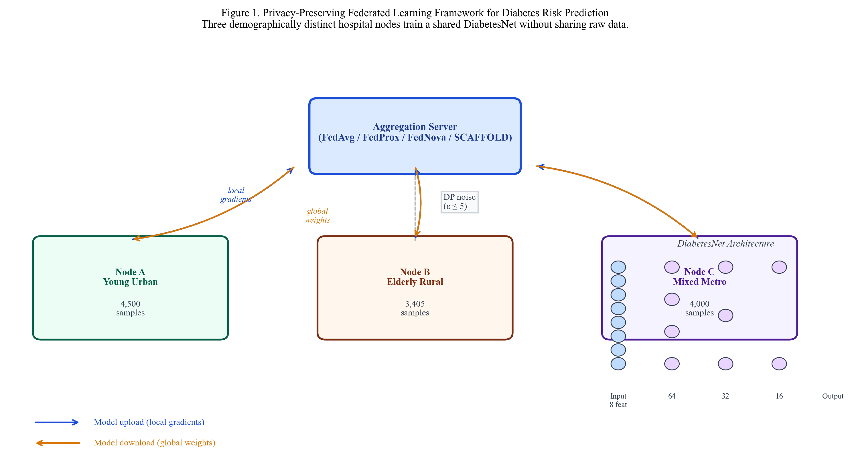
Figure 1. Privacy-preserving federated learning system architecture. Three demographically distinct hospital nodes (Node A: Young Urban, Node B: Elderly Rural, Node C: Mixed Metropolitan) train DiabetesNet locally. Only model updates are transmitted to the aggregation server; raw patient records remain on-site. Optional DP noise injection is indicated. Inset: DiabetesNet four-layer fully connected architecture.
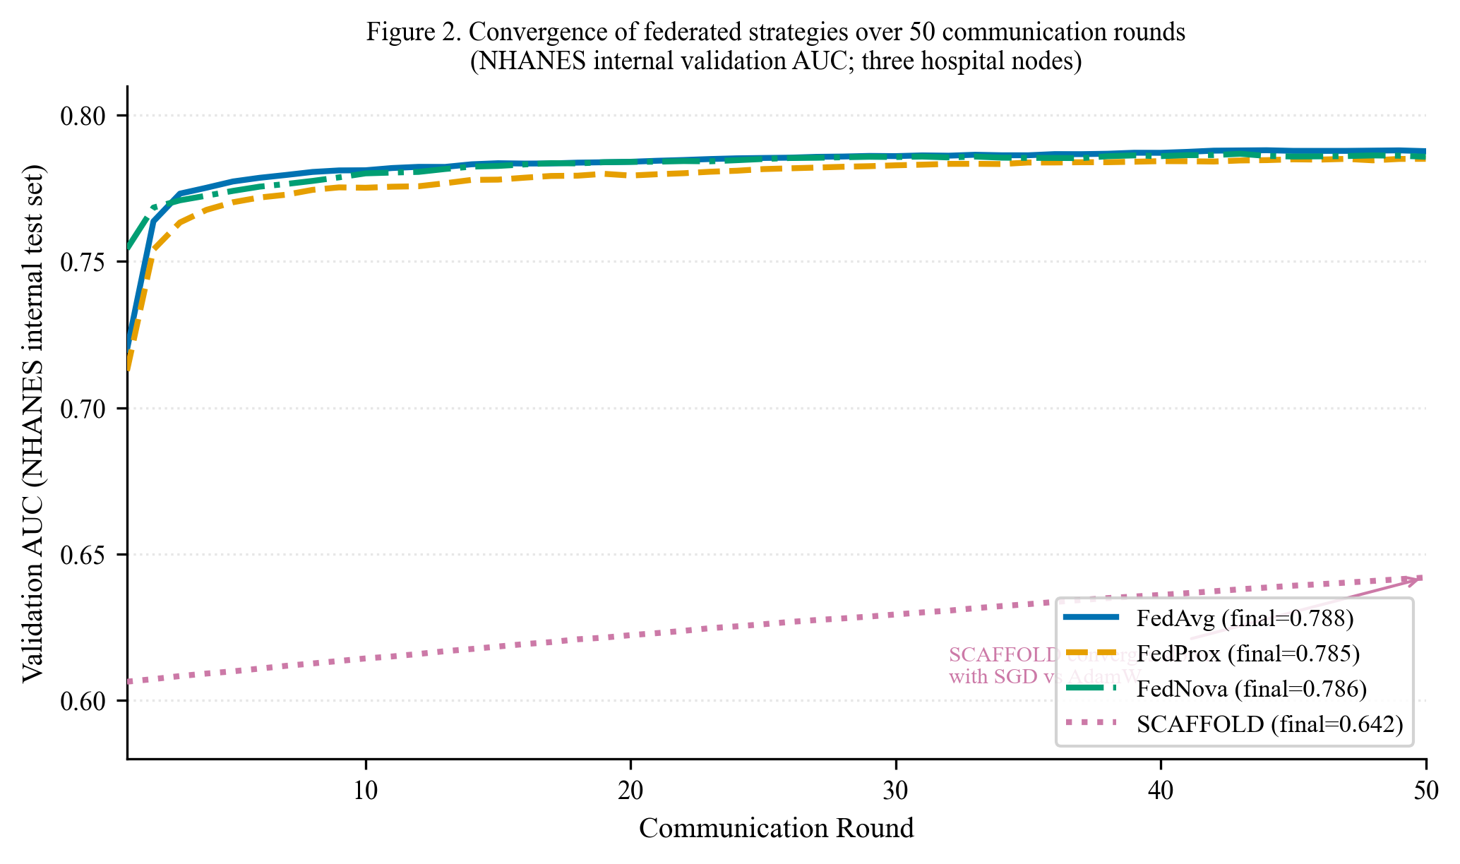
Figure 2. Convergence of four federated aggregation strategies over 50 communication rounds (NHANES internal validation AUC). FedAvg, FedProx, and FedNova converge to AUC ≈ 0.785–0.788 by round 40. SCAFFOLD converges more slowly (final AUC = 0.642) due to its SGD-based implementation.
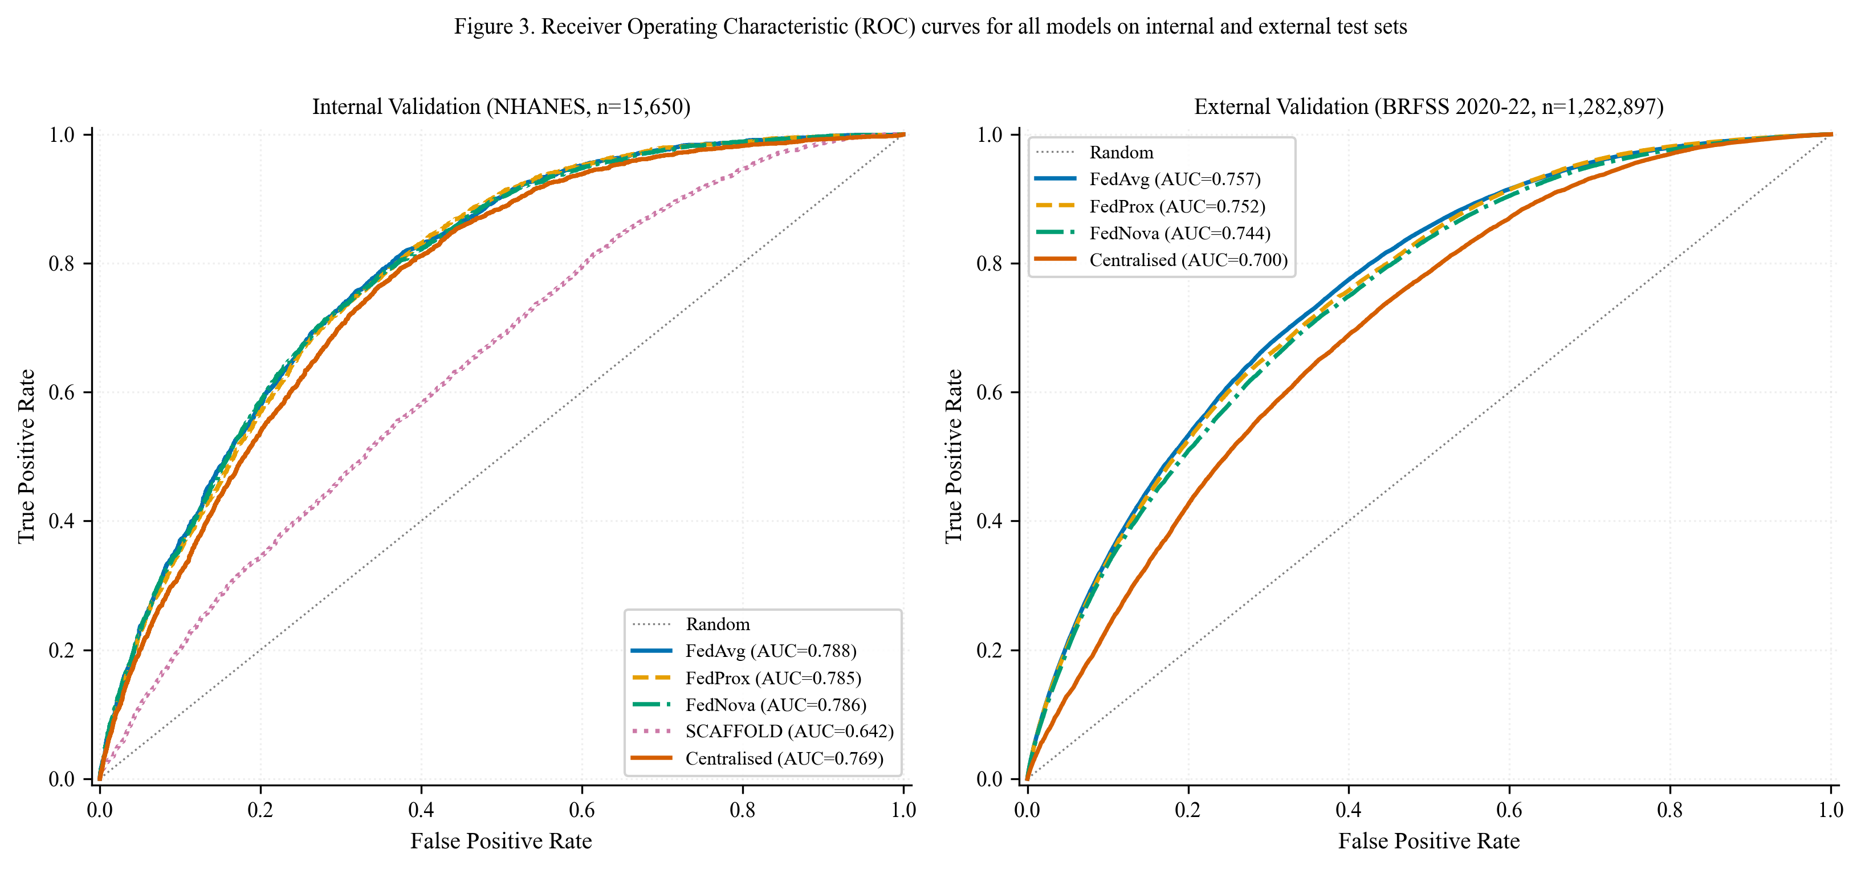
Figure 3. Receiver operating characteristic (ROC) curves for all models. Left: internal NHANES test set (n = 15,650). Right: external BRFSS validation set (n = 1,282,897). Shaded reference: random classifier (AUC = 0.5).
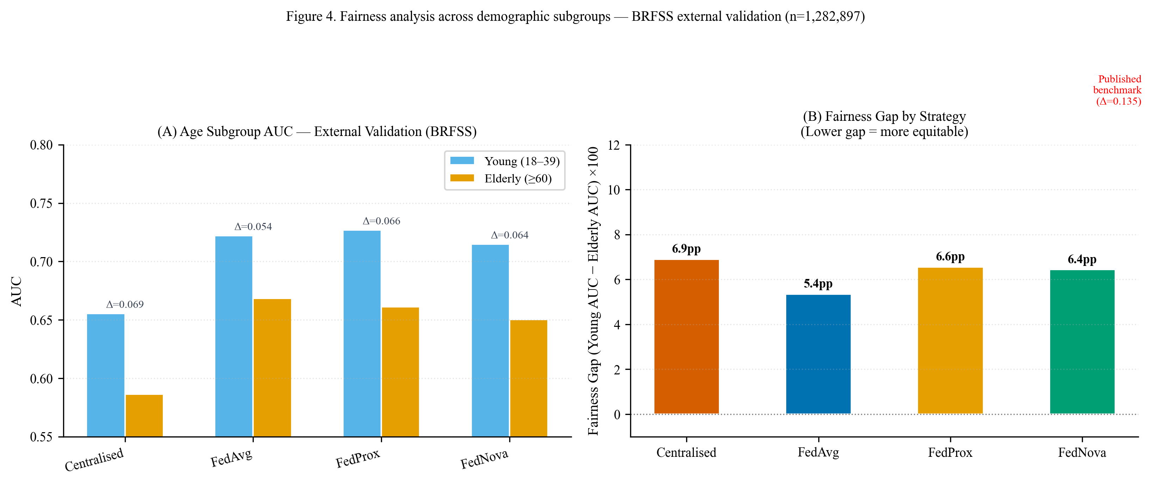
Figure 4. Fairness analysis on BRFSS external validation. (A) Age-stratified AUC for young (18–39) vs. elderly (≥60) respondents. (B) Fairness gap (ΔAUC = Young − Elderly) for each strategy. Dashed red line: published benchmark gap (Δ=0.135).
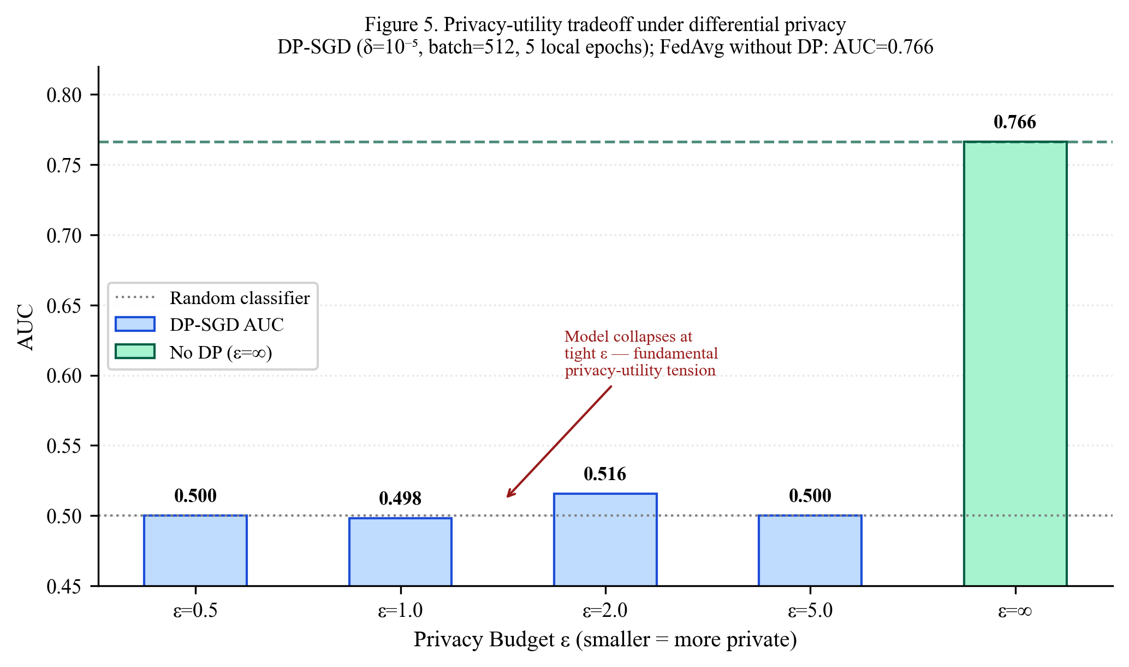
Figure 5. Privacy–utility tradeoff under differential privacy. DP-SGD with δ = 10⁻⁵, clipping norm C = 1.0, batch size 512. Model collapses to AUC ≈ 0.5 at all tested ε ≤ 5 due to high per-round noise at healthcare-scale sampling rates.
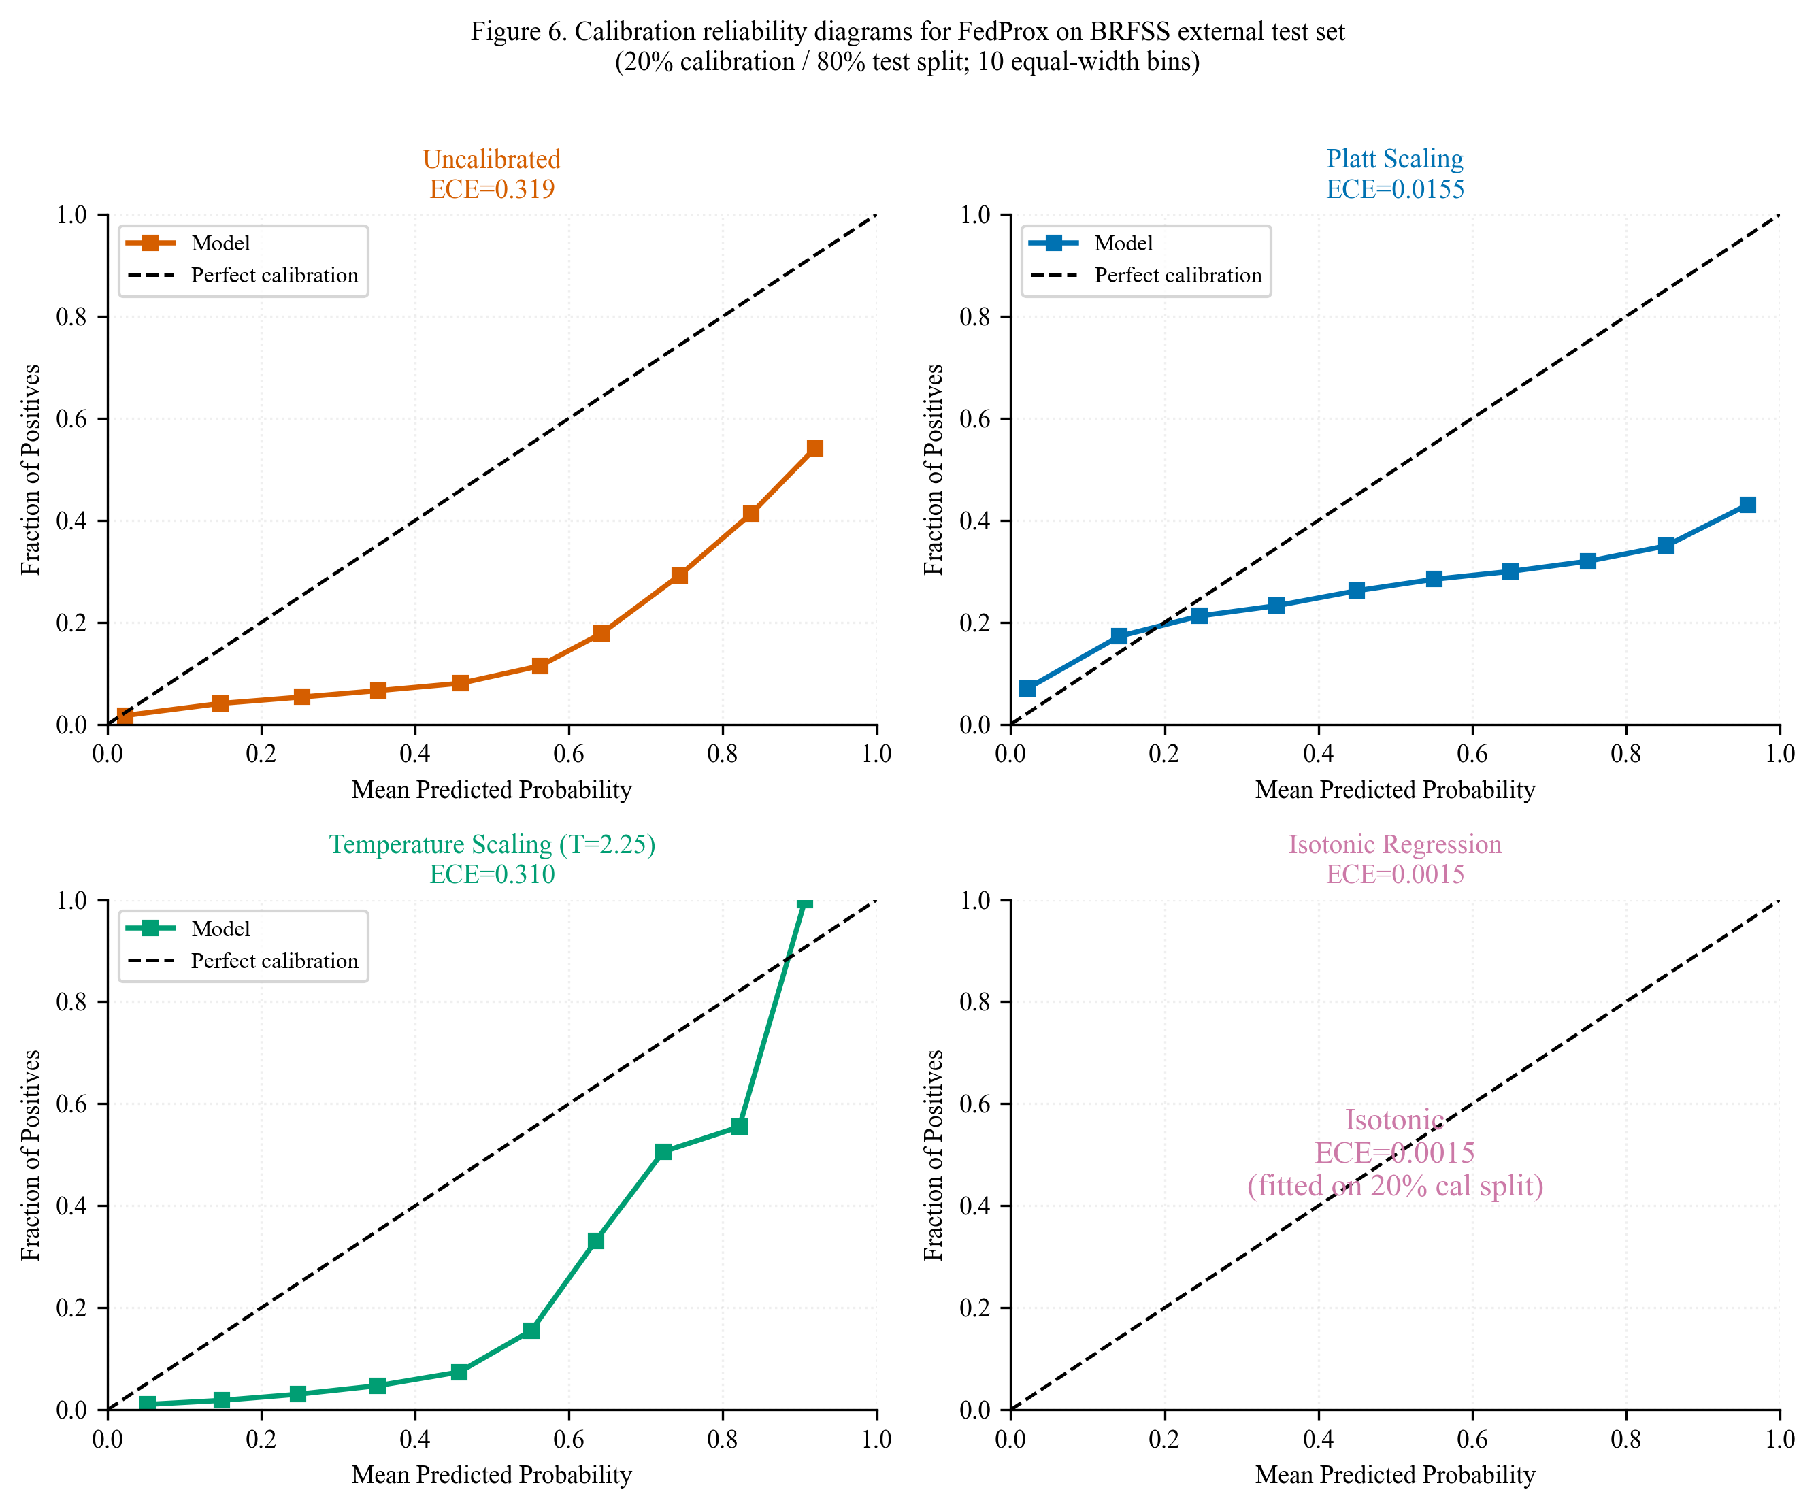
Figure 6. Calibration reliability diagrams for FedProx on the BRFSS external test set (n = 1,026,318). Panels show uncalibrated model (ECE = 0.319), Platt scaling (ECE = 0.016), temperature scaling (ECE = 0.311), and isotonic regression (ECE = 0.001). Diagonal dashed line: perfect calibration.
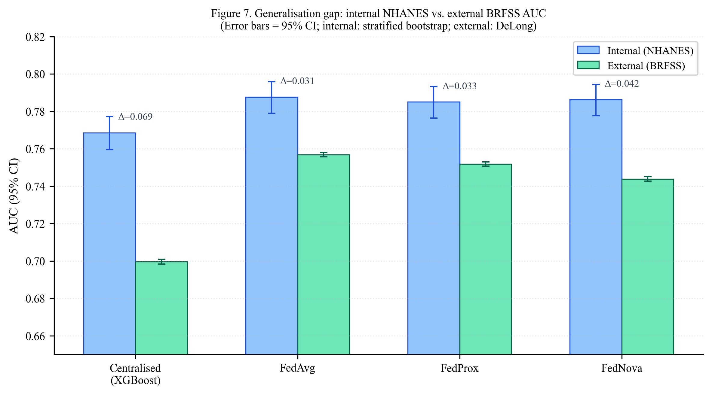
Figure 7. Generalisation gap between internal (NHANES) and external (BRFSS) validation AUC for all models. Error bars: 95% CI. Annotations: ΔAUC = internal − external. Federated strategies show smaller generalisation gaps than the centralised baseline.
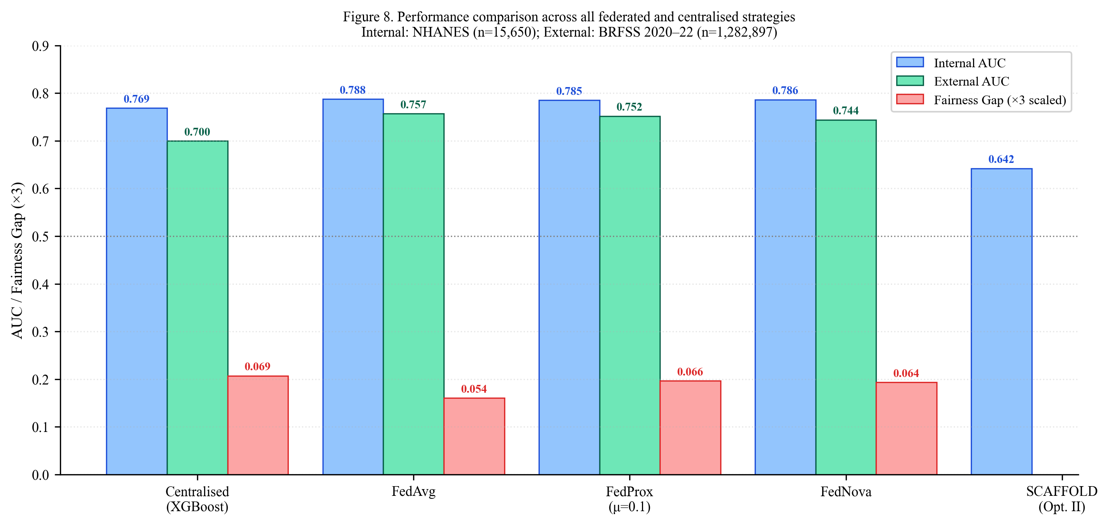
Figure 8. Overall performance summary across strategies. Blue bars: internal AUC; green bars: external AUC; red bars: fairness gap (×3 for visibility). Annotations show exact values. SCAFFOLD external AUC not available (internal evaluation only).

