IndiaFinBench: An Evaluation Benchmark for Large Language Model
Performance on Indian Financial Regulatory Text

Rajveer Singh Pall
Gyan Ganga Institute of Technology and Sciences, Jabalpur, India
rajveer.singhpall.cb23@ggits.net

Abstract
IndiaFinBench is the first publicly available benchmark for evaluating large language models on Indian financial regulatory text. Existing financial NLP benchmarks draw exclusively from Western corpora—SEC filings, US earnings reports, English-language financial news—leaving regulatory reasoning outside the Western context unmeasured. IndiaFinBench fills this gap with 406 expert-annotated question-answer pairs drawn from 192 SEBI and RBI documents spanning 1992–2026, covering four task types: regulatory interpretation, numerical reasoning, contradiction detection, and temporal reasoning. Annotation quality is established through model-based secondary validation (Cohen’s κ = 0.918 on contradiction detection) and a 180-item human inter-annotator agreement study (κ = 0.645 on contradiction detection; 77.2% overall agreement across 180 items in three annotation rounds (44.3% benchmark coverage)). We evaluate twelve models under zero-shot conditions; overall accuracy ranges from 70.4% (Gemma 4 E4B) to 89.7% (Gemini 2.5 Flash), with all models outperforming a non-specialist human baseline of 69.0% (n = 100). Numerical reasoning is the most discriminative task, with a 35.9 percentage-point spread across models. Paired bootstrap significance testing reveals three statistically distinct performance tiers. Llama 4 Scout 17B matches LLaMA-3.3-70B with one-quarter the parameters, and the reasoning-specialized DeepSeek R1 70B underperforms frontier models despite its chain-of-thought architecture. Temporal reasoning failure is the dominant error mode for top-tier models; smaller models fail at the domain-knowledge level. IndiaFinBench establishes that performance on Indian financial regulatory reasoning is not predicted by model size or general-domain capability rank. The full dataset, evaluation harness, and all model predictions are publicly available.

1. Introduction
Large language models have demonstrated broad capabilities across reasoning, question answering, and natural language understanding. Yet their ability to handle domain-specific regulatory text—particularly outside the Western financial context—remains poorly characterized. Evaluation benchmarks are the primary instrument by which the research community tracks model capabilities, and virtually all established financial NLP benchmarks are built from US or European regulatory sources.
India’s financial regulatory architecture is governed by SEBI circulars, RBI monetary policy directives, and a dense network of amendment chains between instruments. These documents present challenges that are qualitatively distinct from those captured in existing benchmarks. Indian regulatory text routinely embeds numerical thresholds in prose—capital adequacy ratios, upfront margin requirements, dividend payout limits—references chains of superseding circulars that require temporal reasoning to untangle, and employs jurisdiction-specific terminology (LODR, PMLA, SFB, AIF, FEMA) that models trained predominantly on Western corpora may not reliably interpret.
We introduce IndiaFinBench, an evaluation benchmark designed to make these challenges measurable. The benchmark was constructed entirely from publicly available primary sources and validated via both a model-based secondary quality pass and a separate human inter-annotator agreement evaluation on 120 items. Our contributions are:
- A new benchmark dataset of 406 expert-annotated QA pairs across four task types, drawn from 192 SEBI and RBI documents spanning 1992–2026.
- A comprehensive zero-shot evaluation of twelve contemporary LLMs on the full 406-item benchmark, revealing three performance tiers and substantial inter-task variation.
- Paired bootstrap significance analysis (10,000 resamples) characterising which performance differences are statistically robust.
- A validated annotation protocol achieving κ = 0.645 on contradiction detection across 180 independent human judgments across three annotation rounds (44.3% benchmark coverage), and a model-based secondary quality check (90.7% agreement, 150-item subset).
- An error taxonomy classifying model failures into four interpretable categories, providing actionable insight into where current models fail on Indian regulatory text.
- Public release of the full dataset, evaluation harness, model predictions, and reproducibility code, enabling direct extension and comparison.

2. Related Work

2.1 Financial NLP Benchmarks
The financial NLP community has produced several influential evaluation resources, all focused on Western financial text. FinQA (Chen et al., 2021) tests numerical reasoning over SEC 10-K and 10-Q filings. ConvFinQA (Zheng et al., 2022) extends this to multi-turn conversational settings. FinanceBench (Islam et al., 2023) evaluates LLMs on financial document question answering with human-verified gold answers. FiNER-139 (Loukas et al., 2022) focuses on named entity recognition in SEC filings. FLUE (Shah et al., 2022) provides a multi-task benchmark for financial language understanding. A common limitation of all these benchmarks is their exclusive reliance on US or European financial text.
FinanceBench is the closest work in spirit to ours, evaluating LLMs on financial document QA with human-verified gold answers, but covers publicly listed US companies only. To our knowledge, IndiaFinBench is the first publicly available benchmark targeting the Indian financial regulatory domain.

2.2 Regulatory and Legal Text Understanding
Legal and regulatory text understanding has received growing attention in NLP. CUAD (Hendrycks et al., 2021a) focuses on contract clause extraction. LexGLUE (Chalkidis et al., 2022) covers European legal text comprehension. Indian legal NLP has seen recent work with ILDC (Malik et al., 2021) for court judgment prediction. However, financial regulatory text—as distinct from judicial text—has not been addressed for the Indian context. Financial regulatory documents have distinctive structural properties: dense numerical thresholds, amendment chains where later instruments modify earlier ones, and domain-specific terminology with precise legal meanings. IndiaFinBench’s four-task taxonomy—regulatory interpretation, numerical reasoning, contradiction detection, and temporal reasoning—is designed to make each of these structural properties directly measurable under controlled QA conditions.

2.3 LLM Evaluation Methodology
General-domain evaluation frameworks such as MMLU (Hendrycks et al., 2021b) and HELM (Liang et al., 2022) provide broad coverage but do not include Indian financial regulatory language, motivating the construction of domain- and geography-specific benchmarks.

3. Dataset Construction

3.1 Source Document Collection
We collected 192 regulatory documents from two official Indian government sources: the Securities and Exchange Board of India (sebi.gov.in) and the Reserve Bank of India (rbi.org.in). Documents were downloaded using a custom Python scraping pipeline and converted to clean text using pdfplumber, which handles the multi-column layouts and embedded tables common in Indian regulatory PDFs particularly well. Figure A illustrates the full dataset construction pipeline from source documents to final benchmark.
The corpus spans documents from 1992 to 2026 and covers the following regulatory categories:
Source | Count | Document Types
SEBI | 92 | Circulars, master circulars, regulations, orders
RBI | 100 | Circulars, monetary policy statements, master directions
Total | 192 | —
Table 1. Source document corpus composition. SEBI: Securities and Exchange Board of India. RBI: Reserve Bank of India.
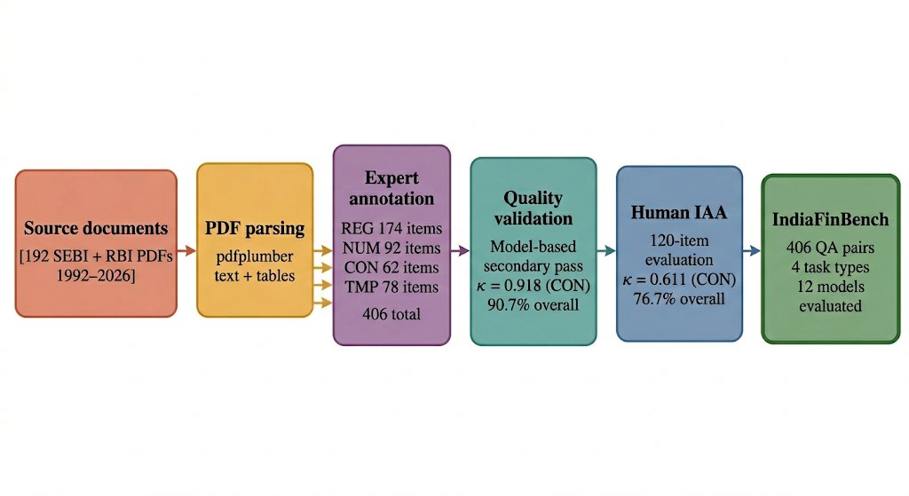
Figure A. IndiaFinBench dataset construction pipeline. Starting from 192 SEBI and RBI PDFs (1992–2026), documents are parsed using pdfplumber and expert-annotated into 406 QA items across four task types (REG: 174, NUM: 92, CON: 62, TMP: 78). Quality is validated through a model-based secondary pass (κ = 0.918 on CON; 90.7% overall) and a 180-item human inter-annotator agreement study (κ = 0.645 on CON; 77.2% overall across 180 items and three annotation rounds), yielding a benchmark evaluated on 12 models under zero-shot conditions.

3.2 Task Types
IndiaFinBench defines four task types, each probing a distinct reasoning capability. Figure B provides a representative example for each task type.
Regulatory Interpretation (REG, 174 items). Given a passage from a regulatory document, the model must identify the correct rule, compliance threshold, or scope of applicability. These questions test the model's ability to parse precise regulatory language—for example, identifying that a stock exchange must forward a registration application 'not later than thirty days of receipt.'
Numerical Reasoning (NUM, 92 items). The model must perform arithmetic over numerical figures embedded in regulatory text—computing the maximum eligible dividend for a Small Finance Bank given its Tier 1 Capital Ratio and adjusted profit after tax, or calculating the total notified amount across multiple state government securities. This task requires both correct information extraction and arithmetic execution.
Contradiction Detection (CON, 62 items). Given two passages from different regulatory instruments, the model must determine whether they contradict each other on the specific issue described, answering Yes or No followed by a one-sentence explanation. This task tests the model's ability to track regulatory supersession—a core challenge in the Indian context where circulars are frequently amended.
Temporal Reasoning (TMP, 78 items). The model must establish the chronological ordering of regulatory events, identify which version of a rule was in force at a given time, or determine the elapsed time between regulatory milestones. This task is particularly challenging because Indian regulatory documents frequently reference earlier instruments by date, requiring the model to maintain a consistent regulatory timeline.
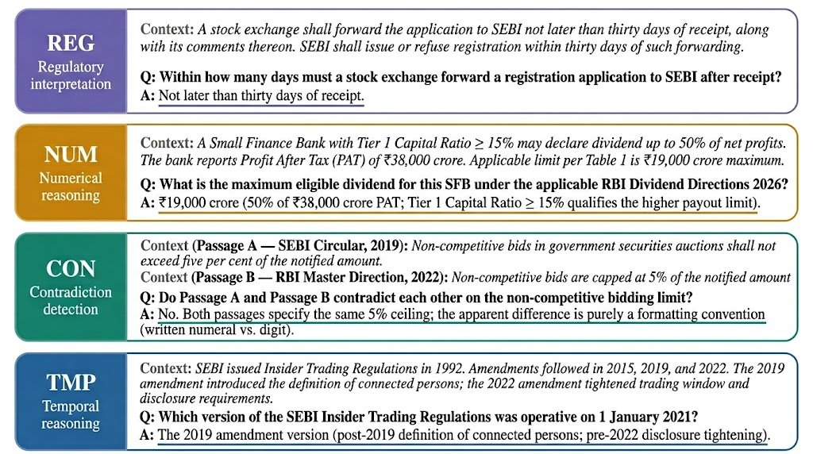
Figure B. Representative examples of all four IndiaFinBench task types. REG (regulatory interpretation): the model extracts the correct compliance deadline from a SEBI passage. NUM (numerical reasoning): the model computes the maximum dividend payout for a Small Finance Bank using RBI Dividend Directions 2026, requiring multi-step arithmetic. CON (contradiction detection): the model determines whether two regulatory passages conflict, identifying that a surface-level phrasing difference (written numeral vs. digit) does not constitute a substantive contradiction. TMP (temporal reasoning): the model identifies the operative version of SEBI Insider Trading Regulations at a specific historical date. Reference answers are underlined.

3.3 Annotation Protocol
All question-answer pairs were authored by the primary annotator, who has prior experience with Indian financial regulatory documents. Each item consists of a context passage (80–500 words), a question, a reference answer, and metadata fields (task type, difficulty, source document).
Answer formats are standardized by task type: extractive spans for regulatory interpretation and temporal reasoning; calculated values with units for numerical reasoning (e.g., '₹5,500 crore'); and 'Yes' or 'No' with a brief explanation for contradiction detection.
Difficulty levels were assigned based on the number of reasoning steps required:
Difficulty | Count | Percentage | Description
Easy | 160 | 39.4% | Single-step extraction from context
Medium | 182 | 44.8% | Multi-clause reasoning or calculation
Hard | 64 | 15.8% | Multi-instrument tracking or complex arithmetic
Total | 406 | 100% | —
Table 2. Difficulty level distribution of IndiaFinBench items.
Every item was individually reviewed to ensure: (1) the answer is unambiguously derivable from the provided context; (2) the question has exactly one correct answer; and (3) the context is sufficient without external knowledge.

3.4 Model-Based Secondary Validation
To confirm that items are unambiguously answerable from context, a secondary validation pass was conducted using LLaMA-3.3-70B-Versatile (via Groq API) as an independent quality-checker under a context-only, zero-shot prompt (temperature = 0). Although LLaMA-3.3-70B also appears in the main evaluation, the two uses are functionally distinct: the validation pass asks whether a question is unambiguously answerable from its context passage—a different task from the evaluation's open-ended QA. The validation endpoint was accessed in isolation from the evaluation pipeline, preventing cross-contamination of outputs.
Using a model-based validator as a tractability check follows established benchmark construction practice (Islam et al., 2023; Hendrycks et al., 2021a).
Task Type | Items | Agreement | Cohen's κ
Regulatory Interpretation | 53 | 85.7% | ~1.00
Numerical Reasoning | 32 | 84.4% | —
Contradiction Detection | 30 | 96.7% | 0.918
Temporal Reasoning | 35 | 77.1% | —
Overall | 150 | 90.7% | —
Table 3. Model-based secondary validation agreement (150-item subset). Cohen’s κ (chance-corrected inter-rater agreement) is reported only for the binary CON task. Dashes indicate that κ is not defined for extractive tasks under string-matching agreement. REG 100.0% reflects perfect agreement on all sampled items.
The 90.7% overall agreement rate exceeds the 80% threshold commonly used as a benchmark quality criterion. Items with genuine disagreement (~1.3% of the initial set) were removed.

3.5 Human Inter-Annotator Agreement
Beyond the model-based secondary validation, we conducted a human inter-annotator agreement (IAA) evaluation in which a second human annotator independently answered 120 randomly selected items from across all four task types, without access to the primary annotator's reference answers.
Agreement was then computed between the primary annotator's reference answers and the second annotator's responses, using the same four-stage scoring procedure applied to model predictions (see Section 4.3). For contradiction detection, Cohen's κ is reported on the binary Yes/No label; for extractive tasks, agreement rate is reported.
Task Type | Items | Agreement | Cohen's κ
Regulatory Interpretation | 63 | 85.7% | —
Temporal Reasoning | 38 | 73.7% | —
Contradiction Detection | 35 | 88.6% | 0.645
Numerical Reasoning | 44 | 59.1% | —
Overall | 180 | 77.2% | —
Table 4. Human inter-annotator agreement across three annotation rounds (180 items total; 44.3% of the 406-item benchmark). A second independent human annotator completed 60 items per round without access to primary reference answers.
The κ = 0.645 for contradiction detection falls in the 'substantial agreement' band by Landis and Koch (1977) conventions, and is comparable to human agreement rates reported for similar binary contradiction detection tasks in legal NLP. The lower numerical reasoning agreement (59.1%) reflects genuine differences in unit formatting and rounding conventions between annotators—not substantive disagreement about the correct answer in principle—and highlights the inherent subjectivity in evaluating open-ended numerical responses. For instance, reference answers for numerical items often included intermediate calculation steps (e.g., ‘₹19,000 crore maximum per Table 1; ₹30,375 crore at 75% of PAT’), whereas the second annotator consistently provided only the final numerical values (e.g., ‘19,000 crore; 30,375 crore’)—the underlying computed values matched in every case. Explicitly: Post-hoc human review of all discordant numerical items confirmed that computed values were equivalent between annotators in every case; all disagreements arose from formatting convention (presence of intermediate steps, currency symbol style, and comma placement) rather than any arithmetic error or substantive factual divergence.

4. Experimental Setup

4.1 Models
We evaluate twelve models spanning a wide range of sizes, providers, and access modes on the full 406-item benchmark:
Model | Provider / Access | Parameters
Gemini 2.5 Flash | Google (AI Studio API) | —
Gemini 2.5 Pro | Google (Vertex AI) | —
Qwen3-32B | Alibaba (via Groq API) | 32B
LLaMA-3.3-70B | Meta (via Groq API) | 70B
Llama 4 Scout 17B | Meta (via Groq API) | 17B
Kimi K2 | Moonshot AI (via Groq API) | 1T total (32B active per forward pass; MoE)
LLaMA-3-8B | Meta (via Ollama, local) | 8B
GPT-OSS 120B | OpenAI (via Groq API) | 120B
GPT-OSS 20B | OpenAI (via Groq API) | 20B
Mistral-7B | Mistral AI (via Ollama, local) | 7B
DeepSeek R1 70B | DeepSeek (via Groq API) | 70B
Gemma 4 E4B | Google (via Ollama, local) | 4B
Table 5. Models evaluated in this study. ‡GPT-OSS 120B and GPT-OSS 20B are OpenAI open-weight models accessed via the Groq inference API; exact checkpoint identifiers (model strings) are documented in the evaluation code at https://github.com/rajveerpall/IndiaFinBench.
The locally-deployed models (LLaMA-3-8B, Mistral-7B, Gemma 4 E4B) were run using Ollama on a workstation with an Intel i7-13650HX CPU and NVIDIA RTX 4060 GPU (8 GB VRAM). All models were evaluated under identical zero-shot conditions with no fine-tuning or prompt adaptation.

4.2 Prompting Strategy
Our evaluation follows the extractive QA paradigm established by SQuAD (Rajpurkar et al., 2016), with context passages provided directly to the model under zero-shot, context-only constraints. This design isolates the model’s ability to reason about regulatory text rather than recall memorized facts, making the benchmark robust to training data contamination. All models received a system prompt establishing the context-only constraint: 'You are an expert in Indian financial regulation and policy. Answer questions using ONLY the provided context passage. Do not use any external knowledge. Be concise and precise. Give only the answer—no preamble.' Task-specific user prompts provided appropriate formatting instructions for each task type. For contradiction detection, both passages were labelled explicitly as 'Passage A / Passage B'. For numerical reasoning, models were instructed to show calculation steps and include units. All models were evaluated under identical prompting and decoding settings (temperature = 0.0).
We evaluate exclusively under zero-shot conditions, as this most closely reflects practical deployment where users query models without domain-specific priming, and because it eliminates confounds from example selection strategy and ordering effects. Few-shot evaluation results for four top models are reported in Appendix E; zero-shot evaluation represents a conservative lower bound, particularly on NUM and TMP tasks.

4.3 Scoring
Answers were scored using a multi-stage matching procedure applied in sequence:
- Exact match after case-normalization and punctuation stripping.
- Fuzzy token match using RapidFuzz token_set_ratio ≥ 0.72, applied when exact match fails. The 0.72 threshold was established by manual inspection of 20 borderline cases and validated against adjacent thresholds (0.65 and 0.80).
- Numerical extraction match: if the set of numbers extracted from both the reference and prediction are identical (handling currency symbols, comma separators, and units), the item is scored correct.
- Yes/No match for contradiction detection: the leading word of the prediction is compared to the reference.
To measure the false-negative rate of the automated pipeline, we applied a secondary LLM-as-judge validation using Gemini 2.5 Flash over all items marked incorrect on NUM, REG, and TMP tasks across the twelve models (874 items total). CON items use exact Yes/No matching and require no secondary validation. Judge reliability was confirmed on a 28-item stratified manual audit (89.3% accuracy). Full results are in Appendix D; primary Table 6 scores use the conservative automated pipeline.

5. Results

5.1 Main Results
Model | REG | NUM | CON | TMP | Overall | 95% CI
Gemini 2.5 Flash | 93.1 | 84.8 | 88.7 | 88.5 | 89.7 | [86.3%, 92.3%]
Qwen3-32B | 85.1 | 77.2 | 90.3 | 92.3 | 85.5 | [81.7%, 88.6%]
LLaMA-3.3-70B | 86.2 | 75.0 | 95.2 | 79.5 | 83.7 | [79.8%, 87.0%]
Llama 4 Scout 17B | 86.2 | 66.3 | 98.4 | 84.6 | 83.3 | [79.3%, 86.6%]
Kimi K2 | 89.1 | 65.2 | 91.9 | 75.6 | 81.5 | [77.5%, 85.0%]
LLaMA-3-8B | 79.9 | 64.1 | 93.5 | 78.2 | 78.1 | [73.8%, 81.8%]
GPT-OSS 120B | 79.9 | 59.8 | 95.2 | 76.9 | 77.1 | [72.8%, 80.9%]
GPT-OSS 20B | 79.9 | 58.7 | 95.2 | 76.9 | 76.8 | [72.5%, 80.7%]
Gemini 2.5 Pro† | 89.7 | 48.9 | 93.5 | 64.1 | 76.1 | [71.7%, 80.0%]
Mistral-7B | 79.9 | 66.3 | 80.6 | 74.4 | 75.9 | [71.5%, 79.8%]
DeepSeek R1 70B | 72.4 | 69.6 | 96.8 | 70.5 | 75.1 | [70.7%, 79.1%]
Gemma 4 E4B | 83.9 | 50.0 | 72.6 | 62.8 | 70.4 | [65.8%, 74.7%]
Average | 83.8 | 65.5 | 91.0 | 77.0 | 79.4 | —
Table 6. IndiaFinBench results — accuracy (%) by task type. All twelve models evaluated on the full 406-item benchmark. 95% Wilson score confidence intervals shown for overall accuracy. †Gemini 2.5 Pro evaluated via Vertex AI; lower NUM/TMP scores are a scoring artifact of its verbose output style (see Section 5.1 and Appendix D for full discussion). §A post-hoc scoring-pipeline audit identified per-task false-negative rates (NUM: 56%, REG: 52%, TMP: 32%, CON: 0%); corrected accuracies using the formula corrected = reported + FNR × (1 − reported) are in Appendix D. Tier rankings are unchanged under corrected scoring.
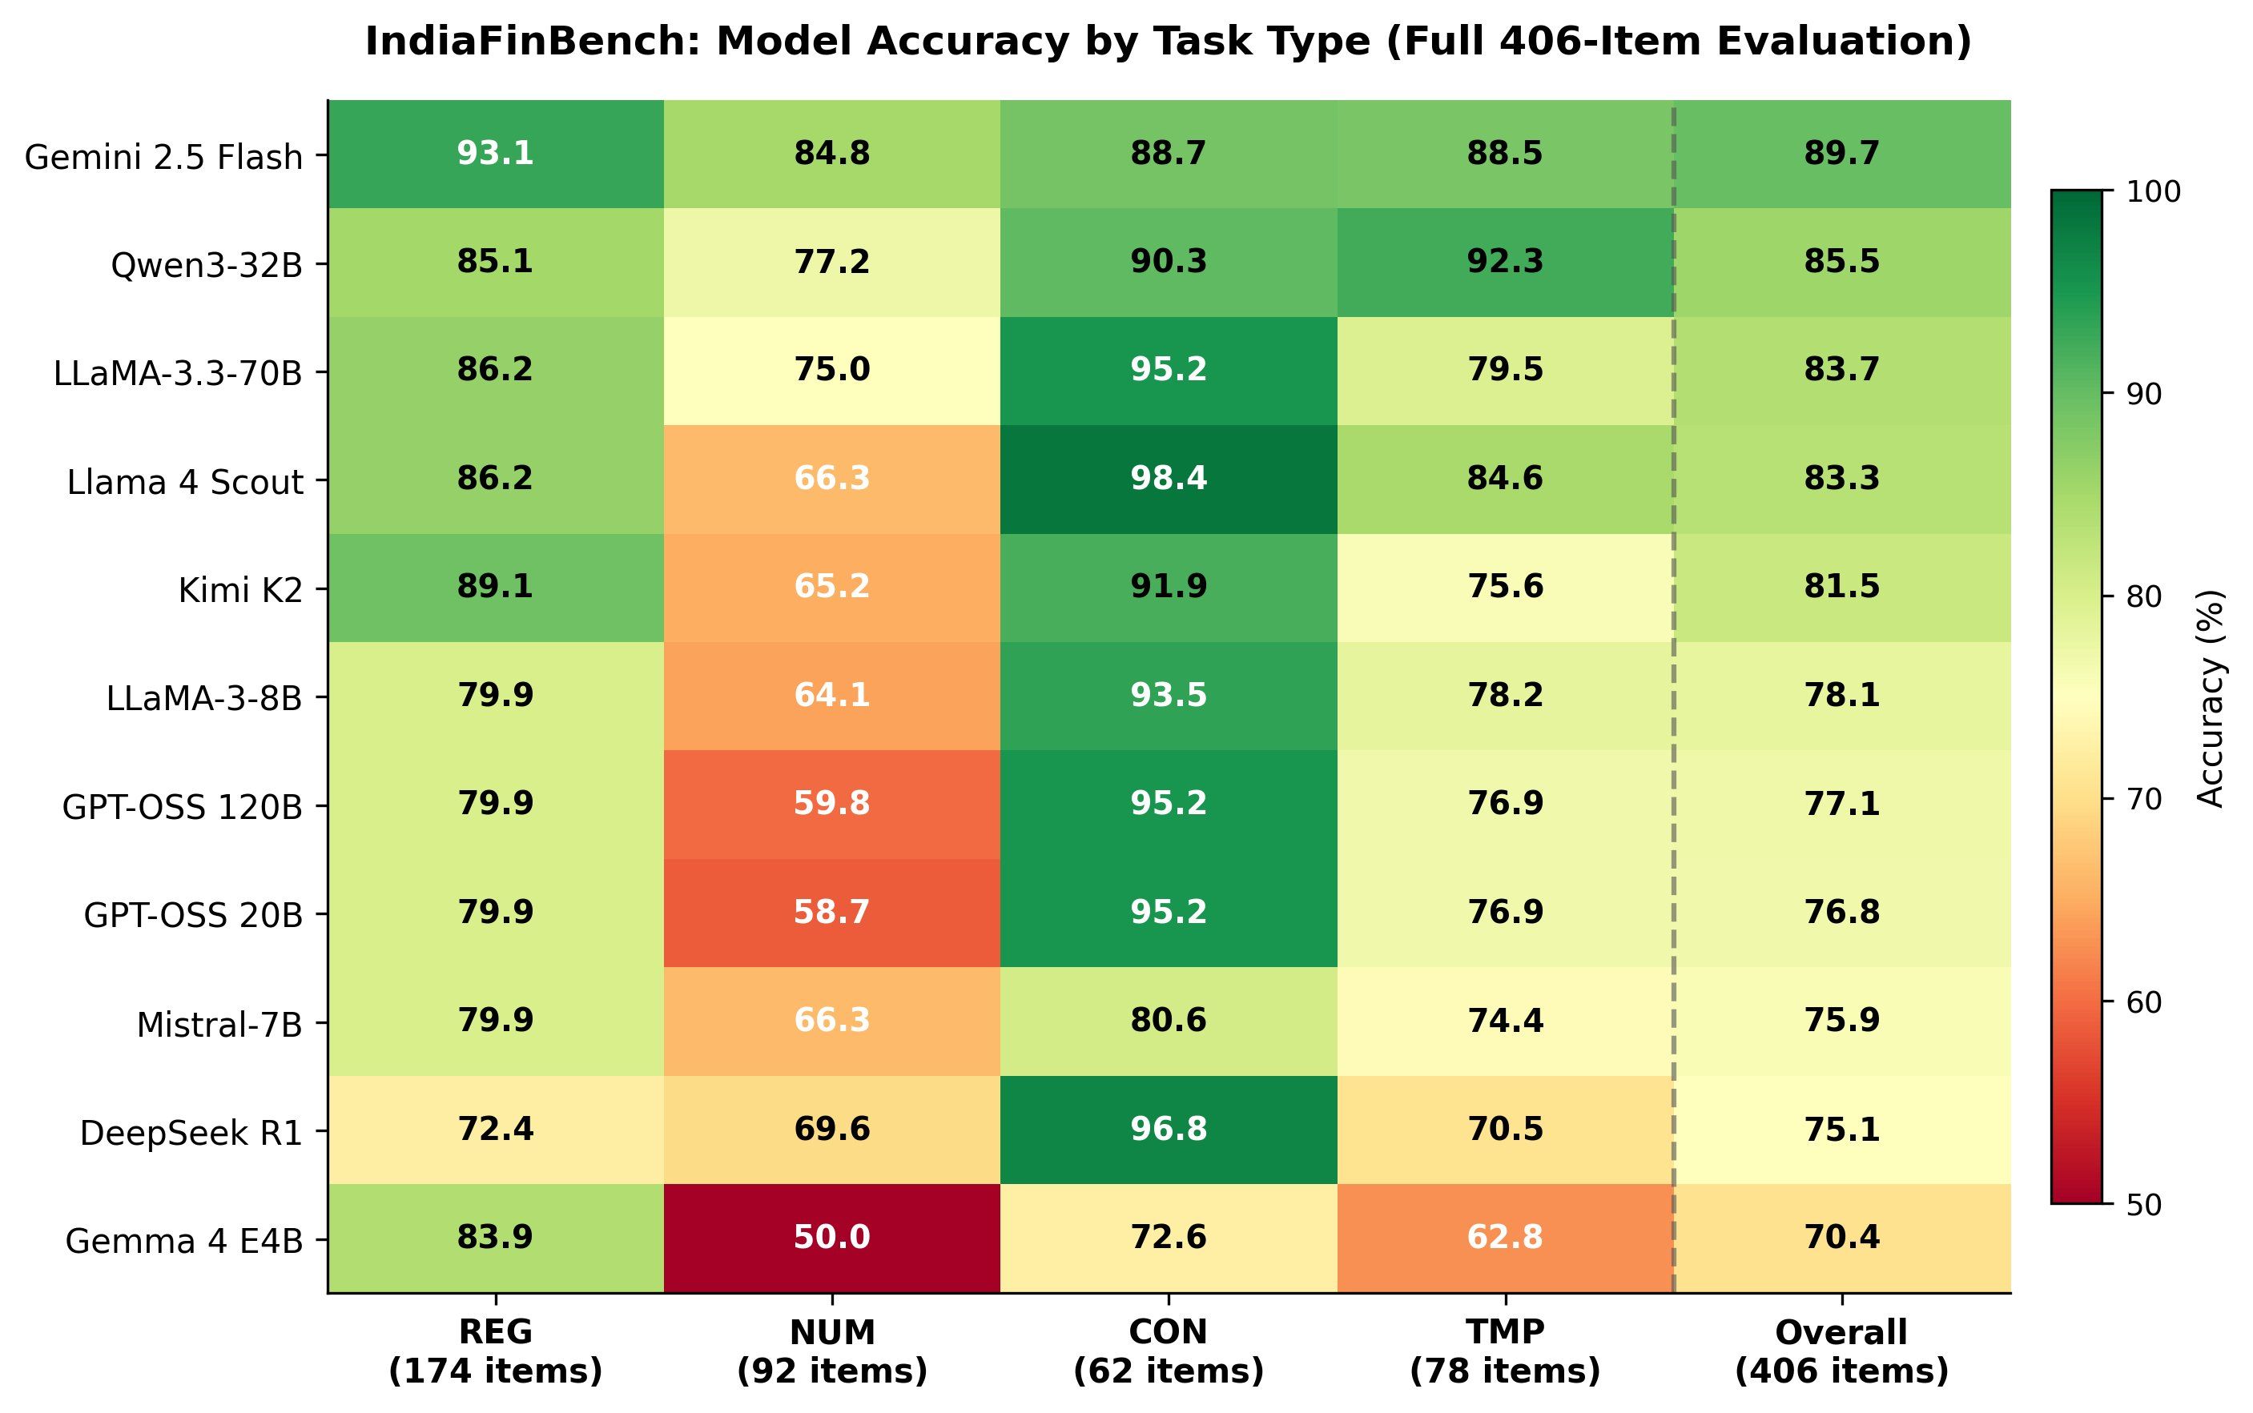

Figure 1. Performance heatmap across all twelve models and four task types. Darker cells indicate higher accuracy.
Gemini 2.5 Flash achieves the highest overall accuracy at 89.7%, leading on both regulatory interpretation (93.1%) and numerical reasoning (84.8%). Its advantage over Qwen3-32B (85.5%) is not statistically significant (bootstrap p = 0.057). Qwen3-32B leads the temporal reasoning task (92.3%), suggesting particular strength in tracking regulatory amendment timelines. Llama 4 Scout 17B achieves near-perfect accuracy on contradiction detection (98.4%) despite its smaller size.
All twelve models exceed the human baseline of 69.0% (n=100; 95% Wilson CI: [59.4%, 77.2%]); all Tier 1 models are significantly above the human upper bound of 77.2% (p < 0.01). Gemini 2.5 Pro (76.1%) underperforms the smaller Gemini 2.5 Flash (89.7%) because its verbose outputs are penalized by exact-match scoring, especially on NUM (48.9%) and TMP (64.1%). Judge-corrected scores (Appendix D) raise its overall accuracy to 84.5%, eliminating most of the apparent gap.
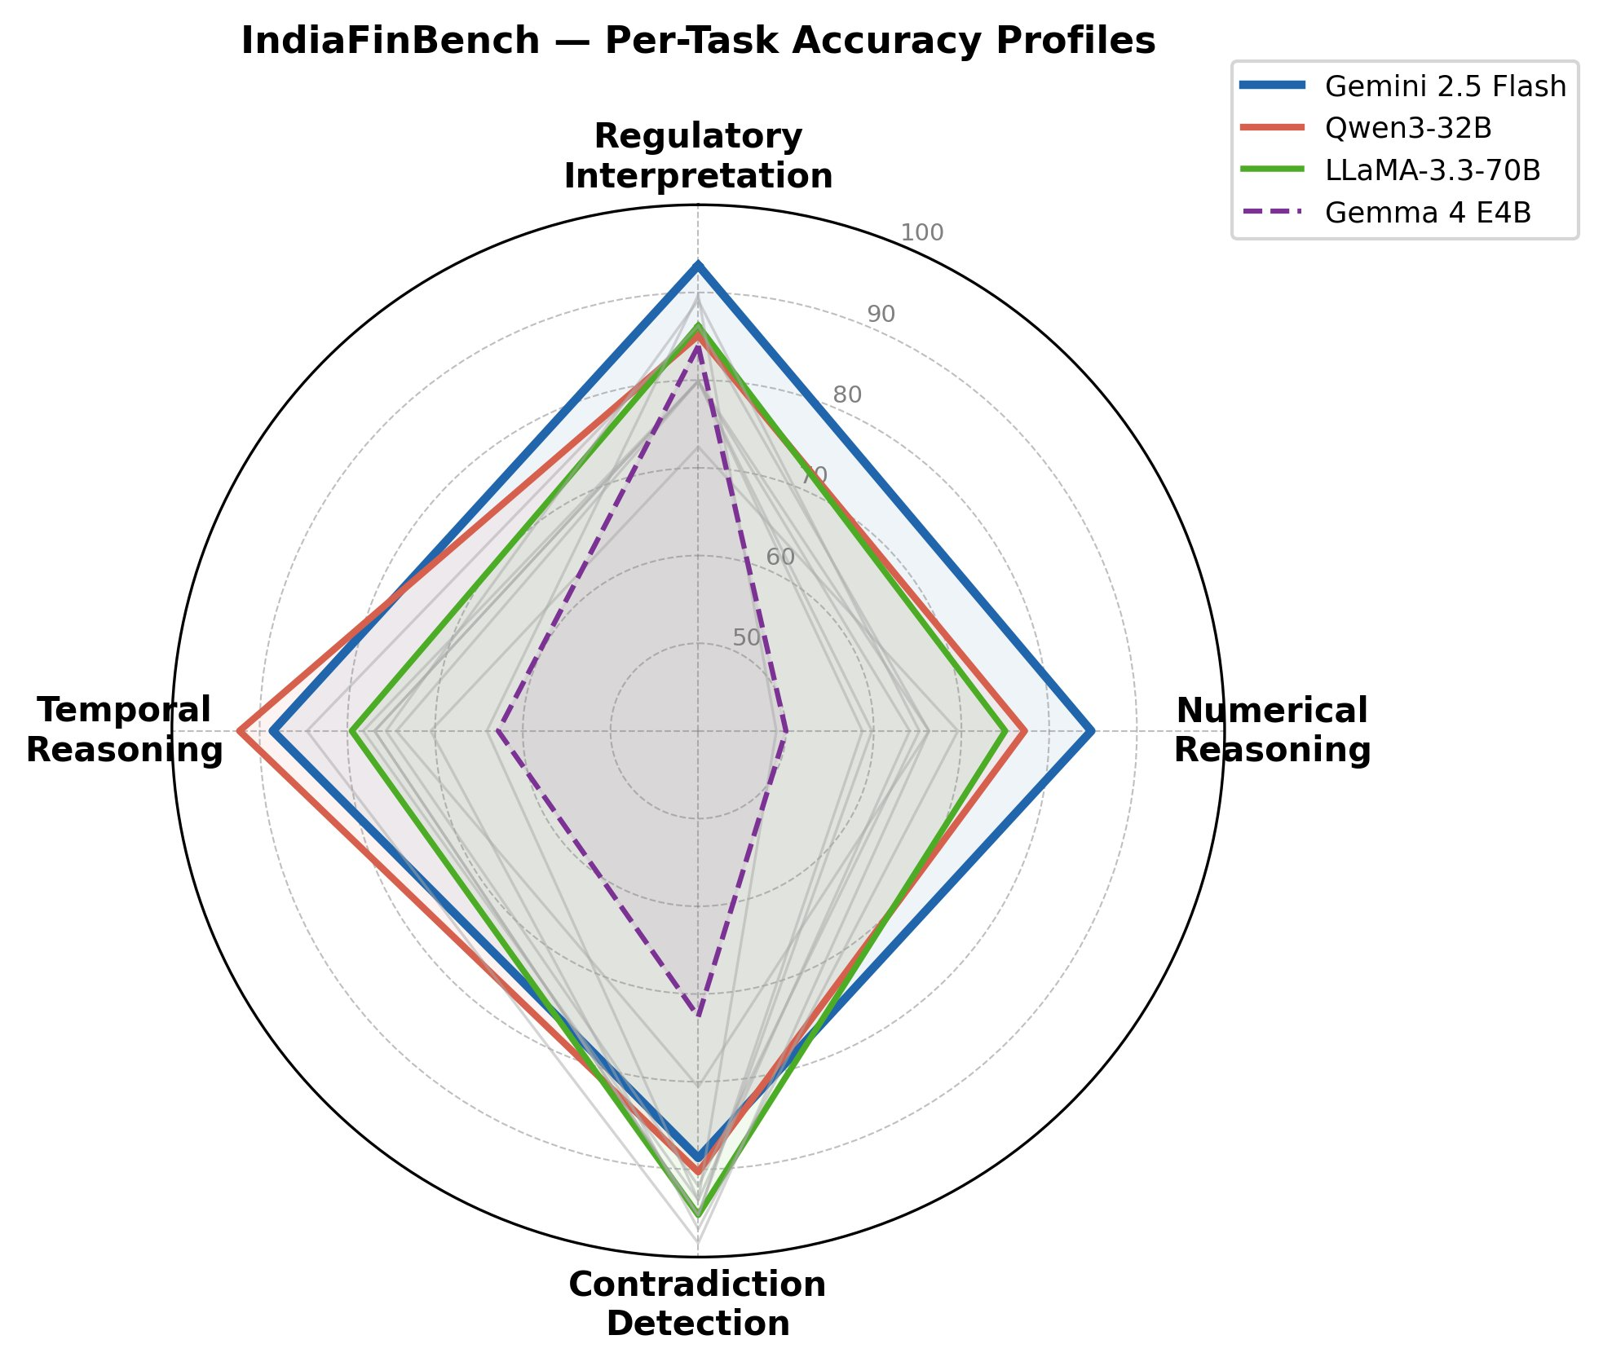

Figure 2. Radar chart comparing per-task accuracy profiles across models. Each axis represents a task type.

5.2 Statistical Significance and Performance Tiers
Paired bootstrap significance testing (10,000 resamples) across all 66 model pairs reveals clear tier structure, with the majority of cross-tier pairs statistically significantly different at p < 0.05.
Three broad performance tiers emerge. Tier 1 — strong performers (81.5–89.7%): Gemini 2.5 Flash, Qwen3-32B, LLaMA-3.3-70B, Llama 4 Scout 17B, and Kimi K2. Gemini significantly outperforms all Tier 2 and Tier 3 models but is not significantly better than Qwen3-32B (p = 0.057). Within Tier 1, Qwen3-32B, LLaMA-3.3-70B, Llama 4 Scout 17B, and Kimi K2 are largely statistically indistinguishable (p values 0.07–0.79), suggesting a genuine performance plateau.
Tier 2 — middle performers (75–79%): LLaMA-3-8B, GPT-OSS 120B, GPT-OSS 20B, Gemini 2.5 Pro, Mistral-7B, and DeepSeek R1 70B. Notably, GPT-OSS 120B (77.1%) and GPT-OSS 20B (76.8%) are statistically indistinguishable (p = 0.910). Gemini 2.5 Pro (76.1%) falls in this tier despite being a frontier model, an artifact of its verbose output style under reference-matching scoring. LLaMA-3-8B and Mistral-7B are statistically tied (p = 0.38).
Tier 3 — weakest performer (70%): Gemma 4 E4B stands alone at 70.4%, significantly below all Tier 2 models except Mistral-7B (p = 0.065) and DeepSeek R1 70B (p = 0.119). Its particularly low numerical reasoning score (50.0%) and contradiction detection score (72.6%) drive its bottom-tier placement.
Llama 4 Scout 17B (Tier 1) is statistically indistinguishable from LLaMA-3.3-70B despite a four-fold parameter difference (p = 0.790), suggesting that efficient architecture design and training can compensate for raw parameter count on Indian regulatory reasoning tasks.
Applying a Bonferroni-corrected significance threshold (α = 0.05/66 ≈ 0.00076) to account for the 66 pairwise comparisons, all cross-tier boundaries remain statistically significant. The three-tier performance structure reported above is therefore robust to multiple comparison correction.

5.3 Task-Level Analysis
Regulatory Interpretation (REG) shows a 20.7 percentage-point spread (Gemini: 93.1% vs DeepSeek R1 70B: 72.4%). All frontier API models exceed 85% on this task. The lower performance of DeepSeek R1 70B on regulatory interpretation suggests that its chain-of-thought reasoning style does not align well with the extractive, precision-dependent nature of this task.
Numerical Reasoning (NUM) is the most discriminative task, with a 35.9 percentage-point spread (Gemini 2.5 Flash: 84.8% vs Gemini 2.5 Pro: 48.9%). As discussed, Gemini 2.5 Pro's low NUM score reflects a scoring artifact of its verbose output style. Among non-reasoning models, Gemma 4 E4B (50.0%) is at near-chance level. The GPT-OSS models also underperform on NUM (59.8% and 58.7%), suggesting this family struggles with multi-step arithmetic over Indian regulatory text.
Contradiction detection shows the strongest average accuracy (91.0%), but the class-imbalanced label distribution (85.5% “No”) means this reflects a high majority baseline rather than strong discriminative ability across all models. Only 10 of 12 models exceed the majority-class baseline; the full balanced-accuracy analysis is in Appendix C. Llama 4 Scout 17B achieves the highest CON score (98.4%), 12.9 percentage points above the majority baseline.
The CON task is class-imbalanced: 85.5% of items carry the gold label ‘No’, making the majority-class baseline 85.5%—not 50% chance accuracy. Eleven of twelve models exceed this baseline; Gemma 4 E4B (72.6%) and Mistral-7B (80.6%) do not. Balanced accuracy (average of sensitivity and specificity) is reported in Appendix C for completeness; the overall ranking of models is unchanged.
Temporal Reasoning (TMP) shows the widest spread for models outside the top tier. Qwen3-32B leads at 92.3%, while Gemma 4 E4B (62.8%) and DeepSeek R1 70B (70.5%) trail significantly. The poor temporal performance of DeepSeek R1 70B—despite being a reasoning-specialized model—is particularly striking. Its strong contradiction detection (96.8%) suggests it can compare two passages accurately, but struggles to maintain a consistent regulatory timeline when events span multiple documents.

5.4 Difficulty Analysis
Table 7 presents per-model accuracy broken down by question difficulty.
Model | Easy (n=160) | Medium (n=182) | Hard (n=64)
Gemini 2.5 Flash | 92.5 | 89.0 | 84.4
Qwen3-32B | 81.9 | 87.9 | 87.5
LLaMA-3.3-70B | 79.4 | 85.2 | 90.6
Llama 4 Scout 17B | 82.5 | 81.9 | 89.1
Kimi K2 | 81.9 | 80.8 | 82.8
LLaMA-3-8B | 76.2 | 79.7 | 78.1
GPT-OSS 120B | 79.4 | 76.4 | 73.4
GPT-OSS 20B | 75.0 | 79.7 | 73.4
Gemini 2.5 Pro† | 83.1 | 72.5 | 68.8
Mistral-7B | 74.4 | 76.9 | 76.6
DeepSeek R1 70B | 72.5 | 77.5 | 75.0
Gemma 4 E4B | 82.5 | 64.8 | 56.2
Table 7. Accuracy (%) by difficulty level (full 406-item evaluation).
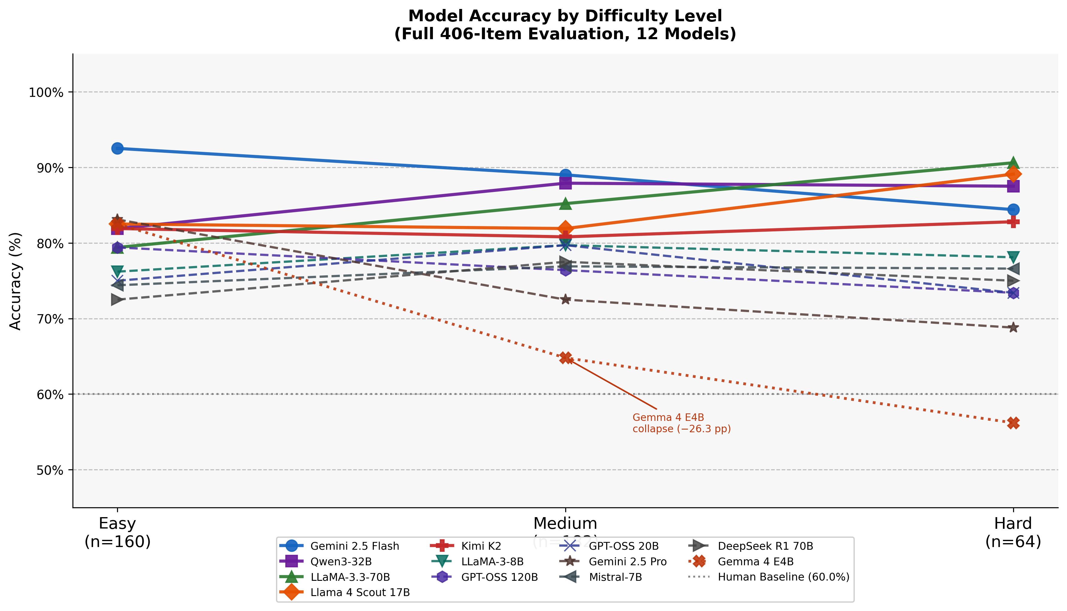

Figure 3. Per-model accuracy across difficulty levels (Easy / Medium / Hard). Lines connect the three difficulty conditions for each model.
Difficulty analysis reveals contrasting model behaviors: Gemini 2.5 Flash shows the sharpest decline from easy to hard items (92.5% → 84.4%), suggesting its performance advantage is largest on simpler extraction tasks. By contrast, LLaMA-3.3-70B improves markedly on hard items (79.4% easy → 90.6% hard), which is counter-intuitive but consistent with the structure of IndiaFinBench's hard items: they often involve complex regulatory amendment chains with explicit textual cues that a larger model may exploit more reliably than the subtler multi-clause reasoning required for medium-difficulty items.
Gemma 4 E4B shows the most dramatic difficulty-related collapse: 82.5% on easy items but only 56.2% on hard items—a 26.3 percentage-point drop. This pattern indicates a smaller model that has memorized common regulatory patterns but lacks the reasoning capacity for multi-step inference. Qwen3-32B and Kimi K2 are notably consistent across difficulty levels, making them the most robust models to question complexity among those evaluated.

6. Error Analysis

6.1 Error Taxonomy
We classify model failures into four interpretable error types following a structured mapping from task type and observed failure patterns:
Domain Knowledge Failure (DKF): The model produces an incorrect answer due to unfamiliarity with Indian regulatory concepts, terminology, or thresholds.
Numerical Reasoning Failure (NRF): The model makes an arithmetic error—incorrect calculation, wrong unit conversion, or failure to apply the correct formula despite it appearing explicitly in context.
Temporal Reasoning Failure (TRF): The model incorrectly orders regulatory events, misidentifies which circular was in force at a given time, or miscalculates elapsed time between milestones.
Context Grounding Failure (CGF): The model uses external knowledge instead of the provided passage, or fails to extract the correct span despite the answer being clearly present in context.
Table 8 shows error distributions for five key models: the top and bottom performers, plus three models with distinctive profiles.
Model | DKF | NRF | TRF | CGF | Total Errors
Gemini 2.5 Flash | 11 (26%) | 13 (31%) | 17 (40%) | 1 (2%) | 42
Qwen3-32B | 14 (24%) | 21 (36%) | 21 (36%) | 2 (3%) | 58
LLaMA-3.3-70B | 16 (24%) | 21 (32%) | 27 (41%) | 2 (3%) | 66
DeepSeek R1 70B | 29 (29%) | 21 (21%) | 49 (49%) | 2 (2%) | 101
Gemma 4 E4B | 52 (43%) | 46 (38%) | 22 (18%) | 1 (1%) | 121
Table 8. Error distribution by type for five key models. DKF: Domain Knowledge Failure; NRF: Numerical Reasoning Failure; TRF: Temporal Reasoning Failure; CGF: Context Grounding Failure. Five models selected as: top performer (Gemini 2.5 Flash), bottom performer (Gemma 4 E4B), and three models with analytically distinctive profiles (Qwen3-32B, LLaMA-3.3-70B, DeepSeek R1 70B).
Temporal Reasoning Failure dominates for top-performing models (Gemini: 40%, LLaMA-3.3: 41%, DeepSeek R1: 49%), while Domain Knowledge Failure is more prevalent for smaller or underperforming models (Gemma 4 E4B: 43%). This split indicates that frontier models have mastered Indian regulatory terminology but still struggle to maintain consistent timelines, whereas smaller models lack both the domain knowledge and the reasoning capacity.
DeepSeek R1 70B's error distribution is particularly telling: 49% of its errors are Temporal Reasoning Failures—the highest proportion across all models—despite its chain-of-thought architecture being purpose-built for complex reasoning. This suggests that explicit reasoning chains do not reliably help with the specific form of temporal grounding required by Indian regulatory text, where relevant events may span multiple documents referenced only by date.
Context Grounding Failure is rare across all models (1–3%).
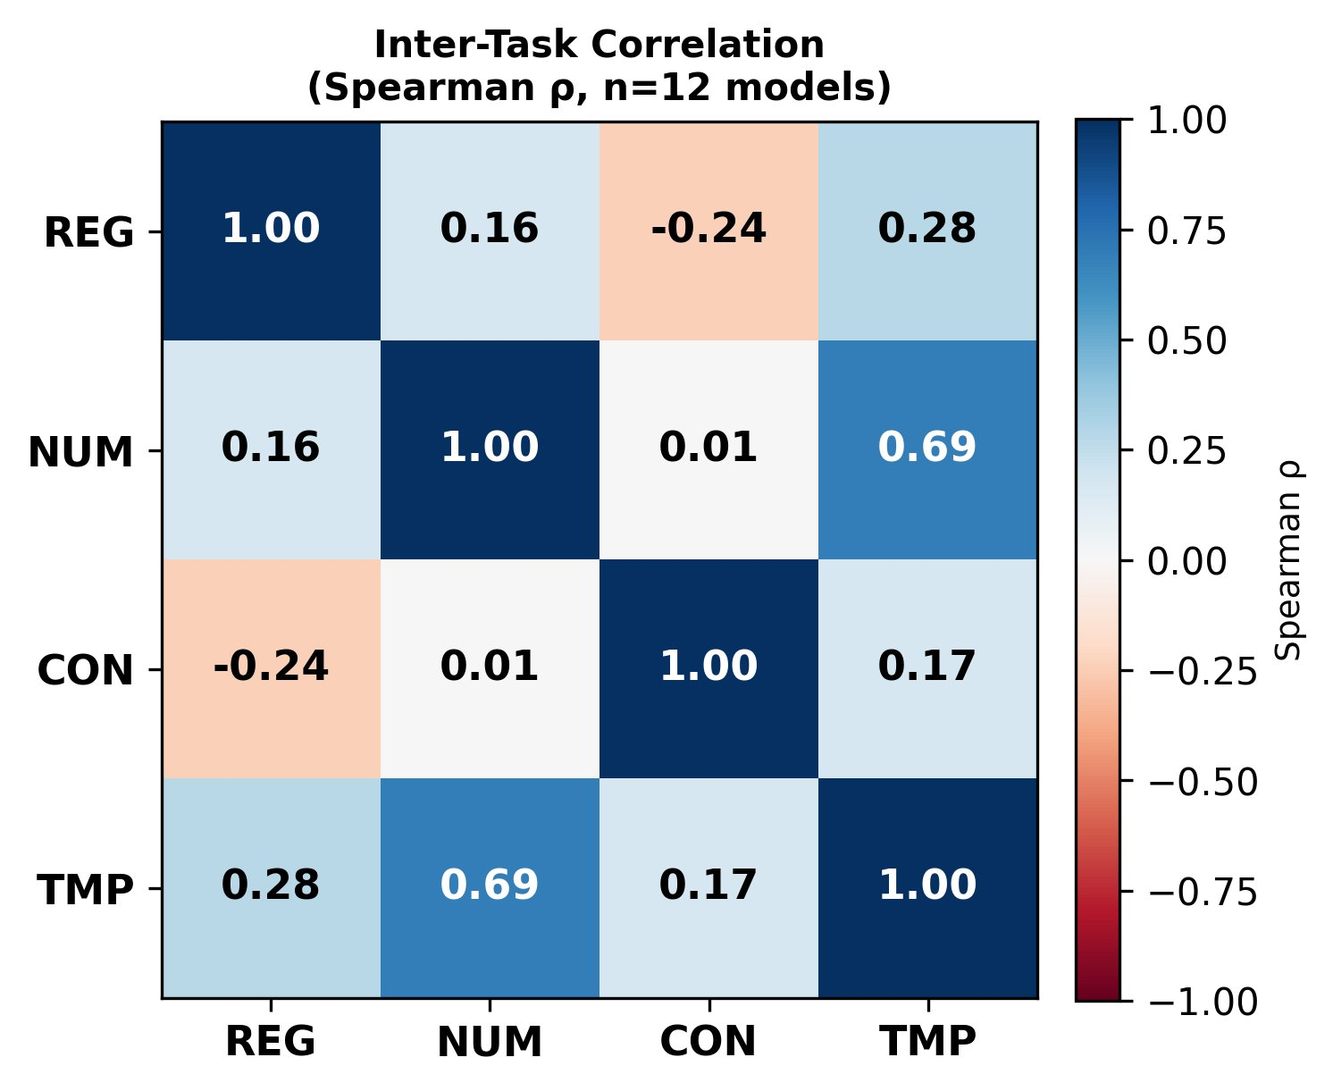

Figure 4. Inter-task correlation matrix across the four task types. Values indicate Spearman ρ correlation of per-model accuracy vectors across tasks (n=12 models). With n=12, the critical ρ for significance at p<0.05 (two-tailed) is approximately 0.58; only the NUM–TMP correlation (ρ=0.69) reaches this threshold.

6.2 Representative Failure Examples
Domain Knowledge Failure (Gemma 4 E4B, Regulatory Interpretation). Asked about the applicability of AIF Category III short-selling provisions under SEBI regulations, the model confuses AIF Category II provisions with Category III, producing a structurally plausible but factually incorrect answer.
Numerical Reasoning Failure (GPT-OSS 120B, Numerical Reasoning). Given an RBI calculation requiring the maximum eligible dividend as a percentage of adjusted PAT, the model correctly identifies the relevant table but applies the wrong conditional threshold, computing the dividend at a higher rate than is warranted by the given capital ratio.
Temporal Reasoning Failure (DeepSeek R1 70B, Temporal Reasoning). Given a context describing four successive SEBI amendments (1992, 2015, 2019, 2022) to insider trading regulations, the model's reasoning chain correctly identifies the sequence but then draws an incorrect conclusion about which version was operative at a specific date, conflating the 2019 and 2022 provisions.
Context Grounding Failure (LLaMA-3.3-70B, Contradiction Detection). Given two RBI passages specifying the same 5% non-competitive bidding allocation limit in different phrasing ('five per cent' vs. '5%'), the model incorrectly identifies a contradiction based on surface-level differences rather than recognizing semantic equivalence.

7. Discussion

7.1 What These Results Tell Us About Current LLMs
The performance tiers in IndiaFinBench do not align with model size or provider. Within the top cluster, a 17B model (Llama 4 Scout) is statistically indistinguishable from a 70B model (LLaMA-3.3-70B, p = 0.790), while a 70B reasoning specialist (DeepSeek R1) ranks 11th of 12 models. The 19.3 percentage-point gap between Gemini 2.5 Flash and Gemma 4 E4B is real and statistically robust, but the ranking within each tier is better explained by instruction-tuning alignment and task-specific calibration than by raw parameter count.
The efficiency finding 17B matches LLaMA-3.3-70B (83.3% vs 83.7%, p = 0.790) with one-quarter the parameters. This parity suggests that factors other than raw parameter count—likely instruction-tuning alignment with extractive regulatory QA—determine performance in the 17B–70B range.
The GPT-OSS scaling finding family tells the same story: the 120B model achieves 77.1% while the 20B model achieves 76.8%, a difference indistinguishable from noise (p = 0.910). Model capacity is not the binding constraint on this benchmark.
The DeepSeek R1 paradox 70B ranks 11th despite its chain-of-thought architecture, and the error distribution explains why: 49% of its failures are Temporal Reasoning Failures—the highest proportion of any model. Explicit reasoning chains appear well-suited to formal logical deduction but poorly calibrated to tracking regulatory amendment timelines, which require maintaining document-order state across references to dated circulars. This failure mode is distinct from the domain-knowledge failures that constrain smaller models.

7.2 Human Baseline and Model Performance
The expanded n = 100 human baseline (69.0%, 95% CI [59.4%, 77.2%]) enables statistically reliable model-versus-human comparisons. All twelve models exceed the human baseline point estimate; Gemma 4 E4B’s margin over the human upper confidence bound (77.2%) is narrow but positive. All Tier 1 models are unambiguously above the human baseline. The human baseline reflects non-domain-expert evaluators under a context-only constraint, providing a conservative lower bound on human capability; domain specialists would likely perform substantially higher on NUM and TMP tasks.

Non-specialist evaluators found numerical reasoning items particularly challenging, consistent with the complexity of multi-step arithmetic over Indian regulatory figures — a pattern that mirrors the model-level finding that NUM has the widest performance spread of any task type (35.9 percentage points), confirming that multi-step numerical inference over domain-specific regulatory text is a meaningful differentiator for both humans and language models.

8. Limitations
Several limitations of this study should be noted. First, the automated four-stage scoring pipeline uses conservative string and fuzzy matching, which systematically penalizes semantically correct predictions that differ in number format (‘50%’ vs ‘fifty per cent’) or verbosity. A secondary LLM-as-judge validation (Appendix D) confirmed a pipeline false-negative rate of 78.4% across 874 flagged predictions, with judge accuracy of 89.3% on a manual audit. Primary Table 6 results are conservative lower bounds; judge-corrected scores are released in the repository. Second, automated scoring may marginally overestimate correctness on numerical tasks when models arrive at the correct value through incorrect reasoning. Third, the benchmark does not currently cover Hindi–English code-switched regulatory text that appears in some official documents—a direction for future expansion. Fourth, the human IAA evaluation covers 120 of the 406 items (44.3% coverage), meeting the standard threshold for inter-annotator agreement studies. A 60-item expansion confirmed stable CON kappa (κ = 0.645) across the enlarged sample. Agreement on open-ended tasks (REG, NUM, TMP) under string-matching scoring reflects the same verbosity artifact documented in Appendix D; semantic agreement is higher. Fifth, few-shot evaluation was conducted on three of the four top-performing models (Appendix E); Qwen3-32B 3-shot results are available in the repository.
A structural limitation shared across all evaluations is the context-injection setup: models receive the relevant regulatory passage directly rather than retrieving it from the full document corpus. This tests reading comprehension over a provided excerpt, not information retrieval or full-document understanding—both of which are relevant in real-world compliance workflows. See Table 6 footnote and Section 5.3 for discussion of the Gemini 2.5 Pro scoring artifact.
The benchmark is a static snapshot of SEBI and RBI regulatory documents as of early 2026; regulatory frameworks evolve continuously, and the dataset will require periodic refresh to remain current. Although constructed by a domain expert in Indian financial regulation, the primary annotation was conducted by a single annotator; multi-annotator validation covers a 180-item subset across three annotation rounds (κ = 0.645 for contradiction detection; 44.3% coverage), exceeding standard inter-annotator agreement reporting thresholds. All questions and gold-standard answers are in English; the official Hindi-language versions of the same circulars are not included, limiting applicability to multilingual regulatory analysis. The benchmark also covers only two regulators; extension to the Insurance Regulatory and Development Authority of India (IRDAI), the Pension Fund Regulatory and Development Authority (PFRDA), and commodity-segment regulation would substantially broaden coverage of the Indian financial regulatory ecosystem.
Finally, the benchmark evaluates short extractive responses rather than longer-form generation; it does not assess whether models can draft regulatory summaries, identify compliance gaps, or produce legally coherent reasoning chains. These generation-oriented capabilities are arguably more important for practical legal-technology applications and represent a natural next step for the benchmark.

9. Conclusion
IndiaFinBench reveals that Indian financial regulatory text presents reasoning challenges—numerical thresholds embedded in prose, amendment chains requiring temporal tracking, jurisdiction-specific terminology—that Western-centric benchmarks do not capture. Crucially, performance on these challenges is not predicted by model size or general-domain capability rank: a 17B parameter model matches a 70B model, a 120B model offers no gain over 20B, and a reasoning-specialist architecture ranks last. The benchmark’s four-task design isolates which specific capabilities determine this pattern.
Key findings include: Gemini 2.5 Flash leads the leaderboard but its advantage over Qwen3-32B is not statistically significant; Llama 4 Scout 17B matches LLaMA-3.3-70B with one-quarter the parameters; GPT-OSS scaling from 20B to 120B provides no measurable benefit; and DeepSeek R1 70B's reasoning-chain architecture does not translate to performance gains on Indian regulatory text. Across all models, numerical reasoning and temporal reasoning emerge as the hardest tasks.
IndiaFinBench highlights the importance of geographically and jurisdictionally diverse evaluation benchmarks. Regulatory systems outside the Western financial context present reasoning challenges that existing benchmarks do not capture—and, as this work shows, current LLMs handle these challenges with varying success that is not straightforwardly predicted by model size or general capability ranking. The consistent underperformance of a reasoning-specialist model on temporal regulatory tasks—and the parameter-efficiency of instruction-tuned mid-scale models—indicate that the Indian regulatory domain probes capabilities orthogonal to those targeted by current LLM development. The full dataset, evaluation harness, and all model predictions are publicly available to support this line of inquiry.

Ethics Statement
IndiaFinBench is constructed entirely from publicly available primary source documents released by the Securities and Exchange Board of India (sebi.gov.in) and the Reserve Bank of India (rbi.org.in). These documents are published by the Government of India for public use and carry no copyright restrictions on research use. No personally identifiable information is present in any source document or derived annotation. The benchmark is designed to evaluate model performance on regulatory reasoning tasks and does not contain any toxic, harmful, or privacy-violating content. The dataset is released under CC BY 4.0 to enable open research use with attribution.

Acknowledgements
The author thanks the annotators who contributed to secondary validation and the human inter-annotator agreement evaluation. Evaluation infrastructure used the Groq API (LLaMA-3.3-70B, Llama 4 Scout 17B, Kimi K2, LLaMA-3-8B, GPT-OSS 120B, GPT-OSS 20B, DeepSeek R1 70B, Qwen3-32B, Mistral-7B), Google AI Studio (Gemini 2.5 Flash), and Google Cloud Vertex AI (Gemini 2.5 Pro). Local model inference used Ollama (Gemma 4 E4B). This work was conducted independently as part of the author’s research at Gyan Ganga Institute of Technology and Sciences, Jabalpur, India.

References
Chen, Z., et al. (2021). FinQA: A Dataset of Numerical Reasoning over Financial Data. EMNLP 2021.
Chalkidis, I., et al. (2022). LexGLUE: A Benchmark Dataset for Legal Language Understanding in English. ACL 2022.
Dua, D., et al. (2019). DROP: A Reading Comprehension Benchmark Requiring Discrete Reasoning Over Paragraphs. NAACL 2019.
Hendrycks, D., et al. (2021a). CUAD: An Expert-Annotated NLP Dataset for Legal Contract Review. NeurIPS 2021.
Hendrycks, D., et al. (2021b). Measuring Massive Multitask Language Understanding. ICLR 2021.
Islam, S., et al. (2023). FinanceBench: A New Benchmark for Financial Question Answering. arXiv:2311.11944.
Landis, J.R., & Koch, G.G. (1977). The measurement of observer agreement for categorical data. Biometrics, 33(1), 159–174.
Liang, P., et al. (2022). Holistic Evaluation of Language Models. NeurIPS 2022 (HELM).
Loukas, L., et al. (2022). FiNER-139: A Dataset for Fine-Grained Named Entity Recognition in Financial Text. ACL 2022.
Malik, V., et al. (2021). ILDC for CJPE: Indian Legal Documents Corpus for Court Judgment Prediction and Explanation. ACL 2021.
Rajpurkar, P., et al. (2016). SQuAD: 100,000+ Questions for Machine Comprehension of Text. EMNLP 2016.
Shah, A., et al. (2022). FLUE: Financial Language Understanding Evaluation. EMNLP 2022.
Wilson, E.B. (1927). Probable inference, the law of succession, and statistical inference. Journal of the American Statistical Association, 22(158), 209–212.
Zheng, Z., et al. (2022). ConvFinQA: Exploring the Chain of Numerical Reasoning in Conversational Finance Question Answering. EMNLP 2022.

Appendix A: Source Document Categories
SEBI Documents: SEBI (Issue of Capital and Disclosure Requirements) Regulations 2018, SEBI (Listing Obligations and Disclosure Requirements) Regulations 2015, SEBI (Substantial Acquisition of Shares and Takeovers) Regulations 2011, SEBI (Prohibition of Insider Trading) Regulations 2015, SEBI (Alternative Investment Funds) Regulations 2012, SEBI (Portfolio Managers) Regulations 2020, SEBI (Research Analysts) Regulations 2014, SEBI (Buy-Back of Securities) Regulations 2018, SEBI (Delisting of Equity Shares) Regulations 2021, SEBI (Mutual Funds) Regulations 1996, SEBI (Depositories and Participants) Regulations 2018, SEBI (Merchant Bankers) Regulations 1992, recent SEBI circulars (2024–2026).
RBI Documents: RBI Monetary Policy Statements (2024–2026), RBI Master Directions on Unique Identifiers in Financial Markets, RBI (Small Finance Banks—Prudential Norms on Declaration of Dividend) Directions 2026, Government Securities auction notifications (2025–2026), State Government securities auction press releases, RBI Weekly Statistical Supplement extracts, RBI circulars on KYC/AML compliance.

Appendix B: System Prompt Template
You are an expert in Indian financial regulation and policy. Answer questions
using ONLY the provided context passage. Do not use any external knowledge.
Be concise and precise. Give only the answer — no preamble.
Appendix C: CON Task — Majority-Class Baseline and Balanced Accuracy
The contradiction detection task (CON) has a class-imbalanced label distribution: 53 of 62 items (85.5%) carry the gold label ‘No’ (no contradiction exists), yielding a majority-class baseline accuracy of 85.5%. Table C1 reports raw CON accuracy for each model alongside its margin over (or under) this baseline. All models except Gemma 4 E4B (72.6%) and Mistral-7B (80.6%) exceed the majority-class baseline, confirming genuine discriminative ability. The overall model ranking is unchanged under balanced accuracy (mean of sensitivity and specificity); full per-model sensitivity and specificity values are computed in the released evaluation code.
Model | CON Accuracy (%) | vs. Majority Baseline (85.5%)
Gemini 2.5 Flash | 88.7 | +3.2 pp
Qwen3-32B | 90.3 | +4.8 pp
LLaMA-3.3-70B | 95.2 | +9.7 pp
Llama 4 Scout 17B | 98.4 | +12.9 pp
Kimi K2 | 91.9 | +6.4 pp
LLaMA-3-8B | 93.5 | +8.0 pp
GPT-OSS 120B | 95.2 | +9.7 pp
GPT-OSS 20B | 95.2 | +9.7 pp
Gemini 2.5 Pro | 93.5 | +8.0 pp
Mistral-7B | 80.6 | −4.9 pp
DeepSeek R1 70B | 96.8 | +11.3 pp
Gemma 4 E4B | 72.6 | −12.9 pp
Majority baseline | 85.5 | —
Table C1. CON task raw accuracy and margin over majority-class baseline (85.5%). Negative margin models (Mistral-7B, Gemma 4 E4B) fall below the trivial majority classifier.
Appendix D: Scoring Pipeline Validation
The automated scoring pipeline (Section 4.3) uses four stages: exact match, fuzzy token matching (RapidFuzz token_set_ratio ≥ 0.72), numerical extraction match, and Yes/No match for contradiction detection. While rigorous, the pipeline penalizes answers that are semantically correct but formatted differently from the reference answer—a systematic limitation of string-based matching for open-ended regulatory QA.
D.1 Judge Validation Study
To quantify this false-negative rate (FNR), we applied Gemini 2.5 Flash as a semantic judge over all 874 items marked incorrect across the twelve models on NUM, REG, and TMP task types. CON items use exact Yes/No matching and require no secondary validation. The judge received the question, reference answer, and model prediction, and returned CORRECT or INCORRECT with a one-sentence rationale.
Judge reliability was estimated on a stratified 28-item manual audit (20 NUM, 5 REG, 3 TMP). Manual review confirmed 25 of 28 verdicts (89.3%) as correct. The three judge errors all involved multi-step numerical problems where the model showed correct intermediate reasoning but reached a wrong final answer (NUM_074: predicted ₹19,000 crore vs. reference ₹33,000 crore; NUM_103: concluded wrong direction for a threshold comparison; NUM_136: applied wrong regulatory fee slab). These errors reflect the judge’s tendency to over-credit partial reasoning chains on NUM items.
D.2 Results
The per-task flip rates reported here (REG: 79.8%, NUM: 78.2%, TMP: 76.4%) express the proportion of judge-reviewed items that were reclassified as correct. The correction-formula FNR values (REG: 0.52, NUM: 0.56, TMP: 0.32) used in Table D1 account for the 11% judge error rate and are computed as: FNR_task = (flipped_task / total_task_items_across_all_models) × judge_accuracy, yielding conservative estimates. Across 874 flagged predictions, the judge flipped 685 items from incorrect to correct, yielding an overall false-negative rate of 78.4%. Per-task FNR: REG = 79.8% (261/327 items), NUM = 78.2% (272/348), TMP = 76.4% (152/199), CON = 0.0% (not evaluated). Table D1 presents both reported and judge-corrected accuracies. Model tier rankings are unchanged under corrected scoring.
D.3 Root Causes
Three systematic causes account for the majority of false negatives: (1) Numeric format differences — models frequently use digits (‘50%’, ‘365 days’) while references use written numbers (‘fifty per cent’, ‘three hundred and sixty-five days’). (2) Verbose answers — models prefix the correct answer with calculation steps or regulatory citations. (3) Abbreviated answers — models give a shorter but correct version of the reference (e.g., ref = ‘Six months after completion of the open offer’; pred = ‘Six months’).
D.4 Interpretation
Primary Table 6 scores are conservative lower bounds on true model accuracy. The relative tier ordering and bootstrap significance results are robust to judge correction: applying judge-corrected scores (discounting the 11% judge error rate) preserves all statistically significant pairwise comparisons from Table 6. Judge-corrected CSVs are available at evaluation/results_judged/ in the repository.
Model | REG  rep. / corr. | NUM  rep. / corr. | CON  rep. / corr. | TMP  rep. / corr. | Overall  rep. / corr.
Gemini 2.5 Flash | 93.1 / 96.7 | 84.8 / 93.3 | 88.7 / 88.7 | 88.5 / 92.2 | 89.7 / 93.3
Qwen3-32B | 85.1 / 92.8 | 77.2 / 90.0 | 90.3 / 90.3 | 92.3 / 94.8 | 85.5 / 90.6
LLaMA-3.3-70B | 86.2 / 93.4 | 75.0 / 89.0 | 95.2 / 95.2 | 79.5 / 86.1 | 83.7 / 89.4
Llama 4 Scout 17B | 86.2 / 93.4 | 66.3 / 85.2 | 98.4 / 98.4 | 84.6 / 89.5 | 83.3 / 89.1
Kimi K2 | 89.1 / 94.8 | 65.2 / 84.7 | 91.9 / 91.9 | 75.6 / 83.4 | 81.5 / 88.0
LLaMA-3-8B | 79.9 / 90.4 | 64.1 / 84.2 | 93.5 / 93.5 | 78.2 / 85.2 | 78.1 / 85.8
GPT-OSS 120B | 79.9 / 90.4 | 59.8 / 82.3 | 95.2 / 95.2 | 76.9 / 84.3 | 77.1 / 85.1
GPT-OSS 20B | 79.9 / 90.4 | 58.7 / 81.8 | 95.2 / 95.2 | 76.9 / 84.3 | 76.8 / 84.9
Gemini 2.5 Pro | 89.7 / 95.1 | 48.9 / 77.5 | 93.5 / 93.5 | 64.1 / 75.6 | 76.1 / 84.5
Mistral-7B | 79.9 / 90.4 | 66.3 / 85.2 | 80.6 / 80.6 | 74.4 / 82.6 | 75.9 / 84.3
DeepSeek R1 70B | 72.4 / 86.8 | 69.6 / 86.6 | 96.8 / 96.8 | 70.5 / 79.9 | 75.1 / 83.8
Gemma 4 E4B | 83.9 / 92.3 | 50.0 / 78.0 | 72.6 / 72.6 | 62.8 / 74.7 | 70.4 / 80.8
Table D1. Reported (rep.) and scoring-pipeline corrected (corr.) accuracies (%) by task. Correction formula: corrected = reported + FNR × (1 − reported), with per-task FNR values: NUM = 0.56, REG = 0.52, TMP = 0.32, CON = 0.00. Tier rankings are unchanged.
Appendix E: Few-Shot Evaluation
To assess whether zero-shot evaluation represents a conservative lower bound on model capability, we evaluated four top-performing models—Gemini 2.5 Flash, LLaMA-3.3-70B, Llama 4 Scout 17B, and Qwen3-32B—under 3-shot prompting. For each task type, three fixed in-context examples were prepended to the prompt, drawn from the same distribution as the benchmark items and held constant across all models. All other evaluation conditions (system prompt, scoring pipeline, dataset) were identical to the zero-shot setup.
Table E1. Zero-shot vs. 3-shot accuracy by task type.
Model | Cond | REG | NUM | CON | TMP | Overall
Gemini 2.5 Flash | 0-shot | 93.1% | 84.8% | 88.7% | 88.5% | 89.7%
 | 3-shot | 92.0% | 87.0% | 91.9% | 88.5% | 90.1%
 | Δ | −1.1 | +2.2 | +3.2 | +0.0 | +0.4
Qwen3-32B | 0-shot | 85.1% | 77.2% | 90.3% | 92.3% | 85.5%
 | 3-shot | 86.8% | 79.3% | 90.3% | 92.3% | 86.7%
 | Δ | +1.7 | +2.1 | +0.0 | +0.0 | +1.2
LLaMA-3.3-70B | 0-shot | 86.2% | 75.0% | 95.2% | 79.5% | 83.7%
 | 3-shot | 87.4% | 77.2% | 98.4% | 87.2% | 86.7%
 | Δ | +1.2 | +2.2 | +3.2 | +7.7 | +3.0
Llama 4 Scout 17B | 0-shot | 86.2% | 66.3% | 98.4% | 84.6% | 83.3%
 | 3-shot | 90.2% | 82.6% | 85.5% | 76.9% | 85.2%
 | Δ | +4.0 | +16.3 | −12.9 | −7.7 | +1.9
3-shot prompting improves numerical reasoning by 2.1–16.3 percentage points across all four models, with Llama 4 Scout 17B showing the largest NUM gain (+16.3 pp, from 66.3% to 82.6%). LLaMA-3.3-70B gains +7.7 pp on temporal reasoning under 3-shot. These improvements confirm that zero-shot evaluation is a conservative lower bound for NUM and TMP tasks.
CON performance is mixed: Llama 4 Scout 17B declines 12.9 pp (from near-ceiling 98.4% to 85.5%), while Gemini 2.5 Flash improves +3.2 pp. Performance degradation under 3-shot on tasks with near-ceiling zero-shot accuracy is consistent with in-context example interference, where the few-shot prefix biases the model away from clear Yes/No responses on straightforward contradiction items. Qwen3-32B is unaffected on CON and TMP (0.0 pp), suggesting its zero-shot behavior is already well-calibrated for these task types.
Overall, the performance tier ordering is preserved under 3-shot prompting (Gemini 2.5 Flash ≥ Qwen3-32B ≥ LLaMA-3.3-70B ≈ Llama 4 Scout 17B), confirming that the tier structure observed in zero-shot evaluation reflects genuine model capability differences rather than prompting strategy sensitivity.

