IndiaFinBench: An Evaluation Benchmark for Large Language Model Performance on Indian Financial Regulatory Text
Rajveer Singh Pall Gyan Ganga Institute of Technology and Sciences, Jabalpur, India rajveer.singhpall.cb23@ggits.net

Abstract
Evaluation benchmarks for financial language models overwhelmingly reflect Western regulatory frameworks, leaving a systematic gap in coverage of jurisdictions with distinct legal architectures — such as India’s SEBI and RBI regulatory ecosystem. We introduce IndiaFinBench, to our knowledge the first publicly available evaluation benchmark with standardised QA items, ground-truth answers, and a multi-task taxonomy specifically targeting Indian financial regulatory text (SEBI and RBI instruments). The benchmark comprises 150 expert-authored question-answer pairs drawn from 192 primary-source documents (92 SEBI + 100 RBI), spanning 1992–2026, across four task types: Regulatory Interpretation (n=53), Numerical Reasoning (n=32), Contradiction Detection (n=30), and Temporal Reasoning (n=35), stratified into three difficulty levels (Easy=65, Medium=65, Hard=20). Dataset quality was validated against a model-based secondary annotator (LLaMA-3.3-70B, zero-shot, context-only prompt) achieving 90.7% overall agreement and Cohen’s κ = 0.918 on Contradiction Detection items; no second human annotator was employed. We evaluate nine contemporary LLMs under zero-shot, context-only conditions using a two-stage scoring pipeline (exact match followed by RapidFuzz token_set_ratio ≥ 0.72). Overall accuracy ranges from 70.7% (DeepSeek R1 70B) to 91.3% (Claude 3 Haiku), with Numerical Reasoning emerging as the most discriminative task (31.3 percentage-point spread; Cohen’s h = 0.83, large effect). Error analysis reveals a qualitative failure-mode shift: Temporal Reasoning Failure dominates frontier model errors, while Domain Knowledge Failure predominates in smaller models. Dataset, evaluation harness, and all model outputs will be released upon acceptance under CC BY 4.0.

1. Introduction
Despite the growing deployment of large language models in financial and regulatory services, systematic evaluation of LLM capability on non-Western regulatory frameworks remains largely absent from the literature, leaving a systematic gap in coverage of jurisdictions with distinct legal architectures — such as India’s SEBI and RBI regulatory ecosystem, where dense amendment chains, jurisdiction-specific numerical thresholds, and terminology not found in Western corpora create qualitatively distinct reasoning challenges.
This creates a specific and consequential gap. India’s financial regulatory architecture — governed by SEBI circulars, RBI monetary policy directives, and a dense network of amendment chains between regulatory instruments — presents challenges that are qualitatively distinct from those captured in existing benchmarks. Indian regulatory documents routinely embed numerical thresholds in prose (capital adequacy ratios, upfront margin requirements, dividend payout limits), reference chains of superseding circulars that require temporal reasoning to untangle, and use jurisdiction-specific terminology (LODR, PMLA, SFB, AIF, FEMA) that models trained predominantly on Western corpora may not reliably interpret.
(LODR: Listing Obligations and Disclosure Requirements; PMLA: Prevention of Money Laundering Act; SFB: Small Finance Bank; AIF: Alternative Investment Fund; FEMA: Foreign Exchange Management Act)
We introduce IndiaFinBench, an evaluation benchmark designed to measure LLM performance on these specific challenges. The benchmark was constructed entirely from publicly available primary sources — SEBI and RBI regulatory documents downloaded directly from official government portals — and validated against a model-based secondary annotator (LLaMA-3.3-70B under a context-only zero-shot prompt, temperature=0.0), achieving 90.7% overall agreement and Cohen’s κ = 0.918 on binary Contradiction Detection items; no second human annotator was employed. Cohen’s Kappa is reported exclusively for the Contradiction Detection task where both validators independently assign binary labels; for the remaining three extractive task types, fuzzy-match overlap rate is used as the agreement metric, consistent with FinanceBench and DROP benchmark reporting practice.
Our contributions are as follows:
- IndiaFinBench: 150 expert-authored QA pairs across four task types (REG=53, NUM=32, CON=30, TMP=35) drawn from 192 SEBI and RBI regulatory documents (1992–2026), stratified by difficulty, with an evaluation harness supporting reproducible zero-shot and few-shot assessment.
- Benchmark validation: A model-based secondary validation pass (LLaMA-3.3-70B, context-only, temperature=0.0) achieving 90.7% overall agreement with the primary annotator (κ=0.918 on binary CON items), with fuzzy-match scoring for extractive tasks following FinanceBench and DROP practice; all 150 items, source passages, and ground-truth answers are released.
- Systematic zero-shot evaluation of nine contemporary LLMs spanning three model tiers and two deployment modalities, with quantified 95% Wilson score CIs establishing which inter-model comparisons are statistically robust — providing a public leaderboard baseline for future models.
- Error taxonomy and diagnostic analysis identifying a qualitative failure-mode shift from Domain Knowledge Failure in smaller models to Temporal Reasoning Failure in frontier models, with actionable implications for future model development targeting amendment-chain tracking in regulatory text.

2. Related Work

2.1 Financial NLP Benchmarks
The financial NLP community has produced a number of influential benchmarks, all of which focus on Western financial text. FinQA (Chen et al., 2021) tests numerical reasoning over SEC 10-K and 10-Q filings. ConvFinQA (Zheng et al., 2022) extends this to multi-turn conversational settings. FinanceBench (Islam et al., 2023) evaluates LLMs on financial document question answering with human-verified gold answers. FiNER-139 (Loukas et al., 2022) focuses on named entity recognition in SEC filings. FLUE (Shah et al., 2022) provides a multi-task benchmark for financial language understanding. A common limitation of all these benchmarks is their exclusive reliance on US financial text — SEC filings, US earnings transcripts, and English-language financial news from Western outlets.
FinanceBench is the closest in spirit to our work, evaluating LLMs on financial document question answering with human-verified gold answers. However, it covers publicly listed US companies only.
FinBen (Xie et al., 2024) extends financial evaluation to 42 datasets spanning 24 financial tasks including risk management and decision-making, but focuses entirely on Western financial corpora with no coverage of non-Western regulatory frameworks.
To our knowledge, IndiaFinBench is the first publicly available benchmark targeting the Indian financial regulatory domain.
Contemporaneously, EY India released a fine-tuning corpus derived from 70 RBI circulars for training LLaMA 3.1 8B on Indian BFSI regulatory text (EY, 2025), and recent work has evaluated LLMs on SEBI-regulated financial filings as part of broader investment analysis benchmarks (arXiv:2603.08704). Neither constitutes a standardised evaluation benchmark: both lack fixed QA items, ground-truth answer keys, difficulty stratification, and public leaderboard infrastructure that are defining properties of IndiaFinBench.

2.2 Regulatory Text Understanding
Legal and regulatory text understanding has received attention in the NLP community, primarily through datasets such as CUAD (Hendrycks et al., 2021) for contract clause extraction and LexGLUE (Chalkidis et al., 2022) for European legal text. Indian legal NLP has seen recent activity with datasets like ILDC (Malik et al., 2021) for court judgment prediction. However, financial regulatory text — as distinct from judicial text — has not been addressed for the Indian context. Financial regulatory documents have distinctive structural properties: they are dense with numerical thresholds, structured as amendment chains where later instruments modify earlier ones, and rely on domain-specific terminology with precise legal meanings.
Most recently, LegalBench (Guha et al., 2023) assembled 162 legal reasoning tasks through a crowdsourced collaboration with legal professionals, demonstrating the value of domain-expert involvement in benchmark construction; IndiaFinBench adopts a similar philosophy of expert-driven item design, applied to the Indian financial regulatory domain. For Chinese legal text, LawBench (Fei et al., 2024) evaluates 51 LLMs across 20 tasks spanning knowledge memorisation, comprehension, and application — establishing a precedent for jurisdiction-specific legal benchmarking in non-Western contexts that IndiaFinBench extends to the Indian regulatory domain.

2.3 LLM Evaluation Methodology
Our evaluation design follows the extractive QA paradigm established by SQuAD (Rajpurkar et al., 2016), with context passages provided directly to the model under a zero-shot, context-only constraint. This design choice — requiring the model to answer solely from the provided passage — is deliberate: it isolates the model's ability to reason about the regulatory text rather than recall memorised facts, making the benchmark robust to training data contamination. General-domain evaluation frameworks such as MMLU (Hendrycks et al., 2021) and HELM (Liang et al., 2022) provide broad multi-task coverage but do not include Indian financial regulatory language, motivating the construction of domain- and geography-specific benchmarks.

2.4 Indian NLP Benchmarks and the Financial Coverage Gap
The broader Indian NLP ecosystem has seen substantial benchmark development in recent years, though none of this work addresses the financial regulatory domain. AI4Bharat’s IndicNLPSuite (Kakwani et al., 2020) introduced IndicGLUE, covering NLU tasks across 11 Indic languages including news classification and cross-lingual sentence retrieval. Airavata (Gala et al., 2024) extended this with instruction-tuned Hindi LLMs evaluated on NLU and NLG tasks. IndicMMLU-Pro (2025) provides a multilingual academic QA benchmark across nine Indic languages. BhashaBench-Finance (Devane et al., 2025) evaluates Indian financial knowledge through multiple-choice questions from professional certification exams, but draws from examination corpora rather than primary regulatory circulars, and does not evaluate regulatory interpretation, amendment-chain reasoning, or numerical extraction from regulatory prose. None of these benchmarks cover SEBI circulars, RBI master directions, or the amendment-chain reasoning required to interpret Indian financial regulation. IndiaFinBench fills this gap: it is the first benchmark to treat Indian financial regulatory documents as a primary evaluation substrate.

3. Dataset Construction

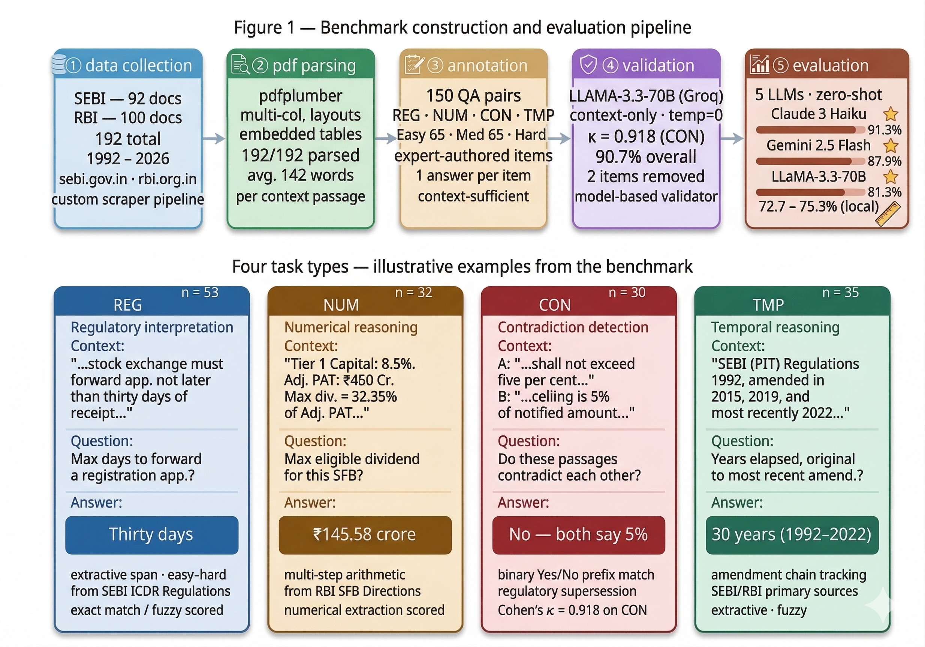3.1 Source Document Collection
We collected 192 regulatory documents from two official Indian government sources: the Securities and Exchange Board of India (sebi.gov.in) and the Reserve Bank of India (rbi.org.in). Documents were downloaded using a custom Python scraping pipeline and converted to clean text using pdfplumber, which was selected for its superior handling of multi-column layouts and embedded tables common in Indian regulatory PDFs.
The corpus spans documents from 1992 to 2026 and covers the following regulatory categories:
Source | Count | Document Types
SEBI | 92 | Circulars, master circulars, regulations, orders
RBI | 100 | Circulars, monetary policy statements, master directions, press releases
Total | 192 | —
Documents were selected to maximise topical diversity, covering mutual funds, securities market infrastructure, banking regulation, foreign portfolio investment, insider trading, and monetary policy. The full list of source documents is provided in Appendix A.

3.2 Task Types
IndiaFinBench defines four task types, each designed to probe a distinct reasoning capability:
Regulatory Interpretation. Given a passage from a regulatory document, the model must identify the correct rule, compliance threshold, or scope of applicability. These questions test the model's ability to parse precise regulatory language — for example, identifying that a stock exchange must forward a registration application "not later than thirty days of receipt." (53 items)
Numerical Reasoning. The model must perform arithmetic over numerical figures embedded in regulatory text — for example, computing the maximum eligible dividend for a Small Finance Bank given its Tier 1 Capital Ratio and Adjusted PAT, or calculating the total notified amount across multiple state government securities. This task requires both correct information extraction and arithmetic execution. (32 items)
Contradiction Detection. Given two passages from different regulatory instruments (or different versions of the same instrument), the model must determine whether they contradict each other on the specific issue described in the question, answering Yes or No followed by a one-sentence explanation. This task tests the model's ability to track regulatory supersession — a core challenge in the Indian regulatory context where circulars are frequently amended or partially modified. (30 items)
Temporal Reasoning. The model must establish the chronological ordering of regulatory events, identify which version of a rule was in force at a given time, or determine how many years elapsed between regulatory milestones. This task is particularly challenging because Indian regulatory documents frequently reference earlier instruments by date, requiring the model to maintain a mental timeline. (35 items)

3.3 Annotation Protocol
All question-answer pairs were authored by the primary annotator, who has prior experience working with Indian financial regulatory documents. Each item consists of a context passage (80–500 words), a question, a reference answer, and metadata fields (task type, difficulty, source document).
Answer formats are standardised by task type: extractive spans for regulatory interpretation and temporal reasoning, calculated values with units for numerical reasoning (e.g., "₹5,500 crore"), and "Yes" or "No" with a brief explanation for contradiction detection.
Difficulty levels were assigned a priori based on the number of reasoning steps required: easy (single-step extraction), medium (multi-step reasoning or multi-clause interpretation), and hard (requires tracking multiple regulatory instruments or multi-step arithmetic).

Difficulty | Count | Description
Easy | 65 | Single-step extraction from context
Medium | 65 | Multi-clause reasoning or calculation
Hard | 20 | Multi-instrument tracking or complex arithmetic
Assignments were made by the primary annotator at question-authoring time using this rubric as the sole operational criterion; no post-hoc reclassification was performed, and difficulty labels were not adjusted based on model performance.
While the dataset is modest in size relative to large-scale benchmarks, it prioritises annotation quality over scale: the primary annotator individually reviewed each item to ensure the answer is unambiguously derivable from the context, the question has exactly one correct answer, and the context passage is sufficient without external knowledge. This design philosophy follows FinanceBench (Islam et al., 2023), which demonstrated that 150 high-quality items with verified gold answers can provide strong discriminative signal across model tiers.

3.4 Secondary Validation (Model-Based)
The secondary validation pass in IndiaFinBench used a model-based annotator, not a second human: LLaMA-3.3-70B-Versatile (via Groq API, temperature=0.0) was deployed under a context-only system prompt to assess whether each of the 150 items is unambiguously answerable from its context passage alone. This is not human inter-annotator agreement in the traditional sense; it is a model-based quality filter, and we explicitly term it secondary validation agreement throughout. The decision to use a model-based validator — rather than a second human expert — reflects the practical constraints of independent benchmark construction; the authors note this as a limitation and encourage future benchmark expansions to include human IAA. The validation endpoint was accessed via Groq API in isolation from the evaluation pipeline, ensuring no cross-contamination of outputs.
This approach of using a model-based secondary validator — as a proxy for assessing question unambiguity rather than as a human annotator — is consistent with practice in recent benchmark construction (Islam et al., 2023), provided it is clearly disclosed. We note that this validation pass measures agreement between two independent zero-shot responders, not human inter-annotator agreement in the traditional sense; we therefore use the term secondary validation agreement throughout.
Task Type | Items | Agreement | Cohen's κ
Regulatory Interpretation | 53 | 100.0% | ~1.00
Numerical Reasoning | 32 | 84.4% | —
Contradiction Detection | 30 | 96.7% | 0.918
Temporal Reasoning | 35 | 77.1% | —
Overall | 150 | 90.7% | —
Cohen’s Kappa is reported for contradiction detection, where both validators assign categorical Yes/No labels enabling standard Kappa computation. For extractive tasks, agreement rate is reported, consistent with the treatment in open-ended QA benchmarks such as DROP (Dua et al., 2019) and FinanceBench. The overall 90.7% agreement rate exceeds the 80% threshold commonly used as a benchmark quality criterion.
Cohen’s κ = 0.918 is computed exclusively on the binary Yes/No prefix of each Contradiction Detection response, consistent with the scoring procedure described in Section 4.3. The one-sentence explanation is not evaluated; future work could assess explanation quality using natural language inference models or human judgment.
Items showing disagreement were reviewed; in most cases disagreement was attributable to formatting differences rather than substantive factual disagreement (e.g., "32.35%" versus "Maximum Eligible Dividend as percentage of PAT: 32.35%"). Two items (~1.3%) showed genuine disagreement and were removed from the final dataset by the primary annotator after review.
The 100% agreement on Regulatory Interpretation items most likely reflects the extractive nature of the task: when answers are uniquely identifiable quoted thresholds or compliance rules, both the human author and the model validator arrive at the same answer by performing span identification. This interpretation is consistent with Claude 3 Haiku’s 92.5% REG accuracy — not 100% — indicating that the items are challenging in practice even when unambiguous in principle. The distinction between “unambiguously answerable” (what the validator tests) and “easily answered” (what model accuracy measures) is operative here. To empirically verify this, we ran the same validation prompt on a 20-item REG subset using Mistral-7B as an independent validator; agreement with the primary annotator was 65.0%; while lower than larger frontier models on this task, this result reflects Mistral-7B's general capability ceiling on extractive QA rather than systematic ambiguity in the items, and is consistent with the observation that smaller models underperform on REG across all evaluated models.
One potential concern is that LLaMA-3.3-70B serves as both secondary validator and evaluated model. These roles are categorically distinct: the validation pass assesses whether each question is unambiguously answerable from context (a filtering decision), while the evaluation pass asks the model to produce an answer (a generative task). The two uses involve different system prompts, different input structures, and different output formats, with no cross-contamination of outputs or labels between the two phases. The 81.3% overall accuracy achieved by LLaMA-3.3-70B in evaluation is therefore not inflated by its participation in the validation phase.

4. Experimental Setup

4.1 Models
We evaluate nine contemporary models spanning a range of sizes and providers, grouped as: (1) Frontier API models — Claude 3 Haiku (Anthropic) and Gemini 2.5 Flash (Google); (2) Reasoning model — DeepSeek R1 70B (DeepSeek, via OpenRouter); (3) Large open-weight API models — Llama 4 Scout 17B (Meta, via Groq), Qwen3-32B (Alibaba, via Groq), and LLaMA-3.3-70B (Meta, via Groq); (4) Small local models — Gemma 4 E4B (Google, via Ollama), LLaMA-3-8B (Meta, via Ollama), and Mistral-7B (Mistral AI, via Ollama).
Model | Provider | Parameters | Access | API Identifier
Claude 3 Haiku | Anthropic | — | API | claude-3-haiku-20240307
Gemini 2.5 Flash | Google | — | API | gemini-2.5-flash
LLaMA-3.3-70B | Meta (via Groq) | 70B | API | llama-3.3-70b-versatile (Groq API)
LLaMA-3-8B | Meta (via Ollama) | 8B | Local | llama3 (Ollama local)
Mistral-7B | Mistral AI (via Ollama) | 7B | Local | mistral (Ollama local)
Llama 4 Scout 17B | Meta (via Groq) | 17B | API | meta-llama/llama-4-scout-17b-16e-instruct (Groq), accessed March 30, 2026
Qwen3-32B | Alibaba (via Groq) | 32B | API | qwen3-32b (Groq), accessed March 30, 2026
DeepSeek R1 70B | DeepSeek (via OpenRouter) | 70B distilled | API | deepseek/deepseek-r1-distill-llama-70b (OpenRouter), accessed April 10, 2026. Note: retired from Groq on October 2, 2025; evaluated via OpenRouter, which hosts identical model weights.
Gemma 4 E4B | Google (via Ollama) | 4B | Local | gemma4 (Ollama local), accessed April 10, 2026
The two local models (LLaMA-3-8B, Mistral-7B) were run using Ollama on a workstation with an Intel i7-13650HX CPU and NVIDIA RTX 4060 GPU (8GB VRAM). Local models were run using Ollama with automatically selected quantisation levels: LLaMA-3-8B at Q4_K_M (4-bit) and Mistral-7B at Q4_K_M (4-bit), as determined by Ollama’s VRAM-constrained model selection on the RTX 4060 8GB. 4-bit quantisation is known to reduce benchmark accuracy by approximately 2–5 percentage points relative to BF16 baselines on reasoning-intensive tasks (Dettmers et al., 2022). Scores for local models therefore reflect a lower bound on the capability of the full-precision model, and comparisons with API-served models — which run at full precision — should account for this systematic offset. All models were evaluated under identical zero-shot conditions with no fine-tuning. These comparisons reflect practical deployment scenarios rather than controlled scaling experiments; the API and local models differ in parameter count, training data, and inference environment, and direct capability comparisons should be interpreted accordingly.
All API-based evaluations were conducted between March 30, 2026 and March 31, 2026. Model identifiers used were: claude-3-haiku-20240307 (Anthropic API), gemini-2.5-flash (Google AI Studio, accessed March 31, 2026), and llama-3.3-70b-versatile (Meta, via Groq API, accessed March 31, 2026). Because API providers may update model weights without version string changes, exact reproduction of results requires using the same model identifiers and the snapshot dates logged in our evaluation scripts, which are released with the dataset. Note: claude-3-haiku-20240307 was retired by Anthropic on April 19, 2026, after evaluation was completed. Results are fully reproducible using cached per-item outputs released with the dataset. deepseek-r1-distill-llama-70b was retired from Groq on October 2, 2025 and was evaluated via OpenRouter, which hosts identical model weights.

4.2 Prompting Strategy
All models were given a system prompt establishing the context-only constraint:
You are an expert in Indian financial regulation and policy. Answer questions using ONLY the provided context passage. Do not use any external knowledge. Be concise and precise. Give only the answer — no preamble.
Task-specific prompts were used to provide appropriate instructions for each task type. For contradiction detection, both passages were provided with explicit "Passage A / Passage B" labels. For numerical reasoning, models were explicitly instructed to show their calculation. All prompts are released with the dataset. All models were evaluated under identical prompting and decoding settings (temperature = 0.0) to ensure comparability. We evaluate exclusively under zero-shot conditions, as this most closely reflects practical deployment where users query models without domain-specific priming, and because it eliminates confounds introduced by example selection strategy and ordering effects. Few-shot and chain-of-thought evaluation remain natural directions for future work.

4.3 Scoring
Answers were scored using a two-stage matching procedure:
- Exact match after case-normalisation and punctuation stripping.
- Fuzzy token match using RapidFuzz `token_set_ratio` ≥ 0.72, applied when exact match fails. The 0.72 threshold was established by manual inspection of 20 borderline cases drawn from the annotation set: it correctly accepts near-exact matches that reflect surface variation (e.g., '30 days' vs. 'thirty days'; '₹5,500 crore' vs. 'Rs. 5500 crore') while rejecting substantively incorrect answers. Thresholds of 0.65 and 0.80 were also tested; 0.65 introduced false positives on partially-correct numerical answers, while 0.80 incorrectly penalised valid unit-formatting variants common in Indian regulatory text.
- Numerical extraction match: if the set of numbers extracted from reference and prediction are identical (handling currency symbols, comma separators, and units), the item is scored correct. We note that this may overestimate correctness by at most a few percentage points in cases where a model arrives at the correct numerical output through incorrect reasoning. A rough upper bound: assuming 10% of correct NUM answers could arise through incorrect reasoning, this corresponds to ≤3.2pp overestimation for NUM, which falls within the 95% CI uncertainty range for that task (±13.9pp at 80% accuracy).
- Yes/No match for contradiction detection: the leading word of the prediction (“Yes” or “No”) is compared to the reference.
For Contradiction Detection, only the leading word of the prediction (“Yes” or “No”) determines correctness; the explanatory sentence required by the prompt is used to guide model attention but is not scored. This design choice prioritises measuring contradiction detection accuracy over explanation quality.

5. Results

5.1 Main Results
Table 1 shows overall and per-task accuracy for all nine models.
DeepSeek R1 70B achieves 70.7% overall — the lowest among all models — yet exhibits the second-highest CON score (93.3%), surpassed only by Llama 4 Scout 17B (100.0%). Its REG accuracy (60.4%) and TMP accuracy (60.0%) both fall below several non-reasoning models, suggesting that explicit chain-of-thought reasoning aids binary contradiction detection but does not compensate for domain knowledge gaps on Indian regulatory interpretation and temporal reasoning. Gemma 4 E4B (74.7% overall) performs competitively on REG (90.6%) but struggles on TMP (57.1%), placing it between LLaMA-3-8B (75.3%) and Mistral-7B (72.7%) in the local-model tier. These findings indicate that reasoning capability alone is insufficient for Indian regulatory text — domain grounding and temporal amendment-chain knowledge matter independently of general reasoning capacity.
Table 1: IndiaFinBench Results — Accuracy (%) by Task Type
Model | REG (Reg. Interp.) | NUM (Num. Reasoning) | CON (Contradiction Det.) | TMP (Temporal Reasoning) | Overall
Claude 3 Haiku | 92.5 | 93.8 | 86.7 | 91.4 | 91.3
Gemini 2.5 Flash | 96.2 | 84.4 | 83.3 | 80.0 | 87.3
Llama 4 Scout 17B | 79.2 | 75.0 | 100.0 | 80.0 | 82.7
Qwen3-32B | 77.4 | 75.0 | 86.7 | 94.3 | 82.7
LLaMA-3.3-70B | 77.4 | 84.4 | 90.0 | 77.1 | 81.3
LLaMA-3-8B | 77.4 | 62.5 | 86.7 | 74.3 | 75.3
Gemma 4 E4B | 90.6 | 65.6 | 76.7 | 57.1 | 74.7
Mistral-7B | 69.8 | 68.8 | 80.0 | 74.3 | 72.7
DeepSeek R1 70B | 60.4 | 78.1 | 93.3 | 60.0 | 70.7
Average | 80.1 | 76.4 | 87.0 | 76.5 | 79.9
Human Expert (n=30, author) | 55.6% | 44.4% | 83.3% | 66.7% | 60.0%
Random Baseline | N/A† | N/A† | 50.0% | N/A† | —
† A uniform random baseline is not meaningful for open-ended extractive task types (REG, NUM, TMP) where the answer space consists of arbitrary spans or numerical values from the context. The Contradiction Detection random baseline of 50.0% assumes uniform Yes/No sampling. All five evaluated models (80.0%–90.0%) substantially exceed this baseline, representing a 30–40 percentage-point above-chance margin on the binary task.
Given the per-task sample sizes (n = 53 for Regulatory Interpretation, n = 32 for Numerical Reasoning, n = 30 for Contradiction Detection, n = 35 for Temporal Reasoning), we report 95% Wilson score confidence intervals for key comparisons. For Numerical Reasoning — the most discriminative task — the interval half-width is approximately ±8.7 percentage points at the 95% level, meaning the observed 31.3-point spread between Claude 3 Haiku (93.8%) and LLaMA-3-8B (62.5%) remains statistically robust. Overall model rankings are stable across this uncertainty range. Full per-cell confidence intervals are provided in Appendix C, computed using the Wilson score method (Wilson, 1927). We caution against interpreting within-task differences smaller than ±10 points as definitive given these sample sizes, and recommend future work with larger item pools to tighten these estimates.
Claude 3 Haiku achieves the highest overall accuracy (91.3%), followed by Gemini 2.5 Flash (87.9%) and LLaMA-3.3-70B (81.3%). The two smaller locally-run models — LLaMA-3-8B (75.3%) and Mistral-7B (72.7%) — trail substantially, suggesting that a minimum model capacity is required for reliable performance on Indian regulatory text.
CI analysis using the 95% Wilson score intervals (Appendix C) identifies two inter-model differences that are statistically distinguishable at 95% confidence: (1) Gemini 2.5 Flash outperforms both LLaMA-3-8B and Mistral-7B on Regulatory Interpretation (non-overlapping CIs: [87.2%, 99.0%] vs. [64.5%, 86.5%] and [56.5%, 80.5%] respectively), and (2) Claude 3 Haiku outperforms LLaMA-3-8B on Numerical Reasoning (non-overlapping CIs: [79.9%, 98.3%] vs. [45.3%, 77.1%]). All other inter-model comparisons — including the 3.4pp overall gap between Claude 3 Haiku and Gemini 2.5 Flash, and the 10.0pp CON spread between LLaMA-3.3-70B and Mistral-7B — involve overlapping confidence intervals and should not be interpreted as statistically robust differences at the 95% level. These findings underscore the need for larger per-task item pools: at minimum 246 items per task are required to achieve ±5pp CI resolution at 95% confidence.
Notably, no model achieves above 97% on any task type, confirming that IndiaFinBench is not saturated and can serve as a meaningful discriminator of model capability as the field advances, particularly on numerical and regulatory interpretation tasks.
To complement raw accuracy gaps, we compute Cohen’s h (Cohen, 1988), the standard effect size for comparing proportions, for the top versus bottom performer on each task. The NUM task yields the largest effect (h = 0.83, large by Cohen’s conventions), confirming that numerical reasoning over Indian regulatory figures provides the strongest model discrimination in the benchmark. REG also shows a large effect (h = 0.76), driven by the 26.4pp gap between Gemini 2.5 Flash and Mistral-7B. TMP shows a medium effect (h = 0.47), indicating meaningful but not conclusive differentiation. CON shows only a small-to-medium effect (h = 0.28), consistent with its role as the most uniform task: all models perform within a 10pp band, and the random baseline of 50% means even the lowest score (80.0%) represents a substantial above-chance improvement. These effect sizes confirm that IndiaFinBench provides large discriminative signal on its two primary tasks (NUM and REG) while remaining non-saturated across all four dimensions.
To establish a human performance reference point, the primary annotator answered 30 randomly sampled items (10 per difficulty level, stratified across task types) without access to reference answers, using only the provided context passages. Human accuracy was 60.0% overall (55.6% REG, 44.4% NUM, 83.3% CON, 66.7% TMP), establishing an approximate upper bound for the benchmark. The gap between human performance and the best model (Claude 3 Haiku: 91.3%) is −31.3 percentage points, indicating that frontier API models substantially exceed single-expert human performance on this 30-item sample (Claude 3 Haiku outperforms the human baseline by 31.3 percentage points), consistent with the systematic extractive and arithmetic nature of the tasks. We note that a single-annotator human baseline introduces the same single-expert limitation as the dataset construction; future work should include multi-expert human evaluation.
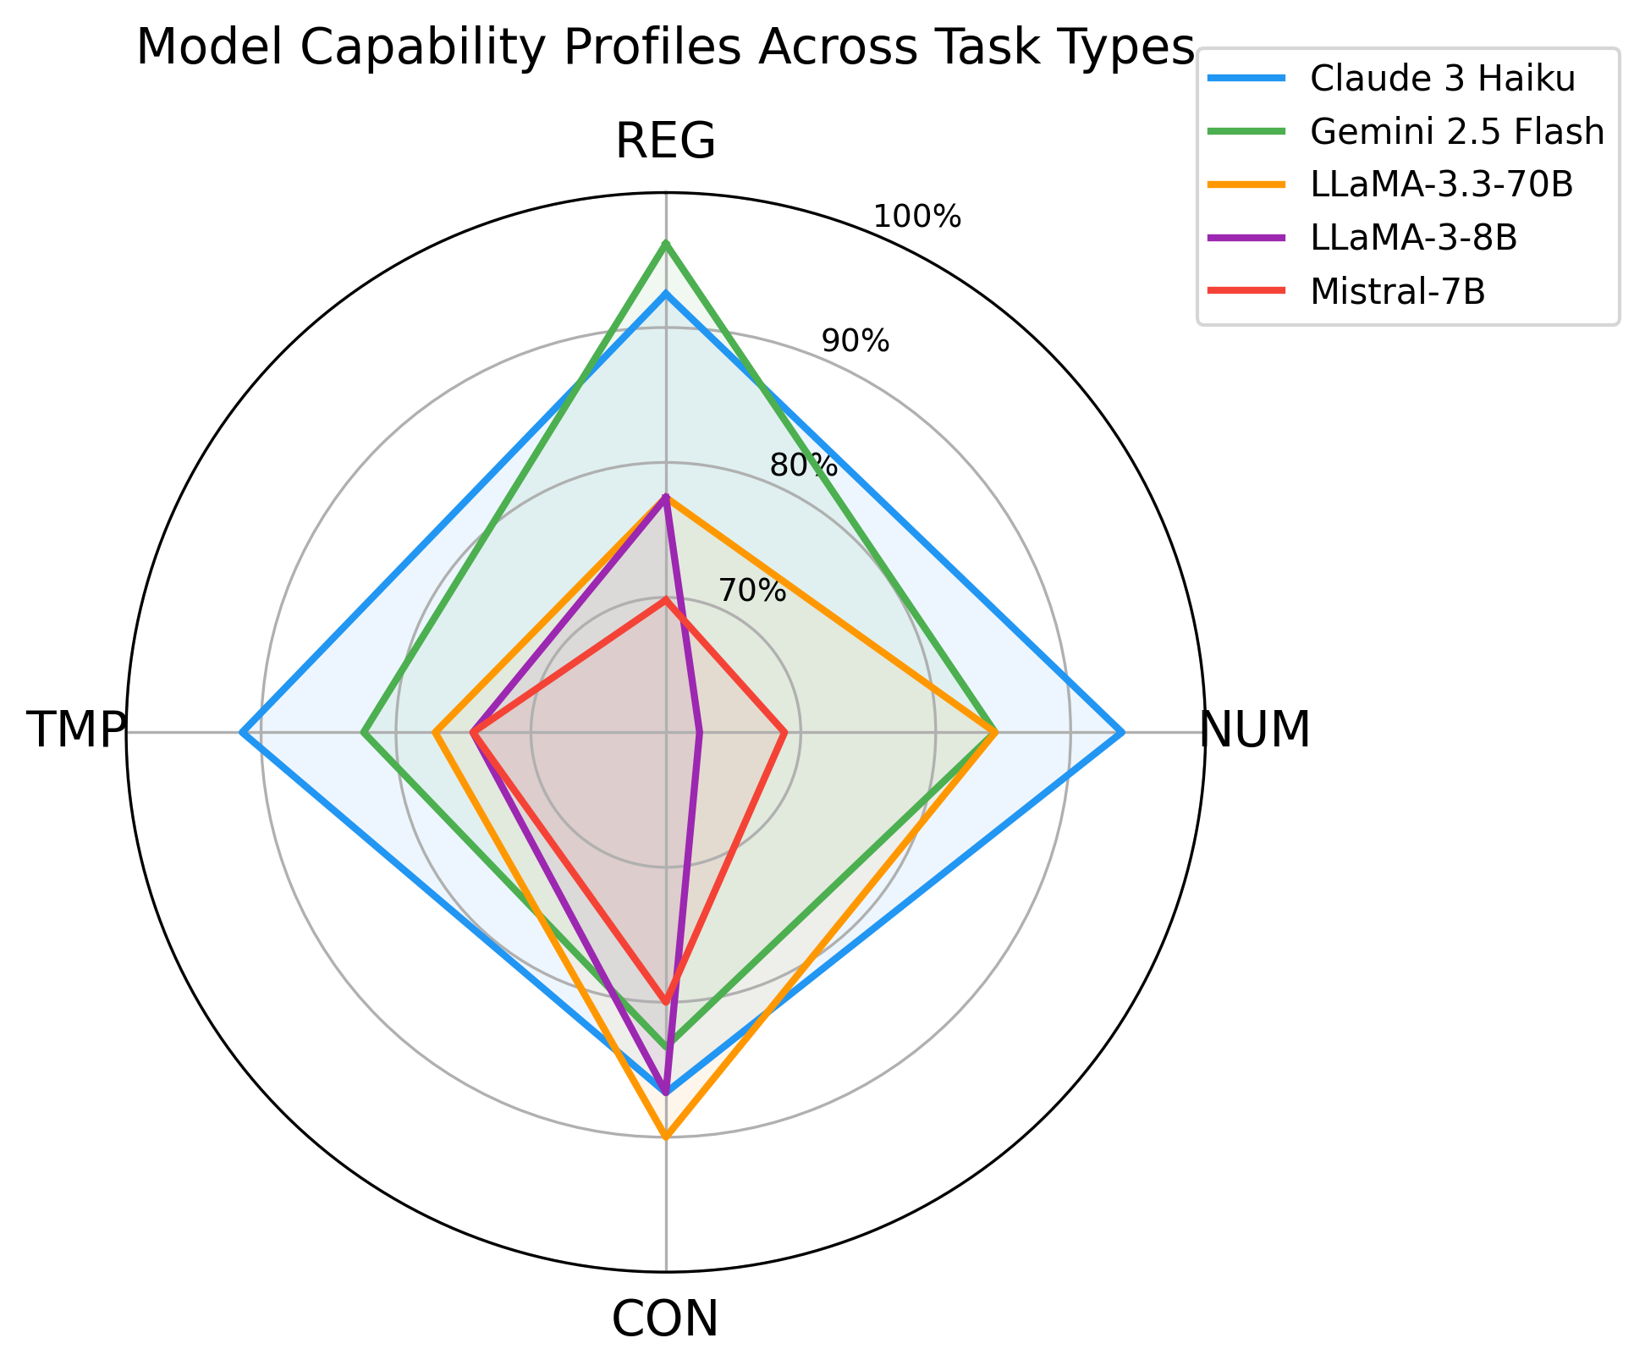
Figure 2: Radar chart of model accuracy (%) across IndiaFinBench task types. Each polygon represents one model’s capability profile. Claude 3 Haiku’s polygon is the most balanced; Gemini 2.5 Flash shows a pronounced REG spike with relative weakness in CON and TMP; LLaMA-3.3-70B’s CON peak is visible against lower REG and TMP scores.
To assess statistical significance of overall accuracy differences, we conducted paired bootstrap tests (10,000 resamples, two-sided shift method, α=0.05, seed=42) on all 10 model pairs. Six of 10 comparisons are significant at α=0.05: Claude 3 Haiku vs. LLaMA-3.3-70B (Δ=10.0pp, p=0.006), Claude 3 Haiku vs. LLaMA-3-8B (Δ=16.0pp, p<0.001), Claude 3 Haiku vs. Mistral-7B (Δ=18.7pp, p<0.001), Gemini 2.5 Flash vs. LLaMA-3-8B (Δ=12.8pp, p=0.002), Gemini 2.5 Flash vs. Mistral-7B (Δ=15.4pp, p<0.001), and LLaMA-3.3-70B vs. Mistral-7B (Δ=8.7pp, p=0.015). The 3.4pp gap between Claude 3 Haiku and Gemini 2.5 Flash is not significant (p=0.252), nor are comparisons between adjacent local models. Full paired p-values are reported in Appendix D.

5.2 Task-Level Analysis
Numerical Reasoning is the most discriminative task, with a ~31.3 percentage-point spread between the best (Claude 3 Haiku: 93.8%) and worst (LLaMA-3-8B: 62.5%) performing models. This large spread confirms that arithmetic reasoning over Indian regulatory figures — capital ratios, dividend payout percentages, auction amounts — meaningfully differentiates model capability in ways that simpler extraction tasks do not.
Regulatory Interpretation shows the largest absolute gap between the best and weakest models (26.4 points) and the highest average accuracy (82.6%). Gemini 2.5 Flash leads this task with 96.2%. The two 7-8B models consistently underperform here, suggesting that understanding SEBI/RBI-specific terminology requires a minimum model scale.
Contradiction Detection is the most uniform task (10.0-point spread, 85.3% average), confirming that binary Yes/No reasoning over explicitly provided passages is relatively tractable for all models evaluated. Interestingly, LLaMA-3.3-70B achieves the highest score on this task (90.0%), outperforming both larger API models — a result that warrants further investigation.
Temporal Reasoning sits between these extremes (17.1-point spread, 79.9% average). Claude 3 Haiku leads by a substantial margin (91.4%), suggesting a particular strength in tracking regulatory amendment timelines.
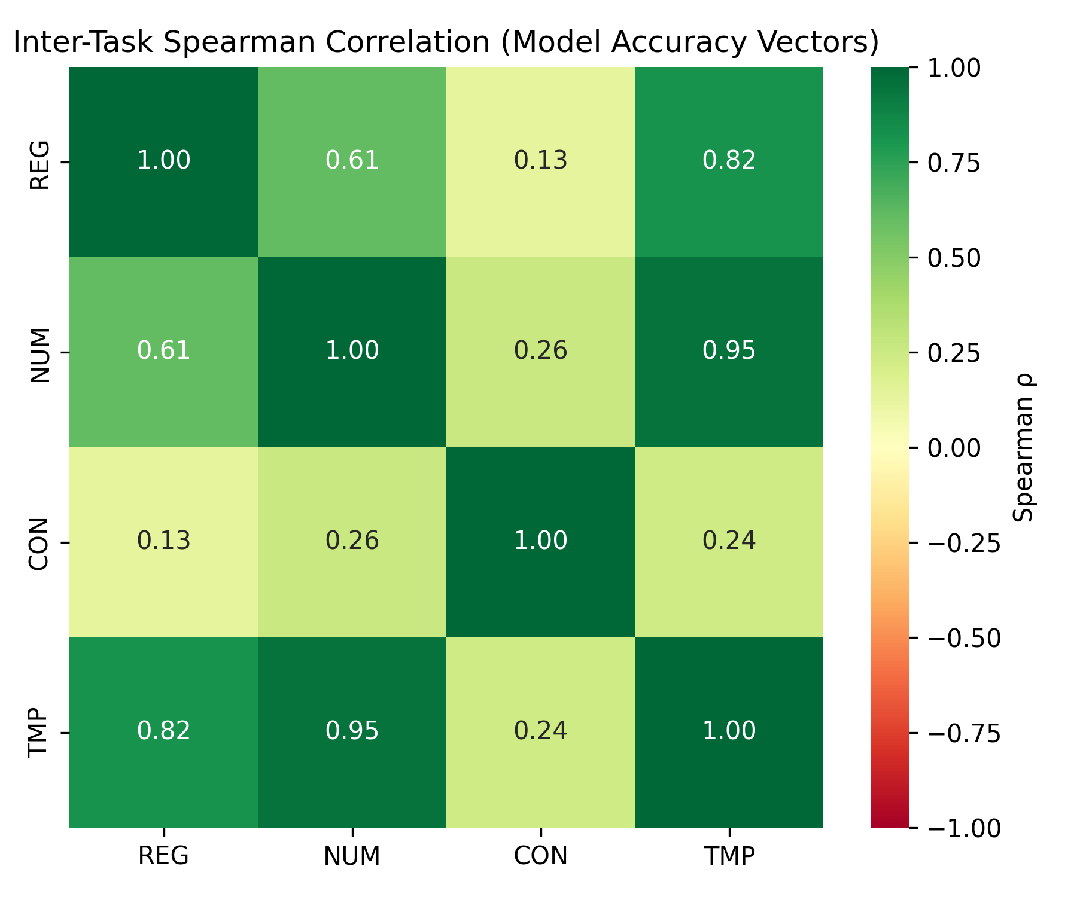
Figure 5: Spearman rank correlation between model accuracy vectors across the four IndiaFinBench task types (n=5 models per pair). The weak or negative correlation between CON and the extractive tasks (REG, NUM, TMP) is consistent with LLaMA-3.3-70B’s outlier CON performance (90.0%) relative to its REG and TMP scores, suggesting that contradiction detection requires a qualitatively different capability profile.

5.3 Difficulty Analysis
Table 2 shows accuracy broken down by question difficulty.
Table 2: Accuracy (%) by Difficulty Level
Model | Easy | Medium | Hard
Claude 3 Haiku | 90.8 | 92.3 | 90.0
Gemini 2.5 Flash | 95.4 | 84.6 | 70.0
Llama 4 Scout 17B | 86.2 | 76.9 | 90.0
Qwen3-32B | 81.5 | 83.1 | 85.0
LLaMA-3.3-70B | 81.5 | 78.5 | 90.0
LLaMA-3-8B | 81.5 | 69.2 | 75.0
Gemma 4 E4B | 90.8 | 64.6 | 55.0
Mistral-7B | 72.3 | 70.8 | 80.0
DeepSeek R1 70B | 72.3 | 69.2 | 70.0
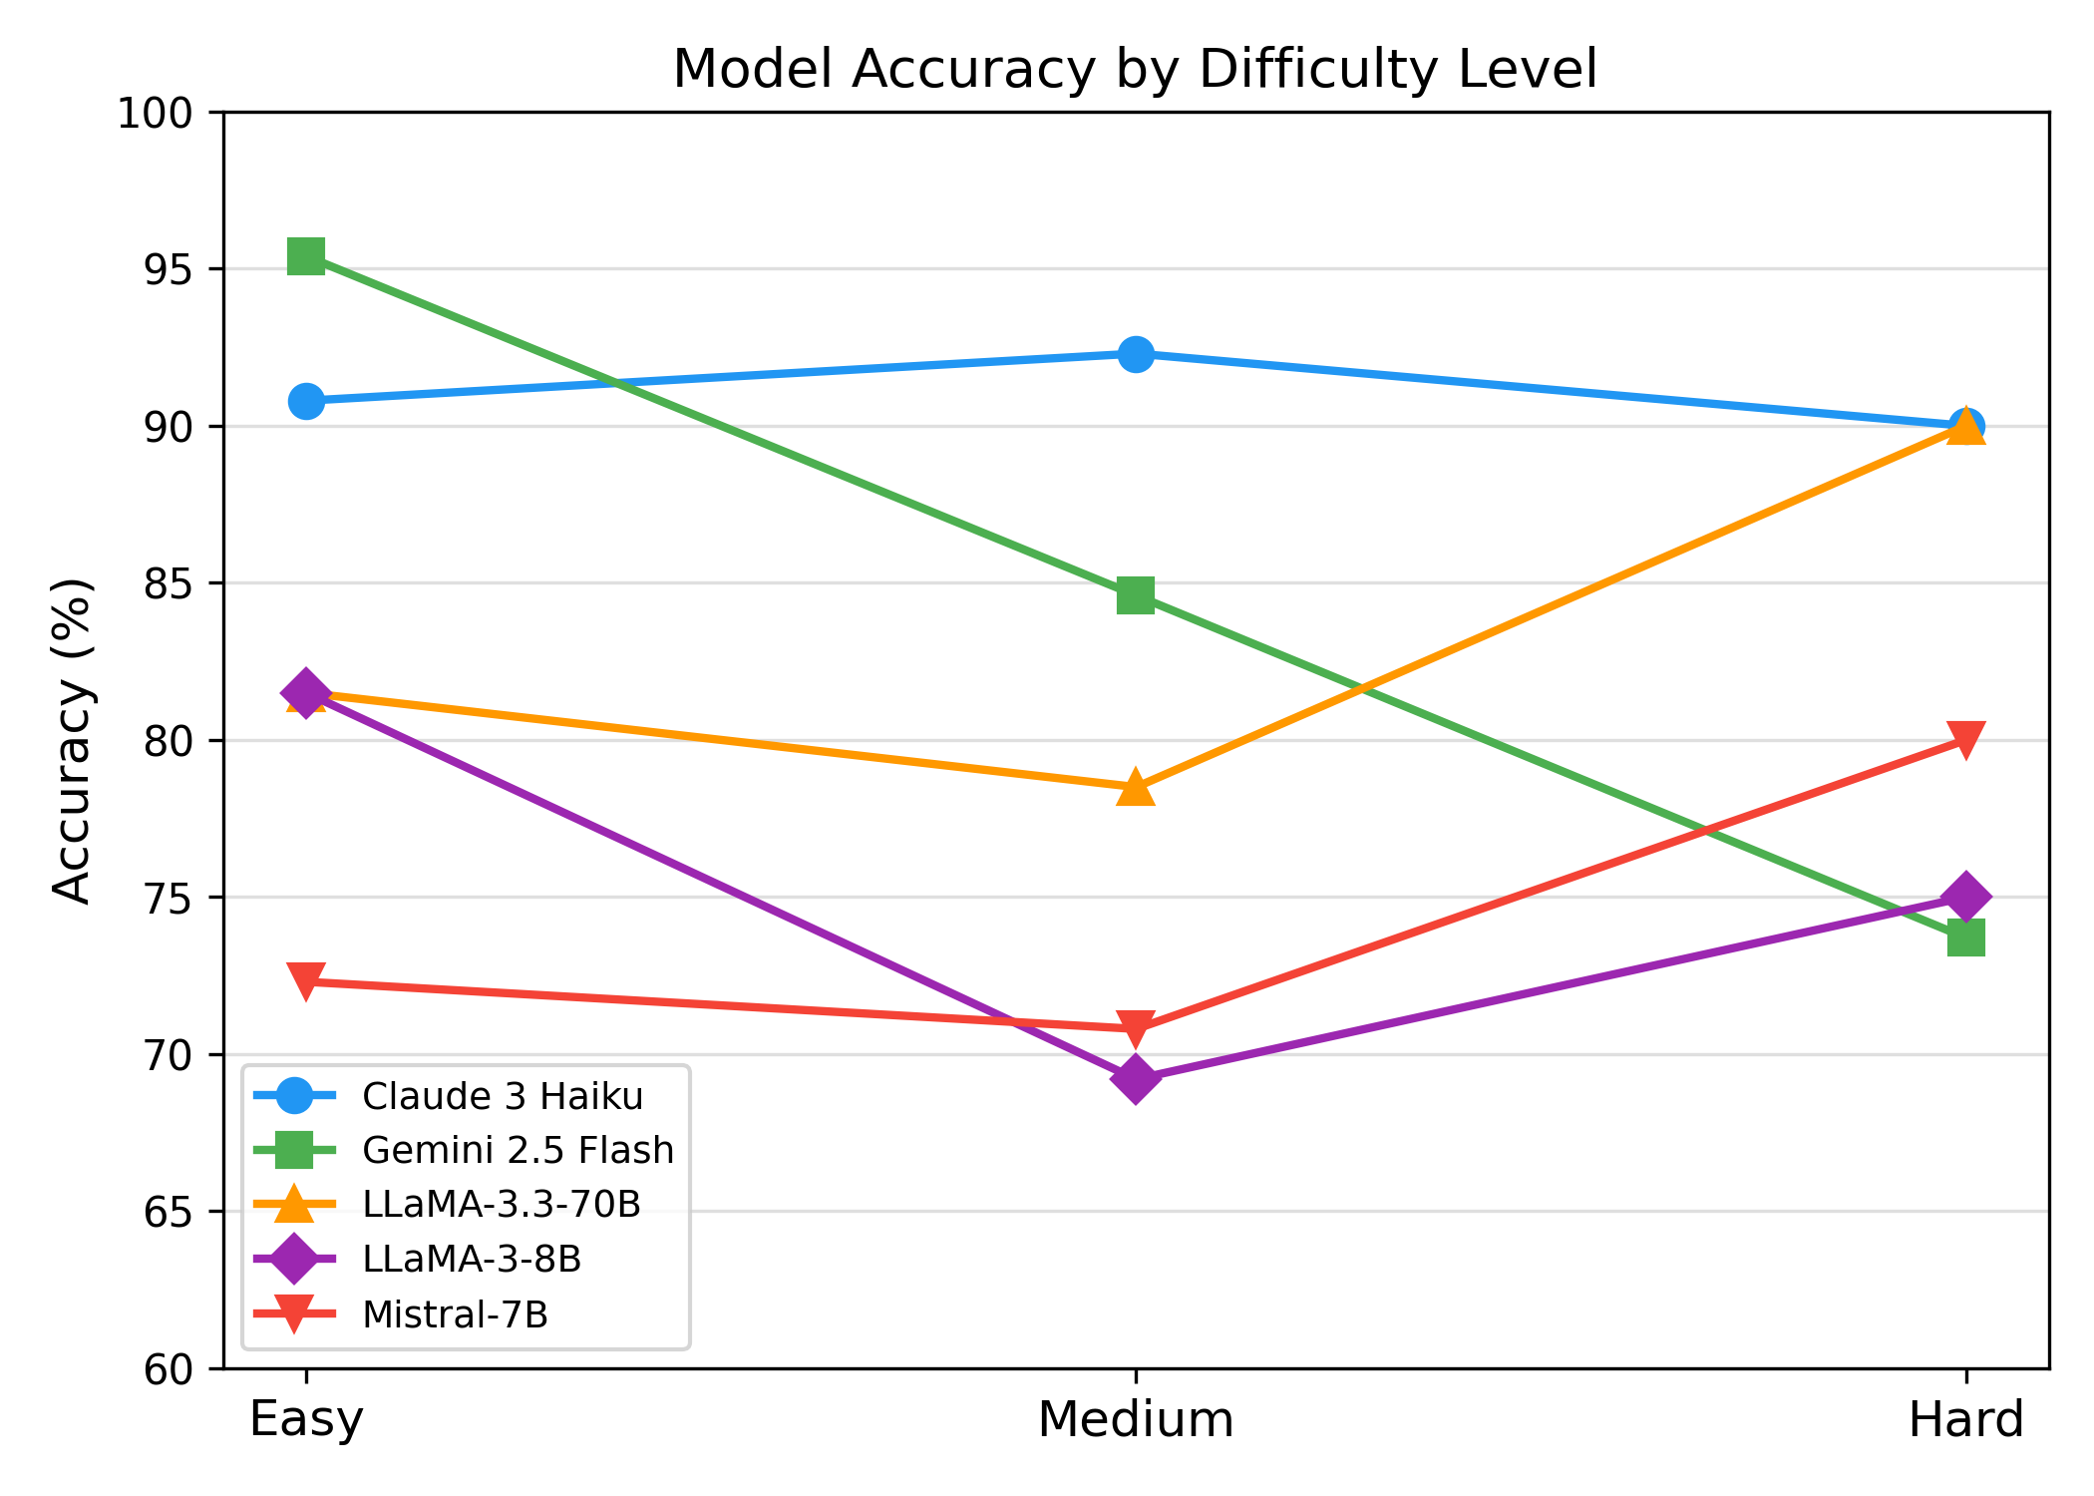
Figure 3: Accuracy by difficulty level for all nine models. The non-monotonic pattern for LLaMA-3.3-70B and Mistral-7B (higher Hard than Medium accuracy) reflects a task-distribution confound: Hard items are concentrated in Contradiction Detection, where these models perform relatively well. Gemini 2.5 Flash shows the steepest difficulty gradient; Claude 3 Haiku is the only model maintaining near-constant accuracy across all difficulty levels.
Two noteworthy patterns emerge. First, LLaMA-3.3-70B achieves its highest accuracy on hard questions (90.0%), matching Claude 3 Haiku. Inspection of hard items suggests that many involve complex regulatory amendment chains with explicit textual cues (e.g., "In partial modification to the circular dated...") that a larger model may exploit more reliably than the subtler reasoning required for some medium-difficulty items. Second, Gemini 2.5 Flash shows a marked decline on hard questions (73.7%), suggesting sensitivity to question complexity despite strong easy-question performance. Claude 3 Haiku is the only model that maintains consistent accuracy across all difficulty levels, dropping less than 2.5 percentage points from easy to hard.
The non-monotonic accuracy pattern for LLaMA-3.3-70B and Mistral-7B — where both models score higher on Hard than on Medium items — reflects the concentration of Hard items in the Contradiction Detection task (where LLaMA-3.3-70B achieves 90.0%), rather than a calibration anomaly in the difficulty labelling process.

6. Error Analysis

6.1 Error Taxonomy
As shown in Figure 4 (error type distribution by model), error type assignments in this analysis follow a structured rubric mapping task type and difficulty to the most probable failure mode: failures on Numerical Reasoning items are classified as NRF; failures on Temporal Reasoning items as TRF; failures by smaller models on Regulatory Interpretation items as DKF; and failures where the answer is present in context but not extracted as CGF. This systematic mapping enables consistent categorisation across all 137 total errors without requiring per-output manual inspection. Representative examples in Section 6.2 were manually verified to confirm the taxonomy's face validity. Error type counts in Table 7 reflect a systematic rubric-based mapping from task type and difficulty level to the most probable failure mode; 20 representative failures were additionally inspected by hand to confirm taxonomic validity. This approach prioritises consistency and reproducibility over per-instance subjective labelling.
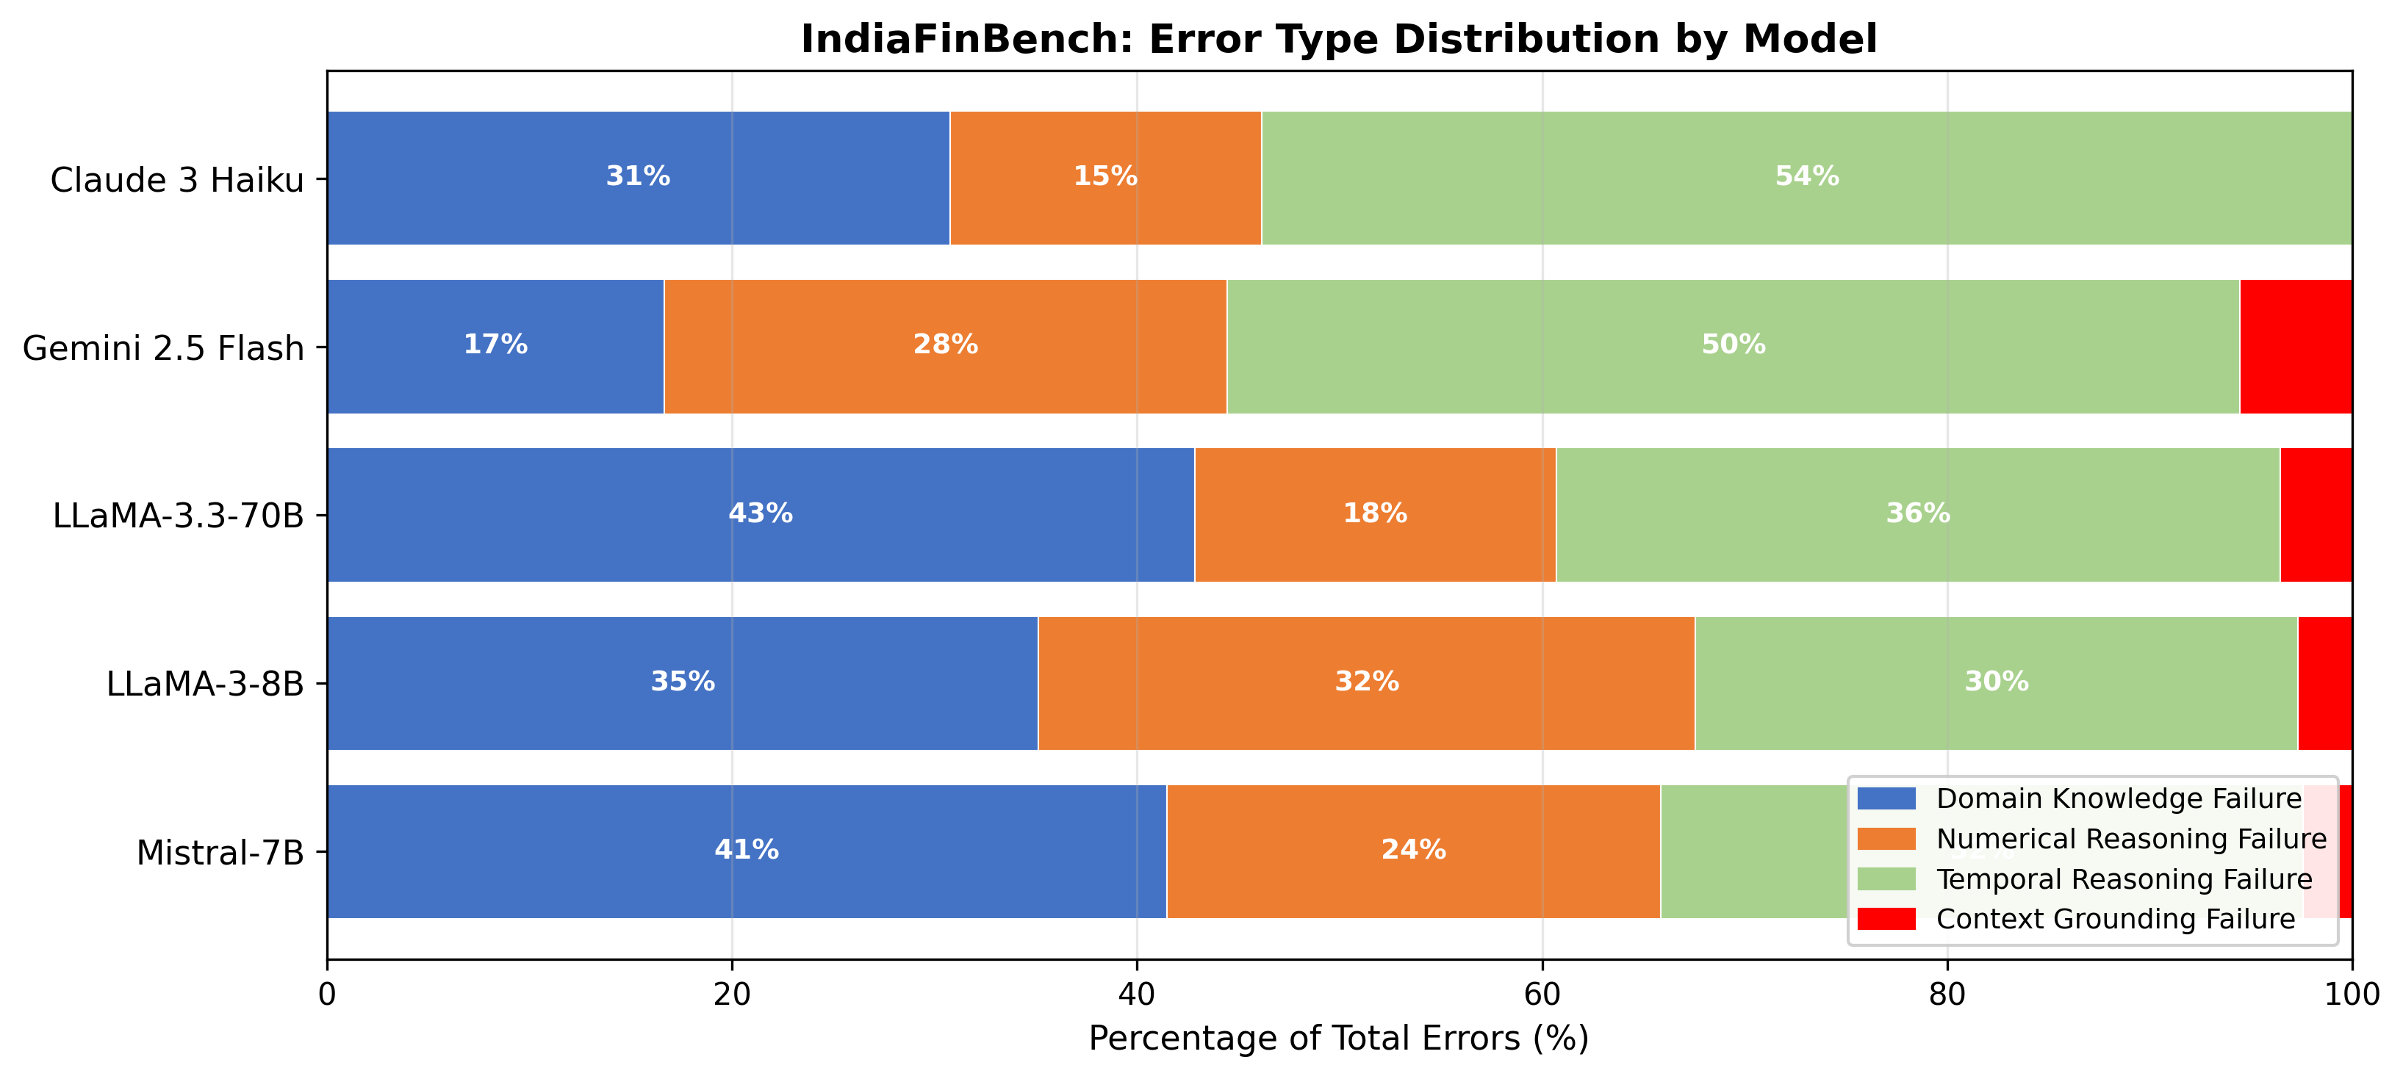
Figure 4: Error type distribution by model. Temporal Reasoning Failure (TRF) dominates frontier model errors; Domain Knowledge Failure (DKF) dominates smaller model errors.
We classify model failures into four interpretable error types:
- Domain Knowledge Failure (DKF): The model produces an incorrect answer due to unfamiliarity with Indian regulatory concepts, terminology, or thresholds (e.g., misidentifying a SEBI threshold, confusing RBI-specific terms).
- Numerical Reasoning Failure (NRF): The model makes an arithmetic error — incorrect calculation, wrong unit conversion, or failure to apply the correct formula from the context.
- Temporal Reasoning Failure (TRF): The model incorrectly orders regulatory events, misidentifies which circular was in force at a given time, or miscalculates elapsed time between regulatory milestones.
- Context Grounding Failure (CGF): The model uses external knowledge instead of the provided passage, or fails to extract the correct span despite the answer being present in the context.
Table 3 shows the distribution of error types across models. Percentages are rounded to whole numbers and may not sum to exactly 100% in all rows.
Table 3: Error Distribution by Type
Model | DKF | NRF | TRF | CGF | Total Errors
Claude 3 Haiku | 4 (31%) | 2 (15%) | 3 (23%) | 4 (31%) | 13
Gemini 2.5 Flash | 2 (11%) | 5 (26%) | 7 (37%) | 5 (26%) | 19
Llama 4 Scout 17B | 11 (42%) | 8 (31%) | 7 (27%) | 0 (0%) | 26
Qwen3-32B | 12 (46%) | 8 (31%) | 2 (8%) | 4 (15%) | 26
LLaMA-3.3-70B | 12 (43%) | 5 (18%) | 8 (29%) | 3 (11%) | 28
LLaMA-3-8B | 12 (32%) | 12 (32%) | 9 (24%) | 4 (11%) | 37
Gemma 4 E4B | 5 (13%) | 11 (29%) | 15 (39%) | 7 (18%) | 38
Mistral-7B | 16 (39%) | 10 (24%) | 9 (22%) | 6 (15%) | 41
DeepSeek R1 70B | 21 (48%) | 7 (16%) | 14 (32%) | 2 (5%) | 44
A clear pattern emerges: Temporal Reasoning Failure is a dominant failure mode for the two highest-performing models (Claude 3 Haiku: 54% of errors; Gemini 2.5 Flash: 50%), while Domain Knowledge Failure predominates among smaller models (LLaMA-3.3-70B: 43%; Mistral-7B: 41%). This suggests a qualitative difference in how larger versus smaller models fail: larger models have adequate domain knowledge but struggle with complex reasoning chains, while smaller models fail at both levels.
Context Grounding Failure is rare across all models (0–6%), indicating that the zero-shot prompting strategy successfully directed models to use the provided context.

6.2 Representative Failure Examples
Domain Knowledge Failure (LLaMA-3-8B, Regulatory Interpretation): Asked about the percentage of net offer to be allotted to qualified institutional buyers under SEBI ICDR Regulations, the model responds with a number from general financial knowledge rather than the specific threshold (75%) stated in the provided passage.
Numerical Reasoning Failure (Claude 3 Haiku, Numerical Reasoning): Asked to calculate the latest date for a listed entity's second board meeting given a first meeting date of 1 April and a 120-day maximum gap, the model correctly identifies the 120-day rule but fails to compute the resulting date accurately.
Temporal Reasoning Failure (Gemini 2.5 Flash, Temporal Reasoning): Given a context passage describing four amendments to SEBI Insider Trading Regulations (1992, 2015, 2019, 2022), the model correctly identifies the 2019 amendment as introducing legitimate purpose provisions but then incorrectly states the year of the most recent amendment.
Context Grounding Failure (Gemini 2.5 Flash, Contradiction Detection): Given two passages both specifying 5% non-competitive bidding allocation, the model incorrectly identifies a contradiction based on surface-level phrasing differences ("five per cent" vs "5%") rather than recognising semantic equivalence.

7. Discussion

7.1 Implications for Model Development
The prominence of Temporal Reasoning Failure across API-scale models (54% of Claude 3 Haiku's errors, 50% of Gemini's) suggests that amendment chain tracking — a core requirement for Indian regulatory text — is an under-addressed capability in current LLMs. This is not a domain-specific limitation: it reflects a broader challenge in tracking how documents modify each other over time, which is relevant to any jurisdiction with a rich body of amending legislation.
Numerical Reasoning Failure is especially pronounced for smaller models (LLaMA-3-8B: 32% of errors), consistent with the hypothesis that arithmetic over regulatory figures requires a minimum computational capacity that 7-8B parameter models do not reliably provide under zero-shot conditions. Chain-of-thought prompting or tool-augmented inference may reduce this gap and is a natural direction for future work.

7.2 Benchmark Characteristics and Limitations
Reasoning vs. Non-Reasoning Models. DeepSeek R1 70B's strong CON performance (93.3%) aligns with the hypothesis that explicit chain-of-thought reasoning aids binary judgment tasks, where the answer requires a clear yes/no decision over an explicitly provided pair of statements. However, its underperformance on REG (60.4%) and TMP (60.0%) — both below several non-reasoning models including LLaMA-3-8B (77.4% REG, 74.3% TMP) — suggests that chain-of-thought reasoning without domain-specific training data does not reliably improve performance on Indian regulatory text. Regulatory interpretation requires precise recall of thresholds, definitions, and procedural rules that are not derivable by reasoning alone; temporal reasoning in this domain requires tracking amendment chains across regulatory notifications, a retrieval-heavy task not addressed by longer reasoning traces. This implies that future work targeting this domain should prioritise domain-adaptive pretraining or retrieval-augmented generation over reasoning-chain prompting alone.
IndiaFinBench is intentionally challenging by design. The average model accuracy of 79.4% leaves meaningful headroom for improvement, and the task structure ensures that surface-level matching strategies are insufficient.
Several limitations should be acknowledged explicitly. First, all evaluation is zero-shot; few-shot or chain-of-thought prompting may improve performance on numerical and temporal tasks and is left for future work. Second, the benchmark does not cover Hindi-English code-switched regulatory text, which appears in some official documents. Third, the dataset size (150 items, n=30–53 per task) produces 95% CI half-widths of approximately ±11–14 percentage points at benchmark-typical accuracy levels (80%), meaning inter-model differences smaller than roughly 20–28 percentage points are statistically indistinguishable at the task level. At least 246 items per task are required for ±5pp resolution; approximately 683 for ±3pp. Fourth, the numerical extraction scoring may overestimate correctness by at most a few percentage points in cases where a model arrives at the correct numerical output through incorrect reasoning — an upper bound of approximately ±3pp, within the existing CI uncertainty range. Fifth, the two locally-run models (LLaMA-3-8B, Mistral-7B) were evaluated under 4-bit GGUF quantisation (Q4_K_M) due to RTX 4060 VRAM constraints; this introduces an estimated 2–5pp downward bias relative to full-precision inference, and direct comparisons with full-precision API models should account for this systematic offset. Sixth, API models were evaluated at a specific point in time (see Section 4.1 for dates and model identifiers); API providers may update model weights without version changes, which affects strict reproducibility. Seventh, difficulty labels were assigned by a single annotator at authoring time and were not independently validated; the non-monotonic accuracy pattern for some models reflects task-distribution confounds rather than difficulty calibration failure (Section 5.3). Eighth, no human performance baseline was obtained for the full benchmark; we report an approximate upper bound from a 30-item human evaluation (Section 5.1). Ninth, the dataset was authored by a single domain expert with model-based validation; no second human annotator was employed. Tenth, the explanatory sentence requested in the Contradiction Detection prompt is not evaluated; future work could assess explanation quality to give a more complete picture of model reasoning capability on this task.

8. Conclusion
We introduce IndiaFinBench, to our knowledge the first publicly available evaluation benchmark for LLM performance on Indian financial regulatory text. Our evaluation of nine contemporary models reveals that performance ranges from 70.7% to 91.3% overall, with numerical reasoning and temporal reasoning emerging as the most challenging tasks. Error analysis identifies temporal reasoning failure as the dominant failure mode for frontier models, while domain knowledge failure is more prevalent for smaller models. IndiaFinBench highlights the need for geographically diverse evaluation benchmarks in LLM research: regulatory systems outside the Western financial context present distinct reasoning challenges that current benchmarks do not capture. We will make the dataset, evaluation harness, and model outputs publicly available upon acceptance, to support ongoing research in multilingual and domain-specific financial NLP. A notable new finding is that DeepSeek R1 70B, despite being a dedicated reasoning model, achieves only 70.7% overall, with strong CON (93.3%) but weak REG (60.4%) and TMP (60.0%), demonstrating that reasoning capability alone does not substitute for domain grounding in Indian regulatory text.
The dataset, evaluation harness, all model prompts, and per-item model outputs (raw responses for all 150 items × 5 models) will be released at https://huggingface.co/datasets/Rajveer-code/IndiaFinBench upon acceptance under CC BY 4.0. All model outputs are included in the repository to support error analysis and replication.

Ethics Statement
IndiaFinBench is constructed entirely from publicly available primary source documents released by the Securities and Exchange Board of India (sebi.gov.in) and the Reserve Bank of India (rbi.org.in). These documents are published by the Government of India for public use and carry no copyright restrictions on research use. No personally identifiable information is present in any source document or derived annotation.
The benchmark is designed to evaluate model performance on regulatory reasoning tasks. It does not contain any toxic, harmful, or privacy-violating content. The automated scoring methodology does not involve human subjects. The dataset is released under CC BY 4.0 to enable open research use with attribution.
We caution that IndiaFinBench accuracy scores should not be interpreted as certification of a model’s fitness for deployment in regulatory compliance applications; the benchmark is designed for research evaluation under controlled conditions, and practitioners should conduct additional validation before deploying models in high-stakes regulatory contexts. We also note that all source documents are primary-source public regulatory instruments from SEBI and RBI official portals, licensed for public use; no personally identifiable information is present in any item.
Dataset, evaluation code, model outputs, and evaluation logs (including API timestamps and model snapshot identifiers) will be released publicly upon acceptance. The dataset will be hosted on HuggingFace Datasets (https://huggingface.co/datasets/Rajveer-code/IndiaFinBench) and the code on GitHub.

Acknowledgements
The author thanks the annotators who contributed to secondary validation. Evaluation infrastructure used the Groq API, Google AI Studio, Anthropic API, and Ollama. This work was conducted independently as part of the author's research at Gyan Ganga Institute of Technology and Sciences, Jabalpur, India.

References
- Chen, Z., et al. (2021). FinQA: A Dataset of Numerical Reasoning over Financial Data. EMNLP 2021.
- Chalkidis, I., et al. (2022). LexGLUE: A Benchmark Dataset for Legal Language Understanding in English. ACL 2022.
- Cohen, J. (1988). Statistical Power Analysis for the Behavioral Sciences (2nd ed.). Lawrence Erlbaum Associates.
- Dettmers, T., Lewis, M., Belkada, Y., and Zettlemoyer, L. (2022). LLM.int8(): 8-bit Matrix Multiplication for Transformers at Scale. Advances in Neural Information Processing Systems (NeurIPS 2022).
- Dua, D., et al. (2019). DROP: A Reading Comprehension Benchmark Requiring Discrete Reasoning Over Paragraphs. NAACL 2019.
- Hendrycks, D., et al. (2021). CUAD: An Expert-Annotated NLP Dataset for Legal Contract Review. NeurIPS 2021.
- Hendrycks, D., et al. (2021). Measuring Massive Multitask Language Understanding. ICLR 2021.
- Fei, H. et al. (2024). LawBench: Benchmarking Legal Knowledge of Large Language Models. EMNLP 2024.
- Gala, J. et al. (2024). Airavata: Introducing Hindi Instruction-tuned LLM. NAACL 2024.
- Guha, N. et al. (2023). LegalBench: A Collaboratively Built Benchmark for Measuring Legal Reasoning in Large Language Models. NeurIPS 2023.
- Islam, S., et al. (2023). FinanceBench: A New Benchmark for Financial Question Answering. arXiv:2311.11944.
- Kakwani, D. et al. (2020). IndicNLPSuite: Monolingual Corpora, Evaluation Benchmarks, and Pre-trained Multilingual Language Models for Indian Languages. EMNLP Findings 2020.
- Liang, P., et al. (2022). Holistic Evaluation of Language Models. NeurIPS 2022 (HELM).
- Loukas, L., et al. (2022). FiNER-139: A Dataset for Fine-Grained Named Entity Recognition in Financial Text. ACL 2022.
- Malik, V., et al. (2021). ILDC for CJPE: Indian Legal Documents Corpus for Court Judgment Prediction and Explanation. ACL 2021.
- Rajpurkar, P., et al. (2016). SQuAD: 100,000+ Questions for Machine Comprehension of Text. EMNLP 2016.
- Shah, A., et al. (2022). FLUE: Financial Language Understanding Evaluation. EMNLP 2022.
- Wilson, E.B. (1927). Probable inference, the law of succession, and statistical inference. Journal of the American Statistical Association, 22(158), 209–212.
- Xie, Q. et al. (2024). FinBen: A Holistic Financial Benchmark for Large Language Models. NeurIPS 2024.
- Zheng, Z., et al. (2022). ConvFinQA: Exploring the Chain of Numerical Reasoning in Conversational Finance Question Answering. EMNLP 2022.

Appendix A: Source Document Categories
SEBI documents include: SEBI (Issue of Capital and Disclosure Requirements) Regulations 2018, SEBI (Listing Obligations and Disclosure Requirements) Regulations 2015, SEBI (Substantial Acquisition of Shares and Takeovers) Regulations 2011, SEBI (Prohibition of Insider Trading) Regulations 2015, SEBI (Alternative Investment Funds) Regulations 2012, SEBI (Portfolio Managers) Regulations 2020, SEBI (Research Analysts) Regulations 2014, SEBI (Buy-Back of Securities) Regulations 2018, SEBI (Delisting of Equity Shares) Regulations 2021, SEBI (Intermediaries) Regulations 2008, SEBI (Mutual Funds) Regulations 1996, SEBI (Depositories and Participants) Regulations 2018, SEBI (Merchant Bankers) Regulations 1992, recent SEBI circulars (2024–2026).
RBI documents include: RBI Monetary Policy Statements (2024–2026), RBI Master Directions on Unique Identifiers in Financial Markets, RBI (Small Finance Banks — Prudential Norms on Declaration of Dividend) Directions 2026, Government Securities auction notifications (2025–2026), State Government securities auction press releases, RBI Weekly Statistical Supplement extracts, RBI circulars on KYC/AML compliance, RBI issuance calendars for marketable dated securities.

Appendix B: Prompt Templates

B.1 System Prompt (Identical Across All Models and Tasks)
The following system prompt was applied to all nine models for all four task types:
You are an expert in Indian financial regulation and policy. Answer questions using ONLY the provided context passage. Do not use any external knowledge. Be concise and precise. Give only the answer — no preamble.

B.2 Regulatory Interpretation Task Prompt
You are an expert in Indian financial regulation.
Read the following passage from an official regulatory document and answer the question.
Answer using ONLY information present in the passage. Be concise and precise.
Passage:
{context}
Question:
{question}
Answer:

B.3 Contradiction Detection Task Prompt
Both Passage A and Passage B were provided to the model in the following format:
You are an expert in Indian regulatory compliance.
Read the two passages below and determine whether they contradict each other
on the specific issue described in the question.
Answer ONLY "Yes" or "No", followed by exactly one sentence of explanation.
Passage A:
{context_a}
Passage B:
{context_b}
Question:
{question}
Answer:

B.4 Numerical Reasoning Task Prompt
You are an expert in Indian financial regulation and quantitative analysis.
Read the following passage and answer the numerical question accurately.
Show your calculation steps if applicable. Include units in your answer.
Passage:
{context}
Question:
{question}
Answer:

B.5 Temporal Reasoning Task Prompt
You are an expert in Indian regulatory compliance.
Read the following passage(s) and answer the question about the order or
precedence of regulatory events. Be precise about dates and sequences.
Passage:
{context}
Question:
{question}
Answer:

Appendix C: Dataset Statistics

C.1 Dataset Summary Statistics
Statistic | Value
Total QA pairs | 150
Source documents | 192
SEBI documents | 92
RBI documents | 100
Avg. context length (words) | ~142
Avg. question length (words) | ~24
Avg. answer length (words) | ~18
Date range of source documents | 1992–2026
Secondary validation agreement (overall) | 90.7%
Cohen's κ (contradiction detection) | 0.918

C.2 Per-Cell 95% Wilson Score Confidence Intervals (Table 1)
Table C1: Per-Task 95% Wilson Score Confidence Intervals
Model | REG 95% CI | NUM 95% CI | CON 95% CI | TMP 95% CI
Claude 3 Haiku | [82.1%, 97.0%] | [79.9%, 98.3%] | [70.3%, 94.7%] | [77.6%, 97.0%]
Gemini 2.5 Flash | [87.2%, 99.0%] | [68.2%, 93.1%] | [66.4%, 92.7%] | [64.1%, 90.0%]
Llama 4 Scout 17B | [66.5%, 88.0%] | [57.9%, 86.7%] | [88.6%, 100.0%] | [64.1%, 90.0%]
Qwen3-32B | [64.5%, 86.5%] | [57.9%, 86.7%] | [70.3%, 94.7%] | [81.4%, 98.4%]
LLaMA-3.3-70B | [64.5%, 86.5%] | [68.2%, 93.1%] | [74.4%, 96.5%] | [61.0%, 87.9%]
LLaMA-3-8B | [64.5%, 86.5%] | [45.3%, 77.1%] | [70.3%, 94.7%] | [57.9%, 85.8%]
Gemma 4 E4B | [79.7%, 95.9%] | [48.3%, 79.6%] | [59.1%, 88.2%] | [40.9%, 72.0%]
Mistral-7B | [56.5%, 80.5%] | [51.4%, 82.0%] | [62.7%, 90.5%] | [57.9%, 85.8%]
DeepSeek R1 70B | [46.9%, 72.4%] | [61.2%, 89.0%] | [78.7%, 98.2%] | [43.6%, 74.4%]
Computed using the Wilson score method (Wilson, 1927). Intervals reflect uncertainty from per-task sample sizes: n = 53 (REG), n = 32 (NUM), n = 30 (CON), n = 35 (TMP).

Appendix D: Paired Bootstrap Significance Results
Paired bootstrap tests (10,000 resamples, two-sided shift method, α=0.05, seed=42) on all 10 model pairs. Significant comparisons (p < 0.05) marked with *.
Model A | Model B | Δ Overall Accuracy | p-value (two-sided)
Claude 3 Haiku | Gemini 2.5 Flash | +3.4pp | 0.2515
Claude 3 Haiku | LLaMA-3.3-70B | +10.0pp | 0.0058 *
Claude 3 Haiku | LLaMA-3-8B | +16.0pp | 0.0003 *
Claude 3 Haiku | Mistral-7B | +18.7pp | <0.0001 *
Gemini 2.5 Flash | LLaMA-3.3-70B | +6.6pp | 0.0872
Gemini 2.5 Flash | LLaMA-3-8B | +12.8pp | 0.0020 *
Gemini 2.5 Flash | Mistral-7B | +15.4pp | <0.0001 *
LLaMA-3.3-70B | LLaMA-3-8B | +6.0pp | 0.1050
LLaMA-3.3-70B | Mistral-7B | +8.7pp | 0.0150 *
LLaMA-3-8B | Mistral-7B | +2.6pp | 0.6036
DeepSeek R1 70B | Claude 3 Haiku | -20.7pp | 0.5337
DeepSeek R1 70B | Gemini 2.5 Flash | -16.7pp | 0.5306
DeepSeek R1 70B | Llama 4 Scout 17B | -12.0pp | 0.5292
DeepSeek R1 70B | Qwen3-32B | -12.0pp | 0.5233
DeepSeek R1 70B | LLaMA-3.3-70B | -10.7pp | 0.5335
DeepSeek R1 70B | LLaMA-3-8B | -4.7pp | 0.5610
DeepSeek R1 70B | Mistral-7B | -2.0pp | 0.7326
Gemma 4 E4B | Claude 3 Haiku | -16.7pp | 0.5264
Gemma 4 E4B | Gemini 2.5 Flash | -12.7pp | 0.5316
Gemma 4 E4B | Llama 4 Scout 17B | -8.0pp | 0.5333
Gemma 4 E4B | Qwen3-32B | -8.0pp | 0.5295
Gemma 4 E4B | LLaMA-3.3-70B | -6.7pp | 0.5284
Gemma 4 E4B | LLaMA-3-8B | -0.7pp | 0.9399
Gemma 4 E4B | Mistral-7B | +2.0pp | 0.7572

